Extended Data Figures.

Extended Data Fig. 1. RT-PCR of the Calvin-Benson cycle operon in A. degensii. The results of the amplification are shown for genomic DNA (control) and for cDNA. The positive signal for cDNA means the presence of mRNA containing the corresponding (intergenic) fragment. Amplification of the region in front of the operon (8) was used to verify the complete removal of genomic DNA from the RNA preparation. As a positive control, the intragenic region of RubisCO was amplified.

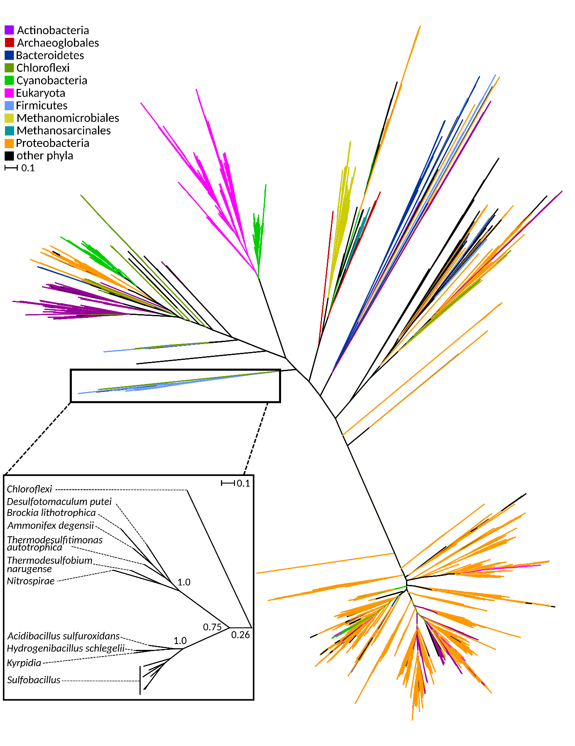
Extended Data Fig. 2. Phylogeny of known phosphoribulokinase sequences. All sequences annotated with EC 2.7.1.19 (no fragments) were downloaded from UniProtKB and clustered to 90% identity. The resulting sequences were compared to the A. degensii enzyme (Accession: C9R9G6), and non-homologous sequences removed. Sequences, clustering alignment and tree in nexus format are available on Zenodo (DOI: 10.5281/zenodo.5795427). The scale bar represents the number of substitutions per site, branch support values represent Shimodaira-Hasegawa test results (1000 replications).

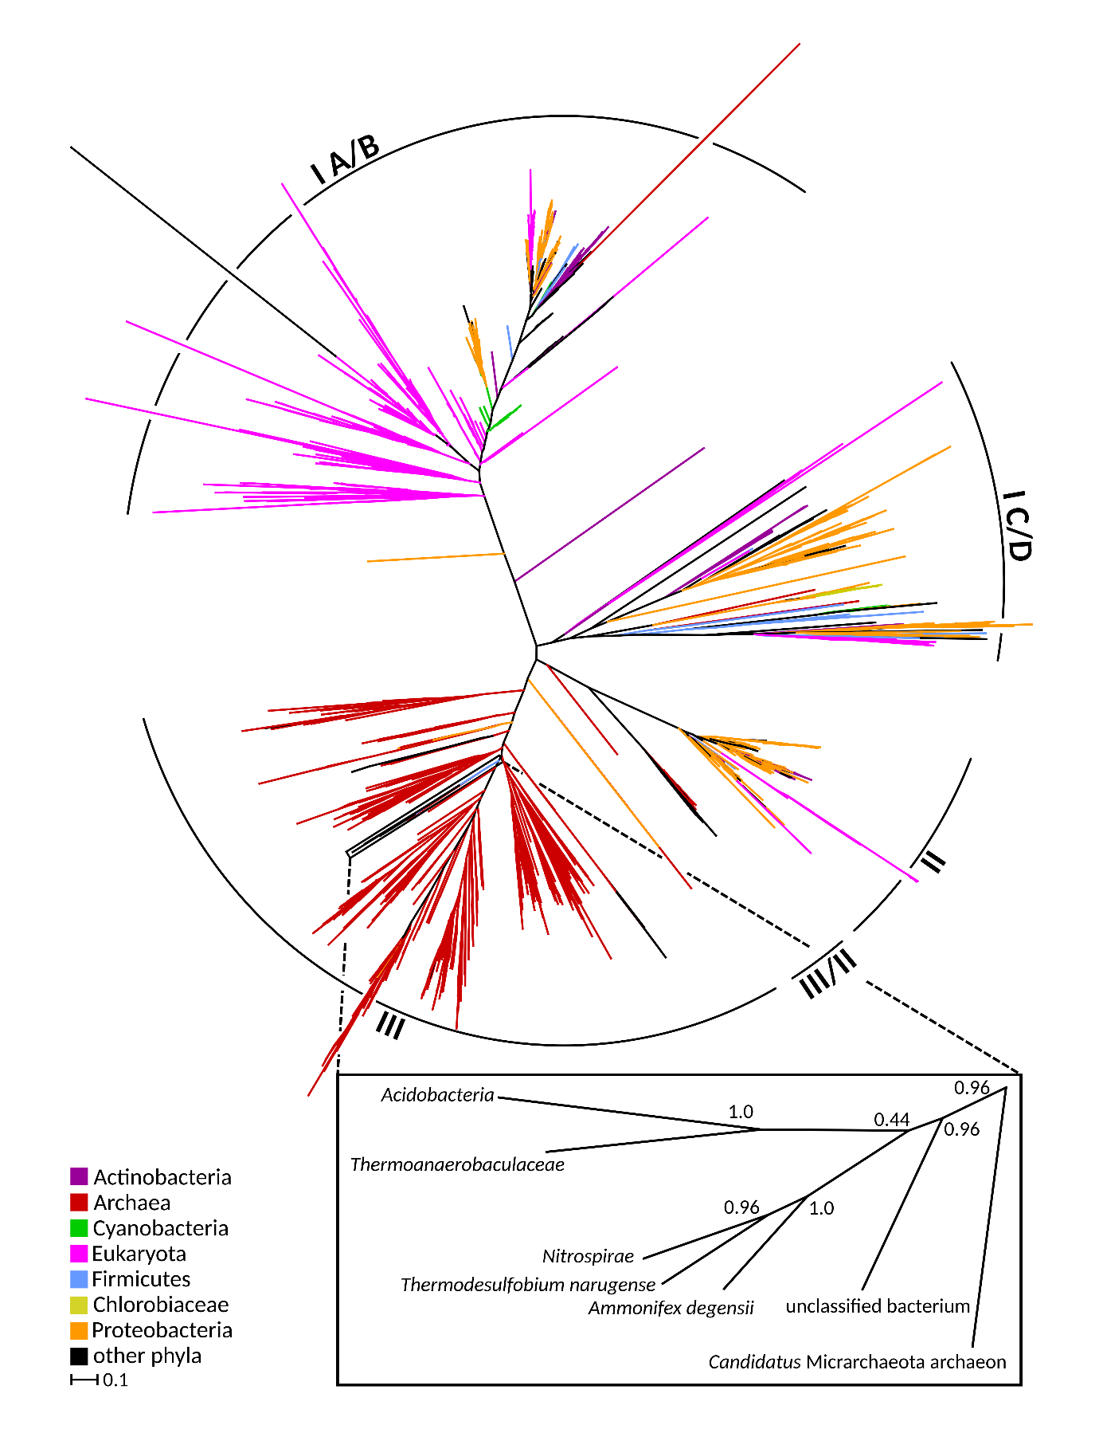
Extended Data Fig. 3. Phylogeny of different forms (I-III) of RubisCO. All sequences annotated with EC 4.1.1.39 (no fragments) were downloaded from UniProtKB and clustered to 90% identity. The resulting sequences were compared to the A. degensii enzyme (Accession: C9R9G7), and non-homologous sequences removed. Sequences, clustering alignment and tree in nexus format are available on Zenodo (DOI: 10.5281/zenodo.5795427). The scale bar represents the number of substitutions per site, branch support values represent Shimodaira-Hasegawa test results (1000 replications).
Extended Data Fig. 4. Detection of S7P in transaldolase assay mixture. (a) Extracted ion chromatogram for S7P ([M-H]- : 289.0325 Da) after 0, 1, 2 and 5 min of incubation; (b) Mass spectrum of the S7P peak (3.854-4.346 min). A representative result from two biological replicates is shown.

Extended Data Tables.
Extended Data Table 1. Catalytic properties of heterologously expressed A. degensii enzymes. The means and standard deviations of three technical replicates are shown. The specific activity at 70°C was estimated based on the assumption that a 10°C rise in temperature doubles the reaction rates.

Enzyme | Assay T[°C] | Gene | Spec. activity [U/mg] | V_{max} [U/mg] | Activity [U/mg],  extrapolated to 70°C | K_{m} [µM]
FBP aldolase/  phosphatase | 48 | Adeg_1859 |  | 0.55±0.01 (FBP) | 2.5 | 190±15 (FBP)
FBP aldolase/  phosphatase | 48 | Adeg_1859 | 0.42±0.01 (DHAP/GAP) |  | 1.9 | ND*
FBP aldolase/  phosphatase | 48 | Adeg_0665 |  | 0.32±0.01 (FBP) | 1.5 | 53±6 (FBP)
FBP aldolase/  phosphatase | 48 | Adeg_0665 | 0.29±0.0003 (DHAP/GAP) |  | 1.3 | ND*
SBP aldolase/  phosphatase | 42 | Adeg_1859 | 0.005±0.001 (DHAP/E4P) | ND* | 0.03 | ND*
SBP aldolase/  phosphatase | 42 | Adeg_0665 | 0.001±0.00001 (DHAP/E4P) | ND* | 0.01 | ND*
Transaldolase† | 48 | Adeg_1864 | 6.32±0.66 | ND* | 29.0 | ND*
Phospho-ribulokinase | 42 | Adeg_1862 |  | 12.8±0.8  (ATP) | 89.1 | 337±0.09  (ATP)
Phospho-ribulokinase | 42 | Adeg_1862 |  | 14.4±1.7  (RuMP) | 100.3 | 70±0.03  (RuMP)
RubisCO‡ | 65 | Adeg_1863 | 3.9±0.3 |  | 5.5 | ND
* ND, not determined.
† Transaldolase was partly purified to an apparent purity of 55%, based on the relative band intensity on an SDS-gel.
‡The enzyme eluted as a dimer on a gel filtration column (63 kDa). Aerobically purified RubisCO was active only under anoxic conditions, anaerobic enzyme preparations were active under oxic conditions (43% activity) and were partially and reversibly inactivated by oxygen.

Extended Data Table 2. Activities of enzymes involved in central carbon metabolism in A. degensii grown under autotrophic conditions with H₂:CO₂ (80:20) gas mixture. The means and standard deviations of at least two biological replicates are shown. The specific activity at 70°C was estimated based on the assumption that a 10°C rise in temperature doubles the reaction rates.
Pathway / Enzyme | T  [C°] | Specific activity [nmol min⁻¹ mg⁻¹] |  | Candidate gene(s),  Genebank locus
Pathway / Enzyme | T  [C°] | Measured | Extrapolated to 70°C | Candidate gene(s),  Genebank locus
FBPAP (F6P formation) | 48 | 28±11 | 130 | adeg_1859, adeg_0665, adeg_0056#
FBPAP (triose phosphate formation) | 48 | 110±5 | 510 | adeg_1859, adeg_0665, adeg_0056#
FBPase | 48 | 15±2 | 69 | adeg_1859, adeg_0665
Transketolase | 48 | 40±16 | 180 | adeg_0469/0470  adeg_1860/1861
Transaldolase (triose phosphate formation) | 48 | 340±60 | 1560 | adeg_1864, adeg_0057
Transaldolase (S7P formation) | 48 | 600±50 | 2760 | adeg_1864, adeg_0057
Pyruvate kinase | 42 | 125±47 | 871 | adeg_0440
PEP synthase | 65 | 8±0 | 11 | adeg_1730
PEP carboxylase* | 42/65 | <5 |  | -§
PEP carboxykinase* | 42/65 | <5 |  | -§
Pyruvate carboxylase* | 42/65 | <5 |  | adeg_1283, 1284?
Malic enzyme (NADP⁺) | 65 | 198±7 | 280 | -§
Malic enzyme (NAD⁺) | 65 | <2 |  | adeg_0169
Malate dehydrogenase | 65 | 224±4 | 317 | adeg_1582†
Citrate synthase | 50 | 7±2 | 27 | adeg_1099? 0226? 0229? ‡
2-Oxoglutarate synthase | 65 | <1 |  | adeg_2122-2125 (?)
Isocitrate dehydrogenase (NADP⁺) | 65 | 740±237 | 1046 | adeg_1102
Pyruvate synthase | 65 | 134±1 | 190 | adeg_1383-1385  adeg_2122-2125 (?)
Pyruvate dehydrogenase | 48 | <2 |  | -§
Lactate dehydrogenase | 65 | 307 | 434 | adeg_1582†
# Putative FBP aldolase.
* We were unable to detect the activity of any anaplerotic carboxylase responsible for pyruvate/PEP conversion to oxaloacetate/malate in cell extract of A. degensii, however, labelling experiments clearly show that oxaloacetate is formed through carboxylation of pyruvate or PEP (Fig. 2, Supplementary Tables 2 and 3).
† There is no annotated malate dehydrogenase in the genome, but Adeg_1582 annotated as lactate dehydrogenase has considerable activity with malate (56 U/mg of malate dehydrogenase activity vs. 85 U/mg lactate dehydrogenase activity, as measured with 5 mM pyruvate/oxaloacetate for recombinant, partly purified enzyme). Note that the ratio of malate and lactate dehydrogenase activities is similar in cell extracts. When the recombinant enzyme was tested with a substrate concentration of 0.5 mM, malate dehydrogenase activity surpassed lactate dehydrogenase activity (9 U/mg vs. 6 U/mg), indicating that the enzyme functions as a malate dehydrogenase rather than a lactate dehydrogenase.
‡ No gene for Si-citrate synthase can be recognized in the genome. Isotopologue profiling data suggests the operation of a Re-specific enzyme⁶¹ (Fig. 2, Supplementary Table 2).
§ -, no gene found.

Extended Data Table 3. Quantification of enzymes involved in the Calvin-Benson cycle and the Wood-Ljungdahl pathway in cell extracts of A. degensii grown with H₂:CO₂ (80:20) and H₂:CO₂:N₂ (10:20:70) gas mixture using high-definition mass spectrometry. Samples were spiked with known amounts of yeast alcohol dehydrogenase 1, and proteins were quantified in reference to the total protein amount (ng); the average is given. -, protein not detected or detected in only one (out of three) biological replicates.
Enzyme | Protein ID | Abundance [%]
Enzyme | Protein ID | 80% H₂ | 10% H₂
Calvin-Benson cycle
FBP aldolase, class II | Adeg_0056 | 0.13 ± 0.01 (n=3) | 0.27 ± 0.03 (n=3)
Transaldolase | Adeg_0057  Adeg_1864 | 0.06 ± 0.02 (n=3)  0.27 ± 0.04 (n=3) | 0.12 ± 0.01 (n=3)  0.19 ± 0.01 (n=3)
FBPAP | Adeg_0665  Adeg_1859 | 0.81 ± 0.1 (n=3)  0.80 ± 0.03 (n=3) | 0.18 ± 0.07 (n=3)  0.15 ± 0.08 (n=3)
RubisCO | Adeg_1863 | 0.64 ± 0.02 (n=3) | 0.61 ± 0.17 (n=3)
Phosphoribulokinase | Adeg_1862 | 0.11 ± 0.02 (n=3) | -*
Transketolase | Adeg_0469/  Adeg_0470,  Adeg_1860/  Adeg_1861 | 0.06 ± 0.02 (n=3)/ 0.11 ± 0.01 (n=3),  0.26 ± 0.07 (n=3)/ 0.27 ± 0.07 (n=3) | 0.04 ± 0.03 (n=3)/ 0.09 ± 0.01 (n=3),  0.09 ± 0.04 (n=3)/ 0.08 ± 0.04 (n=3)
Glyceraldehyde 3-phosphate dehydrogenase | Adeg_1857  Adeg_1617  Adeg_1711 | 0.21 ± 0.13 (n=3)  0.27 ± 0.06 (n=3)  0.25 ± 0.05 (n=3) | 0.14 ± 0.05 (n=3)  0.26 ± 0.07 (n=3)  0.20 ± 0.02 (n=3)
3-phosphoglycerate kinase | Adeg_1616 | 0.50 ± 0.03 (n=3) | 0.58 ± 0.01 (n=3)
Ribosephosphate isomerase | Adeg_0070 | 0.06 ± 0.01 (n=3) | 0.04 ± 0.01 (n=3)
Ribulosephosphate epimerase | Adeg_1309  Adeg_1858 | -*  0.03 ± 0.01 (n=2) | -*  0.004 ± 0.002 (n=2)
Triosephosphate isomerase | Adeg_1615 | 0.003 ± 0.002 (n=3) | 0.002 ± 0.001 (n=2)
Calvin-Benson cycle enzymes in total |  | 4.84 | 3.05
Wood-Ljungdahl pathway
Formate dehydrogenase | Adeg_0156/  Adeg_0157/  Adeg_0158,  Adeg_0283/  Adeg_0284,  Adeg_0334/  Adeg_0332/  Adeg_0331,  Adeg_1427 | 0.34 ± 0.12 (n=3)/ 0.1 ± 0.03 (n=3)/ 0.03 ± 0.01 (n=3),  0.48 ± 0.42 (n=3)/  -,  0.94 ± 0.03 (n=3)/  0.37 ± 0.02 (n=3)/  0.04 ± 0.007 (n=2),  - | 0.07 ± 0.04 (n=3)/  -*/  -*,  0.26 ± 0.18 (n=3)/  0.01 ± 0.003 (n=3),  0.65 ± 0.18 (n=3)/  0.27 ± 0.04 (n=3)/  0.01 ± 0.002 (n=3),  -*
10-Formyl-H₄ folate synthetase | Adeg_2057 | 0.37 ± 0.04 (n=3) | 0.52 ± 0.05 (n=3)
5,10-Methenyl-H₄ folate cyclohydrolase/ 5,10-Methylene-H₄ folate dehydrogenase | Adeg_1277/  Adeg_1278 | 0.22 ± 0.03 (n=3)/  0.06 ± 0.02 (n=3) | 0.29 ± 0.05 (n=3)/  0.05 ± 0.01 (n=3)
5,10-Methylene-H₄ folate reductase | Adeg_0345/  Adeg_0344 | 0.27 ± 0.01 (n=3)/  0.05 ± 0.02 (n=2) | 0.30 ± 0.02 (n=3)/  0.01 ± 0.001 (n=2)
Methyl-H₄ folate: corrinoid iron-sulfur protein methyltransferase | Adeg_0341 | 0.07 ± 0.03 (n=3) | 0.12 ± 0.05 (n=3)
CO dehydrogenase/acetyl-CoA synthase | Adeg_0336  Adeg_0335 | 0.74 ± 0.03 (n=3)/  0.64 ± 0.05 (n=3) | 0.62 ± 0.12 (n=3)/  0.35 ± 0.18 (n=3)
Wood-Ljungdahl pathway enzymes in total |  | 4.72 | 3.53
Note. *Detected in only one (out of three) biological replicates.

Extended Data Table 4. Comparative proteomics for enzymes of the Calvin-Benson cycle and the Wood-Ljungdahl pathway in cell lysates of A. degensii grown with 80 and 10% H₂ in the gas mixture. The data are shown as fold values. For the full proteome expression data are available on Zenodo (DOI: 10.5281/zenodo.5795427).
Enzyme | Protein ID | Relation  10% H₂ vs. 80% H₂
Calvin-Benson cycle
FBP aldolase, class II | Adeg_0056 | 2.42
Transaldolase | Adeg_0057  Adeg_1864 | 1.97  1.12
FBPAP | Adeg_0665  Adeg_1859 | -4.33  -5.68
RubisCO | Adeg_1863 | 1.48
Phosphoribulokinase | Adeg_1862 | -2.70
Transketolase | Adeg_0469/0470  Adeg_1860/1861 | 1.3/1.11  -3.01/-2.02
Glyceraldehyde 3-phosphate dehydrogenase | Adeg_1857  Adeg_1617  Adeg_1711 | -1.48  1.27  1.13
3-phosphoglycerate kinase | Adeg_1616 | 1.53
Ribosephosphate isomerase | Adeg_0070 | -1.34
Ribulosephosphate epimerase | Adeg_1309  Adeg_1858 | -1.38  -1.42
Triosephosphate isomerase | Adeg_1615 | 1.02
Wood-Ljungdahl pathway
Formate dehydrogenase | Adeg_0156/0157/0158,  Adeg_0283/0284,  Adeg_0334/0332/0331,  Adeg_1427 | -2.54/-4.77/2.79,  1.49/1.91  -1.54/-1.33/-2.51  -3.43
10-Formyl-H₄ folate synthetase | Adeg_2057 | 1.05
5,10-Methenyl-H₄ folate cyclohydrolase/ 5,10-Methylene-H₄ folate dehydrogenase | Adeg_1277/Adeg_1278 | 1.77/-1.19
5,10-Methylene-H₄ folate reductase | Adeg_0345/0344 | 1.18/2.12
Methyl-H₄ folate: corrinoid iron-sulfur protein methyltransferase | Adeg_0341 | 1.43
CO dehydrogenase/acetyl-CoA synthase | Adeg_0336/0335 | -1.23/-1.44
Extended Data Table 5. Quantification of enzymes potentially involved in hydrogen oxidation in cell extracts of A. degensii grown with H₂:CO₂ (80:20) or H₂:CO₂:N₂ (10:20:70) gas mixture using high-definition mass spectrometry. Samples were spiked with known amounts of yeast alcohol dehydrogenase 1, and proteins were quantified in reference to the total protein amount (ng); the average is given. -, protein not detected or detected in only one (out of three) biological replicates.
Enzyme | Protein ID | Abundance [%] |  | Relation  10% H₂ vs. 80% H₂
Enzyme | Protein ID | 80% H₂ | 10% H₂ | Relation  10% H₂ vs. 80% H₂
[FeFe] hydrogenase A1 | Adeg_1783 | -* | - | -
[FeFe] hydrogenase A2 | Adeg_1781 | 0.07 ± 0.03 (n=2) | 0.22 ± 0.05 (n=2) | -1.01
F₄₂₀-non-reducing hydrogenase (MvhAGD) | Adeg_2013/  Adeg_2014/  Adeg_2015 | 0.47 ± 0.12 (n=3)/  0.23 ± 0.07 (n=3)/  0.03 ± 0.01 (n=3) | 0.44 ± 0.14 (n=3)/  0.15 ± 0.06 (n=3)/  0.03 ± 0.01 (n=3) | 1.12/  -1.18/  1.09
[NiFeSe] hydrogenase (HysAB) | Adeg_1231/  Adeg_1232 | 0.28 ± 0.02 (n=3)/  0.08 ± 0.01 (n=3) | 0.23 ± 0.07 (n=3)/  0.07 ± 0.01 (n=3) | 1.25/  -1.24
[FeFe] membrane-bound hydrogenase (HybABC) | Adeg_0290/  Adeg_0291/  Adeg_0292 | -/  -/  - | -/  0.04 (n=1)/  - | 2.24/  1.60/  -
Energy converting hydrogenase (EchABCDEF) | Adeg_0549/  Adeg_0550/  Adeg_0551/  Adeg_0552/  Adeg_0553/  Adeg_0554 | -/  -/  0.005 ± 0.001 (n=3)/  0.01 ± 0.002 (n=3)/  0.09 ± 0.01 (n=3)/  - | -/  -/  0.002 ± 0.001 (n=3)/  0.008 ± 0.007 (n=3)/  0.06 ± 0.03 (n=3)/  -* | -/  -/  1.20/  2.35/  -1.07/  -1.70
[NiFe] hydrogenase | Adeg_1787 | 0.24 ± 0.04 (n=3) | 0.009 ± 0.003 (n=3) | -9.06
[FeFe] Group C3 hydrogenases | Adeg_0909/  Adeg_1001 | -/  - | -/  - | -/  -
Methyl-viologen-reducing [FeFe] Group A hydrogenase | Adeg_1425 | 0.17 ± 0.04 (n=2) | 0.11 ± 0.02 (n=3) | -1.25
Note. *The protein was detected in only one (out of three) biological replicates.

Extended Data Table 6. Quantification of enzymes involved in the Calvin-Benson cycle in cell extracts of T. narugense grown with H₂:CO₂ (80:20) gas mixture using high-definition mass spectrometry. Samples were spiked with known amounts of yeast alcohol dehydrogenase 1, and proteins were quantified in reference to the total protein amount (ng); the average is given. -, protein not detected.
Enzyme | Protein ID | Abundance [%]
Calvin-Benson cycle
FBP/SBP aldolase, class II | Thena_1182 | 0.60 ± 0.02 (n=3)
Transaldolase | Thena_1180  Thena_0422 | 0.07 ± 0.006 (n=3)  0.05 ± 0.03 (n=3)
FBP/SBP(?) phosphatase | Thena_1181  Thena_0429  Thena_0472 | 0.11 ± 0.004 (n=3)  0.02 ± 0.008 (n=3)  0.04 ± 0.001 (n=3)
RubisCO | Thena_0423 | 0.06 ± 0.03 (n=3)
Phosphoribulokinase | Thena_0424 | -*
Transketolase | Thena_0425/0426,  Thena_0769/  Thena_0770 | -/-  0.06 ± 0.002 (n=3)/  0.05 ± 0.006 (n=3)
Glyceraldehyde 3-phosphate dehydrogenase | Thena_0427  Thena_1627 | -  0.23 ± 0.03 (n=3)
3-phosphoglycerate kinase | Thena_0428 | 0.10 ± 0.04 (n=3)
Ribosephosphate isomerase | Thena_0430 | 0.01 ± 0.002 (n=3)
Ribulosephosphate epimerase | Thena_0431 | 0.002 (n=1)
Triosephosphate isomerase | Thena_1629 | -**
Calvin-Benson cycle enzymes in total |  | 1.40
Notes. * Although this protein was not detected in the proteome, the corresponding activity was found in T. narugense cell extract.
** This short (232 amino acids) protein usually has very high turnover number, being therefore difficult to detect in the proteome.
Extended Data References
- Li, F., Hagemeier, C. H., Seedorf, H., Gottschalk, G. & Thauer, R. K. Re-citrate synthase from Clostridium kluyveri is phylogenetically related to homocitrate synthase and isopropylmalate synthase rather than to Si-citrate synthase. J. Bacteriol. 189, 4299-4304 (2007).

