Legends for Supplementary Tables and Figures
Supplementary Table 1: ICD-10 codes used to estimate the HFRS, and the points awarded for each diagnosis.
Supplementary Table 2: A complete list of ICD-10 variables extracted from the VAED database.
Supplementary Table 3: A complete list of ICD-10 variables extracted from the VDI database.
Supplementary Table 4: Comparison between included (n=7,001) vs excluded (n=13,457).
Supplementary Table 5: Spearman correlation and Kappa agreement between the two frailty measures.
Supplementary Table 6: Subgroup analysis: Unadjusted and adjusted Cox proportional hazards regression for CFS and the HFRS as continuous variables, adjusting for ANZROD, and sex CFS and HFRS or (a) Patients ≥65 years of age and (b) Patients needing mechanical ventilation.
Supplementary Table 7: Multivariable Logistic Regression analysis for short-term and long-term mortalities in dichotomous scale. Unadjusted and adjusted for sex and ANZROD. The odds ratio (OR) in bold represent statistically significant results. Graphically presented in Figure 2.
Supplementary Figure 1: Prevalence of frailty measure by CFS and HFRS across different age categories.
Supplementary Figure 2: Mortality Proportion between CFS and HFRS treated as a dichotomous variable.
Supplementary Figure 3: Area under the receiver operator curve for short-term mortality. The CFS was significantly better than the HFRS. However, CFS and HFRS must both be measuring different aspects, because the combination of the two was better than either measure on its own. The bottom 2 graphs showed that while both variables may be predictive of mortality, neither provided any worthwhile improvement on top of ANZROD.
Supplementary Figure 4: Area under the receiver operator curve for 1-year mortality for patients ≥65 years of age and those needing mechanical ventilation.
Supplementary Table 1: ICD-10 codes used to estimate the HFRS, and the points awarded for each diagnosis.

ICD-10 Code | Diagnosis | Points Awarded | Frequency | Percentage (%)
N17 | Acute renal failure | 1·8 | 1023 | 14.6
E87 | Other disorders of fluid, electrolyte, and acid-base balance | 2·3 | 940 | 13.4
A41 | Other septicaemia | 1·6 | 660 | 9.4
N18 | Chronic renal failure | 1·4 | 608 | 8.7
I95 | Hypotension | 1·6 | 583 | 8.3
D64 | Other anaemias | 0·4 | 458 | 6.5
J96 | Respiratory failure, not elsewhere classified | 1·5 | 422 | 6.0
S22 | Fracture of rib(s), sternum, and thoracic spine | 1·8 | 411 | 5.9
F10 | Mental and behavioural disorders due to use of alcohol | 0·7 | 344 | 4.9
J18 | Pneumonia, organism unspecified | 1·1 | 331 | 4.7
B96 | Other bacterial agents as the cause of diseases classified to other chapters (secondary code) | 2·9 | 311 | 4.4
E83 | Disorders of mineral metabolism | 0·4 | 290 | 4.1
S06 | Intracranial injury | 2·4 | 289 | 4.1
B95 | Streptococcus and staphylococcus as the cause of diseases classified to other chapters | 1·7 | 230 | 3.3
R13 | Dysphagia | 0·8 | 228 | 3.3
N39 | Other disorders of the urinary system (includes urinary tract infection and urinary incontinence) | 3·2 | 226 | 3.2
F05 | Delirium, not induced by alcohol and other psychoactive substances | 3·2 | 200 | 2.9
S01 | Open wound of head | 1·1 | 191 | 2.7
U80 | Agent resistant to penicillin and related antibiotics | 0·8 | 191 | 2.7
E86 | Volume depletion | 2·3 | 182 | 2.6
S32 | Fracture of lumbar spine and pelvis | 1·4 | 178 | 2.5
J69 | Pneumonitis due to solids and liquids | 1·0 | 177 | 2.5
R41 | Other symptoms and signs involving cognitive functions and awareness | 2·7 | 159 | 2.3
L89 | Decubitus ulcer | 1·7 | 149 | 2.1
R94 | Abnormal results of function studies | 1·4 | 146 | 2.1
R00 | Abnormalities of heartbeat | 0·7 | 145 | 2.1
Z91 | Personal history of risk factors, not elsewhere classified | 0·5 | 145 | 2.1
K59 | Other functional intestinal disorders | 1·8 | 138 | 2.0
S72 | Fracture of femur | 1·4 | 128 | 1.8
F32 | Depressive episode | 0·5 | 127 | 1.8
S42 | Fracture of shoulder and upper arm | 2·3 | 125 | 1.8
W19 | Unspecified fall | 3·2 | 116 | 1.7
A09 | Diarrhoea and gastroenteritis of presumed infectious origin | 1·1 | 116 | 1.7
K92 | Other diseases of the digestive system | 0·8 | 111 | 1.6
G81 | Hemiplegia | 4·4 | 109 | 1.6
R40 | Somnolence, stupor and coma | 2·5 | 107 | 1.5
I63 | Cerebral Infarction | 0·8 | 105 | 1.5
L03 | Cellulitis | 2·0 | 103 | 1.5
S80 | Superficial injury of the lower leg | 2·0 | 102 | 1.5
R45 | Symptoms and signs involving emotional state | 1·2 | 102 | 1.5
R47 | Speech disturbances, not elsewhere classified | 1·0 | 101 | 1.4
S00 | Superficial injury of head | 3·2 | 99 | 1.4
R56 | Convulsions, not elsewhere classified | 2·6 | 98 | 1.4
W18 | Other fall on the same level | 2·1 | 92 | 1.3
Y84 | Other medical procedures as the cause of abnormal reaction of the patient | 0·7 | 92 | 1.3
R79 | Other abnormal findings of blood chemistry | 0·6 | 76 | 1.1
R50 | Fever of unknown origin | 0·1 | 76 | 1.1
X59 | Exposure to unspecified factor | 1·5 | 74 | 1.1
R63 | Symptoms and signs concerning food and fluid intake | 0·9 | 74 | 1.1
W01 | Fall on the same level from slipping, tripping and stumbling | 0·9 | 73 | 1.0
S51 | Open wound of forearm | 0·5 | 72 | 1.0
J22 | Unspecified acute lower respiratory infection | 0·7 | 63 | 0.9
R33 | Retention of urine | 1·3 | 60 | 0.9
R11 | Nausea and vomiting | 0·3 | 60 | 0.9
R55 | Syncope and collapse | 1·8 | 57 | 0.8
Z60 | Problems related to social environment | 1·8 | 54 | 0.8
M25 | Other joint disorders, not elsewhere classified | 2·3 | 52 | 0.7
Y95 | Nosocomial condition | 1·2 | 51 | 0.7
K26 | Duodenal ulcer | 1·6 | 47 | 0.7
G40 | Epilepsy | 1·5 | 44 | 0.6
R29.6 | Tendency to fall | 3·6 | 42 | 0.6
R31 | Unspecified haematuria | 3·0 | 40 | 0.6
M79 | Other soft tissue disorders, not elsewhere classified | 1·1 | 39 | 0.6
Z22 | Carrier of infectious disease | 1·7 | 36 | 0.5
L97 | Ulcer of the lower limb, not elsewhere classified | 1·6 | 35 | 0.5
R02 | Gangrene, not elsewhere classified | 1·0 | 34 | 0.5
N28 | Other disorders of kidney and ureter, not elsewhere classified | 1·3 | 32 | 0.5
M48 | Spinal stenosis (secondary code only) | 0·5 | 30 | 0.4
R26 | Abnormalities of gait and mobility | 2·6 | 29 | 0.4
I67 | Other cerebrovascular diseases | 2·6 | 28 | 0.4
E16 | Other disorders of pancreatic internal secretion | 1·4 | 28 | 0.4
A04 | Other bacterial intestinal infections | 1·1 | 28 | 0.4
W10 | Fall on and from stairs and steps | 0·9 | 28 | 0.4
E05 | Thyrotoxicosis [hyperthyroidism] | 0·9 | 27 | 0.4
Z75 | Problems related to medical facilities and other health care | 2·0 | 23 | 0.3
R32 | Unspecified urinary incontinence | 1·2 | 23 | 0.3
K52 | Other noninfective gastroenteritis and colitis | 0·3 | 23 | 0.3
I69 | Sequelae of cerebrovascular disease (secondary codes) | 3·7 | 22 | 0.3
T83 | Complications of genitourinary prosthetic devices, implants and grafts | 2·4 | 21 | 0.3
S09 | Other and unspecified injuries of the head | 1·2 | 21 | 0.3
W06 | Fall involving bed | 1·1 | 18 | 0.3
M19 | Other arthrosis | 1·5 | 15 | 0.2
M81 | Osteoporosis without pathological fracture | 1·4 | 15 | 0.2
N20 | Calculus of kidney and ureter | 0·7 | 15 | 0.2
G45 | Transient cerebral ischaemic attacks and related syndromes | 1·2 | 13 | 0.2
R44 | Other symptoms and signs involving general sensations and perceptions | 1·6 | 12 | 0.2
G20 | Parkinson's disease | 1·8 | 11 | 0.2
E55 | Vitamin D deficiency | 1·0 | 11 | 0.2
H91 | Other hearing loss | 0·9 | 11 | 0.2
F03 | Unspecified dementia | 2·1 | 10 | 0.1
N19 | Unspecified renal failure | 1·6 | 10 | 0.1
Z93 | Artificial opening status | 1·0 | 10 | 0.1
Z99 | Dependence on enabling machines and devices | 0·8 | 10 | 0.1
M41 | Scoliosis | 0·9 | 9 | 0.1
L08 | Other local infections of the skin and subcutaneous tissue | 0·4 | 8 | 0.1
E53 | Deficiency of other B group vitamins | 1·9 | 7 | 0.1
F00 | Dementia in Alzheimer's disease | 7·1 | 5 | 0.1
G30 | Alzheimer's disease | 4·0 | 5 | 0.1
Z74 | Problems related to care-provider dependency | 1·1 | 4 | 0.1
Z50 | Care involving the use of rehabilitation procedures | 2·1 | 3 | 0.0
F01 | Vascular dementia | 2·0 | 3 | 0.0
M80 | Osteoporosis with pathological fracture | 0·8 | 3 | 0.0
H54 | Blindness and low vision | 1·9 | 2 | 0.0
Z87 | Personal history of other diseases and conditions | 1·5 | 1 | 0.0
Z73 | Problems related to life-management difficulty | 0·6 | 1 | 0.0
M15 | Polyarthrosis | 0·4 | 1 | 0.0
R54 | Senility | 2·2 | 0 | 0.0
R69 | Unknown and unspecified causes of morbidity | 1·3 | 0 | 0.0
G31 | Other degenerative diseases of the nervous system, not elsewhere classified | 1·2 | 0 | 0.0

Supplementary Table 2: A complete list of ICD-10 variables extracted from the VAED database.

Data Field Description | Definition
Month and Year of Admission | Month and Year on which a patient commences an episode of care.
Care type | The nature of clinical service (type of care) provided to an admitted patient during an episode of care. There must be one and only one care type code per episode. A change in care type results in a statistical separation and a new episode with a statis
Care type | 1 NHT/Non-Acute
Care type | P Designated Paediatric Rehabilitation Program/Unit
Care type | 2 Designated Rehabilitation Program/Unit: Level 1
Care type | 6 Designated Rehabilitation Program/Unit: Level 2
Care type | 8 Palliative Care Program
Care type | 5 Mental Health
Care type | 9 Geriatric Evaluation and Management Program
Care type | R1 Restorative Care: On-site
Care type | R2 Restorative Care: Off-site
Care type | 0 Alcohol and Drug Program
Care type | 4 Other care (Acute) including Qualified newborn
Care type | U Unqualified newborn
Care type | N Qualified Newborn
Care type | U Unqualified Newborn
Care type | X Not Applicable
Admission type | The type of admission relating to this episode of care:
Admission type | K Posthumous Organ Procurement
Admission type | S Statistical admission (change in Care Type within this hospital)
Admission type | Y Birth episode
Admission type | M Maternity
Admission type | C Emergency admission through Emergency Department at this hospital (VEMD reporting hospitals only)
Admission type | L Admission – from the Waiting List (ESIS reporting hospitals only)
Admission type | O Other emergency admission
Admission type | X Other admission
Admission type indicator | Admission type indicator derived from Admission Type
Admission type indicator | E Emergency
Admission type indicator | L Elective
Admission type indicator | M Maternity
Admission type indicator | N Newborn (<= 9 days old)
Admission type indicator | S Statistical
Criterion for Admission | This field indicates the criterion for admission for the episode of care.
Criterion for Admission | K Posthumous Organ Procurement
Criterion for Admission | N Qualified newborn
Criterion for Admission | U Unqualified newborn
Criterion for Admission | R Restorative Care: Off-site
Criterion for Admission | O Patient expected to require hospitalisation for a minimum of one night
Criterion for Admission | B Day-only Automatically Admitted Procedures
Criterion for Admission | E Day-only Extended Medical Treatment
Criterion for Admission | C Day-only Not Automatically Qualified Procedures
Criterion for Admission | S Secondary family member
Admission/readmission to rehabilitation | For Care Types P, 2 and 6, this field indicates whether this is the first or subsequent rehabilitation episode for a particular injury/condition.
Admission/readmission to rehabilitation | 0 First rehabilitation admission
Admission/readmission to rehabilitation | 1 Readmission for rehabilitation
RUG ADL on admission | RUG ADL (Resource Utilisation Groups Activities of Daily Living) score as assessed on admission. Cumulative score out of 18.
Source of referral to palliative care | Source of referral to the DH Palliative Care Program (Care Type 8).
Source of referral to palliative care | 01 Community sector – GP
Source of referral to palliative care | 02 Community sector – Specialist
Source of referral to palliative care | 03 Community sector - Self, Carer, Other (family member, neighbour)
Source of referral to palliative care | 04 Community sector- Community-based agency
Source of referral to palliative care | 05 Hospital - Public - Admitted patient
Source of referral to palliative care | 06 Hospital - Private - Admitted patient
Source of referral to palliative care | 07 Hospital - Outpatient - Non-admitted
Source of referral to palliative care | 08 Residential care - Nursing home/hostel
Source of referral to palliative care | 09 Other
5 year age groups | Five-year age groups
5 year age groups | 00-04 05-09 10-14 15-19 20-24
5 year age groups | 25-29 30-34 35-39 40-44 45-49
5 year age groups | 50-54 55-59 60-64 65-69 70-74
5 year age groups | 75-79 80-84 85+
Sex of patient | The sex of the patient:
Sex of patient | 1 Male
Sex of patient | 2 Female
Sex of patient | 3 Indeterminate (only for infants < 90 days old)
Sex of patient | 4 Intersex
Statistical local area (5 digits) | The patient’s Statistical Local Area of residence. Based on Australian Standard Geographical Classification (ASGC) 2011 boundaries and derived from the locality and postcode.
Local government area | The patient’s Local Government Area of residence. Based on Australian Standard Geographical Classification (ASGC) 2004 boundaries for Victoria, and 1999 boundaries for the rest of Australia.
Region of residence | The code for the Department of Health/Human Services Region in which the patient resides; is derived from the field ‘SLA’.
Region of residence | 1 Barwon Southwestern
Region of residence | 2 Grampians
Region of residence | 3 Loddon Mallee
Region of residence | 4 Hume
Region of residence | 5 Gippsland
Region of residence | 8 Eastern
Region of residence | 9 Southern
Region of residence | A North-Western
Region of residence | I Interstate
Region of residence | M Missing
State of residence | State of patient residence derived from SLA:
State of residence | 0 Unknown/Itinerate/Overseas
State of residence | 1 New South Wales
State of residence | 2 Victoria
State of residence | 3 Queensland
State of residence | 4 South Australia
State of residence | 5 Western Australia
State of residence | 6 Tasmania
State of residence | 7 Northern Territory
State of residence | 8 Australian Capital Territory
State of residence | 9 Other Territories
Carer availability | A record of whether a person, such as a family member, friend or neighbour has been identified as providing regular ongoing care or assistance, which is not linked to a formal service.
Carer availability | 1 Carer not needed/ not applicable
Carer availability | 2 Lives alone, has a carer
Carer availability | 3 Lives alone, has no carer
Carer availability | 4 Lives with another, has no carer
Carer availability | 5 Lives with another, has a resident carer
Carer availability | 6 Lives with another, has a non-resident carer
Carer availability | 7 Lives in a mutually dependent situation
Carer availability | 8 Missing or not recorded
Hospital Region | Metropolitan/Rural flag of hospitals.
Month and Year of separation | Month and Year of separation, eg. Jul, Aug
Length of stay | The length of stay is calculated during the PRS/2 processing, summing the total patient days in each of the status segments minus leave with and without permission days.
Hospital in the home length of stay | Hospital in the Home Length of Stay.
Hospital in the Home separation | Flag to indicate that the episode includes a “Hospital In The Home” component.
Patient type | Patient type derived from Separation Account:
Patient type | H Public
Patient type | P Private
Patient type | S Compensable
Patient type | V DVA
Patient type | X Ineligible
Duration of unit stay | Identifies the duration of stay within a specific campus unit.
Duration of unit stay | E Entire admission was at the specified campus unit
Duration of unit stay | P Part of the admission was at the specified campus unit.
Barthel index on separation | The Barthel Index on separation is assessed on the day on which the decision is taken to cease rehabilitation (for Care Types F, E, 2, 6, 7, 9 or K).
RUG ADL on separation | RUGADL (Resource Utilisation Groups Activities of Daily Living) score as assessed on separation (for Care Type 8). Cumulative score out of 18.
Victorian Adjusted AR-DRGv6 | Victorian Adjusted Australian Revised Diagnosis Related Group v6 is the same as AR-DRG v6 except where adjustments are made utilising the VIC-DRG6 field, for case-mix payments.
Victorian adjusted AR-MDCv6 | The Australian Revised Major Diagnostic Category (AR-MDC) Version 6.0 is derived through the same grouping process as the AR-DRG v6.
Clinical speciality | Clinical speciality mapped from VIC. DRG v6.0x (665 DRGs mapped into 27 Clinical Specialties):
Clinical speciality | 01 Neurosurgery
Clinical speciality | 03 Vascular
Clinical speciality | 04 Orthopaedics
Clinical speciality | 05 Neurology
Clinical speciality | 06 Ophthalmology
Clinical speciality | 07 ENT
Clinical speciality | 08 Cardiothoracic
Clinical speciality | 09 Cardiology
Clinical speciality | 10 Rehabilitation
Clinical speciality | 11 Dental
Clinical speciality | 12 Rheumatology
Clinical speciality | 13 Plastics
Clinical speciality | 14 General Medicine
Clinical speciality | 15 Psychiatry
Clinical speciality | 16 General Surgery
Clinical speciality | 17 Nephrology
Clinical speciality | 18 Renal Dialysis
Clinical speciality | 19 Urology
Clinical speciality | 20 Gynaecology
Clinical speciality | 21 Obstetrics & Ante-natal
Clinical speciality | 22 Neonatology
Clinical speciality | 23 Haematology
Clinical speciality | 24 Respiratory
Clinical speciality | 25 Oncology/Radiology
Clinical speciality | 26 Endocrinology
Clinical speciality | 27 Gastroenterology
Clinical speciality | 28 Other/Ungroupable
DRG Type | DRG type:
DRG Type | M Medical
DRG Type | S Surgical
DRG Type | O Other
DRG Coding status | Coding status of separation records:
DRG Coding status | C Coded
DRG Coding status | P Problem DRG (AR-DRG 6.0: 801A, 801B, 801C)
DRG Coding status | <Blank> Not Coded
First external-cause activity | The first diagnosis code is in the range U50 – U73.
First external-cause place of occurrence | The first diagnosis code commencing with Y92.
Principal external-cause | If the first diagnosis is an injury or poisoning, i.e. in the range S00 to T98, then the principal external cause is the first code in the range of V01 to Y91 or Y95 to Y98.
Principal external-cause activity | If the first diagnosis is an injury or poisoning i.e. in the range S00 to T98, and principal external cause in range V01-Y34, then the activity is the first diagnosis code in the range U50 – U73.
Principal external-cause place of occurrence | If the first diagnosis is an injury or poisoning, i.e. in the range S00 to T98, and principal external cause in range V01 – Y89, then “place of occurrence” is the first diagnosis code commencing with Y92.
Duration of stay (hours) in the intensive care unit | The total duration of stay (hours) in an approved Intensive Care Unit (ICU) or Neonatal Intensive Care Unit (NICU), during this episode of care.
Duration of stay (hours) in the intensive care unit | Duration is reported in hours, rounded up to the nearest hour.
Duration of Mechanical Ventilation in ICU | The total duration of Mechanical Ventilation (MV) in hours provided in an approved Intensive Care Unit (ICU) or Neonatal Intensive Care (NICU) during this episode of care.
Duration of Non-Invasive Ventilation | The total number of hours of non-invasive ventilatory assistance given via any route other than intubation or tracheostomy, provided to patients in an approved Neonatal Intensive Care Unit (NICU) or Special Care Nursery (SCN) or Intensive Care Unit (ICU).
Clinical Sub-program | The diagnosis is based on the body system manifesting the reason for rehabilitation. Reported for Care Types 2, 6, 7, K and P. Clinical Sub-Program is assigned by the treating clinician.
Impairment | A code assigned, based on the body system manifesting the reason for rehabilitation. Only reported for Sub-acute records. Reported for Care Type 2,6, P, R1 and R2. Introduction of Version 1 Australian Impairment code-set for Sub-Acute episodes as an optional field.
Mental Health legal status | A funding-source indicator for involuntary patients:
Mental Health legal status | 1 Involuntary for all or part of this episode
Mental Health legal status | 2 Not involuntary at any time during this episode
Mental Health legal status | 9 Not Applicable
Admission Source | Describes where the patient was residing or living before the commencement of an episode of care.
Admission Source | A Transfer from mental health residential facility
Admission Source | B Transfer from Transition Care bed-based program
Admission Source | H Admission from private residence/ accommodation
Admission Source | N Transfer from aged care residential facility
Admission Source | S Statistical Admission (change in Care Type within this hospital)
Admission Source | T* Transfer from acute/ extended care/ rehabilitation/ geriatric centre
Admission Source | * Requires an admission transfer code
Admission Source | Y Birth Episode
Encrypted Campus code | Indicates the hospital campus where the episode of care was provided. The patient activity must be reported under the campus code at which it occurred.
Interpreter Required | The patient’s need for an interpreter, as perceived by the patient or person consenting for the patient.
Interpreter Required | 1 Yes
Interpreter Required | 2 No
Interpreter Required | 9 Not Stated/Inadequately described
Marital status | The current marital or living status of the patient at the time of admission:
Marital status | 1 Never married
Marital status | 2 Widowed
Marital status | 3 Divorced
Marital status | 4 Separated
Marital status | 5 Married
Marital status | 6 De Facto
Marital status | 9 Not stated/inadequately described
Preferred Language | The language (including sign language) is most preferred by the patient for communication. This may be a language other than English even where the person can speak fluent English.
Indigenous status | The indigenous status of the patient as determined by patient self-identification.
Encrypted Transfer Source (FROM) | Identification of the hospital campus the person has been transferred from, following separation from that hospital.
Account class on separation | The patient account classification on separation.
Encrypted Transfer destination (TO) | Identification of the hospital campus to which the patient is transferred after separation from this hospital.
Encrypted Transfer destination (TO) | Y Yes
Encrypted Transfer destination (TO) | N No
Encrypted Transfer destination (TO) | U Uncoded (but eligible for WIES funding when coded)
Separation Mode | Type of separation:
Separation Mode | A Separation and transfer to mental health residential facility
Separation Mode | B Separation and transfer to Transition Care bed-based program
Separation Mode | D Death
Separation Mode | H Separation to private residence/accommodation
Separation Mode | S Statistical Separation
Separation Mode | N Separation and transfer to aged care residential facility
Separation Mode | T* Separation and transfer to other acute hospital/extended care/rehabilitation/geriatric centre
Separation Mode | R Separation and transfer to Restorative Care bed- based program
Separation Mode | * Requires separation transfer code
Separation Mode | Z Left against medical advice
Separation referral | Clinical care and support services arranged by the hospital to meet the person’s recuperative needs when discharged to private accommodation or home. Up to four referrals can be transmitted in the one field.
Separation referral | A Referral to Aged Care Assessment Service (ACAS), arranged before discharge
Separation referral | B Community palliative care support arranged before discharge
Separation referral | C Mental health community services arranged before discharge
Separation referral | D Psychiatric disability support services arranged before discharge
Separation referral | F Domiciliary postnatal care arranged before discharge
Separation referral | G Referral to general practitioner arranged before discharge
Separation referral | K Referral to Aboriginal and Torres Strait Islander (ATSI) service, arranged before discharge
Separation referral | L Alcohol and drug treatment service arranged before discharge
Separation referral | M Referral to a community rehab centre arranged before discharge
Separation referral | P Post-Acute Care Program services arranged before discharge
Separation referral | R Other clinical care &/or support services arranged before discharge
Separation referral | S Referral to private psychiatrist arranged before discharge
Separation referral | T Referral to Transition Care home-based program, arranged before discharge
Separation referral | U Home nursing support arranged before discharge
Separation referral | X No referral or support services arranged before discharge.
Supplementary Table 3: A complete list of ICD-10 variables extracted from the VDI database.

Data Field Description | Justification
Cause of Death
Deceased Date of Death (Month/year) | Estimation of long-term survival after ICU admission
Deceased Age at Death (Month/year) | Estimation of long-term survival after ICU admission

Supplementary Table 4: Comparison between included (n=7,001) vs excluded (n=13,457).

 | Overall | Excluded Patients | Included Patients | p-value
Number of patients, % (n) | 20458 | 13457 | 7001 | -
Age (years), mean (SD) | 61.8 (17.6) | 62.5 (17.5) | 60.5 (17.6) | <0.0001
Male, % (n) | 57.0 (11689) | 55.9 (7523) | 59.5 (4166) | <0.0001
Clinical Frailty Scale score, mean (SD) | 3.4 (1.5) | 3.5 (1.9) (2439) | 3.3 (1.5) | <0.0001
ICU Admission Type, % (n)
- Elective Surgery | 23.8 (4877) | 23.3 (3137) | 24.9 (1740) | 0.014
Comorbidities, % (n)
- Chronic respiratory disorder | 8.5 (1741) | 8.9 (1202) | 7.7 (539) | 0.003
- Cardiovascular disorder | 8.6 (1757) | 9.6 (1287) | 6.7 (470) | <0.0001
- Chronic renal failure | 4.3 (874) | 4.6 (614) | 3.7 (260) | 0.004
- Hepatic failure | 2.6 (536) | 2.6 (355) | 2.6 (181) | 0.82
- Cirrhosis | 2.6 (539) | 2.7 (358) | 2.6 (181) | 0.75
- Immune disorders | 1.7 (351) | 1.5 (200) | 2.2 (151) | <0.0001
- Immunodeficiency | 5 (1020) | 4.6 (625) | 5.6 (395) | 0.002
- Metastatic cancer | 3 (623) | 3.3 (440) | 2.6 (183) | 0.001
- Lymphoma | 1.1 (218) | 1.2 (166) | 0.7 (52) | 0.001
- Leukaemia | 1.4 (279) | 1.2 (168) | 1.6 (111) | 0.049
Charlson Comorbidity Index | 0 (0-2) | 0 (0-2) | 0 (0-2) | 0.85
Pre-ICU (Hours), median (IQR) | 8 (4-22.2) | 8.3 (4.1-22.8) | 7.5 (3.8-20.1) | <0.0001
Scoring and Risk of Death scores
- APACHE-2 score, mean (SD) | 15.6 (7.8) | 15.7 (8.0) | 15.4 (7.5) | 0.034
- APACHE-3 score, mean (SD) | 52.4 (26.2) | 52.6 (26.9) | 51.9 (24.7) | 0.06
- ANZROD Score, (%) median (IQR) | 2.7 (0.8-10) | 2.9 (0.8-10) | 2.3 (0.7-9.1) | <0.0001
Organ failure and supports, % (n)
- Invasive ventilation | 38.4 (7858) | 34.1 (4592) | 46.7 (3266) | <0.0001
- Renal replacement therapy | 3.3 (671) | 2.3 (314) | 5.1 (357) | <0.0001
Mortality, % (n)
- ICU Mortality | 6.5 (1328) | 6.4 (856) | 6.7 (472) | 0.30
- Hospital Mortality | 9.4 (1924) | 9.5 (1282) | 9.2 (642) | 0.39
- 12-month Mortality | 14.6 (2995) | 14.8 (1989) | 14.4 (1006) | 0.43
Length of Stay, median (IQR)
- ICU length of stay (hours) | 46 (24-89) | 44 (23-84) | 47 (24-93) | <0.0001
- Hospital length of stay (days) | 7 (4-14) | 7 (4-13) | 8 (4-15) | <0.0001
ICU >10 days | 5.2 (1057) | 4.6 (617) | 6.3 (440) | <0.0001
Readmission | 4.0 (823) | 4.1 (547) | 3.9 (276) | 0.67
Discharge Destination, % (n)
- Usual residence | 62.3 (12745) | 56.9 (7657) | 64.2 (4496) | <0.0001
SD = standard deviation; n = number; IQR = interquartile range; ICU = intensive care unit; ICU – intensive care unit; SD – standard deviation; APACHE - Acute Physiology And Chronic Health Evaluation

Supplementary Table 5: Spearman correlation and Kappa agreement between the 2 frailty measures.

HFRS | CFS score |  | Spearman's Correlation⁽¹⁾ | Agreement⁽²⁾
HFRS | non-frail  (CFS <5) | Frail  (CFS≥5) | Correlation coefficient  (95%-CI; p-value) | Kappa  (95%-CI; p-value)
Patients ≥65 years of age (n=3359) | 2515 | 844
HFRS (non-frail; n=2435 [72.5%]) | 1924 | 511 | 0.22  (0.18-0.25; p<0.001) | 0.16  (0.11-0.18; p<0.001)
HFRS (frail; n=924 [27.5%]) | 591 | 333 | 0.22  (0.18-0.25; p<0.001) | 0.16  (0.11-0.18; p<0.001)
Mechanical ventilation (n=3266) | 2722 | 544
HFRS (non-frail; n=2414 [73.9%]) | 2039 | 375 | -0.02  (-0.05-0.02; p=0.40) | 0.05  (0.01-0.08; p=0.004)
HFRS (frail; n=852 [26.1%]) | 683 | 169 | -0.02  (-0.05-0.02; p=0.40) | 0.05  (0.01-0.08; p=0.004)
HFRS – hospital frailty risk score; CFS – Clinical Frailty Scale
⁽¹⁾ Spearman correlation based on continuous variables (Except for correlation coefficient for patients needing mechanical ventilation (p=0.40), all others had a p-value of <0.001)
⁽²⁾ Kappa agreement based on dichotomous variables (Except for Kappa agreement for patients needing mechanical ventilation (p=0.004), all others had a p-value of <0.001)

Supplementary Table 6: Subgroup analysis: Unadjusted and adjusted Cox proportional hazards regression for CFS and the HFRS as continuous variables, adjusting for ANZROD, and sex CFS and HFRS or (a) Patients ≥65 years of age and (b) Patients needing mechanical ventilation.

 | Unadjusted | Adjusted
 | HR (95%-CI) | HR (95%-CI)
Patients ≥65 years
CFS | 1.39 (1.32-1.47) | 1.23 (1.16-1.29)
HFRS** | 1.39 (1.30-1.49) | 1.05 (0.97-1.13)
Patients needing mechanical ventilation*
CFS | 1.25 (1.19-1.32) | 1.14 (1.08-1.20)
HFRS** | 1.30 (1.21-1.39) | 1.17 (1.08-1.28)
*Adjusted for sex
**5-unit increase HFRS
Except for Adjusted HFRS for patients ≥65 years (p=0.27) and Adjusted HFRS for patients needing mechanical ventilation (p=0.94), all p-values were <0.001.
CFS - Clinical frailty score; HFRS - hospital frailty risk score; HR - Hazard ratio

Supplementary Table 7: Logistic Regression analysis for short-term and long-term mortalities in dichotomous scale. Unadjusted and adjusted for sex and ANZROD. The odds ratio (OR) in bold represent statistically significant results. Graphically presented in Figure 2.

Frail - outcome | CFS |  |  |  | HFRS
Frail - outcome | Unadjusted |  | Adjusted* |  | Unadjusted |  | Adjusted*
Frail - outcome | OR | 95%-CI | OR | 95%-CI | OR | 95%-CI | OR | 95%-CI
All patients
ICU mortality | 1.99 | 1.62-2.44 | 1.29 | 0.99-1.66 | 1.38 | 1.27-1.50 | 0.99 | 0.88-1.12
Hospital mortality | 2.28 | 1.91-2.72 | 1.60 | 1.28-1.99 | 1.46 | 1.36-1.58 | 1.11 | 1.00-1.22
28-day mortality | 2.41 | 2.20-2.91 | 1.69 | 1.35-2.10 | 1.45 | 1.35-1.56 | 1.09 | 0.98-1.21
90-day mortality | 2.77 | 2.37-3.24 | 2.13 | 1.76-2.58 | 1.48 | 1.38-1.59 | 1.14 | 1.05-1.25
6-month mortality | 2.97 | 2.56-3.45 | 2.37 | 1.98-2.83 | 1.48 | 1.38-1.58 | 1.14 | 1.04-1.24
12-month mortality | 2.97 | 2.56-3.43 | 2.35 | 1.97-2.80 | 1.47 | 1.38-1.57 | 1.13 | 1.04-1.23
Patients ≥65 years of age
ICU mortality | 1.27 | 1.16-1.38 | 1.07 | 0.97-1.18 | 1.32 | 1.17-1.48 | 0.89 | 0.75-1.04
Hospital mortality | 1.35 | 1.25-1.45 | 1.18 | 1.08-1.29 | 1.42 | 1.29-1.57 | 1.03 | 0.90-1.18
28-day mortality | 1.36 | 1.26-1.46 | 1.19 | 1.09-1.29 | 1.42 | 1.29-1.57 | 1.03 | 0.90-1.18
90-day mortality | 1.43 | 1.34-1.53 | 1.29 | 1.19-1.39 | 1.51 | 1.38-1.66 | 1.14 | 1.02-1.28
6-month mortality | 1.45 | 1.36-1.54 | 1.31 | 1.22-1.41 | 1.52 | 1.40-1.66 | 1.15 | 1.03-1.28
12-month mortality | 1.45 | 1.37-1.54 | 1.32 | 1.23-1.42 | 1.51 | 1.39-1.64 | 1.14 | 1.02-1.27
Patients needing mechanical ventilation
ICU mortality | 1.19 | 1.11-1.28 | 1.10 | 1.00-1.20 | 1.34 | 1.22-1.48 | 1.00 | 0.87-1.14
Hospital mortality | 1.25 | 1.17-1.33 | 1.19 | 1.10-1.29 | 1.42 | 1.29-1.55 | 1.09 | 0.97-1.23
28-day mortality | 1.24 | 1.16-1.32 | 1.17 | 1.08-1.28 | 1.38 | 1.26-1.51 | 1.05 | 0.92-1.18
90-day mortality | 1.27 | 1.19-1.35 | 1.23 | 1.13-1.33 | 1.40 | 1.28-1.53 | 1.06 | 0.95-1.19
6-month mortality | 1.27 | 1.20-1.35 | 1.23 | 1.14-1.33 | 1.40 | 1.28-1.52 | 1.01 | 0.95-1.18
12-month mortality | 1.29 | 1.21-1.37 | 1.26 | 1.17-1.35 | 1.38 | 1.27-1.50 | 1.01 | 0.93-1.16
*Adjusted for male sex and ANZROD
CFS - Clinical frailty score, HFRS - hospital frailty risk score

Supplementary Figure 1: Prevalence of frailty measure by CFS and HFRS across different age categories.

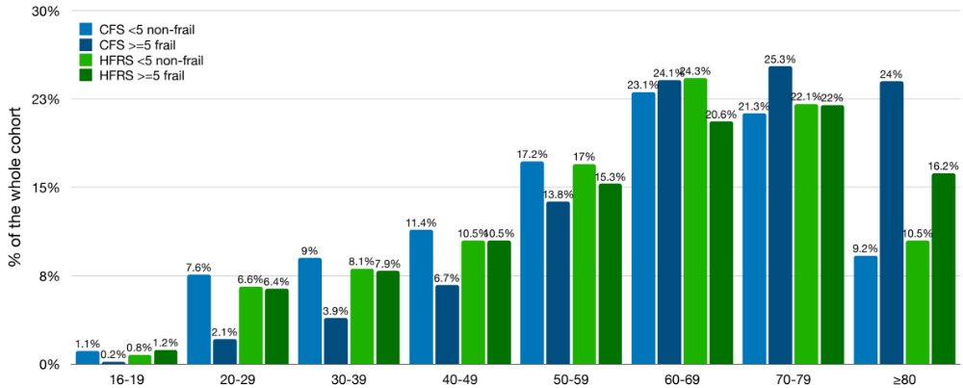

Supplementary Figure 2: Mortality Proportion between CFS and HFRS treated as a dichotomous variable.
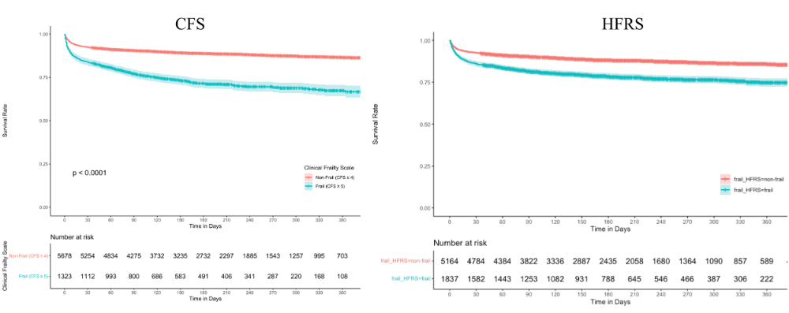

Supplementary Figure 3: Area under the receiver operator curve for short-term mortality. The CFS was significantly better than the HFRS. However, CFS and HFRS must both be measuring different aspects, because the combination of the two was better than either measure on its own. The bottom 2 graphs showed that while both variables may be predictive of mortality, neither provided any worthwhile improvement on top of ANZROD.
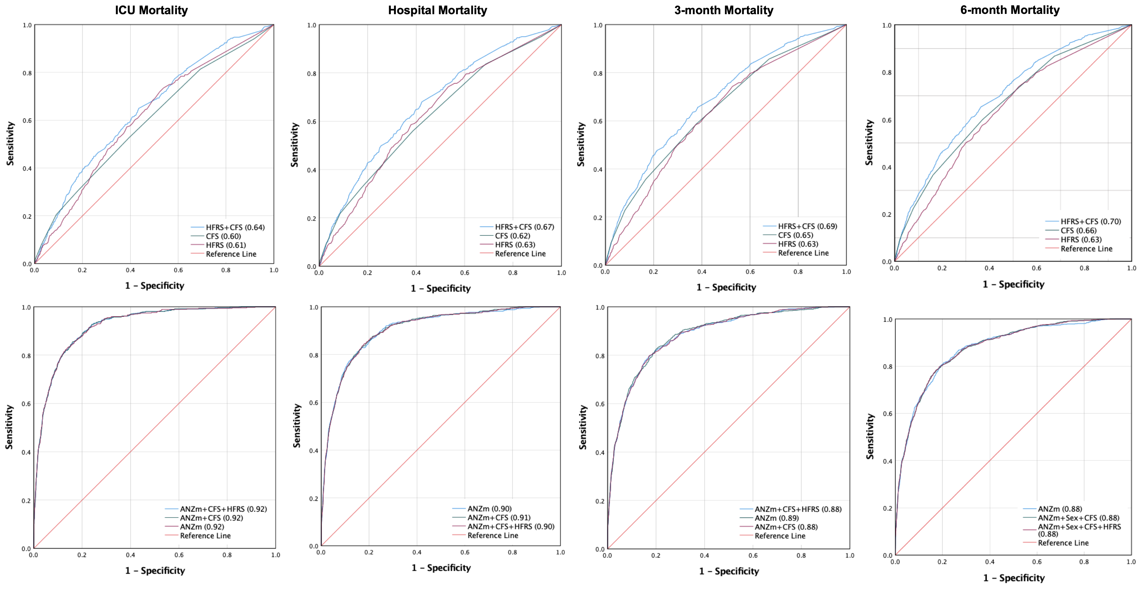
ANZm – ANZROD + male sex, CFS clinical frailty scale, HFRS – hospital frailty risk score

Supplementary Figure 4: Area under the receiver operator curve for 1-year mortality for patients ≥65 years of age and those needing mechanical ventilation.

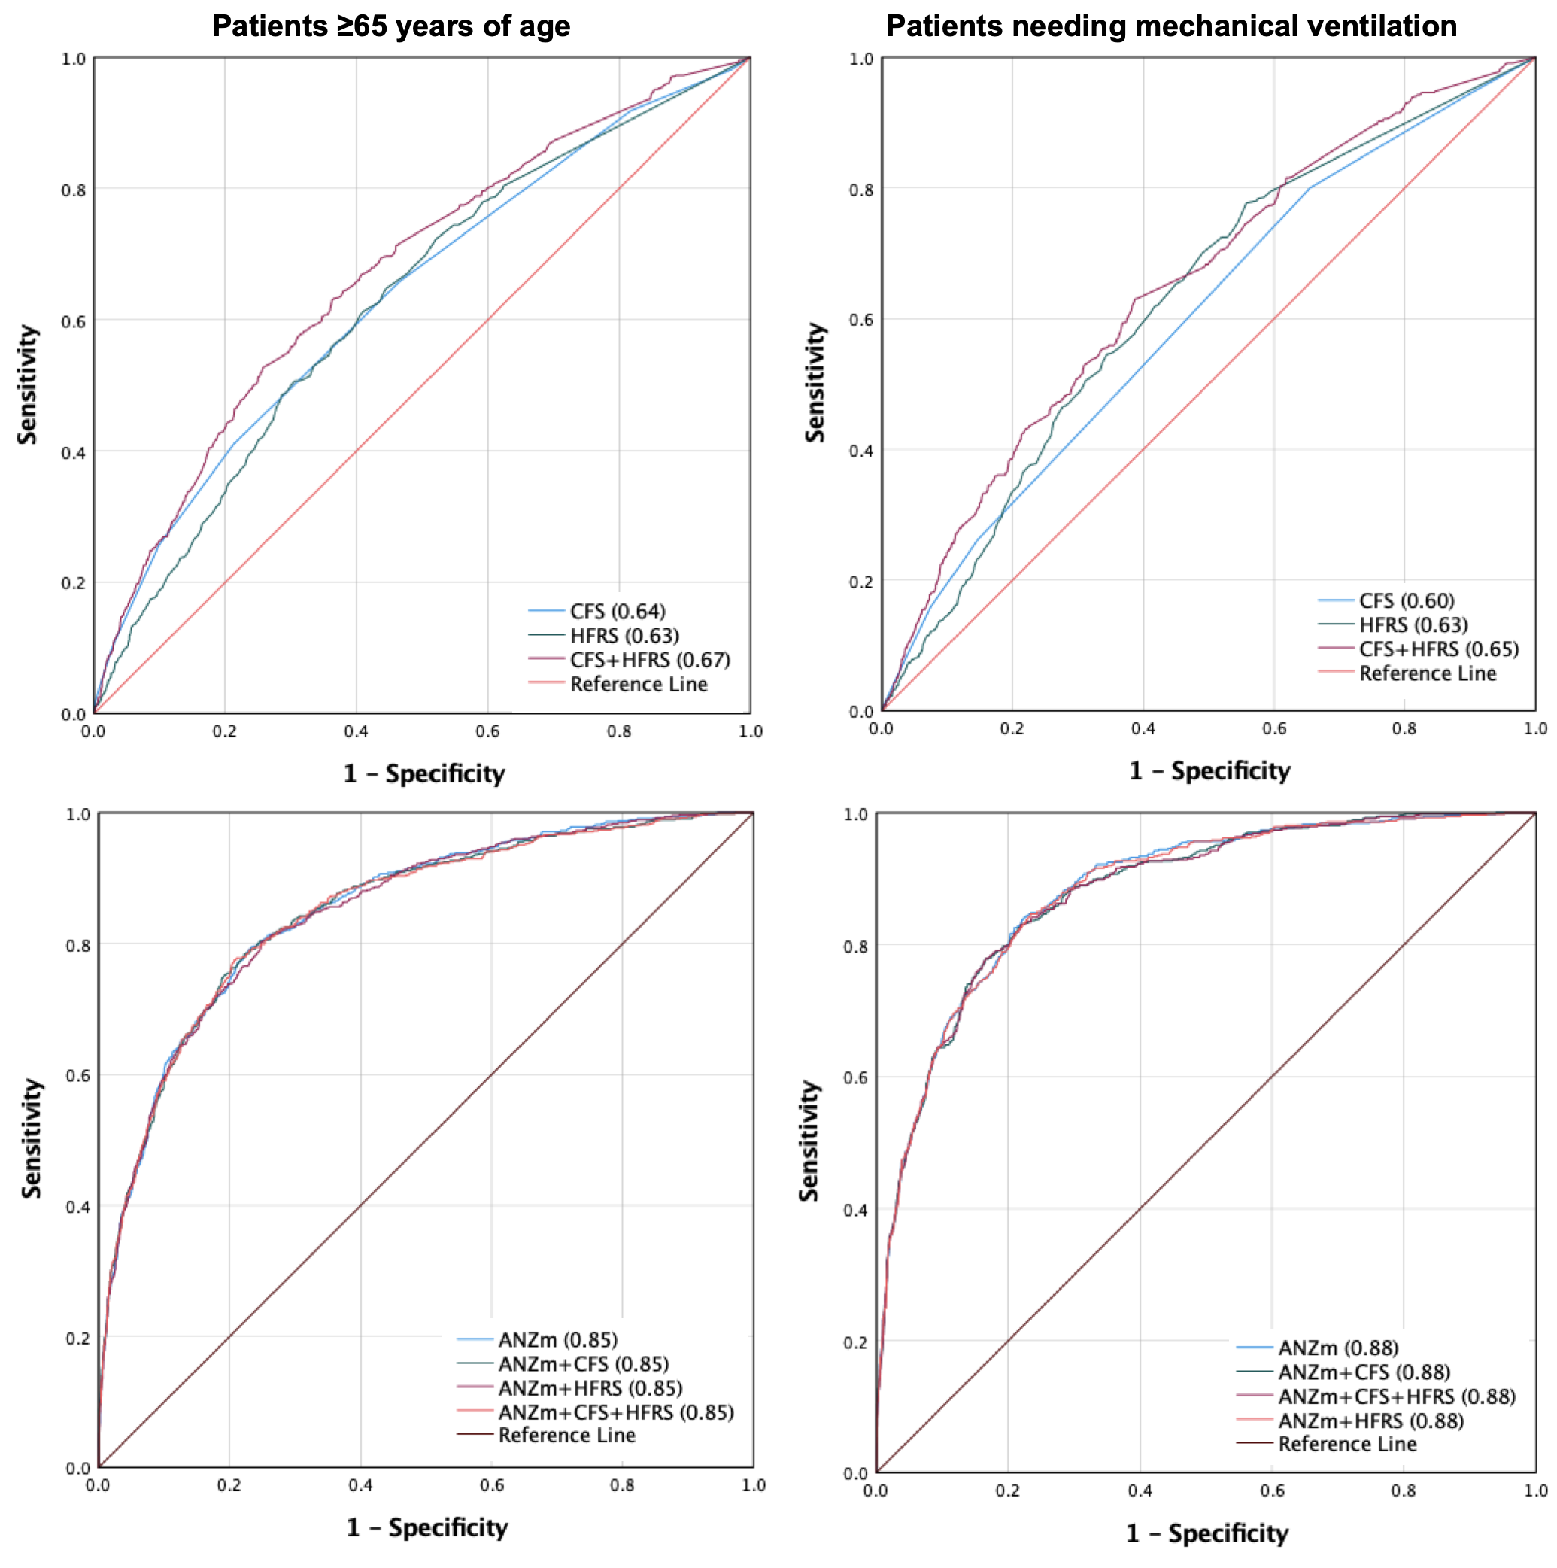
ANZm – ANZROD + male sex, CFS clinical frailty scale, HFRS – hospital frailty risk score

