1. Dr.M.Sahaya Sheela
Department of ECE, Pavai College of Technology, Namakkal-637018, Tamilnadu, India.
Co-Author: hisheelu@gmail.com

2. Dr.R. Prabakaran
Department of EEE, University College of Engineering, BIT Campus, Anna University, Tiruchirappalli-620024, Tamilnadu, India.
Co-Author: hiprabakaran@gmail.com
3. Dr.Arun.C.A
Department of ECE, Vel Tech Rangarajan Dr. Sagunthala R&D Institute of Science and Technology, Chennai-600022, Tamilnadu, India.
Corresponding Author: arunca.me@gmail.com

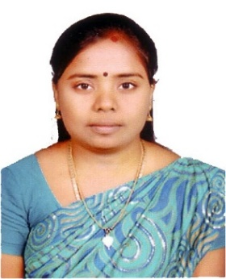

M.Sahaya Sheela working as an Associate Professor and Head of ECE Department at Pavai College of Technology, Namakkal, Tamilnadu. She completed her graduation in the department of Electronics and Communication Engineering in the year 2002 at Madurai Kamaraj University, Tamilnadu, India. She did her post-graduation in Communication Systems domain in the year 2010 at Anna University, Tamilnadu, India. She completed her Ph.D. in the field of Wireless Sensor Networks at Anna University, Chennai, Tamilnadu, India. She is in teaching profession for more than 17 years. She has published and presented several research articles in the reputed Journals and National / International Conferences respectively. Her main area of interest includes Wireless Sensor Networks, Communication Systems and Signal Processing.

R.Prabakaran received B.E (E&I), M.Tech (Embedded Systems) from Sastra University, Thanjavur, Tamil Nadu, India in 2000 and 2005 respectively. He also completed his Ph.D from Anna University, Chennai in 2014. Presently, he is working as Assistant Professor in Department of Electrical and Electronics Engineering, University College of Engineering, BIT Campus, Anna University, Tiruchirappalli, Tamil Nadu, India since 2007 to till date.
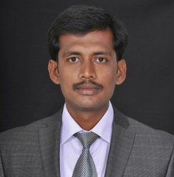
Arun.C.A working as an Associate Professor in the Department of Electronics and Communication Engineering for Vel Tech Rangarajan Dr. Sagunthala R&D Institute of Science and Technology. He received the B.E degree in Electronics and Communication Engineering and M.E degree in VLSI Design from the Anna University, Chennai, Tamilnadu, India, in 2006 and 2010 respectively. He completed his Ph.D. in the field of Signal Processing at Anna University, Chennai, India. He has published and presented several research articles in the reputed Journals and Conferences respectively. His research interests include Digital Signal Processing and VLSI Design.

