Investigation of aquaporins involved in the adaptation of Canavalia rosea to saline-alkaline soils and drought stress
Ruoyi Lin ^{1, 2, #}, Jiexuan Zheng ^{1, 2, #}, Lin Pu ^{1, 2}, Zhengfeng Wang ^{1, 3, 4}, Qiming Mei ^{1, 3, 4}, Mei Zhang ^{1, 5,*} , Shuguang Jian ^{1, 3, 4, 6, *}
1 Guangdong Provincial Key Laboratory of Applied Botany & Key Laboratory of South China Agricultural Plant Molecular Analysis and Genetic Improvement, South China Botanical Garden, Chinese Academy of Sciences, Guangzhou 510650, China.
2 University of the Chinese Academy of Sciences, Beijing 100039, China.
3 Key Laboratory of Vegetation Restoration and Management of Degraded Ecosystems, Center for Plant Ecology, Core Botanical Gardens, Chinese Academy of Sciences, Guangzhou 510650, China.
4 Southern Marine Science and Engineering Guangdong Laboratory (Guangzhou), Guangzhou 511458, China
5 Center of Economic Botany, Core Botanical Gardens, Chinese Academy of Sciences, Guangzhou, 510650, China.
6 CAS Engineering Laboratory for Vegetation Ecosystem Restoration on Islands and Coastal Zones, South China Botanical Garden, Chinese Academy of Sciences, Guangzhou 510650, China
# These two authors contributed equally to this study.
* Correspondence and requests for materials should be addressed to Mei Zhang (zhangmei@scbg.ac.cn) and Shuguang Jian (jiansg@scbg.ac.cn).

Additional file 1: Figure S1. The structural features of the CrAQPs. a CrNIPs. b CrPIPs. c CrTIPs. d CrXIPs. e CrSIPs.
Additional file 1: Figure S2. The overexpression analyses of CrPIP1;5 in the three transgenic Arabidopsis lines (OX 1#, OX 5#, and OX 10#). a RT-PCR and genomic DNA PCR analysis of CrPIP1;5 in the transgenic Arabidopsis lines and WT plants. b Quantitative RT-PCR analysis of CrPIP1;5 in the transgenic Arabidopsis lines and WT plants.
Additional file 1: Figure S3. Overexpression analyses of CrPIP1;5 in the transgenic Arabidopsis lines (OX 1#, OX 5#, and OX 10#) and stress tolerance analyses of transgenic plants with regards to seed germination rates. a Photographs of the transgenic lines and WT seeds germinated on MS medium or MS medium with NaCl, NaCl plus NaHCO₃ (pH 8.2), or mannitol for 7 d. b‒d The seed germination rates in WT and transgenic lines under NaCl (b), NaCl plus NaHCO₃ (pH 8.2) (c), and mannitol (d) stresses after 7 d.
Additional file 1: Figure S4. Salt, salt-alkaline, and high osmotic stress analyses of the transgenic plants with CrPIP1;5’s overexpression based on seedling root lengths. Four-day-old seedlings were transplanted into MS medium containing NaCl, NaCl plus NaHCO₃ (pH 8.2) or mannitol and then grown for 7 d before measuring the root length. a Photographs of the transgenic lines (CrPIP1;5 OX 1#, OX 5#, and OX 10#) and WT seedlings on MS medium or MS medium with NaCl, NaCl plus NaHCO₃ (pH 8.2), or mannitol; b‒d The seedling root lengths (mm) in WT and the transgenic lines under NaCl (b), NaCl plus NaHCO₃ (pH 8.2) (c), or mannitol (d) stresses after 7 d. Error bars indicate the SD based on over three replicates (n ≥ 3). Asterisks indicate significant differences from the control (Student’ s t-test P values, * p < 0.05 and ** p < 0.01).
Additional file 1: Figure S5. Subcellular localization of the CrPIP1;5 protein. Arabidopsis roots expressing 35S:GFP-CrPIP1;5 fusion proteins (upper two lines) and 35S:GFP (lower line) were observed under a laser scanning confocal microscope.
Additional file 1: Table S1. The obtained CrAQPs’ nucleotide and protein sequences information in this study.
Additional file 1: Table S2. Primers' information used in this study.
Additional file 1: Table S3. The categories of cis-acting elements identified in the CrAQPs’ promoter regions.
Additional file 1: Table S4. The conserved motif sequences of the CrAQPs identified by the MEME web server.

Figure S1
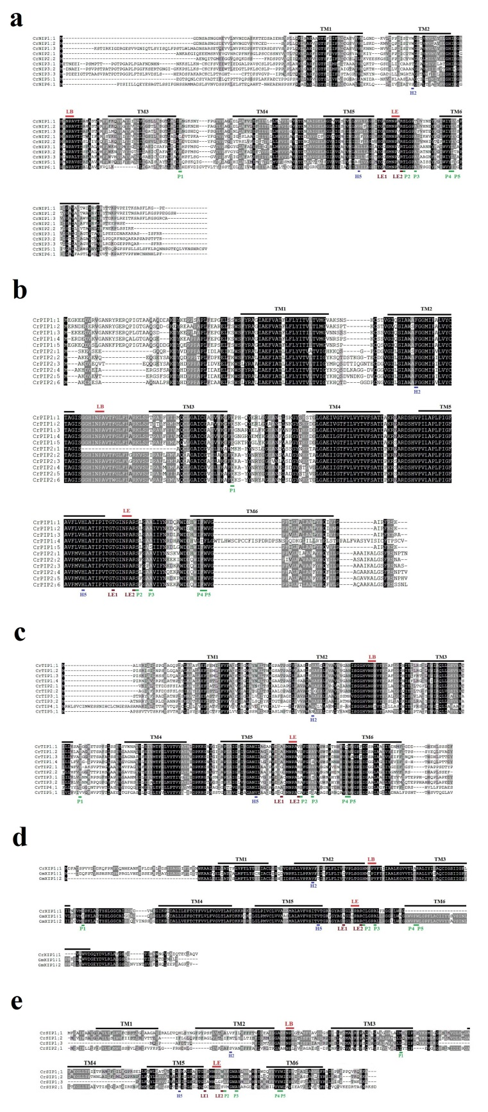

Figure S2
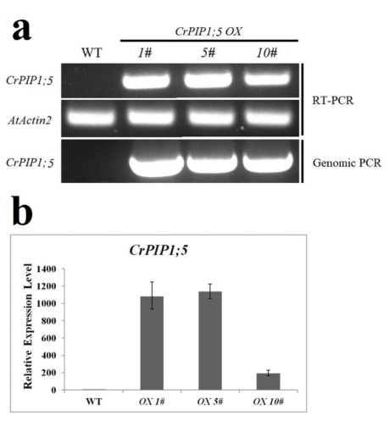
Figure S3
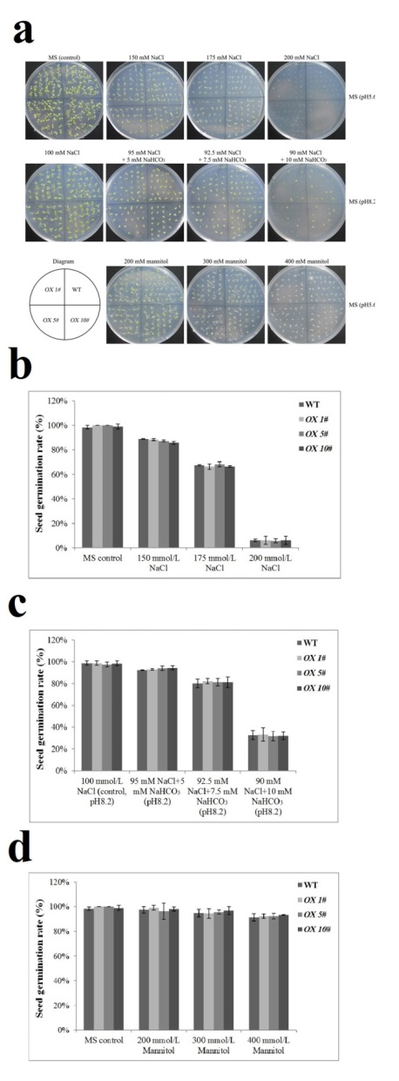

Figure S4
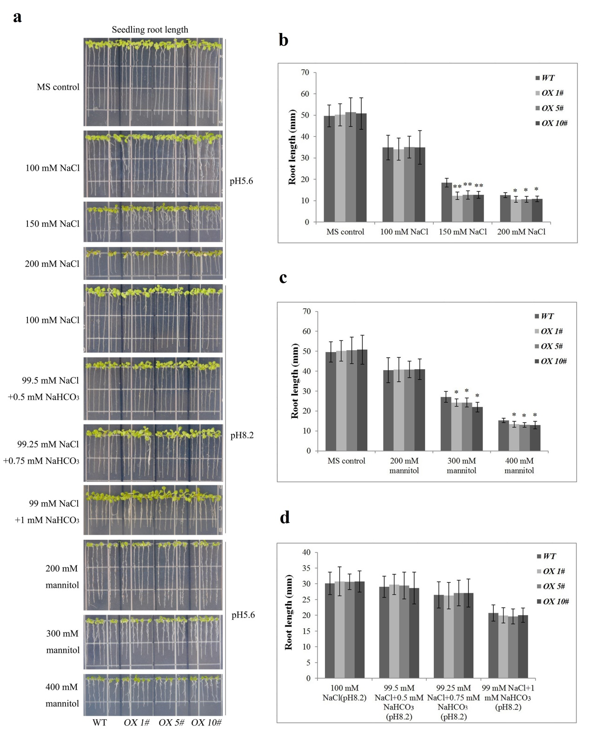

Figure S5
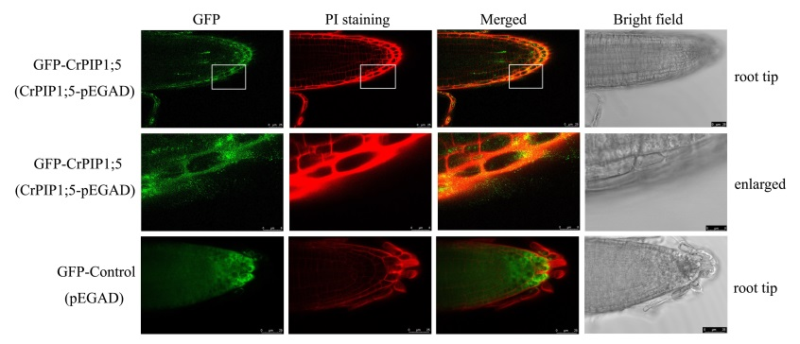
Table S1
See attached file.

Table S2
Primer ID | Sequence (from 5′ to 3′) | Purpose
CrPIP1;1RTF | TGTGAGAGTTGGTGCCAATAG | Primer pair for qRT-PCR of CrPIP1;1 in C. rosea
CrPIP1;1RTR | CTGAAGGTGGCTCTTTGTAGTC | Primer pair for qRT-PCR of CrPIP1;1 in C. rosea
CrPIP1;2RTF | GTTCTTGGCACGCAAGTTATC | Primer pair for qRT-PCR of CrPIP1;2 in C. rosea
CrPIP1;2RTR | CACCACCAAGCCTCTCATATT | Primer pair for qRT-PCR of CrPIP1;2 in C. rosea
CrPIP1;3RTF | CGGCATTAACCCAGCTAGAA | Primer pair for qRT-PCR of CrPIP1;3 in C. rosea
CrPIP1;3RTR | AAGGGCAGCTCCAACAAA | Primer pair for qRT-PCR of CrPIP1;3 in C. rosea
CrPIP1;4RTF | AGGAGTCTAGGTGCTGCTATAA | Primer pair for qRT-PCR of CrPIP1;4 in C. rosea
CrPIP1;4RTR | CGGATCACGATCTGGTGATATAAA | Primer pair for qRT-PCR of CrPIP1;4 in C. rosea
CrPIP1;5RTF | AGGGGTTAACCTTGTGAGCG | Primer pair for qRT-PCR of CrPIP1;5 in C. rosea
CrPIP1;5RTR | TGGTCATCCCAGGCTTTGTC | Primer pair for qRT-PCR of CrPIP1;5 in C. rosea
CrPIP2;1RTF | CCGTCATAGGCCACAAGAAA | Primer pair for qRT-PCR of CrPIP2;1 in C. rosea
CrPIP2;1RTR | GTGCAGTAGACGAGGACAAAG | Primer pair for qRT-PCR of CrPIP2;1 in C. rosea
CrPIP2;2RTF | CTGTGGCTGATGGCTACAATA | Primer pair for qRT-PCR of CrPIP2;2 in C. rosea
CrPIP2;2RTR | CTTAGGATCAGTGGCAGAGAAG | Primer pair for qRT-PCR of CrPIP2;2 in C. rosea
CrPIP2;3RTF | AGCAACCCTTCTCTTCCTTTAC | Primer pair for qRT-PCR of CrPIP2;3 in C. rosea
CrPIP2;3RTR | CGTCACATTCGGTGTTACCT | Primer pair for qRT-PCR of CrPIP2;3 in C. rosea
CrPIP2;4RTF | TGCCACACTTCTCTTCCTTTAC | Primer pair for qRT-PCR of CrPIP2;4 in C. rosea
CrPIP2;4RTR | CAACACCACCACAAACATCAC | Primer pair for qRT-PCR of CrPIP2;4 in C. rosea
CrPIP2;5RTF | GCAGTGACATTTGGGTTGTTT | Primer pair for qRT-PCR of CrPIP2;5 in C. rosea
CrPIP2;5RTR | CCAACCCAACTCCACAGATAG | Primer pair for qRT-PCR of CrPIP2;5 in C. rosea
CrPIP2;6RTF | GGAAAGTGTCGCTGGTTAGA | Primer pair for qRT-PCR of CrPIP2;6 in C. rosea
CrPIP2;6RTR | CTCCTGCGTATCTGTTGTAGTAG | Primer pair for qRT-PCR of CrPIP2;6 in C. rosea
CrEF-αRTF | GACCTTCTTCGTTTCTCGCA | Primer pair for qRT-PCR of reference gene CrEF-α in C. rosea
CrEF-αRTR | CGAACCTCTCAATCACACGC | Primer pair for qRT-PCR of reference gene CrEF-α in C. rosea
CrPIP1;5OXF | GGCAGCGGCCGAATTC ATGGAGGGGAAGGAACAGGA | Primer pair for cloning the full-length CDS of CrPIP2;3 and construction of CrPIP1;5-pEGAD, EcoRI and BamHI sites were underlined
CrPIP1;5OXR | CAGTTATCTAGGATCC TTACTTGGACTTGAAAGGAATGG
AtACT2RTF | GGTAACATTGTGCTCAGTGGTGG | Primer pair for qRT-PCR of reference gene AtActin2 (At3g18780) in Arabidopsis
AtACT2RTF | AACGACCTTAATCTTCATGCTGC
Table S3
See attached file.

Table S4
Group | Motif | E-value | Consensus sequence
CrNIP | 8 | 1.1e-149 |   RSDEATSVDLLQKVLAEFIGTYIFVFAGCGSAIA
CrNIP | 2 | 9.6e-335 |   LFVLVYSTAHISGGHINPAVTF
CrNIP | 6 | 1.1e-276 | 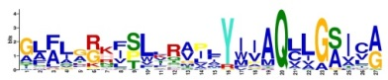  GLFLGRKFSLLRAILYIIAQLLGSICA
CrNIP | 7 | 5.1e-181 |   VGAGQALVLEIIITFGLMFTVYAVATDPK
CrNIP | 1 | 1.3e-365 |   IGFAVFLNILAAGPITGASMNPARS
CrNIP | 4 | 1.4e-370 |   ANVSNAWDDHWIYWVGPFIGAALAALYYQ
CrPIP | 3 | 1.1e-312 | KDYHDPPPAPLFDPEELTSWSFYRAGIAEFVATLLFLYITVLTVIGYKKQ
CrPIP | 10 | 5.9e-061 |   CSGVGILGIAWAFGG
CrPIP | 2 | 9.6e-335 |   LFVLVYSTAHISGGHINPAVTF
CrPIP | 6 | 1.1e-276 |   GLFLGRKFSLLRAILYIIAQLLGSICA
CrPIP | 9 | 2.7e-079 |   FQKAYYNRYGGGANSVSDGYS
CrPIP | 5 | 2.5e-284 |   KGTGLGAEIIGTFVLVYTVFSATDPKRNARDSHVPVLAPLP
CrPIP | 1 | 1.3e-365 |   IGFAVFLNILAAGPITGASMNPARS
CrPIP | 4 | 1.4e-370 |   ANVSNAWDDHWIYWVGPFIGAALAALYYQ
CrTIP | 8 | 1.1e-149 |   RSDEATSVDLLQKVLAEFIGTYIFVFAGCGSAIA
CrTIP | 2 | 9.6e-335 |   LFVLVYSTAHISGGHINPAVTF
CrTIP | 6 | 1.1e-276 |   GLFLGRKFSLLRAILYIIAQLLGSICA
CrTIP | 7 | 5.1e-181 |   VGAGQALVLEIIITFGLMFTVYAVATDPK
CrTIP | 1 | 1.3e-365 |   IGFAVFLNILAAGPITGASMNPARS
CrTIP | 4 | 1.4e-370 |   ANVSNAWDDHWIYWVGPFIGAALAALYYQ
CrXIP | 6 | 1.1e-276 |   GLFLGRKFSLLRAILYIIAQLLGSICA
CrSIP | 6 | 1.1e-276 |   GLFLGRKFSLLRAILYIIAQLLGSICA
CrSIP | 4 | 1.4e-370 |   ANVSNAWDDHWIYWVGPFIGAALAALYYQ

