Adipose-derived stromal cells reverse insulin resistance through inhibition of M1 expression in a type 2 diabetes mellitus mouse model
Lee-Wei Chen^{1, 2, 3*}, Pei-Hsuan Chen¹, Jui-Hung Yen^{4*}

Supplemental Figures
Supplemental Figure 1: Non-diabetic plasma-treated SVFs modulate inflammatory cytokine expression, and suppress JNK and NFκB activation in the liver of diabetic mice. Uncropped Western blot images of p-JNK, JNK, p- NFκB, NFκB, DPP4, and β-actin of liver. Representative images and statistical analysis are presented in Figure 5B.

p-JNK
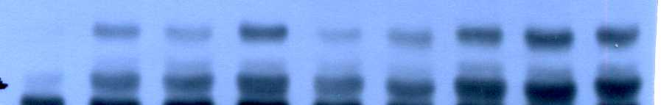
JNK
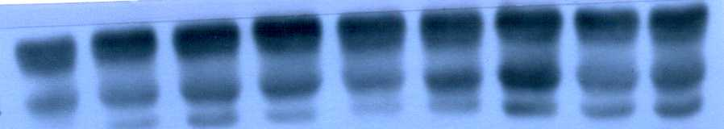
p-NFkB

NF-kB
DPP4
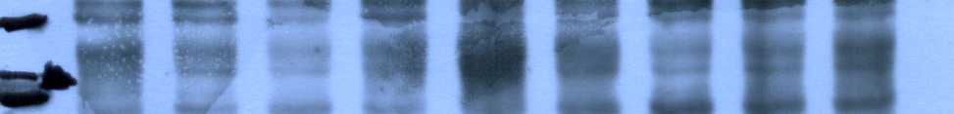
B-actin
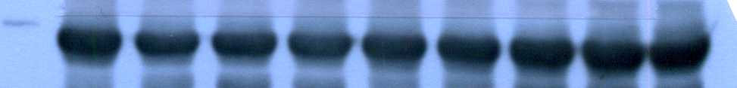
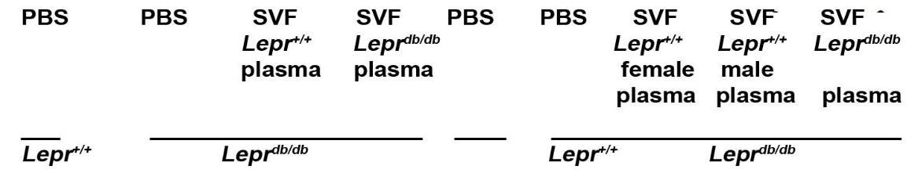

Supplemental Figure 2: The injection of Lepr^{+/+} plasma-treated SVFs enhanced ERK phosphorylation in the liver of Lepr^{db/db} mice following insulin administration. Uncropped Western blot images of pAkt, Akt, pERK, and ERK of liver. Representative images and statistical analysis are presented in Figure 7B.
pAkt
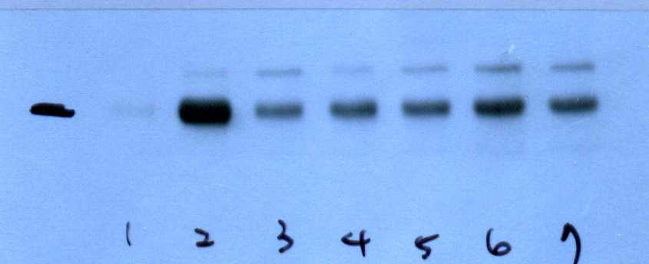
Akt
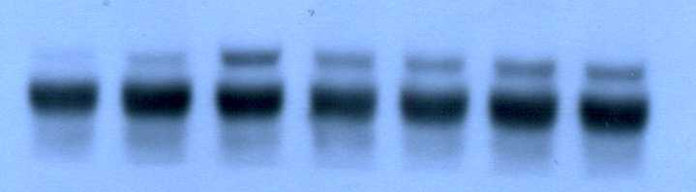
pERK
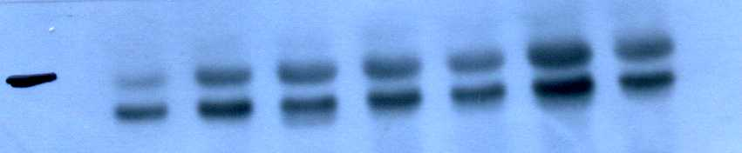
ERK
