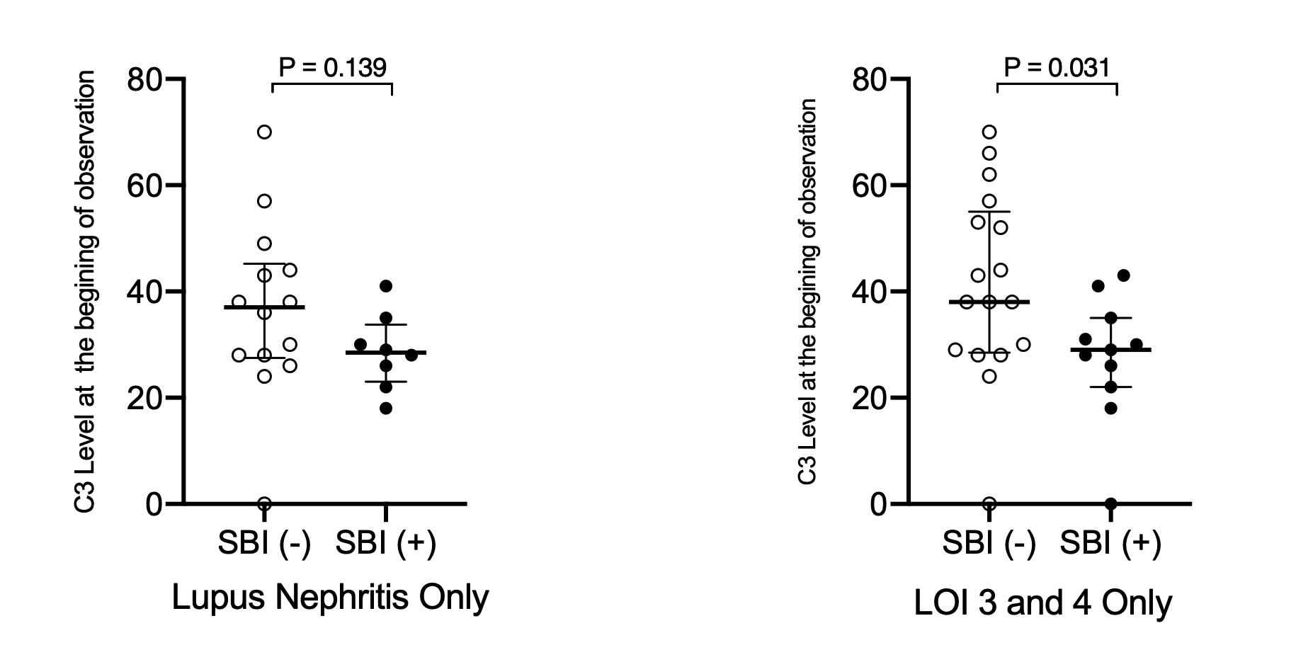
Supplemental Figure 1. C3 level at the beginning of the period of observation compared based upon the presence or absence of a serious bacterial infection (SBI) within subject with a history of lupus nephritis (LN) (left) or level of immunosuppression (LOI) 3 or 4 (right).

