Frequent POLE-Driven Hypermutation in Ovarian Endometrioid Cancer Revealed by Mutational Signatures in RNA Sequencing
Jaime I. Davila, PhD^{* 1,2}
Pritha Chanana, MS³
Vivekananda Sarangi, MS²
Zachary C. Fogarty, MS²
S. John Weroha, MD, PhD⁴
Ruifeng Guo, MD, PhD⁵
Ellen L. Goode, PhD²
Yajue Huang, MD, PhD⁵
Chen Wang, PhD²
Author Affiliations:
* Corrresponding author. Correspondence to davila3@stolaf.edu
- Department of Mathematics, Statistics and Computer Science St Olaf College, Northfield, Minnesota
- Department of Health Sciences Research, Mayo Clinic, Rochester, Minnesota
- Division of Shared Resources, Fred Hutchinson Cancer Research Center, Seattle, Washington.
- Division of Medical Oncology, Mayo Clinic, Rochester, Minnesota
- Division of Anatomic Pathology, Mayo Clinic, Rochester, Minnesota

Supplementary figures
Supplementary figure 1. Boxplot of signature contribution by cohort. Contribution of POLE, MMR, Aging and Germline signatures across the Mayo, GTEx and TCGA measured in mutations per Mb.
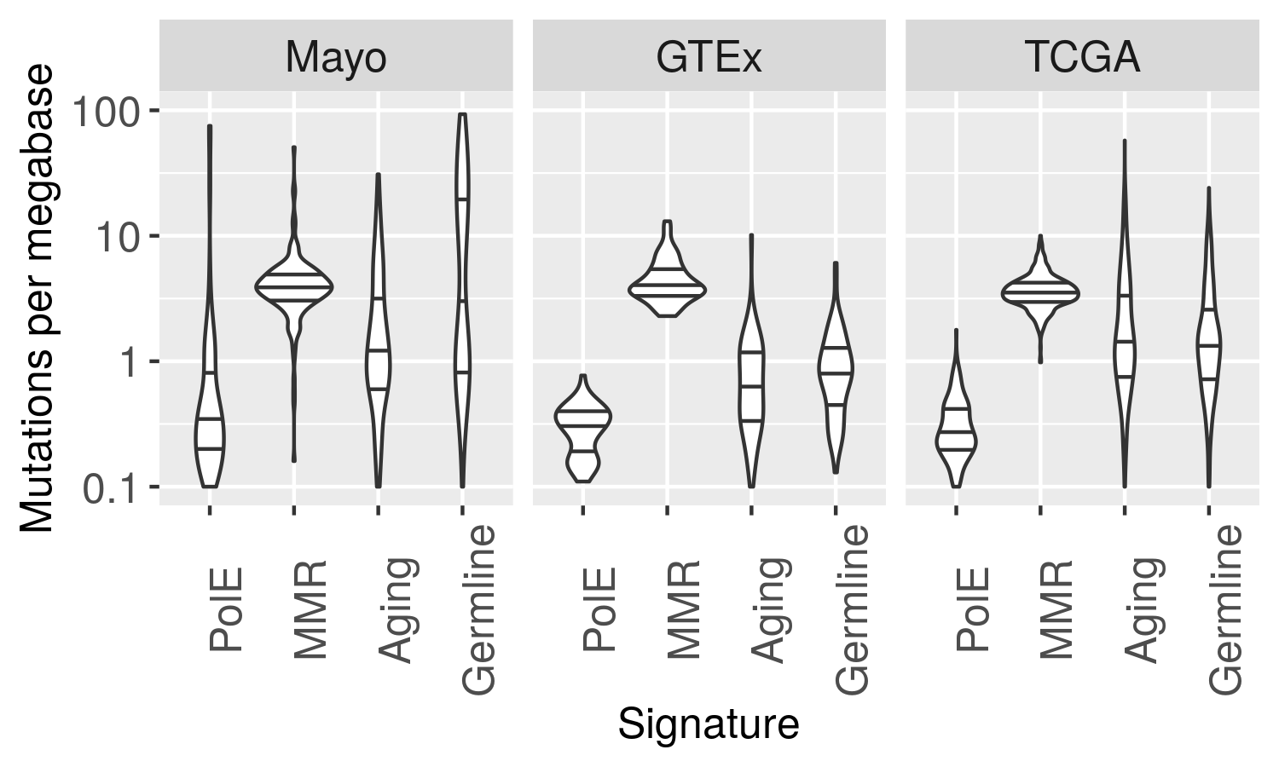

Supplementary figure 2. Cosine similarity distribution between original and reconstructed mutational profile. Histogram of cosine similarity between the original mutational signature and the reconstructed combination of the four mutational signatures identified in the Non-Negative Matrix factorization analysis.
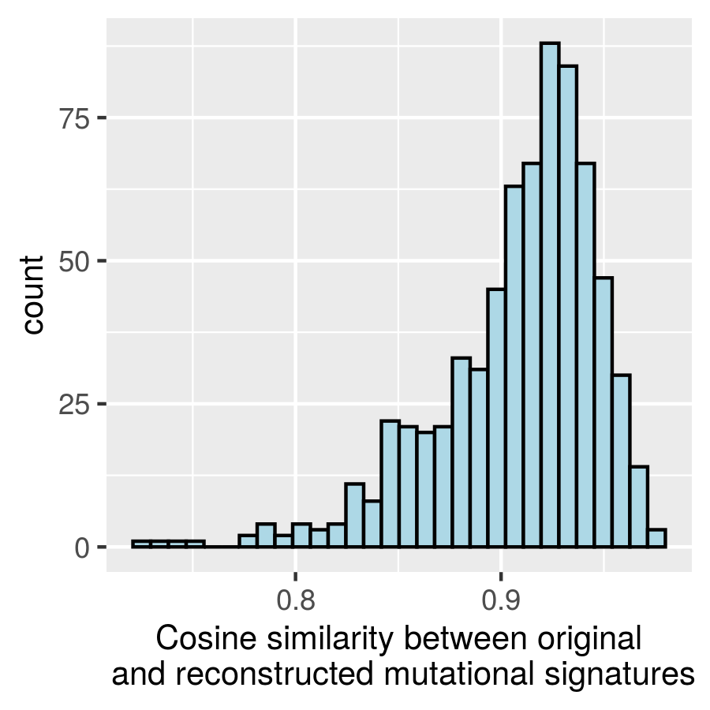

Supplementary figure 3. Histogram of recurring COSMIC POLE hotspots. Lollipop plot depicting the recurring mutations in POLE as found in the COSMIC database, as well as their frequency in this database. Only mutations occurring in over 10 samples were considered.
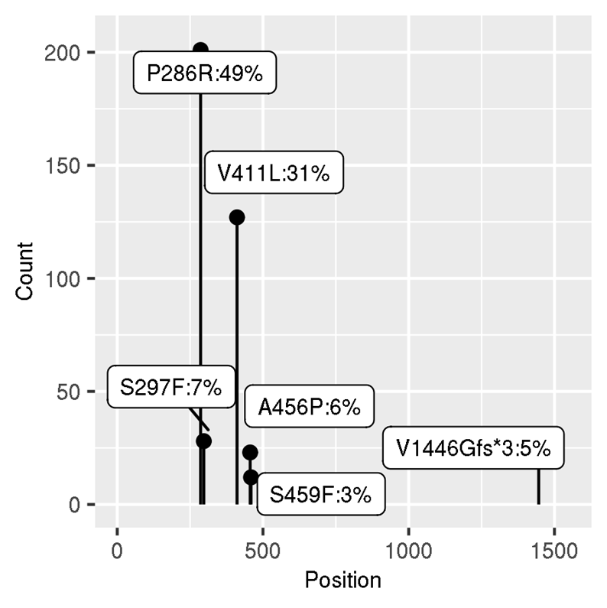

Supplementary figure 4. Boxplot of somatic mutation burden by cohort. Somatic mutation burden in Mayo, GTEx and TCGA cohorts measured in mutations per Mb. 