Appendix
Table 5 F-values for one-way ANOVA of effects of layers on all traits of plants at emergence time (ET) of spring (ET1), late spring (ET2), summer (ET3) and late summer (ET4) at three stages (I-III) of plant growth. Abbreviations for all traits are in Table 1. * p < 0.05, ** p < 0.01, *** p < 0.001.
 |  | ET1 |  | ET2 |  | ET3 |  | ET4
Stage | Trait | n | F | n | F | n | F | n | F
I | TLM (g) | 55 | 21.42*** | 101 | 23.93***
 | MRM (g) | 15 | 28.50*** | 32 | 29.84***
 | LRM (g) | 15 | 3.16 | 27 | 0.22
 | SM (g) | 38 | 10.96*** | 72 | 21.19***
 | PM (g) | 19 | 10.09*** | 21 | 1.59
 | LM (g) | 19 | 4.67* | 22 | 1.84
 | REM (g) | 5 | 0.05 | 18 | 1.06
 | SD (mm) | 53 | 2.19 | 73 | 10.15***
 | PL (cm) | 81 | 1.24 | 74 | 0.433
 | PA (º) | 79 | 1.61 | 76 | 0.648
II | TLM (g) | 88 | 14.73*** | 84 | 29.68*** | 68 | 29.94*** | 72 | 106.25***
 | MRM (g) | 22 | 245.70*** | 23 | 85.57*** | 23 | 85.57*** | 38 | 108.91***
 | LRM (g) | 19 | 38.97*** | 23 | 9.60** | 23 | 9.60** | 28 | 1.419
 | SM (g) | 38 | 103.03*** | 49 | 61.52*** | 33 | 41.75*** | 34 | 137.57***
 | PM (g) | 16 | 16.50** | 24 | 0.88 | 22 | 2.97 | 34 | 19.78***
 | LM (g) | 16 | 23.50*** | 24 | 1.37 | 22 | 4.56* | 34 | 31.63***
 | REM (g) | 11 | 1.18 | 27 | 1.44 | 21 | 3.10
 | BSM (g) |  |  | 16 | 1.90
 | BLM (g) |  |  | 11 | 0.61
 | BREM (g) |  |  | 18 | 2.53
 | SD (mm) | 63 | 33.80** | 51 | 41.89*** | 43 | 12.86*** | 36 | 4.18*
 | PL (cm) | 83 | 8.77*** | 75 | 3.94* | 63 | 12.10*** | 110 | 14.79***
 | PA (º) | 85 | 0.583 | 77 | 0.550 | 65 | 0.601 | 111 | 0.011
 | BL (cm) |  |  | 60 | 4.81*
 | BA (º) |  |  | 59 | 3.88
III | TLM (g) | 104 | 26.95*** | 91 | 8.89*** | 88 | 22.84*** | 72 | 51.83***
 | MRM (g) | 34 | 101.68*** | 28 | 69.79*** | 28 | 69.79*** | 17 | 51.38***
 | LRM (g) | 34 | 21.06*** | 26 | 20.54*** | 26 | 20.54*** | 16 | 11.87**
 | SM (g) | 68 | 58.65*** | 57 | 37.71*** | 44 | 45.31*** | 35 | 87.95***
 | PM (g) | 19 | 3.83 | 16 | 0.77 | 21 | 1.57 | 25 | 0.50
 | LM (g) | 19 | 2.71 | 16 | 0.88 | 21 | 1.36 | 25 | 5.81**
 | REM (g) | 26 | 1.69 | 21 | 0.60 | 25 | 1.35 | 15 | 1.71
 | BSM (g) | 11 | 1.02 | 15 | 3.65
 | BLM (g) | 5 | 10.85* | 4 | 1.17
 | BREM (g) | 5 | 0.01 | 10 | 1.78
 | SD (mm) | 70 | 45.56*** | 61 | 50.22*** | 47 | 15.71*** | 51 | 4.50*
 | PL (cm) | 37 | 3.28* | 29 | 2.40 | 66 | 2.01 | 102 | 11.85***
 | PA (º) | 37 | 0.179 | 29 | 1.39 | 66 | 0.782 | 105 | 1.65
 | BL (cm) | 24 | 0.404 | 29 | 1.72 | 25 | 1.15
 | BA (º) | 23 | 2.31 | 30 | 0.921 | 24 | 1.09

Figure legends
Fig. 7 The photographs (a, c, d) and sketch (b) for whole plant (a, b) and modules (c, d) of Abutilon theophrasti.
Fig. 8 Mean total biomass (±SE) of plants that emerged in spring (ET1), late spring (ET2), summer (ET3) and late summer (ET4) sampled at different growth stages (days of growth).
Fig. 9 Mean values (±SE) of the mass (a, c, e, g, i, k) and allocation (b, d, f, h, j, l) of root (a, b), stem (c, d), petiole (e, f), lamina (g, h), reproduction (i, j) and branch (k, l) organs for plants that emerged in spring (ET1), late spring (ET2), summer (ET3) and late summer (ET4) and sampled at different growth stages (I~III and EX for ET1). Different lowercase letters indicate significant difference between growth stages within emergence treatment (ET), different uppercase letters indicate significant difference between GT treatments for each stage (p < 0.05). The extra sampling (EX) for spring-emerged plants (ET1) was taken before the first time of ET1 sampling as a reference for comparisons.
Fig. 10 Mean values (±SE) of stem length (a) and main root length (b) of plants that emerged in spring (ET1), late spring (ET2), summer (ET3) and late summer (ET4) at different growth stages (I~III). Different lowercase letters indicate significant difference between growth stages within each emergence treatment (ET), different uppercase letters indicate significant difference between ET treatments within each stage (p < 0.05).

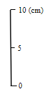

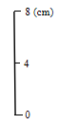
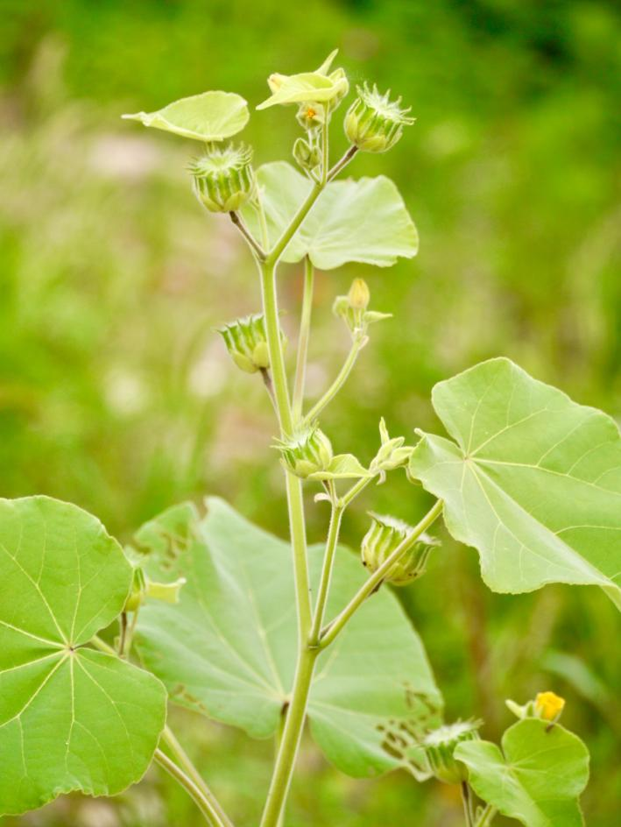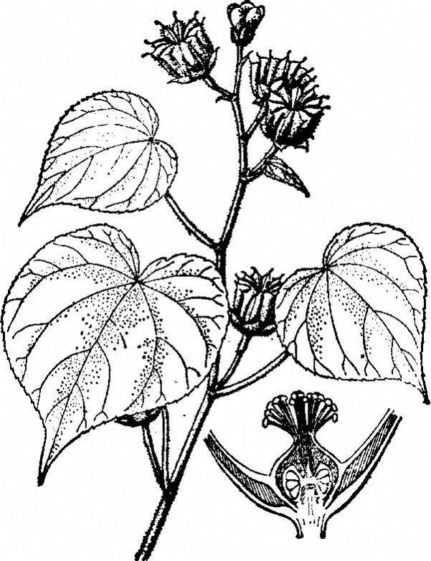
d
b
c
a
8 (cm)
8 (cm)
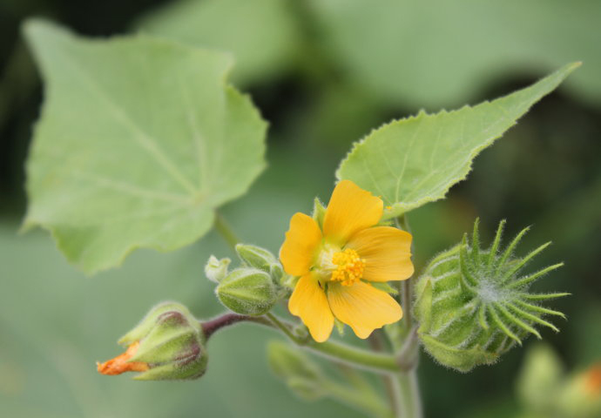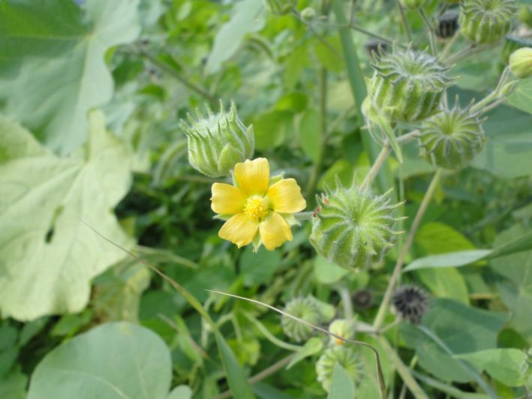
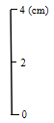

Fig. 7 The photographs (a, c, d) and sketch (b) for whole plant (a, b) and modules (c, d) of Abutilon theophrasti.

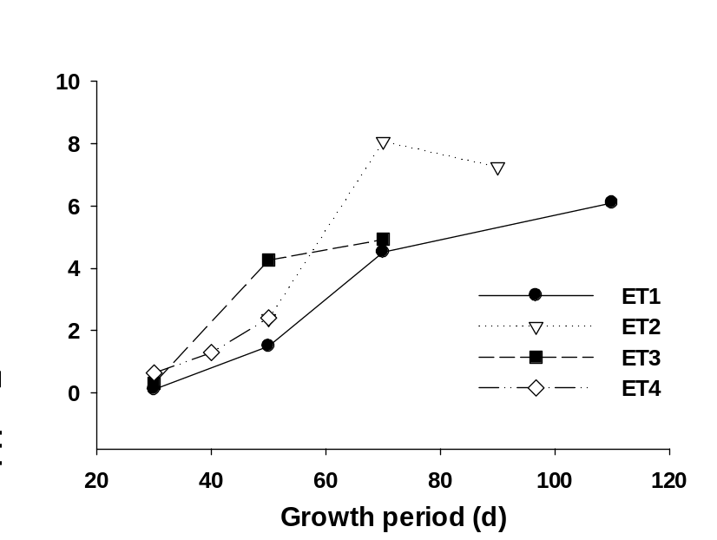
Fig. 8 Mean total biomass (±SE) of plants that emerged in spring (ET1), late spring (ET2), summer (ET3) and late summer (ET4) sampled at different growth stages (days of growth).

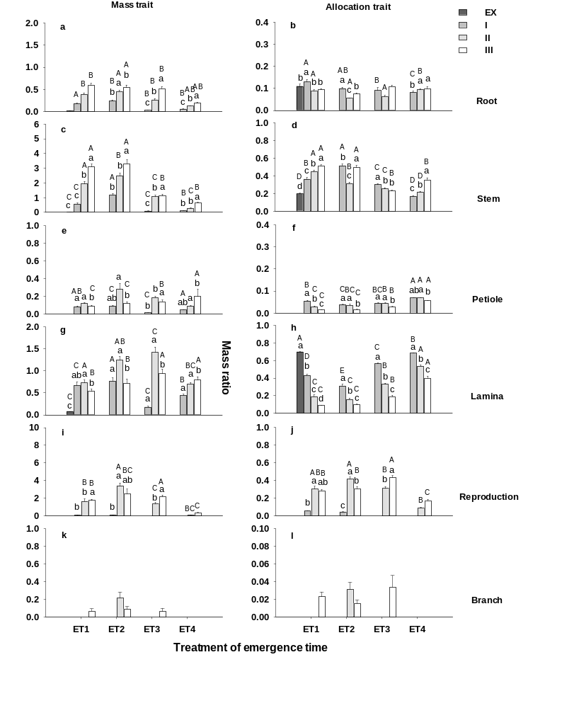
Fig. 9 Mean values (±SE) of the mass (a, c, e, g, i, k) and allocation (b, d, f, h, j, l) of root (a, b), stem (c, d), petiole (e, f), lamina (g, h), reproduction (i, j) and branch (k, l) organs for plants that emerged in spring (ET1), late spring (ET2), summer (ET3) and late summer (ET4) and sampled at different growth stages (I~III and EX for ET1). Different lowercase letters indicate significant difference between growth stages within emergence treatment (ET), different uppercase letters indicate significant difference between GT treatments for each stage (p < 0.05). The extra sampling (EX) for spring-emerged plants (ET1) was taken before the first time of ET1 sampling as a reference for comparisons.

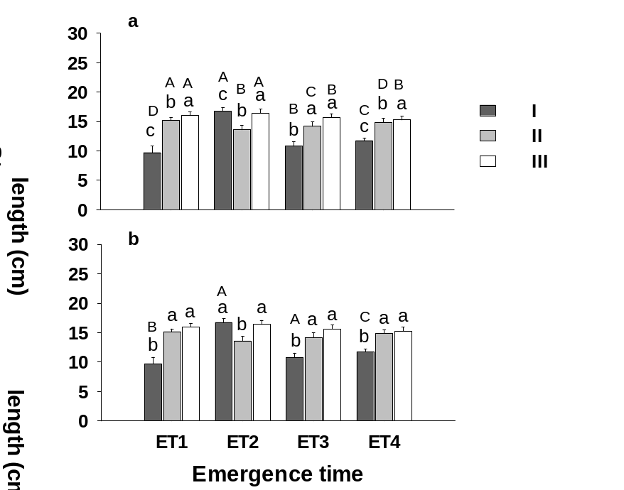
Fig. 10 Mean values (±SE) of stem length (a) and main root length (b) of plants that emerged in spring (ET1), late spring (ET2), summer (ET3) and late summer (ET4) at different growth stages (I~III). Different lowercase letters indicate significant difference between growth stages within each emergence treatment (ET), different uppercase letters indicate significant difference between ET treatments within each stage (p < 0.05).

