Supporting Information
Sulfonated pyromellitic dianhydride-functionalized MCM-41: A multifunctional hybrid catalyst for melting-assisted solvent-free synthesis of bioactive 3,4-dihydropyrimidin-2-(1H)-ones
Ehsan Valiey, Mohammad G. Dekamin*, Zahra Alirezvani
Pharmaceutical and Heterocyclic Compounds Research Laboratory, Department of Chemistry, Iran University of Science and Technology, Tehran, 16846-13114, Iran.
*E-mail: mdekamin@iust.ac.ir

Page | Content
S1 | Title page
S2 | General procedure for preparation of the MCM-41
S2 | General procedure for preparation of the MCM-41-APS-PMDA-SO₃H (1)
S4 | Characterization of the MCM-41-APS-PMDA-SO₃H (1)
S6 | General procedure for the synthesis of 3,4-dihydropyrimidinones catalyzed by the MCM-41-APS-PMDA-SO₃H (1)
S7 | Chemical characterization of 4-(2Chloro-phenyl)-6-methyl-2-oxo-1,2,3,4 tetrahydropyrimidine-5-carboxylicacid ethyl ester (5f)
S8 | Chemical characterization of 4-(4-Methoxy-phenyl)-6-methyl-2-oxo-1,2,3,4-tetrahydropyrimidine-5-carboxylicacid ethyl ester (5e)
S9 | Chemical characterization of 4-[thiophen-2-yl]-6-methyl-2-oxo-1,2,3,4- tetrahydropyrimidine-5-carboxylicacid ethyl ester (5h)

General procedure for preparation of the MCM-41
Nano ordered mesoporous silica MCM-41 were prepared by hydrothermal synthesis conforming to the known method. 2.70 g of diethyl amine was dissolved in 42 mL deionized water at room temperature. The mixture was stirred for 10 min, then 1.47 g of cetyltrimethylammonium bromide (CTAB) was added and the surfactant solution was stirred for 30 min until a clear solution was gained. Next, 2.10 g tetraethyl orthosilicate (TEOS) was gently added and by drop wise addition of HCl solution (1 M), the pH of the mixture was fixed at 8.5 to gain the final precipitate. The resulting mixture was stirred for 2 h, next the resulting white precipitate was filtered and washed with 100 ml of water. Then it was dried at 45 ° C for 12 h and finally, the sample was calcined at 550 °C with the rate of 2 °C/min for 5 h.
General procedure for preparation of the MCM-41-APS-PMDA-SO₃H (1)
In a 200-mL round button flask, (3-aminopropyl) triethoxysilane 0.15 mmol, d= 0.946 g/mL) was added to a 0.15 g MCM-41 in 15 mL dry toluene. After 8 h, the residue white solid MCM-41-(SiCH2CH2CH2NH2)_{x} was filtered, and washed with toluene and chloroform several times to remove any excess of linker. Then, dried solid was dehydrated at 120 ᵒC for 1 h under nitrogen atmosphere Next, 0.15 g white solids and 0.15 g of pyromellitic dianhydride were disperse in dry THF (30 ml) for 1 h. Following this, 0.10 g of triethylamine (TEA) was added to the obtained mixture. The mixture was stirred at room temperature for 24 h, under inert atmosphere. Then, the obtained solid was filtered off and washed with toluene and EtOH for several times, respectively. For sulfonation of prepare solid, 0.10 g of triethylamine was added to 0.10 g of sulfamic acid and stirred for 1h. Following, the obtained solid dissolved in dry toluene (20 mL) and added to the sulfamic acid solution. The mixture was stirred at reflux condition for 36 under inert atmosphere. Finally, the residues were filtered, washed several times and dried in vacuum drying oven at 60 oC for 8 h. The preparation schematic route of the MCM-41-APS-PMDA-SO3H (1) has been shown in Scheme 1.
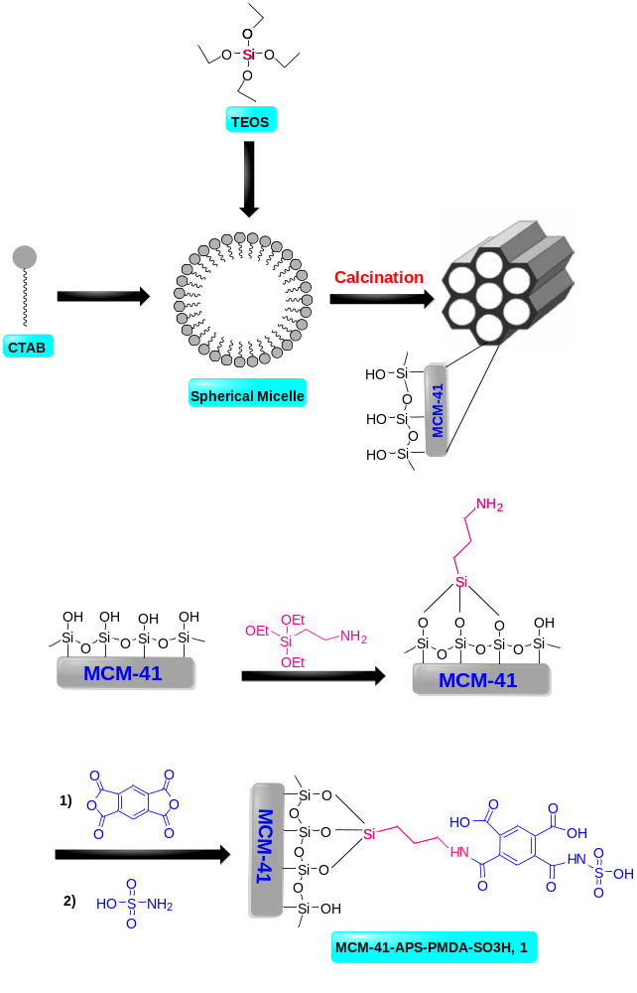
Scheme S1. Schematic preparation of sulfonated pyromellitic dianhydride-aminopropyl silane-functionalized MCM-41 (MCM-41-APS-PMDA-SO₃H, 1)
Characterization of the MCM-41-APS-PMDA-SO₃H (1)

Figure S1. FTIR spectra of the MCM-41 (a), MCM-41-APS (b) MCM-41-APS-PMDA (c) and MCM-41-APS-PMDA-SO₃H (d) (1)
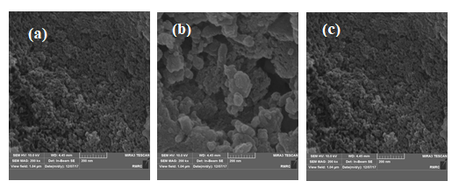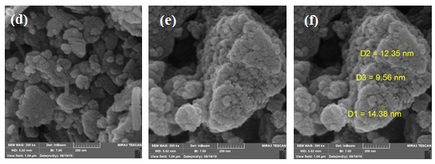
Figure S2. FESEM images of the MCM-41 (a,b and c) and the MCM-41-APS-PMDA-SO₃H (1, d,e and f) materials (b) scale 200 nm

Figure S3. TGA analysis of the MCM-41-APS-PMDA-SO₃H (1) materials.
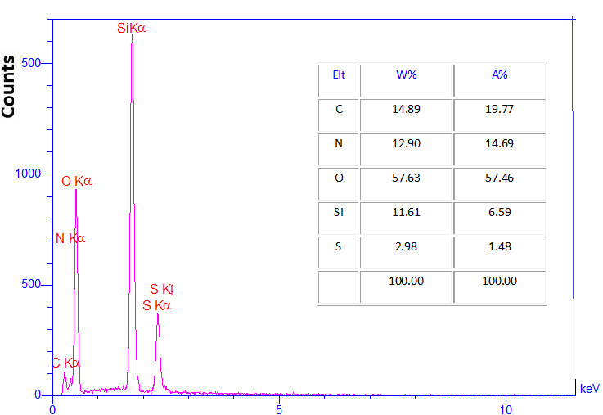
Figure S4. EDX pattern of MCM-41-APS-PMDA-SO₃H (1) materials.

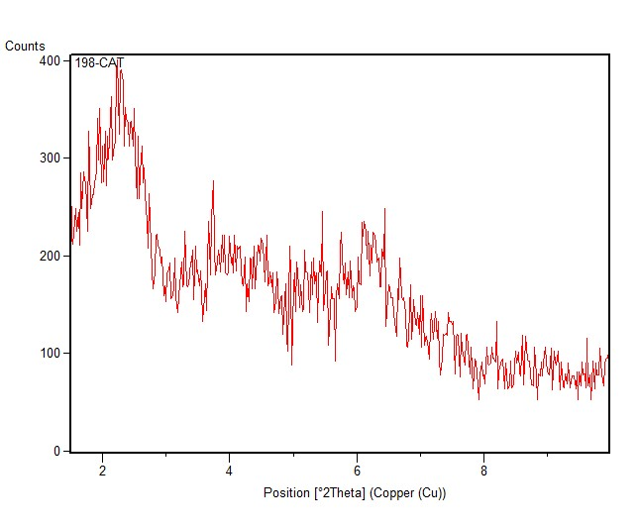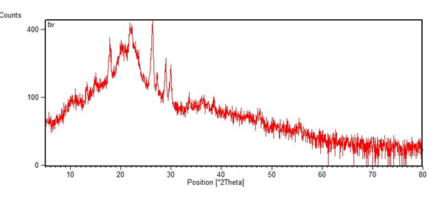
Figure. S5. XRD patterns of a) MCM-41 and b) MCM-41-APS-PMDA-SO₃H (1)
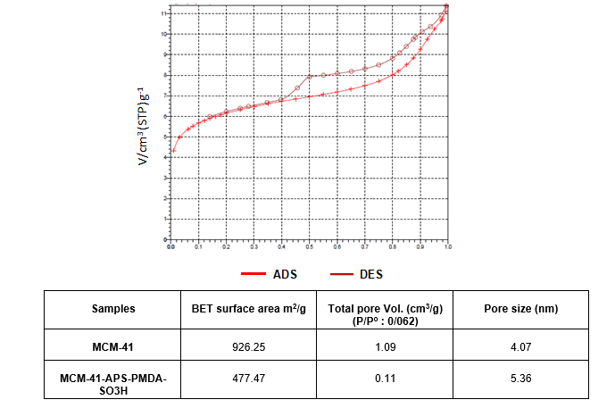
Figure. S6. Adsorption/desorption isotherm of the MCM-41-APS-PMDA-SO₃H (1)

General procedure for the synthesis of 3,4-dihydropyrimidinones catalyzed by the MCM-41-APS-PMDA-SO₃H (1)
In a 5 mL round-bottom flask, a mixture of ethyl acetoacetate (2, 1 mmol), aldehydes (3, 1 mmol), urea (4, 1.2 mmol) and MCM-41-APS-PMDA-SO₃H (1, 15 mg) were heated to 80 ᵒC under solvent-free conditions for times indicated in Table 2. The progress of the reactions was monitored by TLC (Eluent: EtOAc: n-hexane, 1:3). After completion of the reaction, 96% EtOH (5 mL) was added to the mixture. The heterogeneous catalyst was then separated by filtration and allowed to cool filtrate over time to give pure crystals of the desired 3,4-dihydropyrimidinones. The separated catalyst was suspended in ethanol (1 mL), for 30 min and filtered off, heated in an oven at 60 °C for 1.5 h and then reused for successive runs.
Chemical characterization of 4-(2Chloro-phenyl)-6-methyl-2-oxo-1,2,3,4-tetrahydropyrimidine-5-carboxylicacid ethyl ester
Mp: 211-213°C; IR (KBr): ν 3354, 3223, 3107, 2978, 1694, 1639, 1450, 1368, 1230, 1098, cm⁻¹; ¹H NMR (500 MHz, DMSO-d6): δ 0.99 (t, 3H, J = 7 Hz, CH3). 2.3 (s, 3H, CH3), 3.89 (q, 2H, J = 6.9 Hz, OCH2–CH3), 5.63 (d, 1H, J = 2.6 Hz, CH-Ar), 7.25–7.41 (m, 4H, Ar-H), 7.69 (s, 1H, NH), 9.26 (s, 1H, NH).

Figure. S6. FT-IR spectrum of 4-(2Chloro-phenyl)-6-methyl-2-oxo-1,2,3,4-tetrahydropyrimidine-5-carboxylicacid ethyl ester

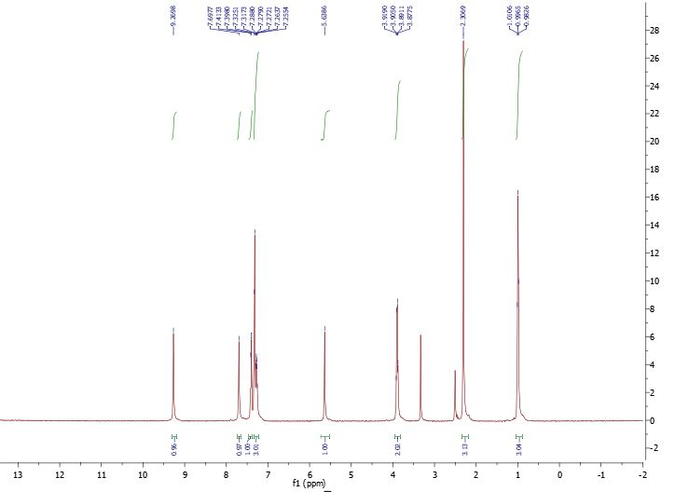
Figure. S7. ¹H NMR spectrum of 4-(2Chloro-phenyl)-6-methyl-2-oxo-1,2,3,4-tetrahydropyrimidine-5-carboxylicacid ethyl ester
Chemical characterization of 4-(4-Methoxy-phenyl)-6-methyl-2-oxo-1,2,3,4-tetrahydropyrimidine-5-carboxylicacid ethyl ester
Mp: 201-203 °C; IR (KBr): ν 3223, 3095, 2929, 2833, 1710, 1655, 1512 cm⁻¹; ¹H NMR (500 MHz, DMSO-d6): δ 1.12(t, J = 7 Hz, 3H CH3), 2.24 (s, 3H, CH3), 3.72 (s, 3H, OCH3), 4 (q, J = 7.2 Hz, 2H, OCH2CH3), 5.1 (d, J = 3.0 Hz, 1H, CH-Ar), 6.88 (d, J = 8.6 Hz, 2H, Ar-H), 7.16 (d, J = 8.5 Hz), 7.66 and 9.16(2H, 2s, 2N–H).

Figure. S8. FT-IR spectrum of 4-(4-Methoxy-phenyl)-6-methyl-2-oxo-1,2,3,4-tetrahydropyrimidine-5-carboxylicacid ethyl ester
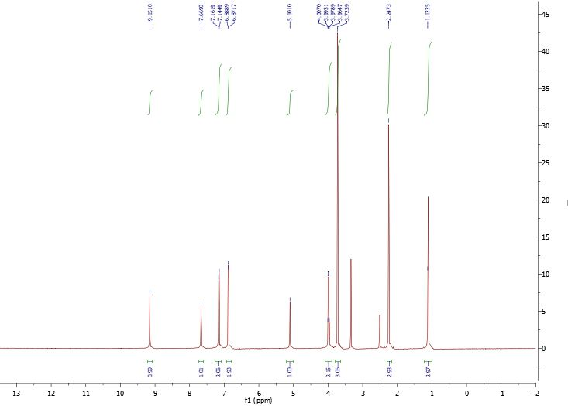
Figure. S9. ¹H NMR spectrum of 4-(4-Methoxy-phenyl)-6-methyl-2-oxo-1,2,3,4-tetrahydropyrimidine-5-carboxylicacid ethyl ester
Chemical characterization of 4-[thiophen-2-yl]-6-methyl-2-oxo-1,2,3,4- tetrahydropyrimidine-5-carboxylicacid ethyl ester
Mp: 212-214 °C; IR (KBr): ν 3223, 3095, 2929, 2833, 1710, 1655, 1512 cm⁻¹; ¹H NMR (500 MHz, DMSO-d6): δ 1.15 (t, 3H, J = 7 Hz), 2.22 (s, 3H), 4.04–4.09 (q, 2H, J= 7.1), 5.47 (s, 1H), 6.89–6.94 (q, 2H), 7.36 (s, 1H), 7.84 and 9.31(2H, 2s, 2N–H).

Figure. S10. FT-IR spectrum of 4-[thiophen-2-yl]-6-methyl-2-oxo-1,2,3,4- tetrahydropyrimidine-5-carboxylicacid ethyl ester

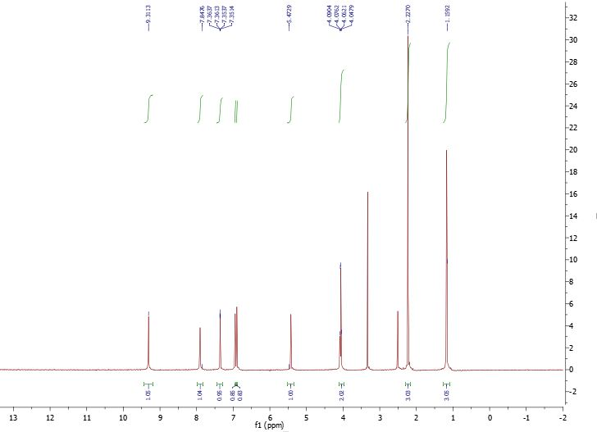
Figure. S11. ¹H NMR spectrum of 4-[thiophen-2-yl]-6-methyl-2-oxo-1,2,3,4- tetrahydropyrimidine-5-carboxylicacid ethyl ester

