Table 1. Optimization of conditions in the reaction of ethyl acetoacetate (2), 4-chlorobenzaldehyde (3a), urea (4) under different conditions.ª
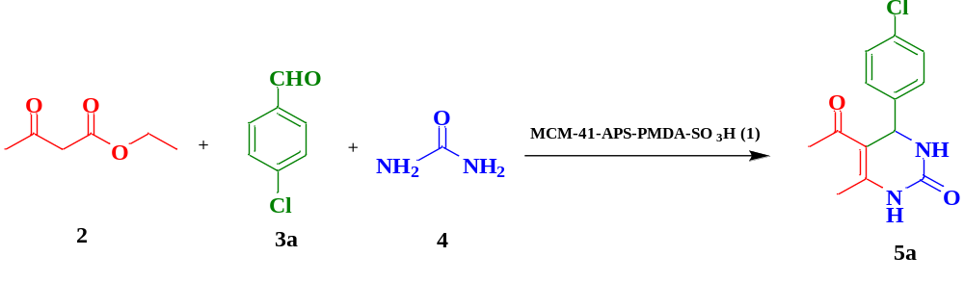
Yield^{b} (%) 5a | Time (min) | Temperature (°C) | Solvent | Catalyst loading (mg) | Entry
26 | 180 | r.t | MeOH | 20 | 1
69 | 90 | Reflux | EtOH | 20 | 2
45 | 90 | Reflux | CH₂Cl₂ | 20 | 3
78 | 120 | 60 | CH₃CN | 20 | 4
62 | 100 | Reflux | DMF | 20 | 5
48 | 150 | Reflux | Toluene | 20 | 6
35 | 240 | r.t | Et2O | 20 | 7
75 | 120 | 60 | CHCl3 | 20 | 8
77 | 55 | Reflux | EtOH/ H₂O (1:2) | 20 | 9
73 | 70 | Reflux | EtOH/ H₂O (1:1) | 20 | 10
95 | 35 | 80 | Solvent-free | 15 | 11
69 | 65 | 80 | Solvent-free | 10 | 12
60 | 90 | 80 | Solvent-free | 5 | 13
57 | 120 | 80 | Solvent-free | 2 | 14
15 | 180 | 80 | Solvent-free | 0 | 15
ªReaction conditions: ethyl acetoacetate (2, 2 mmol), 4-chlorobenzaldehyde (3a, 1 mmol), urea (4, 1.2 mmol), MCM-41-APS-PMDA-SO₃H (1) under different conditions.

Table 2. Scope of the Biginelli 3,4-dihydropyrimidin-2-(1H)-ones catalyzed ), MCM-41-APS-PMDA-SO₃H (1)ª
Entry | Aldehyde (3) | Product | Time (min) | Yield (%)^{b} | mp °C (Obs.) | mp °C (Lit.)
1 | 4-ClC₆H₄ | 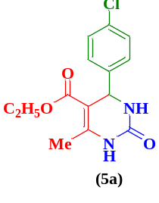 | 35 | 95 | 210-211 | 210-211⁶²
2 | C₆H₅ | 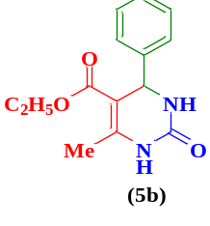 | 55 | 87 | 235-236 | 234-236⁶³
3 | 4-NO₂C₆H₄ | 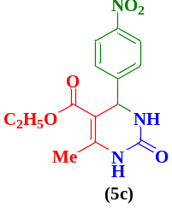 | 50 | 80 | 204 | 204⁶⁴
4 | 3-NO₂C₆H₄ | 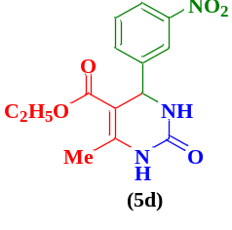 | 60 | 82 | 293-295 | 224-227⁶⁵
5 | 4-CH₃OC₆H₄ | 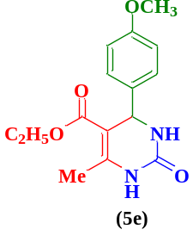 | 55 | 89 | 201-203 | 202-204⁶⁶
6 | 2-ClC₆H₄ | 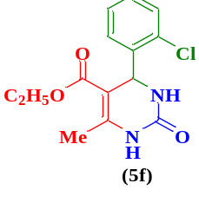 | 60 | 90 | 211-213 | 211-213⁶⁴
7 | 4-OHC₆H₄ | 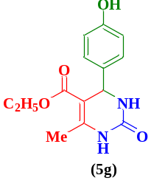 | 55 | 82 | 234–236 | 233-235⁶⁷
8 | 2- Thiophenecarboxaldehyde | 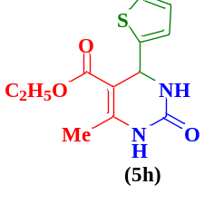 | 45 | 84 | 212-214 | 210-212⁶⁸
9 | 4-Dimethylaminobenzaldehyde | 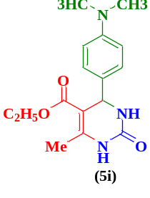 | 45 | 92 | 213-215 | 213-215⁶⁹
10 | 4-FC₆H₄ | 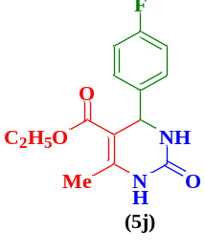 | 60 | 85 | 180 | 180⁷⁰
ªReaction conditions: : ethyl acetoacetate (2, 2 mmol), aldehydes (3, 1 mmol), urea (4, 1.2 mmol), MCM-41-APS-PMDA-SO₃H (1) under solvent-free conditions was heated to 80 ᵒC. ^{b} Isolated yields were reported.

Table 3. Comparison of the catalytic activity of the MCM-41-APS-PMDA-SO₃H (1) with other catalysts
Entry | Catalyst | Amount of catalyst | Solvent | Temp. (ºC) | Time (min) | Yield (%) | References
1 | PPF-SO₃H | 250 mg | EtOH | Reflux | 480 | 81 | ⁶³
2 | PANI-FeCl₃ | 200 mg | CH₃CN | Reflux | 1440 | 83 | ⁷¹
3 | Fe₃O₄/PAA-SO₃H | 60 mg | Solvent-free | RT | 120 | 90 | ⁷²
4 | H₂SO₄.Silica gel | 30 mol ⁒ | Solvent-free | 60 °C | 120 | 89 | ⁷³
5 | Zr(H2PO₄)₂ | 7 mol ⁒ | Solvent-free | 90 °C | 60 | 92 | ⁷⁴
6 | MCM-41-APTES-PMDA-SO₃H | 15 mg | Solvent-free | 80 °C | 35 | 96 | This work

