Supplementary File

(a)
(b)
(c)
(d)

(e)
(f)
Supplementary Figure 1: Scattergram plot (a) Annual Maximum 24-hr Rainfall (b) Maximum Storm Surge (Time interval = ±4 days) (c) Maximum River Discharge (Time interval = ±4 days); and Strip plot (d) Annual Maximum 24-hr Rainfall (e) Maximum Storm Surge (Time interval = ±4 days) (f) Maximum River Discharge (Time interval = ±4 days)
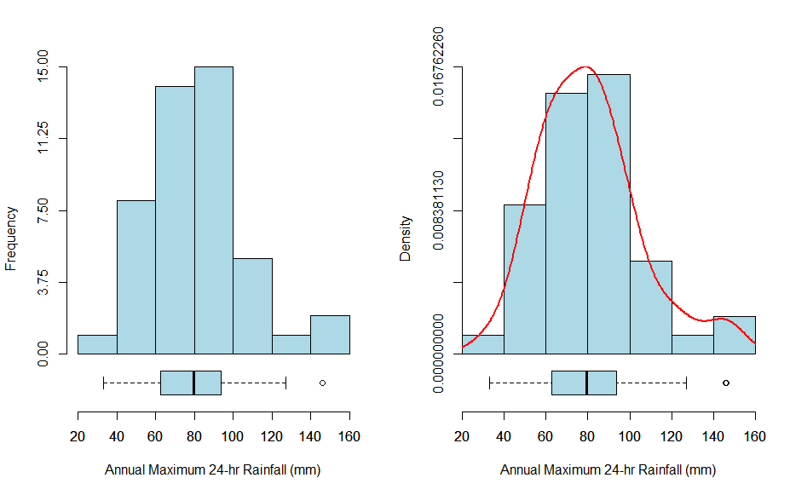
(a)
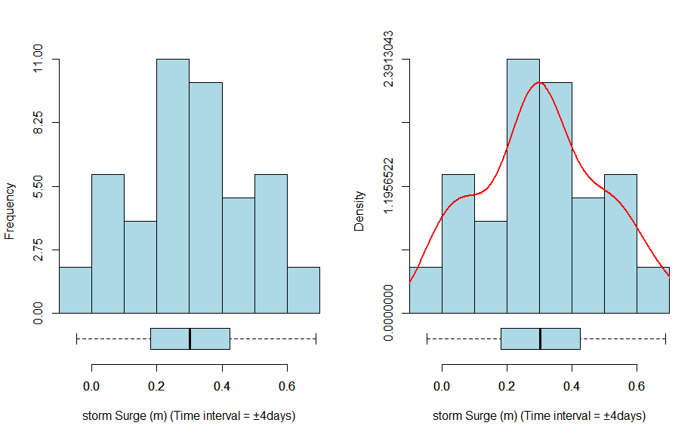

(b)

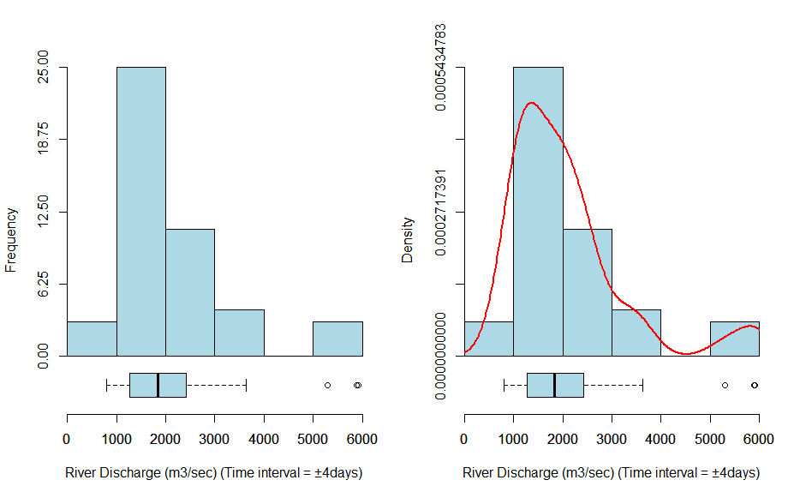(c)
Figure 2: Histogram plots of (a) Annual Maximum 24-hr Rainfall (b) Maximum Storm Surge (Time interval = $±4$ days) (c) Maximum River Discharge (Time interval = $±4$ days)

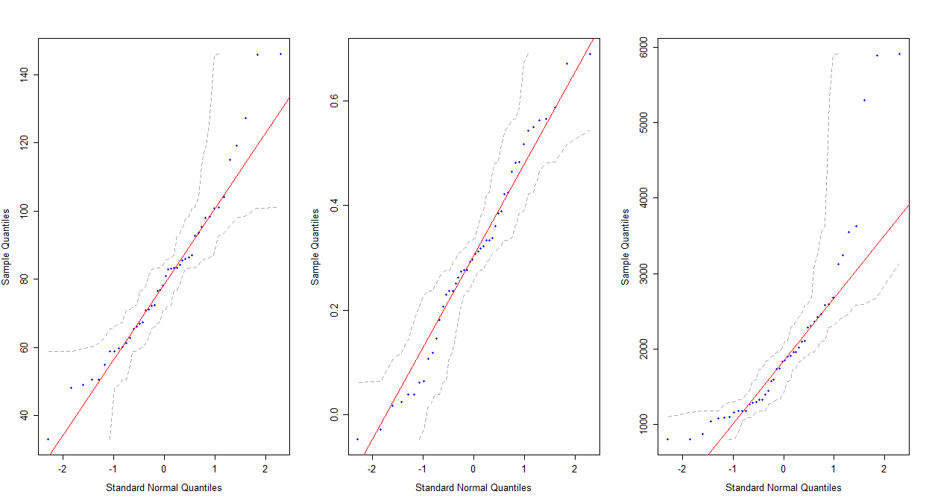
Figure 3: Normal Q-Q plot of the univariate flood characteristics
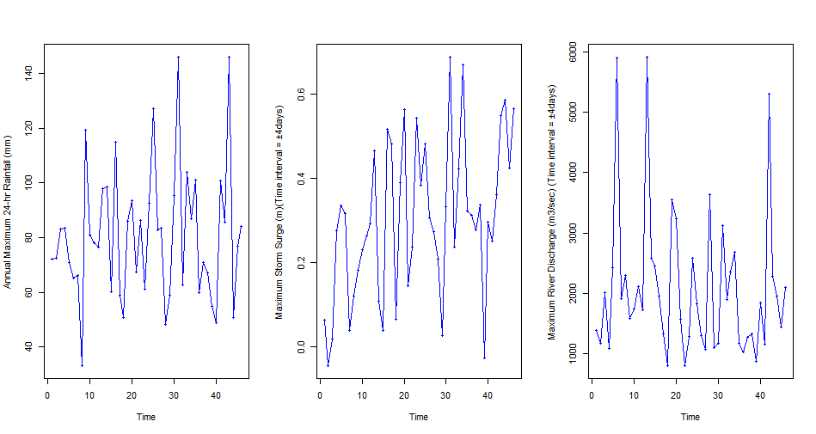
Figure 4: Time series behavior of Annual Maximum 24-hr Rainfall observations and their underlying Maximum Storm Surge and Maximum River Discharge observations within a Time interval (Time lag = $±4 days$)
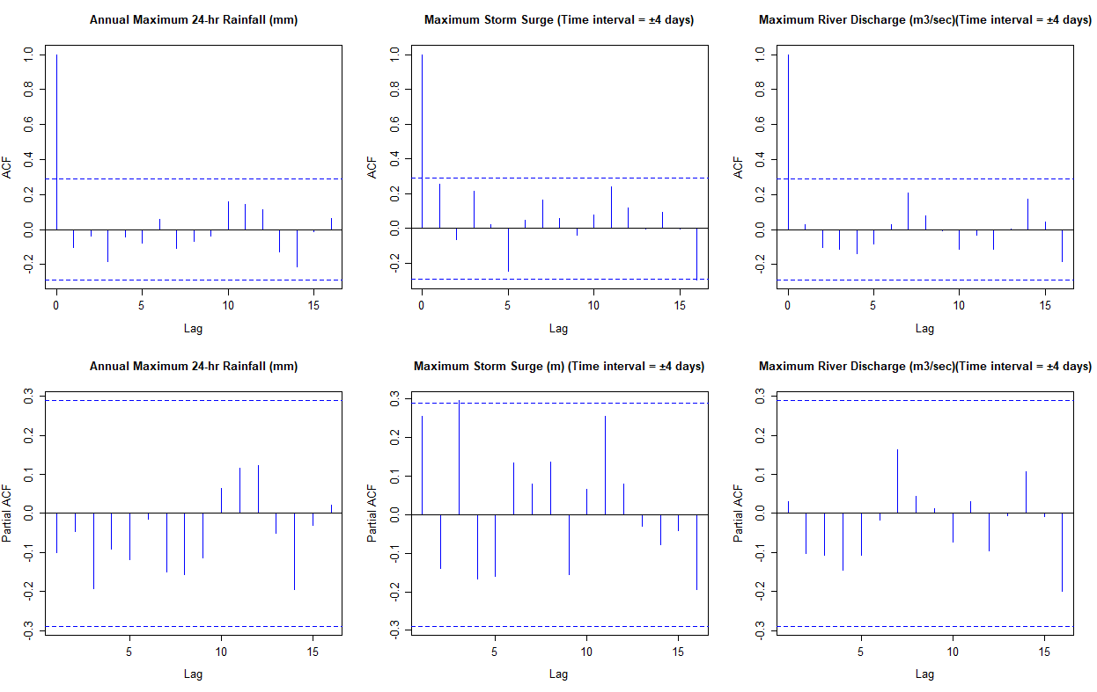
Figure 5: Autocorrelation function (ACF) and partial ACF plots
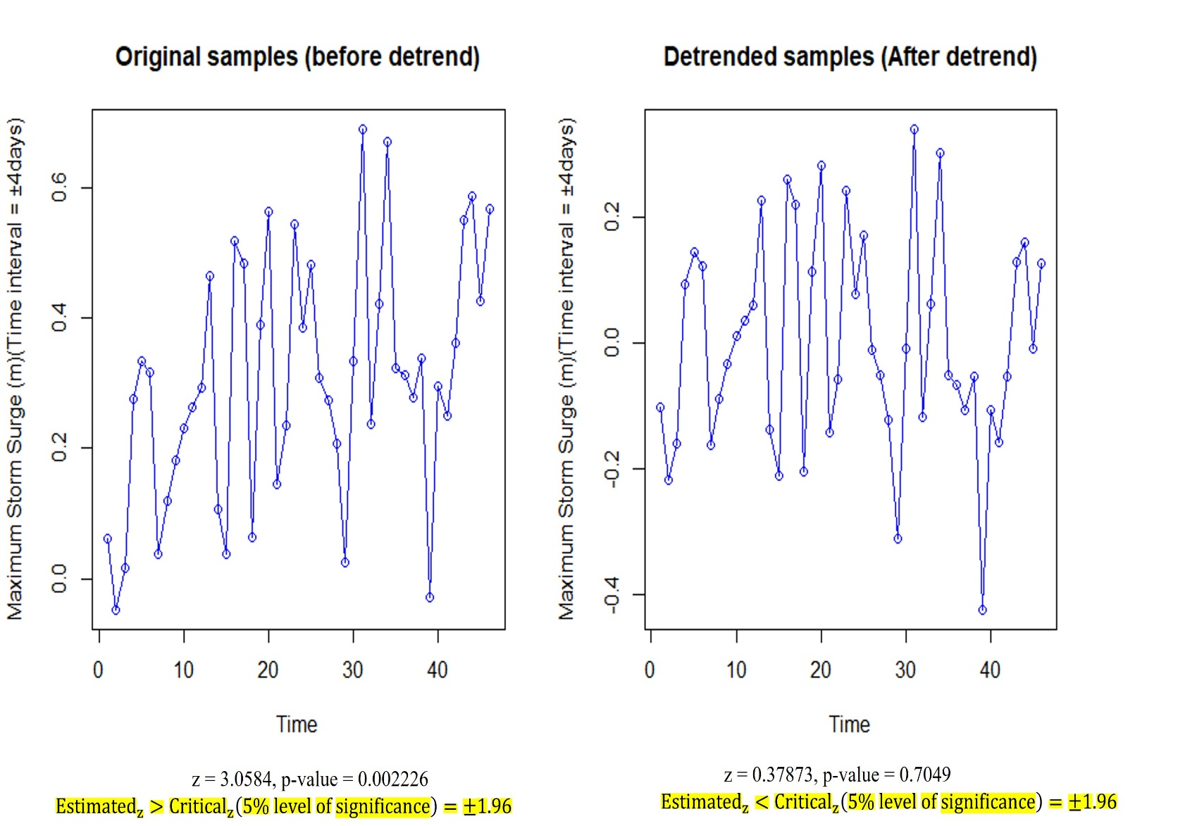

Figure 6: Observing the removal of monotonic time trend (or detrended samples) from Maximum Storm Surge observations via the pre-whitening procedure
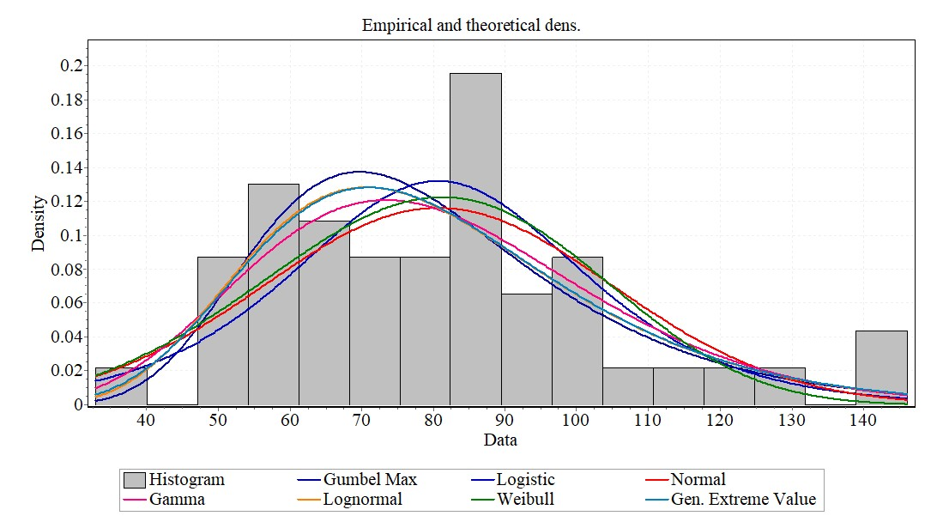(a)
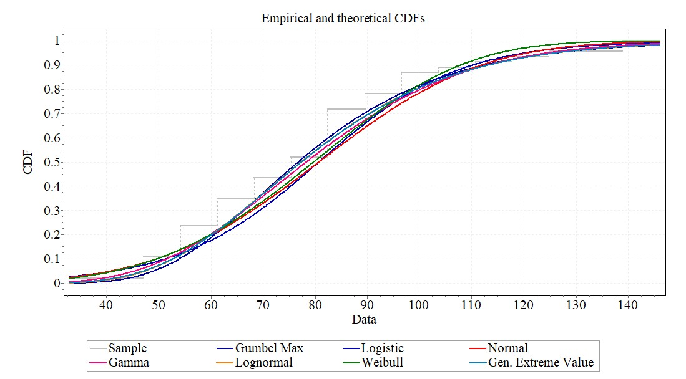(b
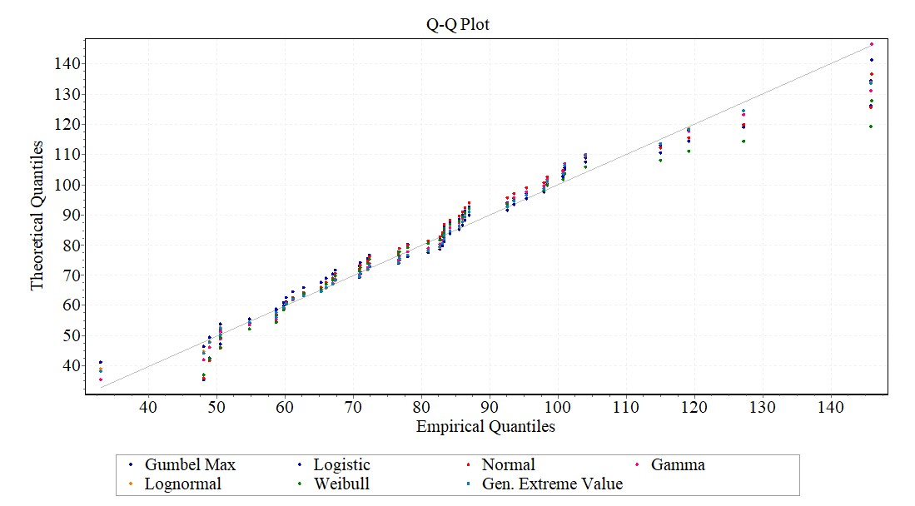

(c)
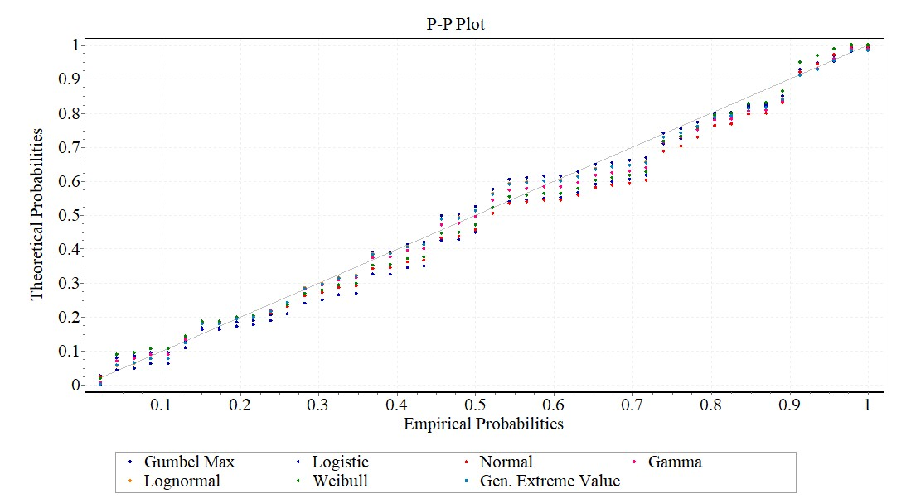 (d)
Figure 7: Graphical-based model consistency check of the candidate’s functions for Annual Maximum 24-hr Rainfall (mm) observations (a) via probability density plot (b) via cumulative distribution plots (c) via quantile-quantile (Q-Q) plots (d) via probability-probability (P-P) plot
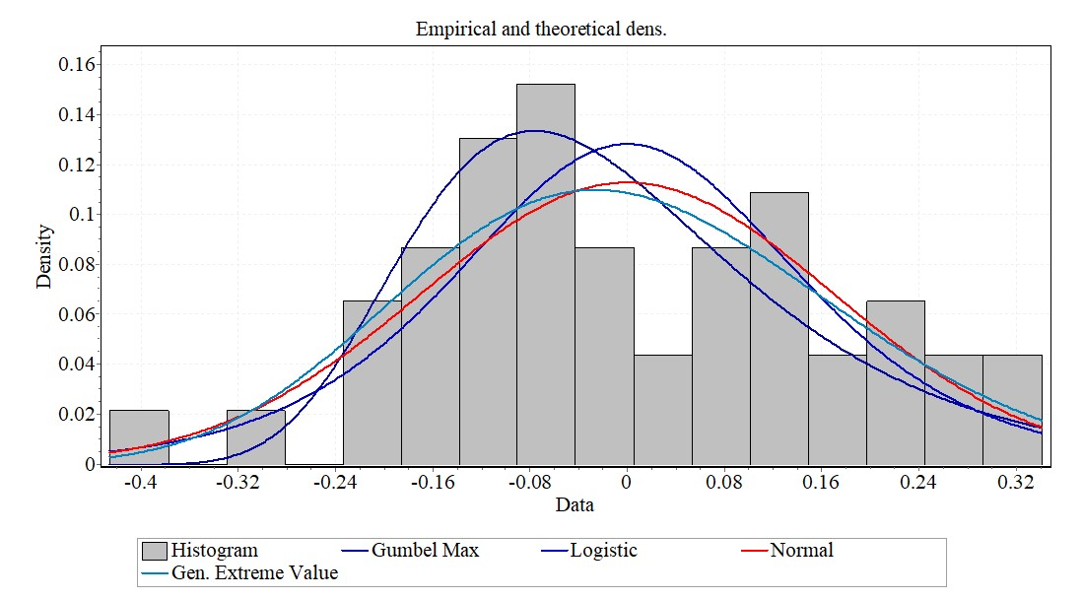(a)
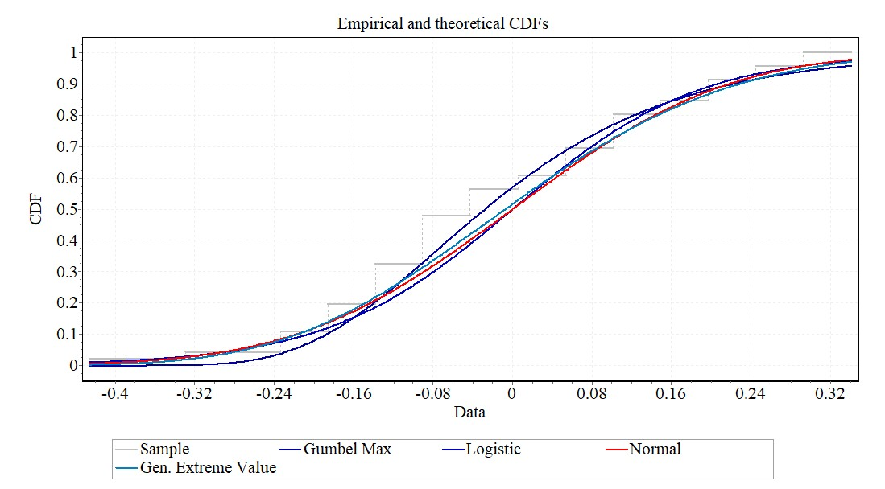(b)
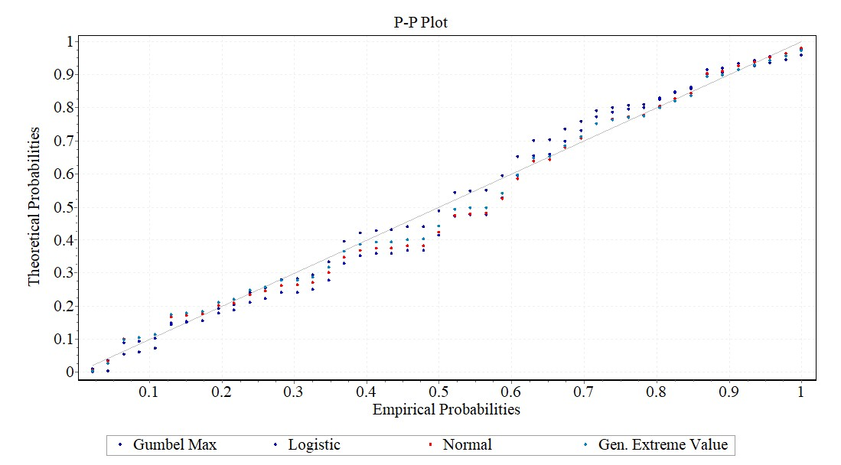(c)
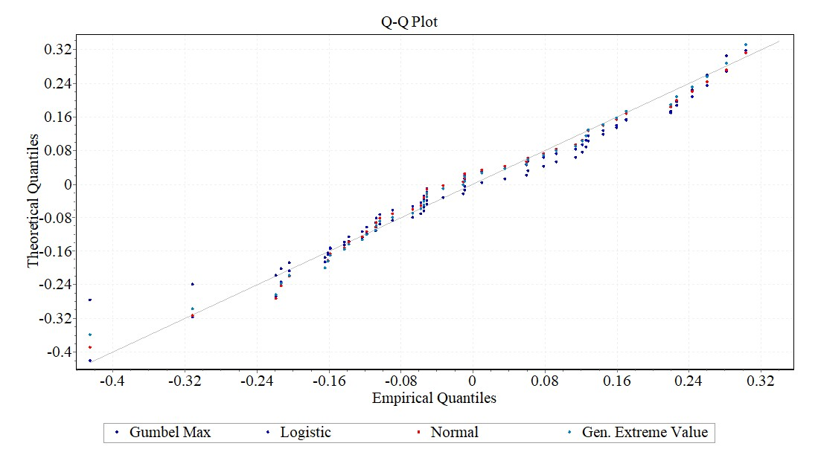(d)
Figure 8: Graphical-based model consistency check of the candidate’s functions for storm surge series (a) via probability density plot (b) via cumulative distribution plots (c) via quantile-quantile (Q-Q) plots (d) via probability-probability (P-P) plots
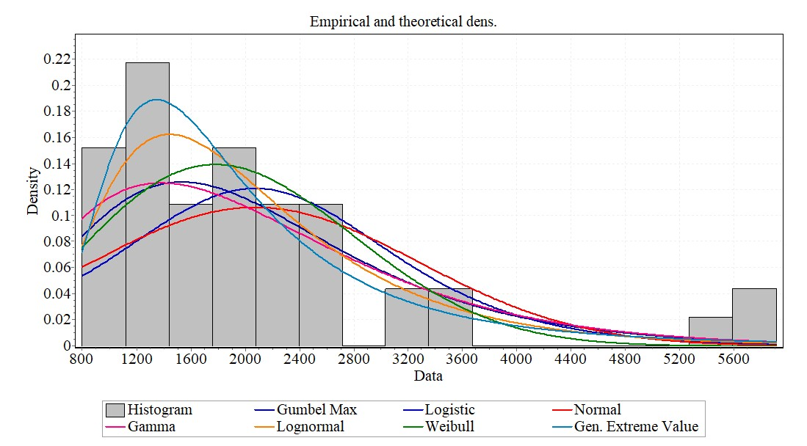(a)
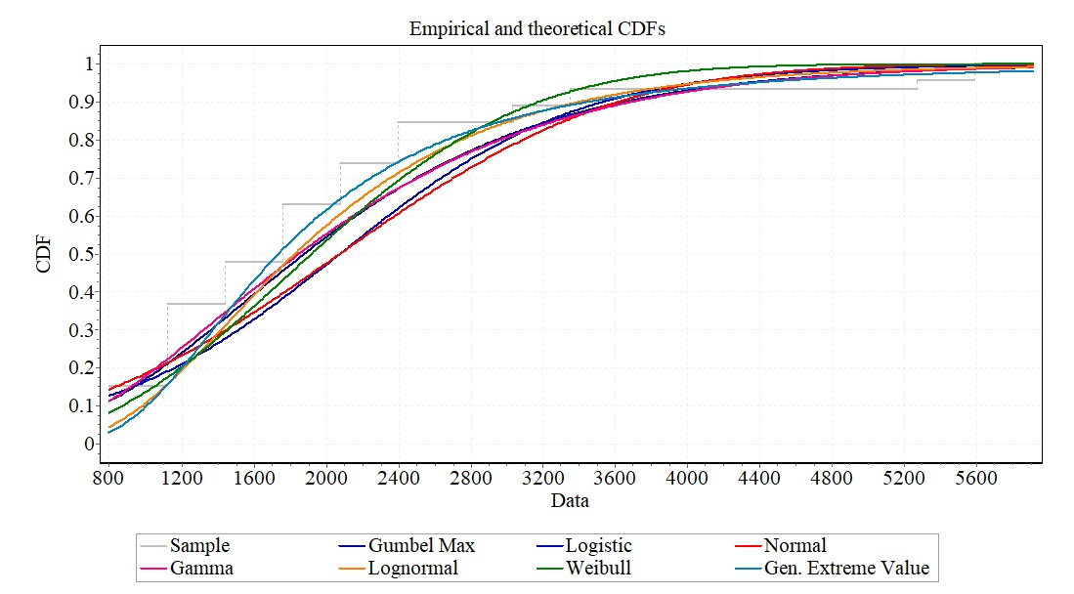(b)
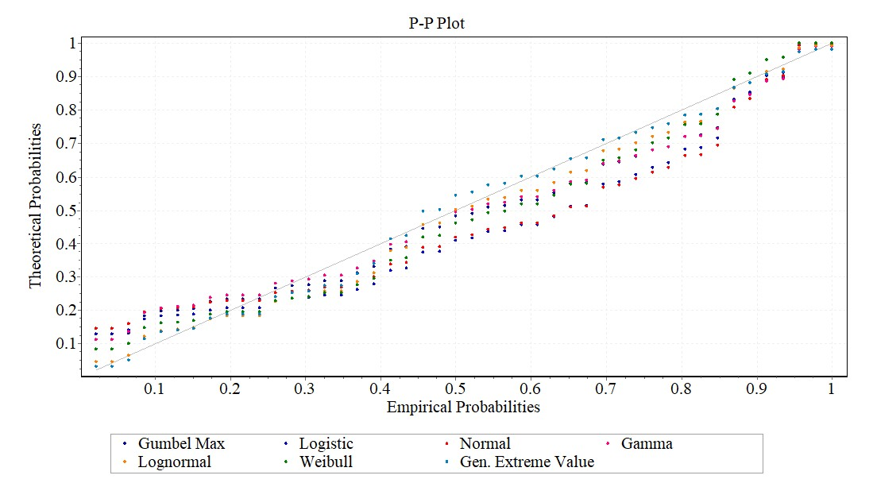

(c)
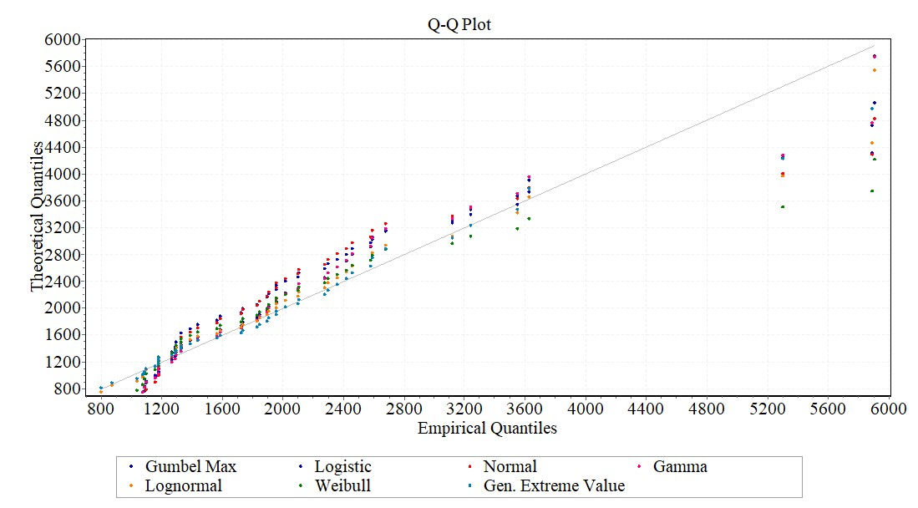(d)
Figure 9: Graphical-based model consistency check of the candidate’s functions for river discharge observations (a) via probability density plot (b) via cumulative distribution plots (c) via quantile-quantile (Q-Q) plots (d) via probability-probability (P-P) plot
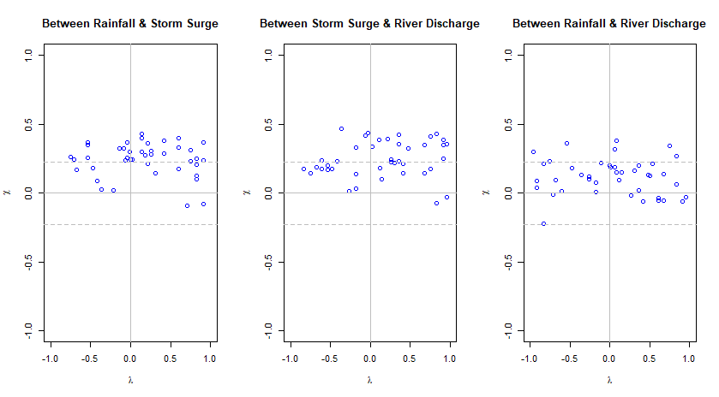(a)
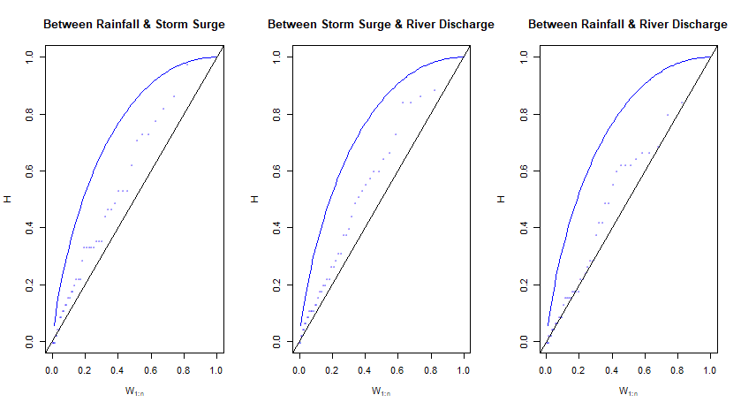(b)
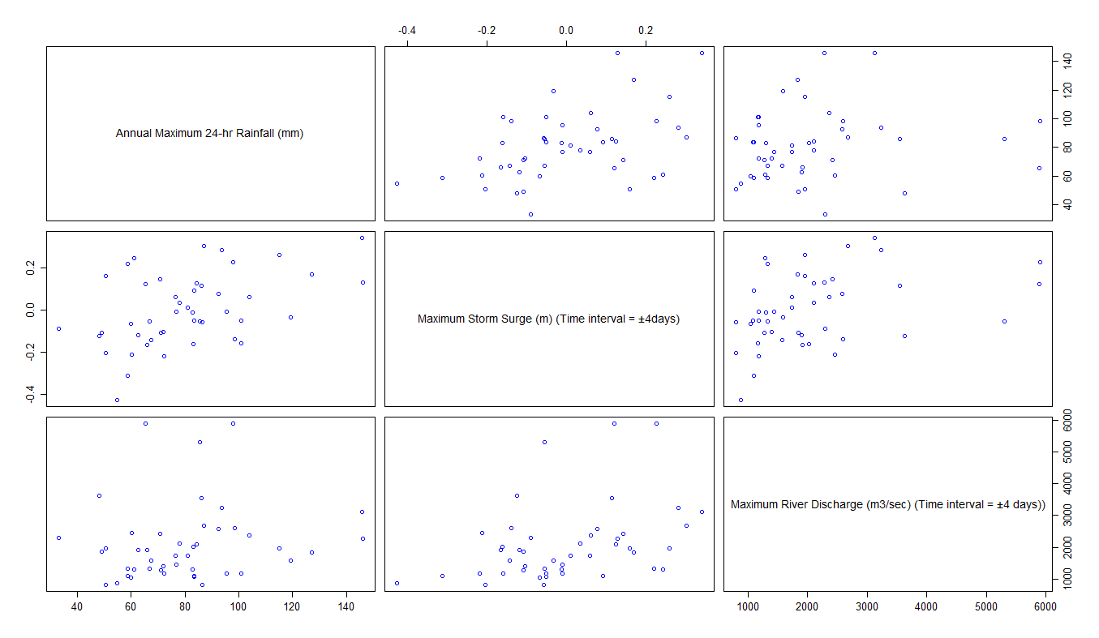 (c)
Figure 10: Graphical-based dependency measures via (a) Chi-plot (b) Kendall or K-plot (c) Scatter plot
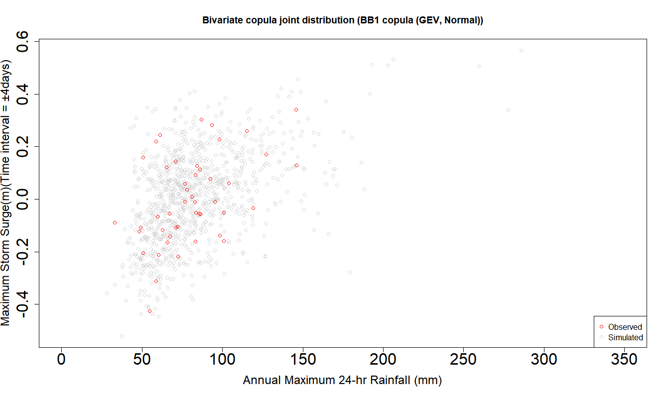(a)
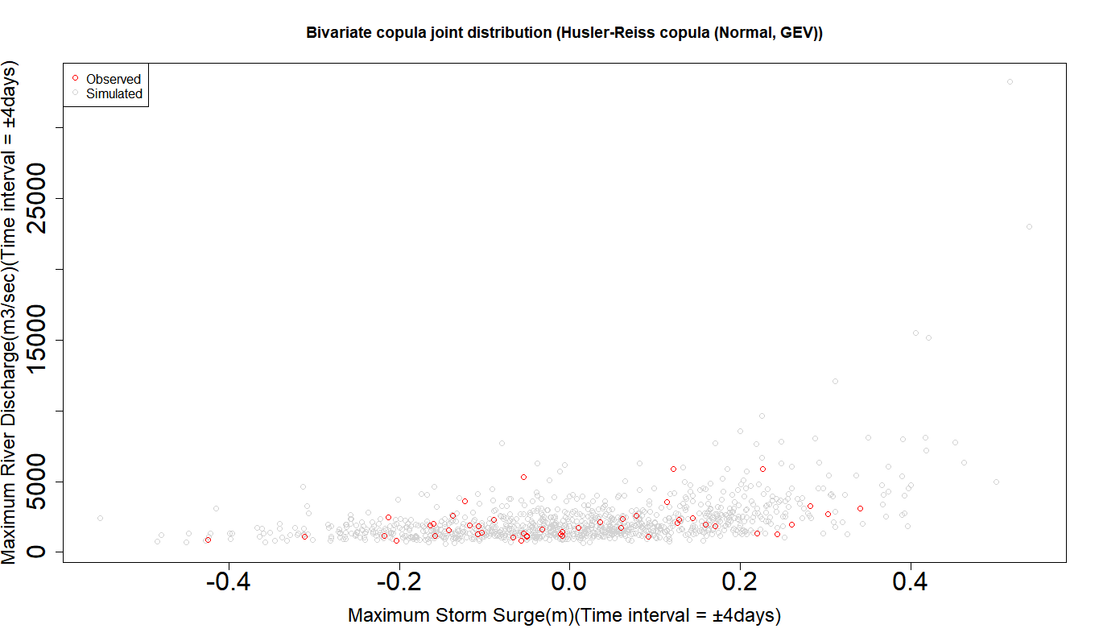(b)
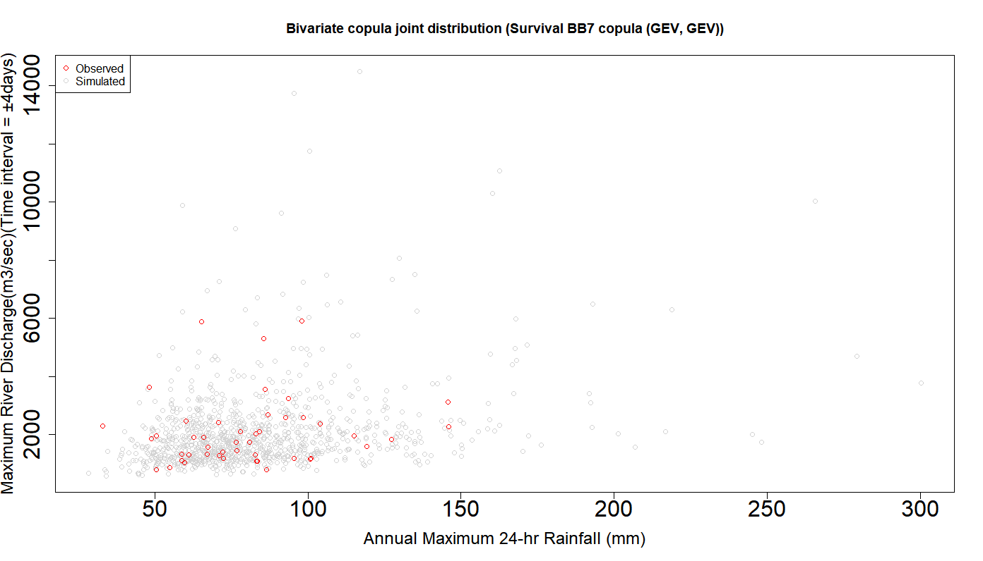(c)
Figure 11: Visual comparison between simulated (sample size, N=1000) observations from the most parsimonious fitted 2D copula vs observed random samples for (a) Annual Maximum 24-hr Rainfall observation- Maximum Storm Surges (Time interval = $±4 days)$ (Note: Theoretical Kendall’s correlation = 0.323 and Empirical Kendall’s correlation = 0.309) (b) Maximum Storm Surges (Time interval = $±4 days)$ - Maximum River Discharge (Time interval = $±4 days)$ (Note: Theoretical Kendall’s correlation = 0.295 and Empirical Kendall’s correlation = 0.292), (c) Annual Maximum 24-hr Rainfall observation- Maximum River Discharge (Time interval = $±4 days)$ (Note: Theoretical Kendall’s correlation = 0.132 and Empirical Kendall’s correlation = 0.141)

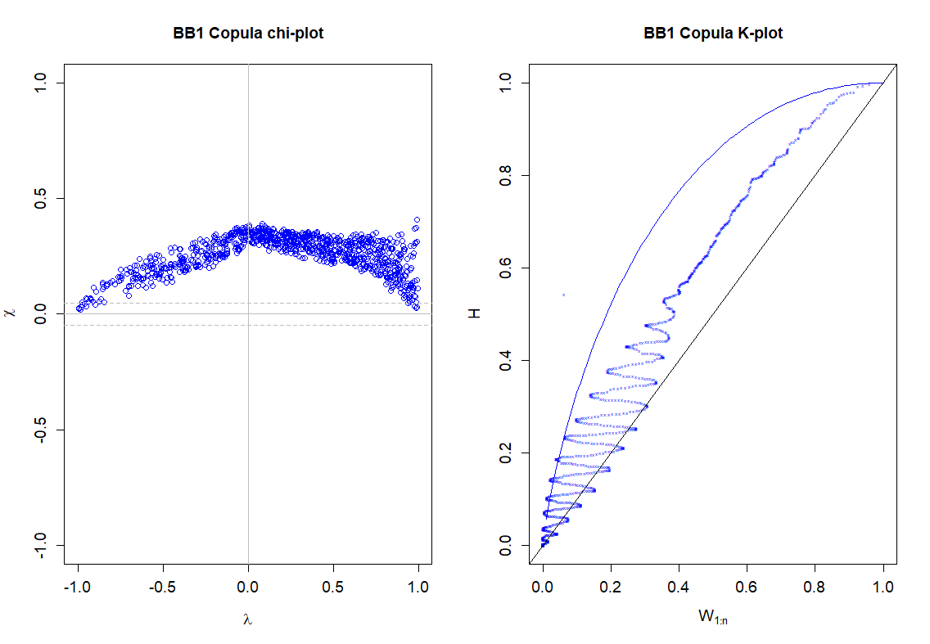 (a)
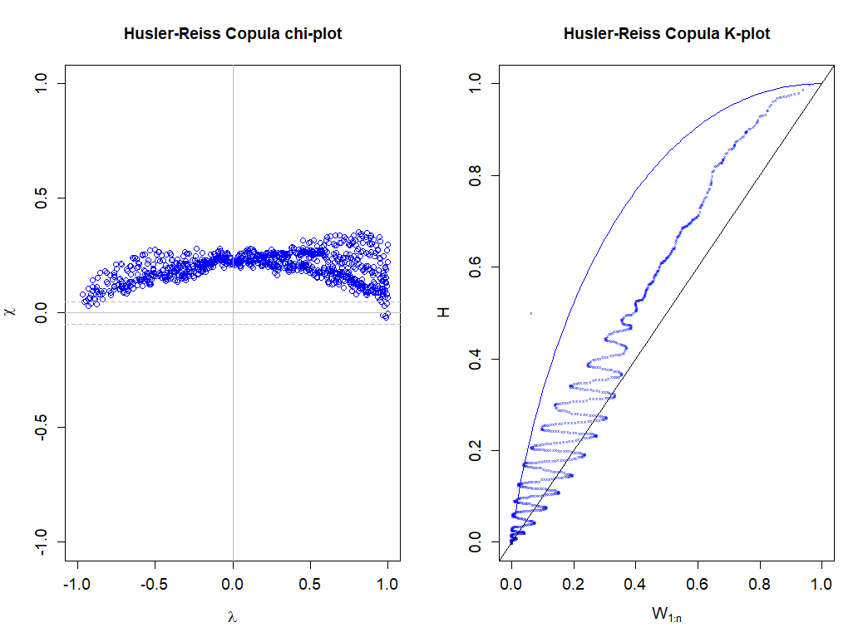 (b)
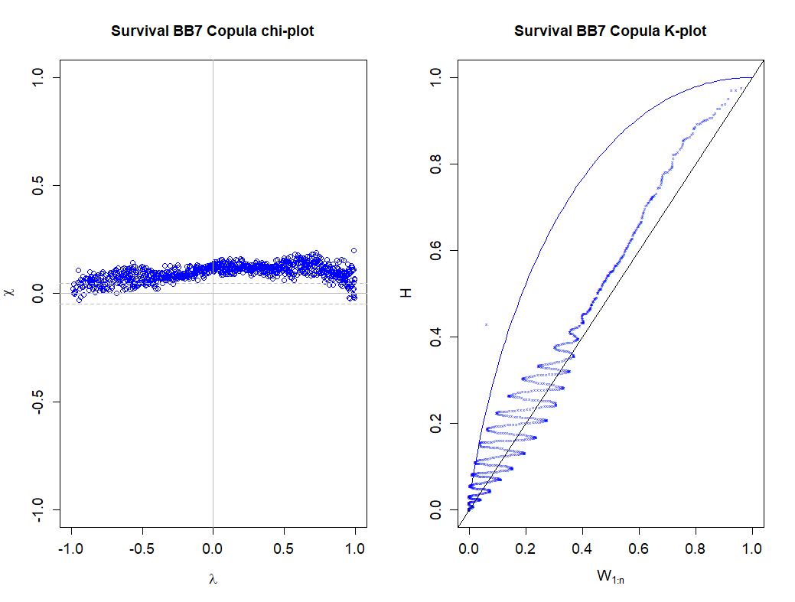
(c)
Figure 12: Chi-plot and K-plot of a random sample (size N =1000) taken drawn from best-fitted bivariate copula using MPL-based dependence parameter estimation fitted to (a) Annual Maximum 24-hr Rainfall observation- Maximum Storm Surges (Time interval = $±4 days)$ (b) Maximum Storm Surges (Time interval = $±4 days)$ - Maximum River Discharge (Time interval = $±4 days)$, (c) Annual Maximum 24-hr Rainfall observation- Maximum River Discharge (Time interval = $±4 days)$

Figure 13: Comparing the performance of asymmetric (or fully nested) Frank copula vs symmetric Gaussian copula in approximating trivariate dependence structure using Log-likelihood statistics [[$Note: {LL}_{Symmetric copula}<{LL}_{Asymmetric(or fully nested) copula]}$

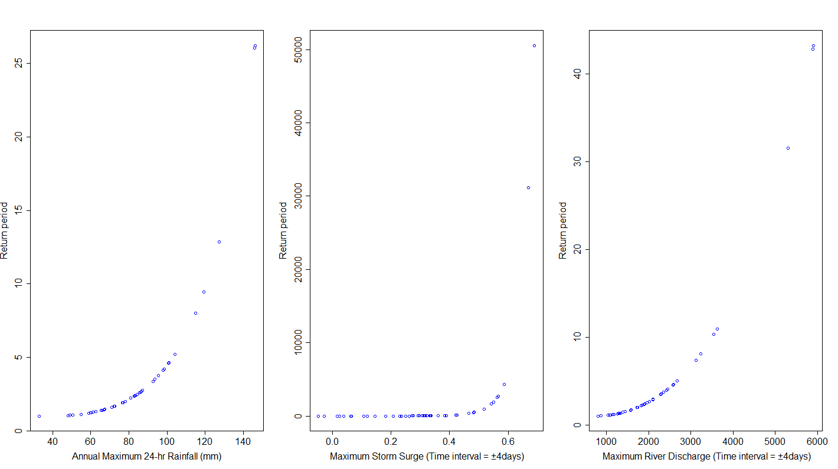

Figure 14: Univariate return period derived from best-fitted marginal cumulative distributions of the flood characteristics

Table 1: Mathematical expressions of 2-D copulas and their associated statistical properties
copula family | Bivariate copula$C_{θ}(u,v)$ | Parameter range $(θ)$ | Generating function (or generator) $ϕ(t)$ | Relation of Kendall’s $τ and θ$ ($τ_{θ})$ | Upper tail dependence coefficient measures ($λ_{up})$
Clayton | $${\left[max\left\{u^{-θ}+v^{-θ}-1;0\right\}\right]}^{{-1}/θ}$$ | $$0≤θ<∞$$ | $$\frac{1}{θ}\left(t^{-θ}-1\right)$$ | $$\frac{θ}{θ+2}$$ | 0
Frank | $$\frac{-1}{θ}\ln\left(1+\frac{\left(e^{-θu}-1\right)\left(e^{-θv}-1\right)}{{(e}^{-θ}-1)}\right)$$ | $$-∞<θ<∞$$ | $$-\ln\left(\frac{e^{-θt}-1}{e^{-θ}-1}\right)$$ | $$1+4\left(\frac{D_{1}\left(-\ln{θ}\right)-1}{\ln{θ}}\right)$$  where$D_{k}\left(x\right)$is the Debye function, for any positive integer k,  $D_{K}\left(x\right)=\frac{k}{x^{k}}\int_{0}^{x}{{t^{k}}/{{(e}^{t}-1)}dt}$ (Zhang and Singh 2006 and Wang et al., 2009) | 0
Gumbel-Hougaard (GH) | $$exp\left\{-{\left[{\left(-\ln\left(u\right)\right)}^{θ}+{\left(-\ln\left(v\right)\right)}^{θ}\right]}^{\frac{1}{θ}}\right\}$$ | $$1≤θ<∞$$ | $${\left(-\ln{t}\right)}^{θ}$$ | $$\frac{θ-1}{θ}$$ | $$2-2^{1/θ}$$
Joe | $$1-{\left[{\left(1-u\right)}^{θ}+{\left(1-v\right)}^{θ}-{\left(1-u\right)}^{θ}{\left(1-v\right)}^{θ}\right]}^{1/θ}$$ | $$1≤θ<∞$$ | $$-\ln\left(1-{\left(1-t\right)}^{θ}\right)$$ |  | $$2-2^{1/θ}$$
Galambos | $$uvexp\left\{{\left[{\left(-\ln{(u})\right)}^{-θ}+{\left(-\ln{(v)}\right)}^{-θ}\right]}^{{-1}/θ}\right\}$$ | $$θ>0$$ |  |  | $2-2ϕ(\frac{1}{θ})$; where $ϕ$ is the cumulative density function of standard normal distribution
Husler-Reiss | $exp\left\{-\overline{u}Φ\left[\frac{1}{θ}+\frac{1}{2}θ\ln\left(\frac{\overline{u}}{\overline{v}}\right)\right]-\overline{v}Φ\left[\frac{1}{θ}+\frac{1}{2}θ\ln\left(\frac{v}{\overline{u}}\right)\right]\right\}$; where $\overline{u}=-\ln\left(u\right), \overline{v}=$ $-\ln\left(v\right)$; $Φ$ = cumulative distribution function of a standardized normal distribution | $$θ≥0$$ |  |  | $$2-2^{1/θ}$$
BB1 | $${\left(1+{\left[{\left(u^{-θ}-1\right)}^{δ}+{\left(v^{-θ}-1\right)}^{δ}\right]}^{1/δ}\right)}^{{-1}/θ}$$ | $$0<θ<∞;$$  $$1≤δ<∞$$ |  |  | $$2-2^{1/δ}$$
BB6 | $$1-{\left(1-exp-{\left[{\left(\left(-\ln{{\left(1-u\right)}^{θ}}\right)\right)}^{δ}+\left({\left(-\ln\left(1-{\left(1-v\right)}^{θ}\right)\right)}^{δ}\right)\right]}^{1/δ}\right)}^{1/θ}$$ | $$1≤θ<∞;$$  $$1≤δ<∞$$ |  |  | $$2-2^{1/{θδ}}$$
BB7 | $$1-{\left[1-{\left({\left(1-u^{θ}\right)}^{-δ}+{\left(1-v^{θ}\right)}^{-δ}-1\right)}^{{-1}/δ}\right]}^{1/θ}$$ | $1≤θ<∞$;  $$0≤δ<∞$$ | $${\left(1-{\left(1-t\right)}^{θ}\right)}^{-δ}-1$$ |  | $$2-2^{1/θ}$$
BB8 | $$\frac{1}{θ}\left(1-{\left[1-\frac{1}{1-{\left(1-δ\right)}^{θ}}\left(1-{\left(1-δu\right)}^{θ}{\left(1-δv\right)}^{θ}\right)\right]}^{\frac{1}{δ}}\right)$$ | $$1≤θ<∞;$$  $$0≤δ≤1$$ | $$-\ln\left[\frac{1-{\left(1-δt\right)}^{θ}}{1-{\left(1-δ\right)}^{θ}}\right]$$ |  | $2-2^{1/θ}$, when $δ=1$  Otherwise, $λ_{up}$ = 0
Note: $θ$ is the copula dependence parameter of monoparametric copulas; $θ \& δ$ jointly are the copula dependence parameters for bi-parametric (or 2-parameter) Archimedean copulas such as BB1, BB6, BB7 & BB8

Table 2: Descriptive statistics of the trivariate flood characteristics

Statistic | Rainfall (mm) | Storm Surges (m) | River Discharge (m3/sec)
Nbr. of observations | 46 | 46 | 46
Nbr. of missing values | 0 | 0 | 0
Sum of weights | 46 | 46 | 46
Minimum | 33.000 | -0.047 | 800.000
Maximum | 146.000 | 0.689 | 5910.000
Freq. of minimum | 1 | 1 | 2
Freq. of maximum | 1 | 1 | 1
Range | 113.000 | 0.736 | 5110.000
1st Quartile | 63.425 | 0.188 | 1275.000
Median | 79.500 | 0.302 | 1840.000
3rd Quartile | 93.350 | 0.424 | 2405.000
Mean | 80.676 | 0.303 | 2074.196
Variance (n) | 576.215 | 0.035 | 1406945.636
Variance (n-1) | 589.020 | 0.035 | 1438211.094
Standard deviation (n) | 24.004 | 0.186 | 1186.147
Standard deviation (n-1) | 24.270 | 0.188 | 1199.254
Variation coefficient (n) | 0.298 | 0.615 | 0.572
Variation coefficient (n-1) | 0.301 | 0.622 | 0.578
Skewness (Pearson) | 0.768 | 0.057 | 1.823
Skewness (Fisher) | 0.794 | 0.059 | 1.885
Skewness (Bowley) | -0.074 | 0.037 | 0.000
Kurtosis (Pearson) | 0.668 | -0.678 | 3.227
Kurtosis (Fisher) | 0.890 | -0.615 | 3.750
Standard error of the mean | 3.578 | 0.028 | 176.820
Lower bound on mean (95%) | 73.469 | 0.247 | 1718.061
Upper bound on mean (95%) | 87.883 | 0.358 | 2430.330
Standard error of the variance | 124.176 | 0.007 | 303201.521
Lower bound on variance (95%) | 405.226 | 0.024 | 989441.093
Upper bound on variance (95%) | 934.420 | 0.056 | 2281574.835
Standard error(Skewness (Fisher)) | 0.350 | 0.350 | 0.350
Standard error(Kurtosis (Fisher)) | 0.688 | 0.688 | 0.688
Mean absolute deviation | 18.446 | 0.148 | 837.334
Median absolute deviation | 15.050 | 0.122 | 575.000

Table 3: The Q statistics (via Ljung-Box test) and their corresponding p-value for flood characteristics
Hydrologic Variables | Statistics | Lag 20 | Lag 10 | Lag 5
Annual Maximum 24-hr Rainfall (mm) | X-squared (Q-statistics) | 13.917 | 5.4392 | 2.6815
 | p-value | 0.8347 | 0.86 | 0.7489
Maximum Storm Surge (m) (Time interval = ±4days) | X-squared (Q-statistics) | 24.146 | 11.362 | 9.0355
 | p-value | 0.2361 | 0.33 | 0.1077
Maximum River Discharge(m3/sec) (Time interval = ±4days) | X-squared (Q-statistics) | 14.641 | 6.1889 | 2.5821
 | p-value | 0.7966 | 0.7992 | 0.7641
 | Critical value | 31.4104 | 18.307 | 11.0705
Null Hypothesis is $H_{0}$ |  | Accept (5% level of significance or 95% Confidence interval) | Accept (5% level of significance or 95% Confidence interval) | Accept (5% level of significance or 95% Confidence interval)
Existence of serial correlation |  | No | No | No
Hypothesis Testing
$H_{0}=$ Null hypothesis = The data are independently distributed and exhibited no autocorrelation/or serial correlation
$H_{a}$ = Alternate hypothesis = The data are not independently distributed and exhibited serial correlation

Table 4: Mann Kendall (M-K) test for identifying monotonic time trend behavior
Hydrologic Variables | Calculated Z value | Critical Z value (Significance level$α=0.05 or 5\%$) | Null Hypothesis $H_{0}$ | Existence of Trend
Annual Maximum 24-hr Rainfall(mm) | z = 0.32195 (p-value = 0.7475) | $$±1.96$$ | Accept | No
Maximum Storm Surge (m) (Time interval = ±4days) | z = 3.0584 (p-value=0.002226) | $$±1.96$$ | Reject | Yes
Maximum River Discharge(m3/sec) (Time interval = ±4days) | z= -0.70085 (p-value=0.4834) | $$±1.96$$ | Accept | No
Note: Bold letter indicate rejection of Null hypothesis $H_{0},$ because estimated z value is higher than critical Z value ($±1.96)$ which clearly reveals the existence of monotonic time trend behavior within time series of Maximum Storm Surge (m) (Time interval = ±4days) observations

Table 5: Probability density function (pdf) of the fitted univariate parametric distributions
Functions | Probability density function (PDFs)
Gamma | $$f\left(x\right)= \frac{x^{α-1}}{β^{α}Γ(α)}e^{\frac{-x}{β}}$$  $$α (shape)>0, β(rate)>0$$
Lognormal | $f\left(x\right)= \frac{e^{-0.5{\left(\frac{\ln\left(x\right)- μ}{σ}\right)}^{2}}}{(x)σ\sqrt{2π}}$  $σ>0 \left(shape parameter\right); μ (scale parameter)$;
Logistic | $$f\left(x\right)=\frac{e^{-\frac{(x-μ)}{s}}}{s{(1+e^{-\frac{\left(x-μ\right)}{s}})}^{2}}$$  $$μ=location, s=scale, x∈(-∞, ∞)$$
Weibull | $f\left(x\right)= \frac{α}{β}{\left(\frac{x}{β}\right)}^{α-1}e^{-{\left(\frac{x}{β}\right)}^{α}}$  $$α>0 \left(shape\right), β>0 \left(scale\right)$$
GEV (Generalized Extreme Value) | $f\left(x\right)=\frac{1}{σ}e^{-{\left(1+kz\right)}^{{-1}/k}{\left(1+kz\right)}^{-1-1/{k }}}for k≠0$  $=\frac{1}{σ}e^{\left(-1-e^{\left(-z\right)}\right)} for k=0$ ;  $k,σ,μ$ signifies for shape, scale & their location parameter, such that, $σ>0$ & $z≡\frac{\left(x-μ\right)}{σ}$  Domain: $1+k{(x-μ)}/σ for k≠0 \&-∞<x<+∞ for k=0$
Gumbel (or Gumbel Max) | $f\left(x\right)= \frac{1}{σ}e^{(-z-e^{-z})}, where$ $z=\frac{x-μ}{σ}$  Domain: $-∞<x<+∞$  $$μ=scale, σ>0=location$$
Normal | $$f\left(x\right)=\frac{1}{σ\sqrt{2π}}e^{-\frac{1}{2}{\left(\frac{x-μ}{σ}\right)}^{2}}$$  $$μ∈R=mean\left(location\right), σ^{2}>0=variance (squared scale)$$

Table 6: Estimated parameters of the univariate marginal distributions via MLE estimators for (a) rainfall (b) storm surge (c) river discharge
(a)
Parametric Functions | Parameters (Standard Error or S.E)
Gamma | Shape = 11.663 (2.396)  rate = 0.144 (0.0303)
Lognormal | meanlog = 4.346 (0.043)  sdlog = 0.297 (0.030)
Logistic | Location = 78.938 (3.370)  scale = 13.209 (1.632)
Weibull | shape = 3.488 (0.372)  scale = 89.479 (4.010)
GEV (Generalized Extreme Value) | Location = 70.386 (3.344)  scale = 20.422 (2.342)  shape = -0.079 (0.096 )
Gumbel (or Gumbel Max) | location = 69.530 (3.126)  Scale = 20.095 (2.243 )
Normal | mean = 80.676 (3.539)  sd = 24.004 (2.502)

(b)
Parametric Functions | Parameters (Standard Error or S.E Estimates)
Logistic | location = -0.003 (0.025)  scale = 0.097 (0.011)
GEV (Generalized Extreme Value) | location = -0.055 (0.027)  Scale = 0.169 (0.020)  shape = -0.320 (0.110 )
Gumbel (or Gumbel Max) | Location = 0.025 (0.025)  scale = 0.017 (0.017)
Normal | mean = 2.340757e-18 (0.024)  sd = 1.676386e-01 (0.017)

(c)
Parametric Functions | Parameters (Standard Error or S.E)
Gamma | shape = 4.095 (NA)  rate = 0.002 (NA)
Lognormal | meanlog = 7.510 (0.071)  sdlog = 0.483(0.050)
Logistic | location = 1884.341 (144.081)  scale = 578.066 (73.254)
Weibull | shape = 1.897 (0.196)  scale = 2354.876 (194.625)
GEV (Generalized Extreme Value) | location = 1494.641(106.463)  scale = 616.376 (91.111)  shape = 0.313 (0.147)
Gumbel (or Gumbel Max) | location = 1586.027 (110.875)  scale = 721.736 (88.186)
Normal | mean = 2074.196 (174.838)  sd = 1186.147 (123.656)

(c)
Table 7: Goodness-of-fit test of fitted univariate distributions for (a) rainfall (b) storm surge (c) river discharge series
(a)
Goodness-of-fit (GOF) test statistics | Gamma | Lognormal | Logistic | Weibull | GEV | Gumbel (or Gumbel Max) | Normal
Kolmogorov-Smirnov statistic (K-S) | D = 0.077526, p-value = 0.945 | D = 0.06969531, p-value = 0.9787862 | D = 0.069393, p-value = 0.9797 | D = 0.12127, p-value = 0.508 | D = 0.067772, p-value = 0.9841 | D = 0.074756, p-value = 0.9593 | D = 0.11349, p-value = 0.594
Anderson-Darling statistic (A-D) | An = 0.22438, p-value = 0.9823 | An = 0.19838, p-value = 0.9909 | An = 0.34696, p-value = 0.8987 | An = 0.7358, p-value = 0.5289 | An = 0.19233, p-value = 0.9924 | An = 0.21676, p-value = 0.9851 | An = 0.5748, p-value = 0.6712
CVM | omega2 = 0.028723, p-value = 0.9812 | omega2 = 0.027741, p-value = 0.984 | omega2 = 0.033047, p-value = 0.9665 | omega2 = 0.10233, p-value = 0.5755 | omega2 = 0.02585, p-value = 0.9885 | omega2 = 0.032342, p-value = 0.9692 | omega2 = 0.077134, p-value = 0.711
Akaike Information Criterion (AIC) | 422.7929 | 422.8302 | 425.6918 | 428.1584 | 424.464 | 423.0694 | 426.9405
Bayesian Information Criterion (BIC) | 426.4502 | 426.4875 | 429.349 | 431.8157 | 429.9499 | 426.7267 | 430.5978
Note: Bold letter indicates that the performance of GEV distribution is better than other distributions, as majority of fitness tests are in favor of this function.

(b)
Goodness-of-fit (GOF) test statistics | Logistic | GEV | Gumbel (or Gumbel Max) | Normal
Kolmogorov-Smirnov statistic (K-S) | D = 0.09686482 , p-value = 0.7447474 | D = 0.09905409 , p-value = 0.7202223 | D = 0.088161, p-value = 0.8362 | D = 0.09595941 , p-value = 0.7547613
Anderson-Darling statistic (A-D) | An = 0.38594, p-value = 0.8619 | An = 0.34016, p-value = 0.9048 | An = 0.55275, p-value = 0.6928 | An = 0.32566, p-value = 0.9173
CVM | omega2 = 0.063468, p-value = 0.7946 | omega2 = 0.057835, p-value = 0.8301 | omega2 = 0.057399, p-value = 0.8328 | omega2 = 0.055294, p-value = 0.846
Akaike Information Criterion (AIC) | -28.00078 | -28.63112 | -23.11164 | -29.76459
Bayesian Information Criterion (BIC) | -24.3435 | -23.14519 | -19.45436 | -26.10731
Note: Bold letter indicates that the performance of Normal distribution is better than other distributions, as majority of fitness tests are in favor of this function

(c)
Goodness-of-fit (GOF) test statistics | Gamma | Lognormal | Logistic | Weibull | GEV | Gumbel (or Gumbel Max) | Normal
Kolmogorov-Smirnov statistic (K-S) | D = 0.095211, p-value = 0.7986 | D = 0.092024, p-value = 0.8308 | D = 0.13287, p-value = 0.3911 | D = 0.1279, p-value = 0.4392 | D = 0.081162, p-value = 0.9223 | D = 0.10751, p-value = 0.6623 | D = 0.16187, p-value = 0.1794
Anderson-Darling statistic (A-D) | An = 0.93545, p-value = 0.3924 | An = 0.45601, p-value = 0.7911 | An = 1.4396, p-value = 0.1916 | An = 1.6059, p-value = 0.1532 | An = 0.26068, p-value = 0.9643 | An = 0.73049, p-value = 0.5331 | An = 2.6262, p-value = 0.04281
CVM | omega2 = 0.12474, p-value = 0.4781 | omega2 = 0.056227, p-value = 0.8402 | omega2 = 0.13173, p-value = 0.4518 | omega2 = 0.22685, p-value = 0.2212 | omega2 = 0.040639, p-value = 0.9318 | omega2 = 0.075027, p-value = 0.7235 | omega2 = 0.40212, p-value = 0.07092
Akaike Information Criterion (AIC) | 764.3733 | 758.6304 | 777.3347 | 772.3201 | 757.7375 | 762.8634 | 785.7612
Bayesian Information Criterion (BIC) | 768.0306 | 762.2877 | 780.992 | 775.9774 | 761.2234 | 766.5207 | 789.4185
Note: Bold letter indicates that the performance of GEV distribution is better than other distributions, as majority of fitness tests are in favor of this function

Table 8: Parametric and non-parametric coefficients of upper tail dependence for fitted 2-D copulas for flood pairs (a) rainfall-storm surge (b) storm surge-river discharge (c) rainfall-river discharge
(a)
Bivariate (or 2-D) copulas for flood pair Rainfall-Storm surge | Tail dependence coefficient
 | Lower tail dependence coefficient (LTDC), ${ λ}_{low}$ | Parametric estimates of Upper tail dependence coefficient (UTDC), ${ λ}_{up}$
Frank | 0 (Symmetric tail dependence behavior) | 0 (Symmetric tail dependence behavior)
Clayton | 0.358 | 0
Gumbel-Hougaard (GH) | 0 | 0.393
Joe | 0 | 0.472
Galambos | 0 | 0.392
Husler-Reiss | 0 | 0.396
BB1 | 0.069 | 0.335
BB6 | 0 | 0.393
BB7 | 0.214 | 0.390
BB8 | 0 | 0
Survival clayton | 0 | 0.413
Survival Joe | 0.432 | 0
Survival Gumbel | 0.375 | 0
Survival BB1 (Rotated BB1 180 degrees) | 0.219 | 0.291
Survival BB6 (Rotated BB6 180 degrees) | 0.375 | 0
Survival BB7 (Rotated BB7 180 degrees) | 0.265 | 0.345
Survival BB8 (RotatedBB8 180 degrees) | 0 | 0
Also, Non-Parametric coefficient of upper tail dependence (or Empirical estimates), $λ_{up}^{CFG}$ = 0.343
Note: It is clearly revealed that BB1 copula provides a good estimation of upper tail limit as compared with the empirical ones, although there is some minor difference between them.

(b)
Bivariate (or 2-D) copulas for flood pair Storm surge-River discharge | Tail dependence coefficient
 | Lower tail dependence coefficient (LTDC), ${ λ}_{low}$ | Upper tail dependence coefficient (UTDC), ${ λ}_{up}$
Frank | 0 (Symmetric tail dependence behavior) | 0 (Symmetric tail dependence behavior)
Clayton | 0.378 | 0
Gumbel-Hougaard (GH) | 0 | 0.350
Joe | 0 | 0.408
Galambos | 0 | 0.354
Husler-Reiss | 0 | 0.365
BB1 | 0.253 | 0.205
BB6 | 0 | 0.350
BB7 | 0.304 | 0.264
BB8 | 0 | 0
Survival clayton | 0 | 0.336
Survival Joe | 0.436 | 0
Survival Gumbel | 0.363 | 0
Survival BB1 (Rotated BB1 180 degrees) | 0.289 | 0.098
Survival BB6 (Rotated BB6 180 degrees) | 0.363 | 0
Survival BB7 (Rotated BB7 180 degrees) | 0.351 | 0.208
Survival BB8 (RotatedBB8 180 degrees) | 0 | 0
Also, Non-Parametric coefficient of upper tail dependence (or Empirical estimates), $λ_{up}^{CFG}$ = 0.33
Note: It is clearly revealed that Husler-Reiss copula provides a good estimation of upper tail limit as compared with the empirical ones, although there is some minor difference between them.

(c)
Bivariate (or 2-D) copulas for flood pair Rainfall-River discharge | Tail dependence coefficient
 | Lower tail dependence coefficient (LTDC), ${ λ}_{low}$ | Upper tail dependence coefficient (UTDC), ${ λ}_{up}$
Frank | 0 (Symmetric tail dependence behavior) | 0 (Symmetric tail dependence behavior)
Clayton | 0.069 | 0
Gumbel-Hougaard (GH) | 0 | 0.161
Joe | 0 | 0.197
Galambos | 0 | 0.169
Husler-Reiss | 0 | 0.176
BB1 | 0.003 | 0.112
BB6 | 0 | 0.161
BB7 | 0.038 | 0.077
BB8 | 0 | 0
Survival clayton | 0 | 0.083
Survival Joe | 0.242 | 0
Survival Gumbel | 0.189 | 0
Survival BB1 (Rotated BB1 180 degrees) | 0.140 | 0.0037
Survival BB6 (Rotated BB6 180 degrees) | 0.189 | 0
Survival BB7 (Rotated BB7 180 degrees) | 0.165 | 0.029
Survival BB8 (RotatedBB8 180 degrees) | 0.877 | 0.042
Also, Non-Parametric coefficient of upper tail dependence (or Empirical estimates), $λ_{up}^{CFG}$ = 0.125
Note: It is clearly revealed that Survival BB7 copula provides a good estimation of upper tail limit as compared with the empirical ones, although there is some minor difference between them.

