Extended Data and Supplementary Information for
Mutations in α-synuclein, TDP-43 and tau prolong protein half-life through diminished degradation by lysosomal proteases
AUTHORS:
Paul J. Sampognaro^{1,2}†, Shruti Arya¹†, Giselle M. Knudsen³, Emma L. Gunderson⁴, Angelica Sandoval-Perez⁴, Charles S. Craik⁴, Matthew P. Jacobson⁴, Aimee W. Kao^{1*}

AFFILIATIONS:
¹ Memory and Aging Center, Department of Neurology, University of California; San Francisco, California, U.S.A
² Neuromuscular Division, Department of Neurology, University of California; San Francisco, California, U.S.A
³Alaunus Biosciences, Inc.; South San Francisco, California, U.S.A
⁴ Department of Pharmaceutical Chemistry, University of California, San Francisco; San Francisco, California, USA.

†These authors contributed equally to this work.
*Corresponding author. Email: aimee.kao@ucsf.edu

This file includes:
Extended Data Figures 1 - 4
Extended Data Tables 1 - 4
Supplementary Data 1 (legend only)
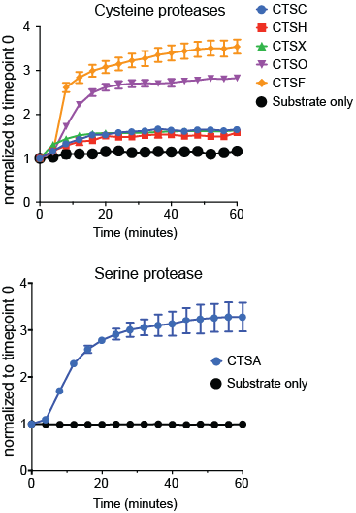

Extended Data Figure 1. Proteases that do not cleave α-syn, TDP-43, or tau are active against a fluorogenic casein substrate. Fluorogenic protease activity assays using casein at pH 4.5 was performed on all enzymes that do not cleave α-syn, TDP-43, or tau. The values obtained were normalized to timepoint t = 0 and plotted relative to activity. All enzymes, including both cysteine and serine proteases, show activity against the optimized fluorogenic peptides compared to the substrate only control.
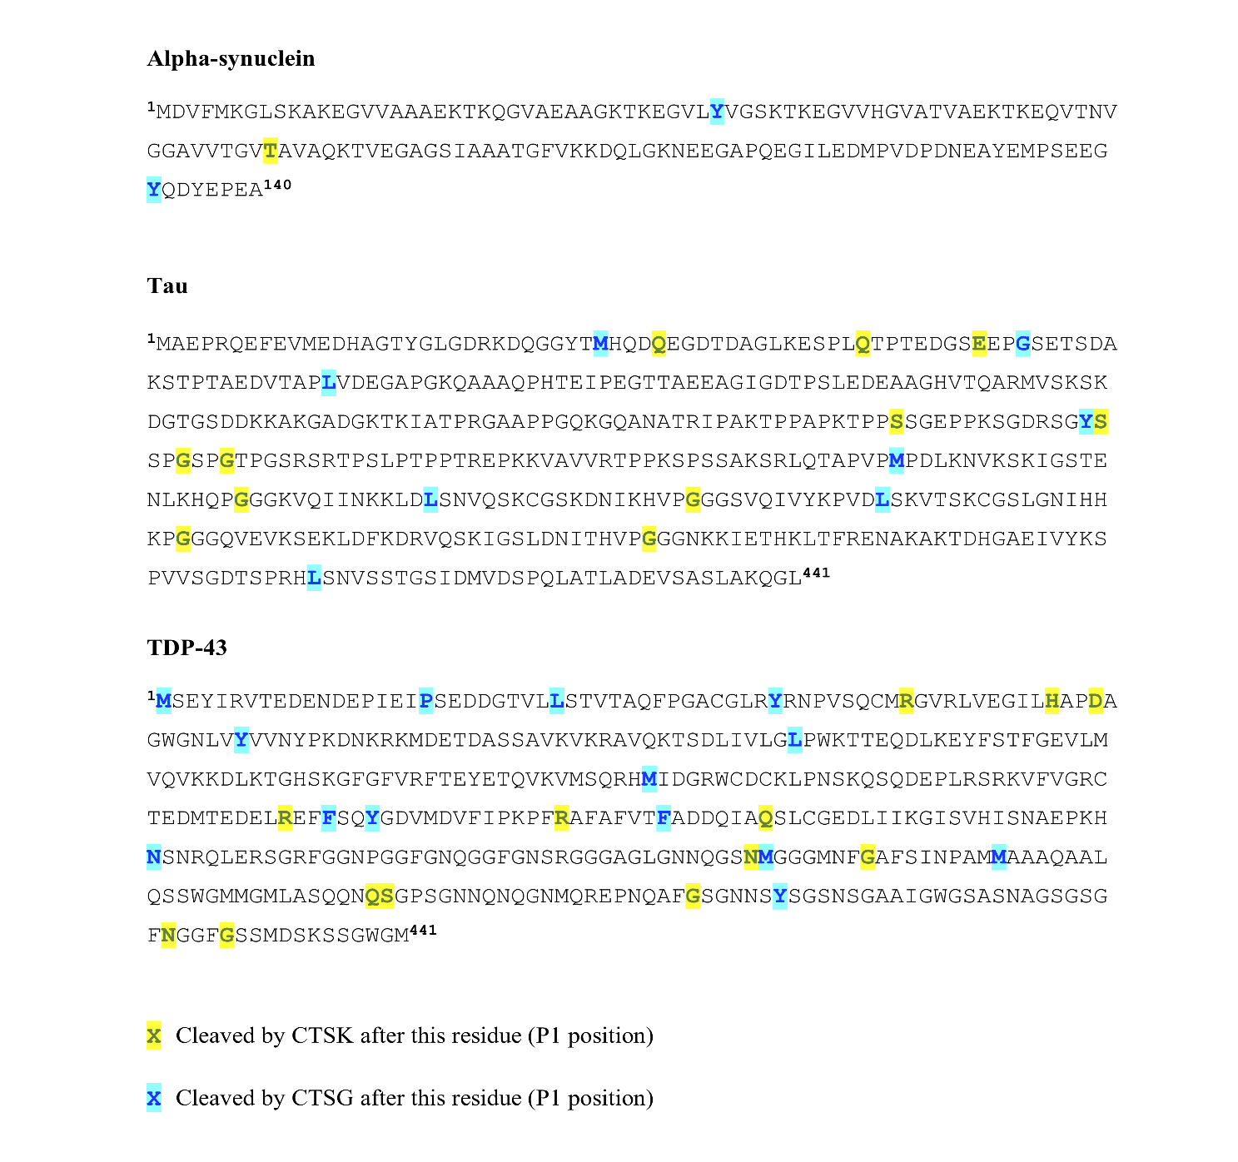

Extended Data Figure 2. PROSPER analysis predicts multiple cathepsin cleavage sites with α-syn, TDP-43, and tau. Cathepsins G (CTSG) and K (CTSK), the lysosomal proteases available in the PROSPER database, demonstrate many sites of cleavage throughout the α-syn, TDP-43, and tau substrates. Yellow highlighted amino acids represent the P1 site of predicted CTSK cleavage. Light blue highlighted amino acids represent the P1 of predicted CTSG cleavage.

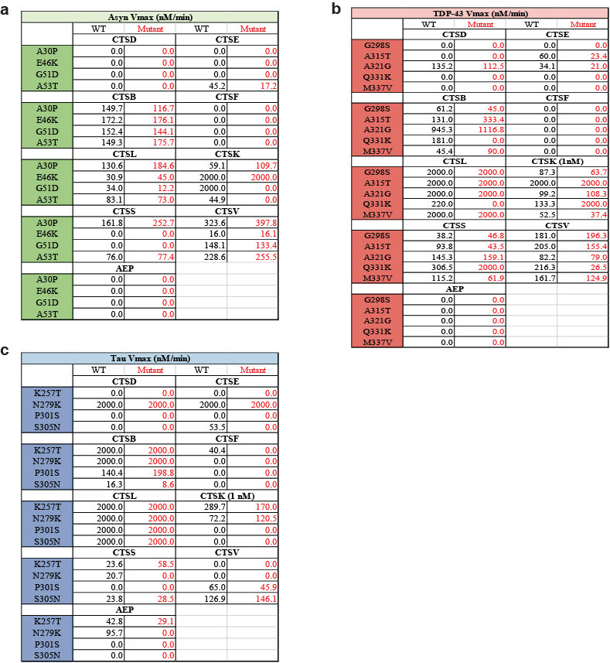
Extended Data Figure 3. Cathepsin activity assay Vmax tables of α-syn, TDP-43, and tau wild type versus mutant substrates. A., α-Syn, B., TDP-43, and C., tau . Vmax values are listed in nM/min. An arbitrary value of 2000 value was given to protease-enzyme substrate interactions that were too fast to be modeled.

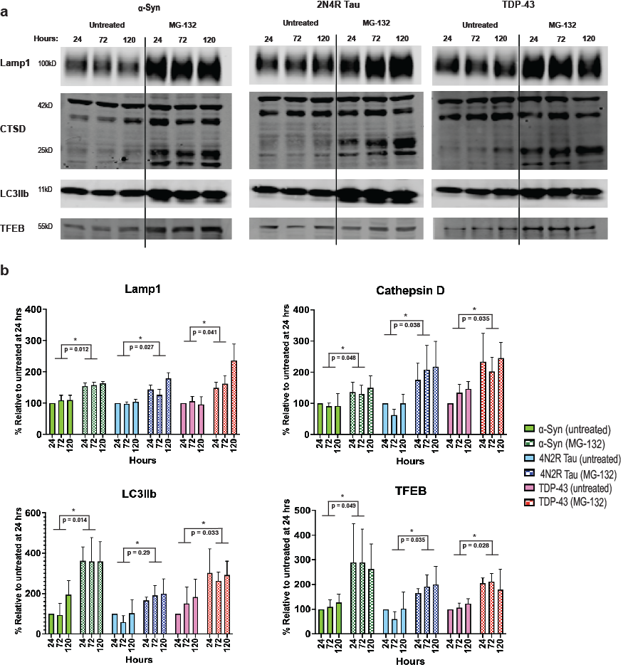
Extended Data Figure 4. Proteasomal inhibitor, MG-132, upregulates markers of autophagy. A., Western blot images demonstrating that Lamp1, cathepsin D (CTSD), LCBIIb, and TFEB are all upregulated after MG-132 treatment at 24, 72, and 120 hours, compared to the no treatment condition. B., Quantification of the results of A. Experiments were performed in triplicate.
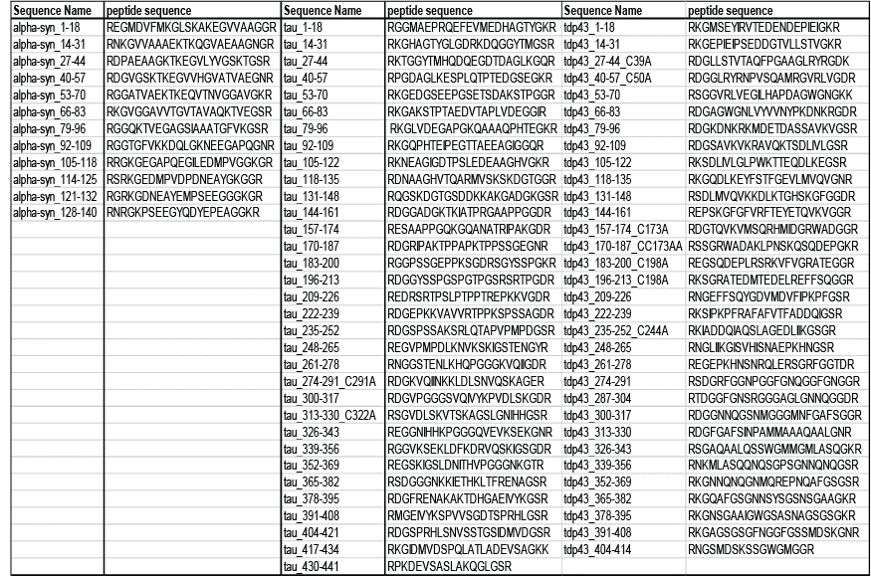

Extended Data Table 1. α-Syn, TDP-43, and tau peptide library. Amino acid sequences for all peptides within the library tested in the described MSP-MS experiments in Figures 2 – 5.

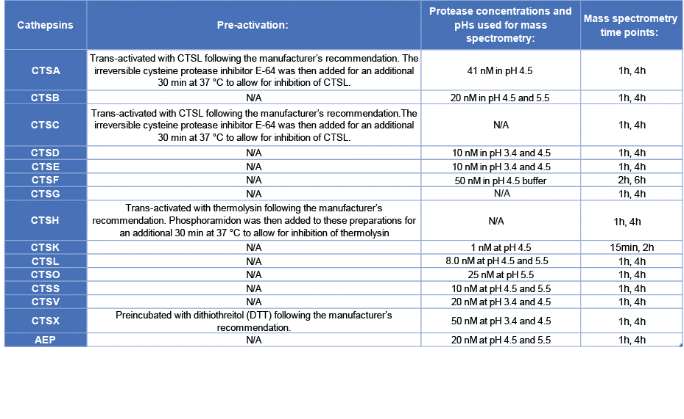

Extended Data Table 2. Pre-activation steps, protease concentrations, tested pHs, and timepoints for in vitro and mass spectrometry experiments. Cathepsin A, C, H, and X required pre-activation for all experiments in Figs. 1-5 and Fig. S1. Protease concentration and mass spectrometry timepoints were chosen and optimized based on the known rate of cleavage for each protease.
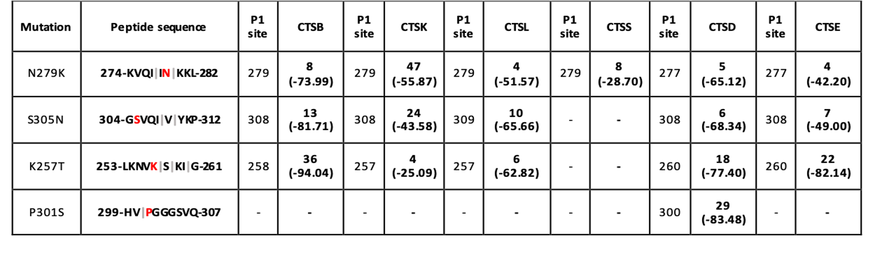
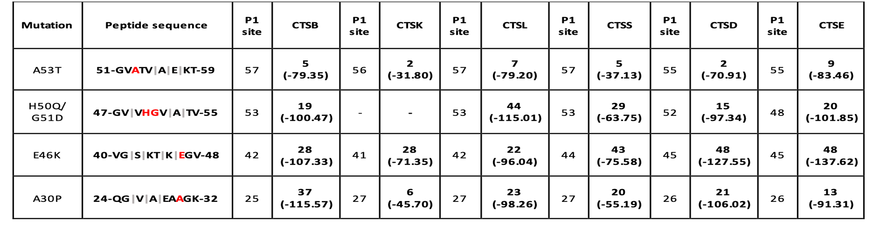
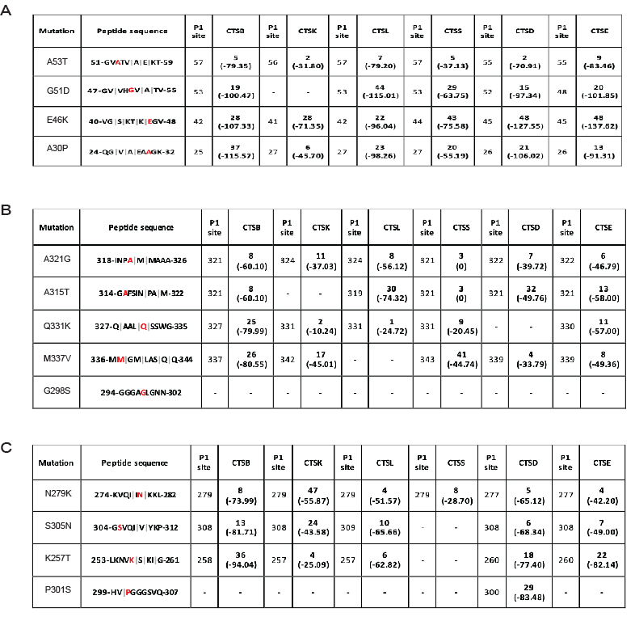
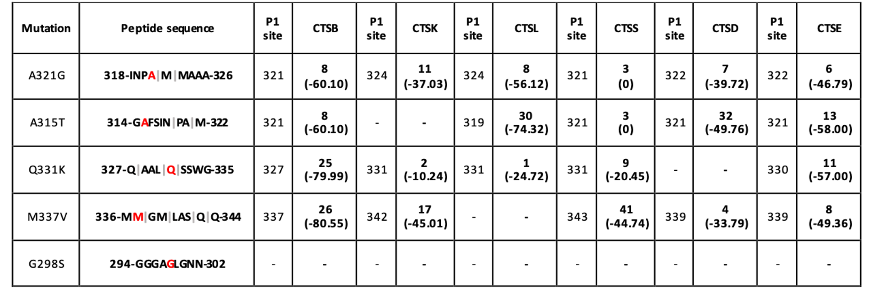

c

b

Tau

TDP-43

a

α-Syn

Extended Data Table 3. WT and mutant α-syn, TDP-43, and tau sequences with high rank order prediction scores of cleavage for select cathepsins. Each mutation and companion wild-type sequences for A, α-Syn; B, TDP-43, and C, tau are represented alongside the rank order prediction scores of PROSPER predicted sites of cleavage for the available cathepsins B, K, L, S, D and E.
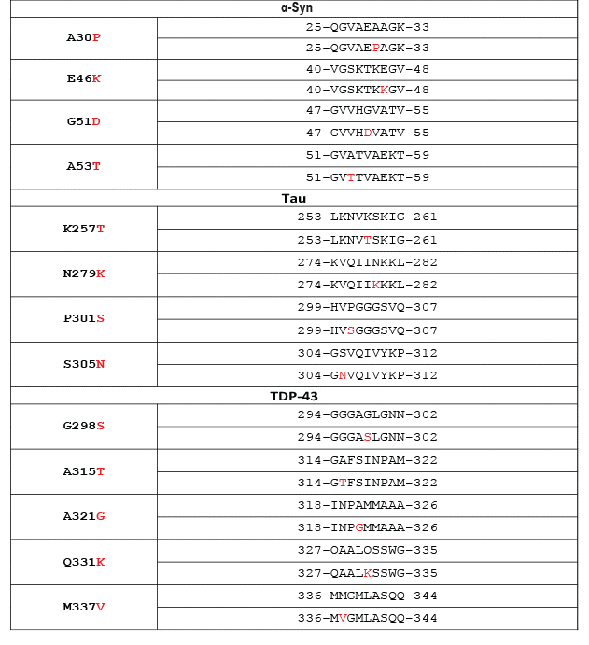

a

b

c

Extended Data Table 4. Fluorogenic peptide sequences for WT and mutant α-syn, TDP-43, and tau. A, α-Syn; B, TDP-43, and C, tau amino acid sequences tested in the described fluorogenic protease activity assays in Figures 2 – 4.

Supplementary Data 1. (separate file)
Spreadsheet file containing all protease cleavage sites (both P1 cleavage site positions and cleavage motifs) observed via the MSP-MS experiments (Fig. 2-4) for all pHs tested.

