A multi-model framework to assess the role of R&D towards a decarbonized energy system

Supplementary Information
The supplementary information provides extra and complementary information regarding the methodology and results of our study. Section A describes and compares the main models taking part in the study (WITCH, MERGE-ETL, GEM-E3 and TIAM-ECN), while section B reports the main quantitative parameters adopted by the models with ITC. Section C shows assumptions regarding technologies and policies and section D shows additional figures detailing the results obtained with TIAM-ECN that complement the discussion carried out in our paper.
- Additional Information to the Methodological Approach
Figure S.1 illustrated the soft-link and the harmonization among the four models considered in this study, as explained in section 2.1 of the paper:
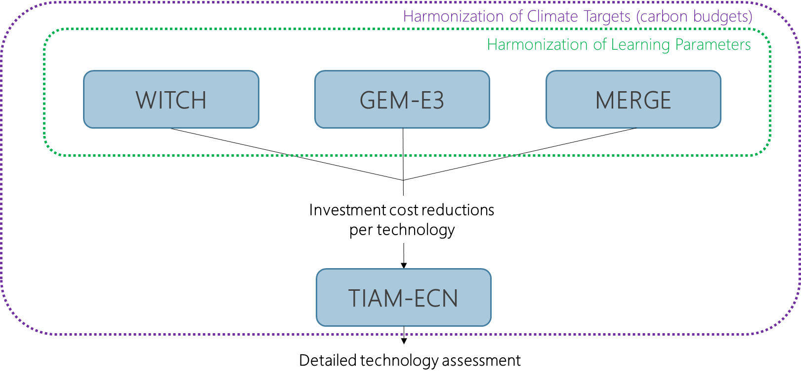
Figure S.1 - Harmonization scheme and soft-link adopted in this study.

A.1. WITCH, MERGE and GEM-E3: IAMs and Endogenous R&D
The three IAMs with ITC employed in this study differ in a number of aspects, such as the regional disaggregation, the temporal resolution, the level of detail in the representation of the different energy and economic sectors, and the technology portfolio (see Table 1). GEM-E3 is a computable general equilibrium (CGE) model with a detailed representation of economy, while MERGE-ETL and WITCH are hybrid models with a single-sector economy description combined with a detailed representation of the energy system. Still, MERGE-ETL and WITCH differ with respect to the representation of energy sectors, especially in the demand side. A commonality between the three IAMs is that they have perfect foresight in their decisions.
All three IAMs endogenously account for ITC based on two-factor learning curves, thus incorporating a set of parameters related to learning effects from experience (or learning-by-doing, LBD) and from R&D (or learning-by-researching, LBR). The two-factor learning curve is a common approach to assess technology learning leading to cost reductions in the energy sector (Rubin et al., 2015; Emmerling et al. 2016, Paroussos et al. 2019, Fragkiadakis 2020, Verdolini et al. 2018). It is based on the cumulative installed capacity (or production) and on the cumulative R&D expenditure, which are reflected on the LBD and LBR rates, respectively (Rubin et al., 2015; Söderholm and Sundqvist, 2007; Kouvaritakis et al. 2000, van der Zwaan and Seebregts, 2004). Some IAMs also include other parameters related to R&D: WITCH and GEM-E3 integrate regional specific knowledge spill-over assumptions to depict the dependence of a region to innovate based on knowledge created elsewhere (Emmerling et al. 2016, Fragkiadakis et al 2019 and 2020). GEM-E3 is also able to include the capacity of a region to absorb knowledge depending on its human capital (Fragkiadakis et al., 2019). In MERGE-ETL and GEM-E3, R&D in one technology may benefit other technologies through direct improvements in common components and methods or through technological spill-overs (see Fragkiadakis et al., 2019; Marcucci, 2014). Because of the ITC feature in these IAMs, the effect of R&D assumptions can be observed in the resulting capital costs of energy technologies. Therefore, we make this the main link between these three models and TIAM-ECN. Because of their intrinsic differences, the three IAMs with ITC will respond differently to the R&D and climate policy assumptions that define our scenarios, thus producing distinct trajectories for the evolution of capital costs of the technologies assessed in this paper.
For further details on the three IAMs with ITC used in this study, we refer the reader to the model documentation of WITCH (Emmerling et al., 2016), MERGE-ETL (Marcucci and Turton, 2015; Marcucci, 2014) and GEM-E3 (Capros et al., 2017).
A.2. TIAM-ECN: Bottom-up IAM and Technology Diffusion
TIAM-ECN (operated by the Energy Transition Unit of TNO) is based on the ETSAP-TIAM, a global energy system cost-optimization model built upon the TIMES model generator (see Loulou and Labriet, 2008; Loulou, 2008; Syri et al., 2008). It minimizes discounted global energy system’s cost based on a partial equilibrium in order to meet end-use service demands subject to a diverse set of constraints. Energy flows and energy conversion technologies are linked from resource level to final use, hence encompassing all main economic sectors, namely: fossil fuels extraction, power and heat supply, industry, transport, built environment and agriculture. Direct links between energy, economy and environment are thus explicitly represented in the model.
One remarkable feature of TIAM-ECN is its technology richness and high regional disaggregation – it spans more than a thousand technologies across 36 geographical regions. This has allowed us answering a diverse set of research questions related to the energy transition at regional and national levels (see, for instance, [references removed]). Technology cost assumptions are usually exogenously defined and, in this study, it is the key variable we use to investigate how combining R&D policies with CO₂ mitigation targets can affect the long-term technology mix.
TIAM-ECN includes exogenous demand projections for different energy end-uses in all economic sectors and regions. These energy service demand projections are fully aligned with SSP2 socio-economic assumptions (Riahi et al., 2017), which are also adopted as reference by the other three models. Moreover, TIAM-ECN accounts for price elasticity of demand, which partially incorporates the impacts of policies on end-use energy consumption.
The table below provides a structured comparison of all models used in this study in order to summarize their main differences and similarities:

Table S.1 – Basic characteristics of the models used in this study.
Model Characteristics | TIAM-ECN | WITCH | MERGE | GEM-E3
Model Framework | Energy System (Bottom-Up) | Top-down, bottom up (Hybrid) | Top-down, bottom-up (Hybrid) | Hybrid CGE
Number of Technologies | 1200 | 28 | 30 | 51
Number of Regions | 36 | 18 | 10 | 19* (46 if EU28 is disaggregated)
Time Horizon (years) | 120 | 150 | 120 | 45
Time-Step (years) | 10 | 5 | 10 | 5
Technological Learning | Exogenous | Endogenous | Endogenous | Endogenous
*In this study, EU28 is considered one single region. The number of regions can reach 46 if EI28 is disaggregated.

- R&D Parameters
Table S.2 - Learning parameters harmonized in WITCH, MERGE-ETL and GEM-E3
Sector | Learning by doing |  |  | learning by research rates |  |  | Time from investment to cost reduction | Knowledge depreciation rate | Knowledge depreciation rate
 | 2015-2030 | 2030-2050 | 2050-2100 | 2015-2030 | 2030-2050 | 2050-2100
Advanced biofuels | 0.08 | 0.04 | 0.02 | 0.13 | 0.13 | 0.13 | 5 | 0.05 | 0.05
CCS | 0.05 | 0.05 | 0.05 | 0.03 | 0.03 | 0.03 | 5 | 0.05 | 0.05
DACC | 0.15 | 0.15 | 0.08 |  |  |  | 5 | 0.05 | 0.05
Wind onshore | 0.059 | 0.059 | 0.03 | 0.17 | 0.17 | 0.17 | 5 | 0.05 | 0.05
Wind offshore | 0.103 | 0.05 | 0.03 | 0.17 | 0.17 | 0.17 | 5 | 0.05 | 0.05
Solar PV | 0.18 | 0.18 | 0.09 | 0.12 | 0.12 | 0.12 | 5 | 0.05 | 0.05
Battery | 0.20 | 0.15 | 0.08 | 0.27 | 0.27 | 0.27 | 5 | 0.05 | 0.05

Table S.3 - Floor costs harmonized in WITCH, MERGE-ETL and GEM-E3. Regionalization based on WITCH model. (Note: bra – Brazil; can – Canada; chi – China; eu – Europe; ind – India; indn – Indonesia; jpnkor – Japan and South Korea; laca - Latin America and Caribbean; mena – Middle East and North Africa; mex – Mexico; oce – oceania; sasia – South Asia; seasia – Southeast Asia ; sa – South Africa; ssa – Subsaharan Africa; te - Non-EU Eastern European countries, including Russia; usa – United States of America)
Floor costs [T$2005/TW] | bra | can | chi | eu | ind | indn | jpnkor | laca | mena | mex | oce | sasia | seasia | sa | ssa | te | usa
Advanced biofuels
Power plant | Coal | CCS | Standard | 1.51 | 2.07 | 0.97 | 1.46 | 1.00 | 0.98 | 1.95 | 1.51 | 2.07 | 1.51 | 1.26 | 1.00 | 0.98 | 1.16 | 2.07 | 1.44 | 1.44
Power plant | Coal | CCS | Oxy-fuel | 1.51 | 2.07 | 0.97 | 1.46 | 1.00 | 0.98 | 1.95 | 1.51 | 2.07 | 1.51 | 1.26 | 1.00 | 0.98 | 1.16 | 2.07 | 1.44 | 1.44
Power plant | Coal | CCS | Integrated gasification combined cycle | 1.51 | 2.07 | 0.97 | 1.46 | 1.00 | 0.98 | 1.95 | 1.51 | 2.07 | 1.51 | 1.26 | 1.00 | 0.98 | 1.16 | 2.07 | 1.44 | 1.44
Power plant | Gas | CCS | 0.98 | 1.05 | 0.74 | 0.75 | 0.74 | 0.74 | 0.99 | 0.98 | 1.05 | 0.98 | 0.68 | 0.74 | 0.74 | 0.63 | 1.05 | 0.73 | 0.66
Power plant | Biomass | CCS | Integrated gasification combined cycle | 2.00 | 2.50 | 1.60 | 2.00 | 1.60 | 1.60 | 2.43 | 2.00 | 2.50 | 2.00 | 2.05 | 1.60 | 1.60 | 2.00 | 2.50 | 2.00 | 2.00
Wind onshore | 0.50 | 0.50 | 0.50 | 0.50 | 0.50 | 0.50 | 0.50 | 0.50 | 0.50 | 0.50 | 0.50 | 0.50 | 0.50 | 0.50 | 0.50 | 0.50 | 0.50
Wind offshore | 0.90 | 0.90 | 0.90 | 0.90 | 0.90 | 0.90 | 0.90 | 0.90 | 0.90 | 0.90 | 0.90 | 0.90 | 0.90 | 0.90 | 0.90 | 0.90 | 0.90
Solar PV | 0.40 | 0.40 | 0.40 | 0.40 | 0.40 | 0.40 | 0.40 | 0.40 | 0.40 | 0.40 | 0.40 | 0.40 | 0.40 | 0.40 | 0.40 | 0.40 | 0.40
Solar CSP | 1.50 | 1.50 | 1.50 | 1.50 | 1.50 | 1.50 | 1.50 | 1.50 | 1.50 | 1.50 | 1.50 | 1.50 | 1.50 | 1.50 | 1.50 | 1.50 | 1.50
Battery
Energy efficiency
Direct Air capture | 0.06 | 0.06 | 0.06 | 0.06 | 0.06 | 0.06 | 0.06 | 0.06 | 0.06 | 0.06 | 0.06 | 0.06 | 0.06 | 0.06 | 0.06 | 0.06 | 0.06

Table S.4 – Initial Knowledge Stock harmonized in WITCH, MERGE-ETL and GEM-E3. Regionalization based on WITCH model. (Note: bra – Brazil; can – Canada; chi – China; eu – Europe; ind – India; indn – Indonesia; jpnkor – Japan and South Korea; laca - Latin America and Caribbean; mena – Middle East and North Africa; mex – Mexico; oce – oceania; sasia – South Asia; seasia – Southeast Asia ; sa – South Africa; ssa – Subsaharan Africa; te - Non-EU Eastern European countries, including Russia; usa – United States of America)
Initial knowledge stock [G$] | bra | can | chi | eu | ind | indn | jpnkor | laca | mena | mex | oce | sasia | seasia | sa | ssa | te | usa
Advanced biofuels | 0,5 | 0,5 | 0,5 | 0,5 | 0,5 | 0,5 | 0,5 | 0,5 | 0,5 | 0,5 | 0,5 | 0,5 | 0,5 | 0,5 | 0,5 | 0,5 | 0,5
Power plant | Coal | CCS | Standard | 0 | 0,8 | 0 | 0,9 | 0 | 0 | 0,4 | 0 | 0 | 0 | 0,3 | 0 | 0 | 0 | 0 | 0 | 1
Power plant | Coal | CCS | Oxy-fuel | 0 | 0,8 | 0 | 0,9 | 0 | 0 | 0,4 | 0 | 0 | 0 | 0,3 | 0 | 0 | 0 | 0 | 0 | 1
Power plant | Coal | CCS | Integrated gasification combined cycle | 0 | 0,8 | 0 | 0,9 | 0 | 0 | 0,4 | 0 | 0 | 0 | 0,3 | 0 | 0 | 0 | 0 | 0 | 1
Power plant | Gas | CCS | 0 | 0,8 | 0 | 0,9 | 0 | 0 | 0,4 | 0 | 0 | 0 | 0,3 | 0 | 0 | 0 | 0 | 0 | 1
Power plant | Biomass | CCS | Integrated gasification combined cycle | 0 | 0,8 | 0 | 0,9 | 0 | 0 | 0,4 | 0 | 0 | 0 | 0,3 | 0 | 0 | 0 | 0 | 0 | 1
Wind onshore
Wind offshore
Solar PV
Solar CSP
Battery | 0,1 | 0,1 | 0,1 | 0,1 | 0,1 | 0,1 | 0,1 | 0,1 | 0,1 | 0,1 | 0,1 | 0,1 | 0,1 | 0,1 | 0,1 | 0,1 | 0,1
Energy efficiency | 0,8 | 6,0 | 2,2 | 35,2 | 0,8 | 0,3 | 24,2 | 0,8 | 1,0 | 0,4 | 2,6 | 0,0 | 0,3 | 0,7 | 0,0 | 1,3 | 41,5
Direct Air capture

- Technology and Policy Assumptions
Table S.5 - Technology portfolio to which investment cost reductions were applied
Technology description | WITCH | MERGE-ETL | GEM-E3 | TIAM-ECN
Hydrogen from gas steam reforming | Advanced Biofuels | gas-H2 | - | HNGA105
Hydrogen from gas steam reforming | Advanced Biofuels | gas-H2 | - | HNGAD105
Hydrogen from gas steam reforming with CCS | Advanced Biofuels | gas-a-H2 | CCSequipmn | HZNGA120
Coal Fischer Tropsch | Advanced Biofuels | coal-FT | - | UFTSYNCOA
Coal Fischer Tropsch with CCS | Advanced Biofuels | coal-a-FT | CCSequipmn | UFTSYNCOACCS
Hydrogen from coal gasification | Advanced Biofuels | coal-H2 | - | HHCO105
Hydrogen from coal gasification | Advanced Biofuels | coal-H2 | - | HBCO105
Hydrogen from coal gasification with CCS | Advanced Biofuels | coal-a-H2 | CCSequipmn | HZHCO120
Hydrogen from coal gasification with CCS | Advanced Biofuels | coal-a-H2 | CCSequipmn | HZBCO120
Biomass Fischer Tropsch | Advanced Biofuels | bio-FT | AdvBiofuels | UFTDBIOSLD110
Biomass Fischer Tropsch with CCS | Advanced Biofuels | bio-a-FT | AdvBiofuels | UZFTDBIOSLD110
Hydrogen from biomass gasification | Advanced Biofuels | bio-H2 | AdvBiofuels | HBIO105
Hydrogen from biomass gasification with CCS | Advanced Biofuels | bio-a-H2 | AdvBiofuels | HZBIO120
Hydrogen from solar thermal | Advanced Biofuels | sth-H2 | - | HLYS120
High pressure electrolysis | Advanced Biofuels | hpe-H2 | - | HLYSI05
High pressure electrolysis | Advanced Biofuels | hpe-H2 | - | HLYSDI05
Electric car | Battery | - | EVehiclesEq | TRCELC010
Gasoline plug-in hybrid car | Electric Vehicles | - | EVehiclesEq | TRCGASPHY010
Diesel plug-in hybrid car | Electric Vehicles | - | EVehiclesEq | TRCDSTPHY010
Electric truck for freight transport | Electric Vehicles Freight | - | EVehiclesEq | TRTELC005
Biomass thermal with CCS | Power plant | Biomass | CCS | Integrated gasification combined cycle | bio-a | CCSequipmn | EZBIOSLD120
Biomass thermal with CCS | Power plant | Biomass | CCS | Integrated gasification combined cycle | bio-a | CCSequipmn | EZBIOSLD130
Biomass thermal with CCS | Power plant | Biomass | CCS | Integrated gasification combined cycle | bio-a | CCSequipmn | EZBIOSLD150
Integrated coal gasification with CCS | Power plant | Coal | CCS | Integrated gasification combined cycle | igcc-a | CCSequipmn | EZIGC1110
Integrated coal gasification with CCS | Power plant | Coal | CCS | Integrated gasification combined cycle | igcc-a | CCSequipmn | EZIGC1120
Integrated coal gasification with CCS | Power plant | Coal | CCS | Integrated gasification combined cycle | igcc-a | CCSequipmn | EZIGC1130
Integrated coal gasification with CCS | Power plant | Coal | CCS | Integrated gasification combined cycle | igcc-a | CCSequipmn | EZIGC925
concentrated solar power | Solar CSP | - | - | ESOTH105
concentrated solar power | Solar CSP | - | - | ESOTHS205
concentrated solar power | Solar CSP | - | - | ESOTHS305
concentrated solar power | Solar CSP | - | - | ESOTHS305
Gas turbine combined cycle with CCS | Power plant | Gas | CCS | ngcc-a | CCSequipmn | EZCCGT110
Gas turbine combined cycle with CCS | Power plant | Gas | CCS | ngcc-a | CCSequipmn | EZCCGT120
Gas turbine combined cycle with CCS | Power plant | Gas | CCS | ngcc-a | CCSequipmn | EZCCGT130
Gas turbine combined cycle with CCS | Power plant | Gas | CCS | ngcc-a | CCSequipmn | EZCCGO110
Gas turbine combined cycle with CCS | Power plant | Gas | CCS | ngcc-a | CCSequipmn | EZCCGO120
Gas turbine combined cycle with CCS | Power plant | Gas | CCS | ngcc-a | CCSequipmn | EZCCGO130
Gas turbine combined cycle with CCS | Power plant | Gas | CCS | ngcc-a | CCSequipmn | EZSOFGAS35
Coal supercritical with CCS | Power plant | Coal | CCS | Standard | pc-a | CCSequipmn | EZPCOA110
Coal supercritical with CCS | Power plant | Coal | CCS | Standard | pc-a | CCSequipmn | EZPCOA120
Coal supercritical with CCS | Power plant | Coal | CCS | Standard | pc-a | CCSequipmn | EZPCOA130
Coal supercritical with CCS | Power plant | Coal | CCS | Standard | pc-a | CCSequipmn | EZSOFCOA35
Coal supercritical with CCS | Power plant | Coal | CCS | Oxy-fuel | pc-a | CCSequipmn | EZOCOA110
Coal supercritical with CCS | Power plant | Coal | CCS | Oxy-fuel | pc-a | CCSequipmn | EZOCOA120
Coal supercritical with CCS | Power plant | Coal | CCS | Oxy-fuel | pc-a | CCSequipmn | EZOCOA130
Solar PV | Solar PV | spv | PVpanels | ESOPV0105
Solar PV | Solar PV | spv | PVpanels | ESOPV105
Solar PV | Solar PV | spv | PVpanels | ESOPV1105
Solar PV | Solar PV | spv | PVpanels | ESOPV2105
Solar PV | Solar PV | spv | PVpanels | ESOPV3105
Solar PV | Solar PV | spv | PVpanels | ESOPV4105
Solar PV | Solar PV | spv | PVpanels | ESOPV5105
Solar PV | Solar PV | spv | PVpanels | ESOPVD0105
Solar PV | Solar PV | spv | PVpanels | ESOPVD105
Solar PV | Solar PV | spv | PVpanels | ESOPVD1105
Solar PV | Solar PV | spv | PVpanels | ESOPVD2105
Solar PV | Solar PV | spv | PVpanels | ESOPVD3105
Solar PV | Solar PV | spv | PVpanels | ESOPVD4105
Solar PV | Solar PV | spv | PVpanels | ESOPVD5105
Solar PV | Solar PV | spv | PVpanels | ESOPVDMG105
Solar PV | Solar PV | spv | PVpanels | ESOPVDSA105
Wind turbine | Wind offshore | wnd | WindTurb | EWIND205
Wind turbine | Wind onshore | wnd | WindTurb | EWIND105
Wind turbine | Wind onshore | wnd | WindTurb | EWIND305
Wind turbine | Wind onshore | wnd | WindTurb | EWINDDMG105
Wind turbine | Wind onshore | wnd | WindTurb | EWINDDMG105
Ethanol production from bio solids | Advanced Biofuels | - | AdvBiofuels | UETHBIOSLD110
Electric bus | Electric Vehicles | - | EVehiclesEq | TRBELC005
Electric small vehicle | Electric Vehicles | - | EVehiclesEq | TRSVELC010

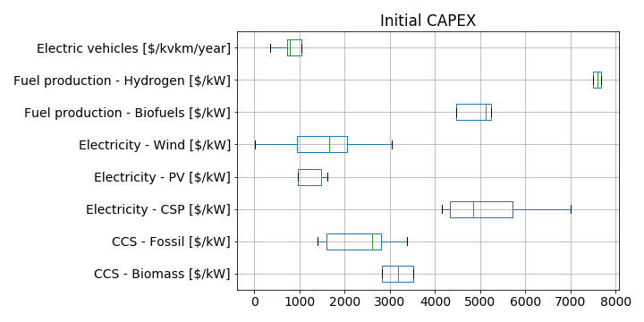
Figure S.2 – Initial Investment Cost (reference year: 2020) range in TIAM-ECN technologies per technology group.

Table S.6 – Prices applied to non-CO₂ greenhouse gases per scenario in TIAM-ECN, in US$/tCO_{2eq}
Year | REF | CB1460 | CB710
2020 | 0 | 0 | 0
2030 | 0 | 0 | 200
2040 | 0 | 27 | 200
2050 | 0 | 55 | 200
2060 | 0 | 200 | 200
2070 | 0 | 200 | 200
2080 | 0 | 200 | 200
2090 | 0 | 200 | 200
2100 | 0 | 200 | 200

- Results
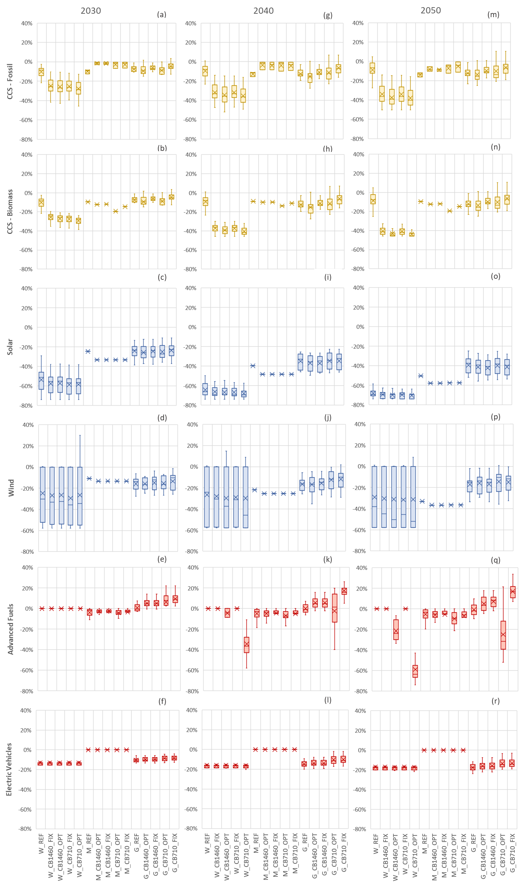
Figure S.3 – Relative Capital cost reductions w.r.t. 2020 for all scenarios

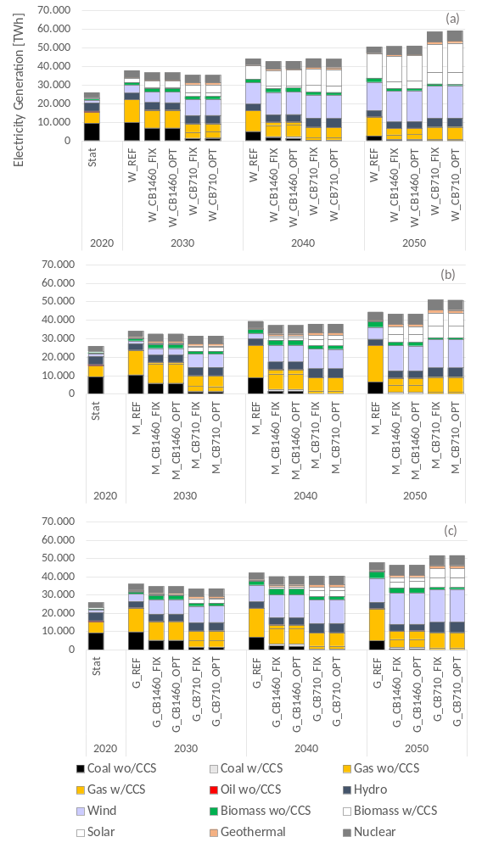
Figure S.4 – Initial Investment Cost (reference year: 2020) range in TIAM-ECN technologies per technology group.
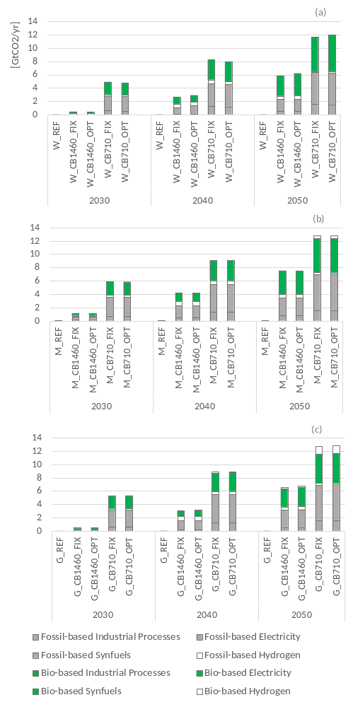
Figure S.5 – Uptake of CCS technologies, GtCO₂/yr.

Supplementary Material References
Capros P., Van Regemorter D., Paroussos L., Karkatsoulis P., 2017. GEM-E3 Model Manual. E3M Lab, Institute of Communications and Computers Systems, National Technical University of Athens. Available at: http://www.e3mlab.eu/e3mlab/GEM%20-%20E3%20Manual/GEM-E3_manual_2017.pdf. (Accessed: 11 March 2022).
Emmerling, J., Drouet, L., Reis, L.A., Bevione, M., Berger, L., Bosetti, V., Carrara, S., Cian, E.D., D’Aertrycke, G.D.M., Longden, T., Malpede, M., Marangoni, G., Sferra, F., Tavoni, M., Witajewski-Baltvilks, J., Havlik, P.: The WITCH 2016 Model - Documentation and Implementation of the Shared Socioeconomic Pathways. Working Paper 2016.42, Fondazione Eni Enrico Mattei (2016), https://ideas.repec.org/p/fem/femwpa/2016.42.html
Fragkiadakis, K., Paroussos, L., Capros, P. (2019). D4.3.2: Technical description of the R&D module of GEM-E3-RD model, Public deliverable of MONROE H2020 project.
Fragkiadakis, Kostas, Panagiotis Fragkos, and Leonidas Paroussos. 2020. "Low-Carbon R&D Can Boost EU Growth and Competitiveness" Energies 13, no. 19: 5236. https://doi.org/10.3390/en13195236
Kouvaritakis, N., Soria, A., Isoard, S., 2000. Modelling energy technology dynamics: methodology for adaptive expectations models with learning by doing and learning by searching. International Journal of Global Energy Issues, 14, 1-4. 10.1504/IJGEI.2000.004384
Loulou, R. (2008) ‘ETSAP-TIAM: The TIMES integrated assessment model. Part II: Mathematical formulation’, Computational Management Science, 5(1–2), pp. 41–66. doi: 10.1007/s10287-007-0045-0.
Loulou, R. and Labriet, M. (2008) ‘ETSAP-TIAM: The TIMES integrated assessment model Part I: Model structure’, Computational Management Science, 5(1–2), pp. 7–40. doi: 10.1007/s10287-007-0046-z.
Marcucci, A., Turton, H., 2015. Induced technological change in moderate and fragmented climate change mitigation regimes. Technological Forecasting and Social Change, 90(A), 230-242, doi: https://doi.org/10.1016/j.techfore.2013.10.027.
Marcucci, A., 2014. The MERGE-ETL model: 2014 Assumptions and Model Calibration. Available at: https://www.psi.ch/sites/default/files/import/eem/ModelsEN/2014MergeCalibration.pdf (Accessed: 27 January 2021)
Paroussos, L., Mandel, A., Fragkiadakis, K. et al., 2019. Climate clubs and the macro-economic benefits of international cooperation on climate policy. Nature Climate Change, 9, 542–546. https://doi.org/10.1038/s41558-019-0501-1
Riahi, K., van Vuuren, D., Kriegler, E., et al., 2017. The Shared Socioeconomic Pathways and their energy, land use, and greenhouse gas emissions implications: An overview, Global Environmental Change, 42, 153-168, doi: https://doi.org/10.1016/j.gloenvcha.2016.05.009
Rubin, E., S., Azevedo, I. M. L., Jaramillo, P., Yeh, S., 2015. A review of learning rates for electricity supply technologies. Energy Policy, 86, pp. 198-218. https://doi.org/10.1016/j.enpol.2015.06.011
Söderholm, P., Sundqvist, T., 2007. Empirical challenges in the use of learning curves for assessing the economic prospects of renewable energy technologies. Renewable Energy 32(15), pp. 2559-257. https://doi.org/10.1016/j.renene.2006.12.007
Syri, S. et al. (2008) ‘Global energy and emissions scenarios for effective climate change mitigation—Deterministic and stochastic scenarios with the TIAM model’, International Journal of Greenhouse Gas Control. Elsevier, 2(2), pp. 274–285. doi: 10.1016/J.IJGGC.2008.01.001.
van der Zwaan, B., Seebregts, A., 2004. Endogenous learning in climate-energy-economic models – an inventory of key uncertainties. Int. J. Energy Technology and Policy, Vol. 2, Nos. 1/2, 2004. DOI: 10.1504/IJETP.2004.004591
Verdolini, E., Anadón, L.D., Baker, E., Bosetti, V., Reis, L.A., 2018. Future prospects for energy technologies: Insights from expert elicitations. Review of Environmental Economics and Policy 12 (1), 133–153. https://doi.org/10.1093/reep/rex028

