Supplementary file
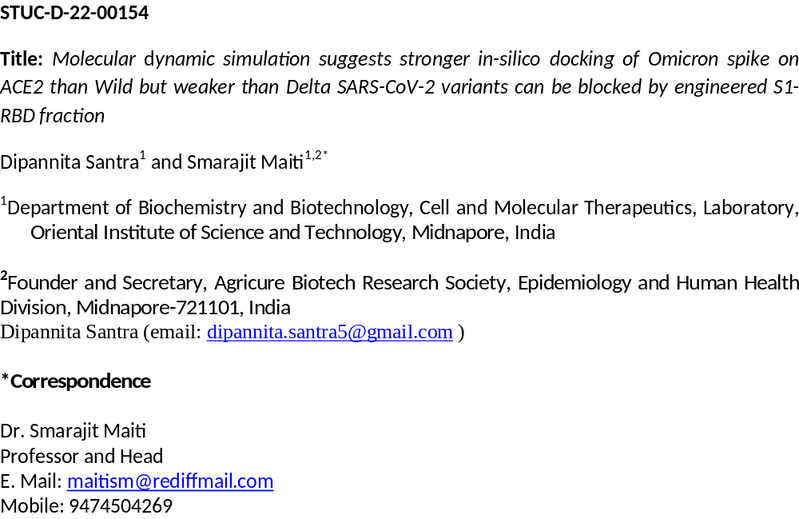

Table S1: HADDOCK competitive binding parameters of different SARS-CoV-2 variants; wild (Wuhan), Delta and Omicron spikes with human ACE2
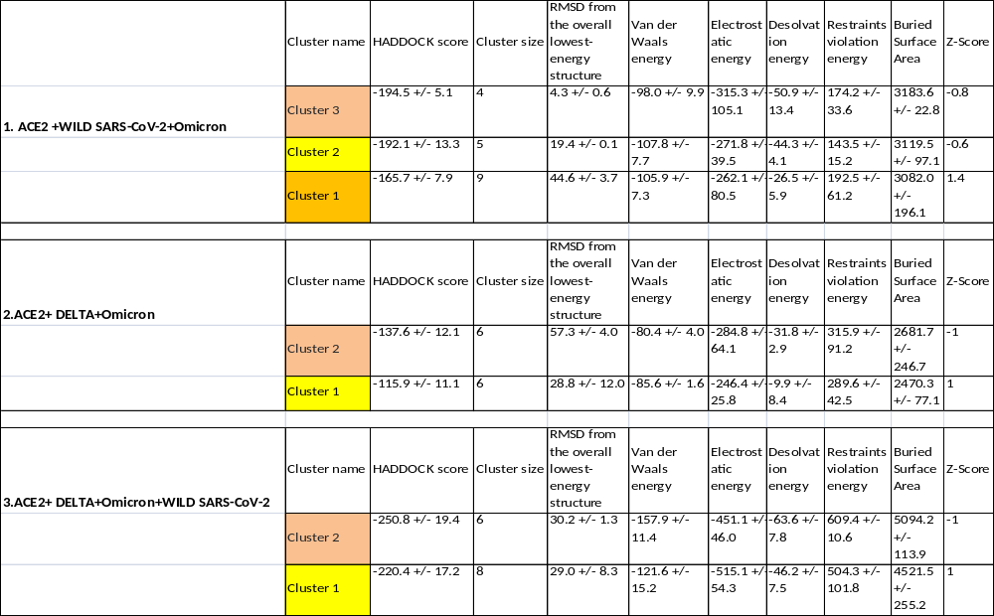

Table S2: Data of HADDOCK competitive binding and blocking of human ACE2 binding by the Wild SARS-CoV-2 spike RBD fraction of 59 amino acid and its different mutants i.e. TYR500SER, TYR500ALA, TYR500GLY, TYR500CYS,
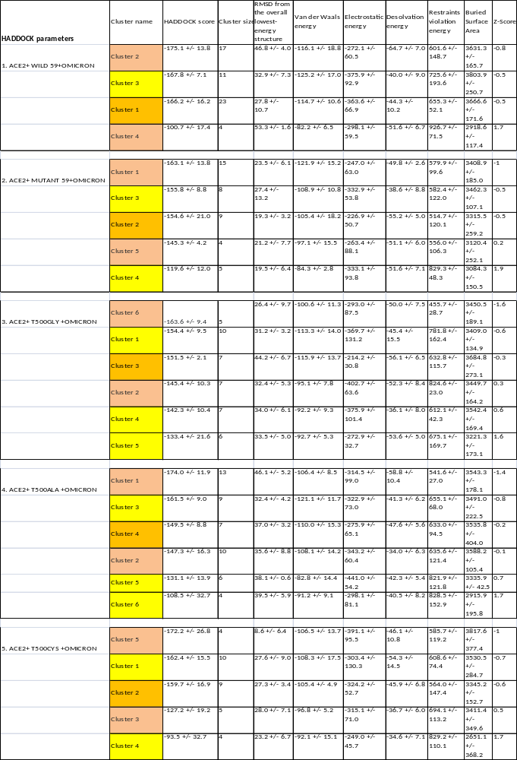
Table S2: Binding parameters i.e. affinities, dissociation constant and different week interactive forces of different SARS-CoV-2 variants; wild (Wuhan), Delta and Omicron spikes with human ACE2
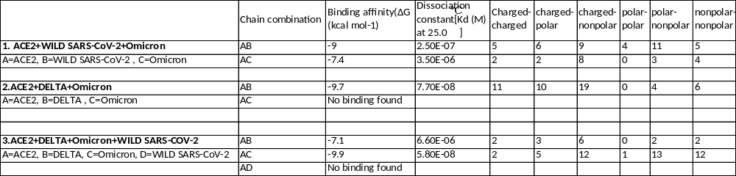
Competitive binding and blocking parameters i.e. affinities, dissociation constant and different week interactive forces of human ACE2 binding by the Wild SARS-CoV-2 spike RBD fraction of 59 amino acid and its different mutants i.e. TYR500SER, TYR500ALA, TYR500GLY, TYR500CYS. 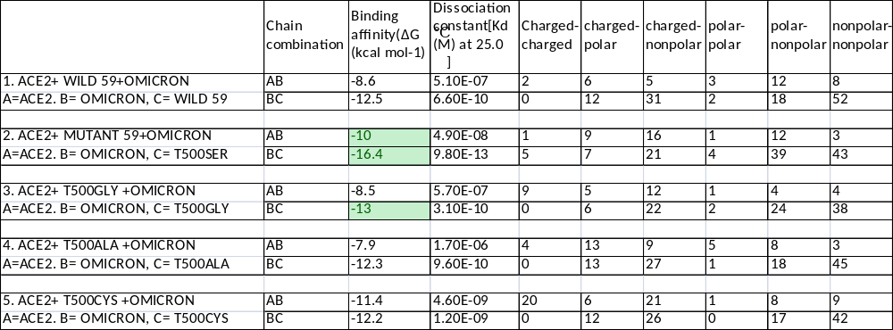

Table S3: H-bonding patterns and bond length during different competitive binding of SARS-CoV-2 variants; wild (Wuhan), Delta and Omicron spikes with human ACE2
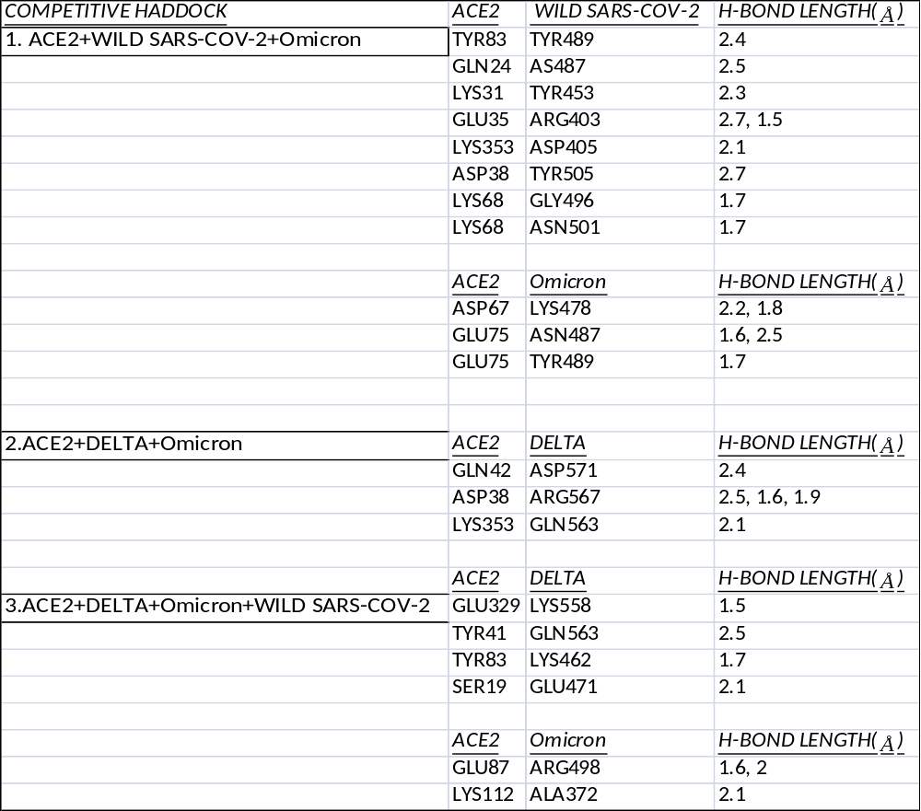

Ramachandran Plot data on different Competitive binding of SARS-CoV-2 variants; wild (Wuhan), Delta and Omicron spikes with human ACE2 and binding/ blocking of human ACE2 binding by the Wild SARS-CoV-2 spike RBD fraction of 59 amino acid and its different mutants i.e. TYR500SER, TYR500ALA, TYR500GLY, TYR500CYS
Spike proteins/ACE2 | RC Plot | Highly Preferred  GREEN (%) | Preferred  BROWN (%) | Questionable  RED (%)
SARS-COV2 (7CWN) | 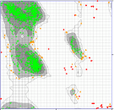 | 94.567 | 3.76 | 1.67
DELTA (7KRQ) | 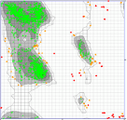 | 94.56 | 3.76 | 1.67
Omicron | 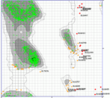 | 94.40 | 4.08 | 1.51
ACE2 +WILD SARS CoV- 2+Omicron | 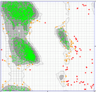 | 93.40 | 4.20 | 2.39
ACE2+DELTA+ Omicron | 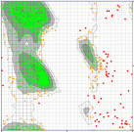 | 93.23 | 4.34 | 2.43
ACE2+ DELTA+ Omicron+WILD SARS-COV-2 | 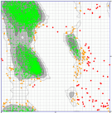 | 93.36 | 4.26 | 2.38
Wild59Cut | 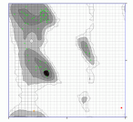 | 96.49 | 1.75 | 1.75
Mutant59T500S | 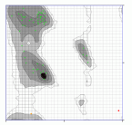 | 96.49 | 1.75 | 1.75
ACE2+WILD59Cut+ Omicron | 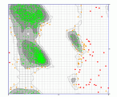 | 93.55 | 4.33 | 2.110
ACE2+ 59CutT500S+ Omicron | 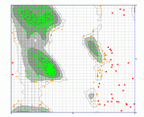 | 93.72 | 4.10 | 2.16

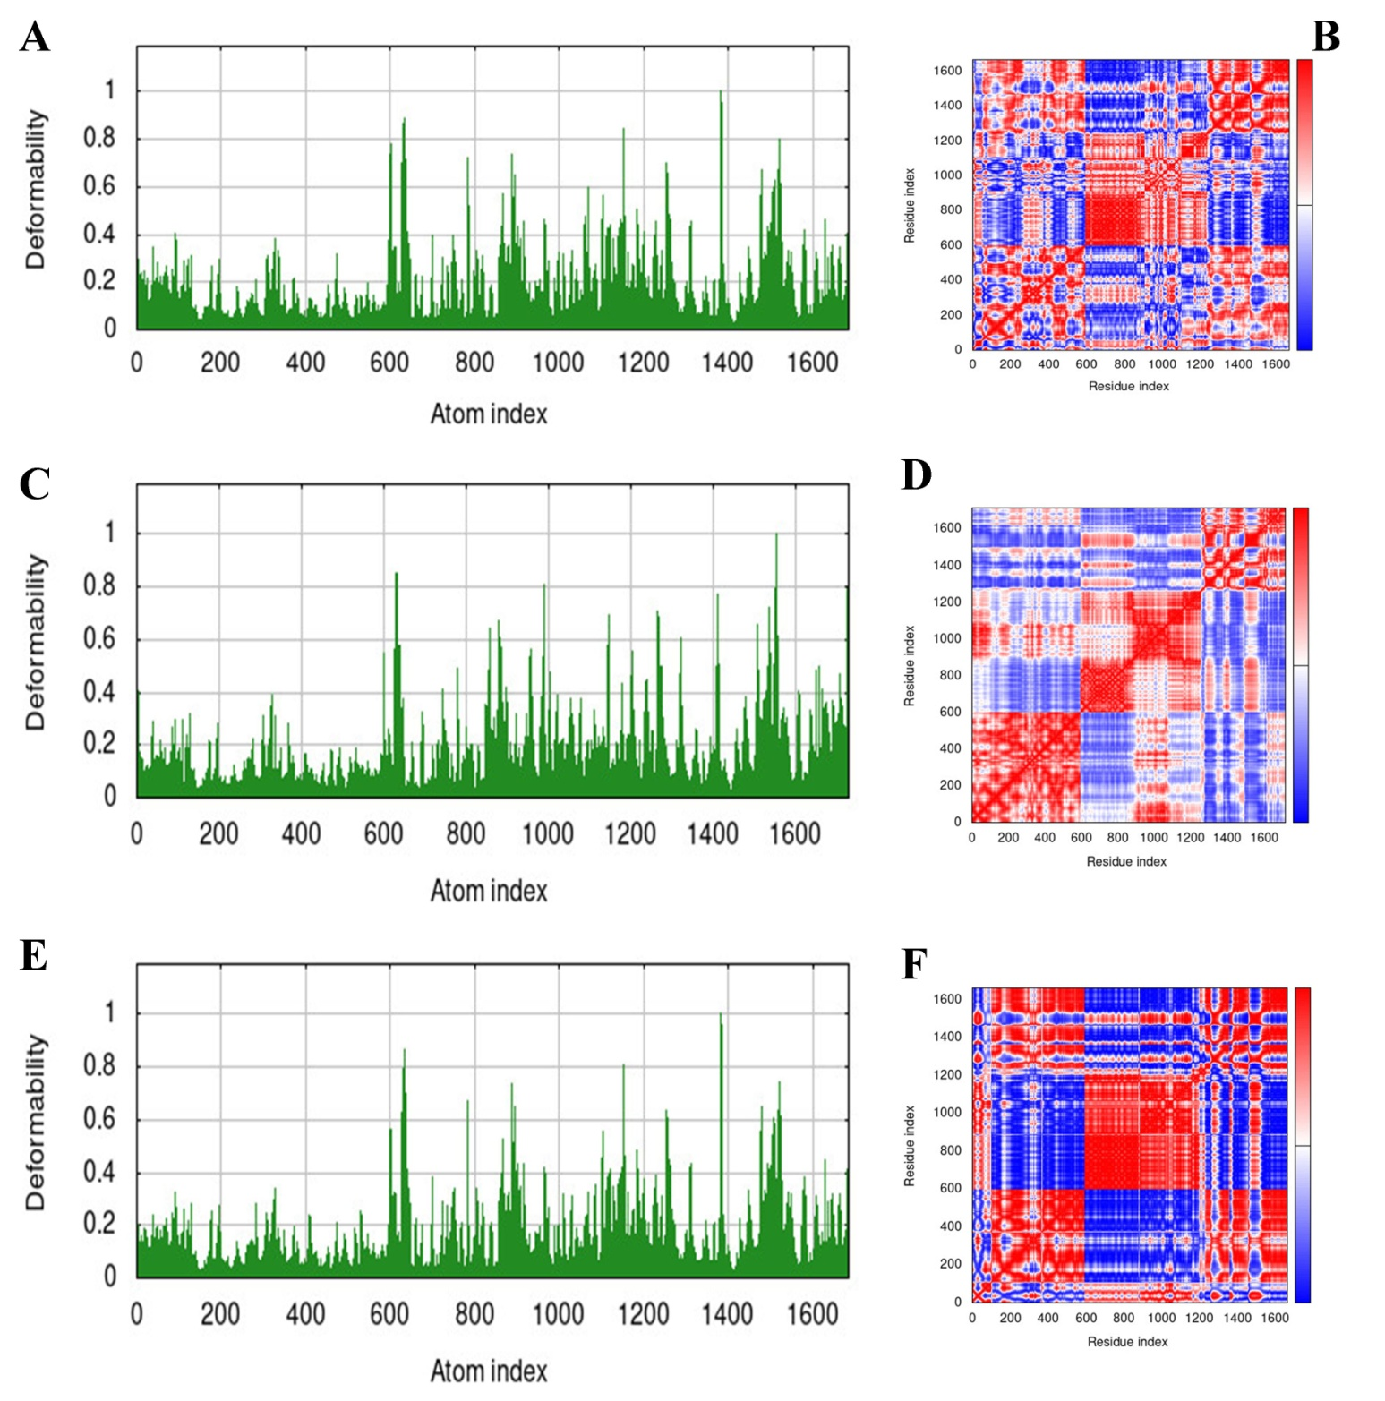
S- Fig 1; The molecular dynamics simulation of different variants with ACE2 docked complex, A, C, E) Main-chain deformability simulation, the hinges are regions with high deformability of Wild type, DELTA and OMICRON with ACE2 respectively; B, D, F ) The covariance matrix between pairs of residues of docked complexes of Wild type, DELTA and OMICRON with ACE2 respectively (red: correlated, white: uncorrelated, blue: anti-correlated).

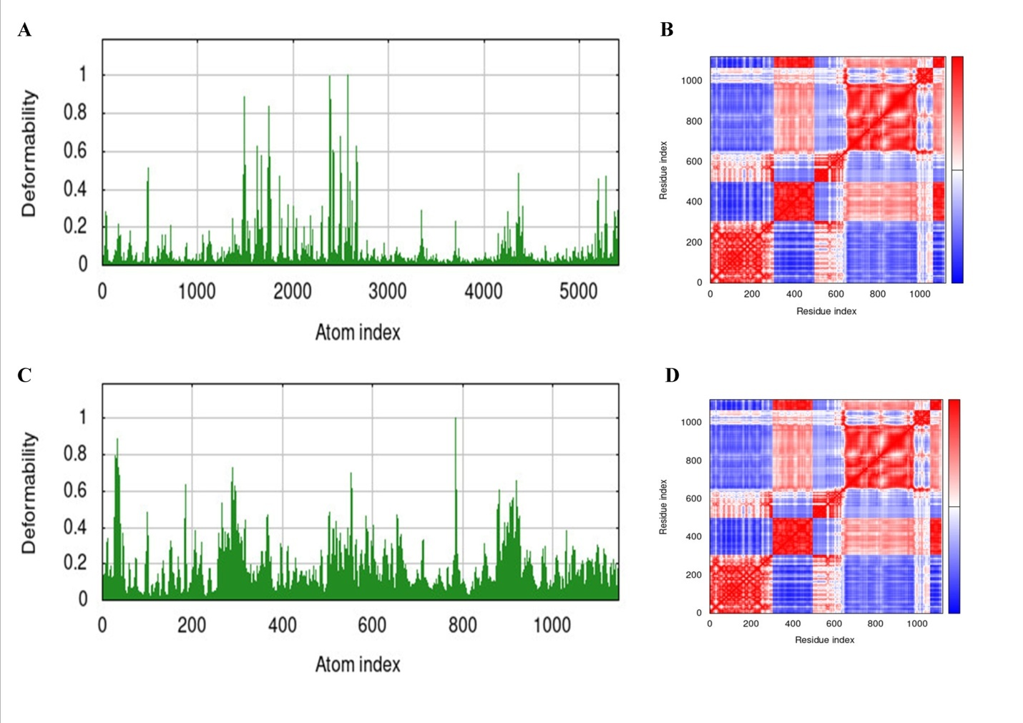
S- Fig 2; The molecular dynamics simulation of different variants with ACE2 docked complex, A, C, E) Main-chain deformability simulation, the hinges are regions with high deformability wild59 and T500S CUTs sequence with OMICRON variant respectively; B, D, F ) The covariance matrix between pairs of residues of docked complexes of wild59 and T500S CUTs sequence with OMICRON variant respectively (red: correlated, white: uncorrelated, blue: anti-correlated).

