Supporting Information
Construction of K⁺ ions gradient in crystalline carbon nitride to accelerate charge separation for efficient visible light H₂ production
Guoqiang Zhang,ª Yangsen Xu,^{c} Chuanxin He,^{a,b} Yongliang Li,^{a,b} Xiangzhong Ren,^{a,b} Peixin Zhang,*^{,a,b} Hongwei Mi*^{,a,b}
ª College of Chemistry and Environmental Engineering, Shenzhen University, Shenzhen, Guangdong, 518060, PR China
^{b} Guangdong Flexible Wearable Energy and Tools Engineering Technology Research Centre Shenzhen University, Shenzhen, Guangdong, 518060, PR China
^{c} Institute of Microscale Optoelectronics, Shenzhen University, Shenzhen 518060, PR China
* Correspondence E-mail: pxzhang@szu.edu.cn, milia807@szu.edu.cn

1. Experimental Section
  - Chemicals and Materials
Melamine (99.0%), KCl (AR, 99.5%), H₂PtCl₆.6H₂O (AR, Pt≥37.5%) and triethanolamine (TEOA, AR, 98.0%) were purchased from Aladdin Reagent Company. All chemicals were used without further purification.
  - Preparation of CN
Typically, the 50 g of melamine powder is put into a 50 ml of crucible with a cover and then heat to 550℃ at a rate of 2 ℃/min in a muffle furnace and maintain at this temperature for 3 h. CN is obtained after cooling down to room temperature. The mass of CN product is about 23 g. By further grinding CN into powder to facilitate the use of the next step.
  - Preparation of KCN x
The 1.5 g of CN powder and 10 g of KCl were ground and mixed evenly, and then heat to 600℃ at a rate of 10 ℃/min in a muffle furnace and maintain at this temperature for several hours. The bright yellow products were obtained after cooled to room temperature, washed with plenty of water and dried at 60℃ under vacuum. According to the different maintain time at 600℃, we denote the samples as KCN x (x = 0.5-4), where x is the maintain time.
  - Preparation of CN-U, CN-C, CN-D, KCN-U, KCN-C and KCN-D
Typically, the 30 g of urea/cyanamide/dicyandiamide is put into a 50 ml of crucible with a cover and then heat to 550℃ at a rate of 2 ℃/min in a muffle furnace and maintain at this temperature for 3 h. According to different precursors (urea, cyanamide, dicyandiamide), the products are named CN-U, CN-C and CN-D in turn. Subsequently, the 1.5 g of CN-U/CN-C/CN-D powder and 10 g of KCl were ground and mixed evenly, and then heat to 600℃ at a rate of 10 ℃/min in a muffle furnace and maintain at this temperature for 2 h. The bright yellow products were obtained after cooled to room temperature, washed with plenty of water and dried at 60℃ under vacuum. According to the different precursors, we denote the samples as KCN-U, KCN-C and KCN-D.
  - Characterizations
The crystalline structure was recorded by using an X-ray diffractometer (XRD) (Empyrean), using Cu K_{α} radiation (λ = 1.54056 A). Scanning electron microscope (SEM) images are measured on Hitachi SU8010. Transmission electron microscope (TEM) images were taken using a JEOL JEM-2010 operated at 200 kV. The UV-Vis absorption spectra were recorded on a UV-3600 scanning spectrophotometer (Shimadzu). The Fourier transform infrared (FTIR) spectra were recorded on a Nicolet iz10 spectrometer. Fluorescence emission spectra were recorded on a LabRAM HR Evolution spectrograph. X-ray photoelectron spectrum (XPS) analyses were performed on an ESCALAB 250Xi spectrometer with an Al-K_{α} (1486.6 eV) achromatic X-ray source. Transient state fluorescence spectra were recorded on an Edinburgh instruments FS5 fluorescence spectrometer. Inductively coupled plasma spectrometry (ICP-OES) was performed on Ultima 2, Horiba. Brunauer-Emmett-Teller (BET) specific surface area was measured using a Micrometrics ASAP 2020 HD88 Surface Area and Pore Size Analyzer. The solid-state ¹³C NMR spectra were recorded on a Bruker Avance II instrument in cross-polarization magic-angle spinning sequence mode.
  - Photocatalytic H₂ production Measurements
The 50 mg of samples added with H₂PtCl₆ (3 wt% Pt) is placed into a 50 mL of TEOA solution (20 vol%) in a closed gas circulation system (Beijing Perfectlight, Labsolar-6A). The visible-light irradiations were obtained from a 300 W Xe lamp (Beijing Perfectlight, PLS-SXE300) with a UVCUT-420 nm filter. All tests are controlled at 15℃ by circulating condensate. The evolved gases are detected in situ by using an online gas chromatograph (GC9790II, Fuli) equipped with a thermal conductivity detector (TCD).
  - AQE calculations of H₂ production
The 100 mg of samples added with H₂PtCl₆ (3 wt% Pt) is placed into a 50 mL of TEOA solution (20 vol%) in a closed gas circulation system. The catalyst solution was irradiated by a 300W Xe lamp applying bandpass filters (center at 400, 420, 475 and 500 nm) for 2 h. All tests are controlled at 25℃ by circulating condensate. The average intensity of irradiation is determined by an FZ-A spectroradiometer (Photoelectric Instrument Factory of Beijing Normal University). The apparent quantum efficiency (AQE) was calculated from equation:
$$AQE=\frac{2 ×the number of evolved H_{2} molecules}{the number of incident photons}×100\%$$
  - Photo-deposition of Pt Nanoparticles
The 50 mg of samples added with H₂PtCl₆ (3 wt% Pt) is placed into a 50 mL of TEOA solution (20 vol%) in a closed gas circulation system. The catalyst solution was irradiated by a 300W Xe lamp with a UVCUT-420 nm filter for 1 h. All tests are controlled at 15℃ by circulating condensate. The catalyst solution was then tested by TEM to describe the distribution of Pt nanoparticles on the catalyst surface.
  - Surface photovoltage measurements
Surface photovoltage (SPV) measurement system consisted of a source of monochromatic light, a lock-in ampliﬁer (SR 830-DSP) with a light chopper (SR 540) and a sample chamber. Monochromatic light is provided by a 300 W Xe lamp (PLS-SXE 300, Beijing Trusttech Co. Ltd, China) and a monochromator (SBP500, Zolix). All measurements are operated at room temperature and under ambient pressure and samples are not pretreated prior to the SPV measurement.

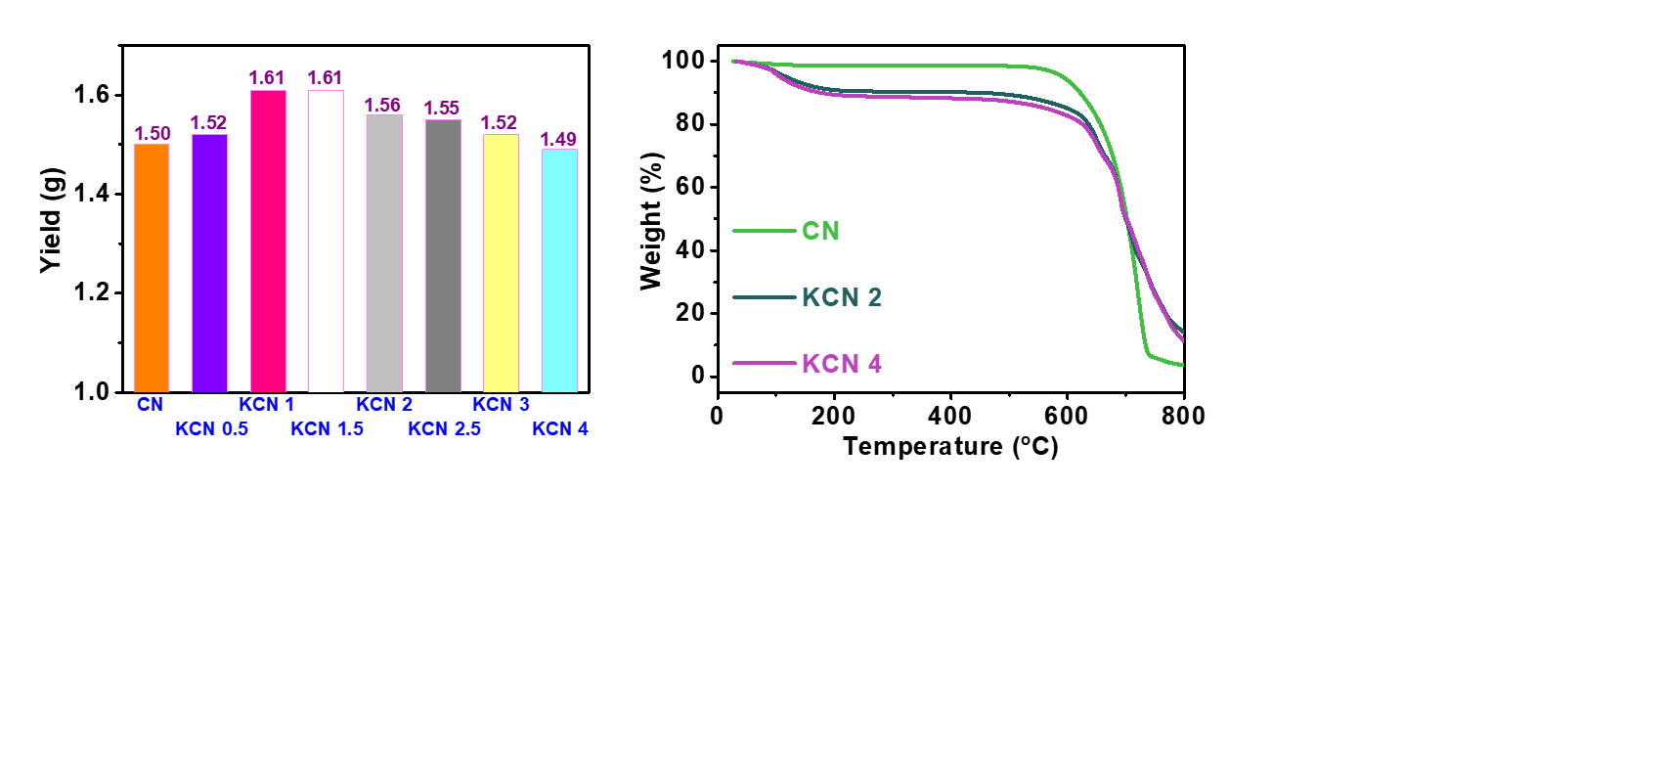
Figure S1. The mass of obtained samples of CN and KCN x (x = 0.5-4).

Figure S2. The thermogravimetry of CN, KCN 2 and KCN 4.

Table S1. The element content in CN, KCN 0.5, KCN 2 and KCN 4 estimated by elemental analysis.
Elemental analysis | CN | KCN 0.5 | KCN 2 | KCN 4
C (wt%) | 34.31 | 31.43 | 28.71 | 27.02
N (wt%) | 61.28 | 54.88 | 48.65 | 44.18
H (wt%) | 2.19 | 2.05 | 1.70 | 1.53
C/N (mol ratio) | 0.653 | 0.668 | 0.688 | 0.714

Table S2. The K element content in CN, KCN 0.5, KCN 2 and KCN 4 estimated by ICP-OES.
ICP | CN | KCN 0.5 | KCN 2 | KCN 4
K (wt%) | Trace | 3.13 | 10.80 | 15.19

Table S3. The full width at half maxima (FWHM) values of the (0 0 2) diffraction peak of CN and KCN x (x = 0.5-4) estimated by XRD results in Figure 2a.
XRD | CN | KCN 0.5 | KCN 1 | KCN 1.5 | KCN 2 | KCN 2.5 | KCN 3 | KCN 4
FWHM (°) | 1.01 | 0.92 | 0.61 | 0.53 | 0.51 | 0.50 | 0.48 | 0.47

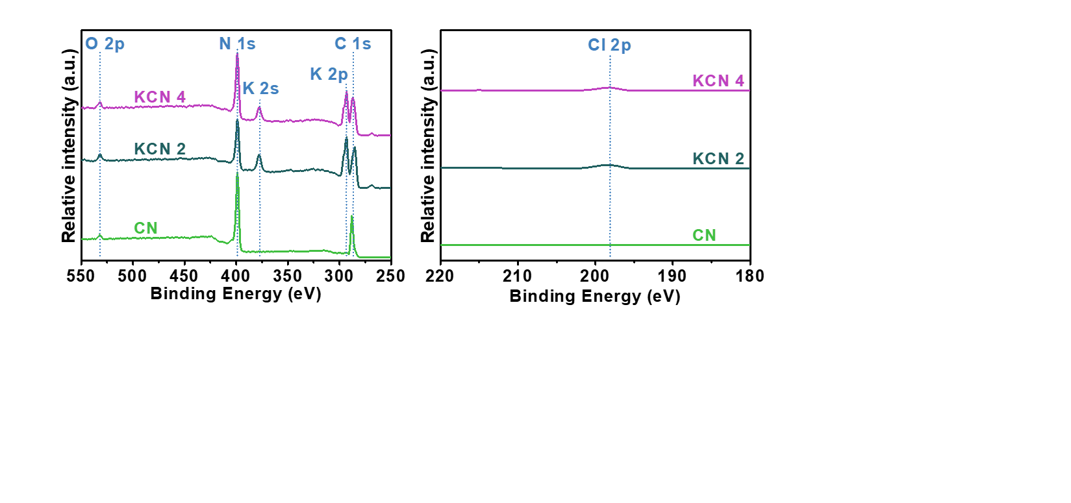
Figure S3. The XPS survey spectra of CN, KCN 2 and KCN 4.

Figure S4. The high-resolution Cl 2p XPS spectra of CN, KCN 2 and KCN 4.

Table S4. The peak area of N-C=N, C≡N and C-C species, and the ratio of C≡N and graphite carbon in C 1s XPS spectra (Figure 3b) of CN, KCN 2 and KCN 4.
 | CN | KCN 2 | KCN 4
N-C=N | 43377.82 | 31721.53 | 29599.23
C≡N | - | 2691.34 | 4509.89
C-C | 5082.95 | 5046.77 | 13406.81
Proportion of C≡N | - | 0.07 | 0.09
Proportion of C-C | 0.10 | 0.15 | 0.28

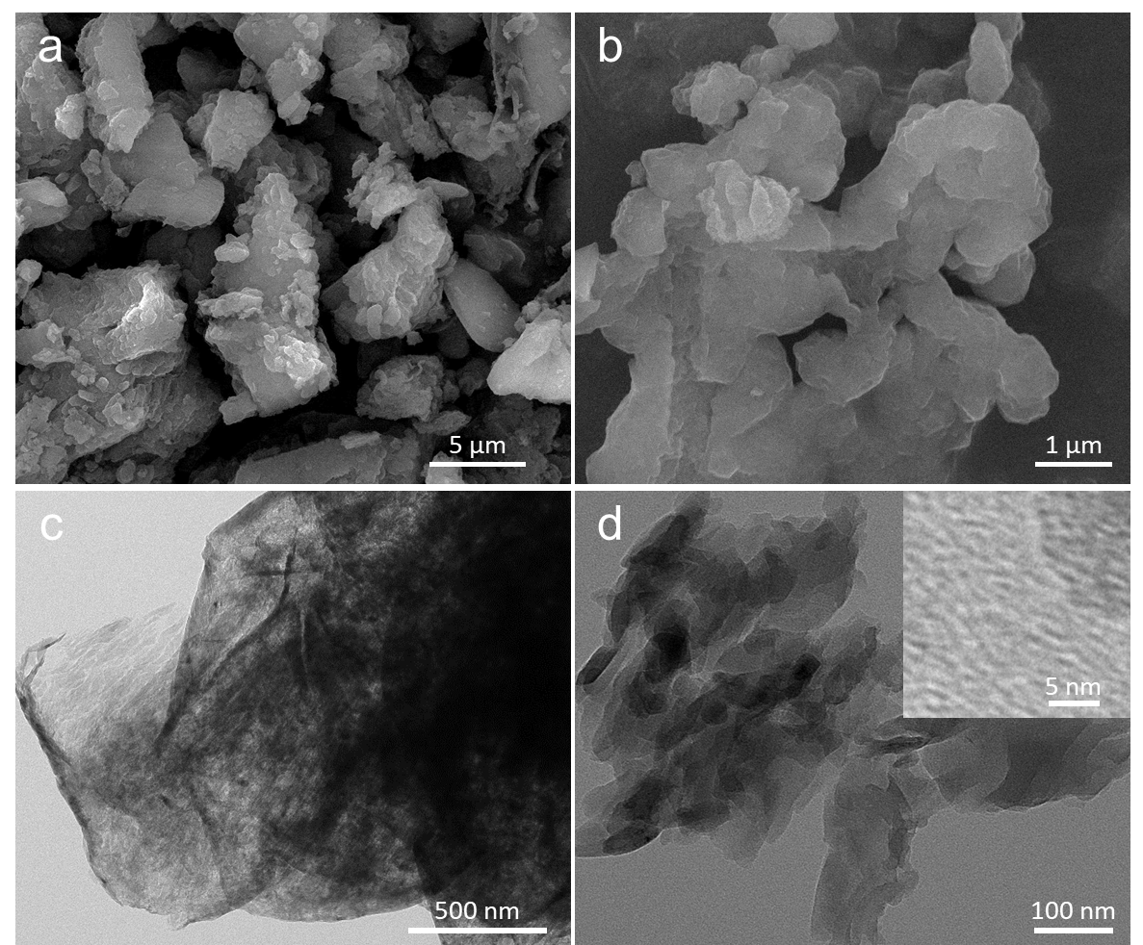
Figure S5. The SEM (a-b) and TEM (c-d) images of CN. Inset in (d) is the high-resolution TEM image.

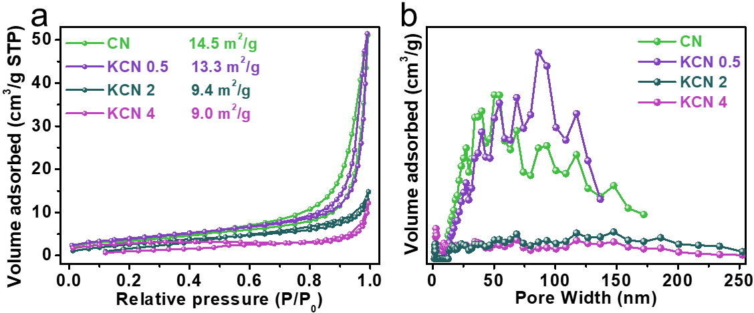
Figure S6. The N₂ adsorption-desorption isotherms (a) and pore size distribution curves (b) of CN, KCN 0.5, KCN 2 and KCN 4.

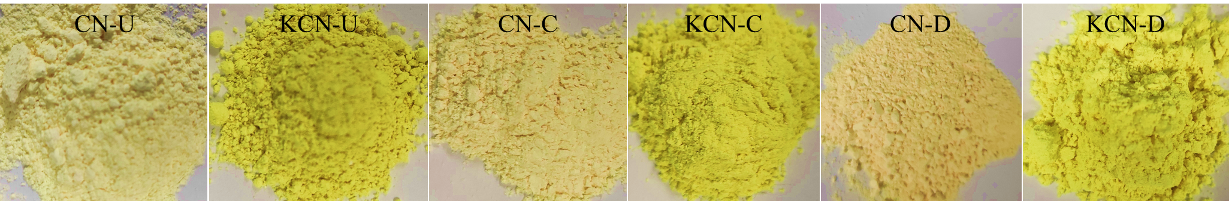
Figure S7. The optical images of CN and KCN obtained from different precursors (urea, cyanamide and dicyandiamide).

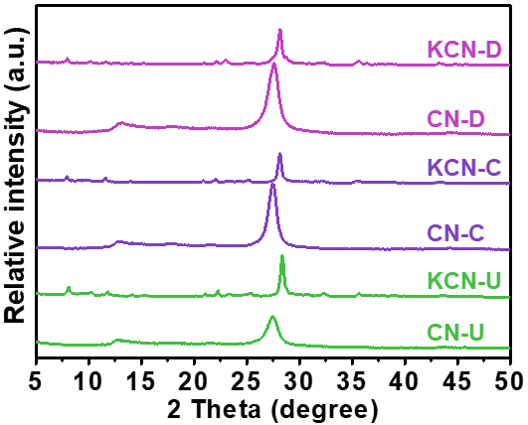
Figure S8. The XRD patterns of CN and KCN obtained from different precursors (urea, cyanamide and dicyandiamide).

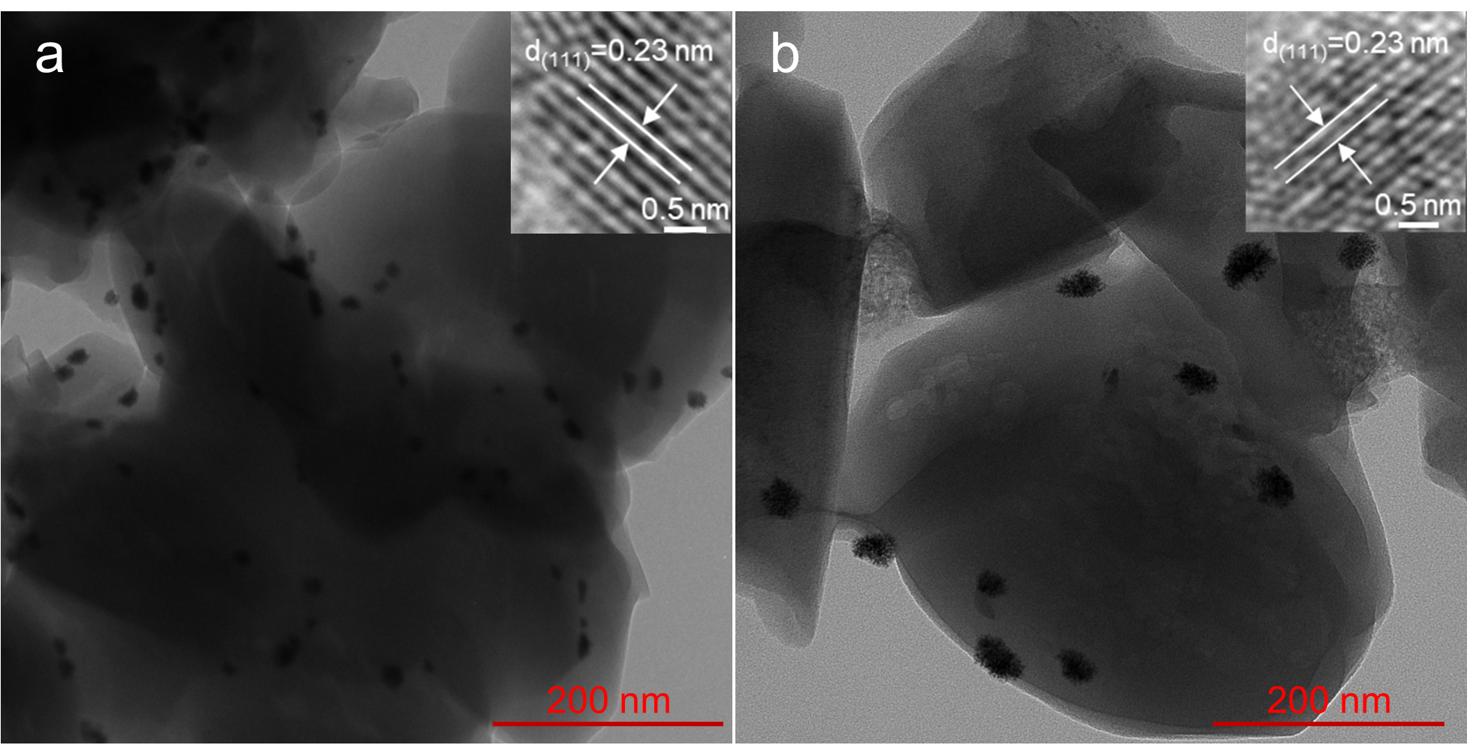
Figure S9. TEM images of the photo-deposited Pt nanoparticles on KCN 2 and KCN 4.

