Supplementary materials
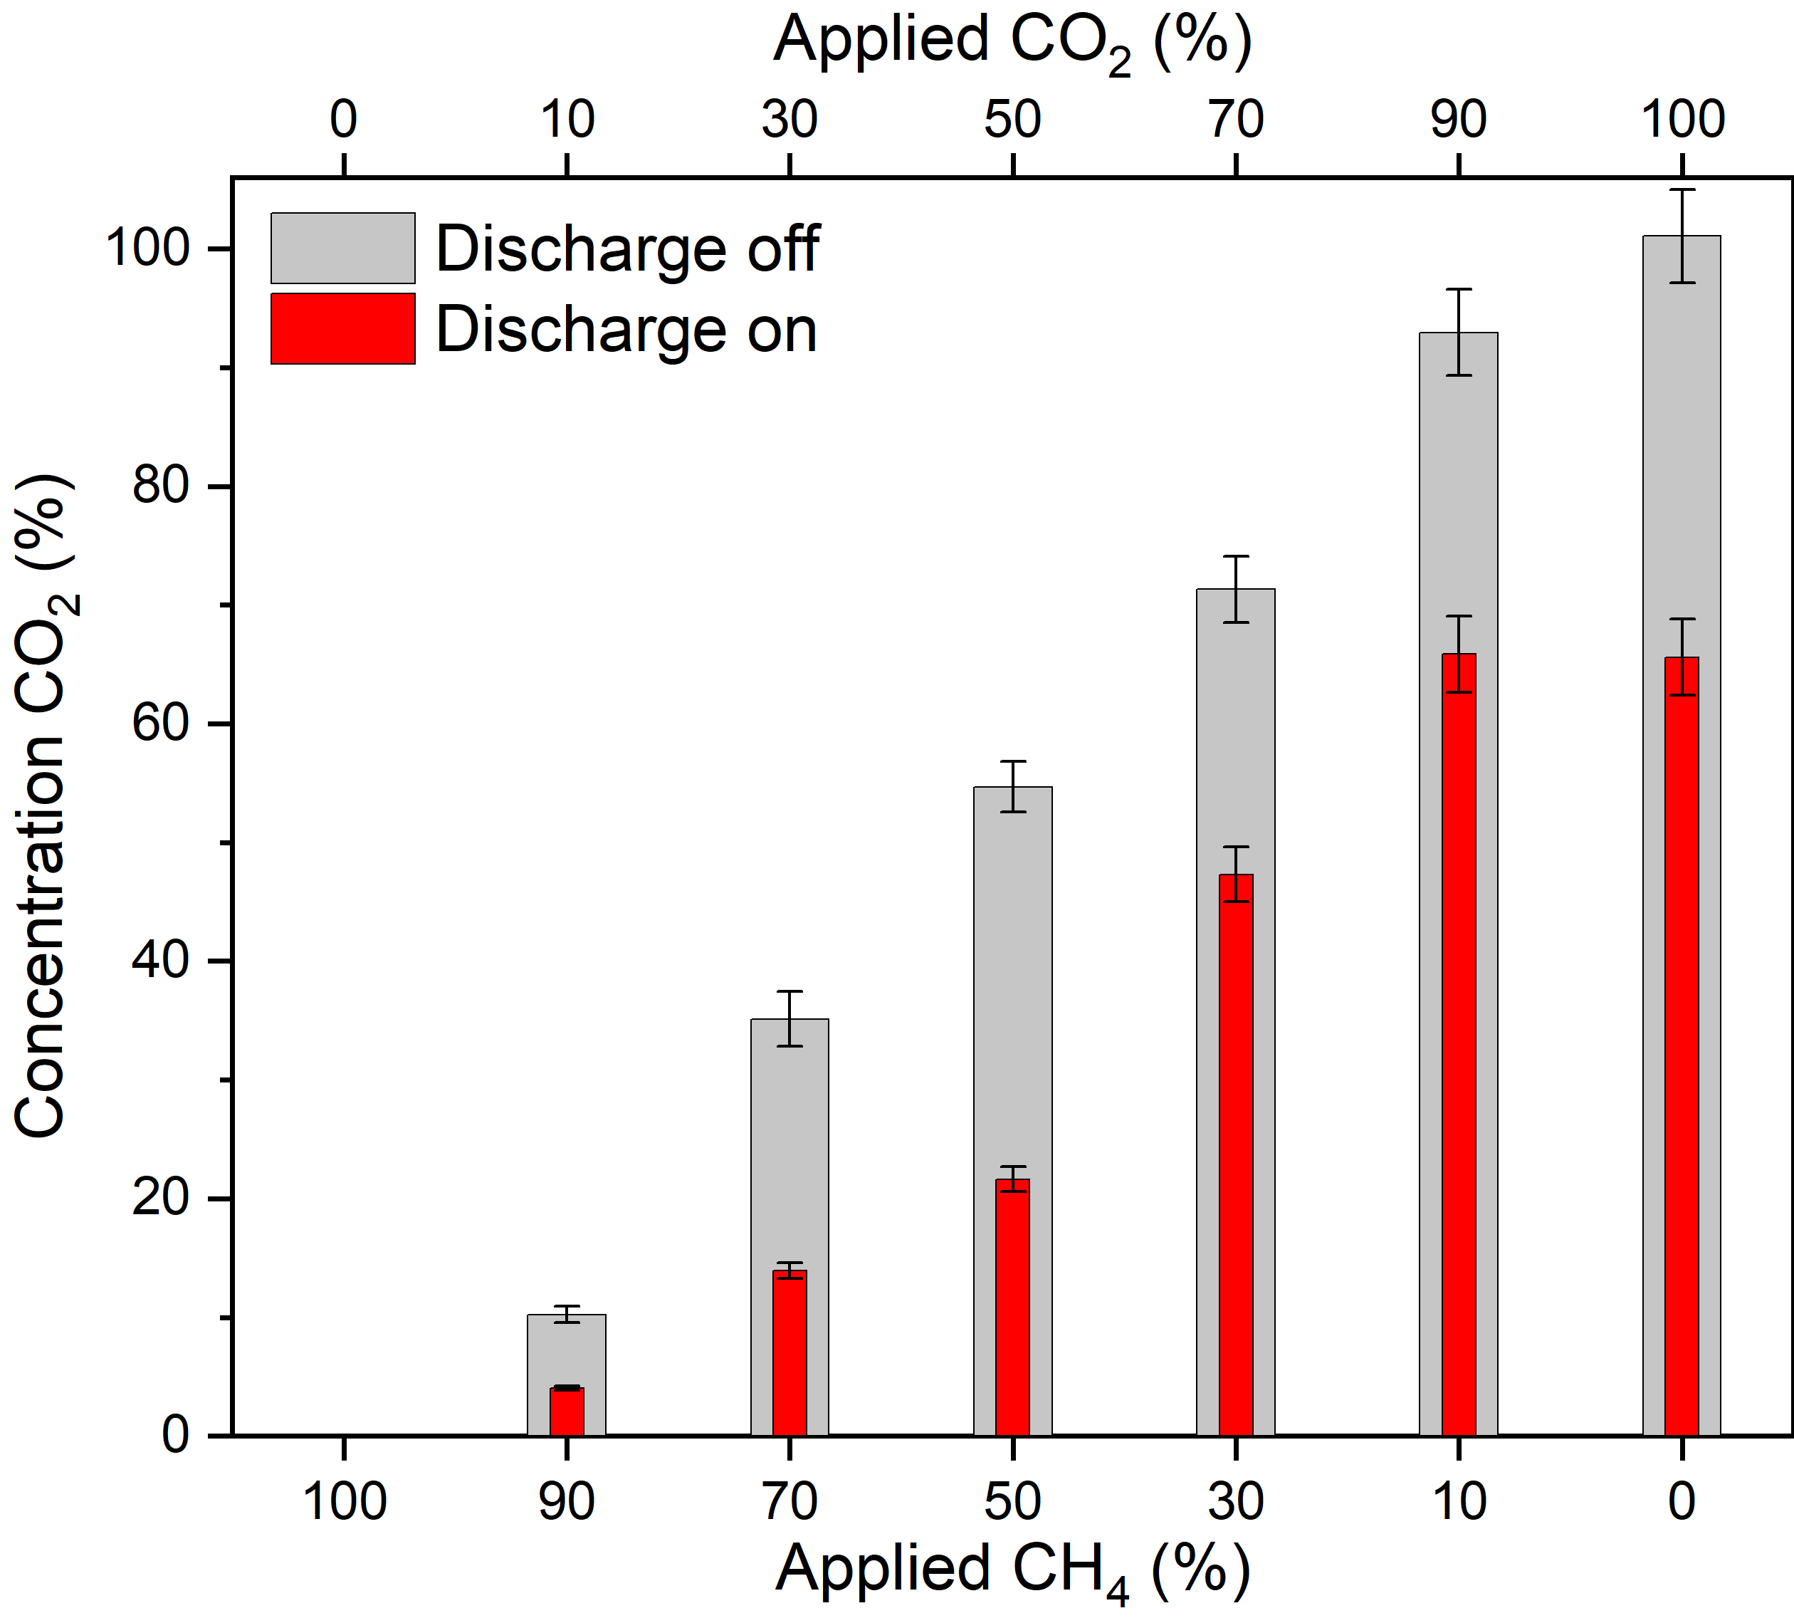
Supplementary Figure 1. Measured CO₂ concentrations with (in grey) and without (in red) the discharge applied for a varying CH₄/CO₂ ratio. The difference between the two indicates the amount of CO₂ that was consumed in the reaction within the discharge.

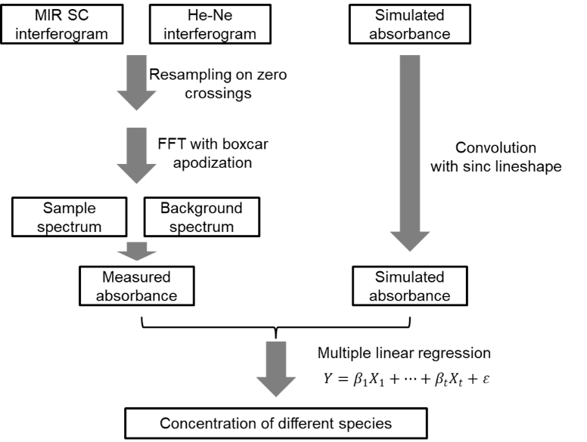
Supplementary Figure 2. Flowchart of the developed analysis algorithms.

