Supplementary Information

Assessment of kinetic modeling for oxidation of humic substances in mature landfill leachate by solar photocatalysis using ZnO–TiO₂

Nicoly Milhardo Lourenço Noharaª, Helcio José Izário Filhoª, Adriano Francisco Siqueira^{b}, Leandro Gonçalves de Aguiarª, Gabriel Caracciolo Koenigkam de Oliveiraª, Evandro Luís Nohara^{c}, Marco Aurélio Kondracki de Alcântara^{b,*}

ª Department of Chemical Engineering, Engineering School of Lorena, University of São Paulo, 12602-810, Lorena, SP, Brazil
^{b} Department of Basic and Environmental Sciences, Engineering School of Lorena, University of São Paulo, 12602-810, Lorena, SP, Brazil
^{c} Department of Mechanical Engineering, University of Taubaté, Taubaté, 12060-440, SP, Brazil

- Corresponding author: E-mail: marko@usp.br (M.A.K. Alcântara)

Content of the Supporting Information

Preparation of photocatalytic material. Photocatalytic degradation assays of landfill leachate. Non-purgeable organic carbon analysis. Analysis of variance for degradation of humic acids and fulvic acids + humins. Comparison of experimental data and values predicted by a statistical model for conversion of humic acids and fulvic acids + humins (PDF).

Preparation of photocatalytic material

Binary mixtures of the photocatalyst were prepared by simple mixing. The inputs used for preparation of the photocatalytic material were acrylic paint (60% w/v), photocatalysts (ZnO–TiO₂, 20% w/v), deionized water (15% w/v), ammonia polyacrylate (PAA-NH₄), 4% w/v), and carboxymethylcellulose (CMC, 1% w/v). The commercial acrylic paint was colorless, semi-gloss, and water-soluble. The paint is mainly composed of methyl methacrylate copolymer, butyl acrylate, 2-hydroxyethyl methacrylate, and acrylic acid at a weight ratio of 60:22.2:10:7.8 with an average molar weight of 15,000 to 35,000 g/mol [1] Regarding photocatalysts, which also served as pigments, TiO₂ had a purity of 99.9% mm⁻¹ and mixed phases (60% anatase and 40% rutile). ZnO had a purity of 99.5% mm⁻¹, and the predominant phase was wurtzite (>90%). The weight composition of the solid binary mixtures used in this study was as follows: (a) 1–65% ZnO and 35% TiO₂, (b) 2–20% ZnO and 80% TiO₂; and (c) 3–44% ZnO and 56% TiO₂. The control consisted of a mixture of varnish and water, used to assess the occurrence of direct photolysis by solar radiation.
Oxide mixtures were homogenized for 60 min using a basic analytical mill (IKA A11) and then suspended in water. In parallel, CMC and PAA-NH₄ were solubilized in deionized water. Subsequently, the solution was mixed with the paint using a mechanical agitator simultaneously with ultrasound. Mixtures were stirred for 15 min for homogenization.
Fig. S1 shows the structure assembled for the painting of plates. In this step, a spray gun (DeVilbiss JGA-503), a dual air filter regulator (DeVilbiss FRC-600), and an air compressor (SCHULZ Classic, mobile MSL) were used.

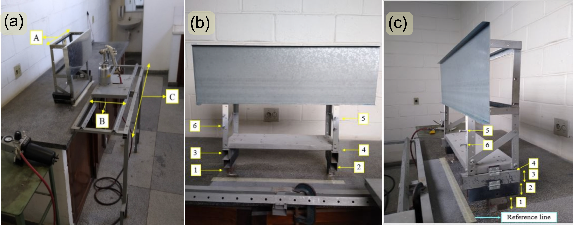

Fig. S1 Paint Lab assembled for the present study. (a) Painting system consisting of a (A) sample holder, (B) mobile car with a spray gun, and (C) fixed structure. (b) Front view of the sample holder with a 750 × 250 × 0.5 mm galvanized steel plate and six height adjustments. (c) Side view of the sample holder with the six height adjustments and reference line.

Figs. S1b and S1c show the six height adjustment points of the sample holder, equally spaced at 5 cm. The adjustments are placed in such a manner to allow for overlay painting. Position number 1 consists of a solid metal bracket measuring 2.5 cm in height, resulting in a total distance of 25 cm between the upper end of the metal plate and the reference line (marked in blue in Fig. S1c). By removal of the solid metal support at position 1, position 2 is achieved. Position 3 is achieved by removing the support at position 2 and position 4 is achieved by removing the support at position 3. Position 5 is achieved by positioning the lower end of the plate at height 5, and position 6 is achieved by positioning the lower end of the plate at height 6.
The distance between the reference line and the gun nozzle was 20 cm. Suspensions were applied by horizontal spraying on four different galvanized steel plates measuring 750 × 250 × 0.5 mm (Fig. S1b). The vertical fan of the spray gun was adjusted to a 5.0 cm height. Application of the first stroke of the first coating would involve the following steps: (i) adjust the galvanized steel plate to height position 1, (ii) securely attach the paint sprayer to the sliding track (placed at 90° to the plate); (iii) bring the sliding track to the left side (beginning) of the fixed structure; and (iv) move the sliding track to the right side, covering a distance of 750 mm in 4.0 s at constant speed with the trigger pulled to the desired pressure. After this procedure, the galvanized steel plate is set to height position 2, and the second stroke is applied in the opposite direction (from right to left). Each coating consisted of six strokes.
Fig. S2 shows the six preset positions of the spray gun along the galvanized steel plate and the direction of each stroke. The figure also highlights the area covered by stroke 2. Note that each stroke overlaps 50% of the area covered by the previous stroke. Nine coatings of suspension were applied per sample. The first coating was semi-wet and applied at 40 psi. This procedure ensured the deposition of a uniform coating without coalescence of droplets. The remaining eight coatings were wet and applied at 20 psi, forming a continuous, uniform film of coalescent droplets. At the end of the procedure, thickness was measured using a Mitutoyo digital micrometer. Films had a mean thickness of 600 ± 80 µm.

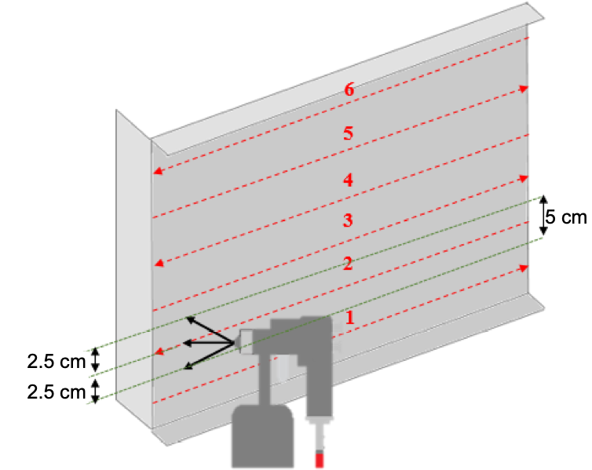

Fig. S2 Schematic (not to scale) showing the horizontal motion of the spray gun along the galvanized steel plate at heights 1 to 6 to complete a coating.

Photocatalytic degradation assay

Leachate was collected from the municipal landfill of Cachoeira Paulista, São Paulo State, Brazil (22°39′4″S 45°3′18″W). After collection, the sample (100 L) was homogenized by mechanical stirring and stored in a cold room at 4 °C until use.
Photocatalytic tests were performed on bench-scale thin-film fixed-bed reactors operated in continuous recirculation mode under solar irradiation. Reactors were positioned in the direction of the Equator at an inclination angle of 23° (Fig. S3).

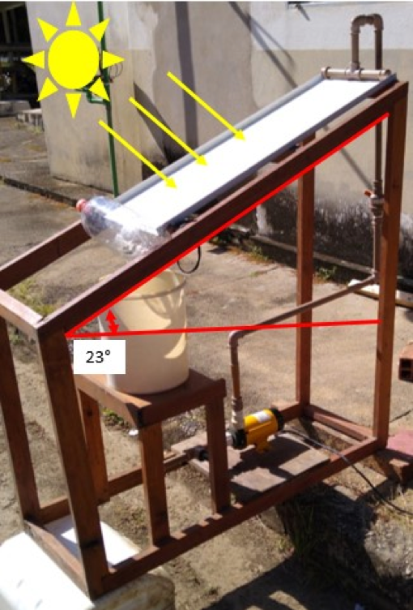

Fig. S3 Thin-film fixed-bed solar reactor used in heterogeneous photocatalytic experiments.

The total volume of fresh leachate used during the experiments was 3 L. The flow rate was maintained at 12–13 L min⁻¹. Reactions were run between 11:00 h and 15:00 h during 5 days with sunny weather and temperatures ranging from 28 to 32 °C in autumn. Solar irradiance was measured by using an ILT 1400ª International Light radiometer, which recorded values of 750–872 mJ cm⁻² at the end of each operation. The mean evaporation rate of leachate during an experimental cycle was 160 mL; this volume was replaced with water, added in 20 mL aliquots every 30 min during the photocatalytic process. Before the beginning of the experiment, the pH of fresh leachate was measured (pH = 7.8–8.0) and adjusted according to the experimental design by adding small portions of 98% (w/w) sulfuric acid (H₂SO₄). pH adjustments during photocatalysis were performed with 10 mol L⁻¹ H₂SO₄ solution, added directly to the reactor reservoir. Aliquots from the reservoir were collected every 20 min for pH control and adjustment during operation. During the photocatalytic process, treated leachate was collected every 5 min for the first 20 min and then every 10 min until 240 min of reaction, totaling 26 samples per experiment.
To assess possible effects of non-catalyzed photolysis on degradation, we performed a control test without addition of oxides or additives. A sample aliquot was collected at the beginning and another at the end of the reaction (240 min). Environmental conditions (temperature, leachate volume, and solar irradiation) were similar to those of other experiments. The control test indicated minimal occurrence of photolytic degradation.

Non-purgeable organic carbon analysis

Separation of humic substances

Separation of humic substances was performed according to the method described by [2]. Separations steps are illustrated in Fig. S4.

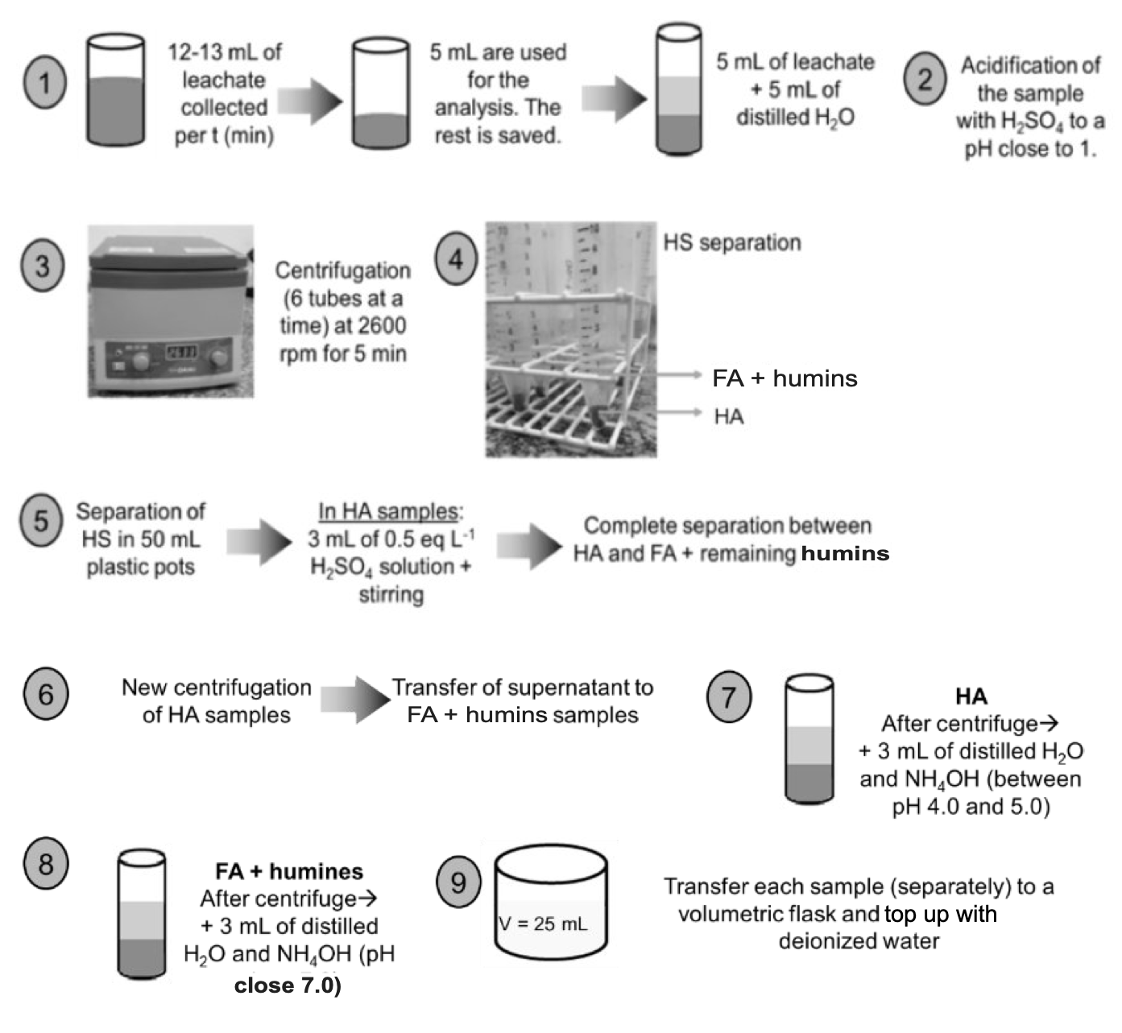

Fig. S4 Separation of humic substances. Adapted from [2].

Characterization of humic substances

Analytical characterization of humic substances was carried out on a Shimadzu TOC-V system by the total combustion method (680 °C) with non-dispersive infrared detection. The equipment can determine total carbon, inorganic carbon, total organic carbon, and non-purgeable organic carbon in aqueous samples within the concentration range of 2.0 to 1,000 mg L⁻¹. Total organic carbon is obtained by subtraction of inorganic carbon from total carbon. Inorganic carbon is determined by acidification of samples and consequent conversion of carbonates into CO₂, which preliminary analyses showed to be present in negligible amounts. Finally, the remaining fraction is quantified as non-purgeable organic carbon. It should be noted that humic acids were determined separately from fulvic acid + humins. During the photocatalytic process, leachate samples were collected every 5 min for the first 20 min and then every 10 min until 240 min of reaction, totaling 26 samples per experiment.

Analyses of variance

Tables S1 and S2 present the analysis of variance for the photocatalytic degradation of humic acids and fulvic acids + humins, respectively.

Table S1 Analysis of variance for humic acid degradation
Source | df | Adj SS | Adj MS | F-value | P-value
Regression | 4 | 0.078088 | 0.019522 | 33.98 | 0.001
[ZnO–TiO₂] | 1 | 0.007812 | 0.007812 | 13.60 | 0.014
Replicate | 1 | 0.007840 | 0.007840 | 13.65 | 0.014
[ZnO–TiO₂]*[ZnO–TiO₂] | 1 | 0.018922 | 0.018922 | 32.94 | 0.002
[ZnO–TiO₂]*[pH] | 1 | 0.043513 | 0.043513 | 75.74 | 0.000
Error | 5 | 0.002873 | 0.000575
Total | 9 | 0.080960

Humic acids Model summary
S | R² | Adjusted R² | Predicted R²
0.0239687 | 96.45% | 93.61% | 86.03%

Table S2 Analysis of variance for fulvic acid + humin degradation
Source | df | Adj SS | Adj MS | F-value | P-value
Regression | 4 | 0.043080 | 0.010770 | 149.58 | 0.000
[ZnO–TiO₂] | 1 | 0.028800 | 0.028800 | 400.00 | 0.000
Replicate | 1 | 0.007840 | 0.007840 | 108.89 | 0.000
[ZnO–TiO₂]*[ZnO–TiO₂] | 1 | 0.003240 | 0.003240 | 45.00 | 0.001
[ZnO–TiO₂]*[pH] | 1 | 0.003200 | 0.003200 | 44.44 | 0.001
Error | 5 | 0.000360 | 0.000072
Total | 9 | 0.043440

Fulvic acids and humins Model summary
S | R² | Adjusted R² | Predicted R²
0.0084853 | 99.17% | 98.51% | 96.94%

Comparison of experimental and model results

Figs S5 and S6 present a comparison of experimental and model results for humic acid and fulvic acid + humin conversions, respectively.

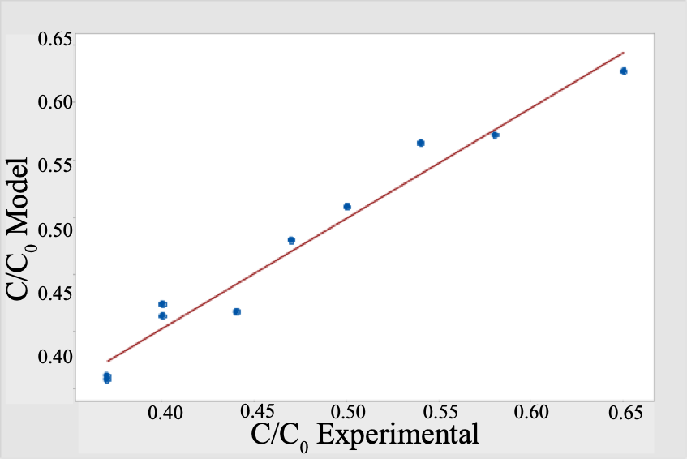

Fig. S5 Comparison of experimental data and values predicted by a statistic model for humic acid conversion after 240 min of solar photocatalysis.

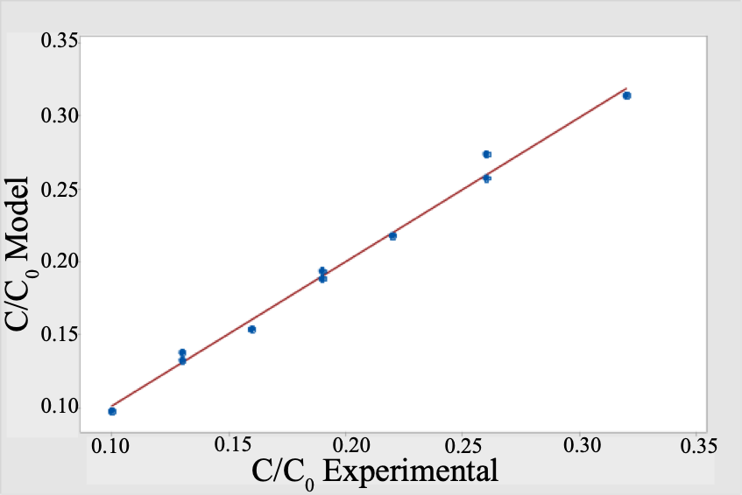

Fig. S6 Comparison of experimental data and values predicted by a statistic model for conversion of fulvic acids + humins after 240 min of solar photocatalysis.

Supplementary Information references

- Jones FN, Nichols ME, Pappas SP. Organic coatings: science and technology. Fourth edition. Hoboken, NJ, USA: John Wiley & Sons, Inc; 2017.
- APHA - American Public Health Association. Standard methods for the examination of water and wasterwater. 23rd edition. Bridgewater LL, Baird RB, Eaton AD, Rice EW, American Public Health Association, American Water Works Association, et al., editors. Washington, DC: American Public Health Association; 2017.

