Supplementary Information for:
Social leaning disfavours the cultural evolution of altruistic punishment
Maxwell N. Burton-Chellew *¹⁻² and Victoire D'Amico ²

¹ Department of Economics, HEC-University of Lausanne, 1015 Lausanne, Switzerland
² Department of Ecology and Evolution, University of Lausanne, 1015 Lausanne, Switzerland.

*Corresponding author: maxwell.burton@unil.ch
maxburtonchellew.com

Version date: Friday 3rd June 2022

SUPPLEMENTARY RESULTS
Information on payoffs reduced punishment
As reported in the main text, we found that the number of punishers was significantly lower when individuals could observe that punishment reduced group profits (Extended Data Figure 2). The mean spending on punishment was also significantly lower in the Group Profits treatment. Specifically, it was 2.7 MU 95% bootstrapped CI = [2.4, 3.1,] in the No-info treatment, 2.3 MU 95% bootstrapped CI = [2.1, 2.6] MU in the Group Behaviours treatment and 2.2 MU 95% bootstrapped CI = [1.8, 2.5]] in the Group Profits treatment (linear mixed model controlling for participant, F_{2,264} = 9.0, P < 0.001; pairwise comparisons between: Group Profits and No-info, t=3.7, estimate = -1.0, S.E. = 0.2799, P < 0.001; Group Profits and Group Behaviours, t=-3.6, estimate = 0.9, S.E. = 0.2524, P < 0.001; Group Behaviours and No-info, t=0.4, estimate = -0.1, S.E. = 0.2776, P = 0.674).

Because social information reduces the level of punishment, then this may in turn reduce the level of cooperation, and this in turn may increase the levels of punishment, we also examine these effects in the opening round, before any effects upon levels of punishment can affect subsequent behaviour. There were significant differences in the opening round between the Group Profits and the Group Behaviours treatments. Specifically, only 44% of individuals chose to punish in the first round of the Group Profits treatment (N = 42/96, 95% CI = [34%, 54%]), with a mean spending on punishment of 1.6 MU, 95% bootstrapped CI = [1.0, 2.3]; compared to 51% choosing to punish and spending 2.2 MU, 95% bootstrapped CI = [1.5, 3.0] in the No-info treatment (N = 35/68, 95% CI = [40%, 63%]), and 60% choosing to punish and spending 2.1 MU, 95% bootstrapped CI = [1.6, 2.7] in the Group Behaviours treatment (N = 60/100, 95% CI = [50%, 69%]) (pairwise statistics from overall model comparing: Group Profits versus Group Behaviours treatment; Fisher’s Exact Test comparing frequency of punishers, P = 0.0317; Linear model comparing levels of spending, t = 3.6, estimate = 1.1, S.E. = 0.3113, P < 0.0001; statistics comparing Group Profits versus No-info treatment; Fisher’s Exact Test, P = 0.345; Linear model, t = 3.9, estimate = 1.3, S.E. = 0.3453, P < 0.0001).

Game experience does not increase support for punishment
Our central result, that information about group profits led to significantly fewer votes for punishment, did not significantly depend upon whether the vote came before or after game experience. Comparing among participants, we find a significantly negative effect of social information containing profits both before game experience (Fisher’s exact test, comparing 30% in the Vote Profits treatment to 52% in the Vote Behaviours treatment, 26/88 versus 44/84 votes, P = 0.003) and after game experience (Fisher’s exact test, comparing 30% in the Group Profits treatment versus 57% in the Group Behaviours treatment, 29/96 versus 57/100 votes, P < 0.001).

Participants in the Vote Behaviours and Vote Profits treatments got to vote two times, once before each game series, which allowed us to test within participants. Around 20% of participants changed their vote, specifically 21% changed in the Vote Behaviours treatment (N = 18/84) and 18% in the Vote Payoffs treatment (N = 16/88, Fisher’s exact test, P = 0.702). Again, we found that experience did not matter, as individual support for punishment did not significantly change after game experience in either treatment (Vote Behaviours: support went from 52% to 45%, from 44 to 38/84 votes, Fisher’s exact test, P = 0.440; Vote Profits: support went from 30% to 36%, from 26 to 32/88 votes, Fisher’s exact test, P = 0.423).

Punishment was costly
Specifically, when sessions played without punishment (N = 23), they made an average profit per capita per round of 2.8 MU, 95% CI = [2.43, 3.16], whereas when sessions played with punishment enabled (N = 29), they not only earned significantly less, but they made a net loss on average per capita per round of -2.2 MU, 95% CI = [-3.41, -1.06] (Welch two sample t-test, t = 7.7, estimated difference = 5.0 MU, 95% CI = [3.65, 6.28], df = 33.2, P < 0.001).

Extended Data Table 1: Social information comparing groups with and without punishment. We showed individuals these data, one round at a time, from Fehr & Gächter ¹ experiment. The mean profit was only shown in some treatments.
Round | Punishment enabled | Mean contribution | Mean punishment | Mean Profit
Round 1 | No | 10.0 | 0 | 6.0
 | Yes | 12.6 | 2.1 | -0.5
Round 2 | No | 8.8 | 0 | 5.3
 | Yes | 13.9 | 2.4 | -1.2
Round 3 | No | 7.4 | 0 | 4.4
 | Yes | 14.8 | 2.1 | 0.5
Round 4 | No | 6.2 | 0 | 3.7
 | Yes | 15.2 | 1.9 | 1.8
Round 5 | No | 5.6 | 0 | 3.4
 | Yes | 15.8 | 1.9 | 2.1

Extended Data Table 2: Data by session from the previous experiment of Fehr & Gächter ¹.
Session | Punishment Institution | Mean contribution (0-20 MU) | Mean punishment | Mean Profit
1 | No | 7.5 | 0 | 4.5
1 | yes | 16.2 | 2.5 | -0.2
2 | No | 5.25 | 0 | 3.15
2 | yes | 13.3 | 1.4 | 2.3
3 | No | 3.6 | 0 | 2.2
3 | yes | 14.3 | 1.7 | 2.0
4 | No | 7.3 | 0 | 4.4
4 | yes | 15.9 | 2.0 | 1.6
5 | No | 7.7 | 0 | 4.6
5 | yes | 14.4 | 2.3 | -0.1
6 | No | 8.2 | 0 | 4.9
6 | yes | 12.4 | 2.6 | -2.6
7 | No | 7.2 | 0 | 4.3
7 | yes | 15.4 | 2.1 | 1.0
8 | No | 8.9 | 0 | 5.3
8 | yes | 16.4 | 1.8 | 2.7
9 | No | 9.4 | 0 | 5.65
9 | yes | 16.1 | 2.8 | -1.0
10 | No | 6.1 | 0 | 3.6
10 | yes | 11.6 | 1.6 | 0.7

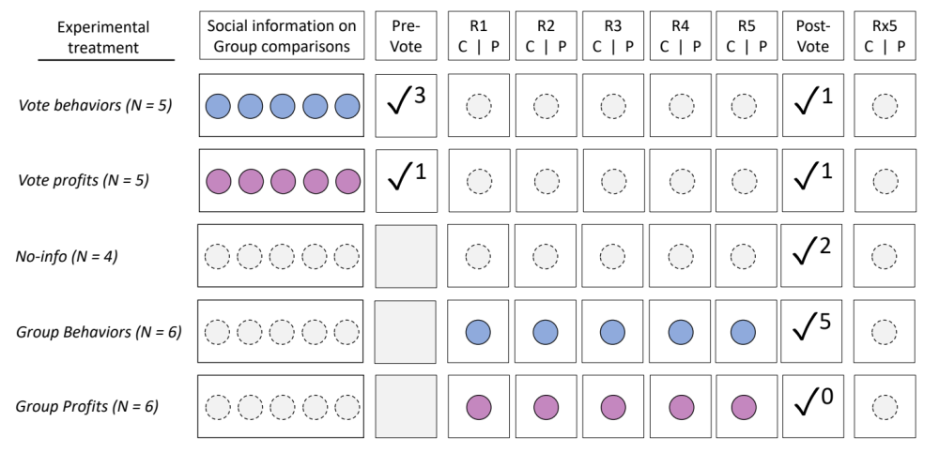
Extended Data Figure 1. Experiment design. N indicates the number of sessions. R1-5 = game round of each game series. C = Contribution phase, P = Punishment phase. Voting determined if the punishment mechanism was enabled or not. The superscript numeral indicates how many sessions subsequently enabled punishment in the relevant game series. Social information, from Extended Data Table 1, summarized either behaviours only (blue) or behaviours and profits (pink) from each round of a previous experiment. The five rounds of social information were shown either in total before the first game series (top two treatments), or round by round in-between the contribution and punishment phases of each round (bottom two treatments). No social information was ever shown in the second game series.

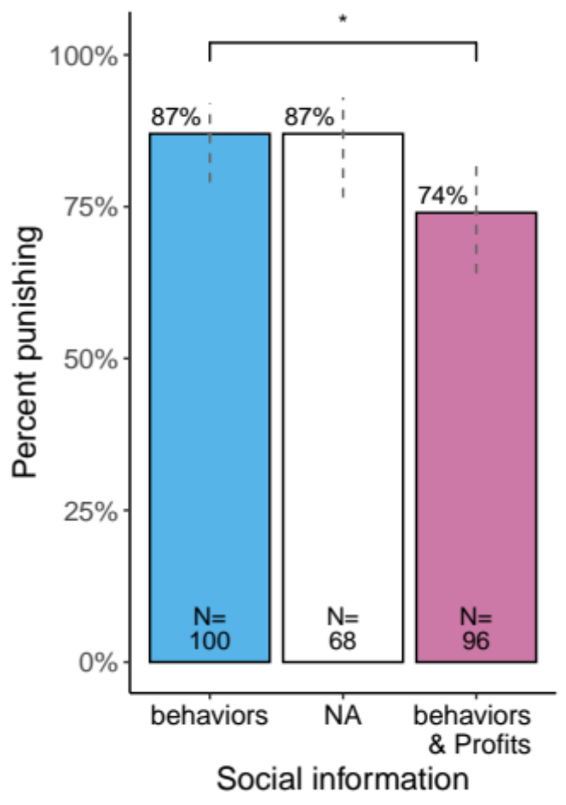
Extended Data Figure 2. Observing group profits reduces the number of punishers. The percentage of individuals that punished somebody at least once in any of the five rounds from the first game series, along with 95% confidence intervals and significant pairwise comparisons. All these sessions had been randomly assigned to play with the punishment mechanism enabled. All individuals saw, in each round, the contributions and payoffs of their groupmates, plus an additional level of social information from the previous experiment of Fehr & Gächter ¹ (Social information, Table 1). All non-shown pair-wise comparisons were non-significant. Dashed lines show 95% confidence intervals.

Appendix 1: full copy of experimental instructions

A. General Instructions (displayed to every participant)

Screen 1, General Instructions

You are going to take part in an economic experiment that has been funded solely for academic research purposes.

If you read the following instructions carefully, you can earn a reasonable amount of money depending on your decisions.

It is therefore very important that you read these instructions carefully. You have all the time you need.

According to the HEC-Labex rules, experimenters are not allowed to lie to you. Therefore, all information given to you during the experiment is true. At no time during the experiment will we lie to you or try to deceive you. For example, if we tell you that you are going to play with a real person, you will really be playing with a real person.

You are not allowed to communicate during the experience. Breaking this rule will exclude you from the experience and will deprive you of any payment. If you have any questions, please don't hesitate to ask us. Please raise your hand. A member of the experiment team will come and answer you privately.

During the experiment, we will not talk about CHF but rather about MUs (Monetary Units).
During the experiment, your earnings will be calculated in MUs.
At the end of the experiment, the total amount you have earned will be converted into CHF with the following rate:

1 MU = 0.025 CHF, so 20 MU = 0.5 CHF.

At the end of the experiment, the generated amount will be immediately paid to you in cash.

We will describe the experimental process on the next page.

Screen 2, Experimental process and instructions for the contribution stage

You will be in a group of 4 people, consisting of yourself and 3 other real people.

There will be 5 rounds of individual decision making. Each decision is anonymous. In each of the 5 rounds, you will be randomly placed in a new group with different people. You will never be grouped with the same person twice during the 5 rounds. There will never be two people in the same group more than once. There are X (according to the session) people participating in the experiment. You will be grouped with 3 different people 5 times, which means that you will interact with 15 different people in total.

For each decision round, there will be 2 steps (step 1 and step 2).

We will first explain Step 1 in full. Then you will have some comprehension questions that will help you understand the instructions (this is not a test!).

We will then explain Step 2 and the experiment will begin.

Step 1: The Contribution Decision

Each member of the group of 4 must decide how to divide 20 MUs. You can keep these 20 MUs in your private account or you can contribute all or part of them to a project. Each MU that you do not put into the project will automatically remain in your private account.

On the next page you can see how your income from step 1 will be calculated.

Screen 3, Instructions for the contribution stage

Step 1: The Contribution Decision

Your Private Account Income:

You will earn 1 MU for every MU you put into your private account.
For example, if you kept 20 MUs in your private account (and therefore did not contribute to the project) your income will be exactly 20 MUs from your private account.
If you keep 6 MU in your account, you will have an income of 6 MU from that account.
Nobody but you receives anything from your private account.

Your project income:

You and your group members will benefit from the amount you put into the project.
In the same way, you will also get an income from the contributions of other group members to the project.
The income of each group member, including you, will be determined as follows:

Project income = sum of all contributions x 0.4

For example, if the sum of all contributions to the project is 60 MU, then you and the other members of your group will receive 60 x 0.4 = 24 MU from the project.
If four group members contribute a total of 10 MU to the project, you and the other members will each receive 10 x 0.4 = 4 MU.

Total income:

Your total income is the sum of your income from your private account and your income from the project :

Income from your private account (= 20 - project contribution)
+ Project income (= 0.4 x sum of all project contributions)
= Your total income

You will start each round, along with the other 3 members of your group, by indicating an individual contribution to the project.

This will be the end of the first step of the round. On the next page, you will find questions to help you understand this step.

Screen 5, Understanding question 1

Question 1: Each member of the group receives 20 MU. No one (including you) contributes to the project.
What is your total income (in MU)?
What is the total income of each other group member?

Screen 6, Understanding question 2

Here is the second question

Question 2: Each member of the group receives 20 MU. You contribute 20 MU to the project. Each of the other three group members also contributes 20 MU to the project.
What is your total income (in MU)?
What is the total income of each other group member?

Screen 7, Understanding question 3

Here is the third question

Question 3: Each group member receives 20 MUs. The other three group members contribute a total of 30 MU to the project.
What is your total income (in MU), if you - in addition to the 30 MU - contribute 0 MU to the project?
What is your total income (in MU), if you - in addition to the 30 MU - contribute 10 MU to the project?
What is your total income (in MU), if you - in addition to the 30 MU - contribute 15 MU to the project?

Screen 8, Understanding question 4

Here is the last question.

Question 4: Each member of the group receives 20 MU. Suppose you contribute 8 MU to the project.
What is your total income (in MU) if the other members of the group together - in addition to you 8 MU - contribute an additional 7 MU to the project?
What is your total income (in MU) if the other members of the group together - in addition to you 8 MU - contribute an additional 12 MU to the project?
What is your total income (in MU) if the other members of the group together - in addition to you 8 MU contribute with 22 additional MU to the project?

Screen 9, Instructions for the punishment stage

Step 2: The Punishment Decision

After you have made your contribution decision, you will see on the screen the details of the decisions of each member of your group.

You will be able to decrease the income of each of the other members of your group by assigning punishment points or you can leave the income unchanged. The other members of your group can also decrease your income if they wish.

Assigning Punishment Points on Income:

You will need to decide if you are awarding punishment points to each of the other 3 members of your group, and if so, how many. In either case, you will need to enter a number for each of them. If you do not want to change the income of a specific member of your group, you will have to enter 0.

Each punishment point assigned costs you 1 MU. For example, if you assign 2 punishment points to one member of your group, it will cost you 2 MU; if you also assign 5 punishment points to another member, it will cost you another 5 MU; and if you assign 0 points to the last member of your group, it will cost you nothing more. In total, in this example, you would have awarded 7 punishment points, so your total punishment costs would be 7 MU (2 + 5 + 0).

At the beginning of step 2, you will receive a new sum of 30 MU.
You can use this money to allocate punishment points to your group members.
The maximum number of punishment points you can award for each round is 30 MU and the maximum punishment you can award to a member of your group is 10 MU.

Screen 10, Instructions for the punishment stage

Step 2: The Punishment Decision

Receiving punishment points

If someone inflicts 0 punishment points on a specific member of their group, it will not affect that member's income. However, if someone inflicts 1 punishment point on a specific member of their group, it will reduce that member's income by 3 MU. If someone inflicts 2 punishment points on a member of their group, that member's income will be reduced by 6 MU, and so on. In short, each punishment point inflicted on another member of his group will reduce the income of that member by 3 MU.

The total income lost in the second step depends on the total number of punishment points suffered. If a person, for example, receives a total of 4 punishment points (inflicted by all other members of his group during this period), his final income will be reduced by 12 MU. If a person receives a total of 5 punishment points, their final income is reduced by 15 MU.

The maximum punishment a person can receive cannot exceed their earnings from the first stage. Therefore, if a person earns 27 MUs in the first stage, he or she could only lose 27 MUs of maximum total punishment, inflicted by the other members of his or her group. Thus, it is impossible to end up with a negative balance.

Similarly, the amount a person can spend on inflicting deductions on others is limited to the received amount of 30 MU. This again ensures that it is impossible to end up with a negative balance.

Your total income from both steps is therefore calculated as follows:

Total income from steps 1 and 2 =
Income from Step 1
- 3 x (sum of punishment points incurred)
+ your second amount received (30 MU)
- total cost of punishment points you have inflicted

After the contribution decision step you, along with the other 3 members of your group, will have to indicate the punishment points you will assign to your group members.

This is the end of step 2. On the next page you will find questions to help you understand this second step of the round.

Screen 11, Understanding questions

Please answer the six comprehension questions. They will help you understand how your income is calculated based on your decisions.

There is a calculator available on the right side of the screen. To access the calculator, click on the image at the bottom right of your screen.

Once you have answered, you will see the correct answers on the next page.

Question 1: Suppose that in step 2, you assign the following punishment points to the other 3 group members: 5, 4 and 0 respectively. What is your total cost of awarding these punishment points?

Question 2: What are your costs if you award a total of 0 points?

Question 3: By how much MU will your income in the first stage change if you receive a total of 0 points of punishment inflicted by the other group members?

Question 4: By how much MU will your income in the first stage change if you receive a total of 4 points of punishment from the other group members?

Question 5: By how much MU will your income in the first stage change if you receive a total of 15 points of punishment from the other group members?

Question 6: What is the value of the second amount that you can use to inflict punishment points?

B. Specific Instructions for Group behaviours and Group profit treatments

Screen 1, Instruction for social information – Group behaviours/Profits

More information

The experiment will now begin

During the experiment, you will all see information from an experiment, similar to yours, that took place in the past at another Swiss university. It was published by Fehr & Gaechter in 2002.

In this other experiment all participants performed the same two steps as you (step 1 and step 2) for at least 5 rounds. They also did the experiment another time, either before or after, with only step 1 (punishing was impossible).

Specifically, we will show you and all other participants the following information (individual averages in the past experiment);

1) What was the average contribution decision (0-20 MU) per round (step 1), depending on whether or not they could punish each other (we will show you the average decision, rounded to one decimal place).

2) What was the average number of punishment points per round that an individual gave to the 3 members of his team (step 2), when they could punish each other (we will show you the average decision, rounded to one decimal place).

3) What was the average profit in MU (positive or negative) (at the end of the round), depending on whether they could, or could not, punish each other (We will show you the average profit made, rounded to one decimal place). [only shown in Group Profits treatment]

This information will appear between the time you have to make a contribution decision and the time you can punish your group members.
You will see the information for the round of the past experiment that corresponds to the round you are in (as a reminder you will be doing 5 rounds).

Screen 2, Understanding questions for social information (True or False)

Please answer the four comprehension questions. They will help you understand the information you are about to see.

When you have answered them, you will see the correct answers on the next page.
Question 1: The additional information we are going to show you comes from an experience that took place in the past?

Question 2: The additional information we are going to show you is separated into a situation where punishing was possible and a situation where punishing was impossible?

Question 3: The additional information we are going to show you corresponds to the averages of the participants according to the different rounds of the past experiment?

Question 4: Each person sees additional information from different experiences?

C. Specific Instructions for Vote behaviours and Vote profit treatments

Screen 1, Instruction for the vote

Vote

Before we begin, each participant, including you, will cast a vote that will determine how the rest of the experiment will proceed.

You can vote for either of these two options:

1) Participate in the experiment WITH the opportunity for everyone to punish and be punished. This implies that everyone will participate in 5 rounds where everyone will first receive 20 MU. You will have to choose how to distribute these 20 MU as explained before (step 1). Then, everyone will receive 30 MU and can punish the members of their group and be punished (step 2).

2) Participate in the experiment WITHOUT the possibility for everyone to punish and be punished. This implies that everyone will participate in 5 rounds where everyone will first receive 20 MU. You will have to choose how to distribute these 20 MU as explained above (step 1). Then, everyone will receive 30 MU but no one will be able to punish the members of their group or be punished (step 2 blocked).

Each participant will vote and the majority vote will be applied for the rest of the experiment. In case of a tie, the experiment will continue without the possibility of punishing or being punished.

Screen 2, Understanding questions for the vote (True or False)

Please answer the three comprehension questions. They will help you understand the vote.

When you have answered, you will see the correct answers on the next page.

Question 1: Will your vote alone determine the outcome of the experiment?

Question 2: Will punishing be possible regardless of the outcome of the vote?

Question 3: If there is a tie, will the experiment proceed without the possibility of punishment?

Screen 3, Instruction for social information – Vote behaviours/Profits

Voting, additional information

Before you vote, you will all see information from an experiment, similar to yours, that took place in the past at another Swiss university. It was published by Fehr & Gaechter in 2002.

In this other experiment, participants did the experiment once with the possibility of punishing each other and once without this possibility. Half of the participants started with one of the two situations and the other half with the other. The situations were then reversed.

Specifically, we will show you and all other participants this information (individual averages in the past experiment);

1) What was, per round, the average contribution decision (0-20 MU) (step 1), depending on whether they could, or could not, punish each other (We will show you the average decision, rounded to one decimal place).

2) What was the average number of punishment points per round given by an individual to the 3 members of his group (step 2), when they could punish each other (We will show you the average decision, rounded to one decimal place).

3) What was the average benefit in MU (positive or negative) (at the end of the round), depending on whether they could punish each other (We will show you the average benefit realized, rounded to one decimal place).[only shown in Vote Profits treatment]

This information will appear on your screen 5 times in a row, corresponding to 5 rounds of the past experiment, then you will have to vote.

Screen 4, Understanding questions for social information (True or False)

See screen B. 2

D. Instructions for the second game series, Treatments voting for the first time

Screen 1, Instruction for the vote

Second part of the experiment

You will now do the experiment a second and final time.

This second experiment is similar to the one you just did (5 rounds and two steps per round) with one exception: before you start, you must take a vote that will determine how this second experiment will be conducted.

Vote

You can vote for either of these two options:

1) Participate in the experiment WITH the opportunity for everyone to punish and be punished. This implies that everyone will participate in 5 rounds where everyone will first receive 20 MU. You will have to choose how to distribute these 20 MU as explained before (step 1). Then, everyone will receive 30 MU and can punish the members of their group and be punished (step 2).

2) Participate in the experiment WITHOUT the possibility for everyone to punish and be punished. This implies that everyone will participate in 5 rounds where everyone will first receive 20 MU. You will have to choose how to distribute these 20 MU as explained above (step 1). Then, everyone will receive 30 MU but no one will be able to punish the members of their group or be punished (step 2 blocked).

Each participant will vote and the majority vote will be applied for the rest of the experiment. In case of a tie, the experiment will continue without the possibility of punishing or being punished.

Screen 2, Understanding questions for the vote (True or False)

See screen C. 2

E. Instructions for the second game series, Treatments voting for the second time

Screen 1, Instruction for the vote

Second part of the experiment

You will now do the experiment a second and final time.

This second experiment is similar to the one you just performed (in 5 rounds and two steps per round). You will again start with a vote that will determine how this second experiment will be conducted.

This time we will not show you any additional information.

Vote

As a reminder, you can vote for either of these two options:

1) Participate in the experiment WITH the opportunity for everyone to punish and be punished. This implies that everyone will participate in 5 rounds where everyone will first receive 20 MU. You will have to choose how to distribute these 20 MU as explained before (step 1). Then, everyone will receive 30 MU and can punish the members of their group and be punished (step 2).

2) Participate in the experiment WITHOUT the possibility for everyone to punish and be punished. This implies that everyone will participate in 5 rounds where everyone will first receive 20 MU. You will have to choose how to distribute these 20 MU as explained above (step 1). Then, everyone will receive 30 MU but no one will be able to punish the members of their group or be punished (step 2 blocked).

Each participant will vote and the majority vote will be applied for the rest of the experiment. In case of a tie, the experiment will continue without the possibility of punishing or being punished.

