Author’s information

¹Research Scholar, Department of ECE, SRM Institute of Science and Technology, Chennai, India.
²Associate Professor, Department of ECE, SRM Institute of Science and Technology, Chennai, India.


Harshita Mathur received the B.Tech degree in Electronics and Communication Engineering from Sir Padampat Singhania University, Udaipur, India, 2015, the M.Tech degree in Telecommunication and Networks from SRM Institute of Science and Technology, Chennai, India, 2018, and is currently pursuing Ph.D. in Electronics and Communication Engineering from SRM Institute of Science and Technology, Chennai, India. She has worked as an assistant professor in electronics and communication engineering department, SRMS CET&R, Uttar Pradesh, India, 2019. Her research interests include 5G and beyond wireless systems, digital signal processing and optical wireless communication. She has published papers in various national and international journals and conferences and is an associate member of the IEI in ET division.

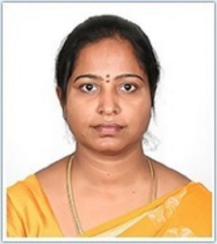
T.Deepa received her B.Tech. degree in Electronics and Communicaiton Engineering (ECE) from Madras University,Chennai,India and her M.Tech degree in Communication Engineering from VIT ,Vellore,Chennai,India in 2004 and 2006 , respectively. She completed her PhD in 2015. She is currently working as an Associate Professor in the department of ECE, SRM Institute of Science and Technology,Kattankulathur, Chennai,India. She has more than 15 publications in SCI/SCOPUS indexed journals and 20 proceedings in International and national conferences. She is currently supervising 6 PhD students. She is an active participant in both academic and research activities. Her research interests are in the areas of wireless communication systems,signal processing, visible light communication, multicarrier and multiple access techniques for 5G communicaitons.

