Additional files

File name: Additional file 1
File format: Excel format.
Title of data:
Mode compositions and porosities of eruptives from the 2011 and 2018 eruptions.
Description of data:
For sample names refer to Table 1. Mode compositions and porosities of the eruptives were determined using the BSE images obtained by EPMA (JEOL JXA-8900 at GSJ, AIST). Eruptives from the 2011 eruptions are composed of 20–25 vol% plagioclase phenocrysts, <5 vol% clinopyroxene phenocrysts, <5 vol% orthopyroxene phenocrysts, <3 vol% olivine phenocrysts, <1 vol% Fe-Ti oxides, and 66–74 vol% groundmass. Eruptives from the 2018 eruptions are composed of 16–33 vol% plagioclase phenocrysts, <6 vol% clinopyroxene phenocrysts, <7 vol% orthopyroxene phenocrysts, <1 vol% of olivine phenocrysts, <1 vol% of Fe-Ti oxides, and 54–73 vol% groundmass. 2018-4L3 has the highest phenocryst content at 46 vol% (and the lowest groundmass content of 54 vol%) and an andesite composition (Table 2), indicating its origin in a silicic andesite end member (Suzuki et al., 2013b). We should note that few olivine phenocrysts were observed in the products of the 2018 eruptions, suggesting that olivines could not be stabilized in the 2018 magma chamber.

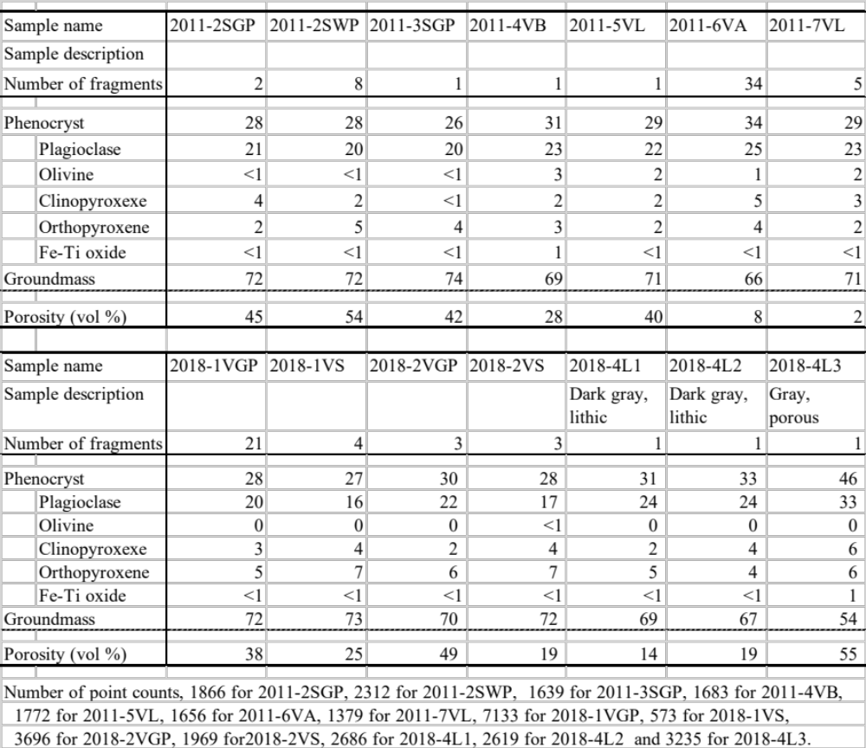

File name: Additional file 2
File format: Pdf format.
Title of data:
Backscattered electron (BSE) images and zoning profiles of olivine, plagioclase, clinopyroxene, and orthopyroxene phenocrysts from the 2011 and 2018 eruptions. (a) olivine, plagioclase, and clinopyroxene phenocrysts in 2011-2SGP. (b) ortho-pyroxene phenocryst in 2011-6VA. (c) olivine phenocryst in 2011-7VL. (d) clinopyroxene phenocryst in 2011-7VL. (e) orthopyroxene phenocryst in 2018-1VGP. (f) plagioclase phenocryst in 2018-1VGP. (g) orthopyroxene phenocryst in 2018-2VGP. (h) clinopyroxene phenocryst in 2018-2VS. (i) plagioclase phenocryst in 2018-4L2. (j) orthopyroxene phenocryst in 2018-4L1. (k) clinopyroxene phenocryst in 2018-4L1. (l) olivines and orthopyroxenes in 2018-4L2.
Description of data:
For sample names refer to Table 1. Backscattered electron (BSE) images were observed by EPMA. Line analyses of the phenocrysts were also carried out along the arrows shown in the BSE images by EPMA. X-axes denote the distance from the rim (mm). Y-axes indicate Mg# (= Mg/(Mg+Fe) x 100% in mol) in olivines and pyroxenes or An# (=Ca/(Ca+Na) x 100% in mol) in plagioclases. Compositional profiles of 13 orthopyroxene phenocrysts and 4 clinopyroxene phenocrysts in 2011-1PP to 2011-7VL and 12 orthopyroxene phenocrysts and 4 clinopyroxene phenocrysts in 2018-1VGP to 2018-1VS with rims showing reverse zoning measured from core to rim.
The calculated diffusion profiles of clino- and ortho-pyroxenes (Saunders et al. 2012) are also shown as colored curves; red, green, and blue curves show residence times of 1, 10, and 100 years. The diffusion profiles were calculated assuming that the reverse zoning profiles were the result of mixing felsic magma with pyroxenes and mafic magma. Temperatures of the mixed magmas were assumed to be 928 ºC for the 2011 eruptions and 944 ºC for the 2018 eruptions. Diffusion coefficients of Mg-Fe in orthopyroxene are 4.39 x10⁻²⁰ at 928 ºC and 5.79x 10⁻²⁰ at 944 ºC (Cherniak and Dimanov, 2010). Diffusion coefficients of Mg-Fe in clinopyroxene are 1.35 x 10⁻²¹ at 928 ºC and 1.96 x 10⁻²¹ at 944 ºC (Cherniak and Dimanov, 2010).
The compositional profiles of 2 orthopyroxene phenocrysts in (a) 2011-3SGP and (b) 2011-6VA show a large change in Mg# 0.02–0.03 mm from the rims, with widths of less than 0.005 mm. The observed Mg# profiles of orthopyroxenes in the 2011 products are similar to those obtained for 1 year by calculation. On the other hand, the compositional profiles of 3 orthopyroxene phenocrysts in 2018-1VGP (e), 2018-2VGP (g), and 2018-4L1 (j) show large changes in Mg# at a distance of 0.04–0.10 mm from the rims. The widths of the Mg# range from 0.010 to 0.028 mm, which is significantly larger than those observed in the 2011 products. The observed Mg# profiles appear to be close to those obtained for 10 years by calculation. The compositional profile of a clinopyroxene phenocryst in 2011-7VL (d) shows a large change in the Mg# at a distance of 0.03 mm from the rims; however, 2 clinopyroxene phenocrysts in 2018-2VS (h) and 2018L1 (k) show large changes 0.06–0.14 mm from the rims. The widths of the Mg# changes are less than 0.010 mm in both the 2011 and 2018 products. Calculation of the Mg# changes in the clinopyroxene by diffusion indicate a width of over 0.01 mm for 100 years at best. The lack of different widths for the Mg# change zones in the 2011 and 2018 products might be due to slower diffusion.
We also measured the widths of the plagioclase-phenocryst rims from the 2011 and 2018 eruptions based on BSE images by SEM. A total of 10% of the 222 plagioclase phenocrysts in the 2011 products (2011-1PP to 2011-7VL) have rims reaching more than 0.1 mm in length (Additional file 2a). The maximum width of the plagioclase-phenocryst rims in 2011-1PP to 2011-5VL from January–February 2011 is 0.16 mm, except for 2011-2SWP (0.20 mm). On the other hand, the rims from 2011-6VA (March) and 2011-7VL (April) showed widths of 0.26 and 0.22 mm, respectively. This increase in the maximum width suggests crystallization of the magma chamber over time. A total of 28 % of the 85 plagioclase phenocrysts in the 2018 products have rims of more than 0.1 mm in width. This increase in the fraction of plagioclases with wide rims suggests that crystallization occurred in the magma chamber over time. The maximum width of the plagioclase-phenocryst rims from the 2018 eruptions is 0.20 mm, which is similar to those found in 2011-6VA and 2011-7VL.
All clinopyroxene phenocrysts from the 2011 products (2011-1PP to 2011-7VL) observed in this study (totaling99) have rims of less than 0.05 mm. On the other hand, 13 % of the 68 clinopyroxene phenocrysts from the 2018 products have rims of more than 0.05 mm in length, and the maximum width of clinopyroxene-phenocryst rims from the 2018 eruptions is 0.16 mm.
A total of 3 % of orthopyroxene phenocrysts in the 2011 products (numbering 135) have rims of more than 0.05 mm, while 21 % of the 82 orthopyroxene phenocrysts in the 2018 products have rims reaching more than 0.05 mm in length. The maximum width of the orthopyroxene-phenocryst rims increased from 0.07 mm in 2011 to 0.16 mm in 2018. The increase in the number of clinopyroxenes and orthopyroxenes with wide rims ( more than 0.05 mm) and the maximum width of the rims from 2011 to 2018 suggests crystallization in the magma chamber over time.
The olivine phenocrysts in the 2011 products have core compositions of Fo_{74–80} (Figure 3d). These phenocrysts have rims that show normal zoning with widths of less than 0.06 mm. In addition, approximately 80 % of the olivine phenocrysts have orthopyroxene rims of less than 0.03 mm. On the other hand, the rare olivine phenocrysts in the 2018 products (Additional file 1) have large orthopyroxene rims. No groundmass-olivines were observed in the 2018 products. These observations indicate that the physical and chemical conditions in the 2018 magma were not sufficiently stable for the crystallization of olivine.

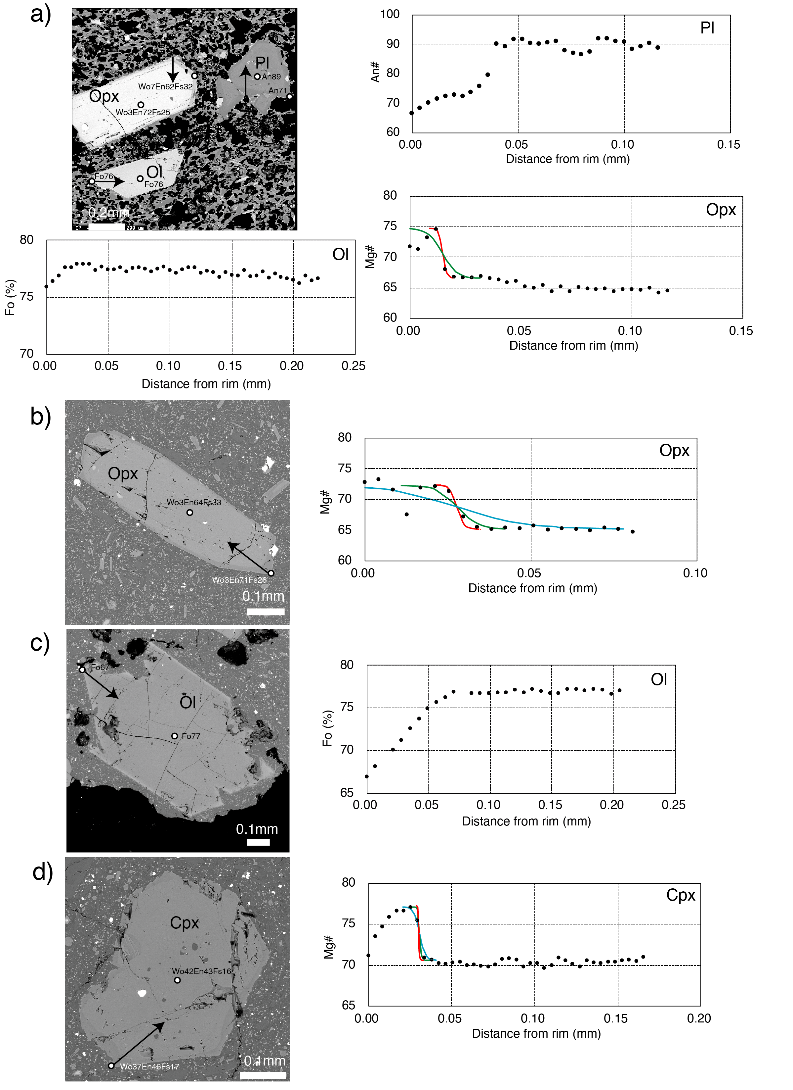
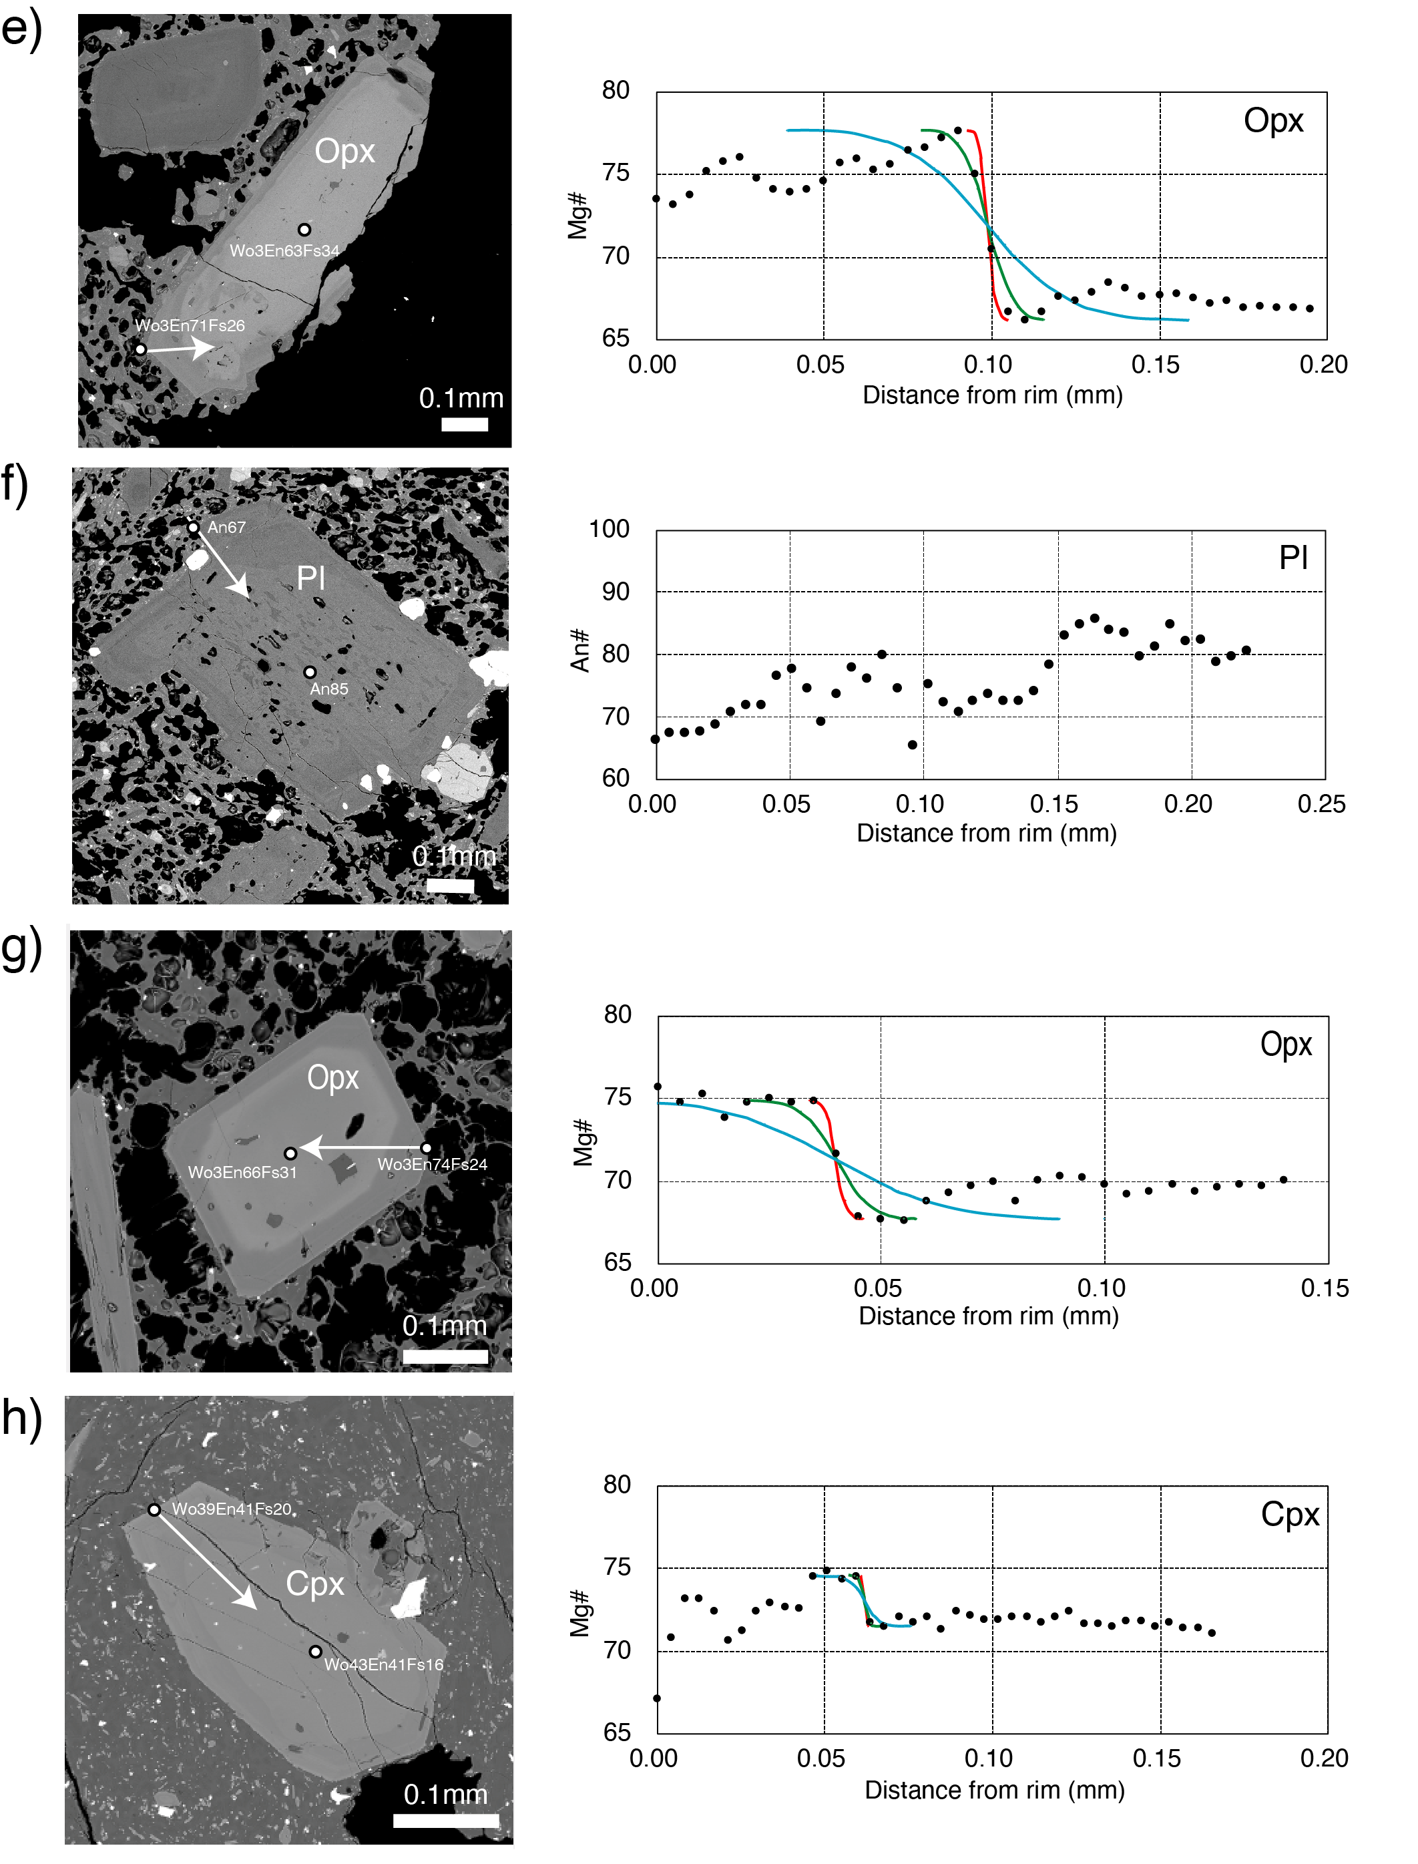
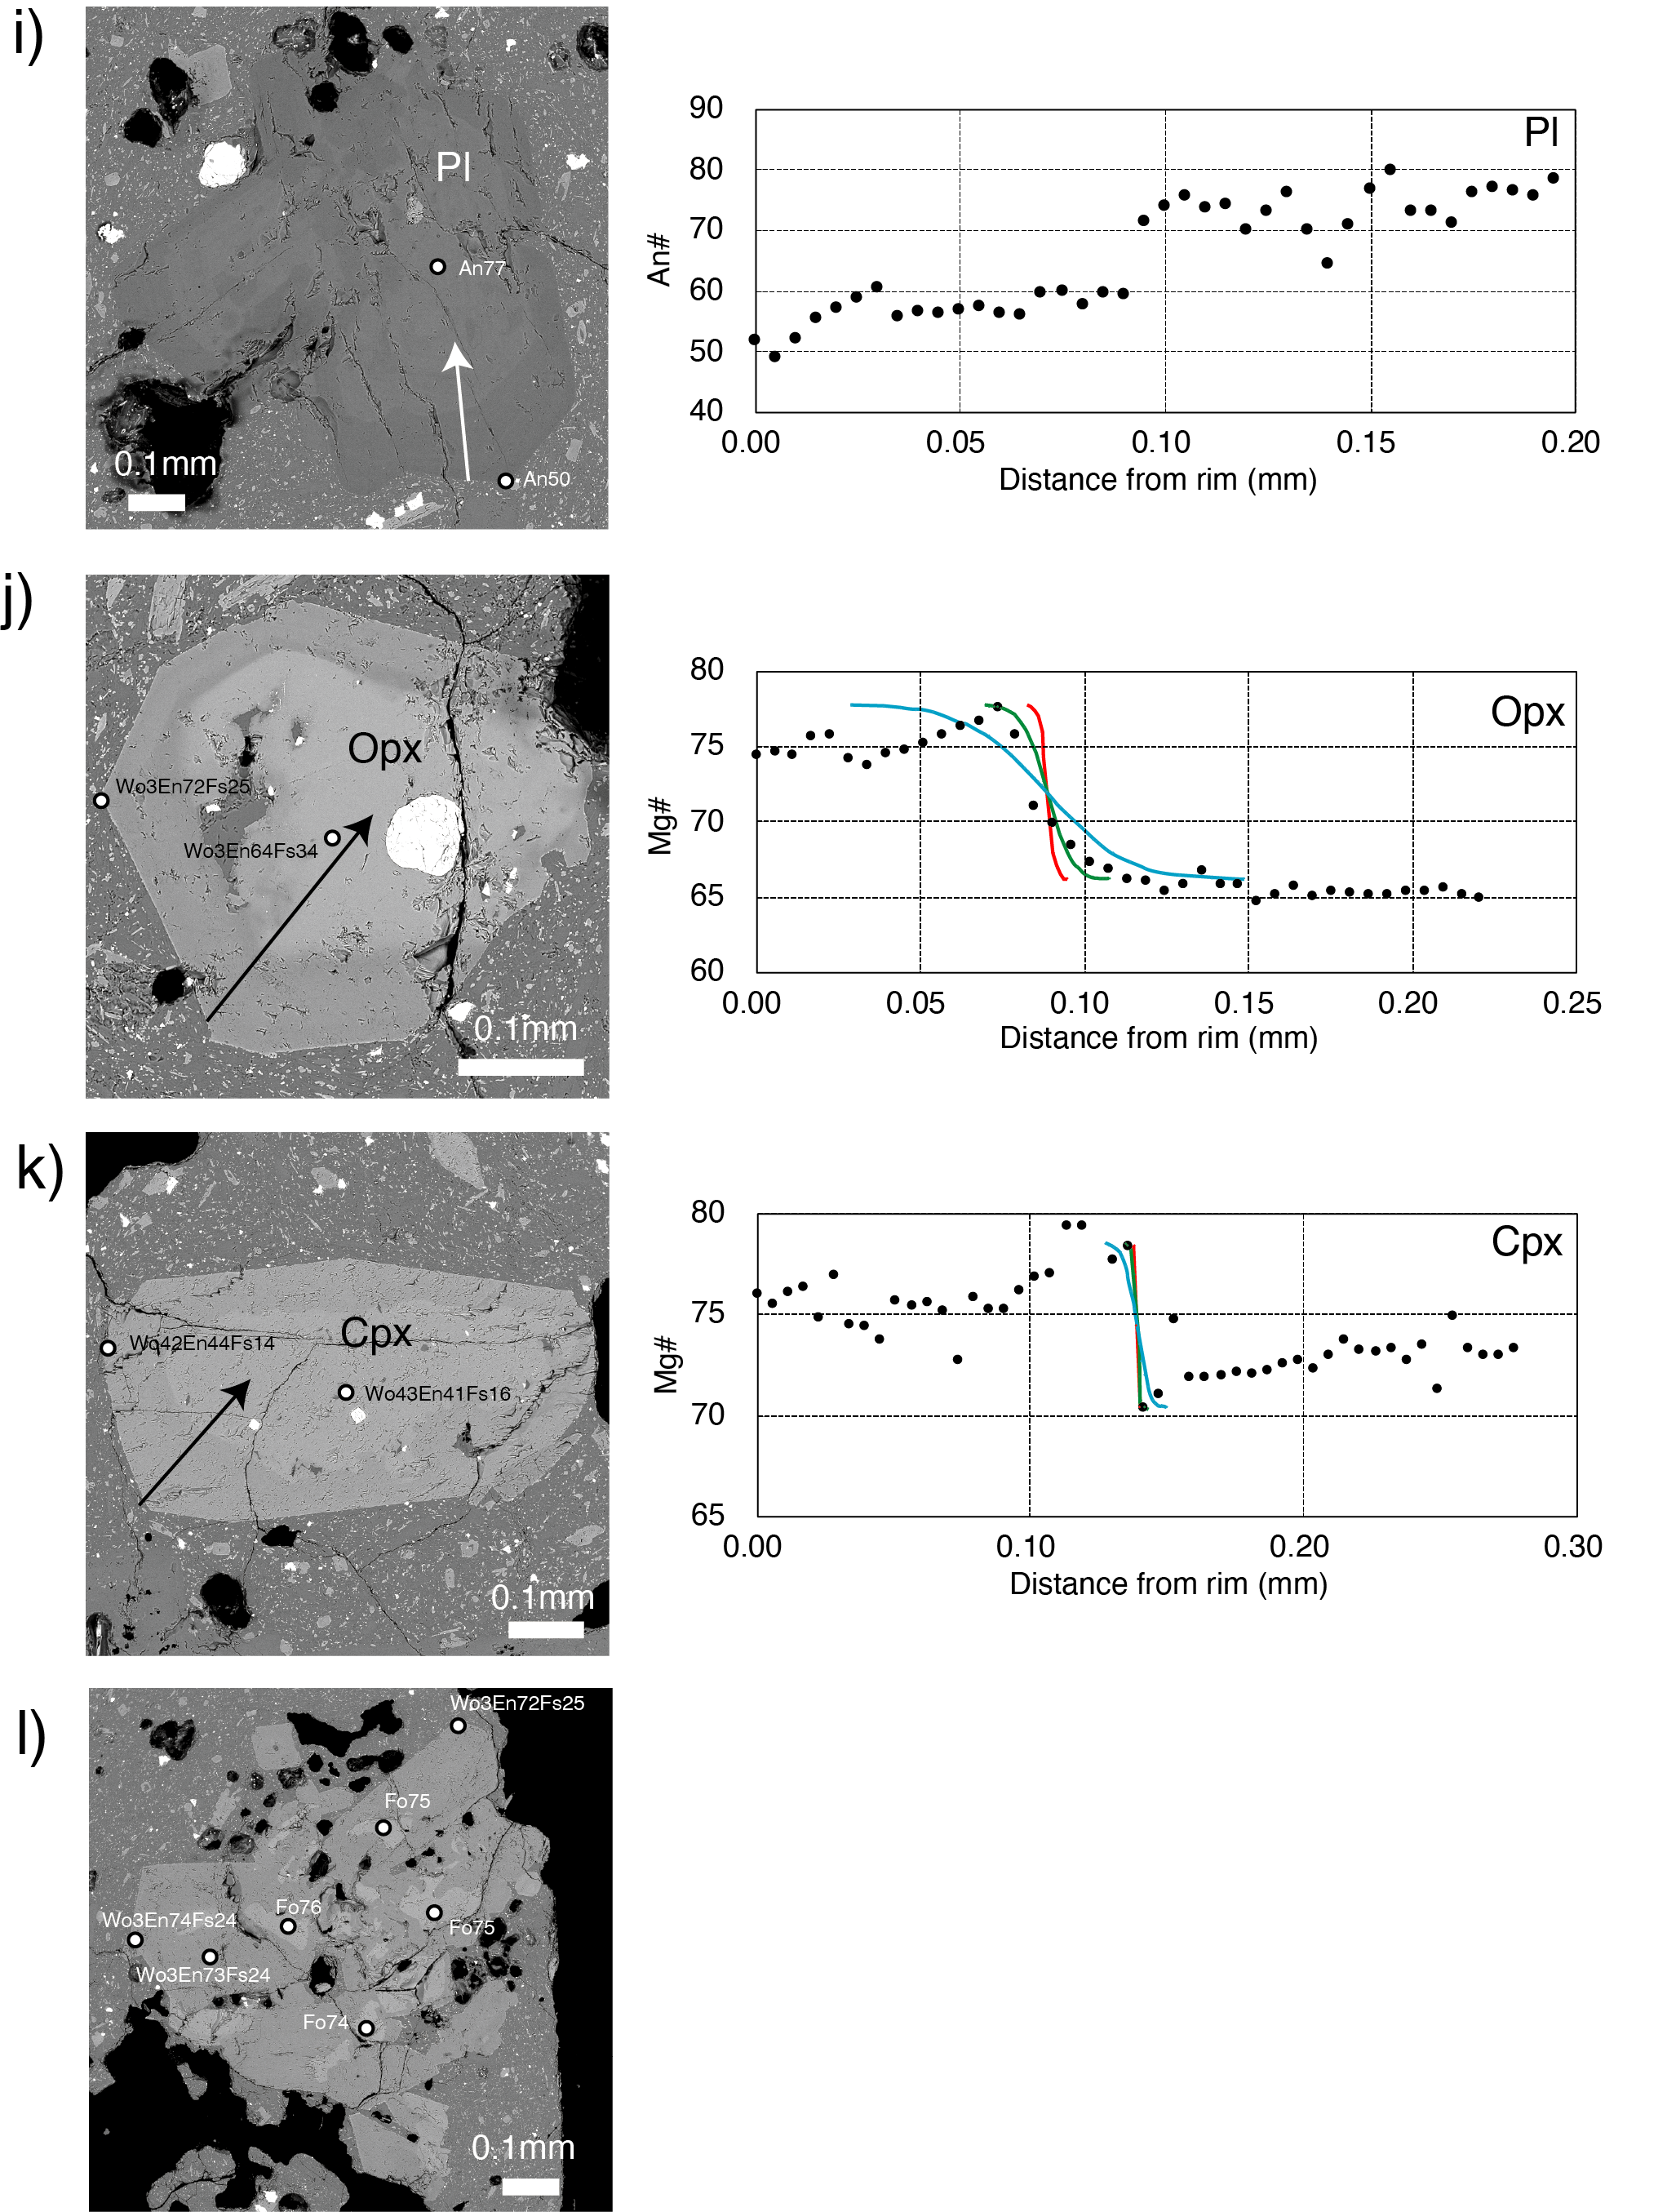

File name: Additional file 3
File format: Excel format.
Title of data:
Chemical compositions (in weight percent) of groundmass in eruptives from the 1716–17, 2011, and 2018 eruptions.
Description of data:
The major element compositions were recalculated on a volatile-free basis. For sample names refer to Table 1. Chemical compositions of the groundmasses were analyzed using EPMA. An accelerating voltage of 15 keV, a beam current of 10 nA, and a defocused beam with a 20-µm diameter were used as EPMA analytical conditions. The groundmasses of 2011-1PP, 2011-2SGP, and 2011-3SGP have andesitic composition, with 61–62 wt% SiO₂, and 2.1–2.2 wt% K₂O. On the other hand, the groundmass of 2011-2SWP has a rhyolitic composition with 71 wt% SiO₂ and 3.8 wt% K₂O. The groundmasses from the eruption products in February-–August 2011 have similar or slightly SiO₂- and K₂O-richer compositions (62–68 wt% SiO₂ and 2.0–3.5 wt% K₂O) to the subplinian gray pumices from January 2011. The groundmasses of 2018-1VGP, 2018-1VS, 2018-2VGP, and 20187-2VS have a dacite composition with 64–66 wt% SiO_{2,} and 2.5–2.9 wt% K₂O. The groundmasses of 2018-4L1 and L2 (dark-gray and lithic lava) also have a dacite composition (66 wt% SiO₂, and 2.7 wt% K₂O), which is the same as 2018-2VS. On the other hand, the groundmass of 2018-4L3 (gray and porous lava) has a rhyolitic composition of 75 wt% SiO₂ and 4.5 wt% K₂O.

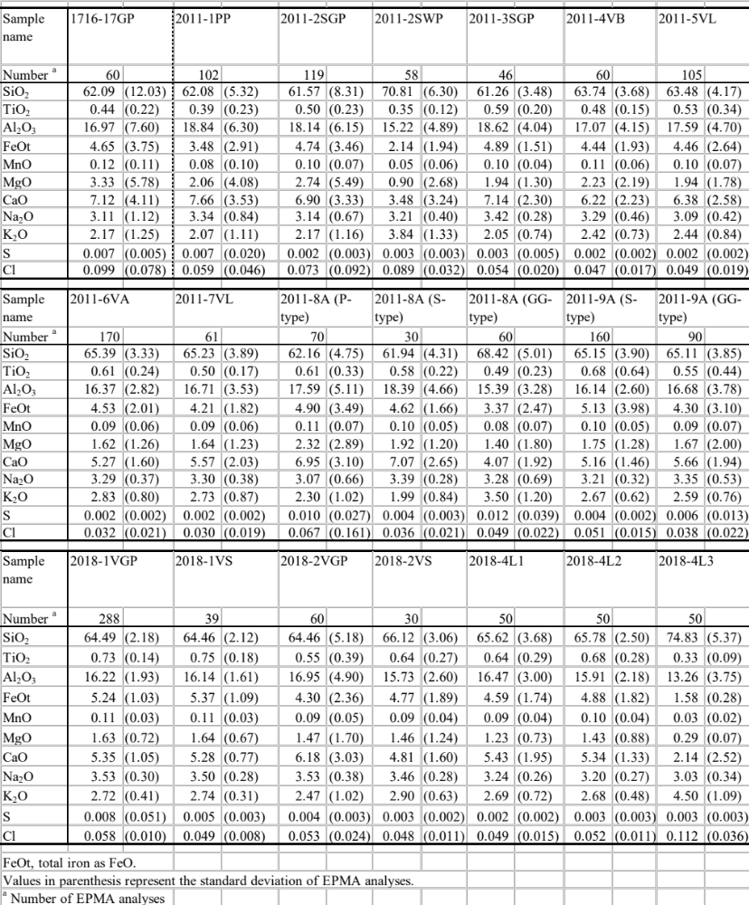

File name: Additional file 4
File format: Excel format.
Title of data:
Chemical compositions (in weight percent) of melt inclusions in phenocrysts from the eruptives in the 1235, 1716–17, 2011, and 2018 eruptions analyzed in this study.
Description of data:
The major element composition was recalculated on a volatile-free basis. The water contents of the inclusions were analyzed by EPMA. For sample names refer to Table 1. Chemical analyses of the melt-inclusions and their host phenocrysts were carried out using EPMA (JEOL JXA-8900 at GSJ, AIST). The analytical conditions are identical to those reported by Saito et al. (2018). A search for the S Kα radiation wavelength was also performed via S analysis and the proportions of sulfide and sulfate in the inclusions determined (Wallace and Carmichael 1994). The H₂O content of the inclusions was estimated via EPMA, assuming that the H₂O content is equal to the difference between 100 % and the sum of the measured contents. The error in this estimation of ±1 wt% was based on repeated analyses of the standard glass samples.
A total of 12 inclusions in 1716-17GP, 3 inclusions in 2011-1PP, 13 inclusions in 2011-2SGP, 5 inclusions in 2011-2SWP, 10 inclusions in 2011-3SGP, 5 inclusions in 2011-4VB, 7 inclusions in 2011-5VL, 2 inclusions in 2011-6VA, 2 inclusions in 2011-7VL, and 15 inclusions in 2018-1VGP were analyzed, except for those shown in Table 3. The host phenocrysts comprised plagioclases, olivines, clinopyroxenes, orthopyroxenes, and ilmenite. The oxygen fugacity and ratio of Fe (+2) to total Fe were calculated from the proportions of sulfide and sulfate in the inclusions. The temperature of the magma was estimated from the chemical compositions of the inclusions and their host olivines or plagioclases, using olivine-liquid and plagioclase-liquid thermometers (Putirka 2008). The olivine-liquid thermometer was applied to the chemical compositions of the melt and the host phenocrysts of 22 olivine-hosted melt inclusions from the 2011 ejecta in order to estimate the temperature of the mafic end member magma with olivine phenocrysts. Temperatures of 940–1041 °C were obtained (average of 990 °C with standard deviation of ±25 °C), which are similar or slightly lower than the estimates obtained for basaltic andesite magma by Suzuki et al. (2013b). Plagioclase-liquid thermometers were also applied to the chemical compositions of the melt and host phenocrysts of 10 plagioclase-hosted melt inclusions to obtain temperatures of 921–953 °C (average of 937 °C with a range of ±16 °C) from 1716–17GP, 912–957 °C (average of 938 °C with standard deviation of ±23 °C) from 2011–2SGP and 2011-3SGP, 953 °C from 2011-2SWP, and 951–983 °C (average of 973 °C with standard deviation of ±15 °C) from 2018-1VGP.
The temperatures and pressures of the magmas were estimated from the chemical compositions of the inclusions and their host clinopyroxenes or orthopyroxenes using clinopyroxene-liquid and orthopyroxene-liquid thermobarometers (Putirka 2008). Clinopyroxene-liquid thermometers were applied to the chemical compositions of the melt and the host phenocrysts of 20 clinopyroxene-hosted melt inclusions to obtain temperatures of 989 °C from 1235S, 940–1014 °C (average of 961 °C with standard deviation of ±28 °C) from 1716-17GP, 925–973 °C (average of 951 °C with standard deviation of ±18 °C) from the 2011 ejecta, and 925–992 °C (average of 955 °C with standard deviation of ±33 °C) from 2018-1VGP. Orthopyroxene-liquid thermometers were applied to the chemical compositions of the melt and host phenocrysts of 14 orthopyroxene-hosted melt inclusions to obtain temperatures of 974 °C from 1716-17GP, 978–1072 °C (average of 978 °C with standard deviation of ±36 °C) from 2011-2SGP, 2011-3SGP, 2011-4VB, 2011-6VA, and 2011-7VL, 946 °C from 2011-2SWP, and 955–1022 °C (average of 979 °C with standard deviation of ±29 °C) from 2018-1VGP. Details of the geological thermometers and barometers are shown in the footnotes.
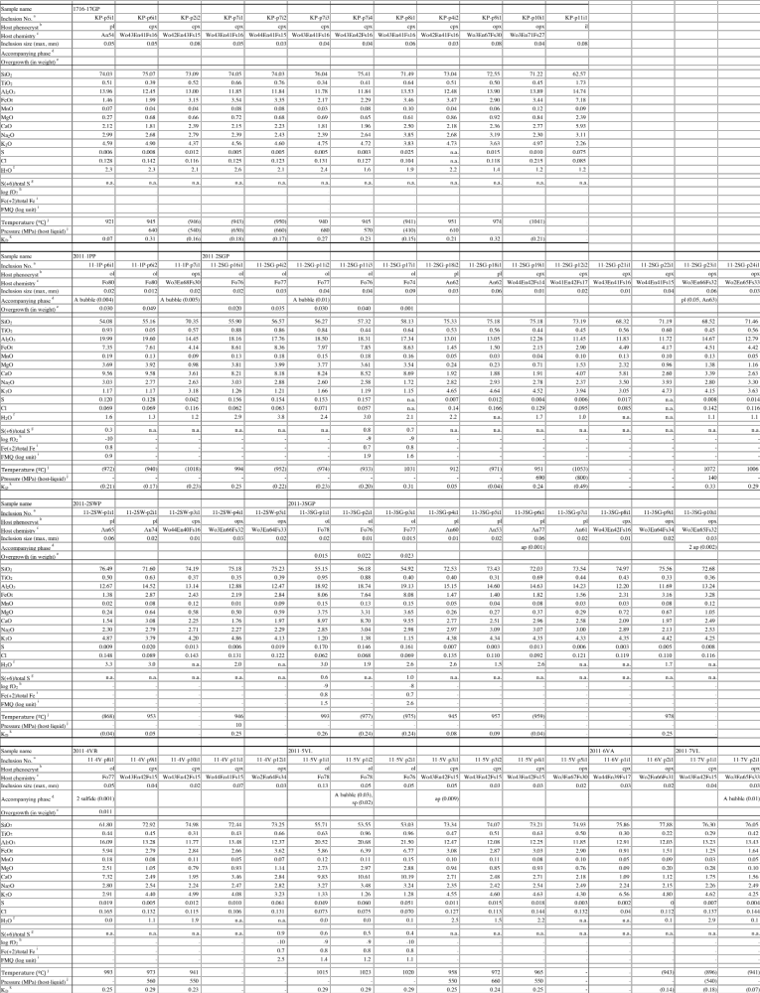

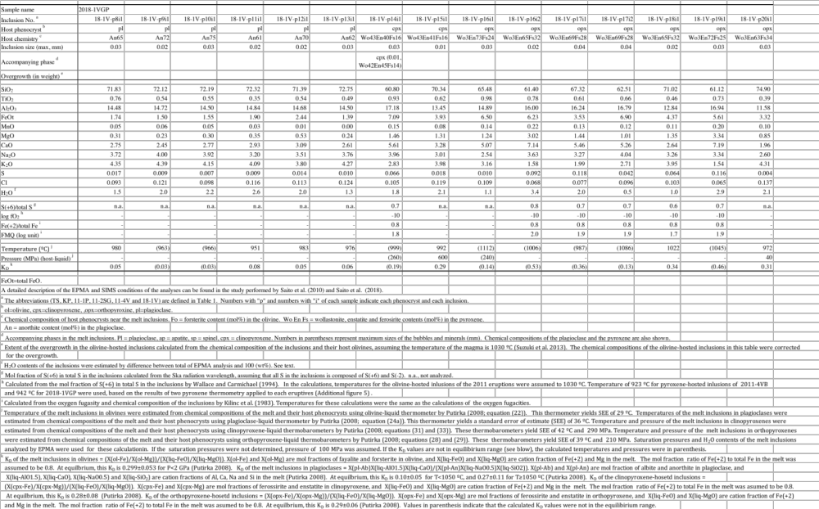

File name: Additional file 5
File format: Pdf format.
Title of data:
Magma temperature estimated from two-pyroxene thermometry and FeTi oxide thermometry applied to the 2011 and 2018 eruptives.
Description of data:
The figure shows the magma temperature estimated from two-pyroxene thermometry (Putirka 2008) and FeTi oxide thermometry (Anderson et al. 1993). For sample names refer to Table 1. Average temperatures of 1 sigma or a range are shown together with the number of intergrown phenocrysts analyzed (in parenthesis).
Two-pyroxene thermometry and FeTi oxide thermometry were applied to the compositions in the borders of intergrown phenocrysts composed of ortho- and clino-pyroxene pairs and magnetite and ilmenite pairs. The application of two-pyroxene thermometry to all eruptions in 2011 yielded temperatures of 908–945 ºC, except for 2011-8A, which gave a higher temperature (1055±10 ºC). Temperature estimation was also conducted from the compositions of the rims of the intergrown phenocrysts to yield temperatures of above 1000 ºC for some of the eruptions in January–April 2011. The increase in the magma temperatures to >1000 ºC might be a result of heat supplied by a high-temperature magma shortly before the eruptions. 2011-2SWP, whose whole-rock composition is dacite (Table 2), has the lowest temperature of 908 ºC in the 2011 eruptives. The application of FeTi oxide thermometry to these samples yielded a similar but wider range of temperatures (891–977 ºC) than the results obtained by two-pyroxene thermometry.
Two-pyroxene thermometry of all eruptions in 2018 yielded temperatures of 914–944 ºC. FeTi oxide thermometry yielded a wider range of temperatures (868–985 ºC) than two-pyroxene thermometry. The large standard deviation (948±121 ºC) for 2018-4 L1 and L2 and the low estimate (868±10 ºC) for 2018-4L3 obtained by FeTi oxide thermometry may have been affected by re-equilibration during or after eruption. We should note that the temperatures of the 2018 eruptives (914–944 ºC) are similar to those of the 2011 eruptives (908–945 ºC), suggesting that the temperature of the magma chamber did not change from 2011 to 2018.
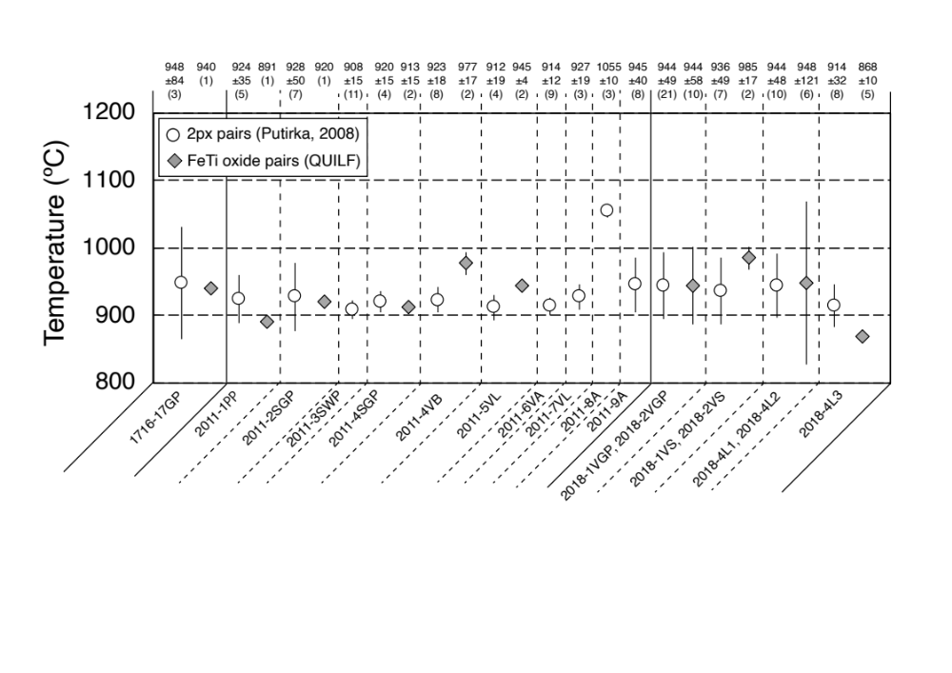

File name: Additional file 6
File format: png format.
Title of data:
Magma temperature and oxygen fugacity estimated from FeTi oxide thermometry applied to coexisting FeTi-oxide pairs in the 2011 and 2018 products.
Description of data:
For sample names refer to Table 1. The temperatures and oxygen fugacities were estimated using QUILF (Anderson et al. 1993). The temperature and oxygen fugacity for 1716-17GP were 940 ºC and -9.9 log units (2.0 log units above FMQ buffer), respectively. The temperatures and oxygen fugacities for the 2011 products were 891 ºC and -12.1 log units (0.6 log units above FMQ buffer) for 2011-1PP, 920 ºC and -10.4 log units (1.8 log units above FMQ buffer) for 2011-2SGP, 913±15 ºC (range, n=2) and -10.5±0.1 log units (range, n=2; 1.8±0.1 log units above FMQ buffer) for 2011-3SGP, 977±17 ºC (range, n=2) and -9.9±0.2 log units (range, n=2; 1.3±0.1 log units above FMQ buffer) for 2011-4VB, and 945±4 ºC (1sigma, n=3) and -10.7±0.1 log units (1sigma, n=3; 1.1±0.2 log units above FMQ buffer) for 2011-5VL. The temperatures and oxygen fugacities for the 2018 products were 944±58 ºC (1sigma, n=10) and -10.0±0.9 log units (1sigma, n=10; 1.8±0.3 log units above FMQ buffer) for 2018-1VGP and 2018-2VGP, 985±17 ºC (range, n=2) and -9.9±0.1 log units (range, n=2; 1.2±0.2 log units above FMQ buffer) for 2018-1VS and 2018-2VS, 948±121 ºC (1sigma, n=6) and -10.5±1.6 log units (1sigma, n=6; 1.4±0.7 log units above FMQ buffer) for 2018-4L1 and 2018-4L2, and 868±10 ºC (1sigma, n=5) and -11.2±0.1 log units (1sigma, n=5; 1.9±0.1 log units above FMQ buffer) for 2018-4L3. The temperatures obtained for 2018-1VGP, 2018-2VGP, 2018-1VS, 2018-2VS, 2018-4L1, and 2018-4L2 (944-985ºC) are similar to those obtained for the 2011 products (913-977ºC), except 2011-1PP. In addition, the oxygen fugacities obtained for the 2018 products (-10.5 to -9.9 log units and 1.2–1.8 log units above the FMQ buffer, for 2018-1VGP, 2018-1VS, 2018-2VGP, 2018-2VS, 2018-4L1, and 2018-4L2) are identical to those of the 2011 products (-10.7 to -9.9 log units and 1.1-1.8 log units above the FMQ buffer), except 2011-1PP. These results suggest that the temperature and oxidation state of the magma chamber did not change from 2011 to 2018.
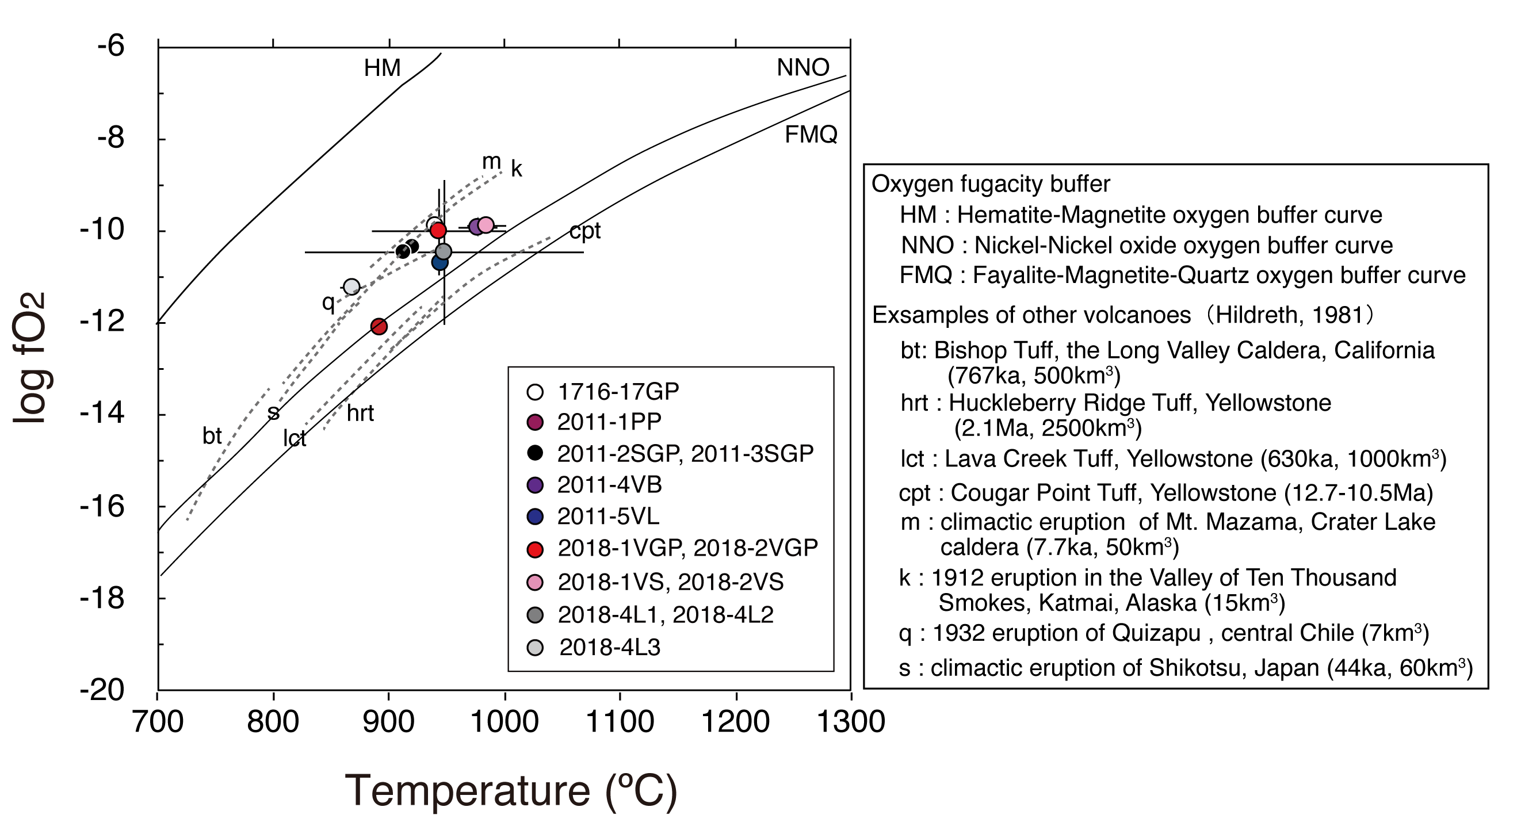

File name: Additional file 7
File format: Excel format.
Title of data:
Densities of H₂O and CO₂ gases at temperatures of 870, 928, 944, and 1030 °C calculated by the Modified Redlich-Kwong equation of state (Holloway 1981).
Description of data:
The bubble volume (vol%) and densities of the A1, A2, B1, B2, M1, M2, F1, and F2 magmas (shown in Additional file 8) were calculated using the densities of the H₂O and CO₂ gases in this table.

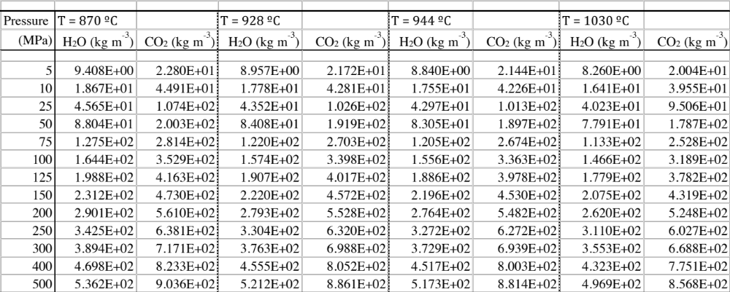

File name: Additional file 8
File format: Excel format.
Title of data:
Mode compositions (in volume percent), chemical compositions (in weight percent) and melt viscosities, bubble volumes, and densities of the A1, A2, B1, B2, M1, M2, F1, and F2 magmas at pressure ranges of 5–500 MPa calculated in this study.
Description of data:
The chemical compositions of the melts were recalculated on a volatile-free basis. FeOt means total iron in terms of FeO. Mode compositions (in volume percent), chemical compositions (in weight percent), and viscosity of the melts were calculated using MELTS program. Bubble volumes and the densities of the magmas were calculated from the MELTS results and the H₂O-CO₂ mixed fluid saturation model of Ghiorso and Gualda (2015), and the densities of H₂O and CO₂ gases (Additional file 7) were calculated using the following procedures, which are also shown in Additional file 4 of Saito et al. (2018).
Step 1. MELTS calculation (Gualda et al. 2012) was performed for the A1, A2, B1, B2, M1, M2, F1, and F2 magmas using the whole-rock composition of 2011-2SGP (Table 2), a temperature of 928 °C (Additional file 5) and an oxygen fugacity of FMQ+2 (Additional file 6) for the A1 and A2 magmas, the whole-rock composition of 2018-1VGP (Table 2), a temperature of 944 °C (Additional file 5) and the oxygen fugacity of FMQ+2 (Additional file 6) for the B1 and B2 magmas, the whole-rock composition and temperature of 1030 °C estimated for basaltic andesite end member of the 2011 eruption by Suzuki et al. (2013b) and an oxygen fugacity NNO for the M1 and M2 magmas, the whole-rock composition of 2011-2SWP (Table 2), a temperature of 870 °C estimated for the silicic andesite end member magma of the 2011 eruption by Suzuki et al. (2013b) and an oxygen fugacity of FMQ+2 for the F1 and F2 magmas. The H₂O and CO₂ contents of the magmas used in these calculations are shown in Table 4. The MELTS calculation gives the mass fraction for the melt and solid phases, kinds of minerals present, chemical compositions, densities of the melt and the minerals, and viscosity of the melt. Volume fractions were calculated from the mass fractions and densities of the melt and minerals.
Step 2. The density of the H₂O and CO₂ gases were calculated at temperatures of 928, 944, 1030, and 870 °C and pressures of 500 and 5 MPa using the Modified Redlich-Kwong equation of state (Holloway 1981). The results of these calculations are summarized in Additional file 7.
Step 3. The H₂O and CO₂ contents (wt%) of the fluid (melt + gas) were calculated from the bulk H₂O and CO₂ contents of the magmas and the mass fraction of the melt and gas phases in the system obtained by the above MELTS calculation, assuming that the solid phases (olivine, plagioclase, clinopyroxene, orthopyroxene, and oxides) did not contain H₂O and CO₂. In addition, the chemical composition of the melt was recalculated assuming the mole fraction of 0.8 for Fe (+2) as the total Fe for the melt.
Step 4. The H₂O and CO₂ contents of the melt, gas fraction in the fluid (wt%), and mole ratio of H₂O and CO₂ in the gas phase in the magmas at given temperatures and pressures were calculated from the chemical composition of the melt and the H₂O and CO₂ contents (wt%) of the fluid (by Step 3), using the H₂O-CO₂ mixed fluid saturation model of Ghiorso and Gualda (2015). An online app of the model, MagmaSat that is provided by Ghiorso and Gualda (2015), was used for these calculations. The results give mass fractions of the H₂O gas, CO₂ gas, and melt in the fluid.
Step 5. Volumes of H₂O and CO₂ gases and the melt in the fluid were calculated from the mass fractions of the H₂O and CO₂ gases and the melt with the densities of H₂O and CO₂ gases (by Step 2) and the density of the melt (by Step 1).
Step 6. The magma density was calculated from the volume fractions of H₂O gas, CO₂ gas, and the melt (by Step 5), with those of the melt and minerals (by Step 1), and the mass fractions of the H₂O and CO₂ gases and the melt (by Step 4), with that of the melt and minerals (by Step 1).
The subplinian gray pumices in 2011-2GSP and 2011-3GSP have porosities of 42–45 vol% and groundmass contents of 72–74 vol% (Additional file 1). The same bubble volume could be reproduced for A1 and A2 magmas at pressure ranges of 50–75 MPa and the same melt contents could be reproduced for A1 and A2 magmas at pressure ranges of 125–200 MPa, which is similar to the pressure estimate for the 2011 felsic magma (120±50 MPa and 152±25 MPa) obtained from the gas saturation pressures of the dacite-rhyolite inclusions in the 2011 products.
The porosity of the groundmass is 19–49 vol% for 2018-VGP, 2018-1VS, 2018-2VGP, and 2018-2VS (Additional file 1). The table shows that the B1 and B2 magmas have the same bubble volumes at pressure ranges of 25–100 MPa. The groundmass content in the 2018 products is 70–73 vol% for 2018-1VGP, 2018-1VS, 2018-2VGP, and 2018-2VS (Additional file 1). The same melt content could be reproduced for the B1 magma over a pressure range of 125–300 MPa, which is consistent with the pressure estimated for the 2018 magma (118±45 MPa and 144±44 MPa) obtained from gas saturation pressures of the andesite-rhyolite inclusions. On the other hand, the same melt content could not be obtained for the B2 magma at 5–500 MPa. This suggests that the B1 magma might be a more realistic match for the 2018 magma than the B2 magma.

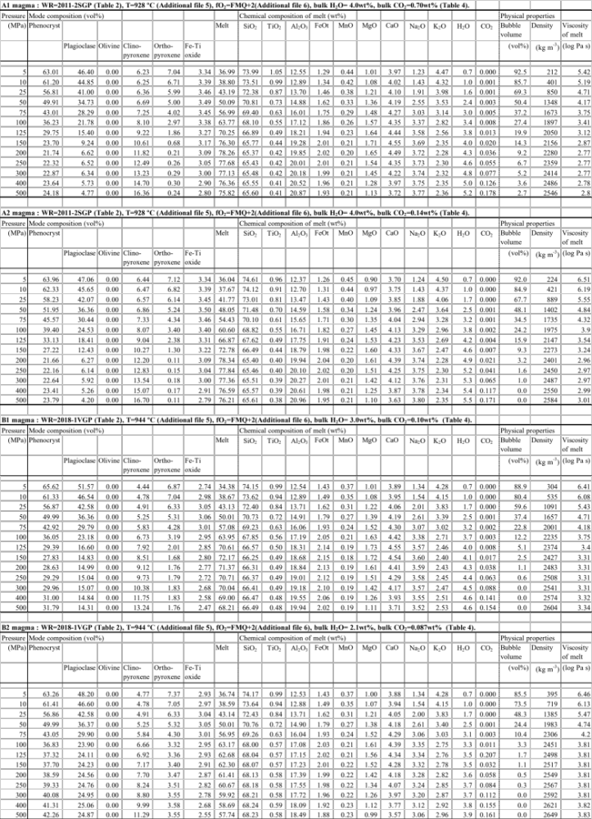

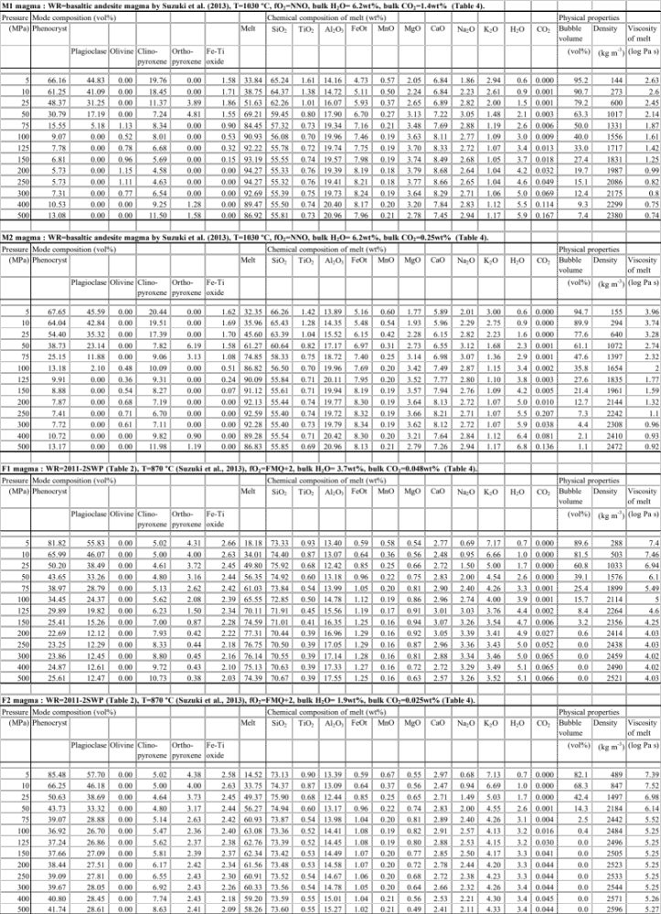
File name: Additional file 9
File format: Excel format.
Title of data:
Mode compositions (in volume percent), chemical compositions (in weight percent) of melts, bubble volume and density of mixed magmas (M1+F1, M1+F2, M2+F1, and M2+F2) calculated in this study.
Description of data:
The chemical compositions of the melts were recalculated on a volatile-free basis. The bubble volume (vol%) and densities (kg m⁻³) of the mixed magmas were calculated based on the results obtained for the M1, M2, F1, and F2 magmas (Additional file 8) with the densities of the phenocrysts and melts obtained by MELTS and the H₂O and CO₂ gases in Additional file 7. The mixing mass ratio of the mafic and felsic magmas is M1 (or M2) : F1 (or F2) = 0.65:0.35.
The subplinian gray pumices of 2011-2GSP and 2011-3GSP have porosities of 42–45 vol% and a groundmass content of 72–74 vol% (Additional file 1). The same bubble volume could be reproduced for the M1+F1 to M2+F2 magmas at pressure ranges of 50–75 MPa and the same melt contents could be reproduced for the M1+F1 to M2+F2 magmas at pressure ranges of 50–100 MPa.

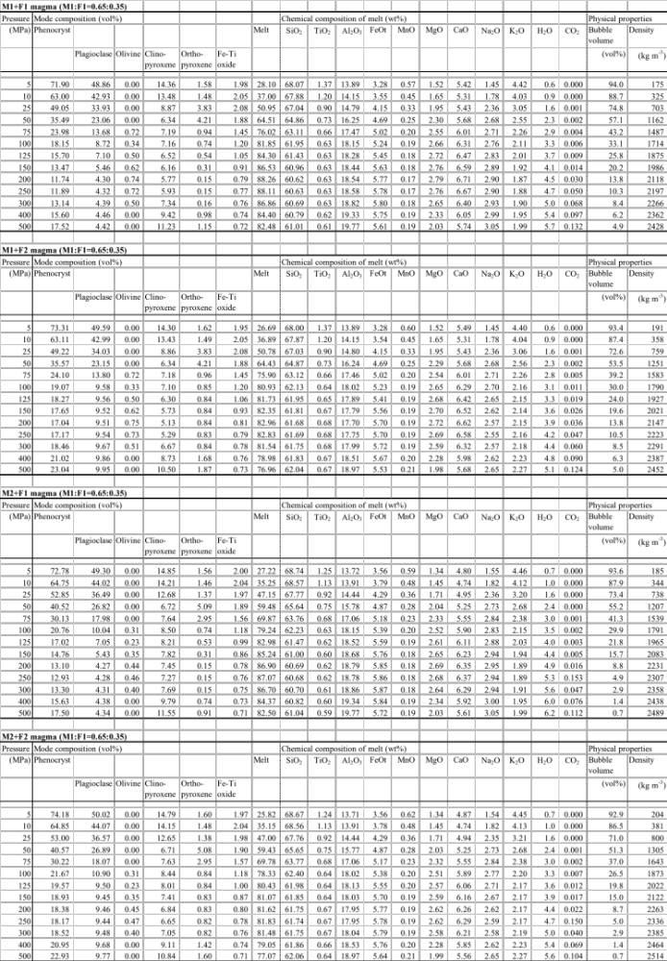

File name: Additional file 10
File format: Excel format.
Title of data:
SO₂ fluxes and mole ratios of SO₂ and H₂S and Cl and S in the volcanic gas were used for calculating the total amount of degassed magma (Table 5).
Description of data:
The volcanic activity in 2011–12 was divided into 4 periods based on the eruption style and the presence or absence of eruptions; subplinian eruptions on 26–27 January 2011, lava effusion with vulcanian eruptions on 28 January–1 February 2011, vulcanian eruptions and ash emissions on 2 February–7 September 2011, and no eruptions but gas emission from the Shinmoedake crater on 8 September 2011–26 September 2012. Neither eruption nor emission of SO₂ gas was detected during the period from 24 January 2013 to 7 October 2017. The volcanic activity from 11 October 2017 to 13 October 2018 can be divided to 5 periods; ash emissions on 11–16 October 2017, no eruption with gas emission from the Shinmoedake crater on 17 October 2017–28 February 2018, lava effusion with vulcanian eruptions and ash emissions on 1–9 March 2018, vulcanian eruptions and ash emissions on 10 March–27 June 2018, and no eruption with gas emission on 28 June–13 October 2018. No eruption or SO₂ gas emission was detected during the period between 11 January and 27 December 2019. The average, maximum, and minimum values for the observed SO₂ fluxes are after Mori and Kato (2013), JMA (2014a, b, c, d, e, f), JMA (2016a, b), JMA (2016a, b), JMA (2018a, b, c, d, e, f, g, h) and JMA (2019a, b). The mole ratio of the Cl and S in the volcanic gas was estimated by chemical analysis of the ash leachate in the deposits (Vinet N. Per. Communication).
The calculation of degassed-magma volume in each period (Table 5) assumes SO₂ flux on days when no SO₂ flux was observed. Two assumptions were made. If SO₂ flux observation was carried out on the days before and after the no-observation day (29 January 2011, 31 January 2011, and 14 October 2017 and 8 March 2018), SO₂ flux was interpolated such that the SO₂ flux on 29 January 2011 was assumed to be 26800 t/d, which is the average of the SO₂ fluxes on 28 and 30 January 2011 (42600 t/d and 11000 t/d). For days on which no SO₂ flux observation was carried out, the minimum SO₂ flux observed in each period was used for the calculation; for example, an SO₂ flux of 100 t/d used in the calculation for the period 2 February–7 September 2011). The values obtained by these assumptions are shown in parenthesis.
We should mention that when the average, minimum, and maximum SO₂ flux values were observed in a day, the maximum value is at most two times larger and the minimum value is 0.3 times larger than the average. For example, the average was 8400 t/d on 3 February 2011, while the maximum was 15200 t/d and the minimum was 2200 t/d. Therefore, we should consider the error for the degassed-magma volume at 30–200 % as when evaluating the volume of the degassed magma.

