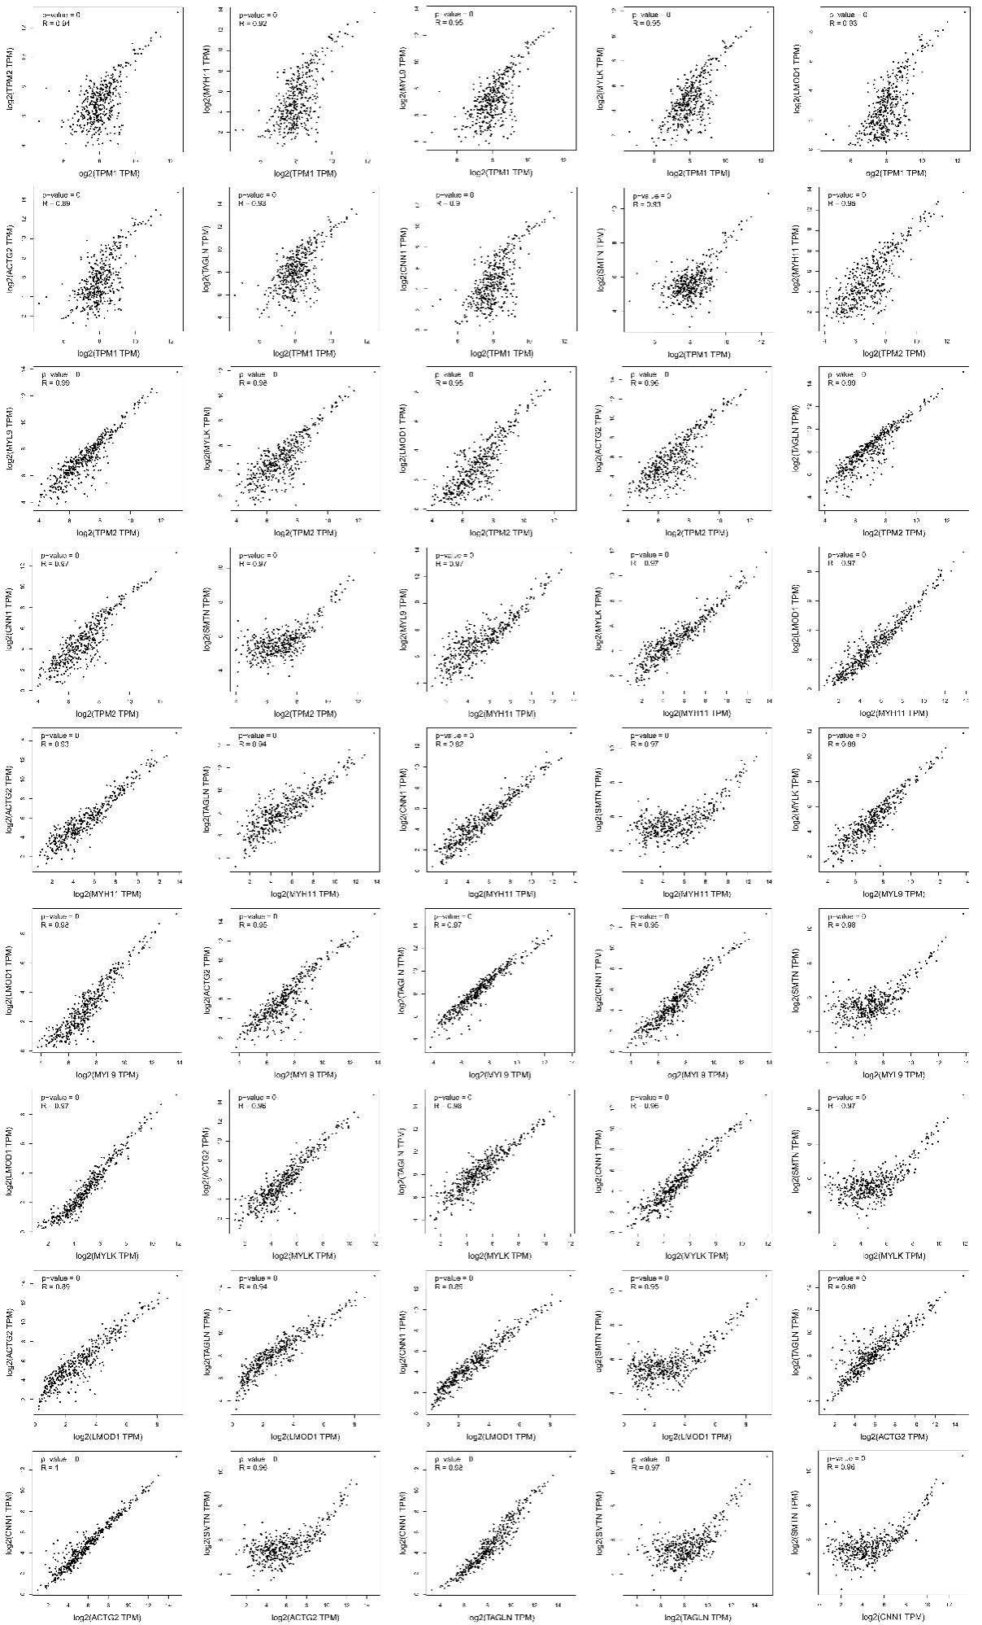
Supplementary materials
Figure 1. The correlation between the pairings of 10 hub genes.
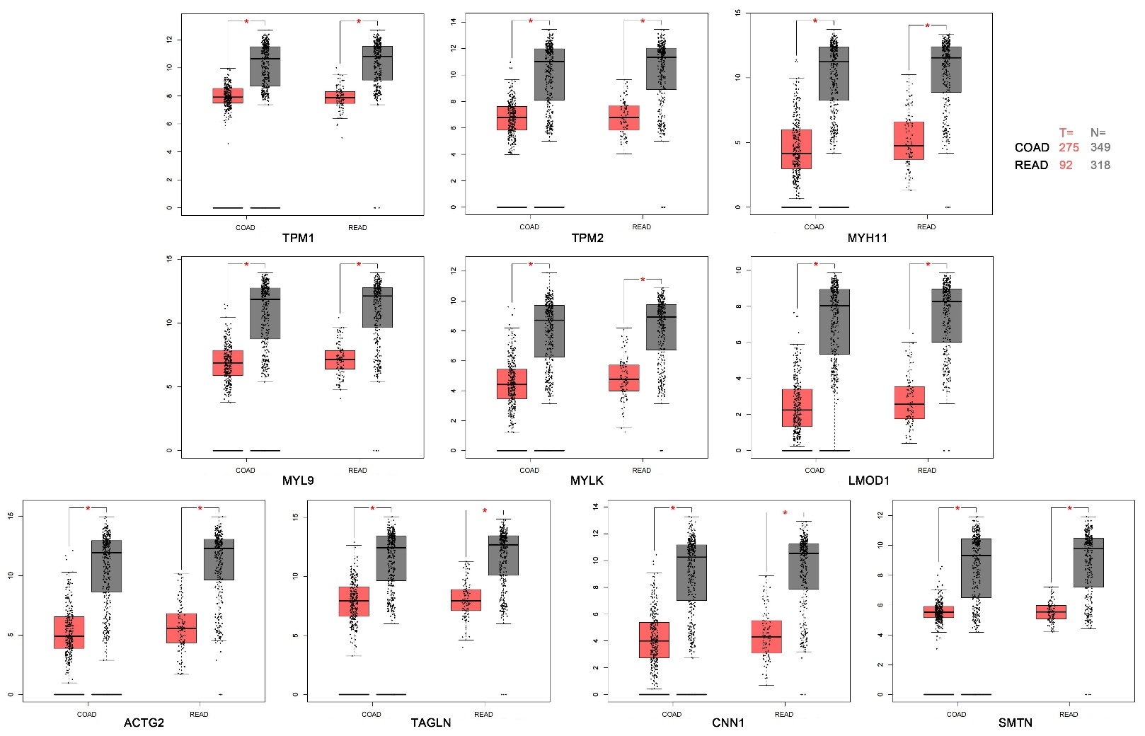
Figure 2. The mRNA expression levels of 10 hub genes.

