SUPPLEMENTAL INFORMATION

Global survey-based assessment of lifestyle changes during the COVID-19 pandemic
Poonam Agarwal, Abhinav Kaushik, Sutapa Sarkar, Deepti Rao, Nilanjan Mukherjee, Vinita Bharat, Subhamoy Das, Amit K. Saha

Table S1: List of countries with less than ten participants who took the online survey.
Algeria | Israel | Romania | Sweden
Austria | Liberia | Saudi Arabia | Switzerland
Bangladesh | Luxembourg | Singapore | Taiwan
Bosnia and Herzegovina | Malaysia | Slovakia | Tanzania
Brazil | Monaco | Slovenia | Turkey
China | Netherlands | South Africa | Uganda
Egypt | Papua New Guinea | Spain | Ukraine
Greece | Poland | Sri Lanka | United Arab Emirates

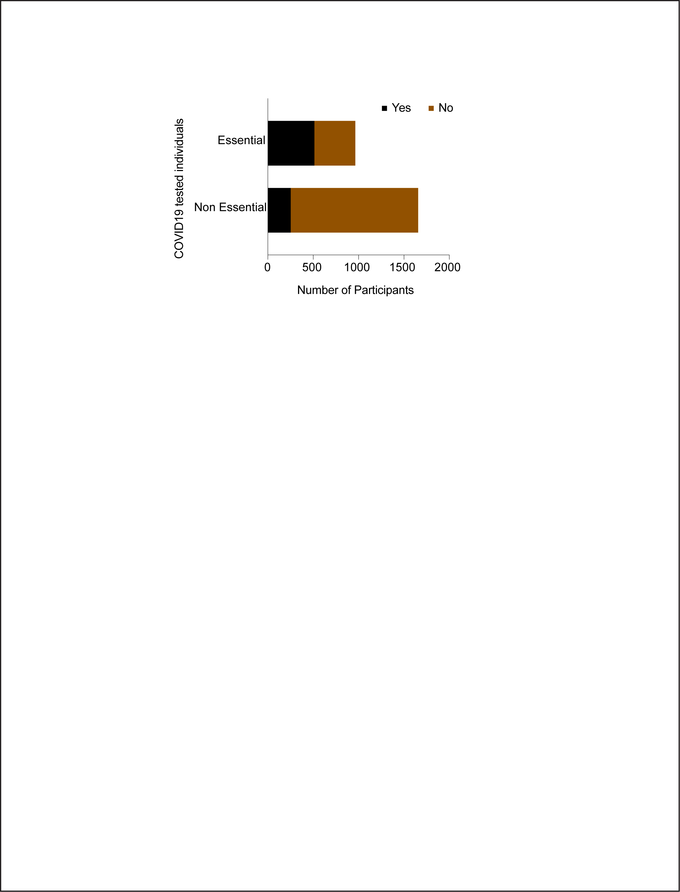
Fig S1. Group wise distribution showing the fraction of total essential and non-essential workers who took the COVID-19 test.
We performed comparative analyses among the various subgroups to explore the following: a) whether there were significant differences between the essential and non-essential workers with respect to their employment status or whether these two groups had similar or variable social interaction patterns. As anticipated and shown in Fig S2A, we found that the non-essential group lost more jobs as opposed to the essential workers. Moreover. there was a bigger effect on social interaction among the non-essential working group as compared to the essential workers (Fig S2B).
We also performed a comparative analysis on two categories of survey takers, namely, those who reported changes in social interactions and also the ones who reported no changes in social interactions. Comparisons were made with respect to a few parameters including COVID-19 test taken, financial loss, household living company and whether they belonged to essential vs. non-essential workers cohort. For all of the above metrics, there was similar distribution in the two groups as depicted by the bar graphs (Fig S3A). We then evaluated what effect these two groups of survey takers had on their 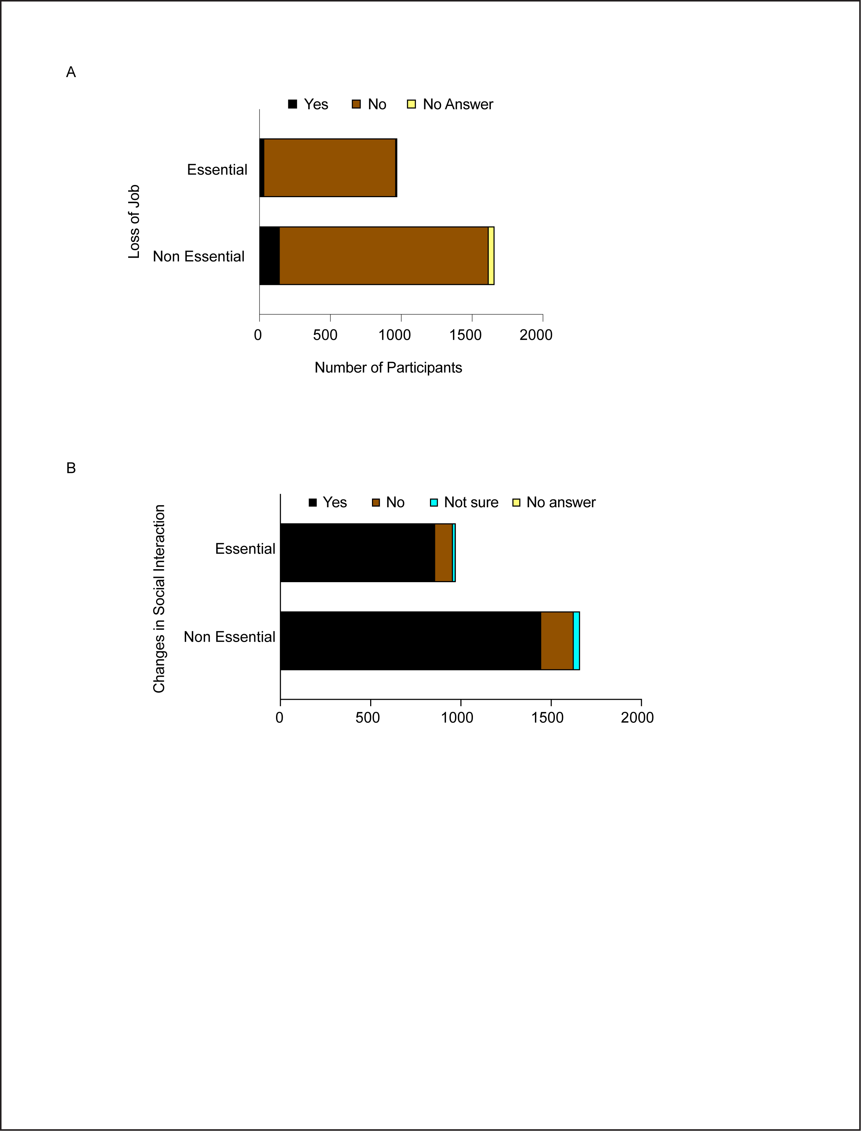
Fig S2: Comparative analyses of essential vs non-essential workers. A. Comparison with regard to their employment status during the study period. B. Change in social interaction levels.
mental health as a result of COVID-19 and social isolation. In particular, we asked about the extent of impact on their mental health by providing different levels or categories to choose from, such as, extremely, moderately to overwhelming or no effect at all. Our analysis shows that a large portion of the social interaction affected individuals had moderate effects on their mental health whereas the majority of the participants who did not have an effect on their social interaction neither had any kind of mental health impact (Fig S3B). Moreover, a substantial proportion of the participants who had changes in their social interaction felt that the overall quality of their mental health could have been better whereas the other group had a neutral opinion. We also measured the differences with regard to stress coping mechanisms in these two groups of individuals. Our data reflects that both these groups had a similar trend of involvement in alternate activities as a way to cope with stress and anxiety. For instance, in both the groups, the largest fraction of people opted to communicate with their friends and family the most followed by pursuing their hobbies (Fig S3C).
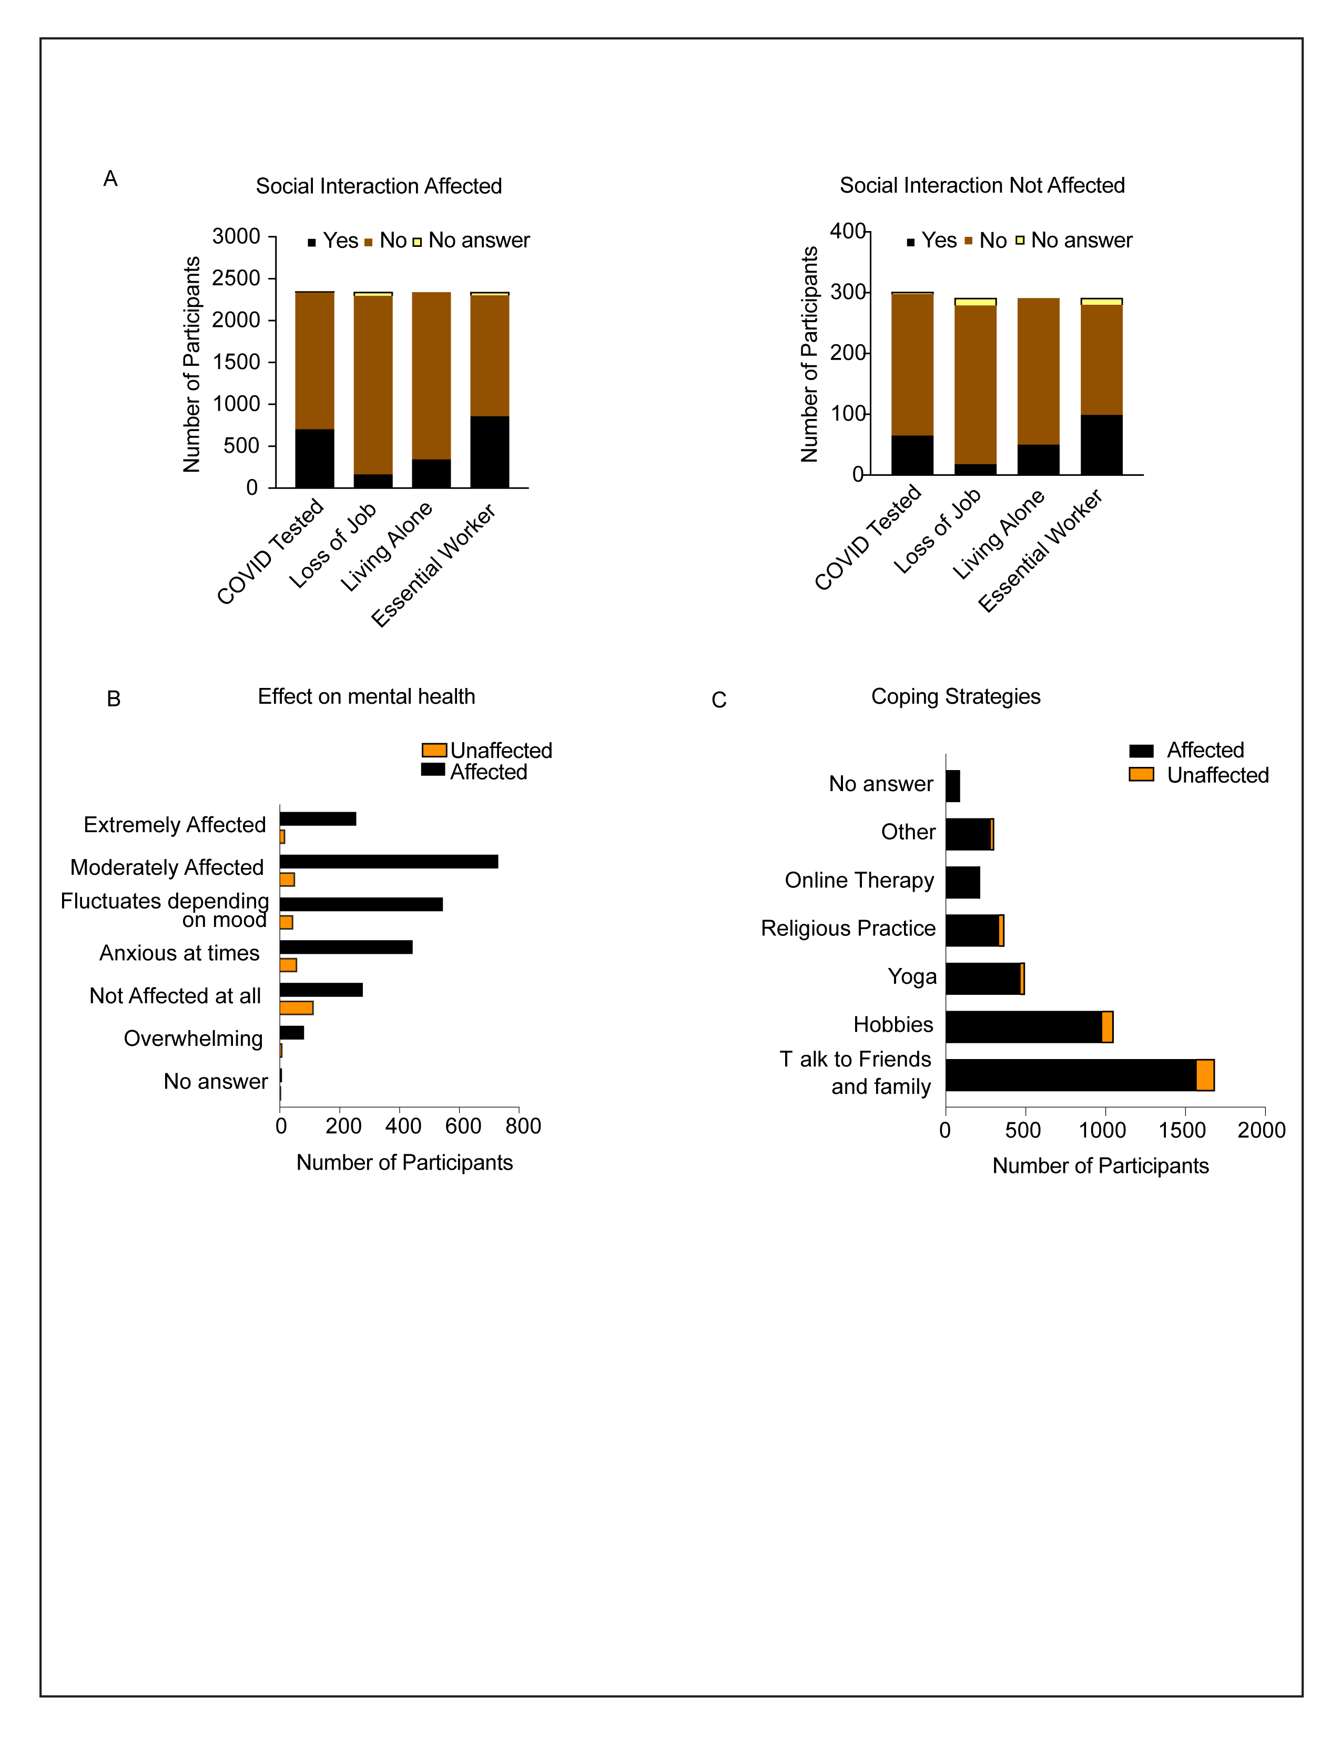Fig S3: Comparative analyses between the two groups of participants who experienced changes in their social interaction and those who reported no changes in social interaction during the study period. The comparisons were based on their: A. Employment status, household companion and COVID-19 test status. B. Mental health status of participants. C. Strategies to cope with mental health issues.

