Supplementary Material
Tropical drivers of interannual vegetation variability in eastern Africa
In-Won Kim*, Malte F. Stuecker, Axel Timmermann, Jong-Seong Kug, So-Won Park and Jin-Soo Kim
*corresponding author. iwkimi@pusan.ac.kr

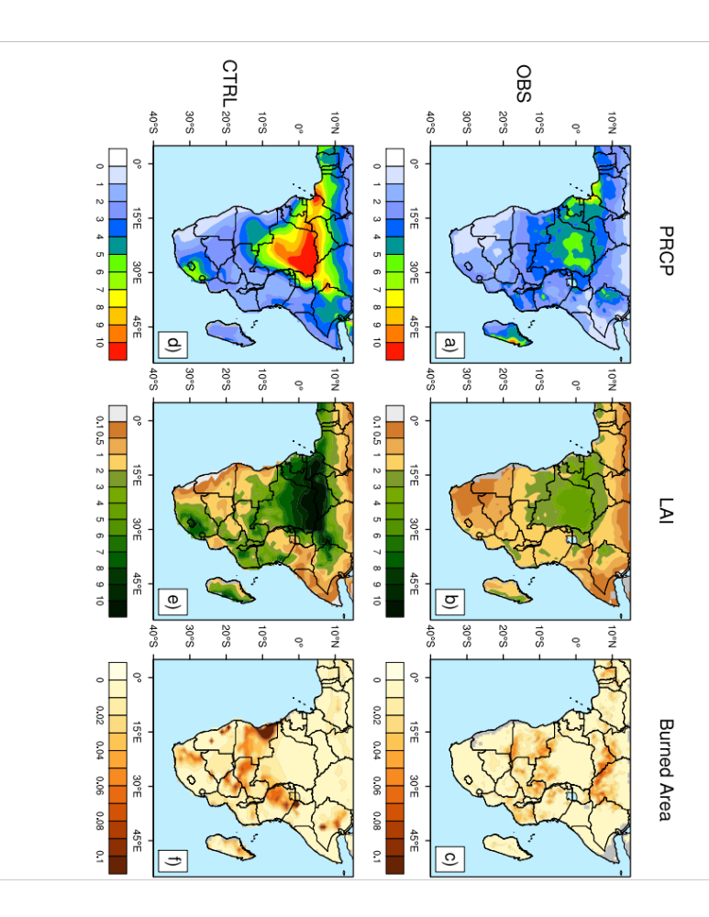
Figure S1. Climatology of PRCP (unit: mm/day), LAI (unit: m2/m2), and burned area (unit: fraction) over Africa in observations (upper, a-c) and the control run (lower, d-f)

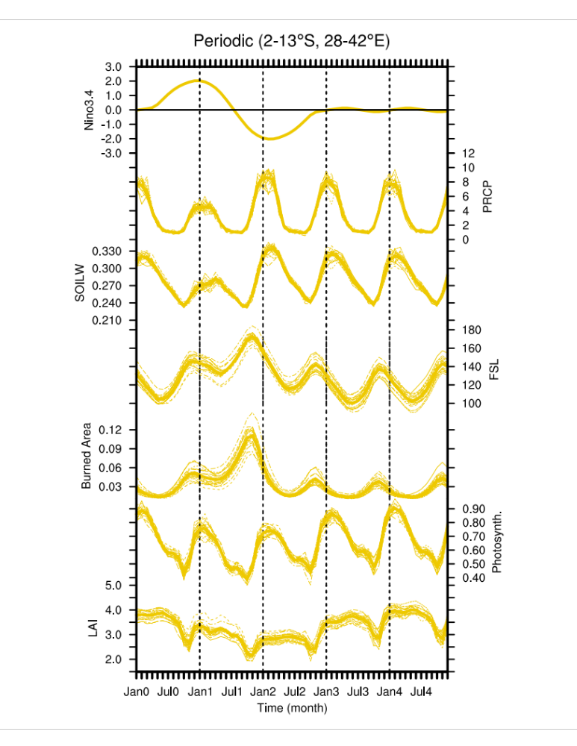
Figure S2. Monthly evolution over Tanzania (2-13°S, 28-42°E) for the Periodic experiment: Niño3.4 index (solid yellow line; unit: K), precipitation (unit: mm/day), upper soil moisture (mm3/mm3), fire seasonal length (day), burned area (unit: fraction), Photosynthesis (unit: mol/m²day), and LAI (unit: m²/m²).
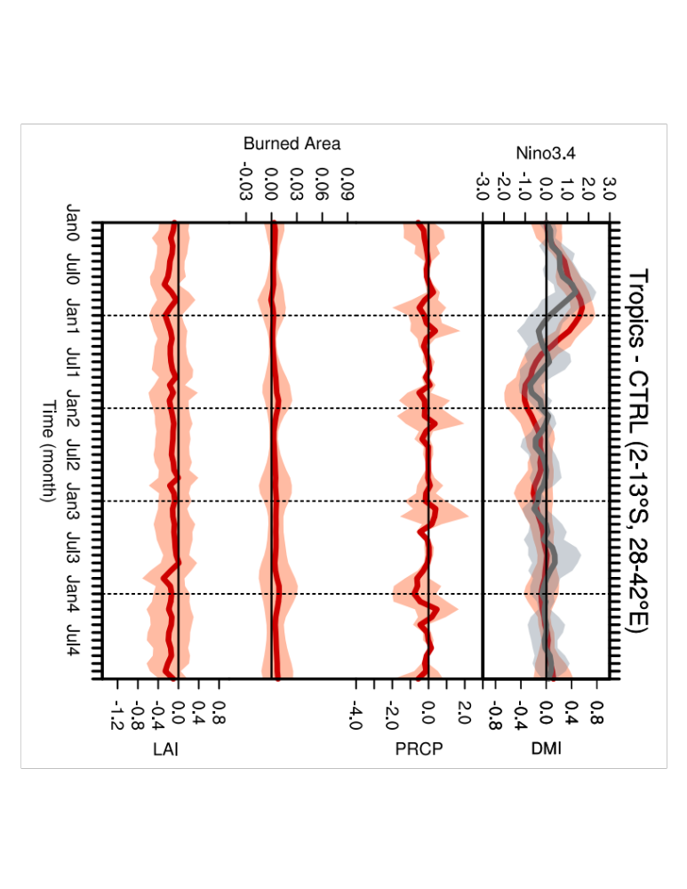
Figure S3. Time evolution over Tanzania (2-13°S, 28-42°E) for the Periodic experiment (b), the Pacific experiment (b) and the Tropics experiment (c): Niño3.4 index (solid red line; unit: K), Dipole Mode Index (DMI; solid gray line; unit: K), precipitation anomalies (unit: mm/day), burned area anomalies (unit: fraction), and LAI anomalies (unit: m2/m2). Transparent shading indicates ± 1 standard deviation.

Table S1. Parameters for equations (1)-(3)

Parameter | Description | Value | Unit
$$α$$ | Regression coefficient of precipitation anomaly on ENSO | -0.36 | K
$$β$$ | Regression coefficient of precipitation anomaly on C-mode | -0.61 | K
$$μ_{1}$$ | Recovery timescale of burned area | 2.50 | fraction
$$θ_{1}$$ | Burned area resistance against drought | 0.01 | mm/day
$$μ_{2}$$ | Resilience timescale of vegetation | 8.33 | m²/m²
$$θ_{2}$$ | Vegetation resistance against burned area | 2.00 | fraction

