Supplementary Figures 1 to 5: Average estimated and true RIs by age, sex and method for five scenarios (Monsurul Hoq Susan Donath, Paul Monagle, John B. Carlin Comparison of statistical methods for estimating continuous paediatric reference intervals: a simulation study)
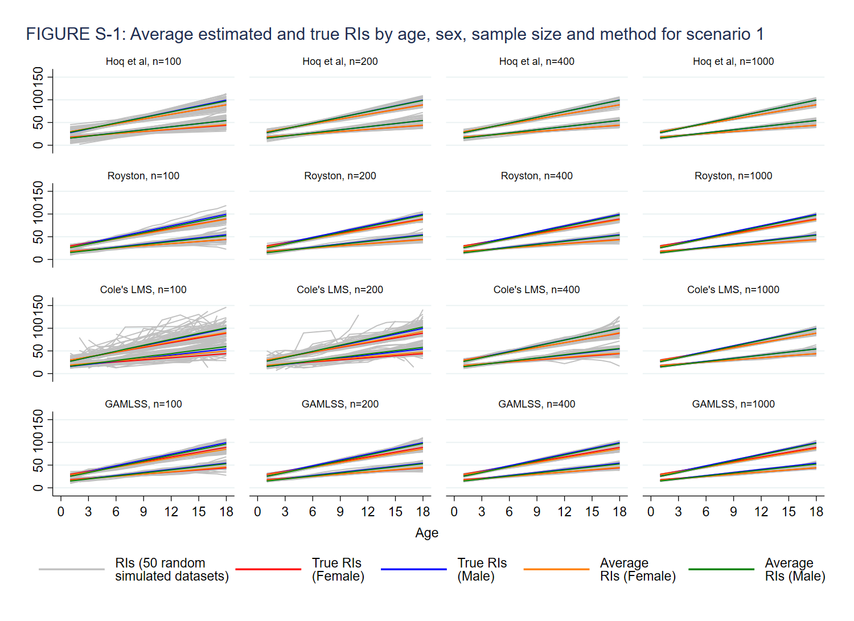
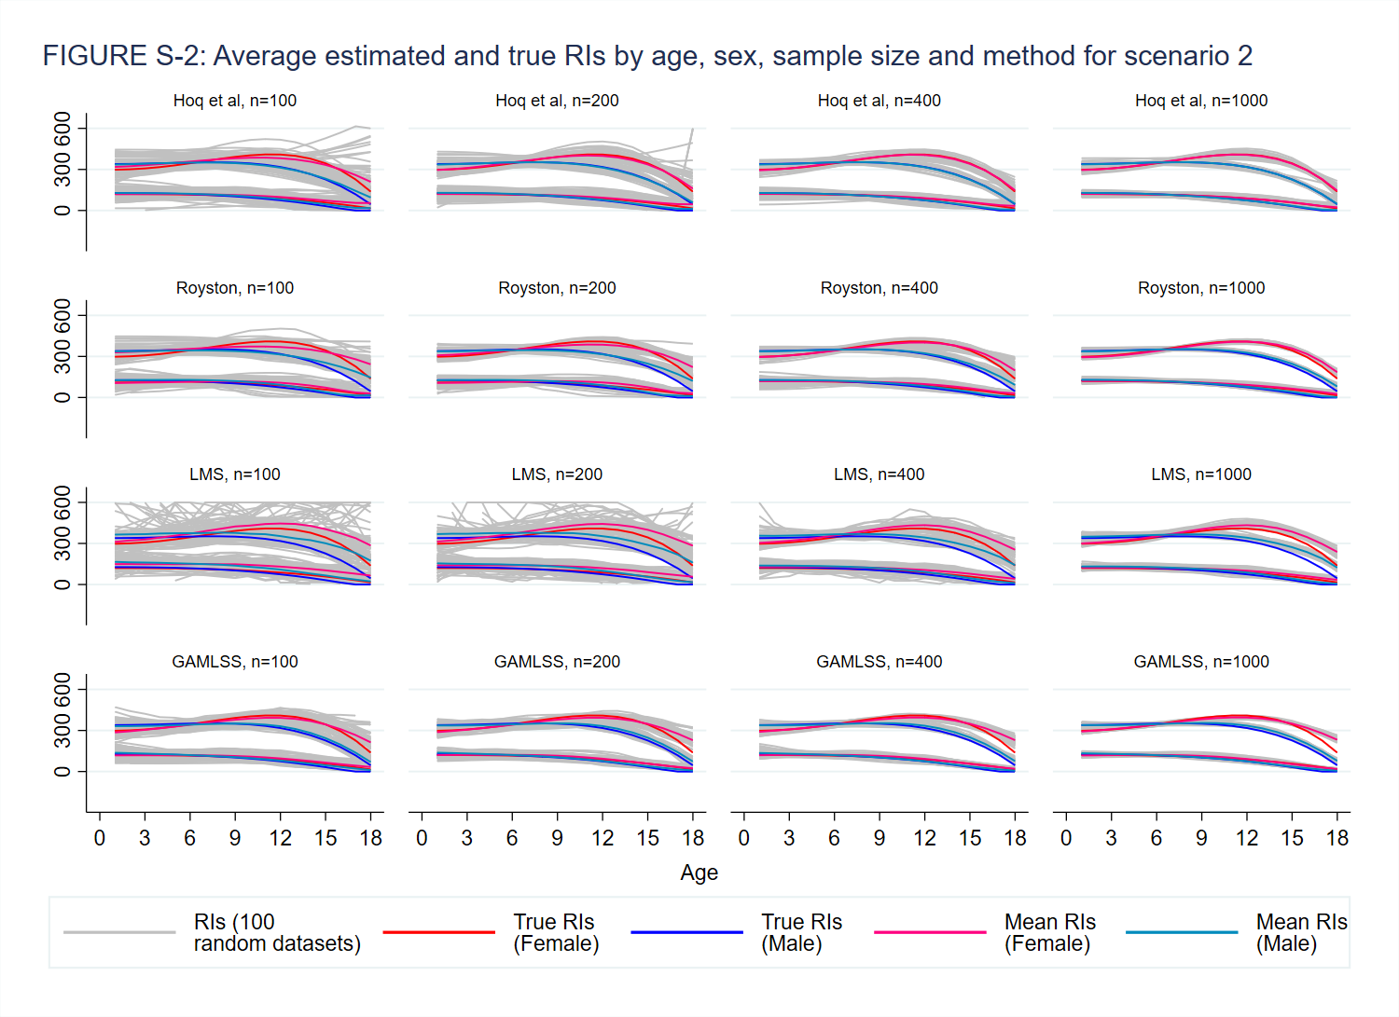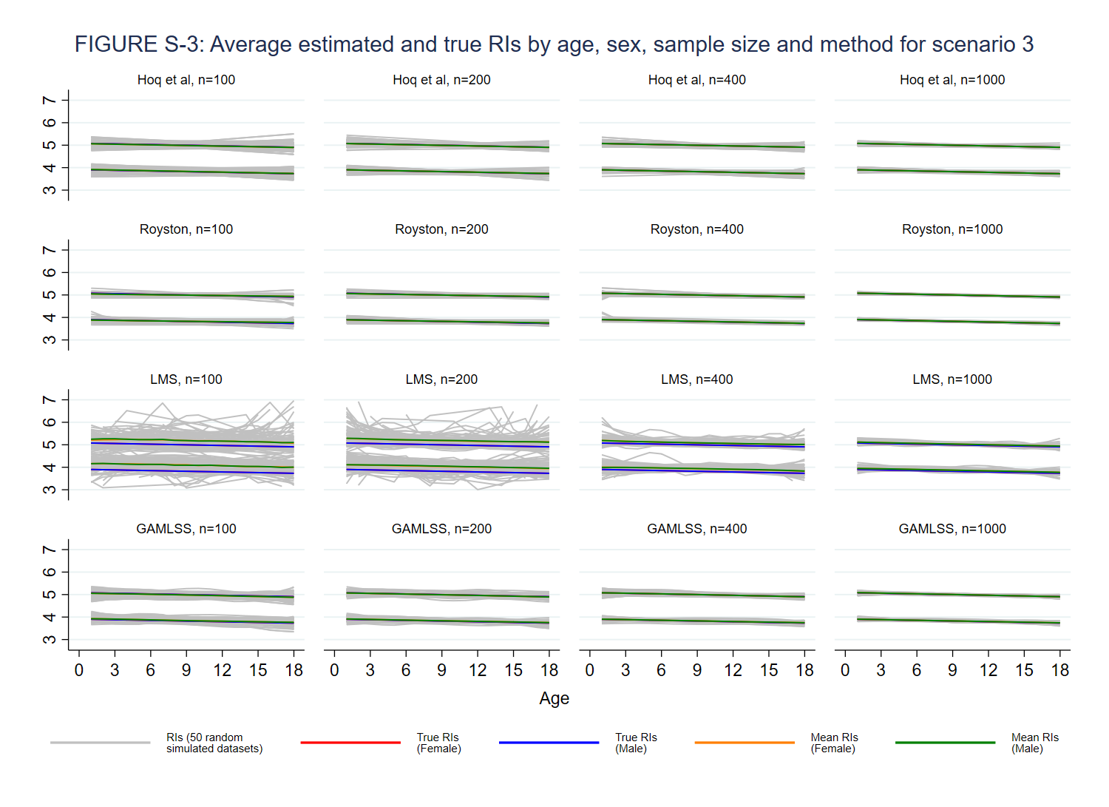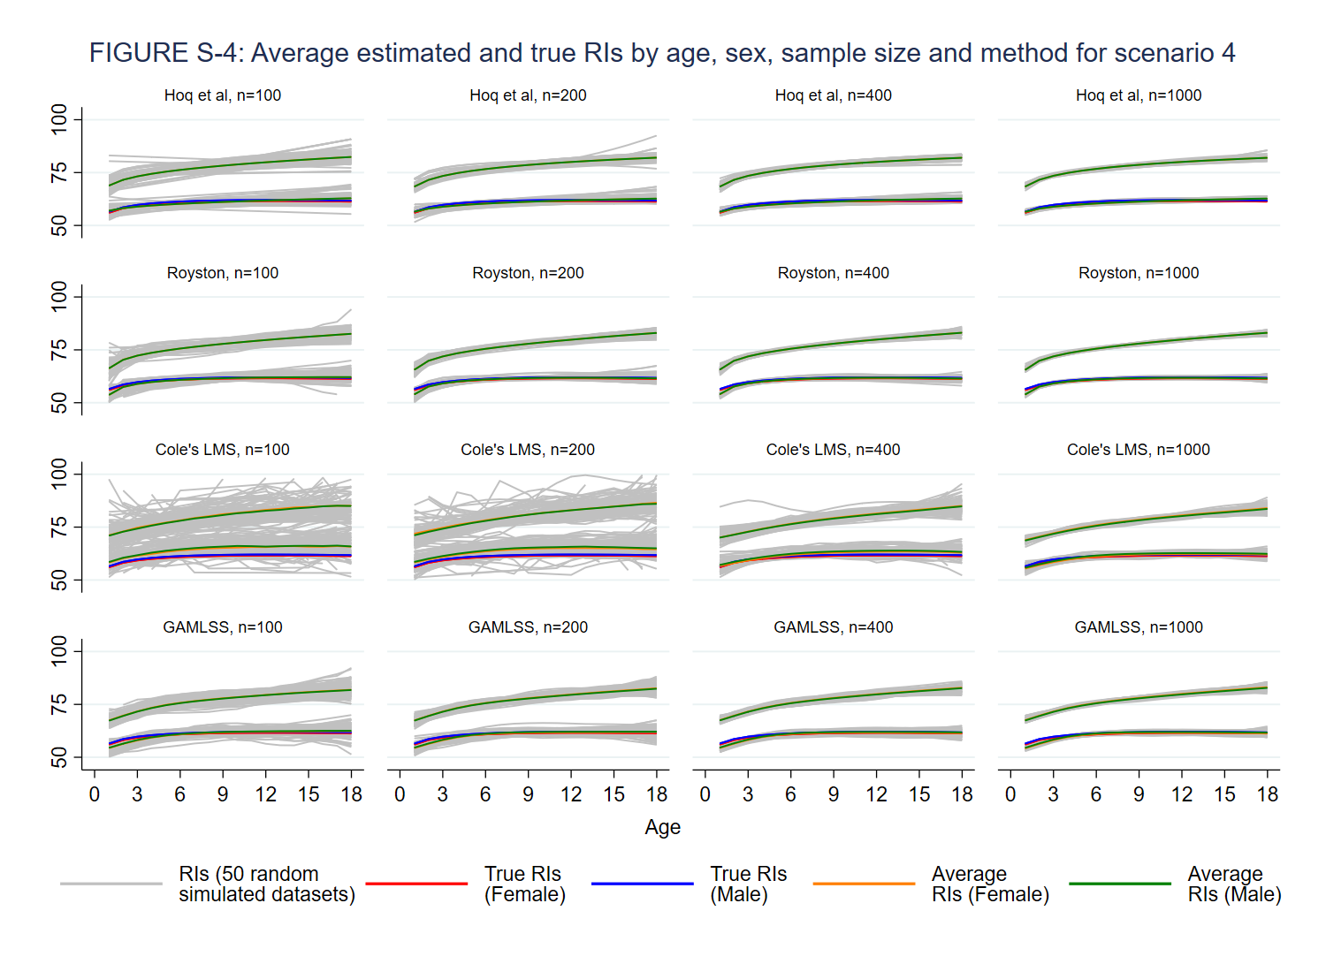

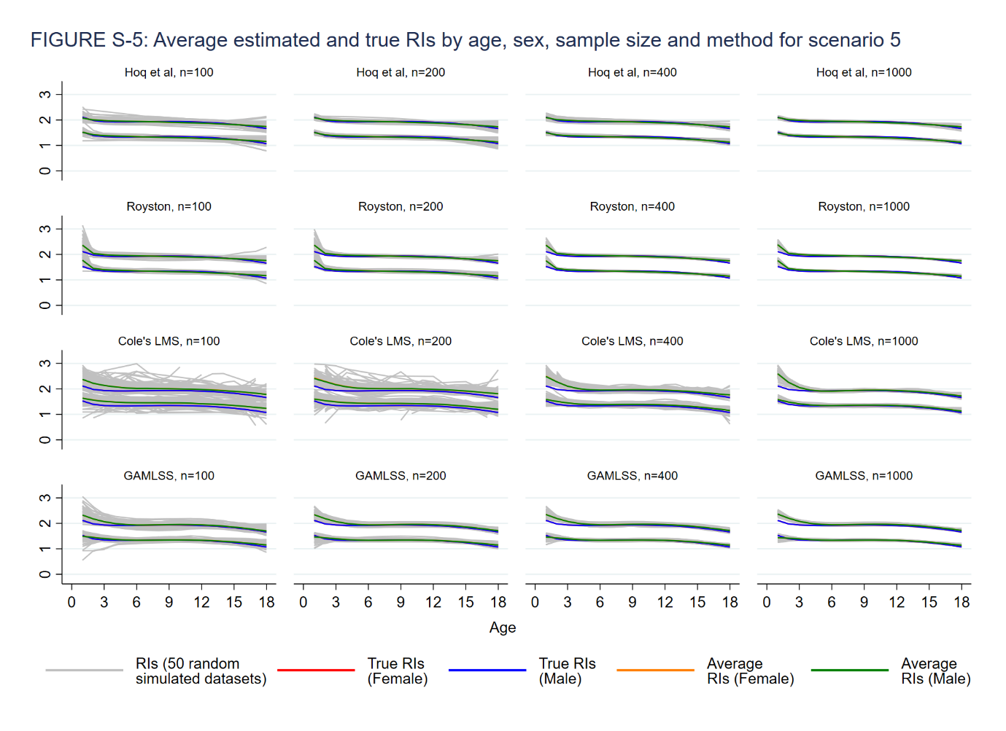
Supplementary Figures 6 – 8: Root mean square error by age, sex and method for three scenarios (Monsurul Hoq Susan Donath, Paul Monagle, John B. Carlin Comparison of statistical methods for estimating continuous paediatric reference intervals: a simulation study)

