Terahertz near-field vortex beams with variable intensity profiles based on geometric metasurfaces: Supplementary Materials
Yang Zhu^{1,#}, Yiwen Zhou^{1,#}, Fuyong Yue¹, Zhiyuan Fan¹, Xiaofei Zang^{1,2,*}, Yiming Zhu^{1,2,*}, and Songlin Zhuang¹
¹Terahertz Technology Innovation Research Institute, Terahertz Spectrum and Imaging Technology Cooperative Innovation Center, Shanghai Key Lab of Modern Optical System, University of shanghai for Science and Technology, Shanghai 200093, China.
²Shanghai Institute of Intelligent Science and Technology, Tongji University, 20092, China.
#These authors contributed equally to this work
* Correspondence: xfzang@usst.edu.cn; ymzhu@usst.edu.cn

- Experimental set-up
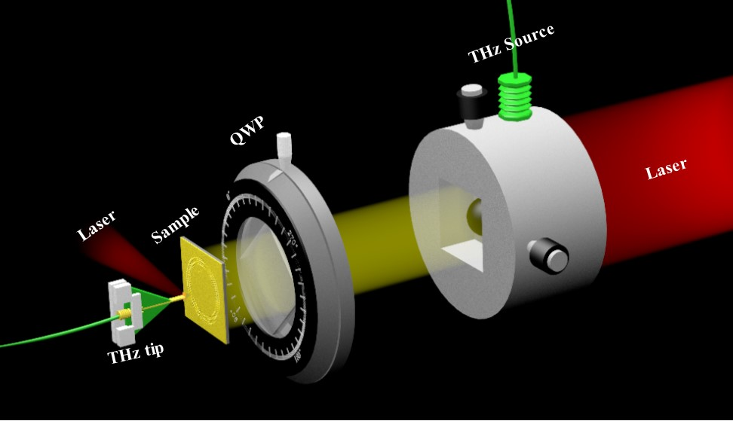
Fig. S1. The schematic of the experimental set-up.
Figure S1 shows the schematic of the experimental set-up for detecting the electric-field intensity distributions of our designed samples. Based on a beam splitter, a femtosecond laser beam with wavelength of 780 nm was split into two directions. One part of a laser beam was guided into the THz source to generate THz waves, while the other part (of laser beam) was radiated into the THz tip that is closest to the sample to detect the electric-field intensity distributions. The quarter-wave plate was used to convert the linearly-polarized THz waves into LCP/RCP THz waves. The sample was fixed, while the corresponding electric-field intensity distributions at the Au/air interface was obtained by scanning the THz tip.
- The near-field vortex with C₅ discrete rotational symmetry
Figure S2 shows the electric field intensity and phase profiles of a generalized vortex with C₅-fold rotational symmetric intensity distribution generated from the designed geometric metasurface. The designed structure parameter is set to be 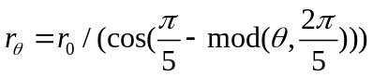, where 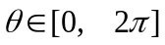. The analytical electric field intensity and phase profile are shown in Figs. S2(a₁) and S2(a₂), respectively. The electric field intensity in Fig. S2(a₁) shows a pentagonal-shaped profile with a hollow dark region in the center and a pentagonal bright ring. The helical phase distribution presents as a pentagonal shape with the phase change of 2π in a round (see the white dotted box in Fig. S2(a₂)). Therefore, the topological charge of the pentagonal-shaped vortex is l=1. The simulated and measured electric field intensities and phase profiles are illustrated in Figs. S2(b₁)-S2(c₂). The electric field distributions in simulation and experiment appear to be a pentagonal-shaped profile, and the phase distributions also exhibit a pentagonal-shaped structure as expected, indicating the realization of transforming a traditional vortex with O(2) continuous symmetry into a generalized vortex C₃-fold discrete rotational symmetry by encoding an azimuthal nonlinear phase.
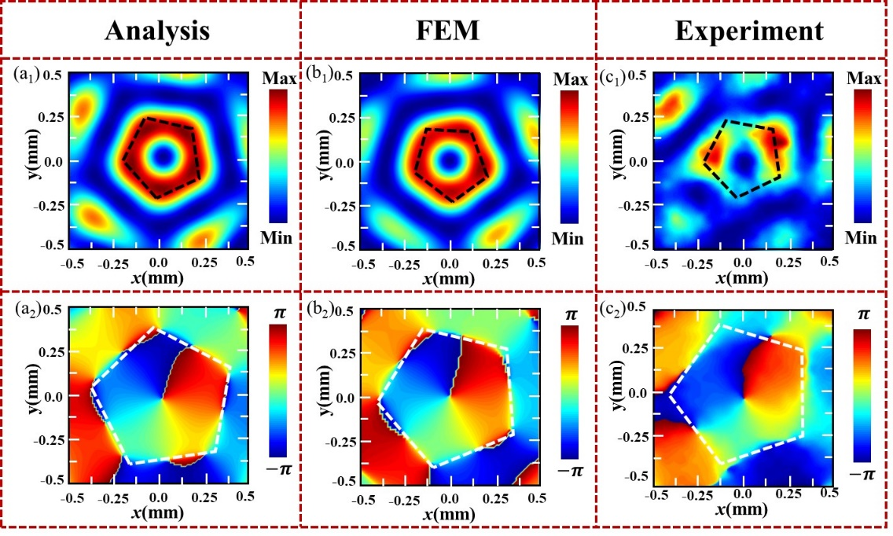
Fig. S2 The electric-field intensity (|E_{z}|²) and phase distributions of the designed geometric metasurface encoded with C₅-fold rotational symmetric helical phase: (a₁) and (a₂) the analysis results, (b₁) and (b₂) the simulated results, (c₁) and (c₂) the measured results.

