Assembling plant diversity mitigates greenhouse gas emissions and achieves high nitrogen removal when treating the low-C/N wastewater by constructed wetlands

Hang Jiang¹, Yuanyuan Du¹, Wenjuan Han², Lichunxiao Wang¹, Chenxu Xiang¹, Ying Ge¹, Jie Chang^{1*}

¹ College of Life Sciences, Zhejiang University, 866 Yuhangtang Road, Hangzhou 310058, PR China
² College of Life and Environmental Science, Wenzhou University, Wenzhou 325035, PR China

To be submitted to: Environmental Science and Pollution Research

* Author to whom all correspondence should be addressed: E-mail: jchang@zju.edu.cn (J. Chang). Phone & Fax: +86 571 8820 6465
Supplementary information
Method
Cost of wastewater treatment
The cost of construction and maintenance was based on a report by Gu et al. (2016). The cost differences between seedlings and planting labor in improving diversity and the carbon to nitrogen (C/N) ratio came from the research. The cost of improving diversity was calculated according to the best combination of plants, and the cost of increasing the C/N ratio was calculated according to the mean value of monoculture to increase the C/N ratio from 1 to 5. Taking one year as the treatment cycle, the C addition was estimated based on an N concentration of 336 mg L⁻¹.
N removal efficiency
The total N removal efficiency (%) was calculated as,
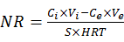$NR efficiency (\%) =\frac{c_{i}×V_{i}-c_{e}×V_{e}}{c_{i}×V_{i}}$$×100$
where $c_{i}$ is the influent TN concentration (mg L⁻¹) and $V_{i}$ is the total influent volume during the whole operation, while the $c_{e}$ is the effluent TN concentration of the end of last hydraulic cycle (mg L⁻¹), $V_{e}$ is the total effluent water volume (L).
Structural equation model (SEM)
The SEM was applied to identify the potential causal relationship between plant diversity and GHG emissions. Plant species richness and identity (the presence or absence of the specific species) were included in the model as exogenous variables. The plant uptake, denitrification, substrate adsorption and NH₄⁺-N or NO₃⁻-N removal potentially mediating plant diversity effects were considered, and the hypothesized framework was constructed (Fig. S7; Table S7). The structural equation model was run using the lavaan package in R 4.1.2. The adequacy between the model and the data was verified using the c2-test and root mean square error of approximation (RMSEA).

Figure S1 to S9
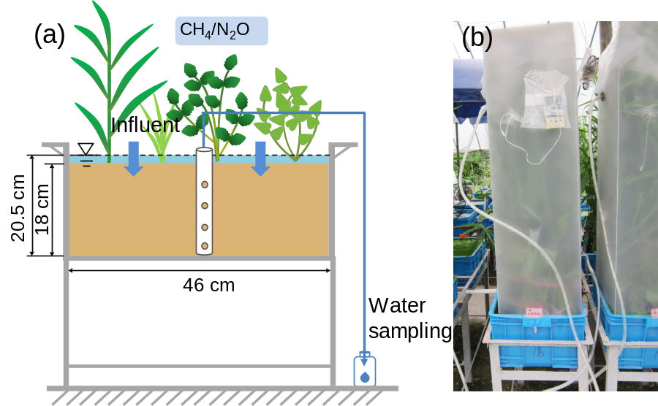
Fig. S1. Illustration of the simulated CW microcosm. (a) The vertical cross-section; (b) photograph of a gas chamber.

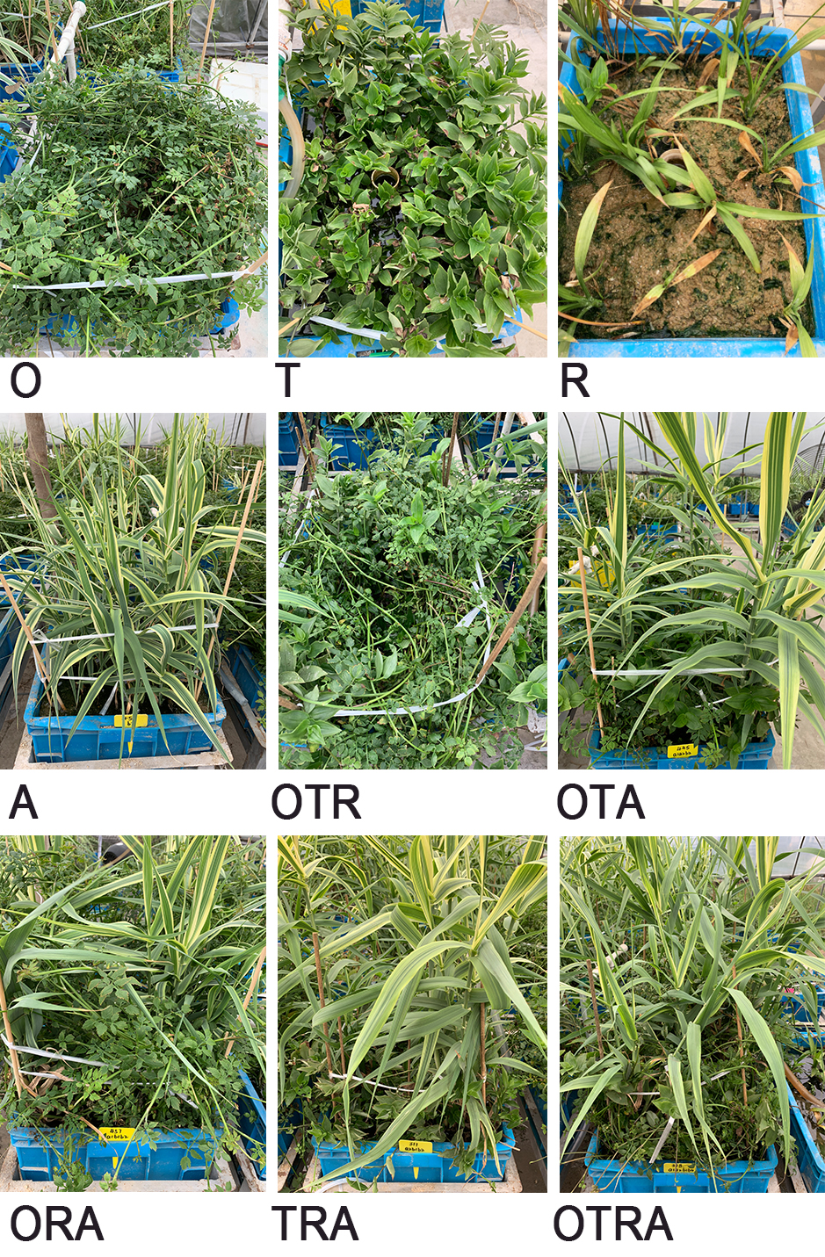
Fig. S2. Photos of the microcosms in this study. The abbreviations of the plant species are as follows: O, Oenanthe javanica; T, Tradescantia fluminensis; R, Reineckia carnea; and A, Arundo donax.

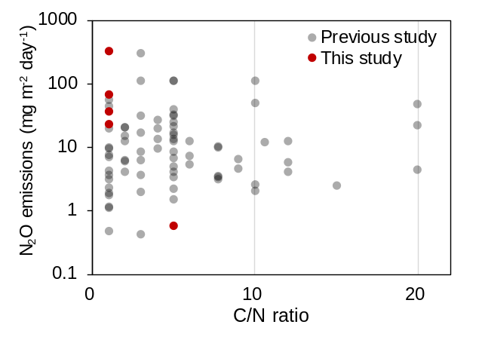
Fig. S3. The N₂O emissions of monoculture CWs with different C/N ratio. The grey dots indicate the data collected in the previous study (n = 76; see Table S4 for relevant data), and the red dots are the monocultures data of this study (n = 8, of which the emissions value of 3 points not shown is 0).

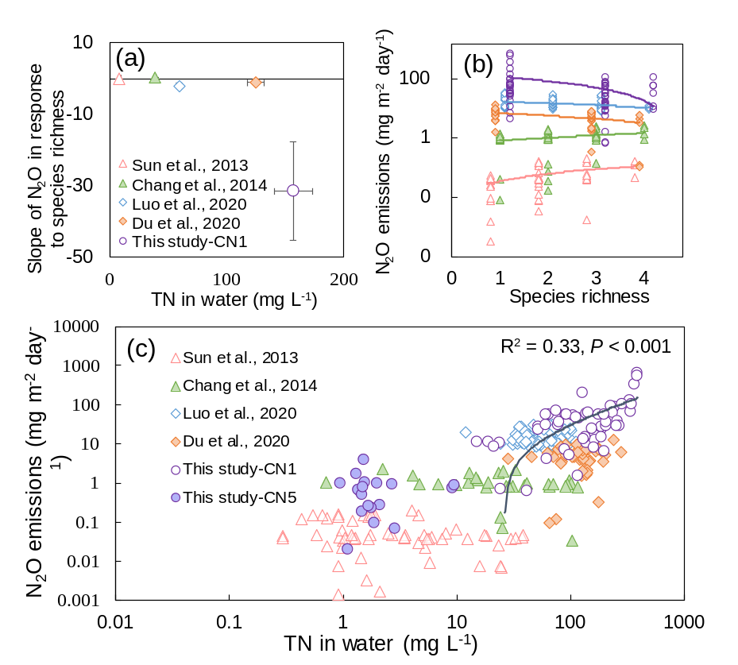
Fig. S4. The effects of N concentration in CWs on N₂O emissions and its response to species richness. (a) The relationship between effluent TN concentrations and the slopes of N₂O emissions response to species richness; (b) the relationship between species richness and N₂O emissions. The Y coordinate axis is the logarithmic coordinate axis, and the fitting lines from top to bottom are this study, Luo et al. (2020), Du et al. (2020), Chang et al. (2014), Sun et al. (2013). (c) The relationship between TN concentration in water and N₂O emissions in microcosms is shown in double logarithmic coordinates, and all points n = 423. The R² and P value are the linear fitting result of all points.

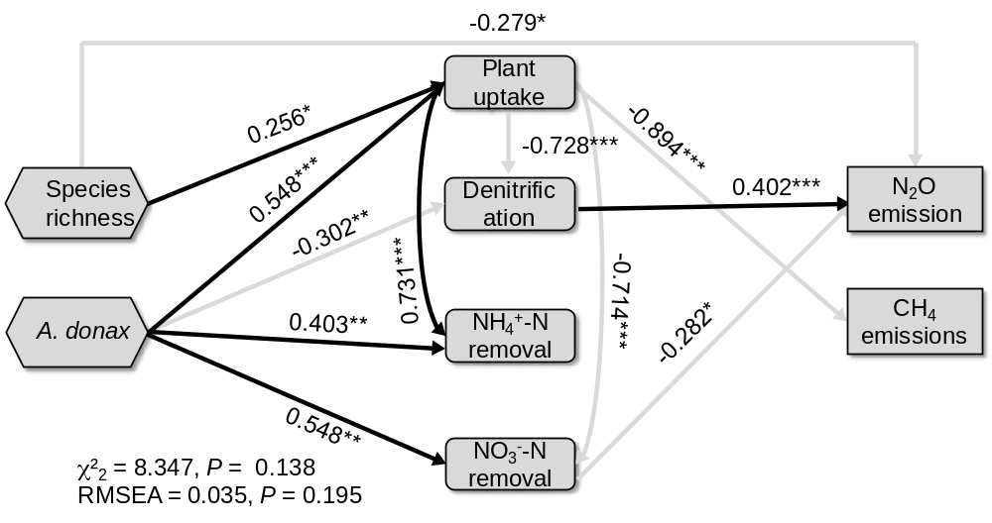
Fig. S5. Structural equation model explaining the underlying mechanisms of the relationship between plant diversity and ecosystem functioning under low C/N ratio. Species richness, the presence of A. donax were selected as the exogenous variables in the model based on the results of one-factor analysis. For simplicity, the substrate adsorption was excluded from the final model (see Fig. S9; Table S7). Numbers next to the arrows are standardized partial effect sizes (relevance between variables) together with their significance, *P < 0.05, **P < 0.01, ***P < 0.001.

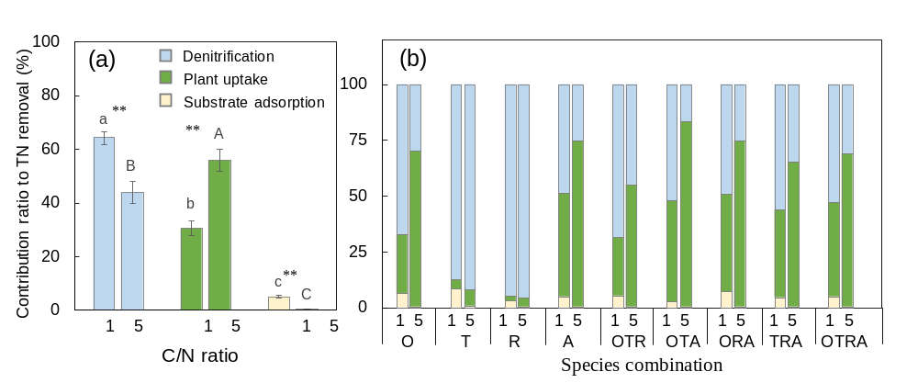
Fig. S6. Contribution ratios of three major N removal pathways to N removal in CWs. The average contribution ratios of the three major N removal pathways to N removal in (a) all microcosms and (b) each species combination. The blue bars represent denitrification, the green bars represent plant absorption, and the orange bars represent substrate adsorption. The number “1” represents a C/N ratio of 1, and the number “5” represents a C/N ratio of 5. The abbreviations of plant species (O, T, R, and A) and letters are the same as those in Fig. S2. The error bars denote the standard errors, and asterisks indicate significant differences under the two C/N ratios (** P < 0.01).

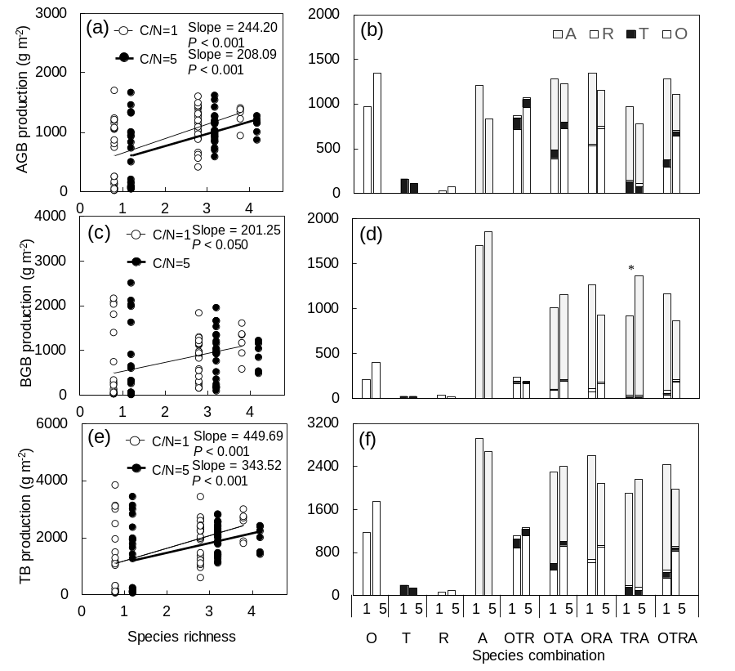
Fig. S7. Effects of plant diversity on plant biomass in CWs. (a) The relationship between aboveground biomass (AGB) production and species richness; (b) difference in AGB production among species combinations; (c) relationship between belowground biomass (BGB) production and species richness; (d) BGB production among species combinations; (e) relationship between total biomass (TB) production and richness; (f) TB production among species combinations. The number “1” represents a C/N ratio of 1, and the number “5” represents a C/N ratio of 5. The open points and thin lines indicate the treatments with a C/N ratio of 1, while the closed points and bold lines indicate the treatments with a C/N ratio of 5. The abbreviations of plant species (O, T, R, and A) are the same as those in Fig. S2. The error bars denote the standard errors, and asterisks indicate significant differences under the two C/N ratios (* P < 0.05).

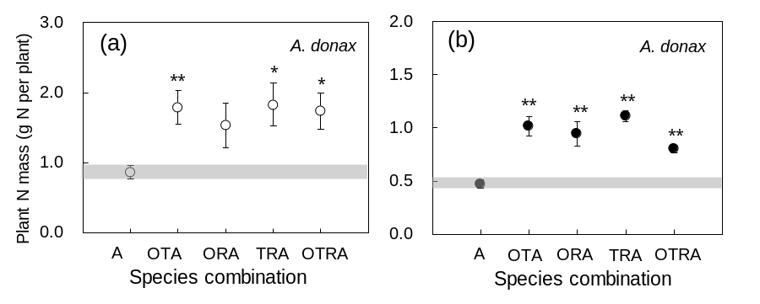
Fig. S8. N mass per A. donax plant in monocultures and in mixed cultures. Regardless of whether the C/N ratio was (a) 1 or (b) 5, the nitrogen content per A. donax plant was higher in the mixtures than in the monoculture. The gray band represents the range of standard errors of the mean addition and subtraction of a single system. The abbreviations of plant species (O, T, R, and A) are the same as those in Fig. S1. The error bars denote the standard errors, and asterisks indicate significant differences under the two C/N ratios (* P < 0.05, ** P < 0.01).

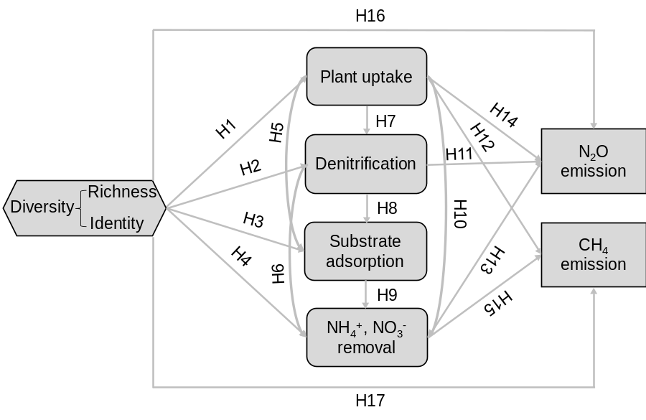
Fig. S9. A conceptual model of the expected causal relationships between plant diversity and GHG emissions. Arrows indicate the expected causal relationships among the variables (H1~H17, see the detailed information in Table S7).

Table S1 to S7
Table S1 Characteristics of the studied species
 | Oenanthe javanica | Tradescantia fluminensis | Reineckia carnea | Arundo donax
Abbreviation | O | T | R | A
Family | Apiaceae | Commelinaceae | Liliaceae | Poaceae
Plant adaptation | Hydrophyte | Mesophyte | Mesophyte | Mesophyte
Functional group | Forb | Forb | Forb | Grass
Root system | Fibrous-root | NA | NA | Fibrous-root
Aerenchyma | Well-developed | Less-developed | NA | Well-developed
N form preference | NH₄⁺ | NA | NO₃⁻ | NH₄⁺
Life cycle | Perennial | Perennial | Perennial | Perennial
Visual presentation | 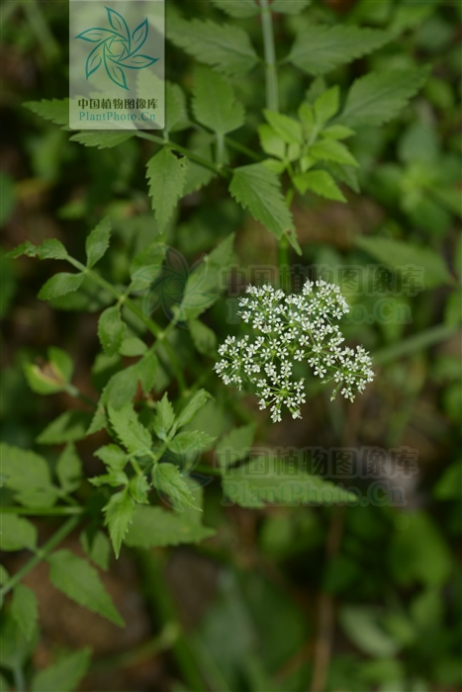 | 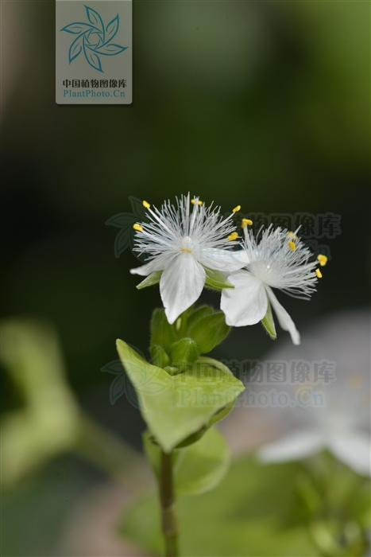 | 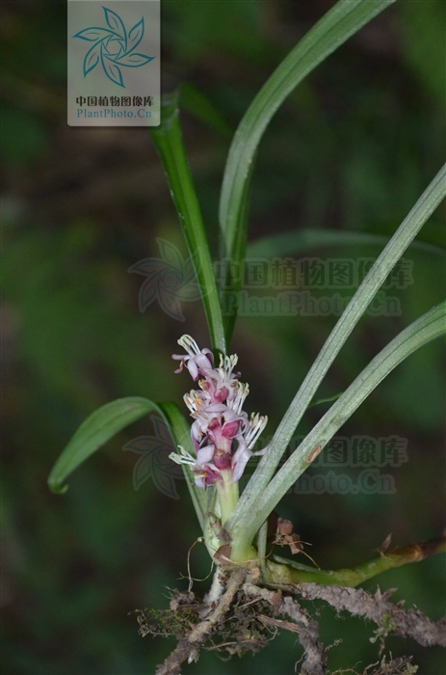 | 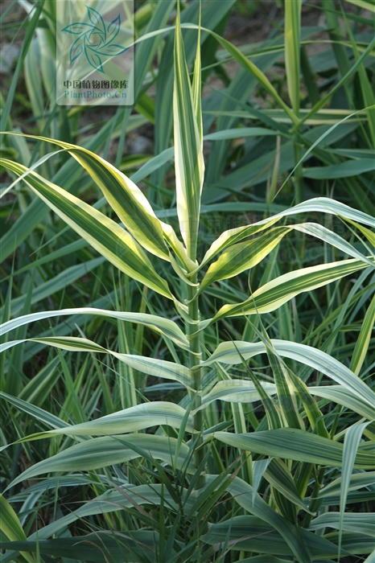
Florescence | June to July | May to October | July to November | September to December
References | Li et al. 2015 |  | Chen et al. 2015 | Tho et al. 2017
Notes: Visual images of plant species come from the Plant Photo Bank of China (PPBC).

Table S2 The GHG emissions of CWs with monocultures of different species under different inflow C/N ratios.
C/N | Species | N₂O  (mg m⁻² day⁻¹) | Proportion of N₂O-N in inflow N (%) | CH₄  (mg m⁻² day⁻¹) | GWP  (g CO₂ eq m⁻² day⁻¹) | References
1 | J. effusus | 2.3 | 0.029 | nd | nd | Han et al. 2016
1 | J. effusus | 3.1 | 0.091 | nd | nd | Du et al. 2020
1 | J. effusus | 9.5 | 0.279 | nd | nd | Du et al. 2020
1 | J. effusus | nd | nd | 5.1 | nd | Zhao et al. 2016
1 | J. effusus | nd | nd | 5.1 | nd | Zhao et al. 2016
1 | O. javanica | 0.5 | 0.006 | nd | nd | Han et al. 2016
1 | O. javanica | 1.8 | 0.054 | nd | nd | Du et al. 2020
1 | O. javanica | 3.6 | 0.106 | nd | nd | Du et al. 2020
1 | O. javanica | nd | nd | 5.6 | nd | Zhao et al. 2016
1 | O. javanica | nd | nd | 3.7 | nd | Zhao et al. 2016
1 | P. arundinacea | 1.1 | 0.014 | nd | nd | Han et al. 2016
1 | P. arundinacea | 1.7 | 0.050 | nd | nd | Du et al. 2020
1 | P. arundinacea | 7.5 | 0.220 | nd | nd | Du et al. 2020
1 | P. arundinacea | nd | nd | 5.9 | nd | Zhao et al. 2016
1 | P. arundinacea | nd | nd | -3.3 | nd | Zhao et al. 2016
1 | R. japonicus | 1.1 | 0.014 | nd | nd | Han et al. 2016
1 | R. japonicus | 4.2 | 0.124 | nd | nd | Du et al. 2020
1 | R. japonicus | 6.7 | 0.198 | nd | nd | Du et al. 2020
1 | R. japonicus | nd | nd | 6.8 | nd | Zhao et al. 2016
1 | R. japonicus | nd | nd | 5.9 | nd | Zhao et al. 2016
1 | A. donax | 35.8 | 1.629 | 12.8 | 10.12 | this study
1 | O. javanica | 65.4 | 2.974 | 10.7 | 18.13 | this study
1 | P. australis | 9.1 | 0.656 | nd | nd | Li et al. 2017
1 | P. australis | 53.28 | 3.560 | nd | nd | Liu et al. 2009
1 | P. australis | 42.96 | 2.871 | nd | nd | Liu et al. 2009
1 | P. australis | 19.15 | 1.280 | nd | nd | Liu et al. 2009
1 | R. carnea | 22.8 | 1.039 | 102.8 | 9.01 | this study
1 | T. fiumiensis | 314.9 | 14.331 | 11.8 | 86.29 | this study
2 | I. pseudacorus | 4.1 | 0.020 | nd | nd | Feng et al. 2020
2 | I. pseudacorus | 5.8 | 0.022 | nd | nd | Feng et al. 2020
2 | I. pseudacorus | 6.0 | 0.030 | nd | nd | Feng et al. 2020
2 | I. pseudacorus | 12.3 | 0.045 | nd | nd | Feng et al. 2020
2 | I. pseudacorus | 19.6 | 0.062 | nd | nd | Feng et al. 2020
2 | I. pseudacorus | 20.3 | 0.064 | nd | nd | Feng et al. 2020
2 | P. australis | 14.9 | 1.028 | nd | nd | Wu et al. 2009
3 | A. calamus | nd | nd | 32.6 | nd | Yan et al. 2012
3 | A. calamus | nd | nd | 47.3 | nd | Yan et al. 2012
3 | A. calamus | 108.7 | 2.159 | 36.5 | nd | Zhao et al. 2014
3 | A. calamus | 293.8 | 2.846 | 110.6 | nd | Zhao et al. 2014
3 | P. australis | 16.8 | 1.273 | nd | nd | Li et al. 2017
3 | I. pseudacorus | 0.4 | nd | nd | nd | Wang et al. 2020
3 | I. pseudacorus | 1.9 | nd | nd | nd | Wang et al. 2020
3 | I. pseudacorus | 3.6 | nd | nd | nd | Wang et al. 2020
3 | I. pseudacorus | 30.3 | nd | nd | nd | Wang et al. 2020
4 | O. javanica | 9.5 | 0.036 | nd | nd | Zhou et al. 2018a
4 | O. javanica | 13.2 | 0.051 | nd | nd | Zhou et al. 2018a
4 | O. javanica | 19.6 | 0.075 | nd | nd | Zhou et al. 2018b
4 | O. javanica | 25.7 | 0.099 | nd | nd | Zhou et al. 2018b
5 | A. calamus | 108.2 | 2.025 | 104.6 | nd | Zhao et al. 2014
5 | A. calamus | 106.8 | 2.012 | 113.0 | nd | Zhao et al. 2014
5 | A. calamus | nd | nd | 48.5 | nd | Yan et al. 2012
5 | A. calamus | nd | nd | 48.5 | nd | Yan et al. 2012
5 | P. australis | 2.2 | 0.152 | nd | nd | Wu et al. 2009
5 | A. donax | 0.6 | 0.076 | 12.7 | 0.5 | this study
5 | O. javanica | 0.0 | 0.000 | 8.6 | 0.0 | this study
5 | R. carnea | 0.0 | 0.000 | 24.3 | 0.5 | this study
5 | T. fiumiensis | 0.0 | 0.000 | 10.0 | 0.3 | this study
5 | A. calamus | 38.9 | 0.109 | nd | nd | Lyu et al. 2017
5 | O. javanica | 31.4 | 0.091 | nd | nd | Zhou et al. 2018a
5 | O. javanica | 24.3 | 0.070 | nd | nd | Zhou et al. 2018a
5 | O. javanica | 3.9 | 0.050 | nd | nd | Zhou et al. 2018a
5 | O. javanica | 3.2 | 0.041 | nd | nd | Zhou et al. 2018a
5 | O. javanica | 16.2 | 0.103 | nd | nd | Zhou et al. 2018a
5 | O. javanica | 12.2 | 0.077 | nd | nd | Zhou et al. 2018a
5 | O. javanica | 15.0 | 0.043 | nd | nd | Zhou et al. 2018b
5 | O. javanica | 13.2 | 0.038 | nd | nd | Zhou et al. 2018b
5 | O. javanica | 8.1 | 0.104 | nd | nd | Zhou et al. 2018b
5 | O. javanica | 6.5 | 0.083 | nd | nd | Zhou et al. 2018b
5 | O. javanica | 30.6 | 0.194 | nd | nd | Zhou et al. 2018b
5 | O. javanica | 21.2 | 0.134 | nd | nd | Zhou et al. 2018b
5 | O. javanica | 1.5 | 0.019 | nd | nd | Zhou et al. 2017
6 | P. australis | 12.3 | 0.906 | nd | nd | Li et al. 2017
8 | Cyperus papyrus | 3.3 | 0.001 | 417.0 | nd | Silva 2016
8 | C. papyrus | 3.10 | 0.001 | 285.5 | nd | Silva 2016
8 | Heliconia sp. | 9.5 | 0.003 | 371.9 | nd | Silva 2016
8 | Heliconia sp. | 3.5 | 0.001 | 93.4 | nd | Silva 2016
10 | P. australis | nd | nd | nd | nd | Wu et al. 2015
10 | A. calamus | nd | nd | 68.6 | nd | Yan et al. 2012
10 | A. calamus | nd | nd | 56.2 | nd | Yan et al. 2012
10 | A. calamus | 48.7 | 1.853 | 101.3 | nd | Zhao et al. 2014
10 | A. calamus | 106.3 | 2.085 | 168.5 | nd | Zhao et al. 2014
10 | C. indica | 2.6 | nd | 0.6 | 7.9 | Chen et al. 2020
10 | P. australis | 2.0 | 0.138 | nd | nd | Wu et al. 2009
12 | P. australis | 12.0 | 0.958 | nd | nd | Li et al. 2017
15 | C. indica | 2.4 | nd | 0.8 | 8.9 | Chen et al. 2020
20 | C. indica | 4.3 | nd | 0.8 | 13.2 | Chen et al. 2020
20 | P. australis | 21.3 | 1.470 | nd | nd | Wu et al. 2009

Table S3 In each microcosm, with the presence and absence of the four species, the emission rates of N₂O and CH₄ (mg m⁻² day⁻¹); the GWP (g CO₂ eq m⁻² day⁻¹); the mass removal rates of NH₄⁺-N, NO₃⁻-N and TN (mg m⁻² day⁻¹); and the plant uptake, denitrification and substrate adsorption (mg N m⁻² day⁻¹); dissolved oxygen (DO, mg L⁻¹), and oxidation-reduction potential (ORP, mV).
Parameter | Oenanthe javanica |  | Tradescantia fluminensis
Parameter | Presence | Absence | Presence | Absence
C/N = 1
GHG
N₂O | 44.45 ± 5.44 | 95.22 ± 35.16 | 86.95 ± 28.32 | 42.09 ± 5.72
CH₄ | 14.46 ± 1.57* | 35.46 ± 9.11 | 15.24 ± 1.44 | 34.48 ± 9.24
GWP | 12.53 ± 1.49 | 26.95 ± 9.54 | 24.15 ± 7.72 | 12.42 ± 1.47
NR
NH₄⁺-N | 522.96 ± 0.30* | 521.32 ± 0.71 | 522.34 ± 0.49 | 522.10 ± 0.58
NO₃⁻-N | 157.48 ± 2.40** | 169.51 ± 0.75 | 164.30 ± 1.94 | 160.99 ± 2.64
TN | 678.64 ± 2.88* | 687.18 ± 1.38 | 684.55 ± 2.35 | 679.80 ± 2.74
N removal pathways
Plant uptake | 249.86 ± 14.97* | 158.58 ± 31.69 | 215.63 ± 22.37 | 201.37 ± 27.67
Denitrification | 392.90 ± 13.34** | 493.38 ± 30.92 | 434.11 ± 20.19 | 441.86 ± 28.91
Substrate adsorption | 35.88 ± 3.17 | 35.22 ± 3.74 | 34.80 ± 3.34 | 36.57 ± 3.49
Water parameter
ORP | 137.97 ± 2.38** | 125.36 ± 3.77 | 132.23 ± 2.69 | 132.53 ± 3.95
DO | 3.57 ± 0.14 | 3.91 ± 0.19 | 3.86 ± 0.15 | 3.55 ± 0.17
C/N = 5
GHG
N₂O | 0.22 ± 0.06 | 0.35 ± 0.18 | 0.28 ± 0.07 | 0.28 ± 0.18
CH₄ | 13.32 ± 1.65 | 16.22 ± 2.14 | 16.05 ± 1.62 | 12.82 ± 2.16
GWP | 0.43 ± 0.05 | 0.55 ± 0.08 | 0.52 ± 0.05 | 0.43 ± 0.08
NR
NH₄⁺-N | 178.92 ± 0.00 | 178.92 ± 0.01 | 178.92 ± 0.00 | 178.92 ± 0.01
NO₃⁻-N | 59.64 ± 0.00** | 59.65 ± 0.00 | 59.64 ± 0.00 | 59.64 ± 0.00
TN | 238.33 ± 0.02 | 238.21 ± 0.06 | 238.28 ± 0.04 | 238.27 ± 0.04
N removal pathways
Plant uptake | 167.36 ± 6.69*** | 89.86 ± 16.49 | 133.12 ± 12.10 | 132.66 ± 16.02
Denitrification | 70.31 ± 6.68*** | 147.41 ± 16.37 | 104.27 ± 11.99 | 104.96 ± 15.97
Substrate adsorption | 0.66 ± 0.03 | 0.95 ± 0.15 | 0.89 ± 0.12 | 0.66 ± 0.04
Water parameter
ORP | 60.92 ± 4.53 | 67.26 ± 4.48 | 65.17 ± 3.74 | 61.95 ± 5.59
DO | 4.19 ± 0.12* | 4.58 ± 0.13 | 4.35 ± 0.13 | 4.38 ± 0.11
Parameter | Reinechia carnea |  | Arundo donax
Parameter | Presence | Absence | Presence | Absence
C/N = 1
GHG
N₂O | 31.53 ± 5.33* | 111.37 ± 33.86 | 32.26 ± 5.18* | 110.46 ± 33.99
CH₄ | 33.34 ± 7.35** | 11.85 ± 1.09 | 13.47 ± 1.41* | 36.70 ± 9.02
GWP | 9.51 ± 1.44* | 30.72 ± 9.24 | 9.17 ± 1.42* | 31.14 ± 9.20
NR
NH₄⁺-N | 522.31 ± 0.49 | 522.14 ± 0.58 | 524.01 ± 0.15** | 520.01 ± 0.54
NO₃⁻-N | 163.46 ± 1.97 | 162.04 ± 2.64 | 163.94 ± 1.65 | 161.44 ± 2.95
TN | 683.36 ± 2.30 | 681.28 ± 2.89 | 685.92 ± 2.10* | 678.07 ± 2.88
N removal pathways
Plant uptake | 209.12 ± 23.22 | 209.51 ± 26.63 | 297.49 ± 14.31*** | 99.04 ± 16.89
Denitrification | 440.04 ± 24.17 | 434.45 ± 23.63 | 355.35 ± 13.58*** | 540.31 ± 19.05
Substrate adsorption | 34.20 ± 2.94 | 37.32 ± 4.00 | 33.08 ± 3.30 | 38.72 ± 3.46
Water parameter
ORP | 130.93 ± 3.03 | 134.16 ± 3.50 | 136.91 ± 3.12* | 126.68 ± 3.02
DO | 3.74 ± 0.17 | 3.70 ± 0.15 | 4.13 ± 0.13*** | 3.22 ± 0.14
C/N = 5
GHG
N₂O | 0.16 ± 0.06 | 0.43 ± 0.18 | 0.44 ± 0.15* | 0.08 ± 0.05
CH₄ | 16.52 ± 2.12 | 12.23 ± 1.24 | 14.16 ± 1.55 | 15.17 ± 2.29
GWP | 0.51 ± 0.06 | 0.45 ± 0.07 | 0.51 ± 0.06 | 0.45 ± 0.06
NR
NH₄⁺-N | 178.92 ± 0.01 | 178.92 ± 0.01 | 178.94 ± 0.00** | 178.90 ± 0.01
NO₃⁻-N | 59.64 ± 0.00 | 59.64 ± 0.00 | 59.65 ± 0.00* | 59.64 ± 0.00
TN | 238.31 ± 0.03 | 238.24 ± 0.05 | 238.41 ± 0.02** | 238.11 ± 0.04
N removal pathways
Plant uptake | 127.41 ± 12.29 | 139.80 ± 15.67 | 174.35 ± 5.78*** | 81.13 ± 15.00
Denitrification | 110.21 ± 12.25 | 97.54 ± 15.54 | 63.45 ± 5.79*** | 155.99 ± 14.91
Substrate adsorption | 0.69 ± 0.03 | 0.91 ± 0.15 | 0.62 ± 0.03** | 1.00 ± 0.14
Water parameter
ORP | 60.73 ± 4.55 | 67.50 ± 4.45 | 58.45 ± 4.75 | 70.35 ± 3.81
DO | 4.34 ± 0.13 | 4.38 ± 0.12 | 4.34 ± 0.11 | 4.38 ± 0.15
Notes: Values are means± standard error. Significant differences between mean values: †P < 0.1, *P < 0.05, **P < 0.01.

Table S4 The N removal efficiency of CWs with monocultures of different species under different inflow C/N ratios.
C/N | Species | Influent N  (mg L⁻¹) | TN removal (%) | references
1 | Phalaris arundinacea | 336.0 | 67.0 | Han et al. 2016
1 | O. javanica | 336.0 | 70.0 | Han et al. 2016
1 | Juncus effusus | 336.0 | 70.0 | Han et al. 2016
1 | Rumex japonicus | 336.0 | 74.0 | Han et al. 2016
1 | Iris pseudacorus | 44.2 | 15.4 | Jia et al. 2018
1 | Phragmites australis | 27.8 | 14.3 | Li et al. 2017
1 | O. javanica | 336.0 | 94.9 | this study
1 | T. fiumiensis | 336.0 | 97.8 | this study
1 | R. carnea | 336.0 | 98.3 | this study
1 | A. donax | 336.0 | 98.4 | this study
1 | Calamagrostis angustifolia | 20.0 | 53.2 | Zhu et al. 2014
1 | P. australis | 20.0 | 60.9 | Zhu et al. 2014
1 | C. angustifolia | 40.0 | 56.4 | Zhu et al. 2014
1 | P. australis | 40.0 | 67.6 | Zhu et al. 2014
2 | I. pseudacorus | 101.6 | 48.7 | Feng et al. 2020
2 | I. pseudacorus | 101.6 | 40.1 | Feng et al. 2020
2 | I. pseudacorus | 134.7 | 40.8 | Feng et al. 2020
2 | I. pseudacorus | 134.7 | 30.9 | Feng et al. 2020
2 | I. pseudacorus | 158.6 | 41.1 | Feng et al. 2020
2 | I. pseudacorus | 158.6 | 31.4 | Feng et al. 2020
2 | P. australis | 55.1 | 59.3 | Wu et al. 2009
2 | I. pseudacorus | 30.0 | 48.0 | Zhi and Ji 2014
2 | P. australis | 20.0 | 66.3 | Zhu et al. 2014
2 | C. angustifolia | 20.0 | 58.7 | Zhu et al. 2014
2 | P. australis | 40.0 | 73.7 | Zhu et al. 2014
2 | C. angustifolia | 40.0 | 61.5 | Zhu et al. 2014
3 | P. australis | 44.7 | 25.5 | Fan et al. 2013
3 | Acorus calamus | 40.1 | 52.5 | Yan et al. 2012
3 | A. calamus | 81.1 | 54.1 | Yan et al. 2012
3 | L. salicaria | 42.6 | 56.7 | Zhao et al. 2010
3 | L. salicaria | 82.6 | 61.7 | Zhao et al. 2010
3 | A. calamus | 39.9 | 81.8 | Zhao et al. 2014
3 | A. calamus | 81.7 | 84.7 | Zhao et al. 2014
3 | P. australis | 44.7 | 39.3 | Fan et al. 2013
3 | T. latifolia | 35.0 | 51.5 | Guo et al. 2020
3 | I. pseudacorus | 41.8 | 2.5 | Jia et al. 2018
3 | P. australis | 26.4 | 45.4 | Li et al. 2017
3 | P. australis | 20.0 | 79.5 | Zhu et al. 2014
3 | C. angustifolia | 20.0 | 64.4 | Zhu et al. 2014
3 | P. australis | 40.0 | 83.0 | Zhu et al. 2014
3 | C. angustifolia | 40.0 | 66.3 | Zhu et al. 2014
5 | Vetiveria zizanioides | 36.0 | 91.4 | Lv et al. 2018
5 | A.calamus | 58.3 | 78.6 | Lyu et al. 2017
5 | Canna indica | 27.9 | 92.0 | Chen et al. 2020
5 | P. australis | 44.5 | 46.6 | Fan et al. 2013
5 | P. australis | 44.5 | 33.7 | Fan et al. 2013
5 | I. pseudacorus | 42.5 | 32.6 | Jia et al. 2018
5 | T. fiumiensis | 67.2 | 99.7 | this study
5 | R. carnea | 67.2 | 99.8 | this study
5 | O. javanica | 67.2 | 99.8 | this study
5 | A. donax | 67.2 | 99.9 | this study
5 | P.s australis | 54.3 | 63.8 | Wu et al. 2009
5 | A. calamus | 41.6 | 49.0 | Yan et al. 2012
5 | A. calamus | 41.6 | 49.0 | Yan et al. 2012
5 | L. salicaria | 41.7 | 51.1 | Zhao et al. 2010
5 | L. salicaria | 41.7 | 51.1 | Zhao et al. 2010
5 | A. calamus | 42.0 | 85.6 | Zhao et al. 2014
5 | A. calamus | 42.3 | 83.2 | Zhao et al. 2014
5 | P. australis | 20.0 | 88.8 | Zhu et al. 2014
5 | C. angustifolia | 20.0 | 78.5 | Zhu et al. 2014
5 | P. australis | 40.0 | 90.1 | Zhu et al. 2014
5 | C. angustifolia | 40.0 | 81.4 | Zhu et al. 2014
6 | T. latifolia | 35.8 | 47.9 | Guo et al. 2020
6 | P. australis | 27.1 | 75.7 | Li et al. 2017
6 | I. pseudacorus | 30.0 | 66.0 | Zhi and Ji 2014
6 | P. australis | 20.0 | 88.8 | Zhu et al. 2014
6 | C. angustifolia | 20.0 | 78.5 | Zhu et al. 2014
6 | P. australis | 40.0 | 90.2 | Zhu et al. 2014
6 | C. angustifolia | 40.0 | 81.1 | Zhu et al. 2014
7 | P. australis | 20.0 | 89.1 | Zhu et al. 2014
7 | C. angustifolia | 20.0 | 78.5 | Zhu et al. 2014
7 | P. australis | 40.0 | 90.4 | Zhu et al. 2014
7 | C. angustifolia | 40.0 | 81.1 | Zhu et al. 2014
8 | A. calamus | 57.3 | 79.3 | Lyu et al. 2017
8 | C. indica | 34.6 | 61.9 | Wang et al. 2020
8 | C. indica | 34.6 | 78.0 | Wang et al. 2020
8 | I. pseudacorus | 30.0 | 67.0 | Zhi and Ji 2014
9 | T. latifolia | 35.8 | 47.8 | Guo et al. 2020
9 | P. australis | 66.0 | 30.0 | Wu et al. 2015
9 | P. australis | 66.0 | 89.9 | Wu et al. 2015
10 | P. australis | 44.0 | 37.0 | Wu et al. 2015
10 | P. australis | 44.0 | 89.3 | Wu et al. 2015
10 | C. indica | 26.0 | 91.4 | Chen et al. 2020
10 | P. australis | 44.7 | 89.4 | Fan et al. 2013
10 | P. australis | 44.7 | 26.3 | Fan et al. 2013
10 | P. australis | 50.7 | 57.0 | Wu et al. 2009
10 | A. calamus | 22.1 | 30.7 | Yan et al. 2012
10 | A. calamus | 41.3 | 46.3 | Yan et al. 2012
10 | L. salicaria | 20.3 | 25.4 | Zhao et al. 2010
10 | L. salicaria | 40.1 | 34.7 | Zhao et al. 2010
10 | A. calamus | 20.8 | 74.3 | Zhao et al. 2014
10 | A. calamus | 40.4 | 87.5 | Zhao et al. 2014
10 | I. pseudacorus | 30.0 | 73.0 | Zhi and Ji, 2014
10 | P. australis | 24.1 | 43.3 | Wu et al. 2015
10 | P. australis | 24.1 | 90.1 | Wu et al. 2015

Table S5 Economic cost of several common C sources
Carbon source | USD kg⁻¹ | USD m⁻³ wastewater
Methanol | 0.32 | 0.29
Sucrose | 0.38 | 0.45
Glucose | 0.34 | 0.43
Acetic acid | 1.03 | 1.30
Sodium acetate | 0.84 | 1.45
Mean | 0.41 | 0.78
Notes: C addition was estimated for an N concentration of 336 mg L⁻¹ and a C/N ratio of 5. The unit prices of different C sources are based on China's industrial wholesale prices.

Table S6 Results of the one-way ANOVA on the effects of plant species richness (SR) or species composition (SC) on N₂O and CH₄ emissions (mg m⁻² day⁻¹), GWP (g CO₂ eq m⁻² day⁻¹) and GWP unit N removal (GWP/NR) (g CO₂-eq g N⁻¹).
Sources of effect |  | df | SS | MS | SS% | F | P
N₂O emission
C/N = 1 | Block | 5 | 7.43 | 1.49 | 9.06 | 1.93 | 0.111
 | SR | 1 | 8.64 | 8.64 | 10.54 | 11.23 | 0.001
 | SC | 7 | 35.17 | 5.02 | 42.88 | 6.53 | <0.001
C/N = 5 | Block | 5 | 0.53 | 0.11 | 9.18 | 1.05 | 0.401
 | SR | 1 | 0.05 | 0.05 | 0.79 | 0.46 | 0.504
 | SC | 7 | 1.16 | 0.17 | 20.30 | 1.66 | 0.146
CH₄ emission
C/N = 1 | Block | 5 | 2.34 | 0.47 | 5.92 | 1.64 | 0.171
 | SR | 1 | 1.76 | 1.76 | 4.47 | 6.20 | 0.017
 | SC | 7 | 24.03 | 3.43 | 60.81 | 12.06 | <0.001
C/N = 5 | Block | 5 | 1.52 | 0.30 | 4.51 | 0.63 | 0.678
 | SR | 1 | 0.27 | 0.27 | 0.79 | 0.55 | 0.462
 | SC | 7 | 12.63 | 1.80 | 37.37 | 3.73 | 0.003
GWP
C/N = 1 | Block | 5 | 7.88 | 1.58 | 10.53 | 2.43 | 0.052
 | SR | 1 | 10.98 | 10.98 | 14.68 | 16.90 | <0.001
 | SC | 7 | 29.98 | 4.28 | 40.06 | 6.59 | <0.001
C/N = 5 | Block | 5 | 1.41 | 0.28 | 3.65 | 0.47 | 0.796
 | SR | 1 | 0.42 | 0.42 | 1.08 | 0.70 | 0.408
 | SC | 7 | 12.88 | 1.84 | 33.26 | 3.07 | 0.011
GWP/NR
C/N = 1 | Block | 5 | 7.97 | 1.59 | 10.51 | 2.41 | 0.053
 | SR | 1 | 11.08 | 11.08 | 14.62 | 16.78 | <0.001
 | SC | 7 | 30.33 | 4.33 | 40.03 | 6.56 | <0.001
C/N = 5 | Block | 5 | 1.41 | 0.28 | 3.64 | 0.47 | 0.797
 | SR | 1 | 0.42 | 0.42 | 1.07 | 0.69 | 0.411
 | SC | 7 | 12.88 | 1.84 | 33.27 | 3.07 | 0.011

Table S7 Hypothesized relations between the considered variables in the conceptual model (Fig. S5) explaining the response of ecosystem functioning to plant diversity under low C/N ratio.
No. | Pathway | Hypothesized relation
H2 | Plant diversity → plant uptake | Plant species richness decreases or has no effect on plant uptake, and species identity affects plant uptake (Geng et al. 2019; Luo et al. 2020)
H1 | Plant diversity → denitrification | Plant species richness increases or has no effect on denitrification rate, and species identity affects denitrification rate (Geng et al. 2019)
H3 | Plant diversity → substrate adsorption | Plant species richness decreases or has no effect on substrate TN, and species identity affects substrate TN (Ge et al. 2015)
H4 | Plant diversity → NH₄⁺, NO₃⁻  removal | Plant species richness decreases or has no effect on N removal, and species identity affects N removal (Cardinale 2011; Ge et al. 2015; Geng et al. 2019)
H5 | Plant uptake → substrate adsorption | The feedback between plant and soil may affect plant N partitioning (Ashton et al. 2008)
H6 | Denitrification →NH₄⁺, NO₃⁻  removal | Denitrification promotes nitrate removal (Bachand and Horne 2000; Geng et al. 2019)
H7 | Plant uptake → denitrification | The stimulating effect of macrophytes on denitrification (Hallin et al. 2015)
H8 | Denitrification → substrate adsorption | Substrate N content affects denitrification intensity (Kuypers et al. 2018)
H9 | Substrate adsorption → NH₄⁺, NO₃⁻ removal | Substrate inorganic N adsorption contributes to N removal (Du et al. 2020)
H10 | Plant uptake →NH₄⁺, NO₃⁻  removal | Plant uptake (with subsequent harvest) contributes to N removal (Vymazal 2020; Geng et al. 2019)
H11 | Denitrification → N₂O emissions | Bacterial denitrification may be key contributor to N₂O emissions. N₂O is an intermediate during denitrification (Miller et al. 2008; Kuypers et al. 2018).
H12 | Plant uptake → CH₄ emissions | Plant uptake increases CH₄ emission (Fan et al. 2021).
H13 | NH₄⁺, NO₃⁻ removal →N₂O emissions | The removal of ammonium and nitrate is accompanied by N₂O emissions (Kuypers et al. 2018)
H14 | Plant uptake→ N₂O emissions | The N₂O efflux can be indirectly controlled by plant N uptake (Saarnio et al. 2013).
H15 | NH₄⁺, NO₃⁻ removal → CH₄ emissions | NH₄⁺ inhibiting CH₄ oxidation (Niklaus et al. 2016), and NO₃⁻ inhibiting methanogenesis (Stadmark and Leonardson 2005)
H16 | Plant diversity →N₂O emissions | Plant diversity increase or decrease N₂O emissions, and plant identity affect N₂O emissions (Sun et al. 2013; Han et al. 2016; Du et al. 2020)
H17 | Plant diversity → CH₄ emissions | Plant diversity increase or does not affect CH₄ emissions, and plant identity affect CH₄ emissions (Zhao et al. 2016; Fan et al. 2021)
Note: hypothesized relations of the individual paths are corresponding with those in the conceptual model (Fig. S9). Arrows indicate the direction of the paths.

References
Ashton IW, Miller AE, Bowman WD, Suding KN (2008) Nitrogen preferences and plant-soil feedbacks as influenced by neighbors in the alpine tundra. Oecologia 156:625-636. https://doi.org/10.1007/s00442-008-1006-1
Bachand PAM, Horne AJ (1999) Denitrification in constructed free-water surface wetlands: II. Effects of vegetation and temperature. Ecol Eng 14:17-32. https://doi.org/10.1016/S0925-8574(99)00017-8
Cardinale BJ (2011) Biodiversity improves water quality through niche partitioning. Nature 472:86-89. https://doi.org/10.1038/nature09904
Chang J, Fan X, Sun HY, Zhang CB, Song CC, Chang SX, Gu BJ, Liu Y, Li D, Wang Y, Ge Y (2014) Plant species richness enhances nitrous oxide emissions in microcosms of constructed wetlands. Ecol Eng 64:108-115. https://doi.org/10.1016/j.ecoleng.2013.12.046
Chen BQ, Liu D, Han WJ, Fan X, Cao HQ, Jiang QS, Liu Y, Chang J, Ge Y (2015) Nitrogen-removal ability and niche of Coix lacryma-jobi and Reineckia carnea in response to NO₃⁻/NH₄⁺ ratio. Aquat Bot 120:193-200. https://doi.org/10.1016/j.aquabot.2014.05.016
Chen X, Zhu H, Yan BX, Shutes B, Tian LP, Wen HY (2020) Optimal influent COD/N ratio for obtaining low GHG emissions and high pollutant removal efficiency in constructed wetlands. J Clean Prod 267:122003. https://doi.org/10.1016/j.jclepro.2020.122003
Du YY, Luo B, Han WJ, Duan YY, Yu CC, Wang M, Ge Y, Chang J (2020) Increasing plant diversity offsets the influence of coarse sand on ecosystem services in microcosms of constructed wetlands. Environ Sci Pollut Res 27:34398-34411. https://doi.org/10.1007/s11356-020-09592-5
Fan J, Wang W, Zhang B, Guo Y, Ngo HH, Guo W, Zhang J, Wu H (2013) Nitrogen removal in intermittently aerated vertical flow constructed wetlands: Impact of influent COD/N ratios. Bioresour Technol 143:461-466. https://doi.org/10.1016/j.biortech.2013.06.038
Fan X, Du YY, Luo B, Han WJ, Niu SD, Gu WL, Liu D, Chang J, Chang SX, Ge Y (2021) Increasing plant diversity to mitigate net greenhouse effect of wastewater treatment in floating constructed wetlands. J Clean Prod 314:127955. https://doi.org/10.1016/j.jclepro.2021.127955
Feng LK, Wang RG, Jia LX, Wu HM (2020) Can biochar application improve nitrogen removal in constructed wetlands for treating anaerobically-digested swine wastewater? Chem Eng J 379:122273. https://doi.org/10.1016/j.cej.2019.122273
Ge Y, Han WJ, Huang CC, Wang H, Liu D, Chang SX, Gu BH, Zhang CB, Gu BJ, Fan X, Du YY, Chang J (2015) Positive effects of plant diversity on nitrogen removal in microcosms of constructed wetlands with high ammonium loading. Ecol Eng 82:614-623. https://doi.org/10.1016/j.ecoleng.2015.05.030
Geng Y, Ge Y, Luo B, Chen ZX, Min Y, Schmid B, Gu BJ, Chang J (2019) Plant diversity increases N removal in constructed wetlands when multiple rather than single N processes are considered. Ecol Appl 29:e01965. https://doi.org/10.1002/eap.1965
Gu BJ, Fan LC, Ying ZC, Xu QS, Luo WD, Ge Y, Scott S, Chang J (2016) Socioeconomic constraints on the technological choices in rural sewage treatment. Environ Sci Pollut Res 23:20360-20367. https://doi.org/10.1007/s11356-016-7267-z
Guo FC, Zhang JM, Yang XY, He Q, Ao L, Chen Y (2020) Impact of biochar on greenhouse gas emissions from constructed wetlands under various influent chemical oxygen demand to nitrogen ratios. Bioresour Technol 303:122908. https://doi.org/10.1016/j.biortech.2020.122908
Hallin S, Hellman M, Choudhury MI, Ecke F (2015) Relative importance of plant uptake and plant associated denitrification for removal of nitrogen from mine drainage in sub-arctic wetlands. Water Res 85:377-383. https://doi.org/10.1016/j.watres.2015.08.060
Han WJ, Chang J, Fan X, Du YY, Chang SX, Zhang CB, Ge Y (2016) Plant species diversity impacts nitrogen removal and nitrous oxide emissions as much as carbon addition in constructed wetland microcosms. Ecol Eng 93:144-151. https://doi.org/10.1016/j.ecoleng.2016.05.030
Jia LX, Wang RG, Feng LK, Zhou X, Lv JL, Wu HM (2018) Intensified nitrogen removal in intermittently-aerated vertical flow constructed wetlands with agricultural biomass: Effect of influent C/N ratios. Chem Eng J 345:22-30. https://doi.org/10.1016/j.cej.2018.03.087
Kuypers MMM, Marchant HK, Kartal B (2018) The microbial nitrogen-cycling network. Nat Rev Microbiol 16:263-276. https://doi.org/10.1038/nrmicro.2018.9
Li J, Yang X, Wang Z, Shan Y, Zheng Z (2015) Comparison of four aquatic plant treatment systems for nutrient removal from eutrophied water. Bioresour Technol 179:1-7. https://doi.org/10.1016/j.biortech.2014.11.053
Li M, Wu HM, Zhang J, Ngo HH, Guo WS, Kong Q (2017) Nitrogen removal and nitrous oxide emission in surface flow constructed wetlands for treating sewage treatment plant effluent: Effect of C/N ratios. Bioresour Technol 240:157-164. https://doi.org/10.1016/j.biortech.2017.02.054
Liu D, Ge Y, Chang J, Peng C, Gu B, Chan GY, Wu X (2009) Constructed wetlands in China: recent developments and future challenges. Front Ecol Environ 7:261-268. https://doi.org/10.1890/070110
Luo B, Du YY, Han WJ, Geng Y, Wang Q, Duan YY, Ren Y, Liu D, Chang J, Ge Y (2020) Reduce health damage cost of greenhouse gas and ammonia emissions by assembling plant diversity in floating constructed wetlands treating wastewater. J Clean Prod 244:118927. https://doi.org/10.1016/j.jclepro.2019.118927
Lv BY, Zhang D, Cui YX, Yin F (2018) Effects of C/N ratio and earthworms on greenhouse gas emissions during vermicomposting of sewage sludge. Bioresour Technol 268:408-414. https://doi.org/10.1016/j.biortech.2018.08.004
Lyu WL, Huang L, Xiao GQ, Chen YC (2017) Effects of carbon sources and COD/N ratio on N₂O emissions in subsurface flow constructed wetlands. Bioresour Technol 245:171-181. https://doi.org/10.1016/j.biortech.2017.08.056
Miller MN, Zebarth BJ, Dandie CE, Burton DL, Goyer C, Trevors JT (2008) Crop residue influence on denitrification, N₂O emissions and denitrifier community abundance in soil. Soil Biol Biochem 40:2553-2562. https://doi.org/10.1016/j.soilbio.2008.06.024
Niklaus PA, Le Roux X, Poly F, Buchmann N, Scherer-Lorenzen M, Weigelt A, Barnard RL (2016) Plant species diversity affects soil–atmosphere fluxes of methane and nitrous oxide. Oecologia 181:919-930. https://doi.org/10.1007/s00442-016-3611-8
Saarnio S, Heimonen K, Kettunen R (2013) Biochar addition indirectly affects N₂O emissions via soil moisture and plant N uptake. Soil Biol Biochem 58:99-106. https://doi.org/10.1016/j.soilbio.2012.10.035
Silva JP (2016) Greenhouse gas emissions from a pilot-scale small decentralized sewage treatment: anaerobic filter + constructed wetland. Ingeniería Y Competitividad 18:101-112. https://doi.org/10.25100/iyc.v18i2.2157
Stadmark J, Leonardson L (2005) Emissions of greenhouse gases from ponds constructed for nitrogen removal. Ecol Eng 25:542-551. https://doi.org/10.1016/j.ecoleng.2005.07.004
Sun HY, Zhang CB, Song CC, Chang SX, Gu BJ, Chen Z, Peng C, Chang J, Ge Y (2013) The effects of plant diversity on nitrous oxide emissions in hydroponic microcosms. Atmos Environ 77:544-547. https://doi.org/10.1016/j.atmosenv.2013.05.058
Tho BT, Lambertini C, Eller F, Brix H, Sorrell BK (2017) Ammonium and nitrate are both suitable inorganic nitrogen forms for the highly productive wetland grass Arundo donax a candidate species for wetland paludiculture. Ecol Eng 105:379-386. https://doi.org/10.1016/j.ecoleng.2017.04.054
Vymazal J (2020) Removal of nutrients in constructed wetlands for wastewater treatment through plant harvesting - Biomass and load matter the most. Ecol Eng 155:105962. https://doi.org/10.1016/j.ecoleng.2020.105962
Wang RG, Zhao X, Liu H, Wu HM (2019) Elucidating the impact of influent pollutant loadings on pollutants removal in agricultural waste-based constructed wetlands treating low C/N wastewater. Bioresour Technol 273:529-537. https://doi.org/10.1016/j.biortech.2018.11.044
Wang W, Song XS, Li FY, Ji XY, Hou MF (2020) Intensified nitrogen removal in constructed wetlands by novel spray aeration system and different influent COD/N ratios. Bioresour Technol 306:123008. https://doi.org/10.1016/j.biortech.2020.123008
Wu HM, Fan JL, Zhang J, Ngo HH, Guo WS, Hu Z, Liang S (2015) Decentralized domestic wastewater treatment using intermittently aerated vertical flow constructed wetlands: Impact of influent strengths. Bioresour Technol 176:163-168. https://doi.org/10.1016/j.biortech.2014.11.041
Wu J, Zhang J, Jia W, Xie H, Gu RR, Li C, Gao B (2009) Impact of COD/N ratio on nitrous oxide emission from microcosm wetlands and their performance in removing nitrogen from wastewater. Bioresour Technol 100:2910-2917. https://doi.org/10.1016/j.biortech.2009.01.056
Yan C, Zhang H, Li B, Wang D, Zhao YJ, Zheng Z (2012) Effects of influent C/N ratios on CO₂ and CH₄ emissions from vertical subsurface flow constructed wetlands treating synthetic municipal wastewater. J Hazard Mater 203-204:188-194. https://doi.org/10.1016/j.jhazmat.2011.12.002
Zhao YJ, Zhang YJ, Ge ZG, Hu CW, Zhang H (2014) Effects of influent C/N ratios on wastewater nutrient removal and simultaneous greenhouse gas emission from the combinations of vertical subsurface flow constructed wetlands and earthworm eco-filters for treating synthetic wastewater. Environ Sci-Proc Imp 16:567-575. https://doi.org/10.1039/c3em00655g
Zhao YJ, Liu B, Zhang WG, Ouyang Y, An SQ (2010) Performance of pilot-scale vertical-flow constructed wetlands in responding to variation in influent C/N ratios of simulated urban sewage. Bioresour Technol 101:1693-1700. https://doi.org/10.1016/j.biortech.2009.10.002
Zhao ZY, Chang J, Han WJ, Wang M, Ma DP, Du YY, Qu ZL, Chang SX, Ge Y (2016) Effects of plant diversity and sand particle size on methane emission and nitrogen removal in microcosms of constructed wetlands. Ecol Eng 95:390-398. https://doi.org/10.1016/j.ecoleng.2016.06.047
Zhi W, Ji GD (2014) Quantitative response relationships between nitrogen transformation rates and nitrogen functional genes in a tidal flow constructed wetland under C/N ratio constraints. Water Res 64:32-41. https://doi.org/10.1016/j.watres.2014.06.035
Zhou X, Jia L, Liang C, Feng L, Wang R, Wu H (2018a) Simultaneous enhancement of nitrogen removal and nitrous oxide reduction by a saturated biochar-based intermittent aeration vertical flow constructed wetland: Effects of influent strength. Chem Eng J 334:1842-1850. https://doi.org/10.1016/j.cej.2017.11.066
Zhou X, Liang C, Jia L, Feng L, Wang R, Wu H (2018b) An innovative biochar-amended substrate vertical flow constructed wetland for low C/N wastewater treatment: Impact of influent strengths. Bioresour Technol 247:844-850. https://doi.org/10.1016/j.biortech.2017.09.044
Zhou X, Wang X, Zhang H, Wu H (2017) Enhanced nitrogen removal of low C/N domestic wastewater using a biochar-amended aerated vertical flow constructed wetland. Bioresour Technol 241:269-275. https://doi.org/10.1016/j.biortech.2017.05.072
Zhu H, Yan BX, Xu YJ, Guan JN, Liu SY (2014) Removal of nitrogen and COD in horizontal subsurface flow constructed wetlands under different influent C/N ratios. Ecol Eng 63:58-63. https://doi.org/10.1016/j.ecoleng.2013.12.018

