Supplemental Material

Methods
The graph theory analysis was performed by GRETNA(Wang et al., 2015) (https://www.nitrc.org/projects/gretna/). The individual’s FC matrix was binarized according to the connectivity strength threshold (range from 0.01 to 0.35, increment = 0.01), resulting in a total of 35 binary networks for each subject. For each binary network, two global metrics were evaluated: functional integration (global efficiency) and functional segregation (local efficiency). Global efficiency expresses the ability of a network to transfer information at the global level, while local efficiency measures the ability of a network to transfer information at the local level. The area under a curve (AUC) of global and local efficiency for each subject was calculated to provide a scalar independent of specific threshold selection. Then, the general linear model was employed to compare AUC of these network measures between the two groups, with age, sex, mean FD as covariates.

Results
Compared with alcohol abstinence participants, the healthy controls showed higher global efficiency. Similar results were found in the local efficiency (see Figure S1 and Table S1).
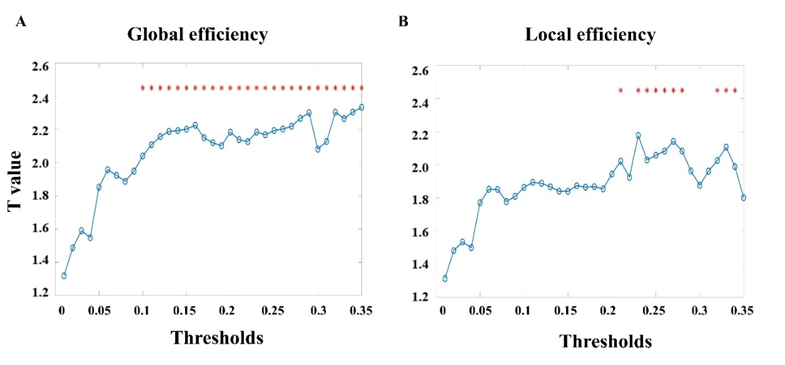
Figure S1: The difference of global(A) and local(B) efficiency between healthy controls and abstinent individuals at thresholds from 0.01 to 0.35; *: p < 0.05.
References
Wang, J., Wang, X., Xia, M., Liao, X., Evans, A., He, Y., 2015. GRETNA: A graph theoretical network analysis toolbox for imaging connectomics. Front. Hum. Neurosci. 9, 1–16. https://doi.org/10.3389/fnhum.2015.00386

Table S1: The difference of AUC of local and global efficiency between healthy controls and abstinent individuals
 | Healthy control | Alcohol abstinence | Statistical value
 | mean(SD) | mean(SD) | t | p-value
Global efficiency | 0.673(0.171) | 0.586(0.198) | 2.197 | 0.030
Local efficiency | 0.670(0.189) | 0.570(0.217) | 2.024 | 0.046

