Enantioselective Synthesis, Computational Molecular Docking and Invitro Anticoagulant Activity of Warfarin-based Derivatives

Zakia Afzal¹, Naghmana Rashid¹, Humaira Nadeem², Arif-ullah Khan², Zaman Ashraf¹

¹Department of Chemistry, Allama Iqbal Open University, H-8/2 Islamabad,44000, Pakistan
²Department of Pharmacy, Riphah International University, 7th Avenue, Islamabad, 44000, Pakistan

Corresponding author
*Department of Chemistry, Allama Iqbal Open University, H-8/2 Islamabad,44000, Pakistan
E-mail address: zakiafaisal9@gmail.com, Tel: (+92)-3217244636

Content
¹H NMR AND ¹³C NMR Spectrum of synthesized compounds
EIMS Spectrum of synthesized compounds
Chiral HPLC Chromatogram
Dock poses of synthesized compounds with 3kp9

¹H NMR spectra and ¹³C NMR spectra
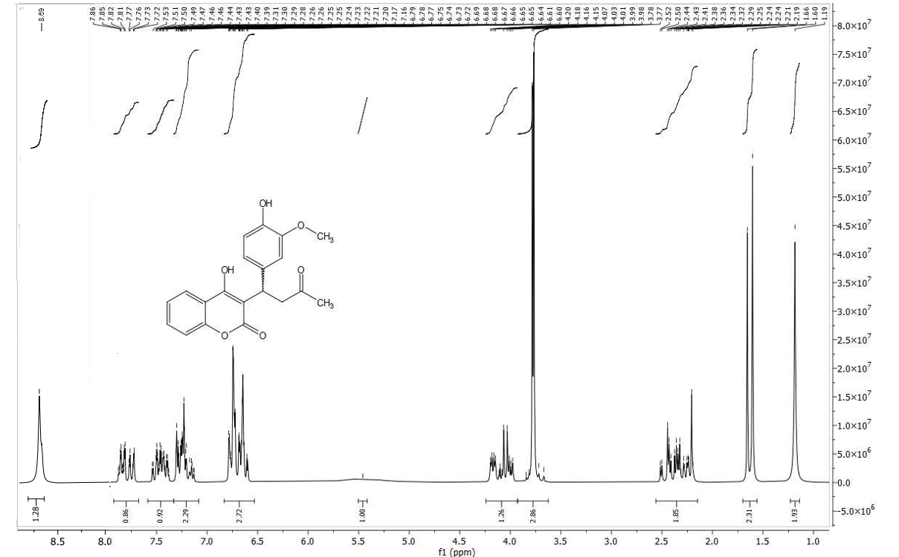
Fig. S1 ¹H NMR of 5a
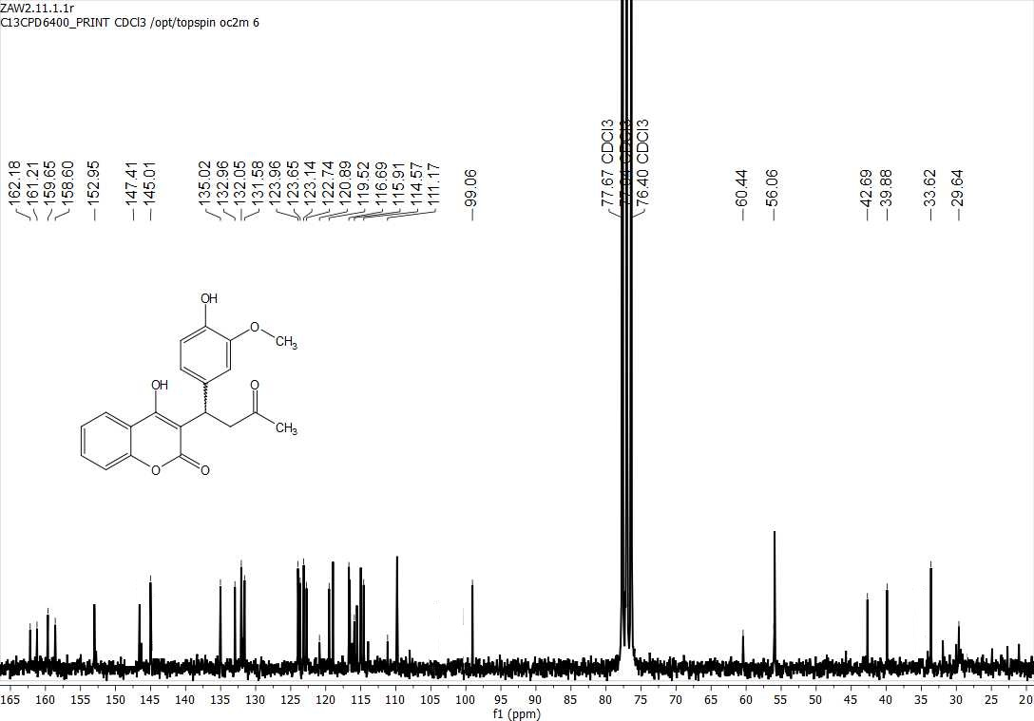
Fig. S2 ¹³C NMR of 5a

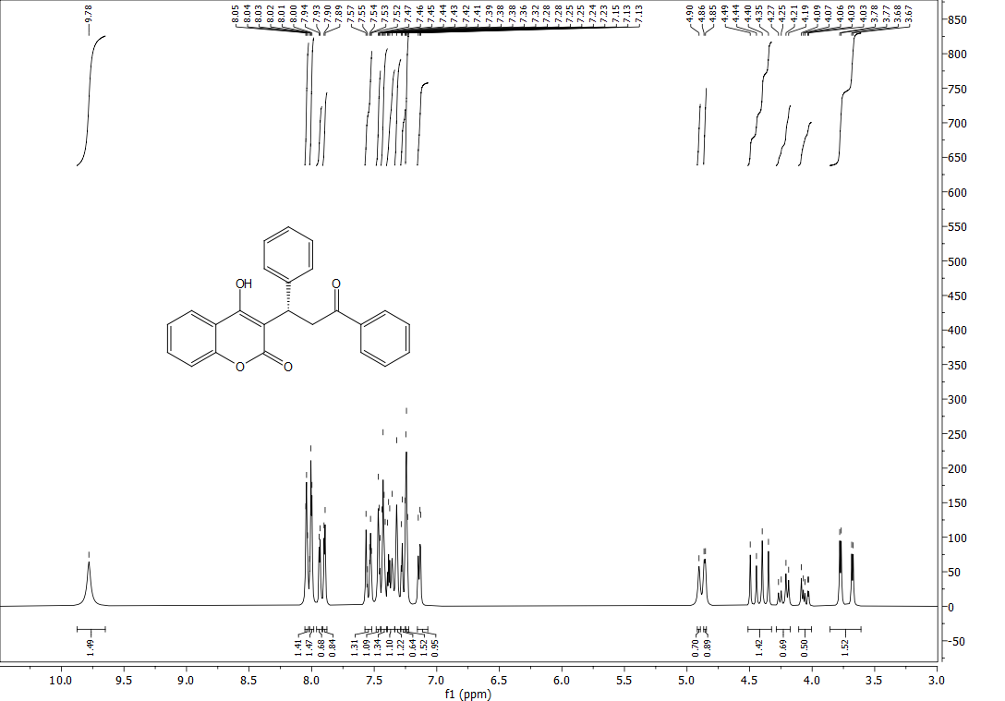
Fig. S3 ¹H NMR of 5b
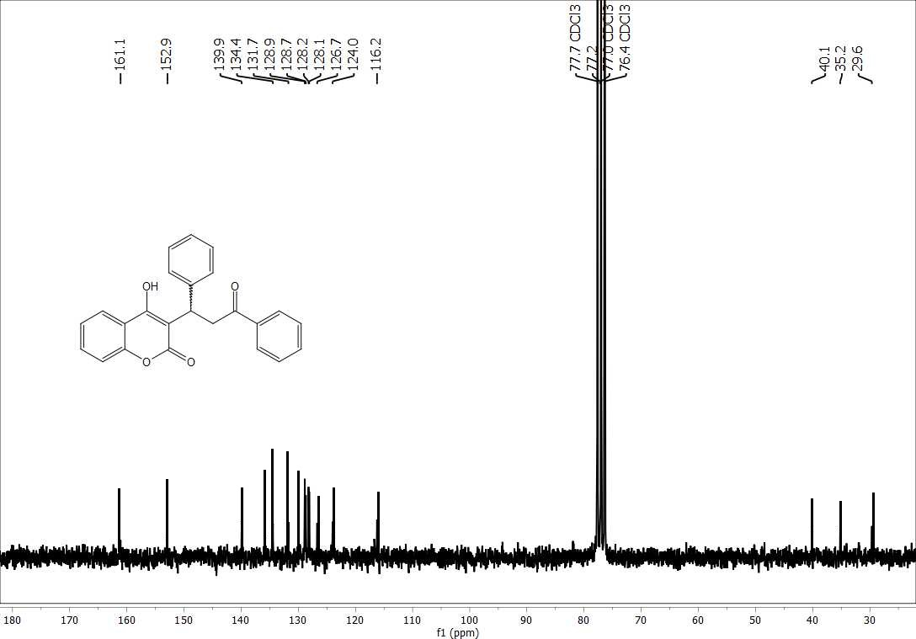
Fig. S4 ¹³C NMR of 5b
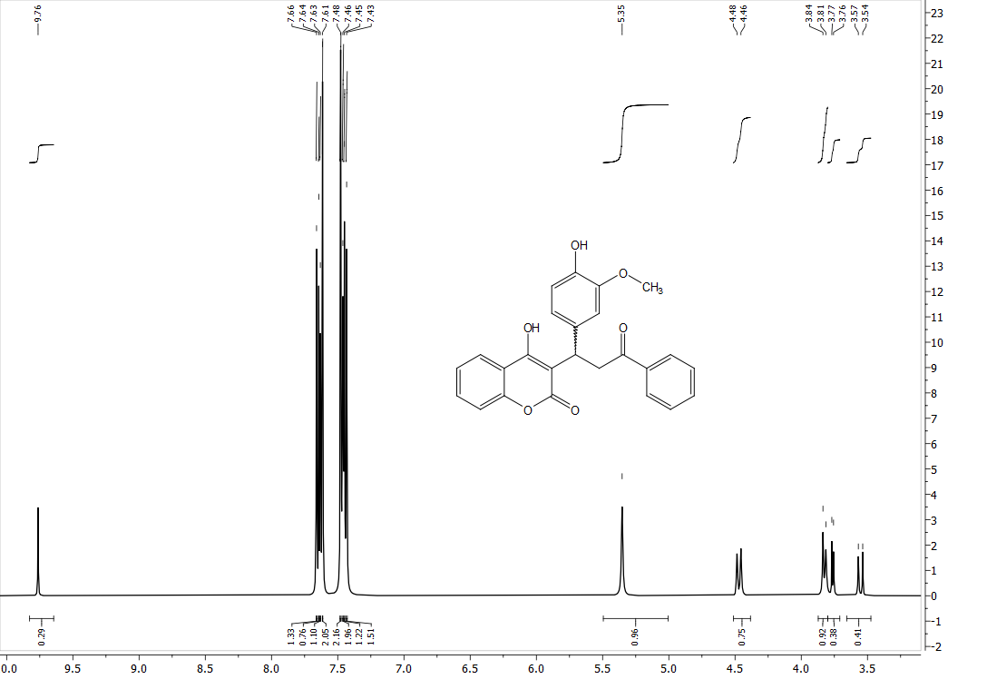
Fig. S5 ¹H NMR of 5c

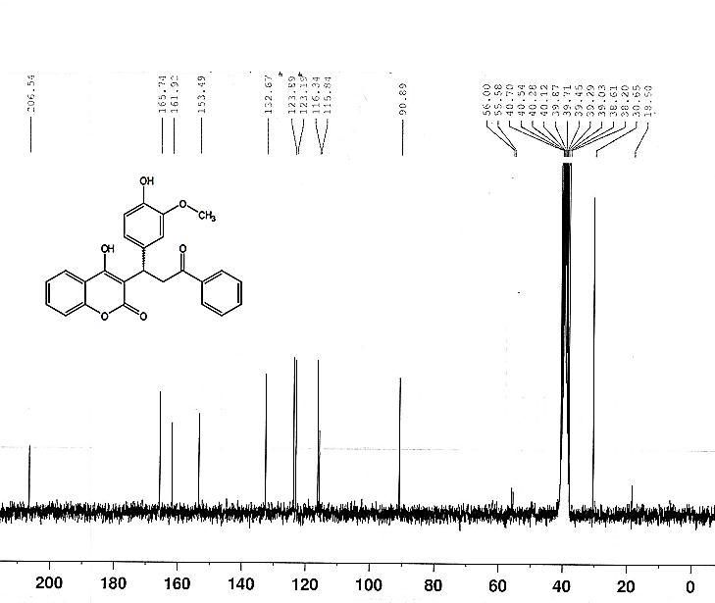
Fig. S6 ¹³C NMR of 5c

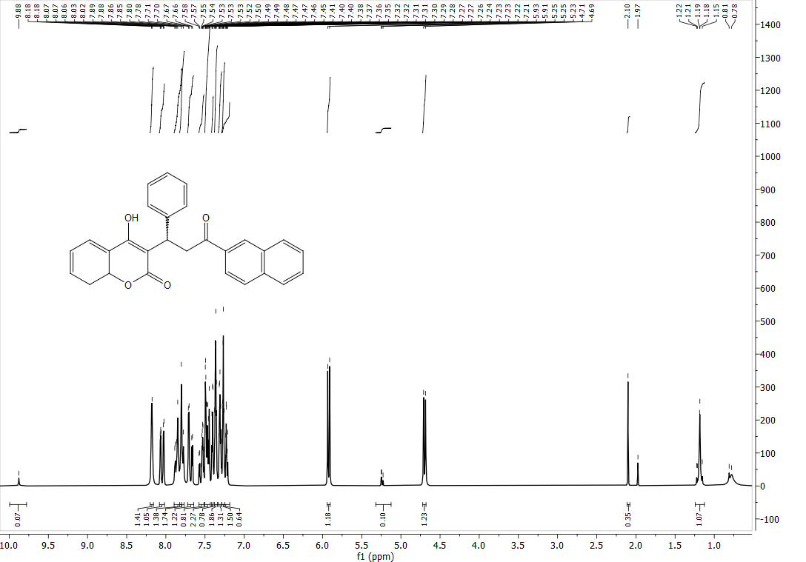
Fig. S7 ¹H NMR of 5d
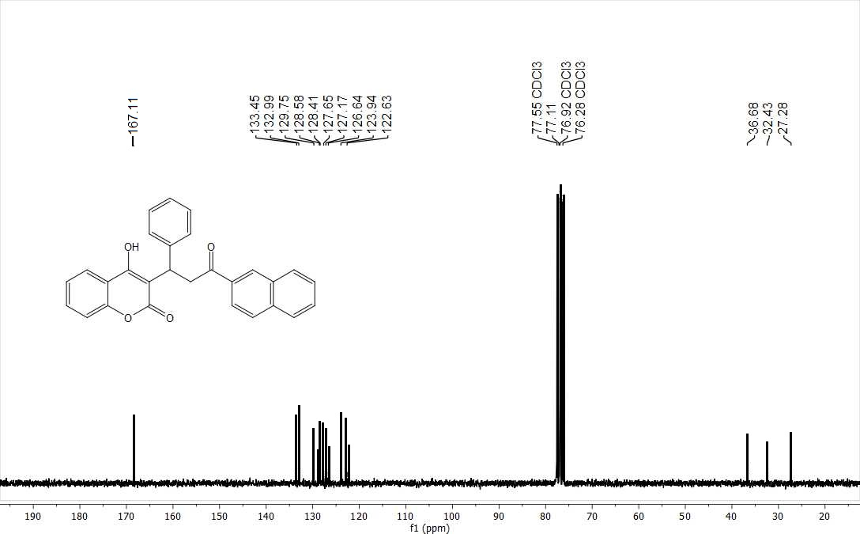
Fig. S8 ¹³C NMR of 5d
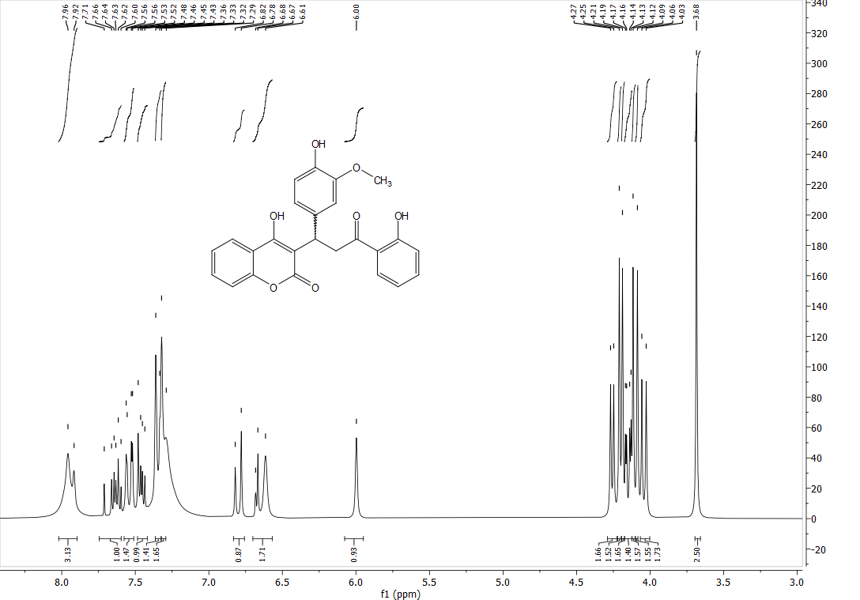
Fig. S9 ¹H NMR of 5e
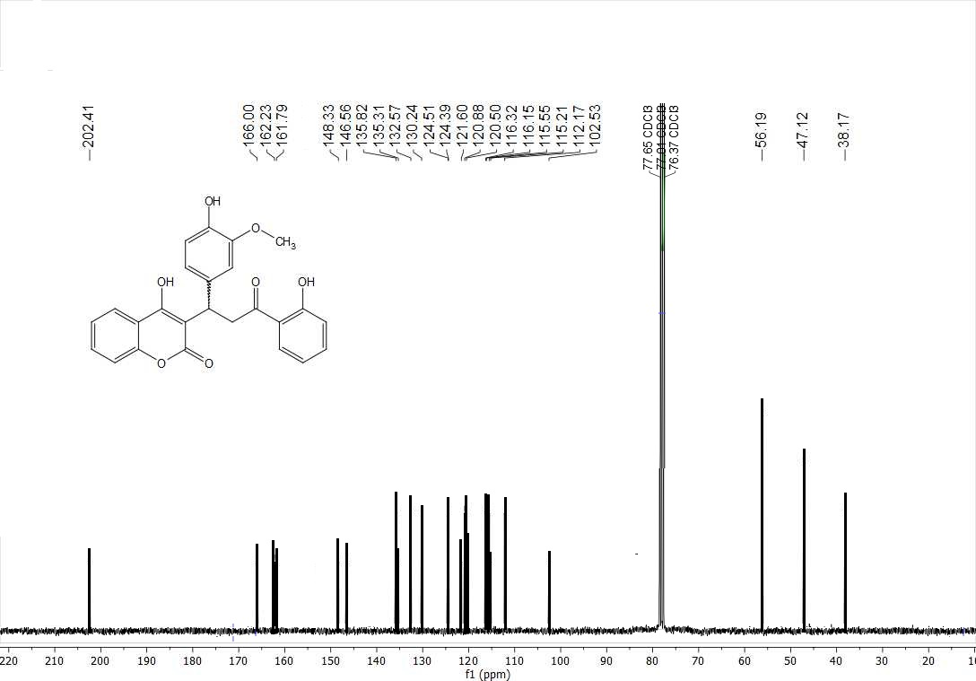
Fig. S10 ¹³C NMR of 5e

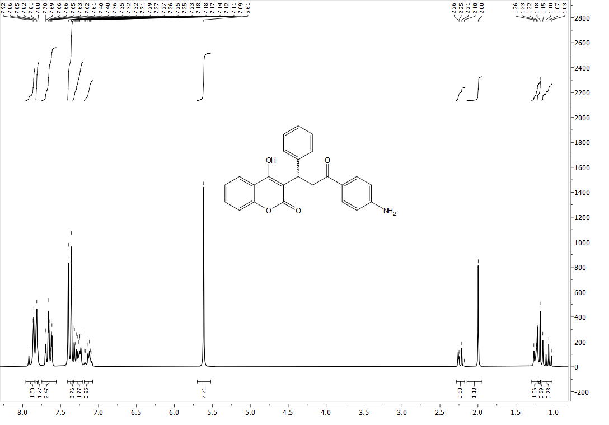
Fig. S11 ¹H NMR of 5f

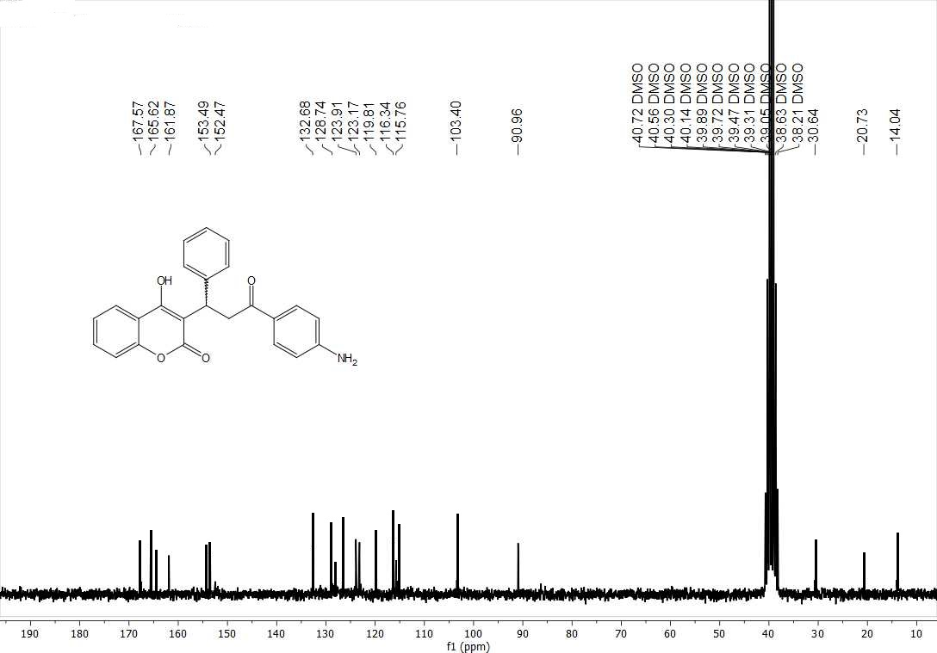
Fig. S12 ¹³C NMR of 5f
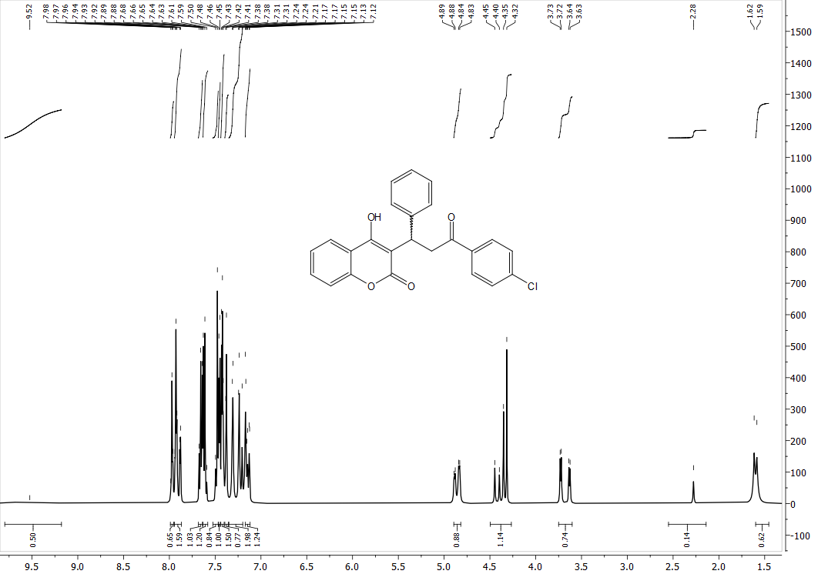
Fig. S13 ¹H NMR of 5g
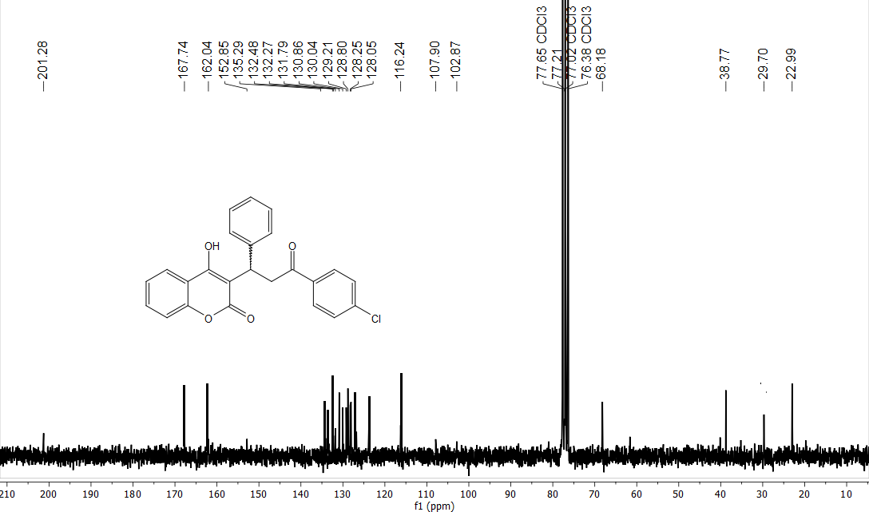
Fig. S14 ¹³C NMR of 5g
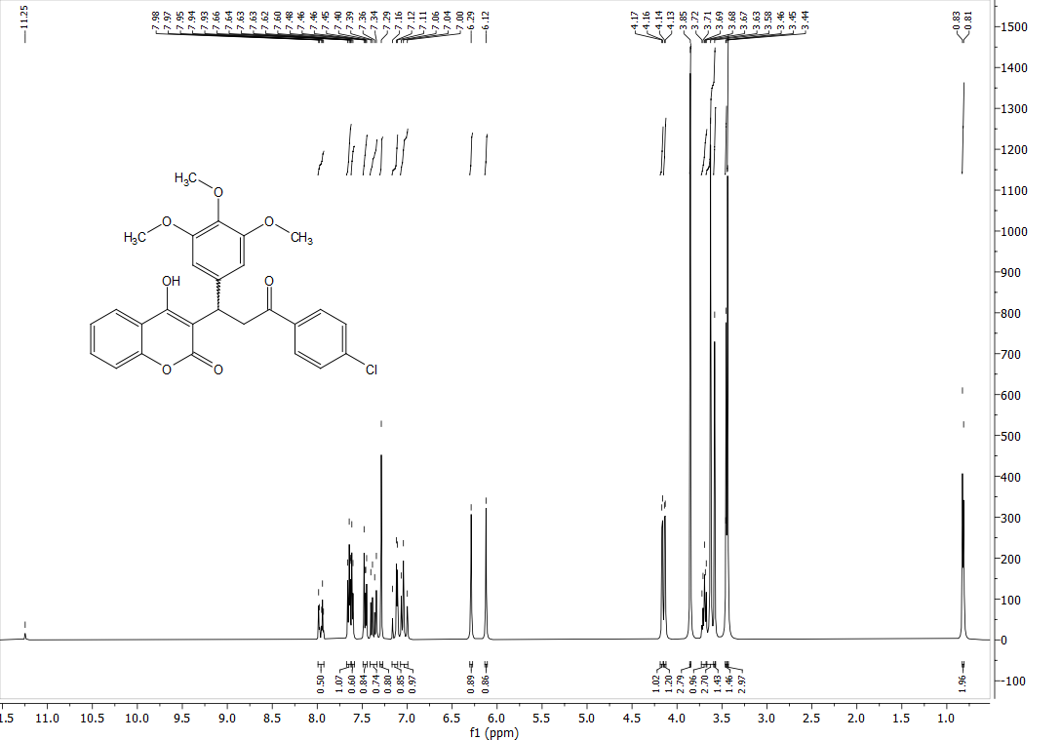
Fig. S15 ¹H NMR of 5h
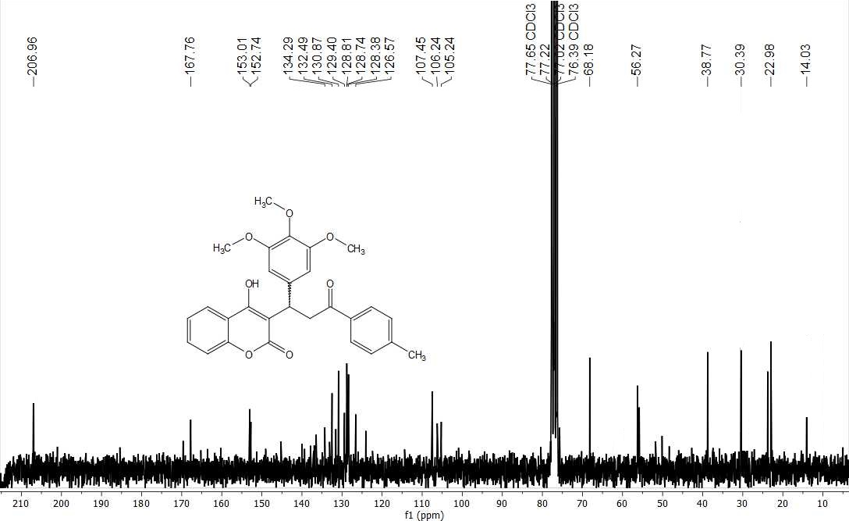
Fig. S16 ¹³C NMR of 5h

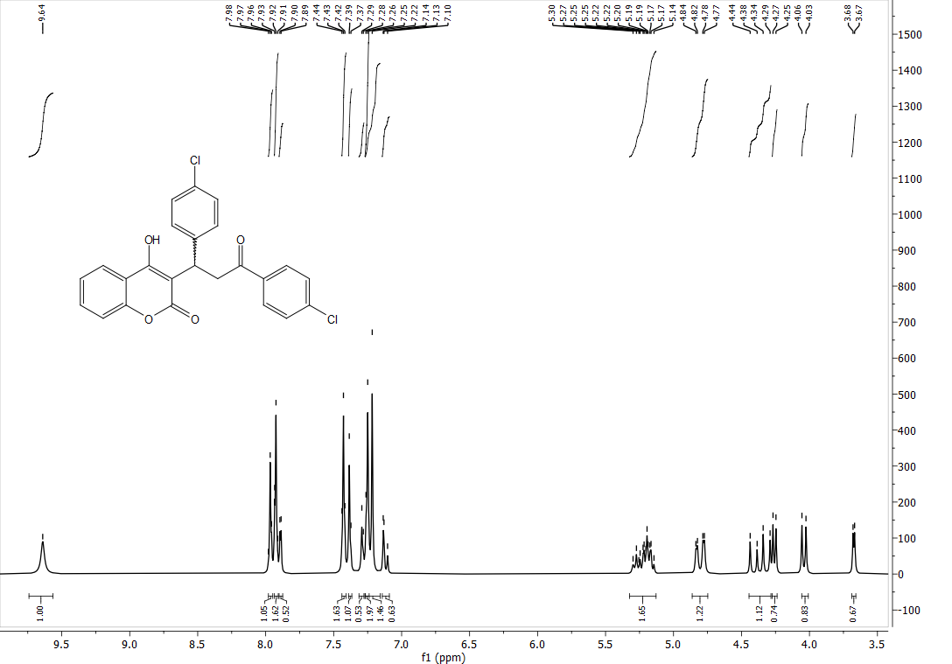
Fig. S17 ¹H NMR of 5i
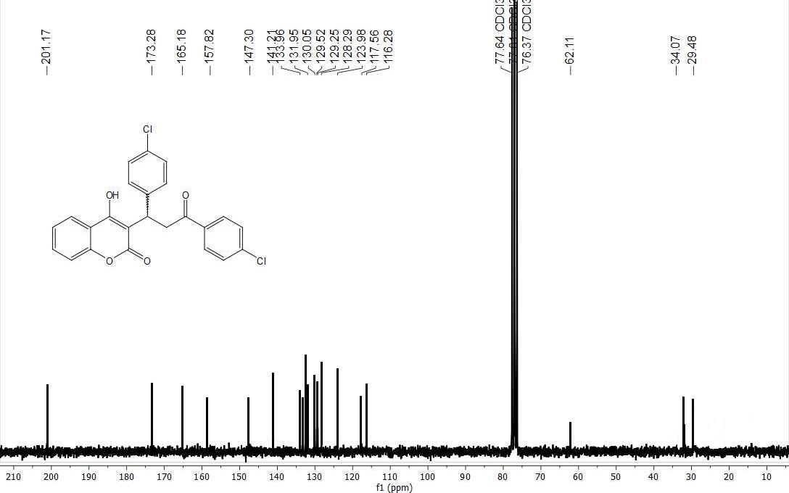
Fig. S18 ¹³C NMR of 5i

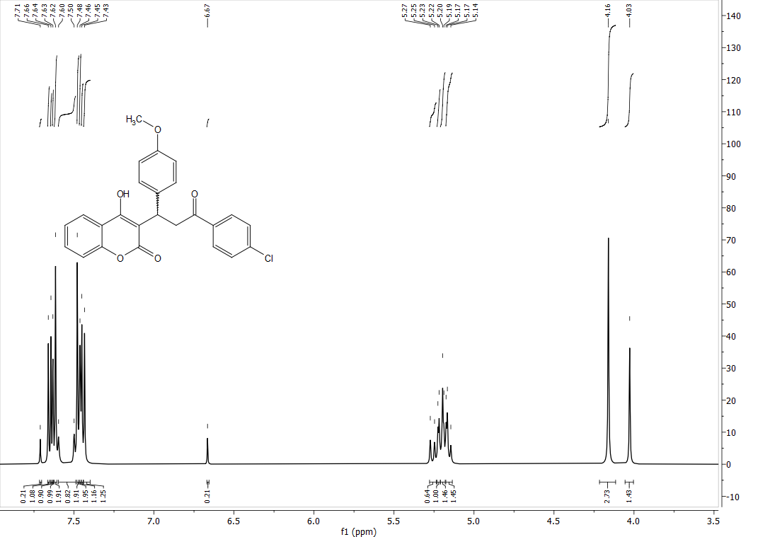
Fig. S19 ¹H NMR of 5j
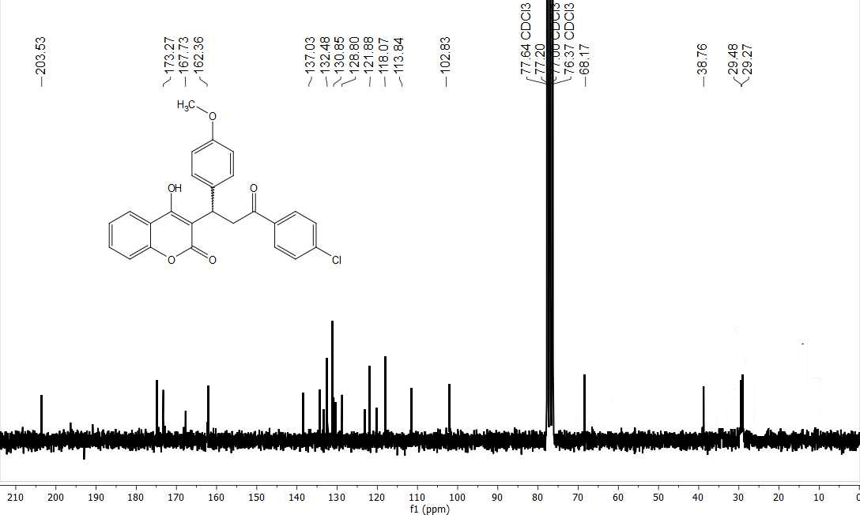
Fig. S20 ¹³C NMR of 5j

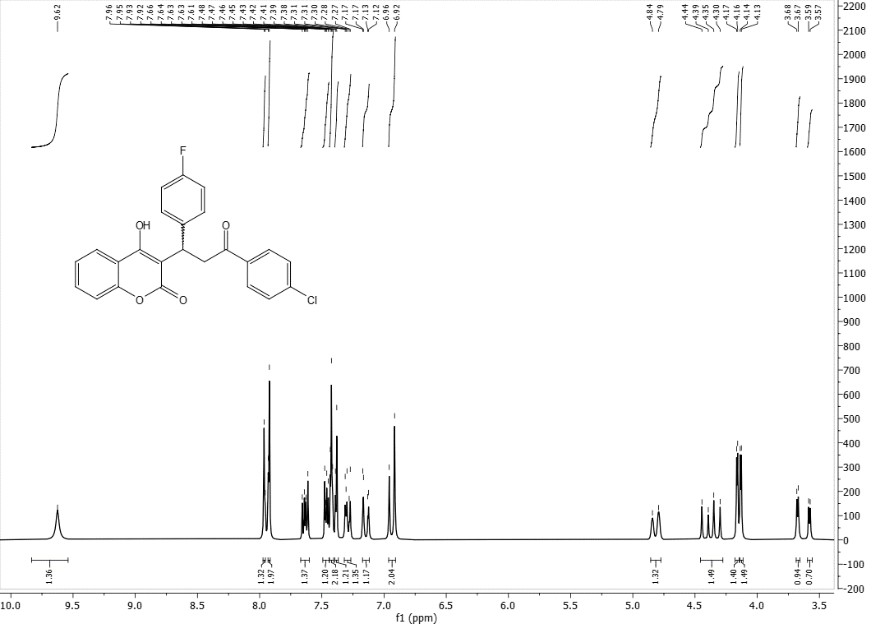
Fig. S21 ¹H NMR of 5k
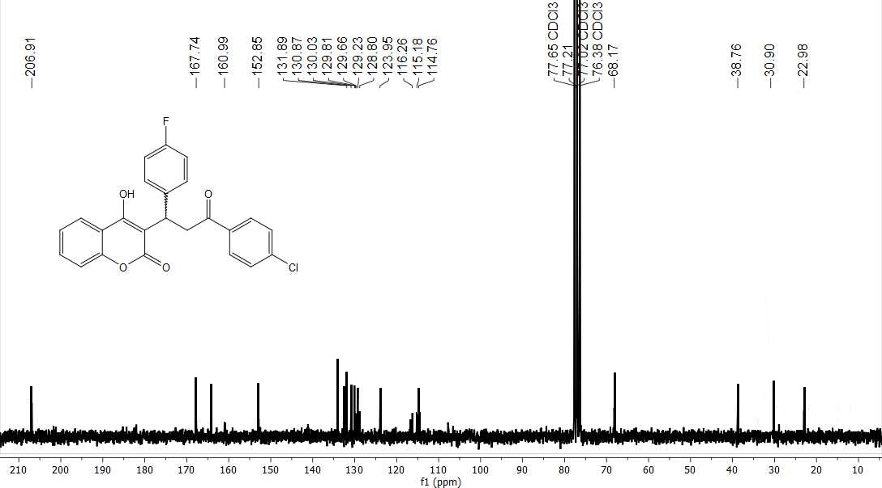
Fig. S22 ¹³C NMR of 5k
EIMS Spectra

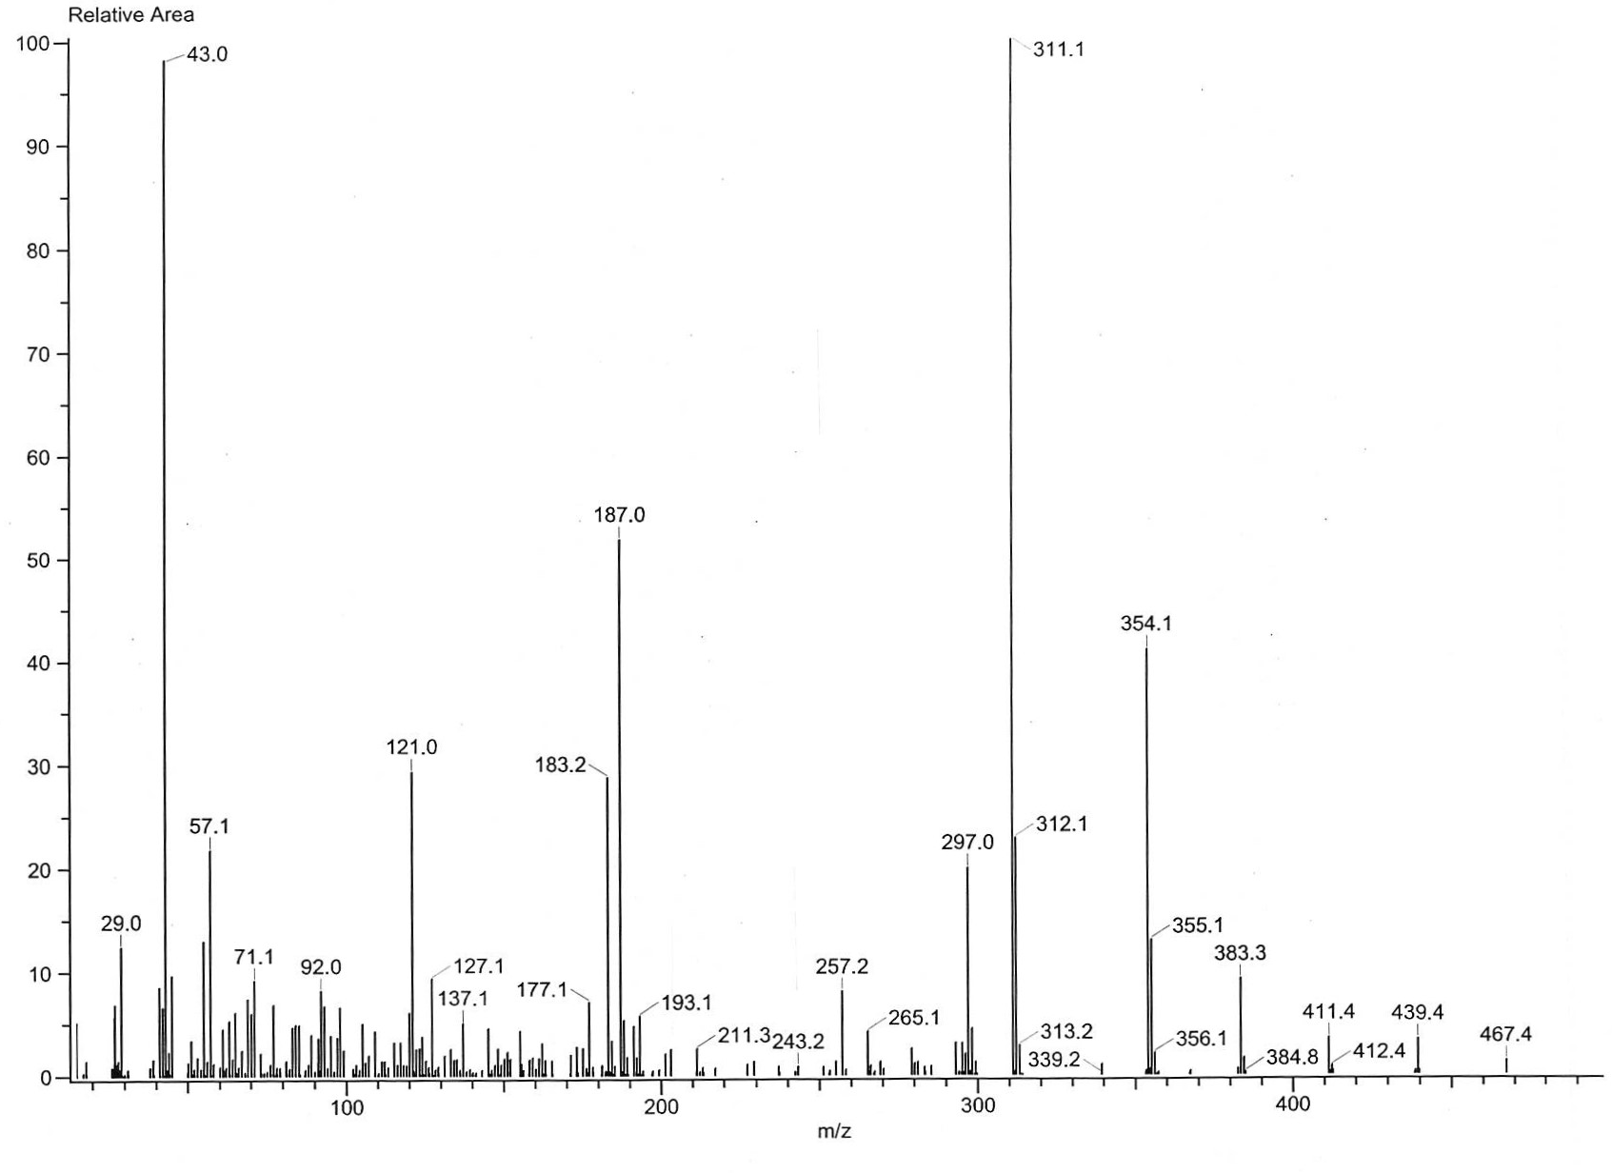
Fig. S23 EIMS spectrum of 5a

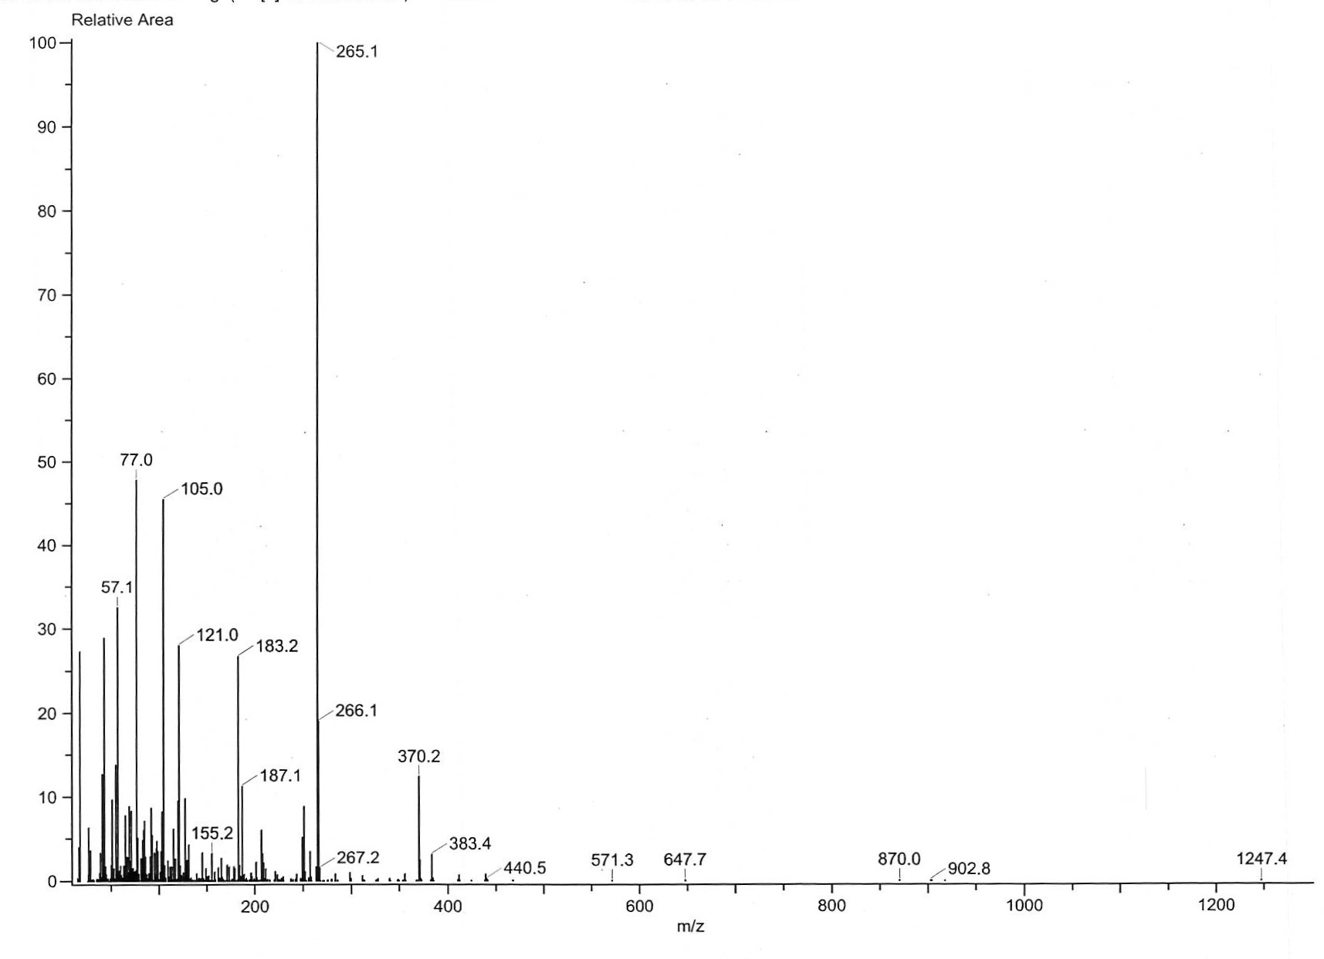
Fig. S24 EIMS spectrum of 5b

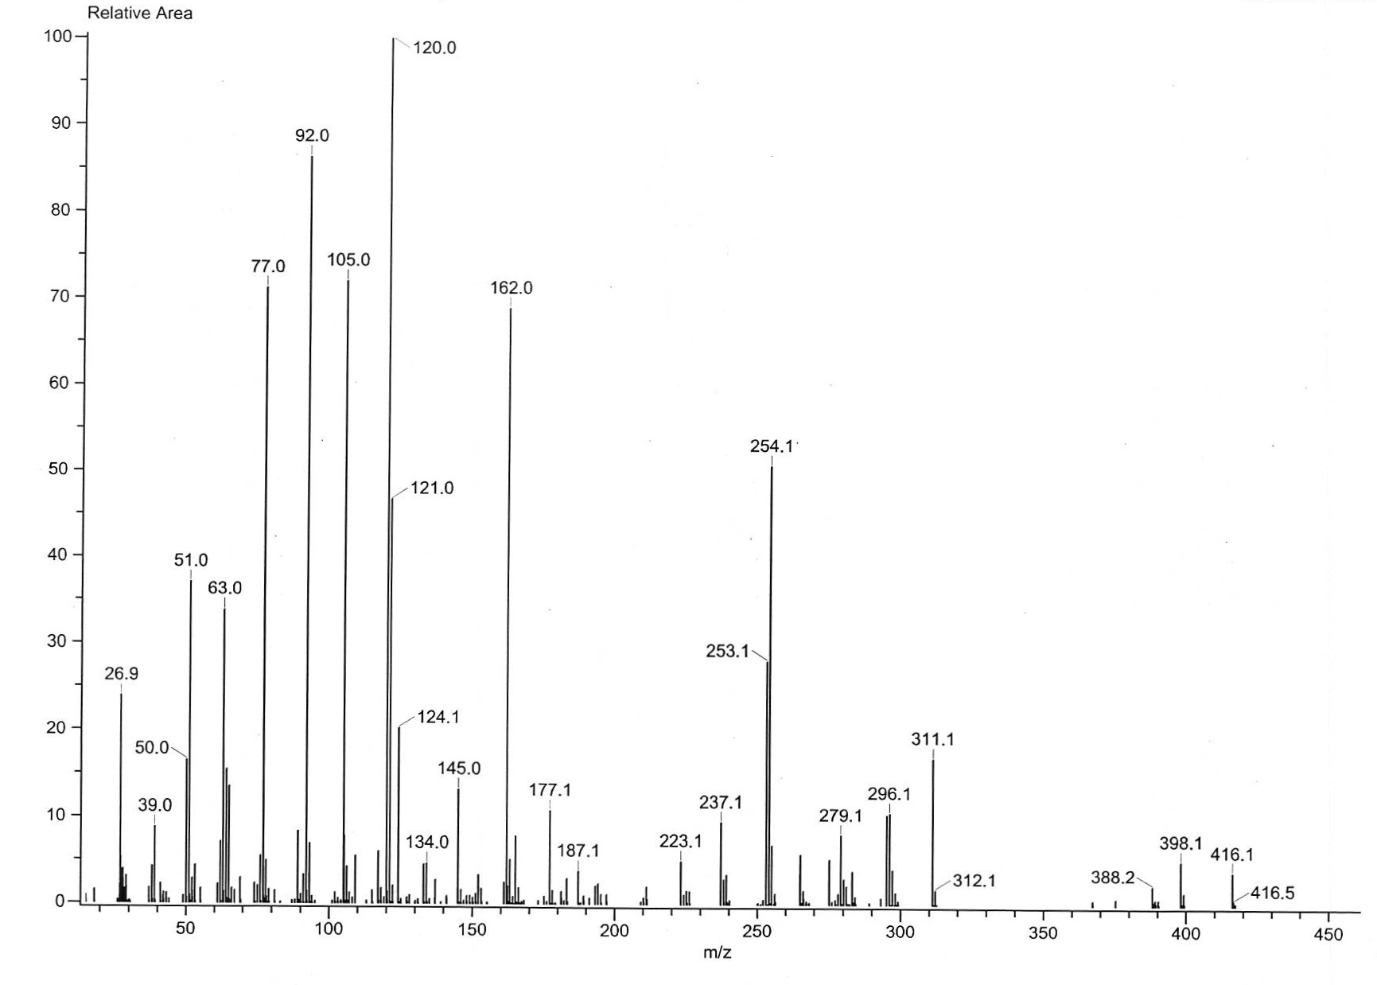
Fig. S25 EIMS spectrum of 5c

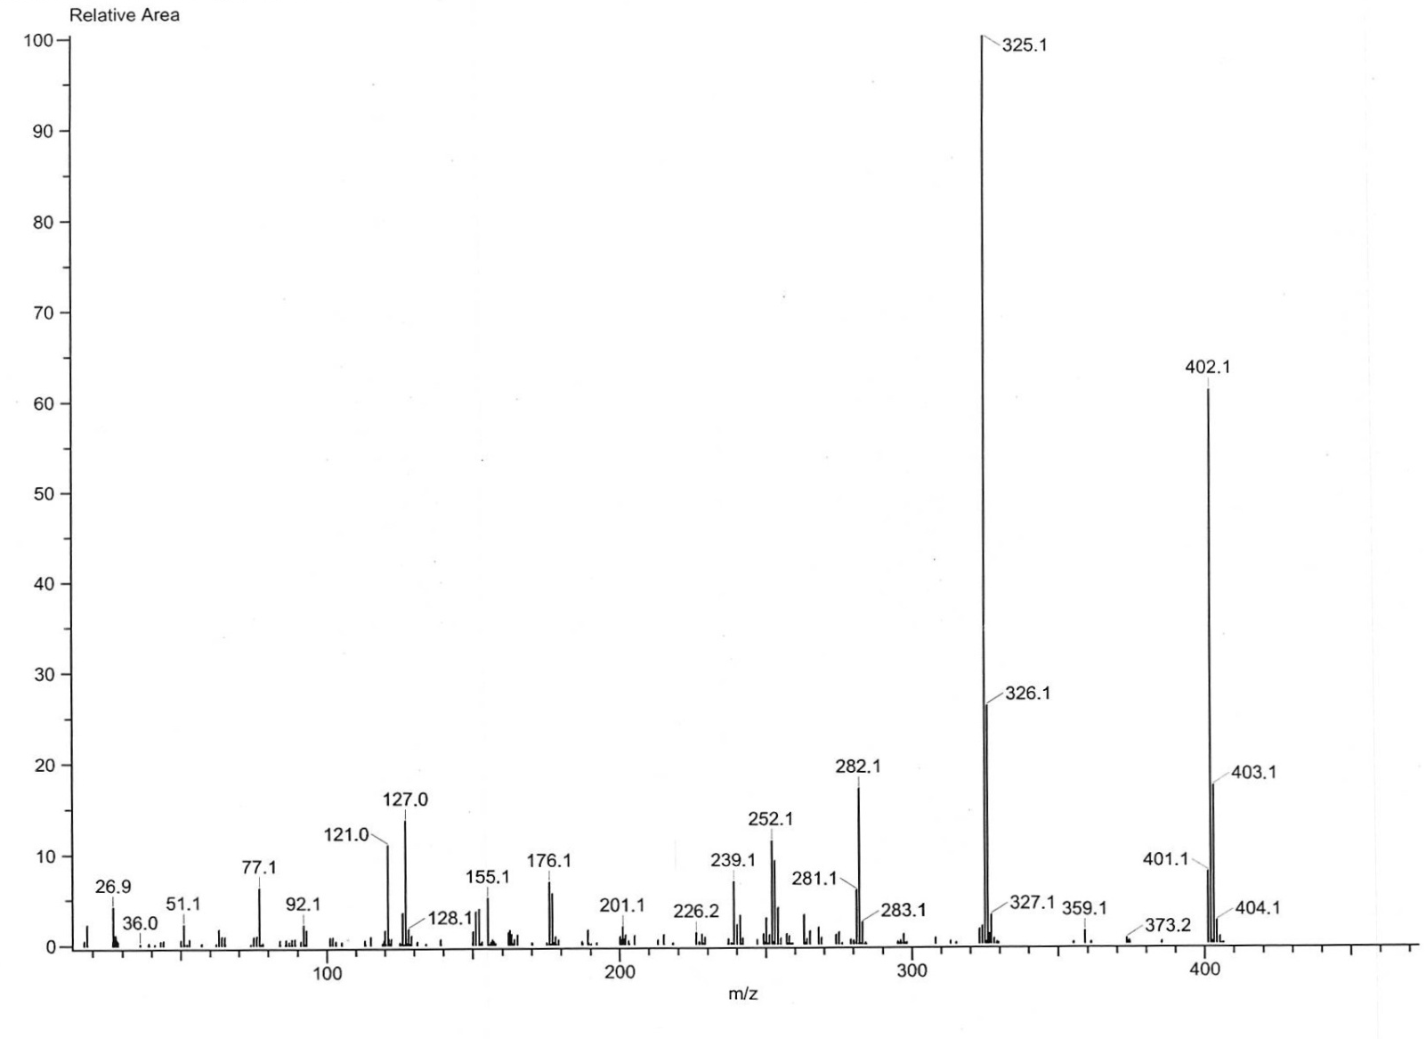
Fig. S26 EIMS spectrum of 5d

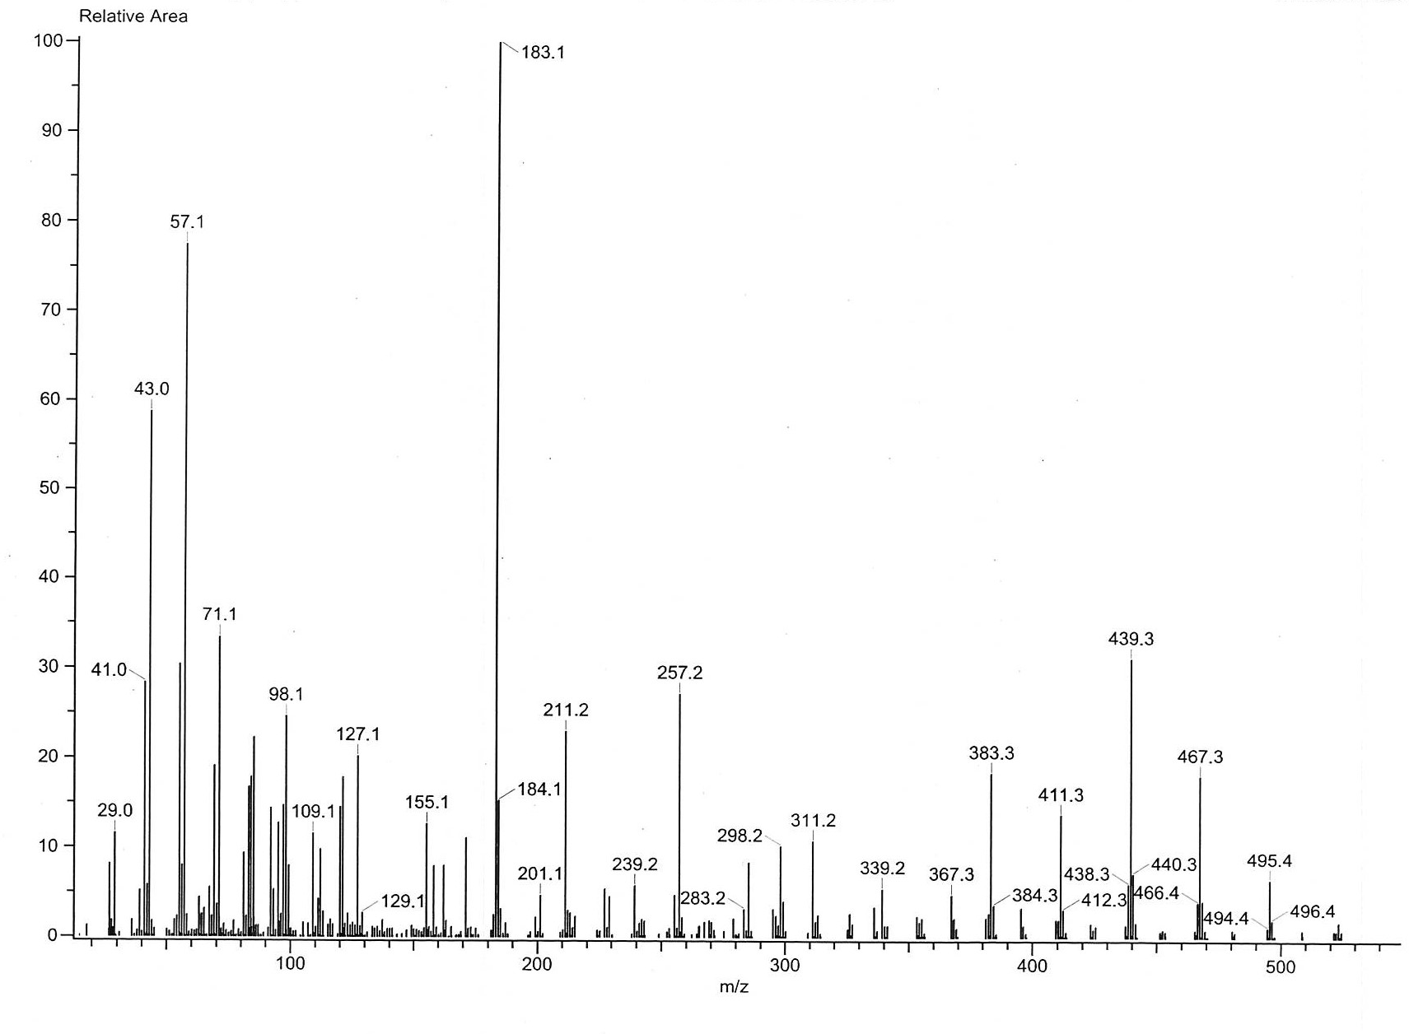

Fig. S27 EIMS spectrum of 5e

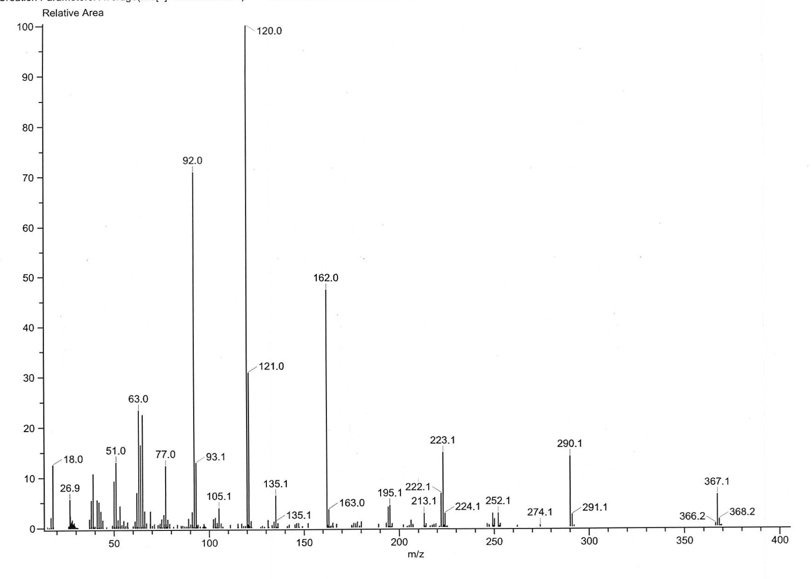
Fig. S28 EIMS spectrum of 5f

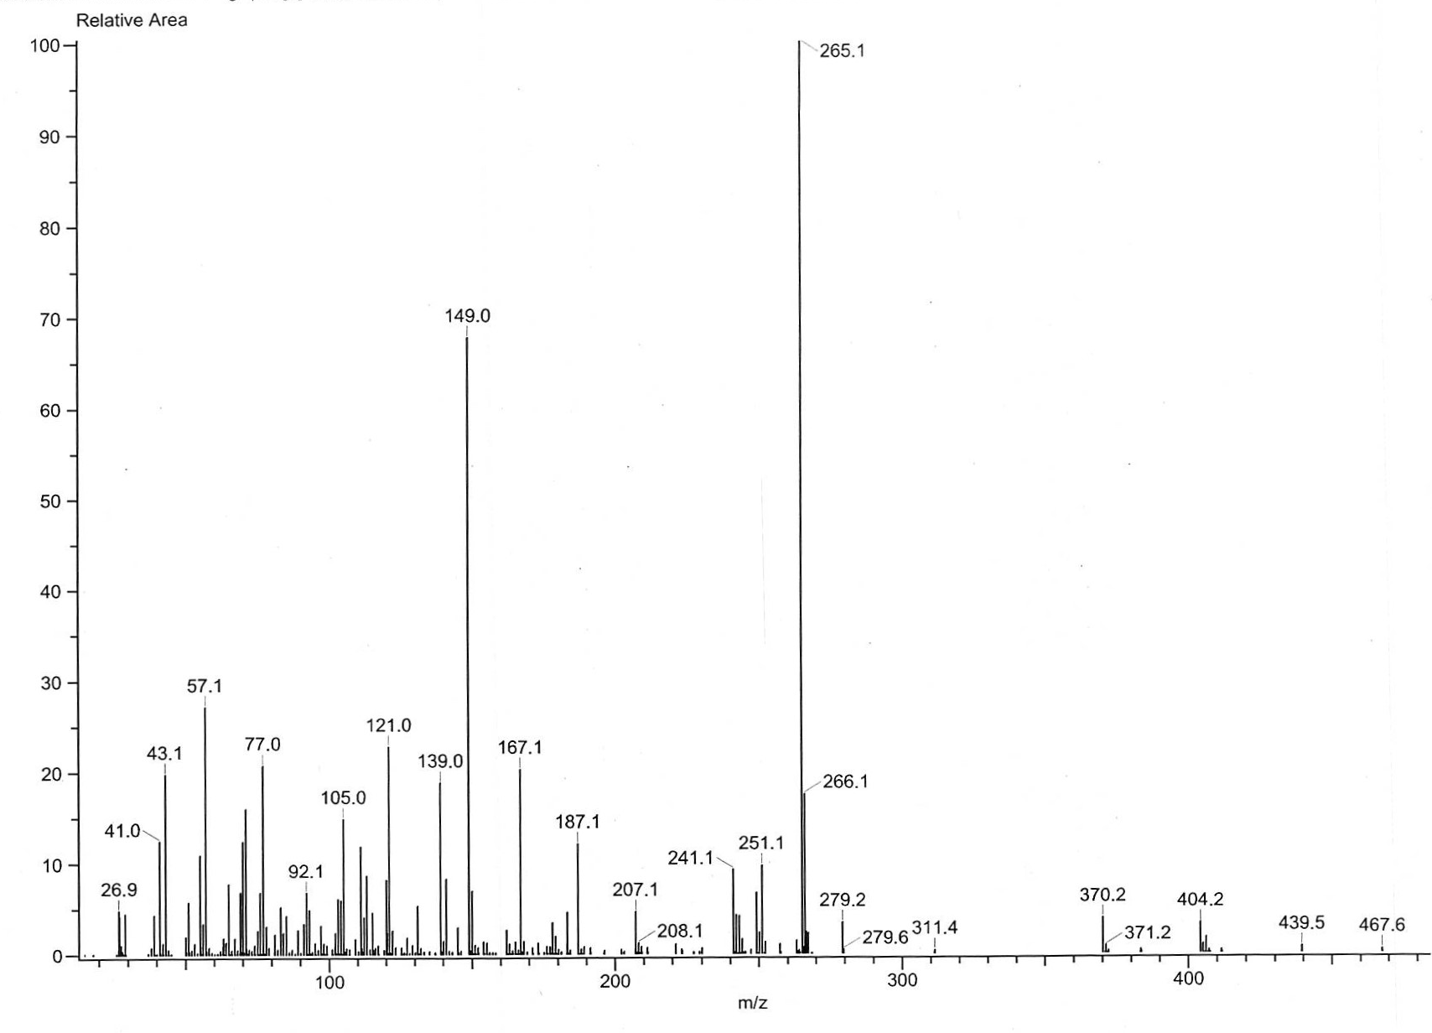
Fig. S29 EIMS spectrum of 5g

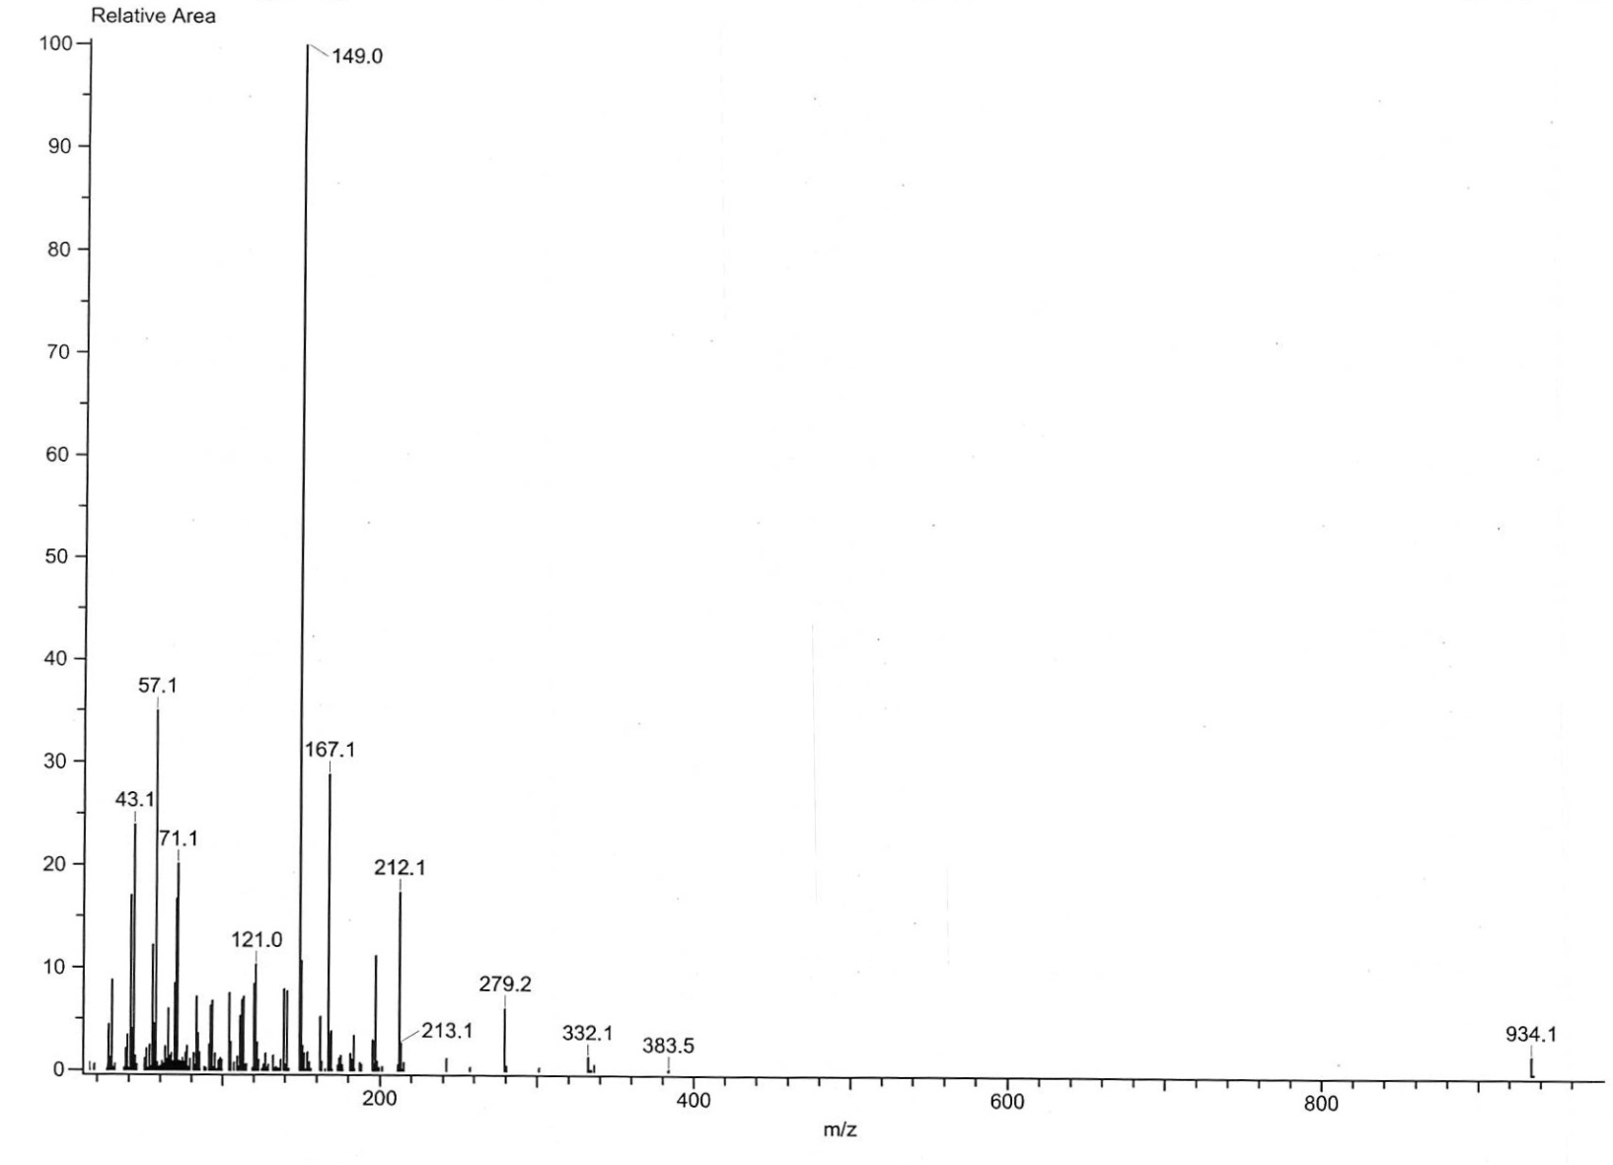
Fig. S30 EIMS spectrum of 5h

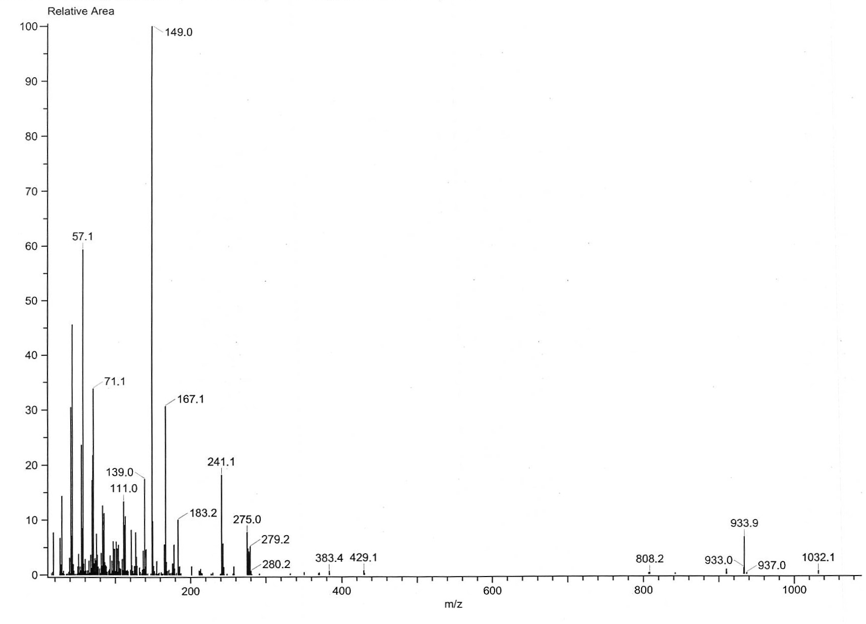
Fig. S31 EIMS spectrum of 5i

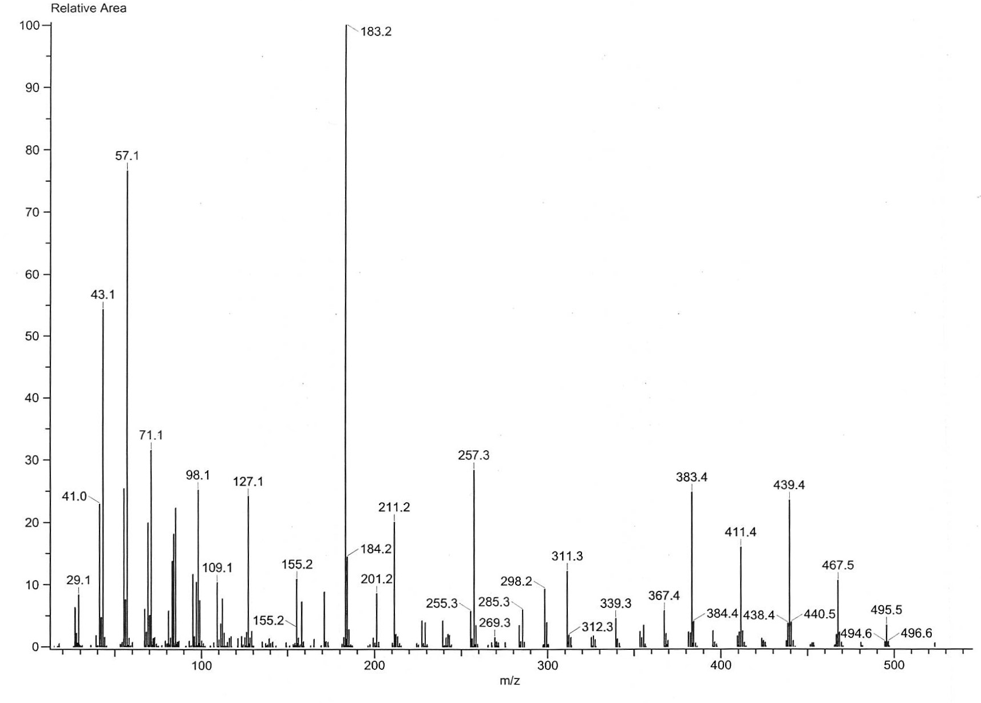
Fig. S32 EIMS spectrum of 5j

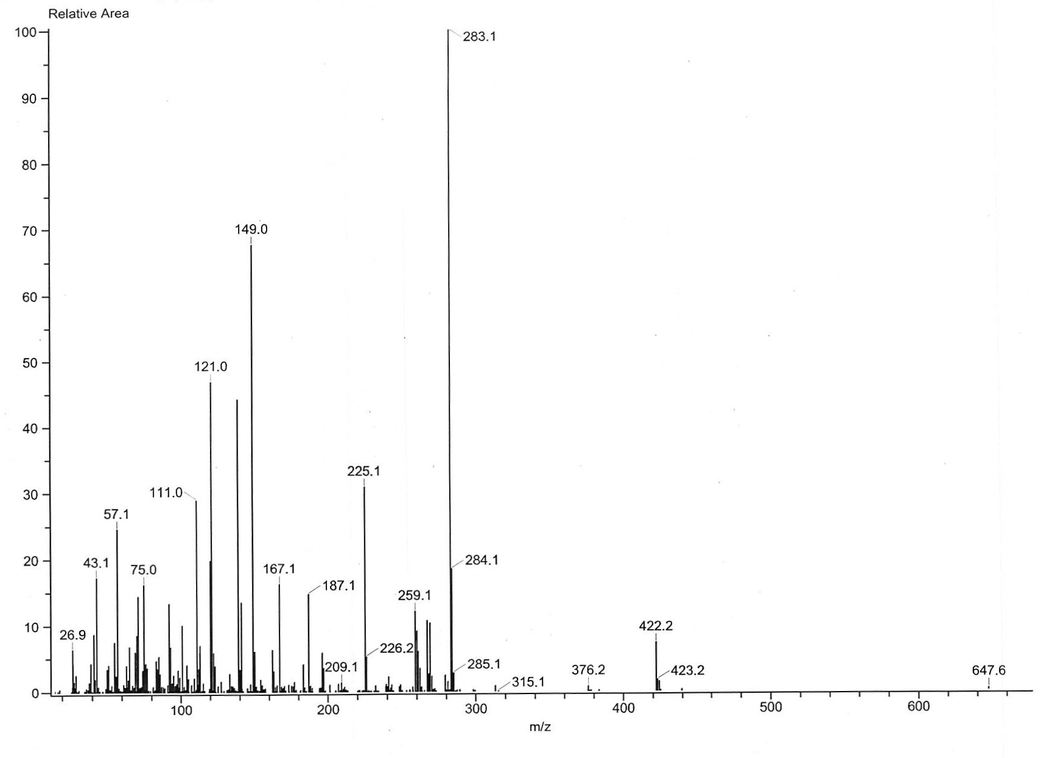
Fig. S33 EIMS spectrum of 5k

Chiral HPLC Chromatogram
All synthesized compounds showed 2 major peaks for two enantiomers and small peaks of their tautomers.
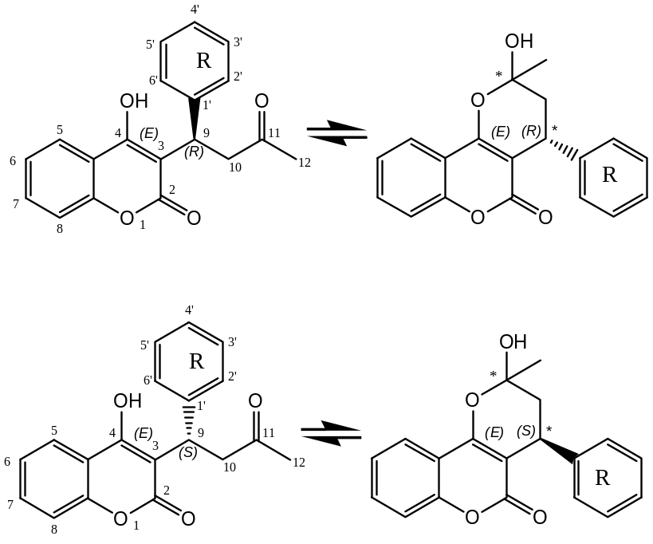

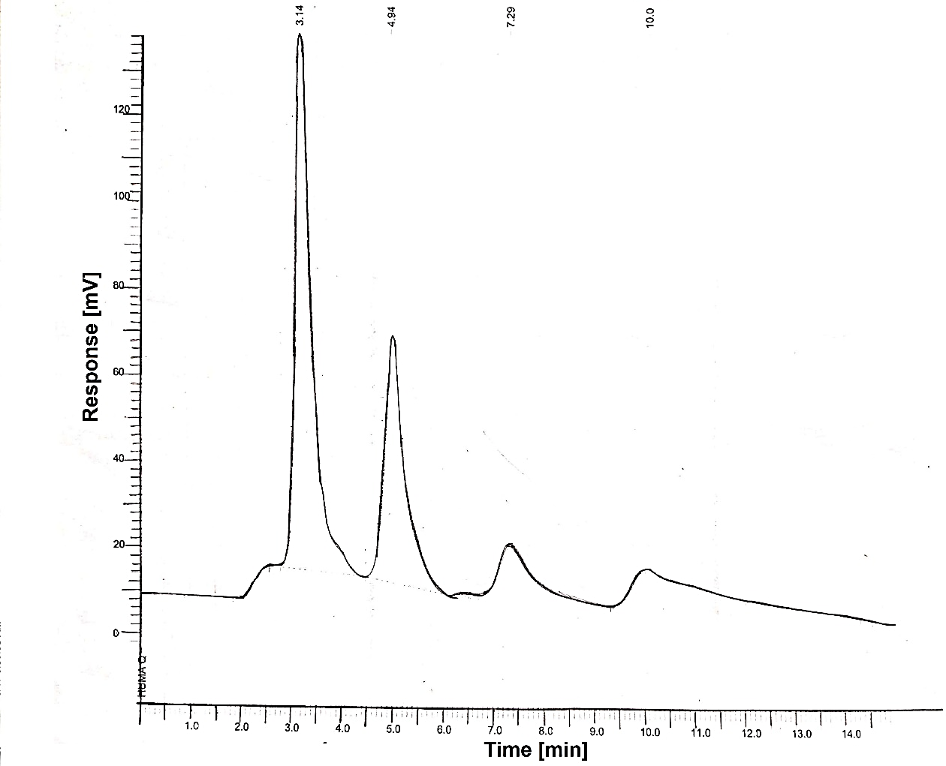
Fig. S34 Chiral HPLC chromatogram of 5a

Peak no | Time [min] | Height [µV] | Area [%] | Area/Height [s]
1 | 3.140 | 1.78e+06 | 95.05 | 15.4945
2 | 4.940 | 91561.07 | 4.64 | 14.7001

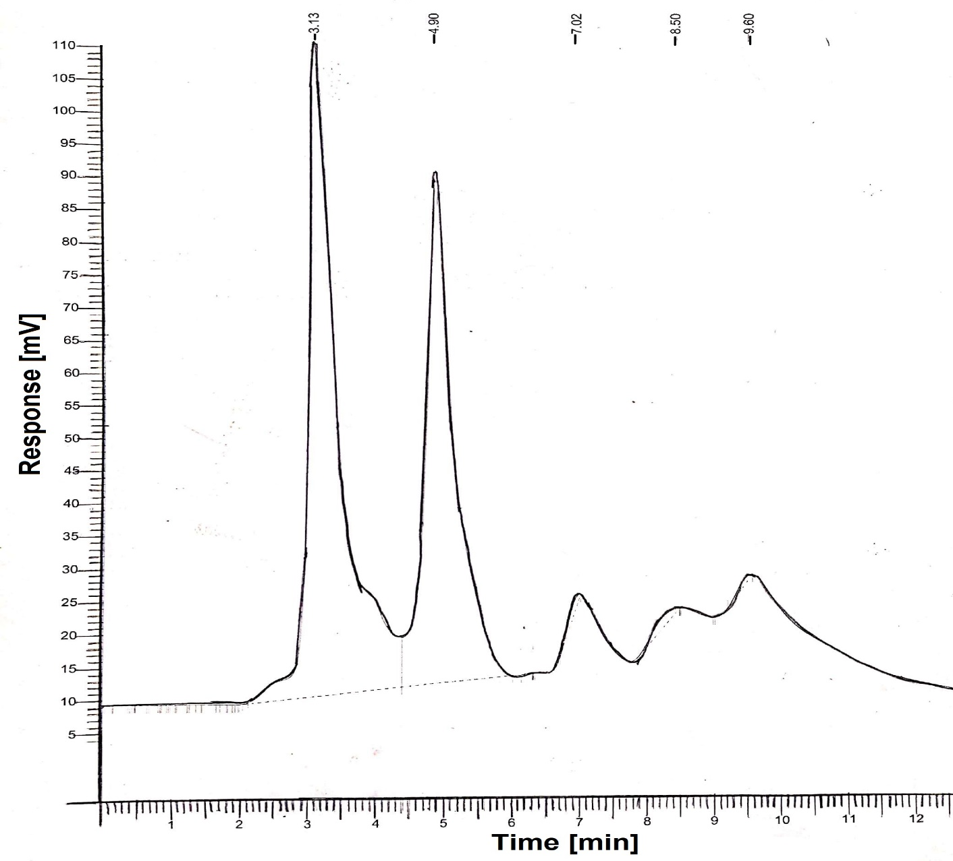
Fig. S35 Chiral HPLC chromatogram of 5b

Peak no | Time[min] | Height [µV] | Area [%] | Area/Height [s]
1 | 3.128 | 195622.53 | 57.73 | 31.8694
2 | 4.901 | 153639.85 | 42.10 | 30.1131

Peak no | Time [min] | Height [µV] | Area [%] | Area/Height [s]
1 | 3.16 | 215450.95 | 84.78 | 23.32
2 | 4.93 | 33915.62 | 14.97 | 26.47
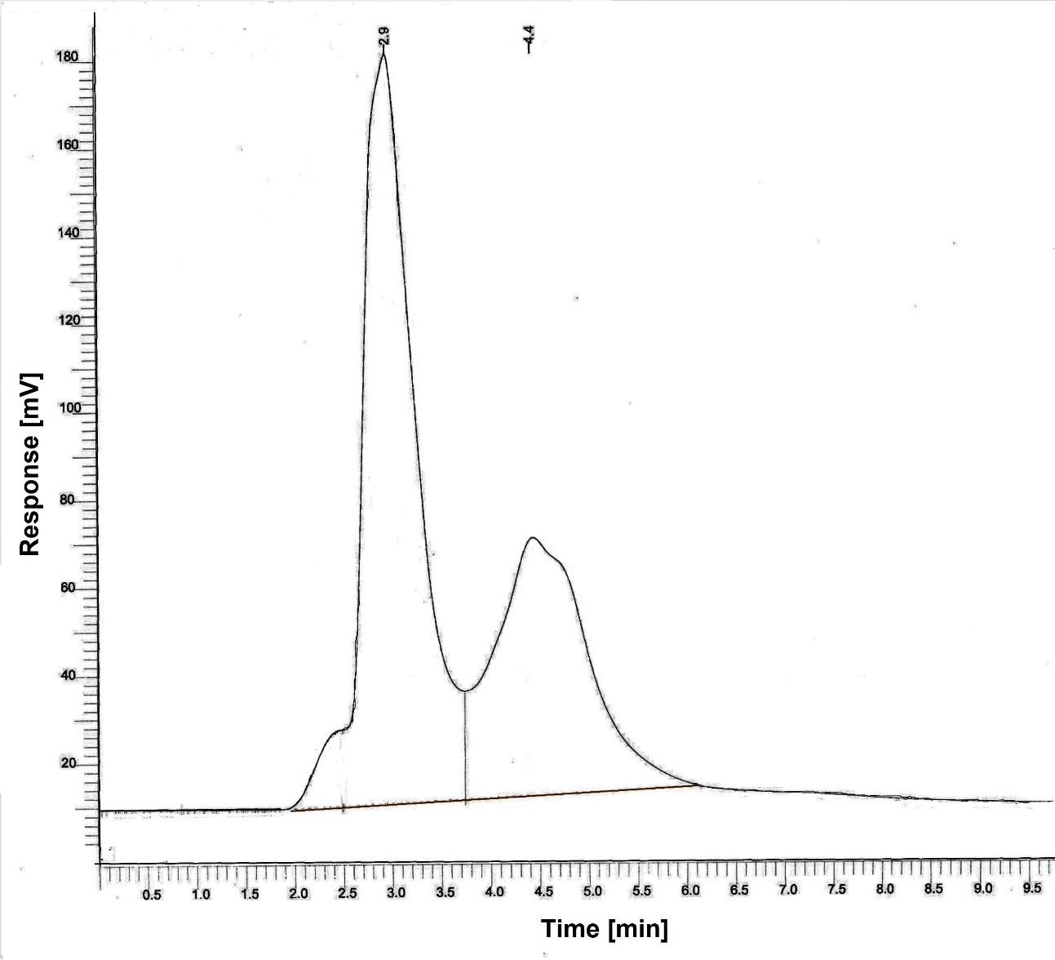

Fig. S36 Chiral HPLC chromatogram of 5c

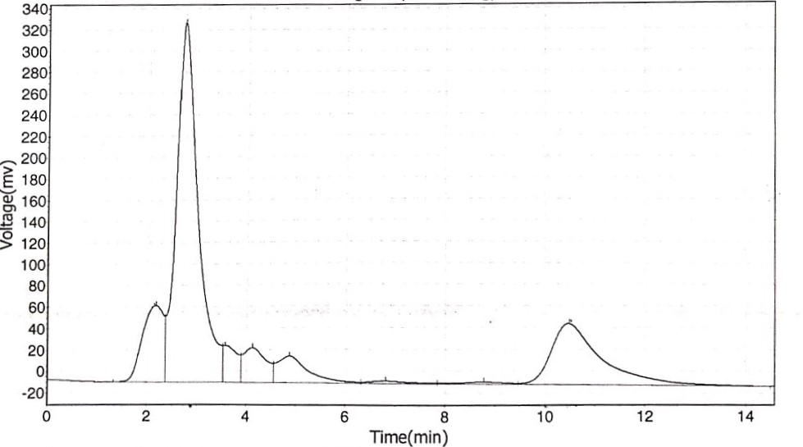
Fig. S37 Chiral HPLC chromatogram of 5d

Peak no | Time [min] | Height [µV] | Area [µV.s] | Area %
1 | 2.73 | 336763.094 | 10158403.00 | 53.00
2 | 10.5 | 56257.313 | 3916503.0 | 20.00

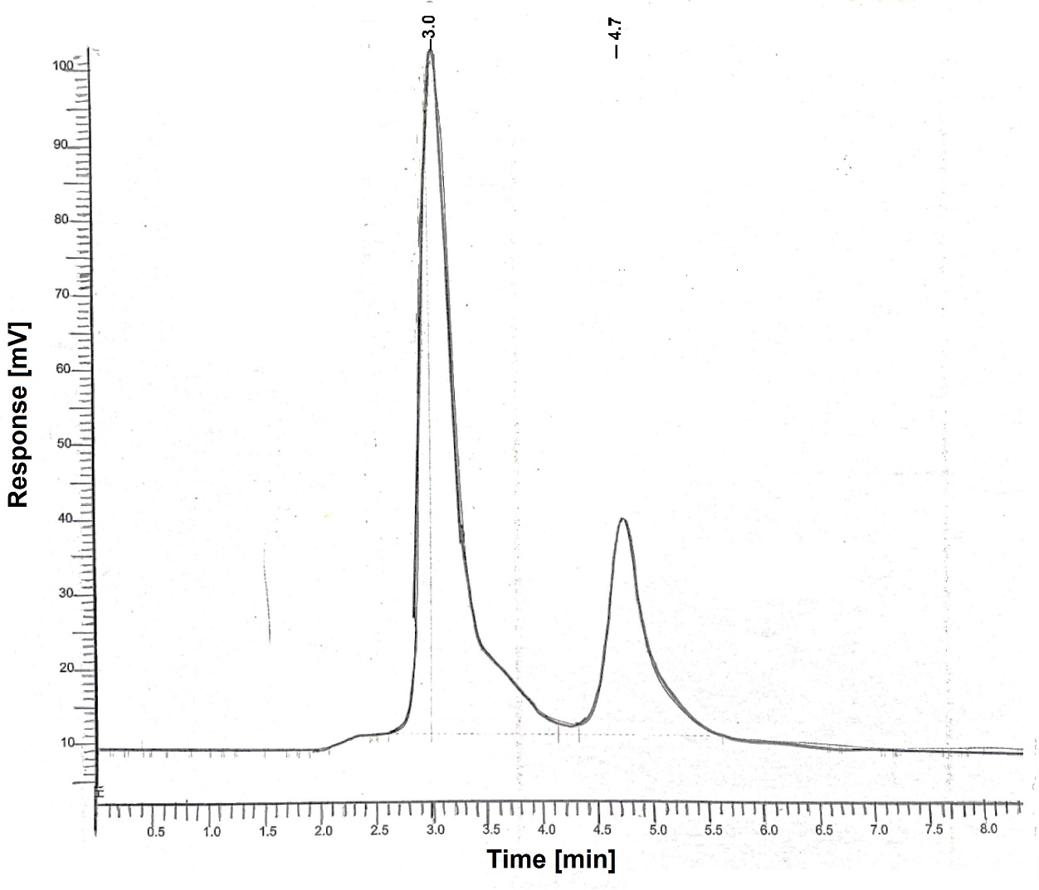
Fig. S38 Chiral HPLC chromatogram of 5e

Peak no | Time[min] | Height [µV] | Area [%] | Area/Height [s]
1 | 3.048 | 179036.45 | 75.37 | 24.910
2 | 4.748 | 57144.64 | 24.22 | 24.10

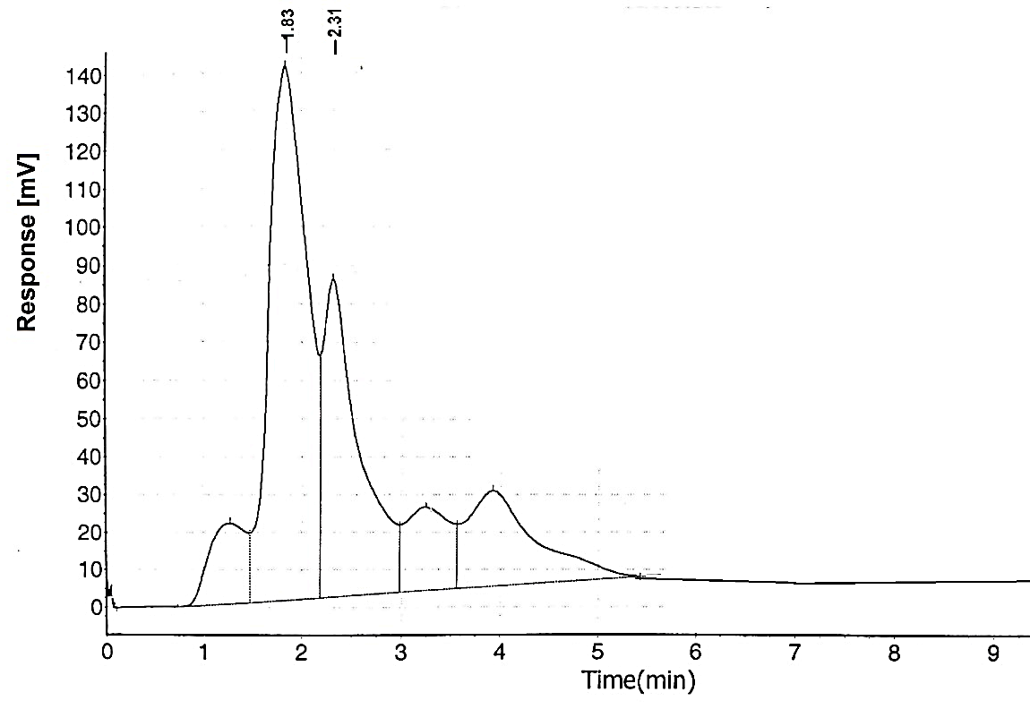
Fig. S39 Chiral HPLC chromatogram of 5f

Peak no | Time [min] | Height [µV] | Area [µV.s] | Area %
1 | 1.83 | 139563.953 | 3709049.250 | 64.28
2 | 2.31 | 83419.453 | 2131565.500 | 35.28

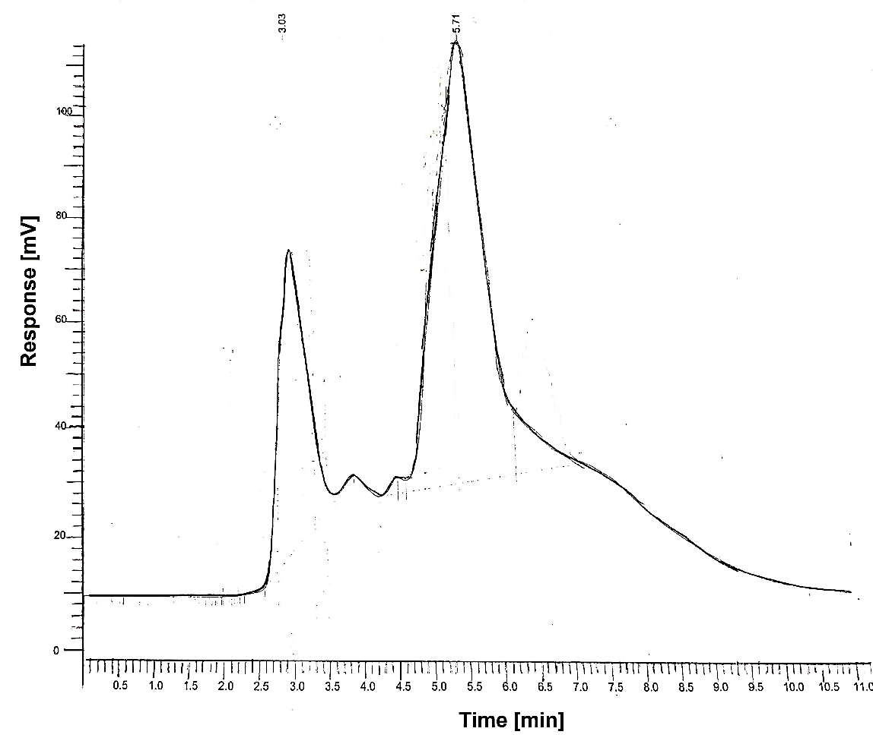

Fig. S40 Chiral HPLC chromatogram of 5g

Peak no | Time [min] | Height [µV] | Area [%] | Area/Height [s]
1 | 3.03 | 110156.59 | 22.62 | 27.97
2 | 5.71 | 165618.66 | 76.53 | 86.69

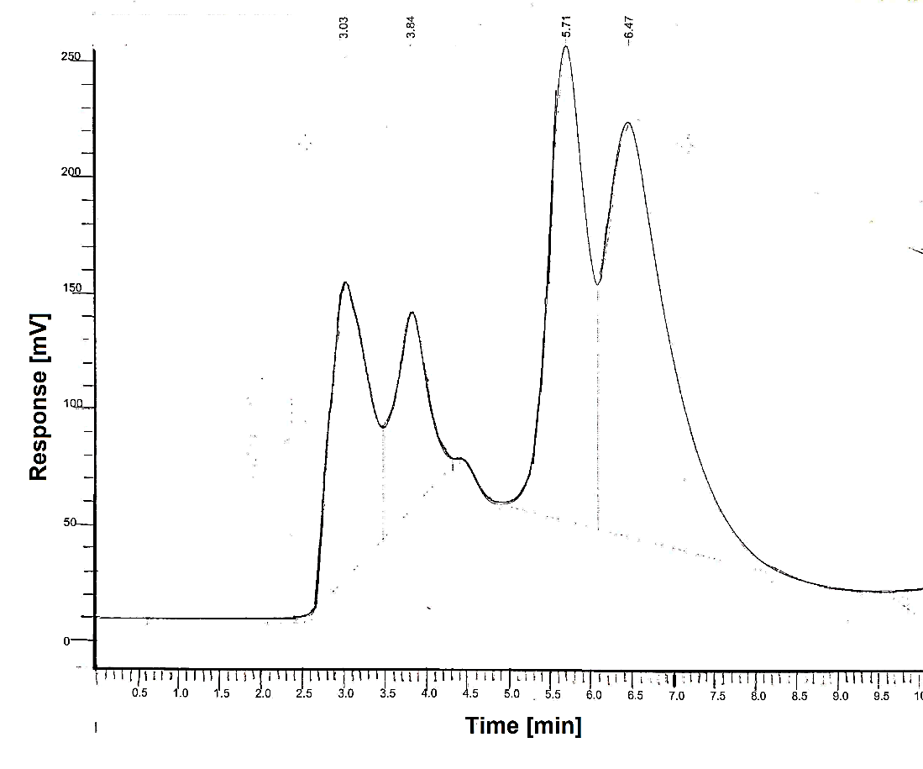
Fig. S41 Chiral HPLC chromatogram of 5h

Peak no | Time [min] | Height [µV] | Area [%] | Norm.Area [%]
1 | 3.03 | 7951306.84 | 18.56 | 17.56
2 | 3.84 | 166864.22 | 10.70 | 29.03
3 | 5.71 | 13070974.61 | 28.86 | 28.86
4 | 6.47 | 18976812.78 | 41.90 | 54.49

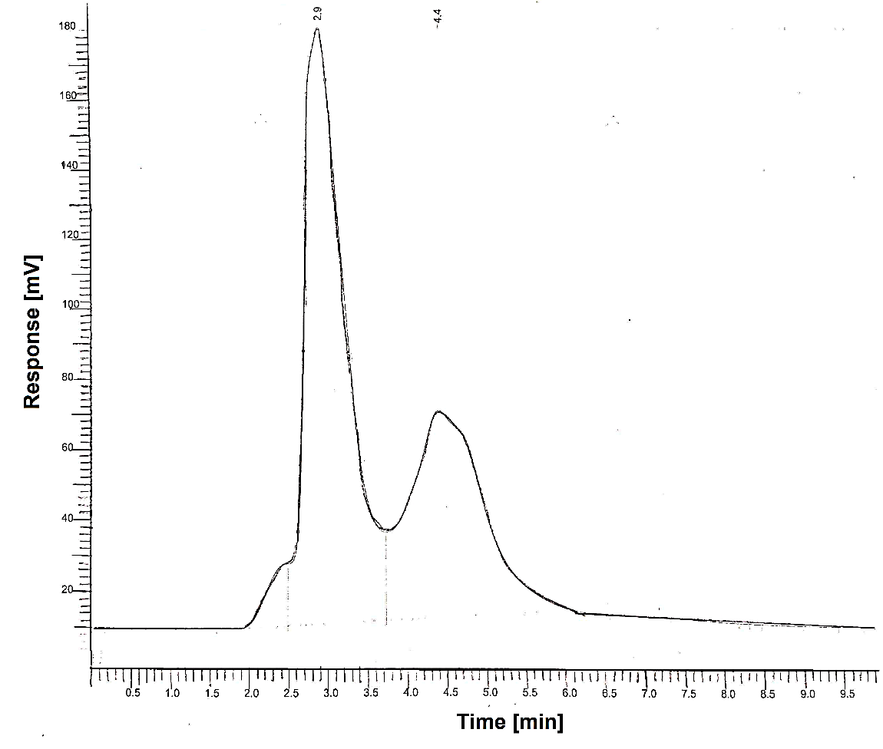
Fig. S42 Chiral HPLC chromatogram of 5i

Peak no | Time [min] | Height [µV] | Area [%] | Area/Height [s]
1 | 2.9 | 331729.19 | 61.44 | 36.31
2 | 4.4 | 113950.45 | 37.64 | 66.89

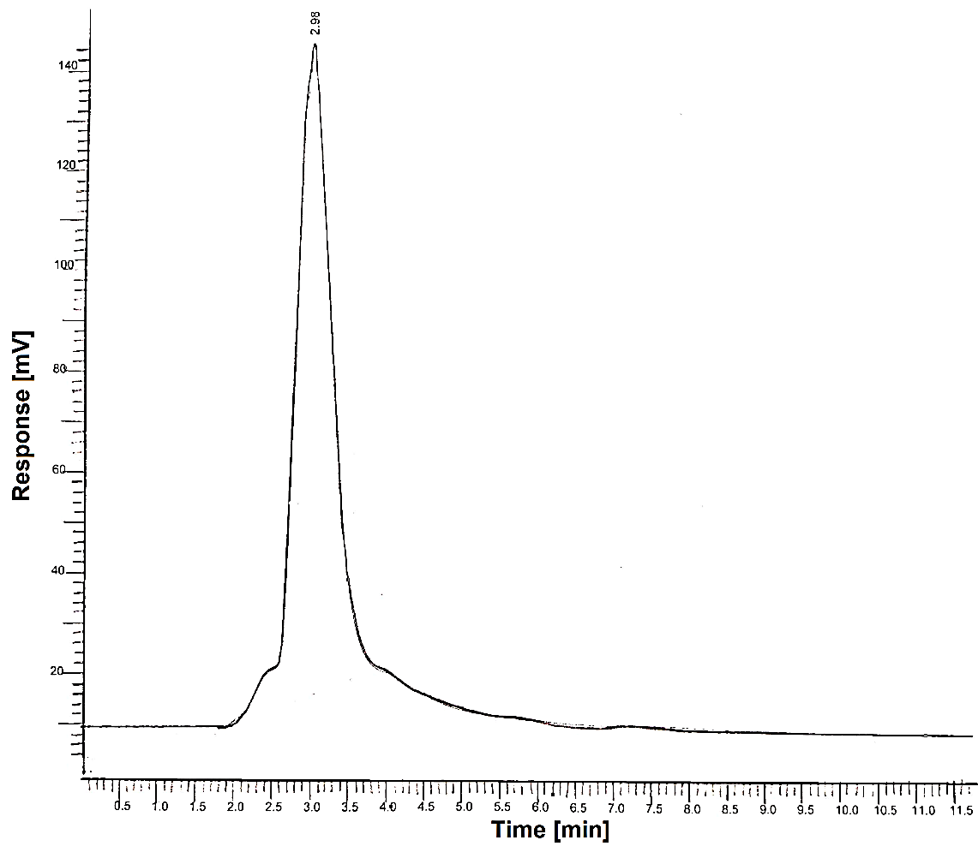
Fig. S43 Chiral HPLC chromatogram of 5j

Peak no | Time [min] | Height [µV] | Area [%] | Area/Height [s]
1 | 2.98 | 252225.61 | 99.98 | 33.13

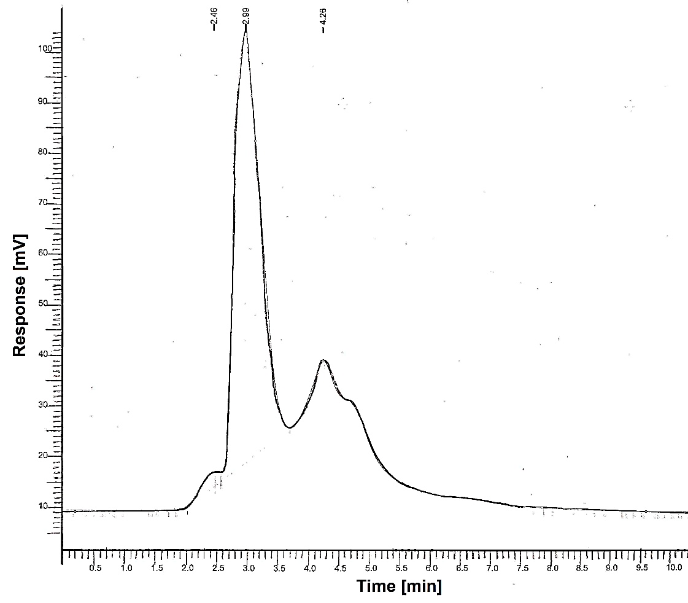
Fig. S44 Chiral HPLC chromatogram of 5k

Peak no | Time [min] | Height [µV] | Area [%] | Area/Height [s]
1 | 2.99 | 166810.46 | 98.61 | 29.6998
2 | 4.26 | 451.07 | 0.40 | 44.4845

Docking studies
Docking studies of Warfarin with 3kp9.
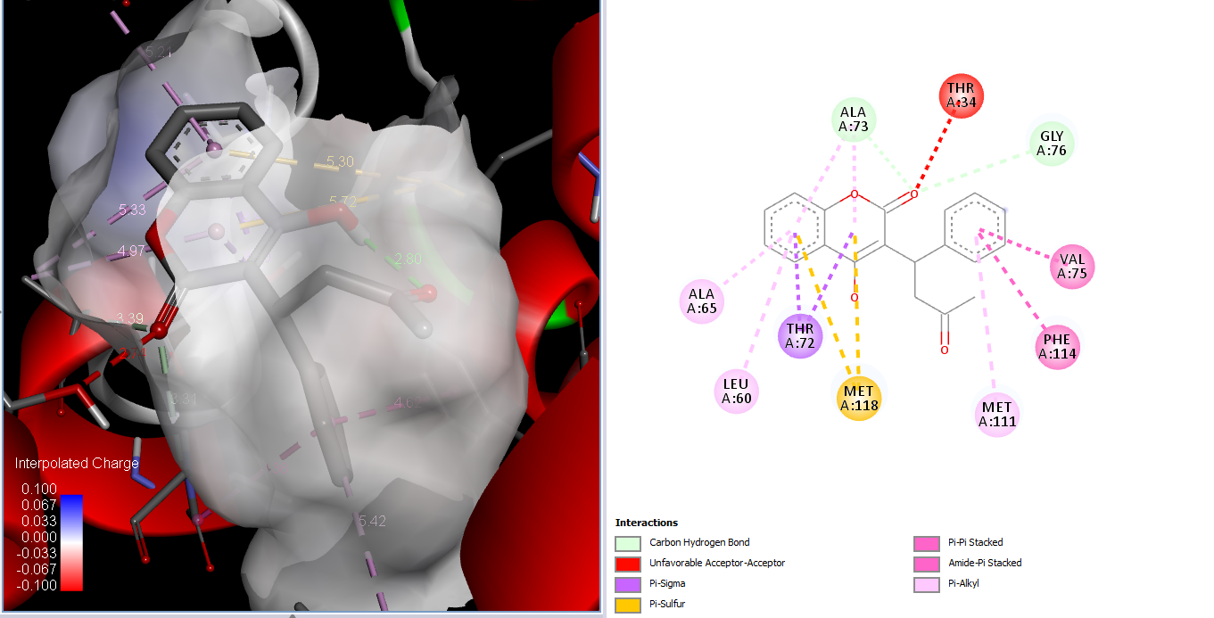
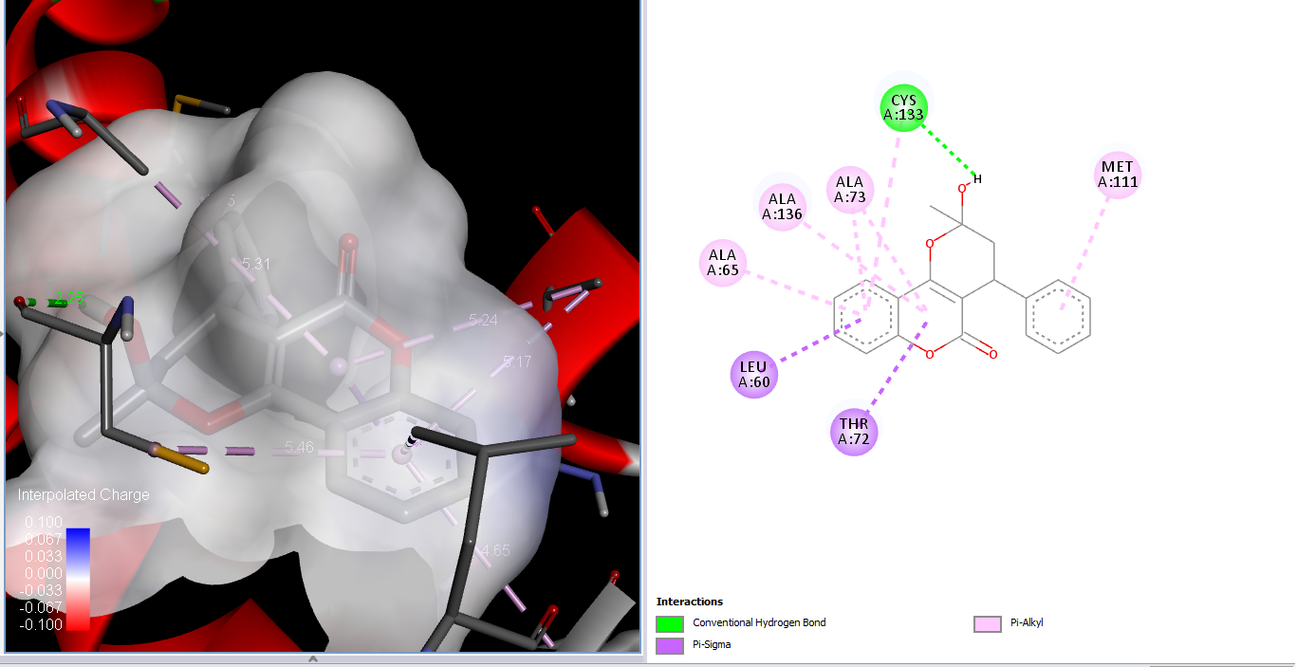
Fig. S45 Upper figures are best dock pose of open chain form of warfarin and lower are best dock pose of ring close form of warfarin, with crystal structure of 3kp9, figures on left showing interpolated charges.
Table. S1 Docking studies of compounds 5a-5k.
Compounds | Docking score kcal/mol | Interactions | Amino Acids
5a | -9.3 | Hydrogen Bonding, Carbon Hydrogen Bonding, pi-Sigma, pi-Sulphur and pi-Alkyl Bonding, Van der Waals Forces | Alanine (ALA A: 73), Threonine (THR A: 34), Methionine (MET A: 118), Threonine (THR A: 72), Cysteine (CYS A: 133)
5b | -9.5 | pi-Sigma, pi-Sulphur, pi-pi Stacked and pi-Alkyl Bonding | Methionine (MET A: 118), Cysteine (CYS A: 133), Phenylalanine (PHE A: 114), Leucine (LEU A: 37), Alanine (ALA A: 65 and A: 136)
5c | -9.1 | Hydrogen Bonding, Carbon Hydrogen Bonding, pi-Alkyl Bonding, Van der Waals Forces | Lysine (LYS A: 41), Alanine (ALA A: 136, A: 73, A: 65), Leucine (LEU A: 37, A 60, A: 121), Valine ( VAL A: 59, A: 140)
5d | -11.6 | Hydrogen Bonding, pi-pi Stacked, Amide pi Stacked, pi-Sulphur and pi-Alkyl Bonding, Van der Waals Forces | Isoleucine (ILE A: 137). Phenylalanine (PHE A: 114), Valine (VAL A: 75, A: 140), Alanine (ALA A: 65, A: 73, A: 136)
5e | -8.8 | Hydrogen Bonding, Carbon Hydrogen Bonding, pi-Sulphur and pi-Alkyl Bonding, Van der Waals Forces | Lysine (LYS A: 41), Methionine (MET A: 118), Alanine (ALA A: 65, A: 73, A: 136) Isoleucine (ILE A: 137), Valine (VAL A: 59, A: 140), Leucine (LEU A: 37, A: 60, A: 121)
5f | -9.4 | Hydrogen Bonding, Carbon Hydrogen Bonding, pi-Sulphur and pi-Sigma Bonding, Van der Waals Forces | Arginine (ARG A: 63), Valine (VAL A: 59), Methionine (MET A: 118), Threonine (THR A: 72), Cysteine (CYS A; 133), Alanine (ALA A: 65, A: 73, A: 136)
5g | -9.7 | Hydrogen Bonding, pi-pi Stacked, pi-Alkyl, pi-Sigma, and pi-Sulphur Bonding | Threonine (THR A: 72), Cysteine (CYS A: 133), Methionine (MET A: 118), Leucine (LEU A: 37), Phenylalanine (PHE A: 114), Methionine (MET A: 122, A: 111)
5h | -7.8 | Hydrogen Bonding, pi-Cation, pi-pi T-shaped, pi-Alkyl, and Alkyl Bonding, Van dar Waals Forces | Glutamine (GLN A:213), Arginine (ARG A: 63), Glutamic acid (GLU A: 217), Tryptofan (TRP A: 64), Lysine (LYS A: 216), Valine (VAL A: 125), Tyrosine (TYR A: 120)
5i | -8.6 | Carbon Hydrogen Bonding, pi-Sulphur, pi-Alkyl, pi-Sigma, and pi-Sulphur Bonding, Van dar Waal Forces | Methionine (MET A: 111, A; 118) Cysteine (CYS A: 133), Alanine (ALA A: 65, A: 136), Valine (VAL A: 59, A: 140) Leucine (LEU: 121, A: 126)
5j | -8.9 | Hydrogen Bonding, Carbon Hydrogen Bonding, pi-Sigma, pi-Sulphur, Amide pi-Stacked and pi-Alkyl Bonding | Lysine (LYS A: 41), Threonine (THR A: 34), Methionine (MET A: 111), Cysteine (CYS A: 133), Tryptophan (TRP A: 64), Valine (VAL A: 59, A: 140), Alanine (ALA A: 65, A: 136)
5k | -9.7 | Hydrogen Bonding, Carbon Hydrogen Bonding, Halogen, pi-Sulphur, pi-pi Stacked and pi-Alkyl Bonding | Glycine (GLY A: 76), Methionine (MET A: 118), Cysteine (CYS A: 133) Phenylalanine (PHE A: 114), Alanine A: 73, A: 136), Leucine (LEU A: 37, A: 121, A: 126)

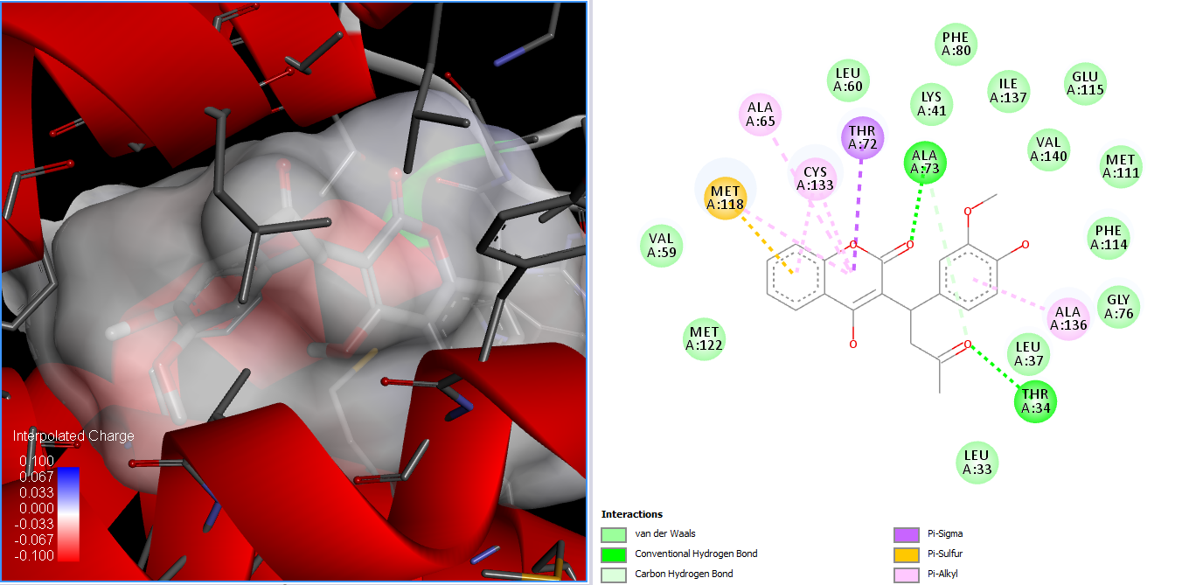
Fig. S46 2D interaction of 3kp9 with compound 5a
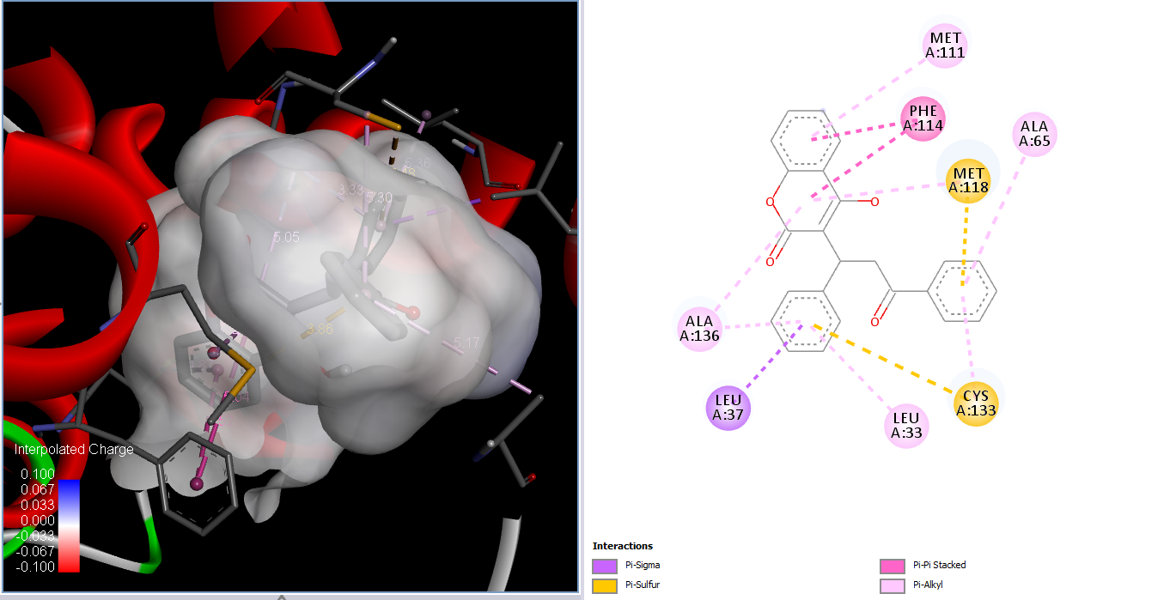

Fig. S472D interaction of 3kp9 with compound 5b
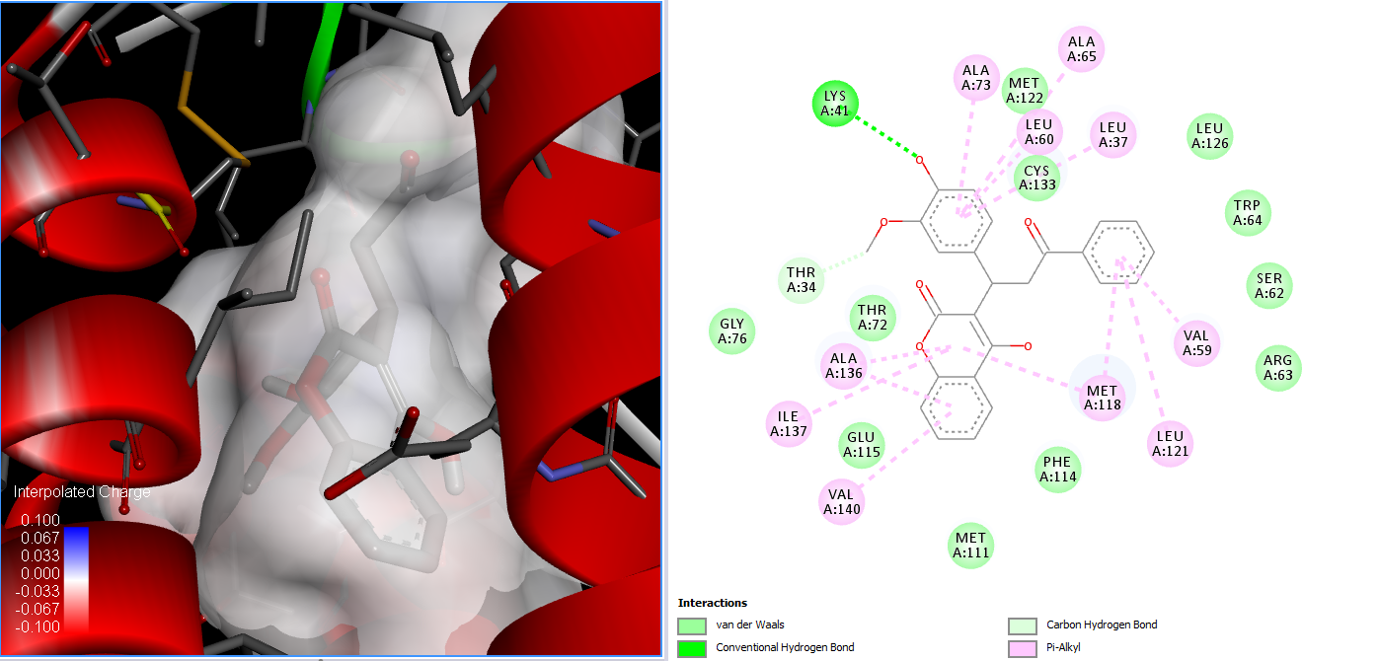

Fig. S48 2D interaction of 3kp9 with compound 5c
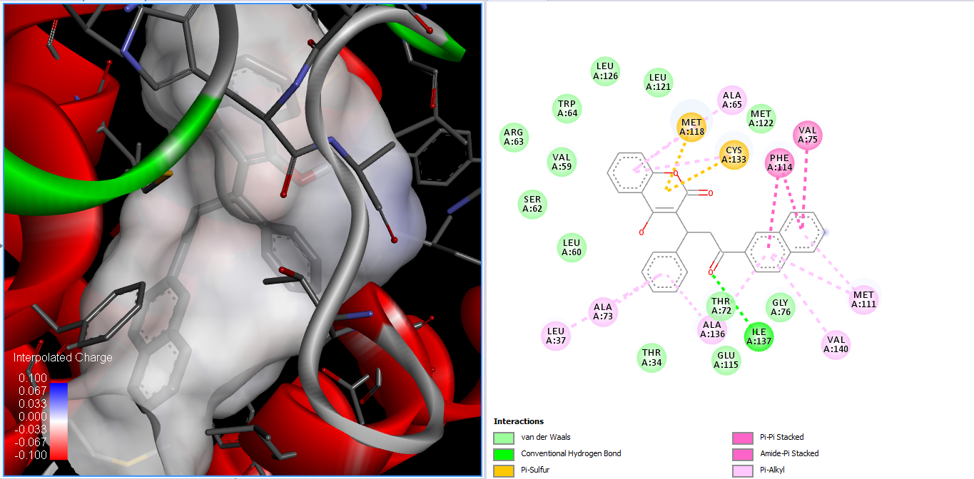

Fig. S49 2D interaction of 3kp9 with compound 5d
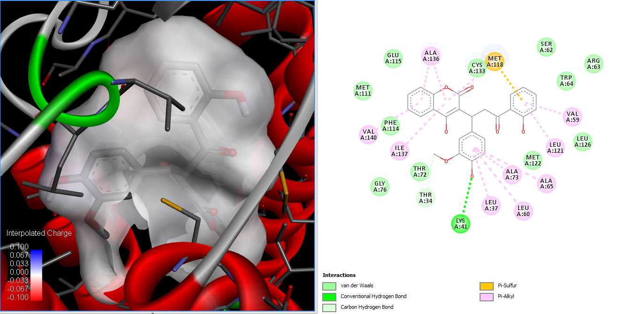

Fig. S50 2D interaction of 3kp9 with compound 5e

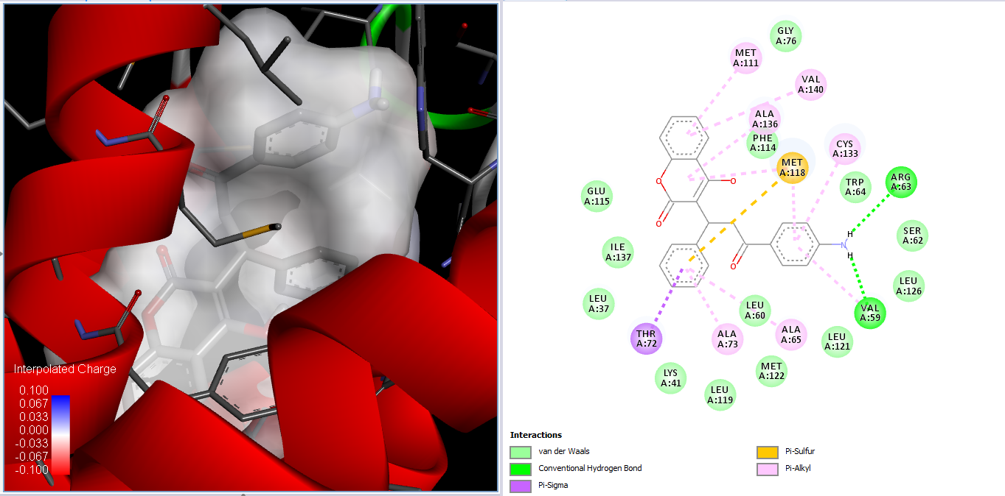

Fig. S51 2D interaction of 3kp9 with compound 5f
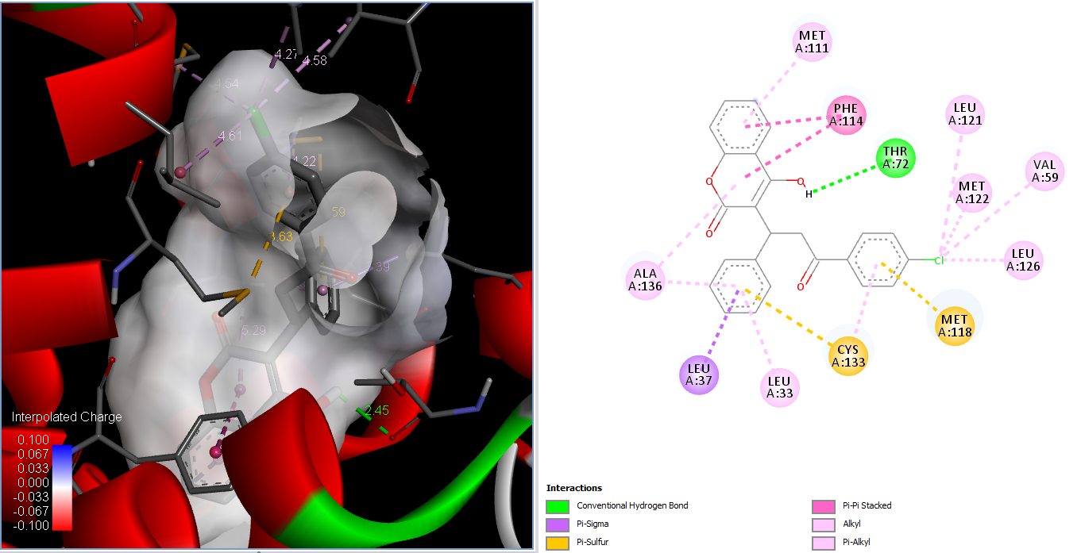

Fig. S52 2D interaction of 3kp9 with compound 5g

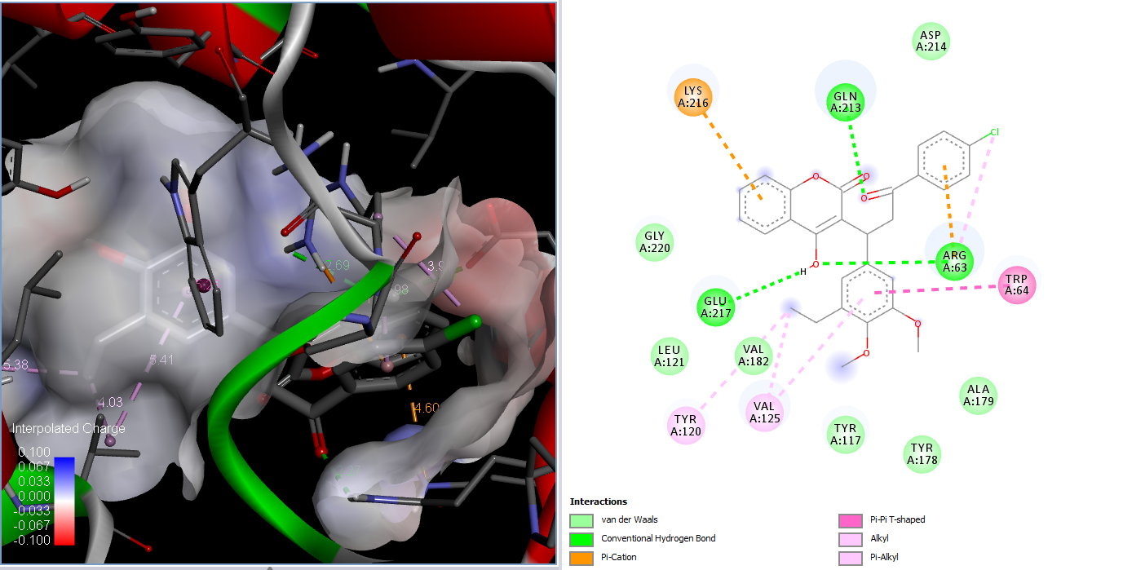

Fig. S53 2D interaction of 3kp9 with compound 5h

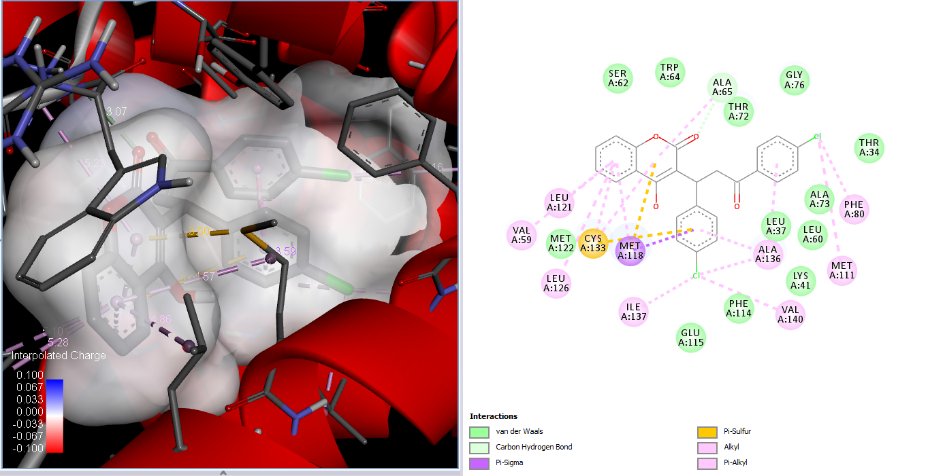

Fig. S54 2D interaction of 3kp9 with compound 5i

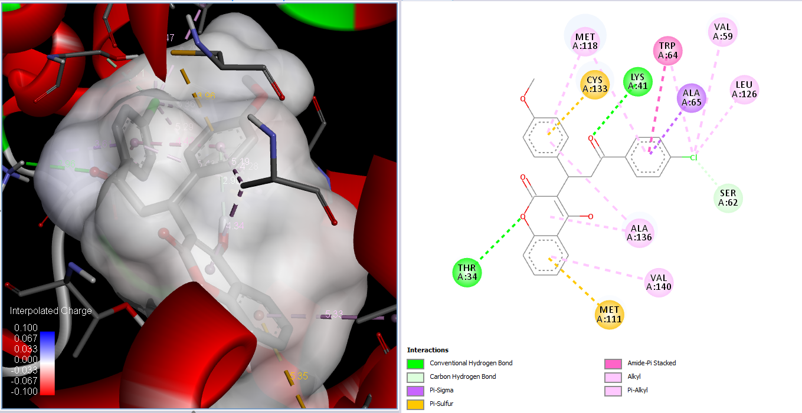

Fig. S55 2D interaction of 3kp9 with compound 5j
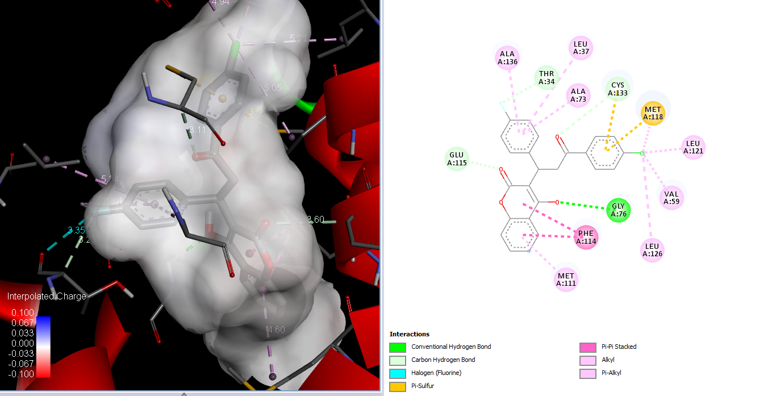
Fig. S56 2D interaction of 3kp9 with compound 5k

