Supplementary material
Yang Zhang, Weiqi Chen, Haosheng Chen
State Key Laboratory of Tribology, Tsinghua University, Beijing 100084, China

The candidate samples in this study include three commercially available non-stick pan brands of Teflon-coated non-stick pans, Brand A, Brand C and “SUPOR”. In order to obtain representative Teflon-coated samples for scientific analyses, samples of three kinds of non-stick pot were used to carry out dry friction and wear experiments at high (150℃) and room temperature according to the method described in the text. For friction and wear tests, A GCr15 steel ball with a diameter of 10.3 mm is used as the upper sample. The friction track radius of ball on disc was 4 mm. Each tests last 900 seconds. The samples rotate with the speed of 75 r/min, thus the velocity is 0.0314 m/s.
The friction coefficient curves were obtained as shown in Figure s.1. The sample of SUPOR displays a lower friction coefficients at 150℃ and room temperature, and are basically stable within 900 seconds, while the other two groups of samples show higher friction coefficients and their friction coefficients still show an upward trend at the end of the experiment. Under high temperature, the samples of "SUPOR" and Brand C have low friction coefficients (0.04~0.05) and are relatively stable. Overall, the "SUPOR" sample has the best tribological properties. Wear resistance of samples are shown in Fig.s.2. The wear rate of Brand A sample increases a lot as temperature rises, while "SUPOR" and Brand C show a relatively low wear rate.
In addition, we also conducted micro-hardness on the Teflon coating surfaces of three groups of samples. The indentation shooting results under 0.01kg indentation load are shown in Figure s.3. The gray-black areas are covered by the Teflon coating, and the white areas are holes that an uncoated substrate area was exposed. From the point view of the coverage, density and uniformity of Teflon coating, the samples of “SUPOR” are more suitable for experimental analysis.
To sum up, in this study, the "SUPOR" Teflon coated non-stick pan was selected as the Teflon coating samples, and the friction and wear behavior of Teflon at room temperature and high temperature were investigated based on the preliminary screening experiments.
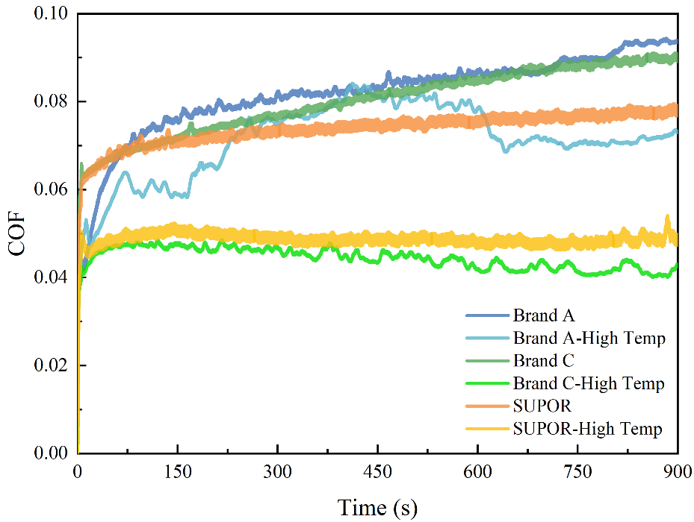
Fig. s.1 Friction coefficient of three brands of non-stick pans at high and room temperatures

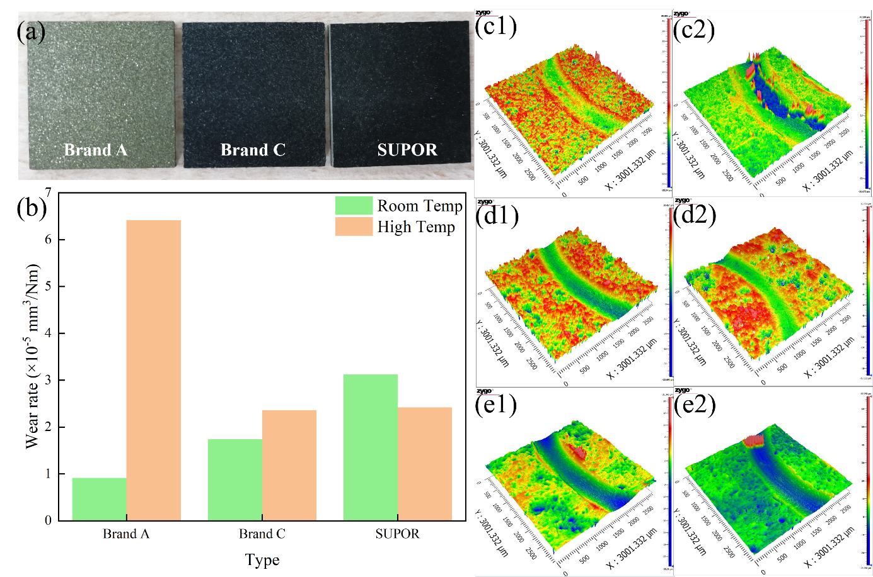
Fig.s.2 Tribological performance of samples of three different brands of pans at room temperature (25℃) and high temperature (150℃): (a) Pictures of samples of three different brands of pans. (b) Wear rates of the three kinds of pans at 25℃ and 150℃. (c1-e2) Wear morphologies of Teflon coatings: (c1, c2) of Brand A at 25℃ and at 150℃, respectively; (d1, d2) of Brand C at 25℃ and at 150℃, respectively; (e1, e2)of SUPOR at 25℃ and at 150℃, respectively.

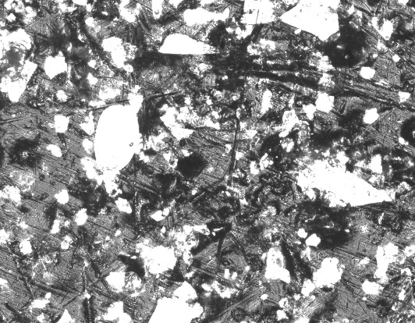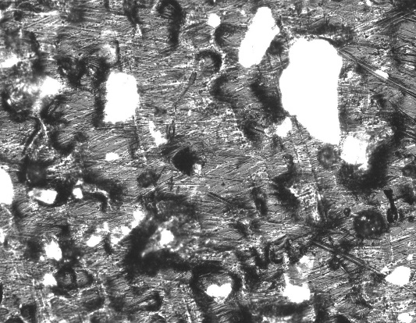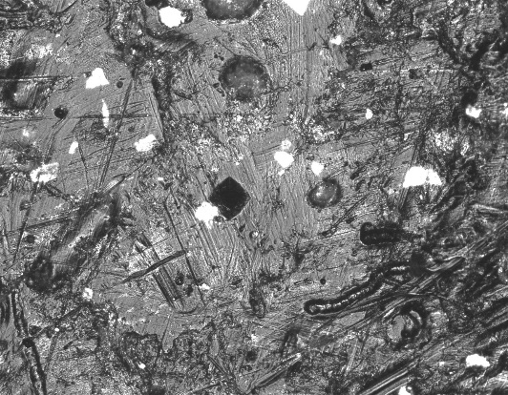
(a)
(c)
(b)
Fig. s.3 Surface morphology of three brands of non-stick pans: (a) Brand A；(b) Brand C；(c) "SUPOR".

