Supplement
Supplemental Table 1: The official and our study definition of body mass index (BMI) 3
Supplemental Table 2: The official and our study definition of alternative Mediterranean Diet 4
Supplemental Table 3: The category and definition of physical activity 6
Supplemental Table 4: The category and definition of smoking status 7
Supplemental Table 5: The category and definition of adequate alcohol consumption 8
Supplemental Table 6: Simple Taiwan healthy lifestyle score 9
Supplemental Table 7: Weighted Taiwan healthy lifestyle score 10
Supplemental Table 8: The official 2018 WCRF/AICR recommended healthy lifestyle score and our study definition 11
Supplemental Table 9: Life’s Simple 7 healthy diet criteria: reference from 2010 AHA definition of ideal Cardiovascular Health and our study definition 14
Supplemental Table 10: Life’s Simple 7 criteria: reference from 2010 AHA definition of ideal Cardiovascular Health and our study definition 15
Supplemental Table 11: International Classification of Diseases—Clinical Modification (ICD-CM) and procedure codes used to define the metabolic syndrome and clinical outcome in the study cohort 17
Supplemental Table 12: The divided groups among different healthy lifestyle score 20
Supplemental Table 13: The definition of important covariates and multivariate COX regression model 21
Supplemental Table 14: Basic characteristics of the study participants at baseline, specified by adherence numbers of healthy lifestyle scores; (A). The weighted Taiwan healthy lifestyle score (0~17 points) (B) The WCRF/AICR recommended healthy lifestyle score (0~7 points) (C) Life’s Simple 7 score (0~14 points) 23
Supplemental Table 15: The incidence cases, follow-up person-years, and the rates of cardiovascular disease events according to lifestyle factors and the hazard ratios and 95% confidence intervals 26
Supplemental Table 16: The incidence cases, follow-up person-years, and the rates of cardiovascular disease events according to lifestyle factors and the hazard ratios and 95% confidence intervals; (A) The weighted Taiwan healthy lifestyle score, according to the score quartiles (B) The WCRF/AICR recommended healthy lifestyle score, according to the numbers of the score (C) Life’s Simple 7, according to the numbers of score (0~14 points) 32
Supplemental Table 17: Sensitivity test of the incidence cases, follow-up person-years, and the rates of cardiovascular disease events and the hazard ratios and 95% confidence intervals 35

Supplemental Figure 1: Flow-chart of study design and participants exclusion criteria 37
Supplemental Figure 2: Kaplan-Meir survival curves for the risk of cardiovascular specified in the study participants among participants stratified by the numbers of healthy lifestyle factors 38
Supplemental Figure 3: The log(-log(survival time)) versus log of CVD event-free survival time including time independent covariates 42
Supplemental Figure 4: Hazard ratios for cardiovascular disease with categories according to the numbers of healthy lifestyle factors among participants stratified by age < 60 y/o and ≥ 60 y/o 51
Supplemental Figure 5: Calibration plot of predicted mean 12.5.following-up years cardiovascular disease (CVD) risk within deciles against the observed 12.5 following-up years CVD risk in the TWsHHH data (N=6048). Data are plotted among participants stratified by lifestyle scores 55
Supplemental Figure 6: Receiver-operating characteristic curves for various models applied to the study population 59

Supplemental Table 1: The official and our study definition of body mass index (BMI)
 | WHO BMI Categories | Taiwan Healthy lifestyle scoring
BMI <18.5 | Under weight | 1
BMI>=18.5 and <25 | Normal weight | 1
BMI>=25 and <30 | Obesity I | 0
BMI>=30 and <35 | Obesity II | 0
BMI>=35 and <40 | Obesity III | 0
BMI>=40 | Obesity IV | 0

Supplemental Table 2: The official and our study definition of alternative Mediterranean Diet
Primary diet metric | Mediterranean Definition |  | Our Definition
 | 0 point | 1 point |  | 0 point | 1 point
 | The amount of intake |  |  | The frequency of intake (time/week)
Vegetables | < Median | ≥ Median | Fresh vegetables | < 7 | ≥ 7
Legumes | < Median | ≥ Median | Legumes | < 1.5 | ≥ 1.5
Fruits and nuts | < Median | ≥ Median | Fresh fruits | < 7 | ≥ 7
Dairy products | ≥ Median | < Median | Milk, goat’s milk, fermented milk, cheese, yogurt, Yakult | ≥ 1.5 | < 1.5
Cereals | < Median | ≥ Median | Rice or Noodles every day | < 2 (cup/day) | ≥ 2 (cup/day)
Meat | ≥ Median | < Median | Beef, pork, goat, chicken | ≥ 4 | < 4
Fish | ≥ Median | < Median | Fish | < 4 | ≥ 4
Olive oil | 0 | 250
Potatoes | ≥ Median | < Median
Eggs | ≥ Median | < Median | Eggs | ≧ 4 | < 4
Sweets | ≥ Median | < Median | Cookies, candies, chocolate, cakes, bread, ice cream, milkshake | Cookies, candies, chocolate, ice cream, milkshake≧0.5  cake, bread ≧1.5 | Cookies, candies, chocolate, ice cream, milkshake < 0.5  cake, bread < 1.5
Nonalcoholic beverages | ≥ Median | < Median | Cola, soda or sweet-beverage | ≥ 0.5 | < 0.5
Monounsaturated lipids | < Median | ≥ Median
Saturated lipids | ≥ Median | < Median | Burger, French frizzed, pizza | > 0 | = 0
Polyunsaturated lipids | ≥ Median | < Median
Percentage energy from saturated lipids | ≥ Median | < Median
Ratio of monounsaturated lipids to saturated lipids | < Median | ≥ Median
Energy intake | ≥ Median | < Median

Supplemental Table 3: The category and definition of physical activity
Total time (mins/week) |  | Healthy lifestyle scoring
0 | Inactive | 0
1~50 | Somewhat active | 1
51~100 | Intermittent active | 1
101~150 | Active | 1
> 150 | Over active | 0

Supplemental Table 4: The category and definition of smoking status
Smoking status | Healthy lifestyle scoring
Current smoking ≧20 years | 0
Current smoking < 20 years | 0
Quit smoking < 1 year | 0
Quit smoking ≧1 year | 0
Never or smoking less than 100 cigarettes | 1

Supplemental Table 5: The category and definition of adequate alcohol consumption
 | The frequency of drinking
 | Once / day | Once / 2-3 days | Once / week | 1-2 times / month | < 1/month
Light | Frequency | Few | Few | Few | Few
Semi-drunk | Frequency | Frequency | Few | Few | Few
Drunk | Frequency | Frequency | Frequency | Few | Few
Few = 0 point; Frequency=1 points

Supplemental Table 6: Simple Taiwan healthy lifestyle score
 | BMI (Kg/m²) | Mediterranean diet | Physical activity (min/week) | Non-smoking status | Alcohol consumption
Unfavorable (0 point) | ≧25 | < 6 points | 0 or > 150 | Current and former | No or few
Healthy (1 point) | < 25 | ≧6 points | 1~150 | Never | Frequency
Mediterranean diet related healthy lifestyle score = BMI + Mediterranean diet + Physical activity + non-smoking status + Alcohol consumption

Supplemental Table 7: Weighted Taiwan healthy lifestyle score
 | BMI (Kg/m²) | Mediterranean diet | Physical activity (min/week) | Non-smoking status | Alcohol consumption
Unfavorable (0 point) | ≧25 | < 6 points | 0 or > 150 | Current and former | No or few
Healthy (1 point) | < 25 | ≧6 points | 1~150 | Never | Frequency
Coefficient | -0.25 | -0.29 | -0.28 | -0.18 | -0.66
Taiwan healthy lifestyle score = 2*BMI + 3*Mediterranean diet + 3*Physical activity + 2*Non-smoking status + 7*Alcohol consumption

Supplemental Table 8: The official 2018 WCRF/AICR recommended healthy lifestyle score and our study definition
2018 WCRF/AICR recommendation | Operationalization of recommendation | Our definition | points
Be a healthy weight | BMI (kg/m²): | BMI (kg/m²):
 | 18.5–24.9 | 18.5–24.9 | 0.5
 | 25–29.9 | 25–29.9 | 0.25
 | <18.5 or ≥30 | <18.5 or ≥30 | 0
 | Waist circumference (cm): | Waist circumference (cm):
 | Men: <94 Women: <80 | Men: <94 Women: <80 | 0.5
 | Men: 94–<102 Women: 80–<88 | Men: 94–<102 Women: 80–<88 | 0.25
 | Men: ≥102 Women: ≥88 | Men: ≥102 Women: ≥88 | 0
Be physically active | Total moderate-vigorous physical activity (mins/week) | Total moderate-vigorous physical activity (mins/week)
 | ≥150 | ≥150 | 1
 | 75–<150 | 75–<150 | 0.5
 | <75 | <75 | 0
Eat a diet rich in wholegrains, vegetables, fruit and beans | Fruits and vegetables (g/day): | The frequency of fruits and vegetables intake
 | ≥400 | One of them every day | 0.5
 | 200–<400 | One of them 1~5 times/week | 0.25
 | <200 | Both of them less than once/week | 0
 | Total fiber (g/day): | The frequency of bean intake
 | ≥30 | Everyday | 0.5
 | 15–<30 | 1~5 times per week | 0.25
 | <15 | Less than 1 time/week | 0
Limit consumption of “fast foods” and other processed foods high in fat, starches or sugars | Percent of total kcal from ultra-processed foods (aUPFs) | The frequency of French fried/ pizza intake
 | Tertile 1 | Tertile 1 | 1
 | Tertile 2 | Tertile 2 | 0.5
 | Tertile 3 | Tertile 3 | 0
Limit consumption of red and processed meat | Total red meat (g/wk) and processed meat (g/wk): | The frequency of pork, beef, goat, chicken and burger intake
 | Red meat <500 and processed meat <21 | Tertile 1 | 1
 | Red meat <500 and processed meat 21–<100 | Tertile 2 | 0.5
 | Red meat >500 or processed meat ≥100 | Tertile 3 | 0
Limit consumption of sugar-sweetened drinks | Total sugar-sweetened drinks (g/day): | The frequency of cola, soda and other sweetened drinks intake
 | 0 | No intake | 1
 | >0–≤250 | Less than 3 times/week | 0.5
 | >250 | 3 times or more/week | 0
Limit alcohol consumption | Total ethanol (g/day):
 | 0 | No drinking | 1
 | >0–≤28 (2 drinks) males and ≤14 (1 drink) females | Few drinking | 0.5
 | >28 (2 drinks) males and >14 (1 drink) females | Frequency drinking | 0

Total scoring of 2018 WCRF/AICR lifestyle score: 0-7 points
WCRF/AICR Score | < 3 | 3~ <4 | 4~ <5 | 5~7
 | Unfavorable | Less healthy | Intermediate | Healthy

Supplemental Table 9: Life’s Simple 7 healthy diet criteria: reference from 2010 AHA definition of ideal Cardiovascular Health and our study definition
Recommended |  | Our study definition
Metric | Optimal amount | Metric | The frequency of intake, times / week
 |  |  | 0 point | 1 point
Fruits and vegetables | ≧ 4.5 cups per day | Fruits or vegetables | < 7 | ≧ 7
Fish | ≧ 2* 3.5-oz servings per week | Fish | <1 | ≧ 1
Fiber-rich whole grains (≧1.1 g of fiber per 10 g of carbohydrate) | ≧ 3*1-oz-equivalent servings per day | Rice or noodles | < 1 (cup/day) | ≧ 1 (cup/day)
Sodium | < 1500 mg per day
Sugar-sweetened beverages | ≦ 450 kcal (36 oz) per week. | Cola, soda, sugar-sweetened neverages | ≧ 1 | < 1
Nuts, legumes, and seeds | ≧ 4 servings per week | Legumes | < 7 | ≧ 7
Processed meats | ≦ 2 servings per week | Beef, pork, goat, chieken and burger | ≧ 1 | < 1
Saturated fat | < 7% of total energy intake | French fried and pizza | ≧ 1 | < 1
Total Life’s Simple 7 healthy diet score: 0~7 points

Supplemental Table 10: Life’s Simple 7 criteria: reference from 2010 AHA definition of ideal Cardiovascular Health and our study definition
Metric | Recommended Optimal Level  (2 points) | Intermediate Level  (1 point) | Poor Level  (0 point)
Body mass index  Recommendation | <25 | 25-29.9 | ≥30
Our definition | <25 | 25-29.9 | ≥30
Healthy diet: Recommendation
Our definition (below) | 5~7 | 3~4 | 0~2
Physical activity: Recommendation (mins/week) | ≧150 moderate intensity or ≧75 vigorous intensity or combination | 0~149 min/week moderate intensity or 0~74 min/week vigorous intensity | 0 min/week
Our definition
Smoking: Recommendation | Never or quit ≥12 month prior | Quit <12 month | Current smokers
Our definition | Never or quit ≥12 month prior | Quit <12 month | Current smokers
Total cholesterol Recommendation | <200 mg/dL untreated | 200-240 mg/dL or <200 mg/dL treated | >240 mg/Dl
Our definition | <200 mg/dL untreated | 200-240 mg/dL | >240 mg/dL
Blood pressure Recommendation | <120/80 mm Hg untreated | <120/80 mm Hg treated or 120-139/80-89 mm Hg | ≥140/90 mm Hg
Our definition | <120/80 mm Hg untreated | 120-139/80-89 mm Hg | ≥140/90 mm Hg
Fasting plasma glucose Recommendation | <100 mg/dL untreated | 100-126 mg/dL or <100 mg/dL treated | >126 mg/dL
Our definition | <100 mg/dL untreated | 100-126 mg/dL | >126 mg/dL

Supplemental Table 11: International Classification of Diseases—Clinical Modification (ICD-CM) and procedure codes used to define the metabolic syndrome and clinical outcome in the study cohort
Diagnosis | Definition | ICD-9 code | ICD-10 code | Procedure code
Hypertension | ≥2 Outpatient department | 401-405, 437.2 | I10, I11.9, I11.0, I12.9, I12.0, I13.10, I13.0, I13.11, I13.2, I15.0, I15.1, I15.2, I15.8, I15.9, N26.2, , I67.4
Diabetes mellitus | ≥2 Outpatient department | 250 | E08, E11, E13
Dyslipidemia | ≥2 Outpatient department | 272 | E78.5
Coronary heart disease | Either discharge diagnosis of ICD-9 or ICD-10 or procedure code | 410 | I21.01, I21.02, I21.09, I21.11, I21.19, I22.0, I22.1 | revascularization PCI (33076B, 33077B, 33078B)  CABG(68023B, 68024B, 68025B)  N26002, N26003
Coronary heart disease |  | 411 | I20.0, I24.0, I24.1, I24.8, I24.9
Coronary heart disease |  | 414.00 | I25.10, I25.750, I25.751, I25.758, I25.759, I25.760, I25.761, I25. 768, I25.769, I25. 811, I25.812
Coronary heart disease |  | 414.01 | I25.10, I25.110, I25.111, I25.118, I25.119, I25.750, I25.751, I25.758, I25.759, I25. 811
Coronary heart disease |  | 414.02 | I25.710, I25.711, I25.718, I25.719, I25.812,
Coronary heart disease |  | 414.03 | I25.730, I25.731, I25.738, I25.739
 |  | 414.04 | I25.720, I25.721, I25.728, I25.729
 |  | 414.05 | I25.700, I25.701, I25.708, I25.709, I25.730, I25.731, I25.738, I25.739, I25.760, I25.761, I25.768, I25.769, I25.790, I25.791, I25.798, I25.799, I25.810, I25.812
 |  | v45.81 | Z95.1
 |  | v45.82 | Z95.5, Z98.61, Z95.8,

Supplement Table 11. (Continued)
Diagnosis | Definition | ICD-9 | ICD-10 | Procedure code
Stroke | discharge diagnosis of ICD-9 or ICD-10 | 433 | 165.1,I63.02, I63.12, I65.21, I63.22, I65.1, I65.23, I65.29 , I63.031, I63.032, I63.039, I63.131, I63.132, I63.139, I63.231, I63.232, I63.239, I65.01, I65.02, I65.03, , I65.09, I63.011, I63.012, I63.019, I65.22, I63.111, I63.112, I63.119, I63.211, I63.212, I63.219, I65.8, 163.09, I63.19, I63.59, I65.9, I63.00, 163.10, I63.20, I63.29
Stroke | discharge diagnosis of ICD-9 or ICD-10 | 434 | I66.01, I66.02, I66.03, I66.09, I66.11, I66.12, I66.13, I66.19, I66.21, I66.22, I66.23, I66.29, I66.3, I63.30, I63.311, I63.312, I63.319, I63.321, I63.322, I63.329, I63.331, I63.332, I63.339, I63.341, I63.342, I63.349, I63.39, I63.6, I66.01, I66.02, I66.03, I66.09, I66.11, I66.12, I66.13, I66.19, I66.21, I66.22, I66.23, I66.29, I66.3, I66.9, I66.40, I66.411, I66.412, I66.419, I66.421, I66.422, I66.429, I66.431, I66.432, I66.439, I66.441, I66.442, I66.449, I66.49, I66.01, I66.02, I66.03, I66.09, I66.11, I66.12, I66.13, I66.19, I66.21, I66.22, I66.23, I66.29, I66.3, I66.8, I66.9, I63.50, I63.511, I63.512, I63.519, I63.521, I63.522, I63.529, I63.531, I63.532, I63.539, I63.541, I63.542, I63.549, I63.59, I63.8, I63.9
Stroke | discharge diagnosis of ICD-9 or ICD-10 | 435 | G45.0,G45.8,G45.1,G45.2,G46.0, G46.1, G46.2, G45.9, I67.841, I67.848
Stroke | discharge diagnosis of ICD-9 or ICD-10 | 436 | I67.89
Stroke | discharge diagnosis of ICD-9 or ICD-10 | 4371 | I67.81, I67.82, I67.89
Stroke | discharge diagnosis of ICD-9 or ICD-10 | 4379 | I67.9
CABG, Coronary artery bypass graft; PCI, Percutaneous coronary intervention

Supplemental Table 12: The divided groups among different healthy lifestyle score
 | Unfavorable | Less healthy | Intermediate | Healthy
Simple Taiwan score (0~5) | 0~1 | 2 | 3 | 4~5
Weighted Taiwan score (0~17) | 0~4 | 5 | 6~7 | 8~17
WCRF/AICR Score | < 3 | 3~ <4 | 4~ <5 | 5~7
Life’s Simple 7 (0~14) | 0~6 | 7~9 | 10~12 | 13~1

Supplemental Table 13: The definition of important covariates and multivariate COX regression model
Covariates | Categories
Sex (Questionnaire) | Women |  | Men
Age (Questionnaire) | 20~39 (y/o) | 40~59 (y/o) |  | ≧60 (y/o)
Marital status (Questionnaire) | Married; Living with spouse |  | Single/divorced/separated
Education level (Questionnaire) | > 9 years |  | ≦ 9 years
Monthly income (Questionnaire) | ≥ 40000 NTD |  | < 4000 NTD
Parental history of CVD (Questionnaire) | Yes |  | No
Menopause status (Questionnaire) | Yes |  | No
Baseline hypertension  (NHIRD, ICD-9 and drug) | ICD-9*2 times or anti-HTN drug≧28 days or mean BP ≥ 140/80 mmHg |  | No record of ICD-9*2 times and anti-HTN drug≧28 days and mean BP < 140/80 mmHg
Baseline diabetes  (NHIRD, ICD-9 and drug) | ICD-9*2 times or anti-diabetes drug≧28 days or Fasting glucose ≥ 126mg/dL  or HbA1C ≥ 6.5 |  | No record of ICD-9*2 times and anti-diabetes drug≧28 days and Fasting glucose < 126mg/dL or HbA1C < 6.5
Baseline hyperlipidemia  (NHIRD, ICD-9 and drug) | ICD-9*2 times or lipid lowering agent≧28  or TC ≥ 240 mg/dL days |  | No record of ICD-9*2 times and lipid lowering agent≧28 days and TC < 240 mg/dL days
History of hormone use (Questionnaire) | Yes |  | No
Abdominal obesity | waist circumflex ≥ 80 cm in women  and ≥ 90 cm in men |  | waist circumflex < 80 cm in women  and < 90 cm in men
Model 1: adjusted for age and sex
Model 2: model 1, additionally education, average month income, marital status, parental history of CVD, menopause status and estrogen exposure
Model 3: model 2, additionally baseline HTN, baseline DM, history of hyperlipidemia, sBP, dBP, triglyceride, non-HDL, fasting glucose, HbA1c; The population attributable risk is the percentage of new cases of heart failure in the population attributable to nonadherence to the low-risk lifestyle factor

NHIRD: National health insurance research database; HTN: Hypertension; HbA1c: Hemoglobin A1c; TC: total cholesterol

Supplemental Table 14: Basic characteristics of the study participants at baseline, specified by adherence numbers of healthy lifestyle scores; (A). The weighted Taiwan healthy lifestyle score (0~17 points) (B) The WCRF/AICR recommended healthy lifestyle score (0~7 points) (C) Life’s Simple 7 score (0~14 points)
(A) The weighted Taiwan healthy lifestyle score (0~17 points)
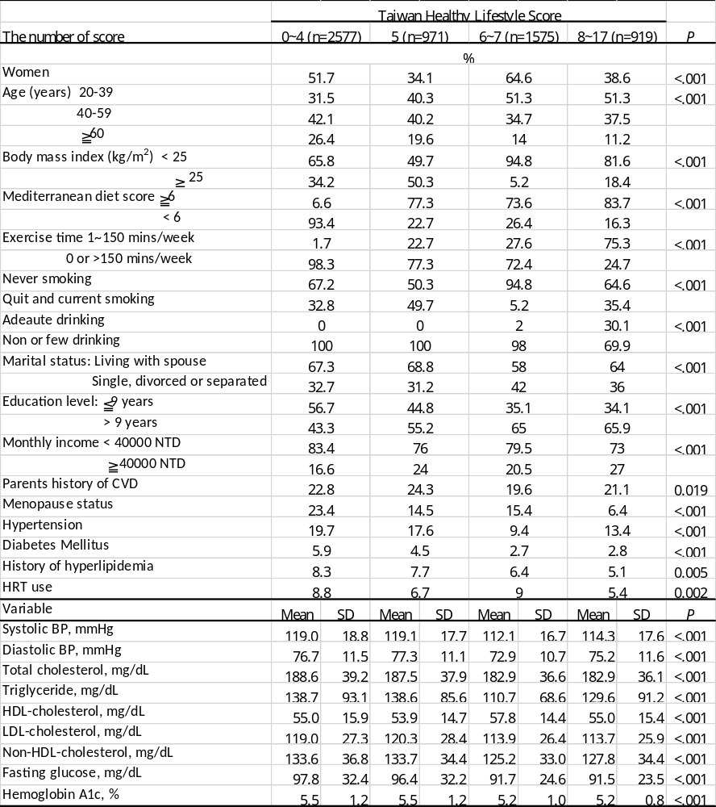
Abbreviation: SD, standard deviation; BP, blood pressure; HDL, high density lipoprotein, LDL, low density lipoprotein; ANOVA and the chi-square tests were used to compare the means and proportions among groups
(B) The WCRF/AICR recommended healthy lifestyle score (0~7 points)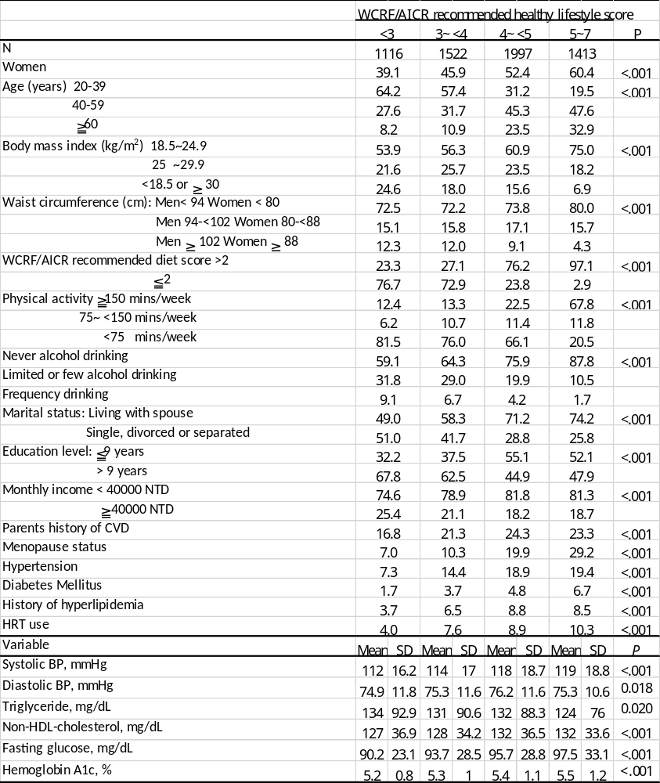
Abbreviation: SD, standard deviation; BP, blood pressure; HDL, high density lipoprotein, LDL, low density lipoprotein; ANOVA and the chi-square tests were used to compare the means and proportions among groups
(C) Life’s Simple 7 score (0~14 points)
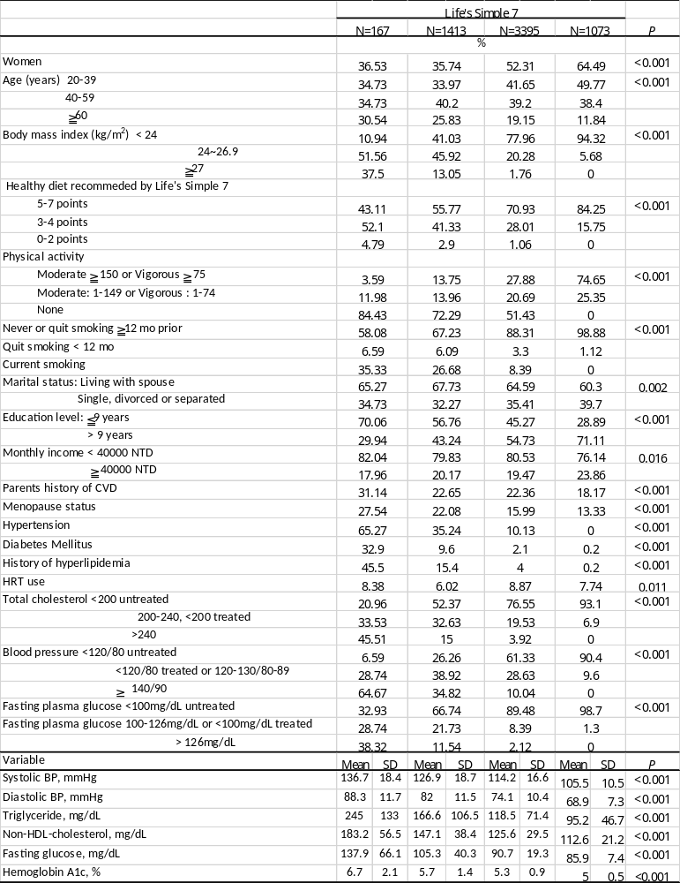
Abbreviation: SD, standard deviation; BP, blood pressure; HDL, high density lipoprotein, LDL, low density lipoprotein; ANOVA and the chi-square tests were used to compare the means and proportions among group
Supplemental Table 15: The incidence cases, follow-up person-years, and the rates of cardiovascular disease events according to lifestyle factors and the hazard ratios and 95% confidence intervals
(A) According to the body mass index in 6048 for TWsHHH study participants (B) According to the Mediterranean diet score in 6048 for TWsHHH study participants (C) According to the time of physical activity in 6048 for TWsHHH study participants (D) According to the smoking status in 6048 for TWsHHH study participants (E) According to the frequency of alcohol consumption in 6048 for TWsHHH study participants;

(Model 1: adjusted for age and sex; Model 2: Model 1 + education, average month income, marital status, parental history of CVD, menopause status and estrogen exposure; Model 3: Model 2 + baseline HTN, baseline DM, history of hyperlipidemia, sBP, dBP, triglyceride, non-HDL, fasting glucose, HbA1c; The population attributable risk is the percentage of new cases of heart failure in the population attributable to nonadherence to the low-risk lifestyle factor.)

BMI | <18.5 | 18.5~24.9 |  |  | 25~29.9 |  |  | 30~34.9 |  |  | 35~39.9 |  |  | ≧ 40 |  |  | P of Logrank
Cases | 10 | 243 |  |  | 165 |  |  | 25 |  |  | 5 |  |  | 1
Pearson-year | 4639 | 47799 |  |  | 16740.8 |  |  | 2876 |  |  | 403 |  |  | 38.6
Rates/1000 py | 2.2 | 5.1 |  |  | 9.9 |  |  | 8.7 |  |  | 12.4 |  |  | 25.9 |  |  | <.001
 | HR | HR | 95% CI |  | HR | 95% CI |  | HR | 95% CI |  | HR | 95% CI |  | HR | 95% CI |  | P of Trend Test | PAF | 95% CI
Univariate | 1.00 | 2.31 | 1.19 | 4.51 | 4.62 | 2.36 | 9.06 | 3.62 | 1.65 | 7.95 | 4.93 | 1.52 | 16.01 | 40.46 | 8.74 | 187.36 | <.001
Model 1 | 1.00 | 1.24 | 0.64 | 2.42 | 1.87 | 0.95 | 3.67 | 2.05 | 0.93 | 4.49 | 4.09 | 1.26 | 13.30 | 36.56 | 7.82 | 171.00 | <.001
Model 2 | 1.00 | 1.23 | 0.63 | 2.40 | 1.79 | 0.91 | 3.51 | 1.87 | 0.85 | 4.11 | 3.36 | 1.02 | 11.10 | 40.22 | 8.53 | 189.66 | <.001
Model 3 | 1.00 | 0.79 | 0.40 | 1.55 | 1.03 | 0.52 | 2.05 | 0.93 | 0.41 | 2.12 | 0.96 | 0.20 | 4.59 | 31.17 | 6.54 | 148.58 | 0.012 | 25.7 | 5.6 | 41.6

 | 0~3 | 4~5 |  |  | 6~7 |  |  | 8~11 |  |  | P of Logrank
Cases | 145 | 209 |  |  | 133 |  |  | 33
Pearson-year | 13786 | 24958 |  |  | 23647 |  |  | 13246
Rates/1000 py | 10.52 | 8.37 |  |  | 5.62 |  |  | 2.49 |  |  | <0.001
 | HR | HR | 95% CI |  | HR | 95% CI |  | HR | 95% CI |  | P of Trend Test | PAF | 95% CI
Univariate | 1.00 | 0.79 | 0.62 | 1.01 | 0.51 | 0.39 | 0.67 | 0.20 | 0.12 | 0.31 | <0.001
Model 1 | 1.00 | 0.88 | 0.69 | 1.13 | 0.73 | 0.56 | 0.96 | 0.40 | 0.25 | 0.63 | <0.001
Model 2 | 1.00 | 0.90 | 0.71 | 1.15 | 0.78 | 0.59 | 1.03 | 0.42 | 0.27 | 0.67 | 0.002
Model 3 | 1.00 | 0.92 | 0.71 | 1.21 | 0.83 | 0.61 | 1.12 | 0.35 | 0.20 | 0.61 | 0.008 | 23.7 | 6.7 | 37.6

Physical activity Mins/week | 0 | 1~49 |  |  | 50~99 |  |  | 100~149 |  |  | >= 150 |  |  | P of Logrank
Cases | 234 | 17 |  |  | 24 |  |  | 30 |  |  | 215
Pearson-year | 36254 | 5690 |  |  | 7170 |  |  | 5130 |  |  | 21393.1
Rates/1000 py | 6.45 | 3.0 |  |  | 3.35 |  |  | 5.85 |  |  | 10.1 |  |  | <.001
 | HR | HR | 95% CI |  | HR | 95% CI |  | HR | 95% CI |  | HR | 95% CI |  | P of Trend Test | PAF | 95% CI
Univariate | 1 | 0.45 | 0.26 | 0.77 | 0.55 | 0.36 | 0.86 | 0.82 | 0.53 | 1.27 | 1.45 | 1.17 | 1.8 | <.001
Model 1 | 1 | 0.60 | 0.35 | 1.04 | 0.75 | 0.48 | 1.17 | 0.86 | 0.56 | 1.32 | 1.04 | 0.84 | 1.3 | 0.70
Model 2 | 1 | 0.65 | 0.38 | 1.13 | 0.80 | 0.51 | 1.25 | 0.94 | 0.61 | 1.45 | 1.12 | 0.9 | 1.4 | 0.26
Model 3 | 1 | 0.60 | 0.33 | 1.09 | 0.82 | 0.50 | 1.34 | 0.91 | 0.57 | 1.45 | 1.08 | 0.84 | 1.38 | 0.33 | -5.3 | -18 | 6

Divided groups | 0 | 1st group |  |  | 2nd group |  |  | 3rd group |  |  | 4th group |  |  | P of Logrank
Cases | 120 | 19 |  |  | 2 |  |  | 43 |  |  | 336
Pearson-year | 8998 | 9299.4 |  |  | 260.7 |  |  | 2397 |  |  | 54600.5
Rates/1000 py | 13.34 | 2.0 |  |  | 7.67 |  |  | 17.9 |  |  | 6.15 |  |  | <.001
 | HR | HR | 95% CI |  | HR | 95% CI |  | HR | 95% CI |  | HR | 95% CI |  | P of Trend Test | PAF | 95% CI
Univariate | 1 | 0.15 | 0.09 | 0.26 | 0.79 | 0.20 | 3.20 | 1.19 | 0.79 | 1.81 | 0.43 | 0.34 | 0.54 | <.001
Model 1 | 1 | 1.01 | 0.58 | 1.76 | 1.54 | 0.38 | 6.24 | 1.01 | 0.66 | 1.53 | 0.97 | 0.74 | 1.27 | 0.57
Model 2 | 1 | 0.98 | 0.56 | 1.72 | 1.87 | 0.46 | 7.64 | 1.10 | 0.72 | 1.67 | 1.03 | 0.79 | 1.35 | 0.98
Model 3 | 1 | 1.03 | 0.56 | 1.93 | 2.51 | 0.61 | 10.33 | 0.97 | 0.61 | 1.56 | 0.90 | 0.66 | 1.21 | 0.54 | 2.4 | -4.7 | 8.9
Note: 0 group: current smoking >=20 years; 1st group: current smoking < 20 years; 2ne group: quit smoking < 1 year; 3rd group: quit smoking >= 1 year; 4th group: never or smoking less than 100 cigarettes

 | Never | Few |  |  | Frequency |  |  | P of Logrank
Cases | 403 | 92 |  |  | 25
Pearson-year | 54756 | 17146.2 |  |  | 3734
Rates/1000 py | 7.36 | 5.37 |  |  | 6.69 |  |  | 0.022
 | HR | HR | 95% CI |  | HR | 95% CI |  | P of Trend Test | PAF | 95% CI
Univariate | 1 | 0.85 | 0.66 | 1.09 | 1 | 0.63 | 1.57 | 0.035
Model 1 | 1 | 0.77 | 0.59 | 0.99 | 0.59 | 0.38 | 0.94 | <.001
Model 2 | 1 | 0.76 | 0.59 | 0.98 | 0.59 | 0.37 | 0.93 | <.001
Model 3 | 1 | 0.79 | 0.6 | 1.05 | 0.5 | 0.29 | 0.87 | 0.001 | 41.1 | 18.1 | 57.6

Supplemental Table 16: The incidence cases, follow-up person-years, and the rates of cardiovascular disease events according to lifestyle factors and the hazard ratios and 95% confidence intervals; (A) The weighted Taiwan healthy lifestyle score, according to the score quartiles (B) The WCRF/AICR recommended healthy lifestyle score, according to the numbers of the score (C) Life’s Simple 7, according to the numbers of score (0~14 points)

(Note: Model 1: adjusted for age and sex; Model 2: Model 1, additionally education, average month income, marital status, parental history of CVD, menopause status and estrogen exposure; Model 3: Model 2 + baseline HTN, baseline DM, history of hyperlipidemia, sBP, dBP, triglyceride, non-HDL, fasting glucose, HbA1c; The population attributable risk is the percentage of new cases of heart failure in the population attributable to nonadherence to the low-risk lifestyle factor.)
(A)
 | 0~4 | 5 |  |  | 6~7 |  |  | 8~17 |  |  | P of Logrank
Cases | 312 | 89 |  |  | 82 |  |  | 37
Pearson-year | 31049 | 12213.6 |  |  | 20456.2 |  |  | 11836.4
Rates/1000 py | 10.05 | 7.29 |  |  | 4.01 |  |  | 3.13 |  |  | <0.001
 | HR | HR | 95% CI |  | HR | 95% CI |  | HR | 95% CI |  | P of Trend Test | PAF | 95% CI
Univariate | 1.00 | 0.86 | 0.64 | 1.15 | 0.72 | 0.53 | 0.98 | 0.45 | 0.29 | 0.70 | <0.001
Model 1 | 1.00 | 0.80 | 0.61 | 1.05 | 0.62 | 0.46 | 0.82 | 0.47 | 0.32 | 0.69 | <0.001
Model 2 | 1.00 | 0.82 | 0.63 | 1.08 | 0.67 | 0.51 | 0.90 | 0.49 | 0.34 | 0.73 | <0.001
Model 3 | 1.00 | 0.82 | 0.61 | 1.11 | 0.69 | 0.51 | 0.95 | 0.44 | 0.28 | 0.68 | <0.001 | 34.3 | 17.8 | 47.4

(B)
 | <3 | 3~ <4 |  |  | 4~ <5 |  |  | 5~7 |  |  | P of Logrank
Cases | 55 | 94 |  |  | 193 |  |  | 178
Pearson-year | 14391 | 19563.7 |  |  | 24508.2 |  |  | 17174.1
Rates/1000 py | 3.82 | 4.8 |  |  | 7.87 |  |  | 10.36 |  |  | <0.001
 | HR | HR | 95% CI |  | HR | 95% CI |  | HR | 95% CI |  | P of Trend Test | PAF | 95% CI
Univariate | 1 | 1.21 | 0.84 | 1.75 | 1.97 | 1.41 | 2.74 | 2.52 | 1.8 | 3.53 | <.001
Model 1 | 1 | 0.99 | 0.69 | 1.44 | 0.88 | 0.63 | 1.23 | 0.89 | 0.63 | 1.26 | 0.38
Model 2 | 1 | 0.94 | 0.65 | 1.36 | 0.83 | 0.59 | 1.17 | 0.88 | 0.62 | 1.24 | 0.49
Model 3 | 1 | 1.33 | 0.75 | 2.34 | 1.32 | 0.76 | 2.29 | 1.44 | 0.82 | 2.51 | 0.30 | -6.2 | -19 | 4.9

(C)
 | 0~6 | 7~9 |  |  | 10~12 |  |  | 13~14 |  |  | P of Logrank
Cases | 36 | 194 |  |  | 255 |  |  | 35
Pearson-year | 1801.91 | 16826.4 |  |  | 42851.6 |  |  | 14157
Rates/1000 py | 20.0 | 11.5 |  |  | 6.0 |  |  | 2.47 |  |  | <0.001
 | HR | HR | 95% CI |  | HR | 95% CI |  | HR | 95% CI |  | P of Trend Test | PAF | 95% CI
Univariate | 1 | 0.63 | 0.40 | 0.99 | 0.36 | 0.23 | 0.56 | 0.16 | 0.09 | 0.27 | <0.001
Model 1 | 1 | 0.54 | 0.35 | 0.85 | 0.37 | 0.24 | 0.58 | 0.21 | 0.12 | 0.37 | <0.001
Model 2 | 1 | 0.60 | 0.38 | 0.94 | 0.43 | 0.27 | 0.66 | 0.27 | 0.15 | 0.47 | <0.001
Model 3 | 1 | 0.84 | 0.51 | 1.39 | 0.86 | 0.50 | 1.48 | 0.60 | 0.29 | 1.24 | 0.02 | 24.5 | 3.1 | 41.2

Supplemental Table 17: Sensitivity test of the incidence cases, follow-up person-years, and the rates of cardiovascular disease events and the hazard ratios and 95% confidence intervals

(A) The simple Taiwan healthy lifestyle score, substitute of body mass index by waist circumflex; (B)The weighted Taiwan healthy lifestyle score, substitute of body mass index by waist circumflex

 | O~1 | 2 |  |  | 3 |  |  | 4~5 |  |  | P of Logrank
Cases | 249 | 205 |  |  | 56 |  |  | 10
Pearson-year | 19303 | 28771.5 |  |  | 21790.6 |  |  | 5689.7
Rates/1000 py | 12.9 | 7.1 |  |  | 2.57 |  |  | 1.76 |  |  | < 0.001
 | HR | HR | 95% CI |  | HR | 95% CI |  | HR | 95% CI |  | P of Trend Test | PAF | 95% CI
Univariate | 1.00 | 0.55 | 0.45 | 0.68 | 0.21 | 0.16 | 0.29 | 0.13 | 0.07 | 0.27 | < 0.001
Model 1 | 1.00 | 0.78 | 0.63 | 0.97 | 0.44 | 0.32 | 0.60 | 0.36 | 0.18 | 0.73 | < 0.001
Model 2 | 1.00 | 0.81 | 0.65 | 1.00 | 0.48 | 0.35 | 0.67 | 0.41 | 0.20 | 0.83 | < 0.001
Model 3 | 1.00 | 0.86 | 0.68 | 1.10 | 0.54 | 0.38 | 0.77 | 0.45 | 0.21 | 0.98 | < 0.001

- The weighted Taiwan healthy lifestyle score, substitute of body mass index by waist circumflex
 | 0~4 | 5 |  |  | 6~7 |  |  | 8~17 |  |  | P of Logrank
Cases | 241 | 194 |  |  | 52 |  |  | 33
Pearson-year | 18822.4 | 26477.9 |  |  | 18515.8 |  |  | 11739
Rates/1000 py | 12.8 | 7.33 |  |  | 2.81 |  |  | 2.81 |  |  | < 0.001
 | HR | HR | 95% CI |  | HR | 95% CI |  | HR | 95% CI |  | P of Trend Test | PAF | 95% CI
Univariate | 1.00 | 0.57 | 0.46 | 0.71 | 0.25 | 0.18 | 0.34 | 0.22 | 0.15 | 0.33 | < 0.001
Model 1 | 1.00 | 0.81 | 0.65 | 1.01 | 0.51 | 0.37 | 0.71 | 0.41 | 0.27 | 0.62 | < 0.001
Model 2 | 1.00 | 0.85 | 0.68 | 1.06 | 0.57 | 0.41 | 0.80 | 0.44 | 0.29 | 0.66 | < 0.001
Model 3 | 1.00 | 0.92 | 0.72 | 1.18 | 0.67 | 0.47 | 0.95 | 0.40 | 0.25 | 0.65 | < 0.001

Supplemental Figure 1: Flow-chart of study design and participants exclusion criteria
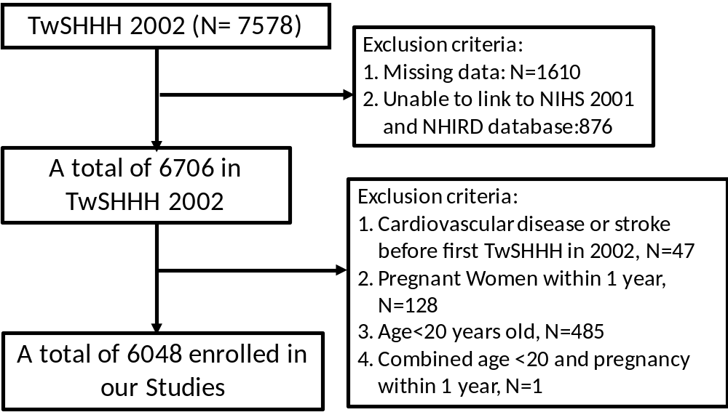

Supplemental Figure 2: Kaplan-Meir survival curves for the risk of cardiovascular specified in the study participants among participants stratified by the numbers of healthy lifestyle factors
(A) by Mediterranean diet related healthy lifestyle score (B) by Taiwan healthy lifestyle score (C) by WCRF/AICR recommended lifestyle score (D) by Life’s Simple 7
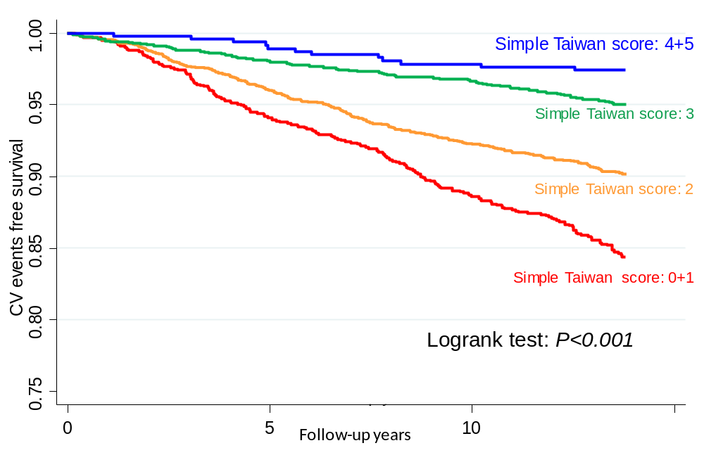
(B)
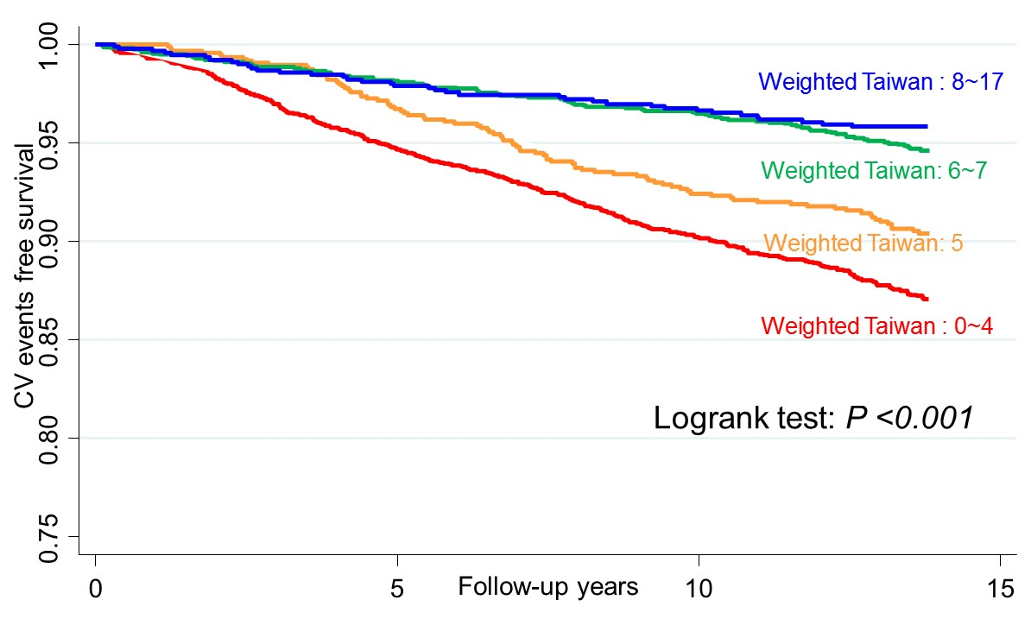

(C)
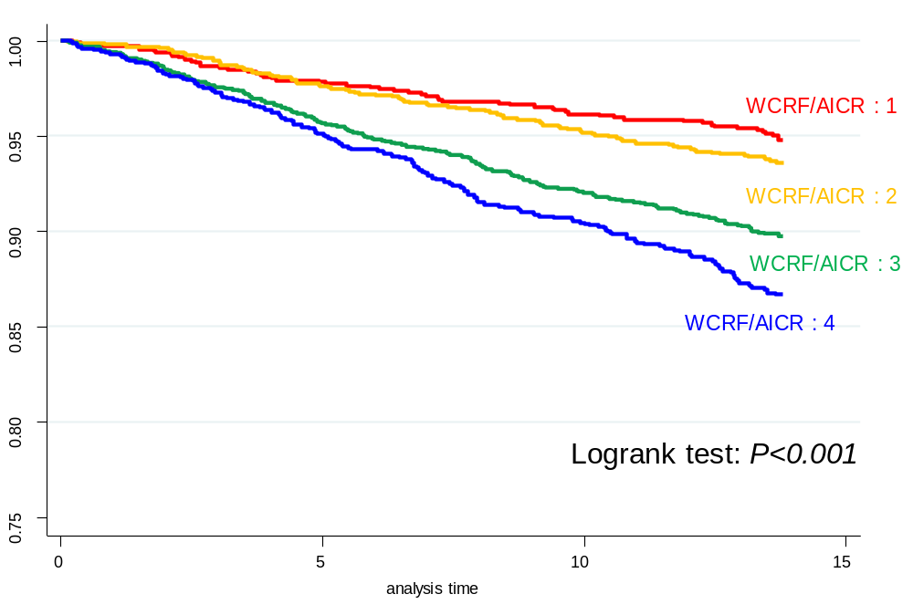

(D)
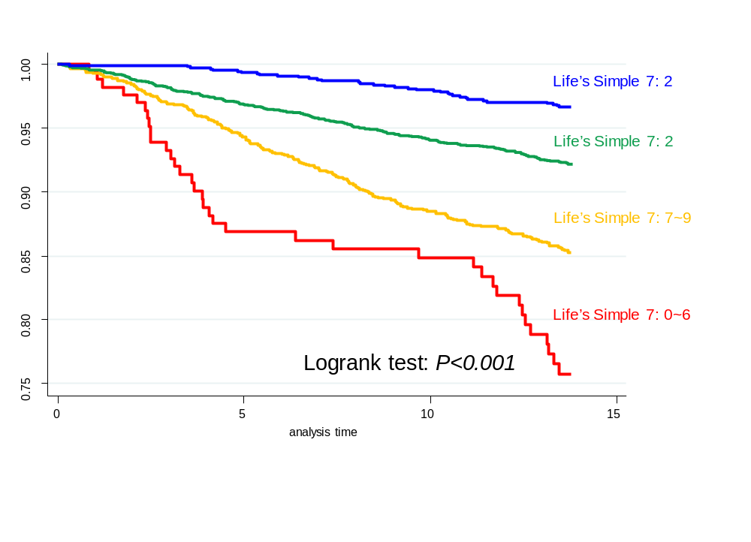

Supplemental Figure 3: The log(-log(survival time)) versus log of CVD event-free survival time including time independent covariates
- CVD event-free survival time of simple Taiwan healthy lifestyle score (B) CVD event-free survival time of weighted Taiwan healthy lifestyle score (C) CVD event-free survival time of WCRF/AICR recommended lifestyle score (D) CVD event-free survival time of Life’s Simple 7 (E) CVD event-free survival time of body mass index (E) CVD event-free survival time of Mediterranean diet score (F) CVD event-free survival time of physical activity (G) CVD event-free survival time of Smoking status (H) CVD event-free survival time of alcohol consumption (I) CVD event-free survival time of ever, former or non-smoking status
(A)
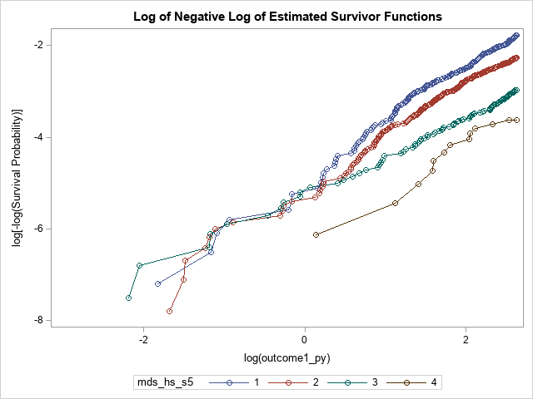

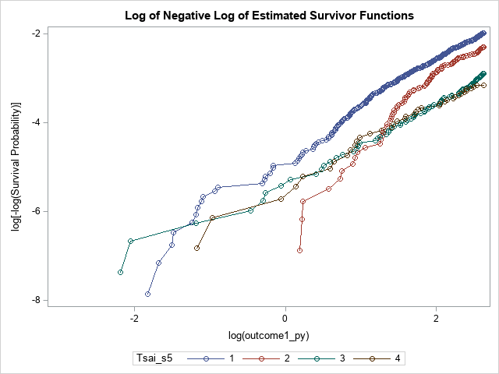

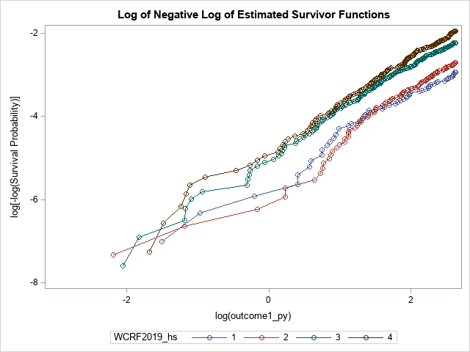

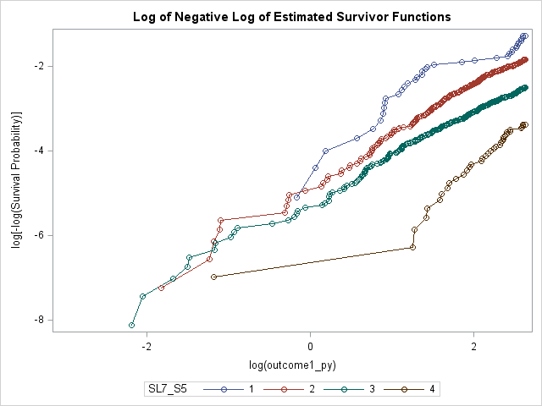

(E)
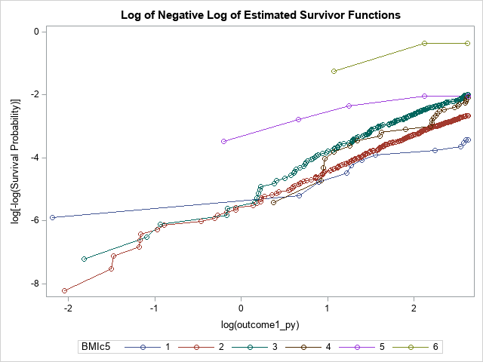

(F)
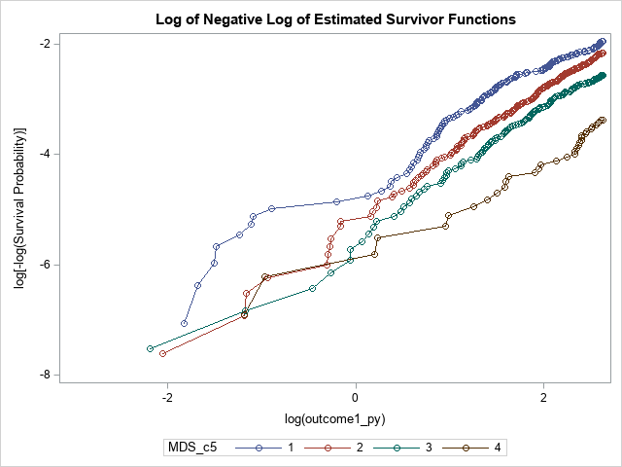

(G)
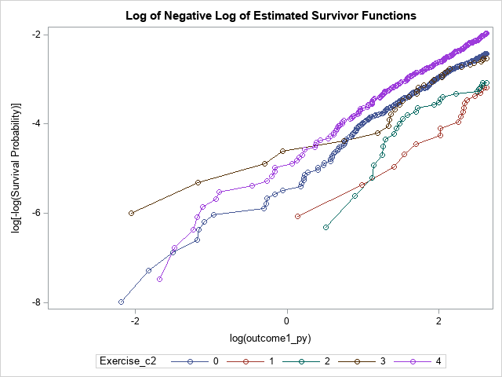

(H)
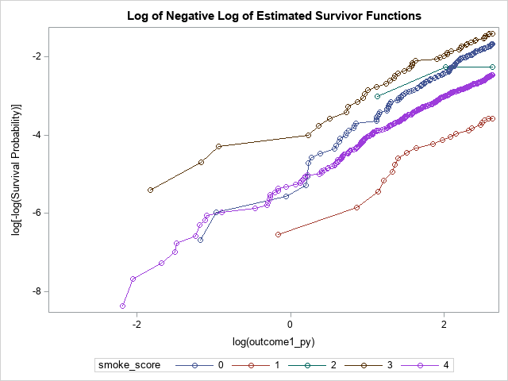

(I)
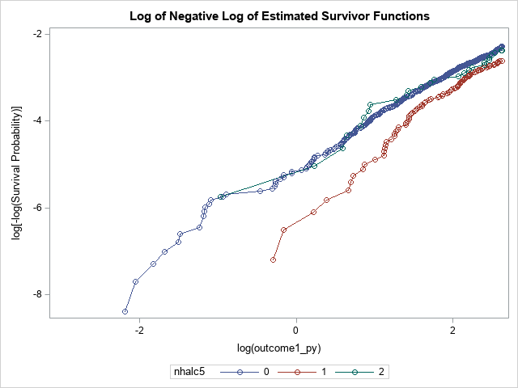
Supplemental Figure 4: Hazard ratios for cardiovascular disease with categories according to the numbers of healthy lifestyle factors among participants stratified by age < 60 y/o and ≥ 60 y/o

(A) Simple Taiwan healthy lifestyle score (B) Weighted Taiwan healthy lifestyle score (C) WCRF/AICR recommended healthy lifestyle score (D) Life’s Simple 7 score
(A)
P for interaction= 0.07

(C)

(D)

Supplemental Figure 5: Calibration plot of predicted mean 12.5.following-up years cardiovascular disease (CVD) risk within deciles against the observed 12.5 following-up years CVD risk in the TWsHHH data (N=6048). Data are plotted among participants stratified by lifestyle scores

(A) Simple Taiwan healthy lifestyle score (B) Weighted Taiwan healthy lifestyle score (C) WCRF/AICR recommended healthy lifestyle score (D) Life’s Simple 7 score

(A)
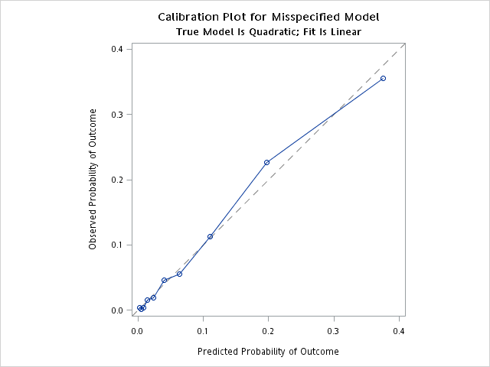

(B)
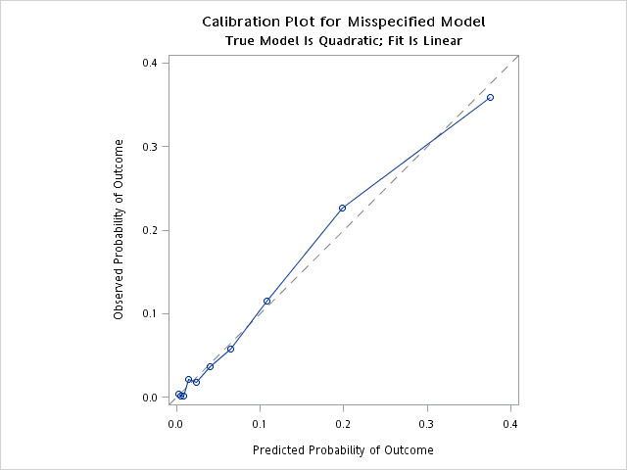

(C)
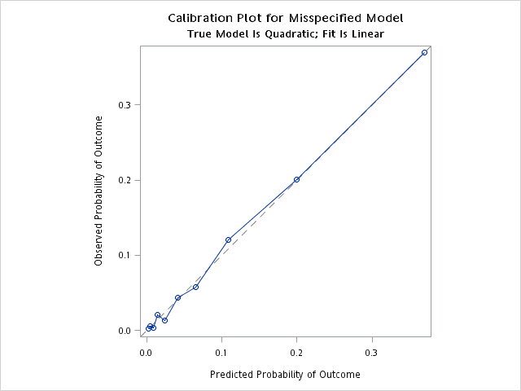

(D)
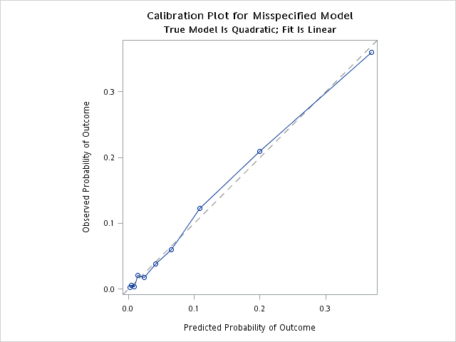
Supplemental Figure 6: Receiver-operating characteristic curves for various models applied to the study population
