Intra-host dynamic variations in SARS-CoV-2

This PDF file includes:

Supplementary figures and tables
Figures S1 to S6
Table S1 to S5

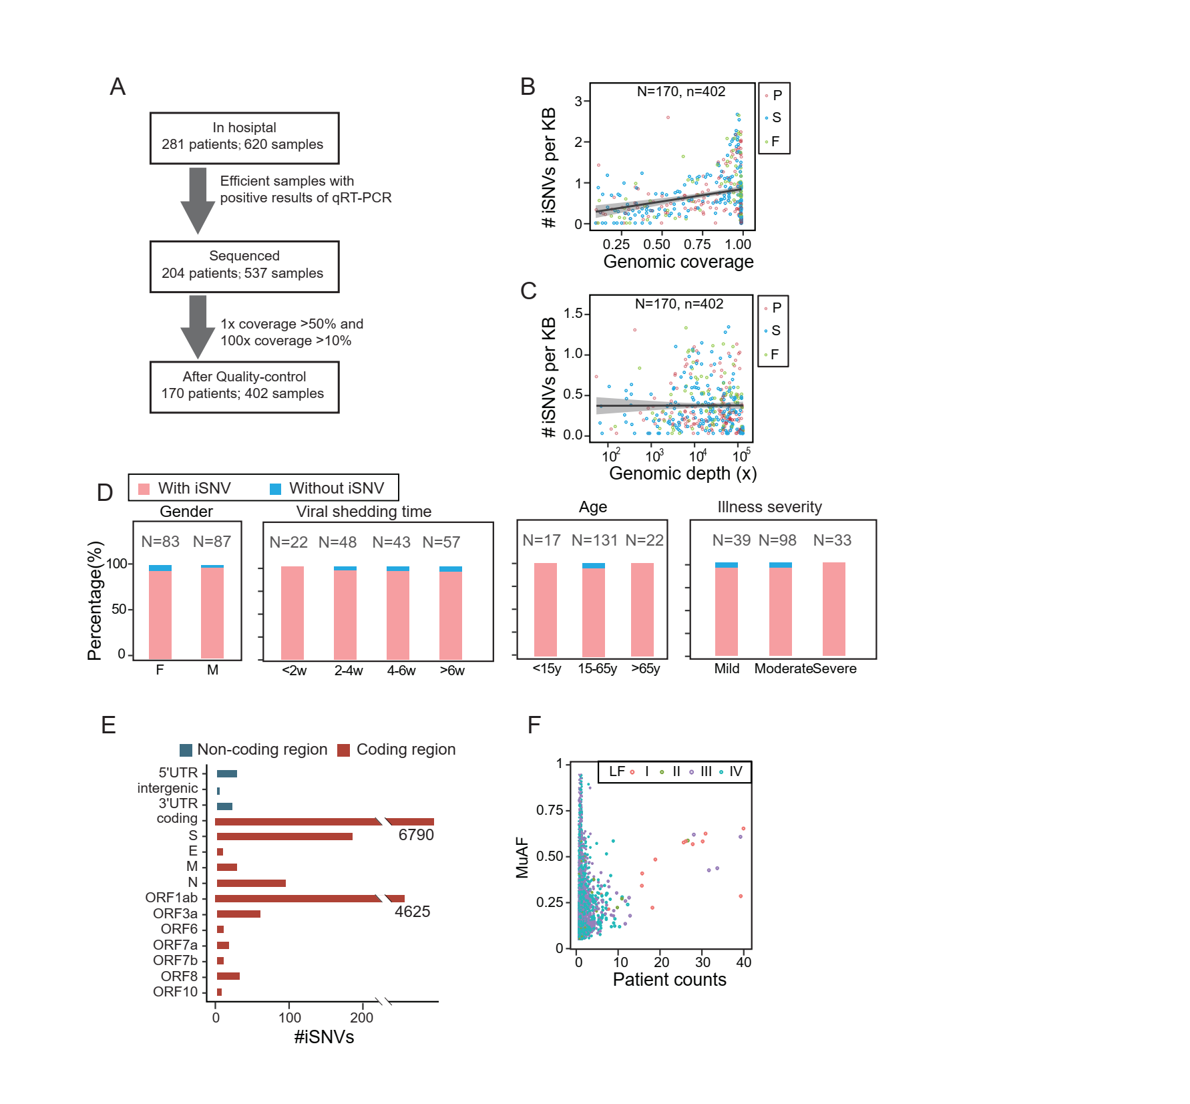
Figure S1. The pipeline of samples selection and iSNV distribution along SARS-Cov-2 genome in patients. (A) The pipeline of patients and sample selected for sequencing and quality control. (B) The number of iSNVs per kb against the genomic coverage with a linear regression. (C) The number of iSNVs per kb against the sequencing depth with a linear regression. (D) The numbers of patients grouped by gender, age, viral shedding time and illness severity, and the proportion of patients with or without iSNV in each group. In the gender group, F is short for female and M is short for male. (E) The iSNV counts in coding (red) and non-coding regions (dark blue). (F) The MuAF of iSNVs against the number of patients with the iSNVs. The average MuAF was used if the iSNV was shared in patients. The color of the point represents the level of SNP frequency in public database reported previously, Level I to IV, the SNP frequency from high to low.

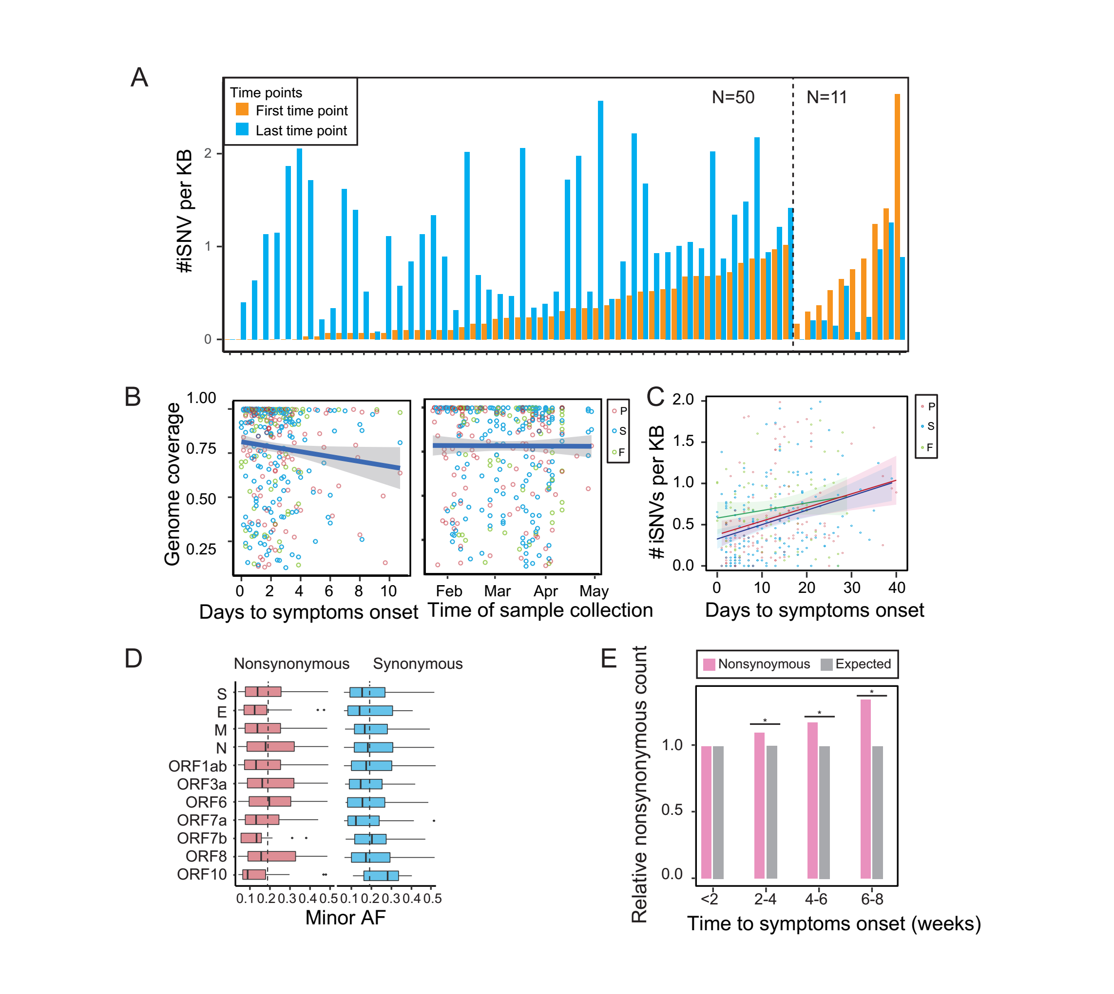
Figure S2. The iSNV distribution along the symptoms onset and genes. (A) The iSNV per KB of the same patients in the first and last time point. The duration of first and last time is more than 5 days. (B) The correlation of iSNV minor allele frequency (minor AF) and genomic coverage with the days post symptom onset and the time of sample collection, respectively, using the samples with more than 100x sequencing depth and linear regression were calculated. (C) The distribution of iSNV per KB against the days post symptom onset, and linear regression were calculated for three sample types. (D) The minor allele frequency (minor AF) of iSNVs causing nonsynonymous (left) and synonymous (right) mutations in each gene. The average frequency in each type of iSNVs was marked by dashed vertical line. (E) The relative nonsynonymous count in epitope regions against time to symptoms onset. The nonsynonymous mutation was colored by pink and expected was colored by grey. The relative nonsynonymous were normalized by the whole epitope region and the expected value was set to 1.

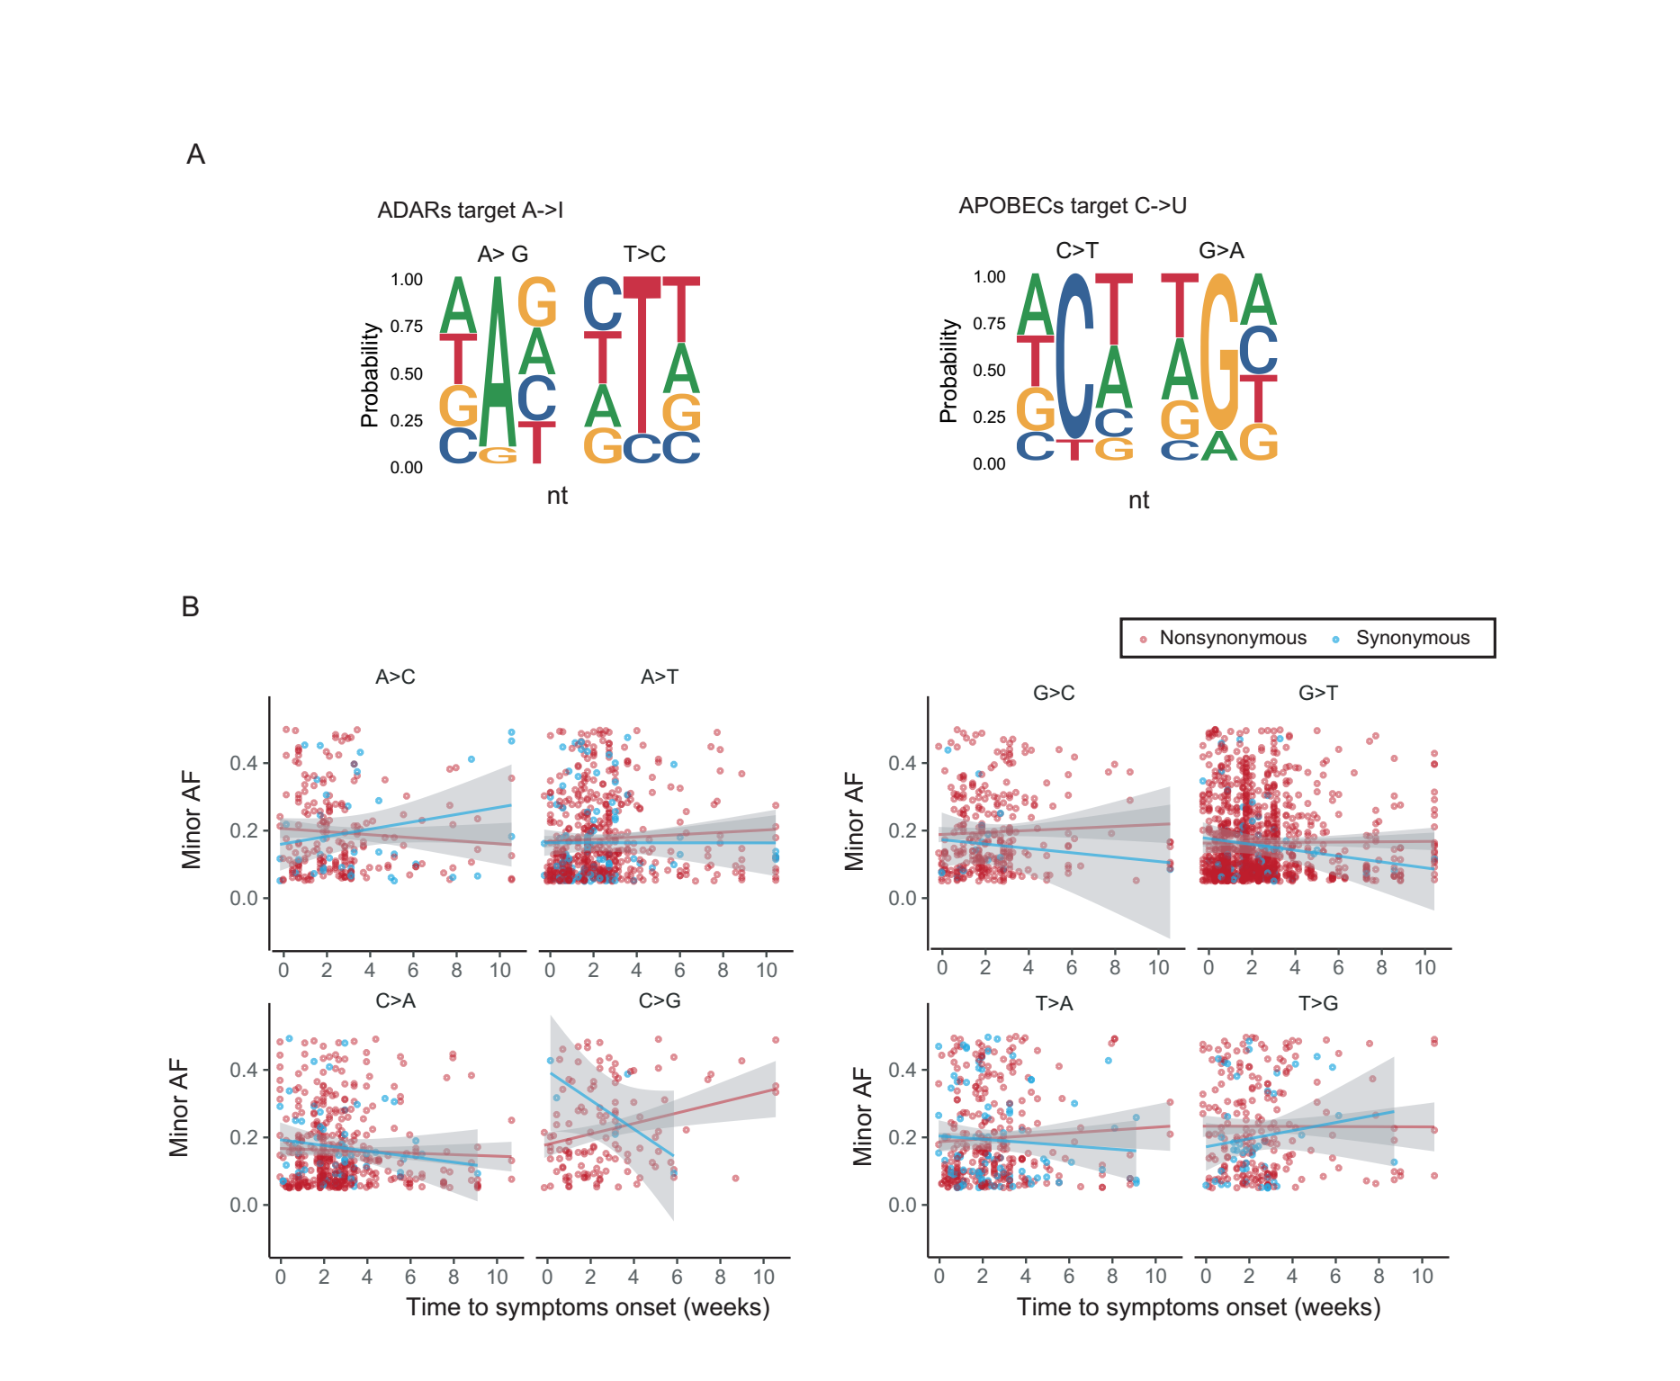
Figure S3. The nucleotide changes of iSNVs and distribution along symptoms onset time. (A) The nucleotide sequence context for the ADARs target (A -> I) and APOBECs target (C -> U). (B) The minor AF of different nucleotide change against the time to symptoms onset of patients. The mutations causing nonsynonymous and synonymous mutations were distinguished by color (red: nonsynonymous mutations, blue: synonymous mutations).
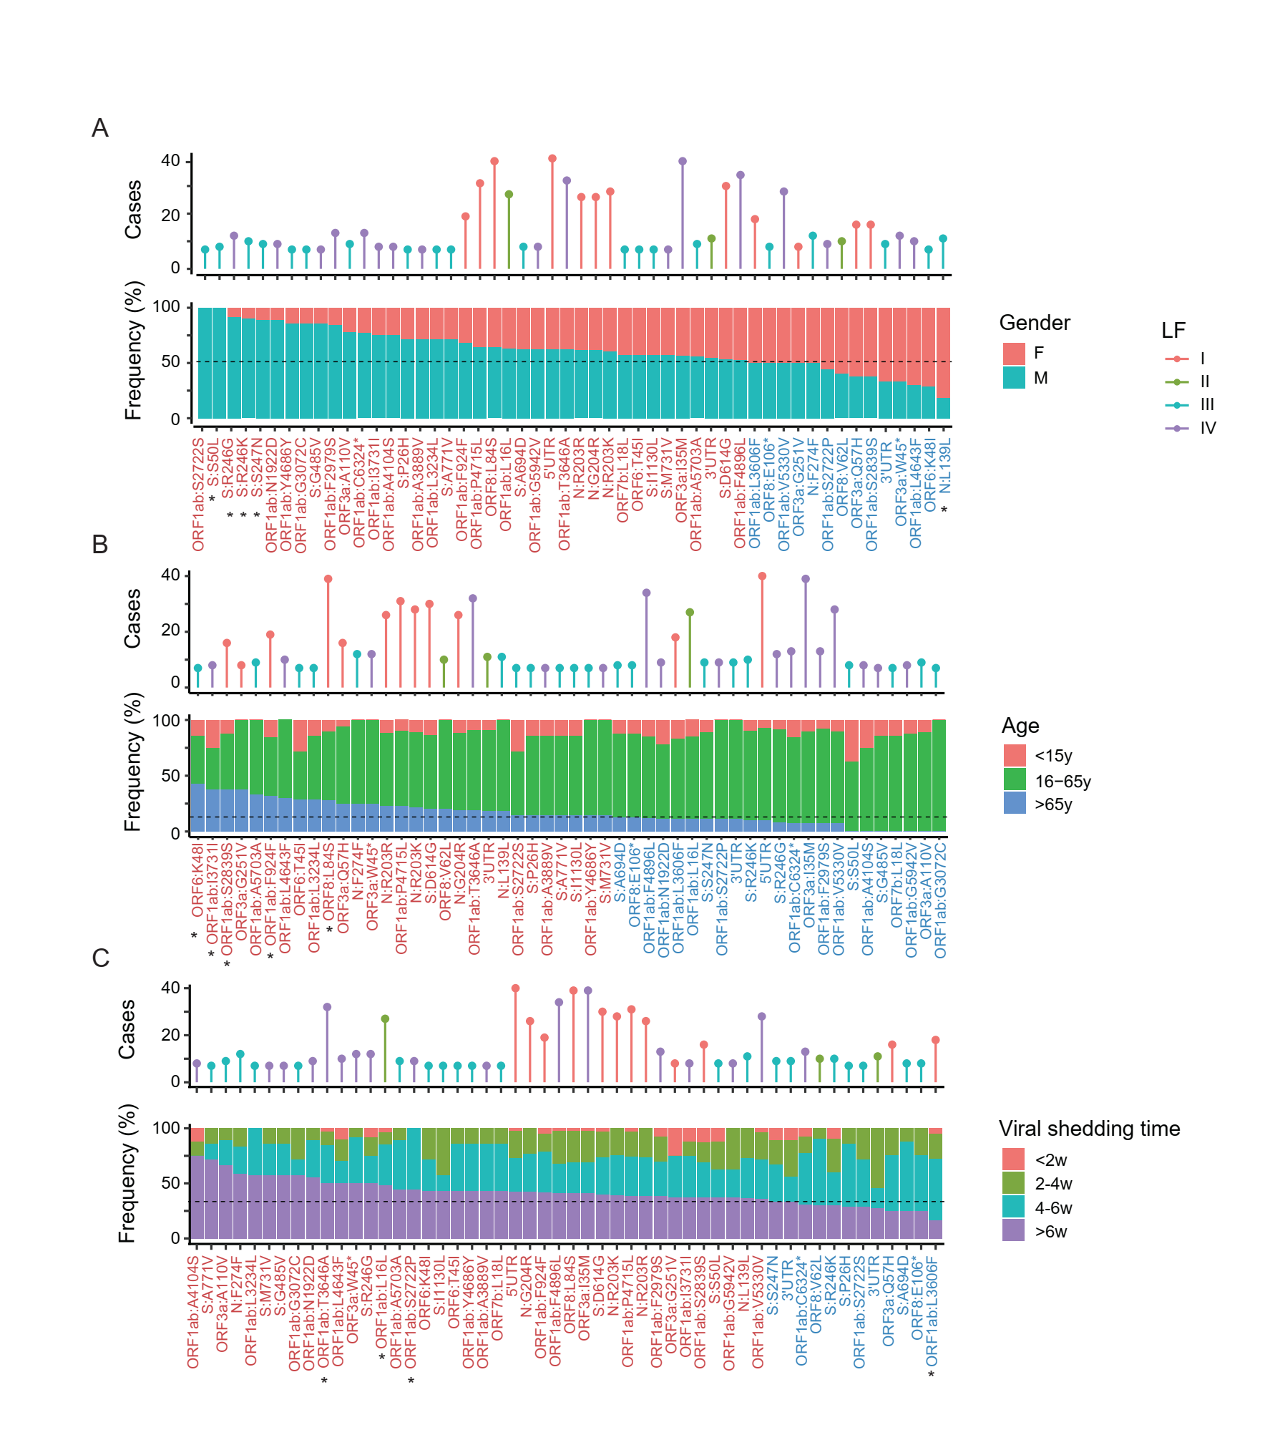
Figure S4. The association of iSNVs with gender, age and viral shedding time of patients. Distribution of iSNVs in patients grouped by gender, age and viral shedding time. The point plots on the top mark the level of SNPs in public database 2019nCovR corresponding to the iSNV site. The middle color titles represent the gene region that the iSNV located. The histogram at the bottom shows the proportion of patients with different clinical states that carrying the iSNV site. The iSNVs marked with star represent that the population carrying this iSNV was significantly differed from the whole patient population. The bars in the lower bar diagram were colored by gender (A), age (B), and viral shedding time (C), respectively.

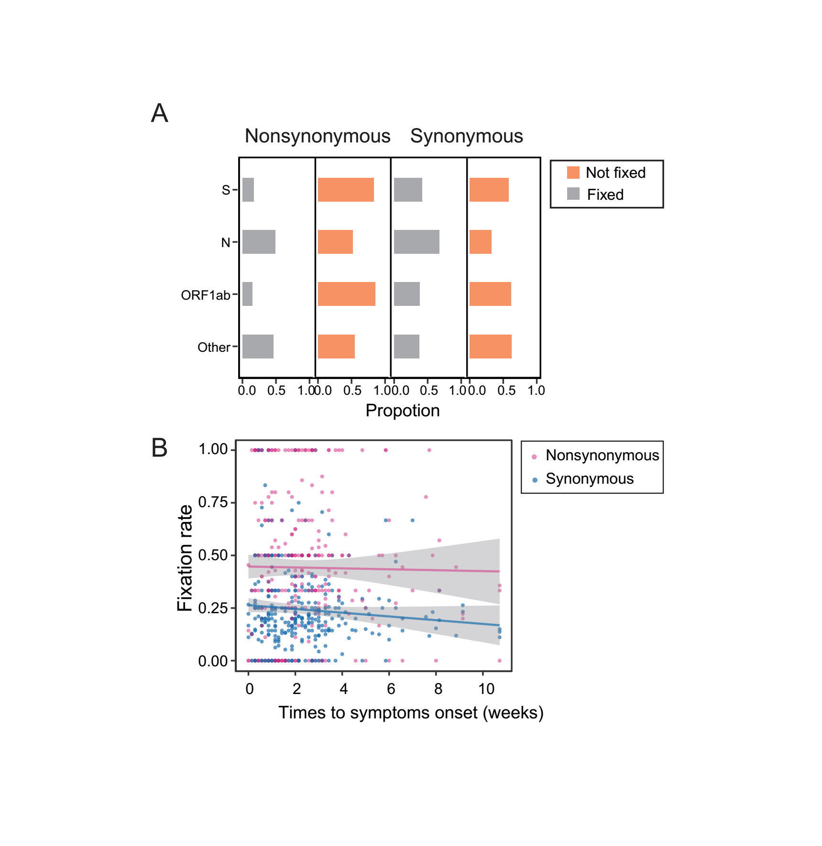
Figure S5. The fixation of iSNVs in different gene and symptoms onset time. (A) The proportion of fixed and not fixed iSNVs causing nonsynonymous and synonymous mutation in each gene. (B) The fixation rate of nonsynonymous and synonymous mutation against the time post symptom onset.
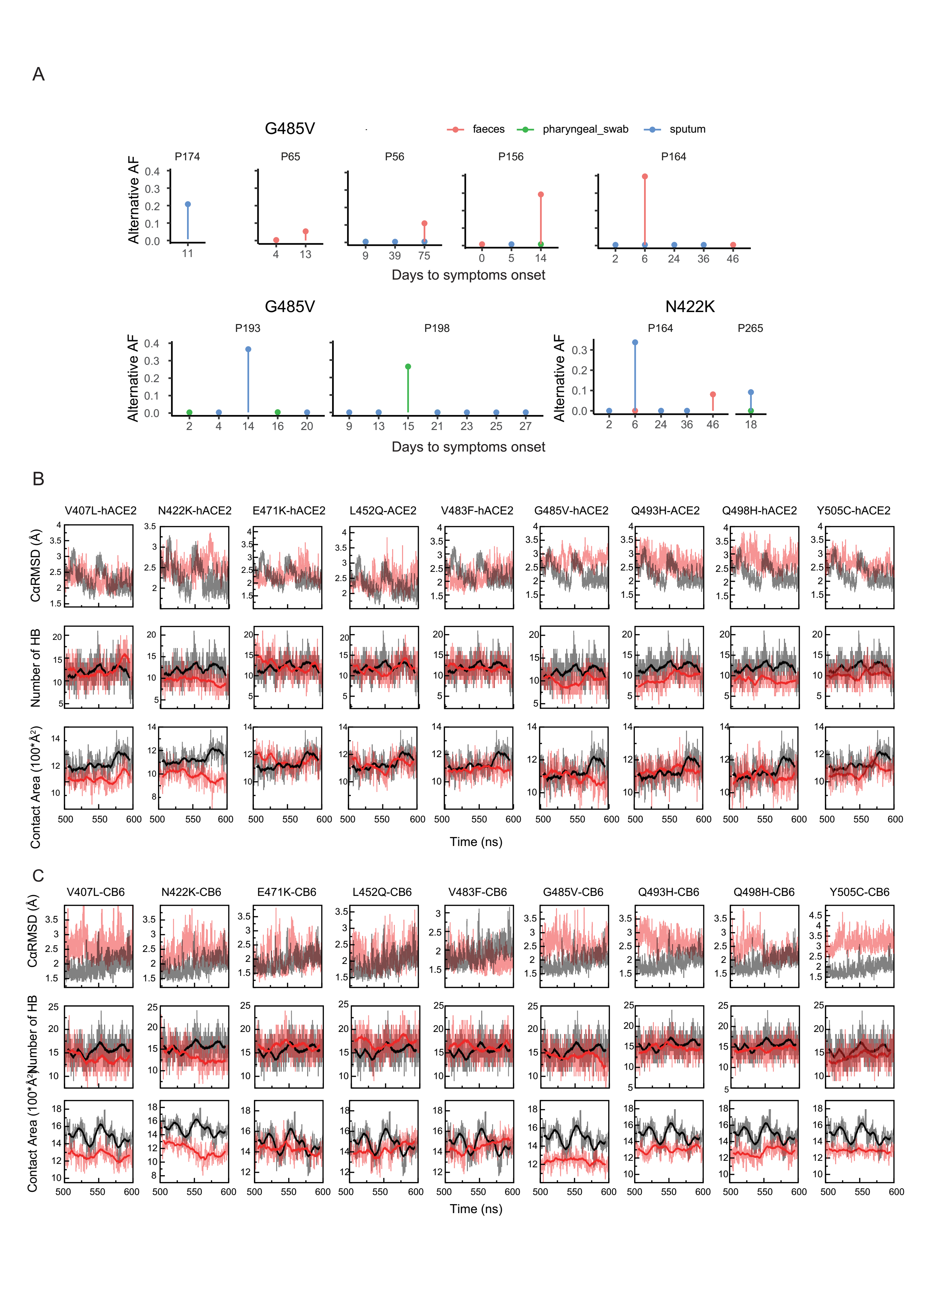
Figure S6. The iSNVs occurs in the S genes. (A) The iSNVs that occurred in different patients along the symptoms onset. The y-axis represents the mutated allele frequency. The color of the point represents samples from pharyngeal swabs, sputum and fecal. (B) The RMSD comparisons, number of hydrogen bond and contact area of the mutants in RBD region compared to WT RBD bound to hACE2. The mutants were colored by red and WT was colored by grey. (D) The RMSD comparisons, number of hydrogen bond and contact area of the mutants in RBD region compared to WT RBD bound to CB6. The mutants were colored by red and WT was colored by grey.

Table S1 Clinical information for patients included in the study

Characteristics | In hospital  patients No. | Sequenced  patients No. | QC patients  No.(%)
Total | 281 | 204 | 170(83.33%)
Age(years)
<15 | 26 | 22 | 17(77.27%)
15-65 | 226 | 158 | 131(82.91%)
>65 | 29 | 24 | 22(91.67%)
Gender
Female | 143 | 102 | 83(81.37%)
Male | 138 | 102 | 87(85.29%)
Illness severity
Mild (M) | 61 | 47 | 39(82.98%)
Moderate (N) | 167 | 117 | 98(83.76%)
Severe (S) | 53 | 40 | 33(82.50%)
Viral shedding time(week)
0-2 | 80 | 36 | 22(61.11%)
2-4 | 70 | 54 | 48(88.89%)
4-6 | 63 | 51 | 43(84.31%)
>6 | 68 | 63 | 57(90.48%)

Table S2 Single nucleotide substitution rate and iSNV identified in other RNA virus

 | SNP (×10⁻³/site/year) | iSNV(×10⁻³/site ) | Reference
SARS-CoV-2 | 0.35–4.67 | 0.53(this paper) | ^{1,2}
Ebola virus | 0.8–1.9 | ~0.5 | ³⁻⁶
Influenza A virus | 1.43–11.62 | 0.43 | ⁷⁻⁹
Yellow fever virus | ∼0.42 | 0.44 | ^{10,11}

Table S3 Samples information that after quality control

Characteristics | Sample Count  No.(%) | iSNV count  median (qu1-qu3) | Wilcoxon test  P-value | # of normalized iSNV  median (qu1-qu3) | Wilcoxon test  P-value | #of samples with iSNV (%) | Fisher-exact test  P-value
Total | 402
Days to symptoms onset
0-7 | 128(31.84%) | 7(2-18.5) | - | 0.331(0.100-0.688) | - | 112(87.5%) | -
8-14 | 104(25.87%) | 11(4-25) | 0.011 | 0.541(0.294-0.972) | 5.74e-4 | 99(95.19%) | 0.0637
15-21 | 81(20.15%) | 15(5-29) | 6.05e-5 | 0.684(0.334-1.133) | 1.79e-6 | 79(97.53%) | 0.0112
22-28 | 45(11.19%) | 11(5-31) | 0.006 | 0.513(0.343-1.111) | 1.23e-3 | 42(93.33%) | 0.408
29-42 | 22(5.47%) | 20.5(11.25-37.75) | 0.0001 | 0.933(0.645-1.423) | 4.00e-6 | 22(100%) | 0.130
43- | 22(5.47%) | 22.5(6-32.25) | 0.015 | 0.836(0.240-1.232) | 5.38e-3 | 20(90.91%) | 1
Specimens
Pharyngeal swab | 136(33.83%) | 10(4-22.25) | 0.791 | 0.439(0.235-0.888) | 0.982 | 128(94.12%) | 0.133
sputum | 182(45.27%) | 11(3-24) | - | 0.514(0.197-0.905) | - | 165(90.66%) | -
faces | 84(20.89%) | 21(5.75-30.25) | 0.001 | 0.771(0.355-1.076) | 0.004 | 81(96.43%) | 0.297

Table S4 Patients clinical information that carrying iSNVs located in S protein RBD domain

Patient ID | Gender | Age | Viral  shedding time | Illness  severity | Clustering  onset groups | iSNV (Days to symptoms onset)
P13 | M | 33 | 63 | Moderate | - | V483F (62)
P56 | M | 59 | 75 | Moderate | F4 | G485V (75)
P65 | M | 6 | 42 | Mild | F6 | G485V (13)
P103 | M | 78 | 35 | Severe | - | E471K (27)
P156 | M | 42 | 48 | Mild | - | G485V (14)
P164 | M | 50 | 52 | Moderate | F1 | V483F (6, 36, 46); G485V (6)
P174 | M | 30 | 23 | Moderate | F1 | G485V (11); Q493H (11)
P165 | M | 33 | 55 | Moderate | F1 | L452Q (6)
P183 | M | 49 | 43 | Moderate | - | Q498H (24)
P193 | M | 41 | 48 | Moderate | - | G485V (14)
P198 | F | 21 | 37 | Moderate | - | V483F (23); G485V (15); Q498H (21)
P201 | F | 76 | 23 | Severe | - | Q493H (5)
P215 | F | 20 | 31 | Moderate | - | E471K (13); Q493H (16)
P230 | M | 24 | 58 | Moderate | - | Y505C (6, 16)
P235 | F | 25 | 10 | Moderate | F2 | L452Q (3)
P247 | F | 23 | 51 | Mild | - | Y505C (21)
P279 | F | 44 | 33 | Moderate | F3 | Q498H (16)

Table S5. Neutralizaing susceptibility of SARS-CoV-2 reference strains and RBD mutants to CB6 mAb

RBD mutant | CB6 IC50 (μg/mL) | Fold change vs. WT
WT | 0.009521 | 1.00
D614G | 0.009122 | 0.96
V407L | 0.01194 | 1.25
L452Q | 0.00853 | 0.90
V483F | 0.00561 | 0.59
Q493H | 0.00412 | 0.43
Q498H | 0.00371 | 0.39

Reference

1 Tang, X. et al. On the origin and continuing evolution of SARS-CoV-2. (2020).
2 Zhang, X. et al. Viral and host factors related to the clinical outcome of COVID-19. Nature 583, 437-440, doi:10.1038/s41586-020-2355-0 (2020).
3 Park, D. J. et al. Ebola Virus Epidemiology, Transmission, and Evolution during Seven Months in Sierra Leone. Cell 161, 1516-1526, doi:10.1016/j.cell.2015.06.007 (2015).
4 Gire, S. K. et al. Genomic surveillance elucidates Ebola virus origin and transmission during the 2014 outbreak. Science 345, 1369-1372, doi:10.1126/science.1259657 (2014).
5 Holmes, E. C., Dudas, G., Rambaut, A. & Andersen, K. G. The evolution of Ebola virus: Insights from the 2013-2016 epidemic. Nature 538, 193-200, doi:10.1038/nature19790 (2016).
6 Ni, M. et al. Intra-host dynamics of Ebola virus during 2014. Nat Microbiol 1, 16151, doi:10.1038/nmicrobiol.2016.151 (2016).
7 Rejmanek, D., Hosseini, P. R., Mazet, J. A., Daszak, P. & Goldstein, T. Evolutionary Dynamics and Global Diversity of Influenza A Virus. J Virol 89, 10993-11001, doi:10.1128/JVI.01573-15 (2015).
8 Bedford, T., Cobey, S., Beerli, P. & Pascual, M. Global migration dynamics underlie evolution and persistence of human influenza A (H3N2). PLoS Pathog 6, e1000918, doi:10.1371/journal.ppat.1000918 (2010).
9 Debbink, K. et al. Vaccination has minimal impact on the intrahost diversity of H3N2 influenza viruses. PLoS Pathog 13, e1006194, doi:10.1371/journal.ppat.1006194 (2017).
10 Liang, H., Lee, M. & Jin, X. Guiding dengue vaccine development using knowledge gained from the success of the yellow fever vaccine. Cell Mol Immunol 13, 36-46, doi:10.1038/cmi.2015.76 (2016).
11 Chen, C. et al. Phylogenomic analysis unravels evolution of yellow fever virus within hosts. PLoS Negl Trop Dis 12, e0006738, doi:10.1371/journal.pntd.0006738 (2018).

