Process design, simulation, and techno-economic analysis of integrated production of furfural and glucose derived from empty fruit bunches

Muhammad Zafran Raja Mohammed¹, Zi Wei Ng¹, Aditya Putranto^{1*}, Zong Yang Kong², Jaka Sunarso², Muhammad Aziz³, Sharif H. Zein⁴, Jannata Giwangkara⁵, Ivan Butar⁶

¹Discipline of Chemical Engineering, School of Engineering, Monash University Malaysia, Bandar Sunway, Selangor 47500, Malaysia
²Research Centre for Sustainable Technologies, Faculty of Engineering, Computing and Science, Swinburne University of Technology, Jalan Simpang Tiga, Kuching, 93350 Sarawak, Malaysia
³Institute of Industrial Science, The University of Tokyo
4-6-1 Komaba, Meguro-ku, Tokyo 153-8505, Japan
⁴Department of Chemical Engineering, Faculty of Science and Engineering, University of Hull, Kingston Upon Hull, HU6 7RX, UK
⁵Climateworks Centre, Level 27, 35 Collins St, Melbourne, VIC 3000, Australia
⁶Monash University, BSD, Serpong, Banten, Indonesia

*Corresponding author: aditya.putranto1@monash.edu

Appendix A: PFD, Mass and Energy Balance Table and ASPEN Simulation Flow Diagram
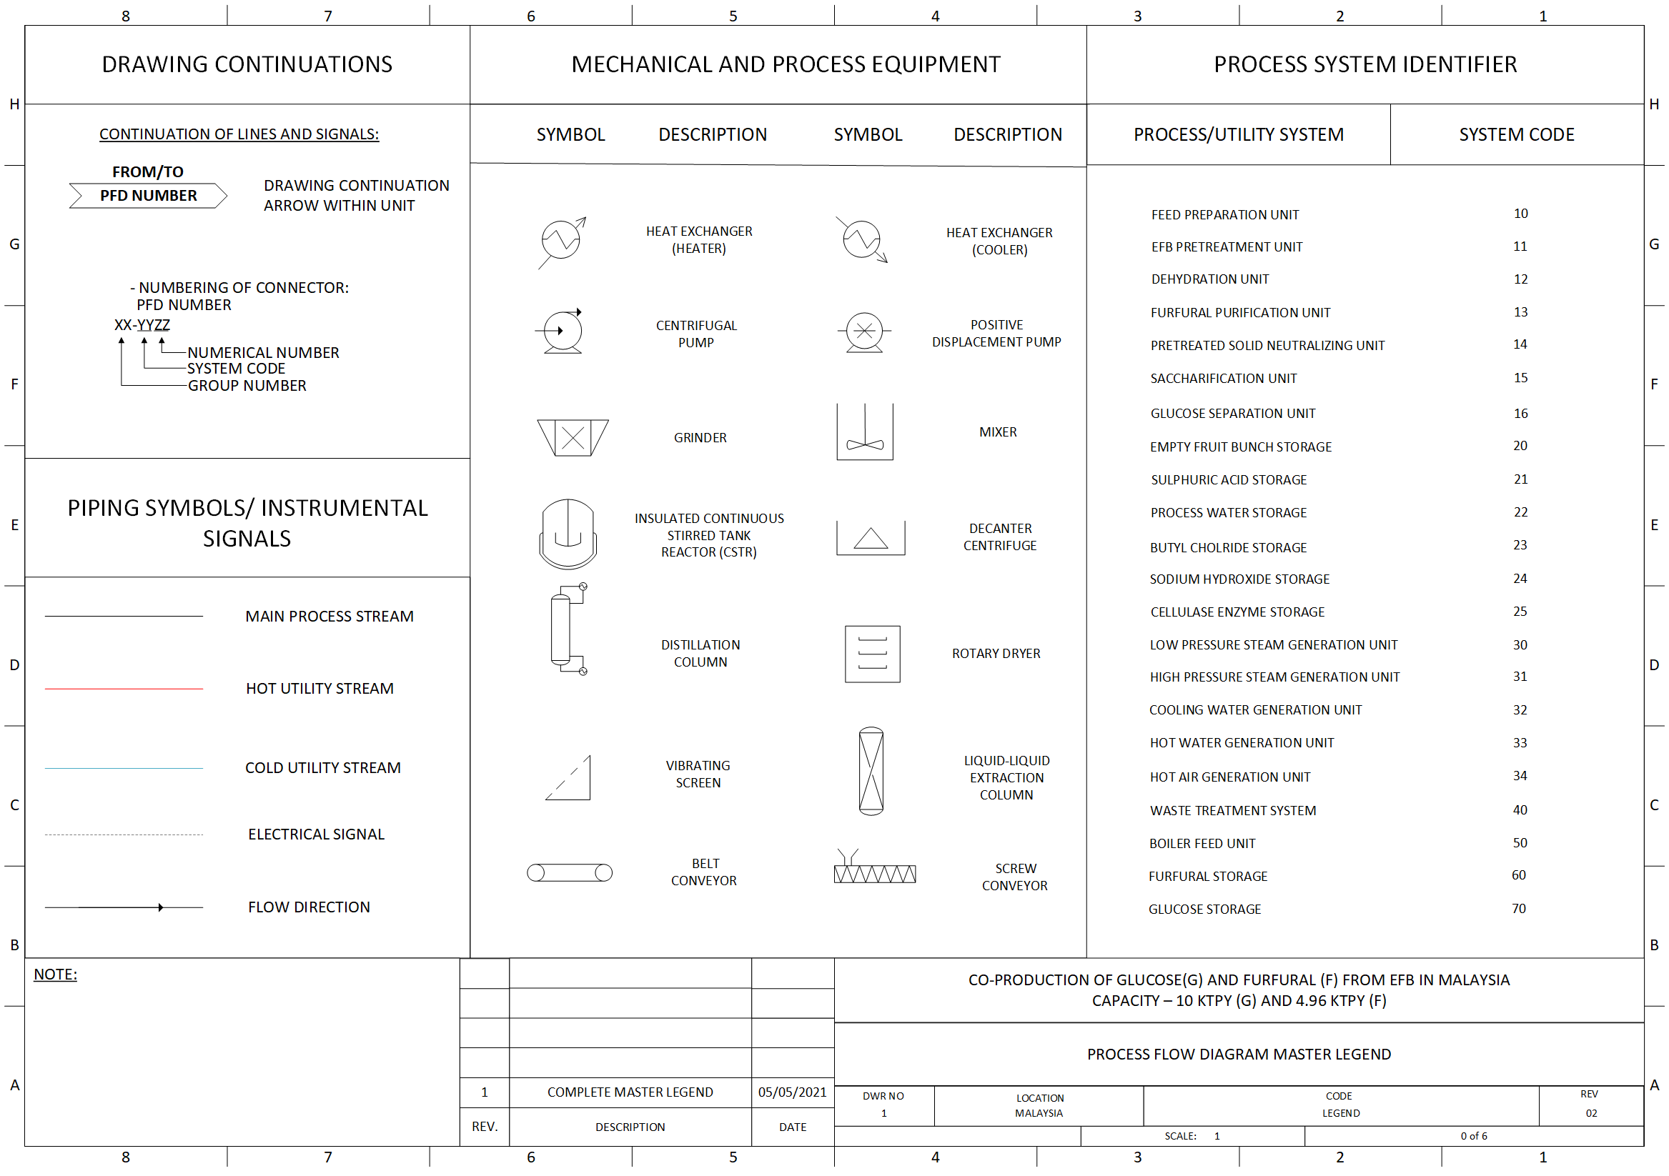
Figure A1: Legend of process flow diagram.
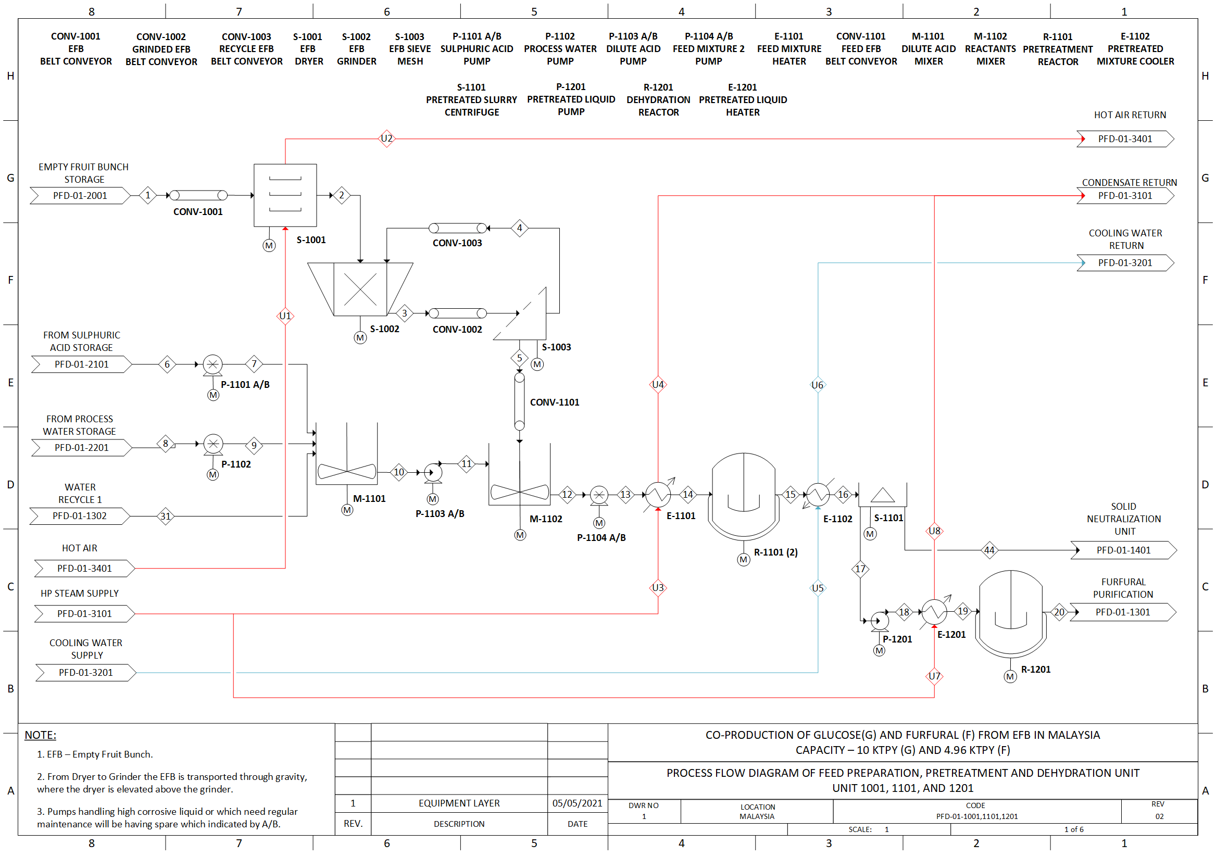
Figure A2: Process flow diagram of feed preparation, pretreatment, and dehydration unit (Unit 1001, 1101 and 1201).
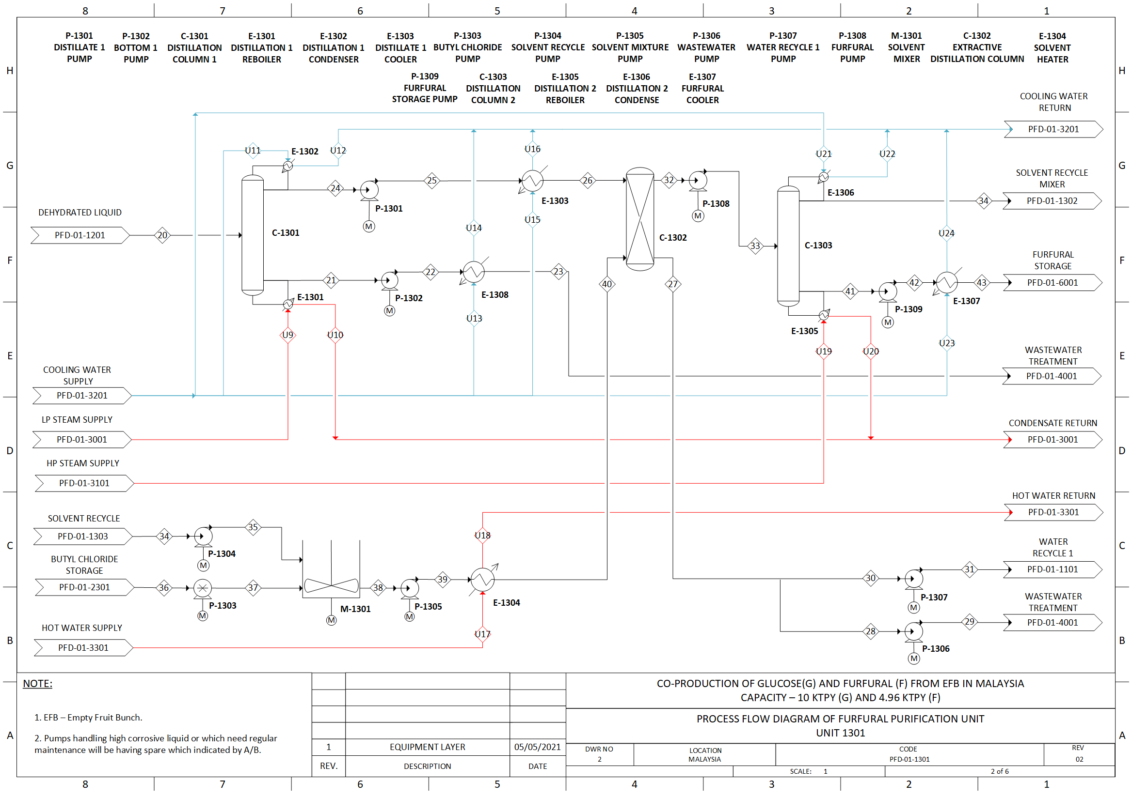
Figure A3: Process flow diagram of furfural purification unit (Unit 1301).
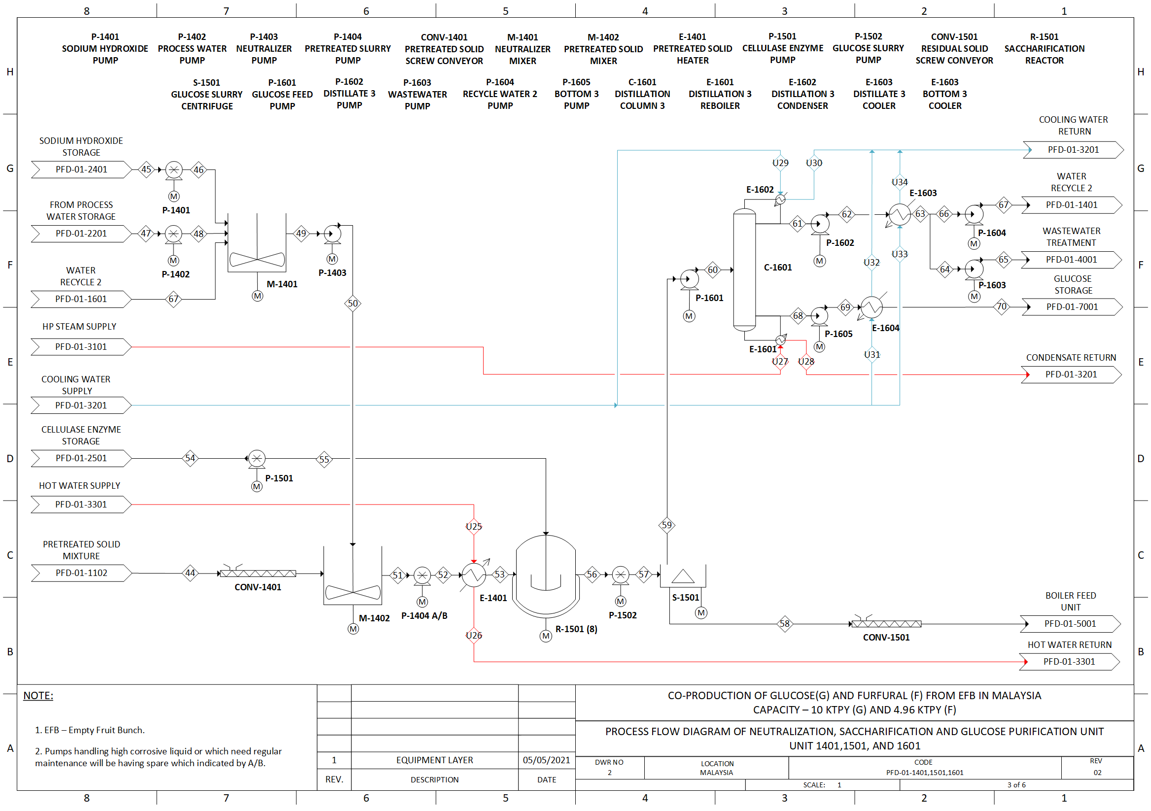
Figure A4: Process flow diagram of neutralization, saccharification and glucose purification unit (Unit 1401, 1501 and 1601).
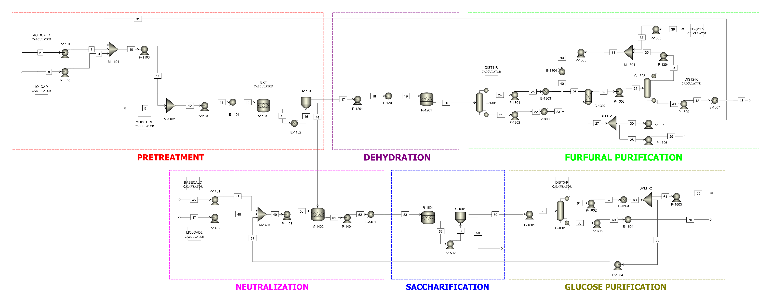
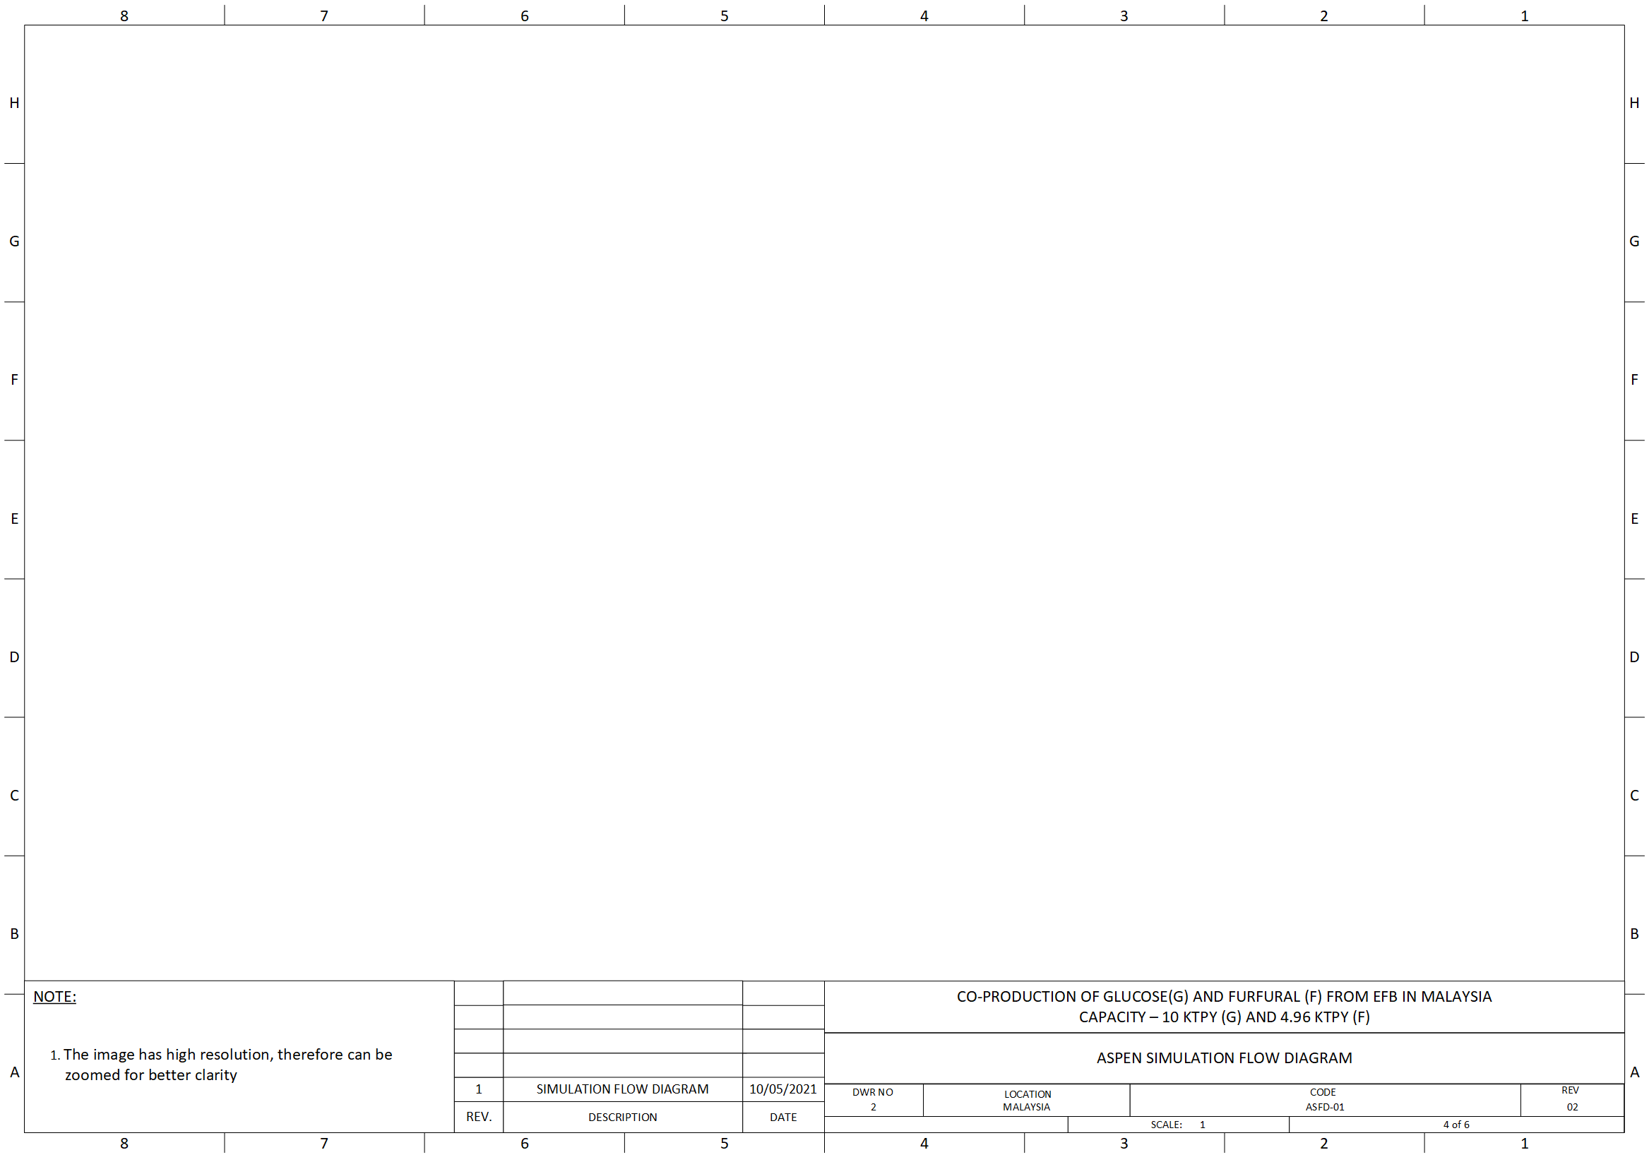
Figure A5: Aspen simulation flow diagram.
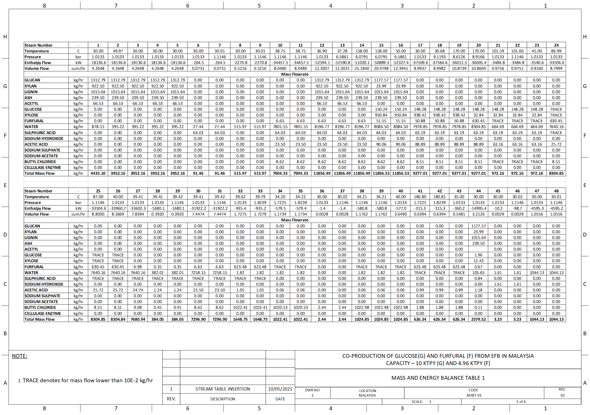
Table A1: Mass and energy balance table 1.
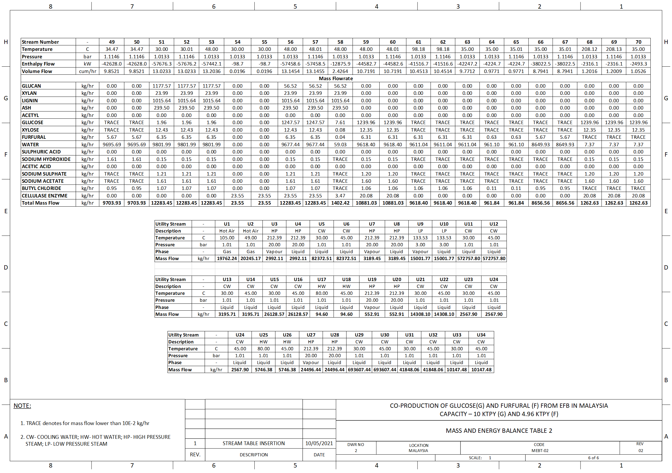
Table A2: Mass and energy balance table 2.

Appendix B: ASPEN Simulation Description
Solid components can be created manually with the following parameters as the property obtained from the literature review. As acetyl group is the derivative of xylan, the property of acetyl group is similar to xylan property,
Table B1: Solid components definition in ASPEN Plus (Wooley and Putsche, 1996).
Component | Molecular weight  (kg/kmol) | Heat of Formation (J/kmol) | Solid Molar Volume (CPSPO1-1) (m3/kmol) | Solid Heat Capacity (VSPOLY-1)  (J/kmol.K)
Glucan | 162.1436 | -976.362E+6 | 0.106 | -11704
Glucan | 162.1436 | -976.362E+6 | 0 | 672.07
Glucan | 162.1436 | -976.362E+6 | 0 | 0
Glucan | 162.1436 | -976.362E+6 | 0 | 0
Glucan | 162.1436 | -976.362E+6 | 0 | 0
Glucan | 162.1436 | -976.362E+6 | 298.15 | 298.15
Glucan | 162.1436 | -976.362E+6 | 1000 | 1000
Xylan | 132.11 | -762.416E+6 | 0.0864 | -9529.9
Xylan | 132.11 | -762.416E+6 | 0 | 547.25
Xylan | 132.11 | -762.416E+6 | 0 | 0
Xylan | 132.11 | -762.416E+6 | 0 | 0
Xylan | 132.11 | -762.416E+6 | 0 | 0
Xylan | 132.11 | -762.416E+6 | 298.15 | 298.15
Xylan | 132.11 | -762.416E+6 | 1000 | 1000
Lignin | 122.493 | -1592.659E+6 | 0.0817 | 31431.7
Lignin | 122.493 | -1592.659E+6 | 0 | 394.427
Lignin | 122.493 | -1592.659E+6 | 0 | 0
Lignin | 122.493 | -1592.659E+6 | 0 | 0
Lignin | 122.493 | -1592.659E+6 | 0 | 0
Lignin | 122.493 | -1592.659E+6 | 298.15 | 298.15
Lignin | 122.493 | -1592.659E+6 | 1000 | 1000
Ash | 162.1436 | -976.362E+6 | 0.106 | -11704
Ash | 162.1436 | -976.362E+6 | 0 | 672.07
Ash | 162.1436 | -976.362E+6 | 0 | 0
Ash | 162.1436 | -976.362E+6 | 0 | 0
Ash | 162.1436 | -976.362E+6 | 0 | 0
Ash | 162.1436 | -976.362E+6 | 298.15 | 298.15
Ash | 162.1436 | -976.362E+6 | 1000 | 1000
Acetyl Group | 132.11 | -762.416E+6 | 0.0864 | -9529.9
Acetyl Group | 132.11 | -762.416E+6 | 0 | 547.25
Acetyl Group | 132.11 | -762.416E+6 | 0 | 0
Acetyl Group | 132.11 | -762.416E+6 | 0 | 0
Acetyl Group | 132.11 | -762.416E+6 | 0 | 0
Acetyl Group | 132.11 | -762.416E+6 | 298.15 | 298.15
Acetyl Group | 132.11 | -762.416E+6 | 1000 | 1000

B.1 Equipment Block Selection
For the equipment selection, RSTOIC is chosen as a reactor since the process involves chemical reactions. It requires inputs such as stoichiometric reaction and conversion rate or extent of reaction while the product mixture goes through a series of separations directly after the reaction. For solid-liquid separation, CFUGE is used as a decanter centrifuge with its given separation ratio and moisture content. The RADFRAC is used as a distillation column for the VLE mixture separation, where it requires input for a number of stages, reflux ratio, and distillate rate. For the LLE mixture separation, EXTRACT is used as an extraction column with its defined feed, solvent, and number of stages. Other equipment such as mixer, heat exchanger, and pump (i.e., MIXER, HEATER, and PUMP) is used for mixing purposes, altering the temperature, and operating pressure of each main equipment, respectively. For ease of calculation and to minimize repetition, a few calculator blocks are included to automatically modify the parameters of specific equipment blocks by changing the flowrate of feed.

B.2 Calculator Block
The equation and calculation used in each calculator block for each unit is shown below,
Table B2: Calculator block definition in ASPEN Plus.
Unit | Calculator | Description | Equation
Pretreatment | ACIDCAL | Used to calculate the amount of required acid using the process condition and solid loading. | ACID=(18*SOLID/1000)/0.7
Pretreatment | LIQLOAD1 | Used to calculate the amount of required freshwater using the process condition and recycle water. | WATER=(((1-0.3) *SOLID)-(0.3*(ACID+MOISTURE+RECYCLE)))/0.3
Pretreatment | MOISTURE | Used to calculate the required moisture in EFB with appropriate dry EFB. | MOISTURE=0.1*SOLID/0.9
Pretreatment | EXT | Used to calculate the extent of the reaction for the secondary reaction using mole flow of xylan, conversion rate and molecular weight of furfural. | E3=(XYLAN*0.974*0.05)/96.08556
Furfural Purification | DIST1-R | Used to calculate the distillate rate of the column using the feedwater flowrate. | DIST=WATER
Furfural Purification | DIST2-R | Used to calculate the distillate rate of the column using the feed solvent flowrate. | DIST=SOLV
Furfural Purification | ED-SOLV | Used to calculate the amount of fresh solvent required using the furfural to solvent ratio and recycled solvent flow. | EXSOLV = ((DILFUR-SOLV)/8.11) - SOLVDIST
Neutralization | BASECAL | Used to calculate the amount of required base using the process condition, solid loading and 10 mol% excess. | NAOH=(((H2SO4*2)+(ACETIC))/MOLEFRAC)*1.1
Neutralization | LIQLOAD2 | Used to calculate the amount of required freshwater using the process condition and recycle water with solid loading, | WATER=(((1-0.2)*SOLID)-(0.2*(BASE+MOISTURE+RECYCLE)))/0.2
Glucose Purification | DIST3-R | Used to calculate the distillate rate of column using the feedwater flowrate. | DIST=WATER

Appendix C: Fixed Capital Investment

C.1 Inside Battery Limit
The total cost required to purchase and install all the process equipment inside the process boundary is defined as the Inside battery limit (IBL). These costs are adjusted with installation, material, electrical system, erection, instrumental control system and piping cost within the process boundary.
The cost of equipment can be determined from Chemical Engineering Design by Gavin and Sinnott and Plant Design and Economics for Chemical Engineers by Peters. Plant Design and Economics for Chemical Engineers by Peters is used for equipment with complex internal structures. These costs are adjusted with the location factor and cost indices. Gavin’s Chemical Engineering Design uses the cost of equipment obtained at the U.S. Gulf in 2006. Peter’s Plant Design and Economics for Chemical Engineers applied graphical correlation to determine the cost of equipment with motor and internal tray in the USA in 2002. The location factor and the cost indices are adapted to Malaysia and the year 2020, respectively. It can be converted into MYR, as in May 2021, the exchange rate of USD to MYR is 4.12 MYR (XE currency, 2021). The final equipment cost with inside battery limit cost is shown below. The following shows the Chemical Engineering Plant Cost Index (CEPCI) and location,
Table C1: Adjusted equipment cost with lang factor in Malaysia in 2020 from Sinnott (Sinnott and Towler, 2020).
Equipment tag | Material of constr. | No. of unit | Ce, Cost US 2006  (USD) | Ce, Cost MY 2020  (USD) | Lang Factor | Phase | C, Cost including installation | Final Cost  MY 2020  (mil. MYR)
P-1103 | CI | 2 | 3426.04 | 3414.30 | 2.56 | Fluid | 8740.61 | 0.04
P-1201 | CI | 1 | 3444.01 | 3432.21 | 2.56 | Fluid | 8786.46 | 0.04
P-1301 | CI | 1 | 3440.30 | 3428.51 | 2.56 | Fluid | 8776.98 | 0.04
P-1302 | CI | 1 | 3310.02 | 3298.68 | 2.56 | Fluid | 8444.61 | 0.03
P-1304 | CI | 1 | 3312.50 | 3301.15 | 2.56 | Fluid | 8450.95 | 0.03
P-1305 | CI | 1 | 3312.54 | 3301.19 | 2.56 | Fluid | 8451.04 | 0.03
P-1306 | CI | 1 | 3303.35 | 3292.03 | 2.56 | Fluid | 8427.61 | 0.03
P-1307 | CI | 1 | 3414.84 | 3403.14 | 2.56 | Fluid | 8712.03 | 0.04
P-1308 | CI | 1 | 3319.89 | 3308.51 | 2.56 | Fluid | 8469.79 | 0.03
P-1309 | CI | 1 | 3306.03 | 3294.71 | 2.56 | Fluid | 8434.45 | 0.03
P-1403 | CI | 1 | 3460.66 | 3448.80 | 2.56 | Fluid | 8828.94 | 0.04
P-1601 | CI | 1 | 3477.77 | 3465.86 | 2.56 | Fluid | 8872.59 | 0.04
P-1602 | CI | 1 | 3472.46 | 3460.56 | 2.56 | Fluid | 8859.03 | 0.04
P-1604 | CI | 1 | 3440.19 | 3428.40 | 2.56 | Fluid | 8776.70 | 0.04
P-1603 | CI | 1 | 3310.04 | 3298.69 | 2.56 | Fluid | 8444.66 | 0.03
P-1605 | CI | 1 | 3312.86 | 3301.51 | 2.56 | Fluid | 8451.87 | 0.03
E-1101 | CS | 1 | 13346.94 | 13301.21 | 2.60 | Fluid-Solid | 34583.14 | 0.14
E-1102 | CS | 1 | 18415.66 | 18352.56 | 2.60 | Fluid-Solid | 47716.65 | 0.20
E-1201 | CS | 1 | 13569.78 | 13523.28 | 2.60 | Fluid | 35160.52 | 0.15
E-1301 | CS | 1 | 35575.21 | 35453.30 | 2.60 | Fluid | 92178.59 | 0.38
E-1302 | CS | 1 | 29367.63 | 29267.00 | 2.60 | Fluid | 76094.19 | 0.31
E-1303 | CS | 1 | 16429.13 | 16372.84 | 2.60 | Fluid | 42569.38 | 0.18
E-1304 | CS | 1 | 10038.03 | 10003.63 | 2.60 | Fluid | 26009.44 | 0.11
E-1305 | CS | 1 | 10384.50 | 10348.91 | 2.60 | Fluid | 26907.18 | 0.11
E-1306 | CS | 1 | 10726.02 | 10689.27 | 2.60 | Fluid | 27792.10 | 0.11
E-1307 | CS | 1 | 10355.64 | 10320.15 | 2.60 | Fluid | 26832.40 | 0.11
E-1308 | CS | 1 | 10391.82 | 10356.21 | 2.60 | Fluid | 26926.14 | 0.11
E-1401 | CS | 1 | 12295.63 | 12253.50 | 2.60 | Fluid-Solid | 31859.10 | 0.13
E-1601 | CS | 1 | 42258.82 | 42114.01 | 2.60 | Fluid | 109496.42 | 0.45
E-1602 | CS | 1 | 22239.32 | 22163.11 | 2.60 | Fluid | 57624.09 | 0.24
E-1603 | CS | 1 | 21266.99 | 21194.12 | 2.60 | Fluid | 55104.71 | 0.23
E-1604 | CS | 1 | 10429.49 | 10393.75 | 2.60 | Fluid | 27023.75 | 0.11
S-1001 | CS | 1 | 545212.02 | 543343.76 | 2.60 | Fluid-Solid | 1412693.78 | 5.83
S-1002 | CS | 1 | 27517.83 | 27423.54 | 2.15 | Solid | 58960.61 | 0.24
CONV-1001 | CS | 1 | 40250.00 | 40112.08 | 2.15 | Solid | 86240.97 | 0.36
CONV-1002 | CS | 1 | 28750.00 | 28651.48 | 2.15 | Solid | 61600.69 | 0.25
CONV-1003 | CS | 1 | 28750.00 | 28651.48 | 2.15 | Solid | 61600.69 | 0.25
CONV-1101 | CS | 1 | 34500.00 | 34381.78 | 2.15 | Solid | 73920.83 | 0.31
CONV-1401 | CS | 1 | 31625.00 | 31516.63 | 2.15 | Solid | 67760.76 | 0.28
CONV-1502 | CS | 1 | 40250.00 | 40112.08 | 2.15 | Solid | 86240.97 | 0.36
Total |  |  |  |  |  |  | 2790825.39 | 11.52
According to Peter's Plant Design and Economics for Chemical Engineers that is used to calculate the cost of equipment, the graph of purchase cost with their respective unit size or capacity is used to find the cost at U.S.A in 2002 (Peters et al., 2003).
Table C2: Adjusted equipment cost with lang factor at Malaysia in 2020 (Peters et al., 2003).
Equipment tag | Material of constr. | No. of unit | Ce, Cost US 2002 (USD) | Ce, Cost MY 2020 (USD) | Lang Factor | Phase | Cost including installation | Final Cost  MY 2020 (Mil. MYR)
P-1101 | CI | 2 | 550 | 672.46 | 2.56 | Fluid | 3443.01 | 0.01
P-1102 | CI | 1 | 600 | 733.60 | 2.56 | Fluid | 1878.01 | 0.01
P-1104 | CI | 2 | 1600 | 1956.26 | 2.57 | Fluid-Solid | 10055.16 | 0.04
P-1303 | CI | 1 | 550 | 672.46 | 2.56 | Fluid | 1721.51 | 0.01
P-1401 | CI | 1 | 550 | 672.46 | 2.56 | Fluid | 1721.51 | 0.01
P-1402 | CI | 1 | 680 | 831.41 | 2.56 | Fluid | 2128.41 | 0.01
P-1404 | CI | 2 | 1650 | 2017.39 | 2.57 | Fluid-Solid | 10369.39 | 0.04
P-1501 | CI | 1 | 550 | 672.46 | 2.56 | Fluid | 1721.51 | 0.01
P-1502 | CI | 1 | 1700 | 2078.52 | 2.57 | Fluid-Solid | 5341.81 | 0.02
S-1003 | CS | 1 | 33000 | 40347.81 | 2.15 | Solid | 86747.79 | 0.36
M-1101 | CS | 1 | 10080 | 12324.42 | 2.60 | Fluid | 32043.50 | 0.13
M-1102 | CS | 1 | 11700 | 14305.13 | 2.60 | Fluid-Solid | 37193.34 | 0.15
M-1301 | CS | 1 | 4280 | 5232.99 | 2.60 | Fluid | 13605.77 | 0.06
M-1401 | CS | 1 | 10780 | 13180.28 | 2.60 | Fluid | 34268.74 | 0.14
M-1402 | CS | 1 | 11780 | 14402.94 | 2.60 | Fluid-Solid | 37447.66 | 0.15
R-1101 | CS | 2 | 13820 | 16897.17 | 2.60 | Fluid-Solid | 87865.30 | 0.36
R-1201 | CS | 1 | 130500 | 159557.24 | 2.60 | Fluid | 414848.83 | 1.71
R-1501 | CS | 8 | 141000 | 172395.18 | 2.60 | Fluid-Solid | 3585819.76 | 14.80
S-1101 | SS 316 | 1 | 85000 | 103926.17 | 2.78 | Fluid-Solid | 288914.76 | 1.19
S-1501 | SS 316 | 1 | 85000 | 103926.17 | 2.78 | Fluid-Solid | 288914.76 | 1.19
C-1302 | CS | 1 | 137100 | 167626.80 | 2.60 | Fluid | 435829.69 | 1.80
C-1301 | CS | 1 | 192000 | 234750.88 | 2.60 | Fluid | 610352.30 | 2.52
C-1303 | CS | 1 | 116000 | 141828.66 | 2.60 | Fluid | 368754.51 | 1.52
C-1601 | CS | 1 | 107200 | 131069.24 | 2.60 | Fluid | 340780.03 | 1.41
Total |  |  |  |  |  |  | 6701767.04 | 27.66

Therefore, the total equipment cost is calculated as MYR 39.17 million.

C.2 Outside Battery Limit
Table C3: OBL cost of each facility.
Facilities | Percentage of FCI (%) (Peters et al., 2003) | Cost (Million MYR)
Building | 7.00 | 5.71
Yard Improvements | 2.50 | 2.04
Steam Generation | 3.00 | 2.45
Steam Distribution | 1.00 | 0.82
Air Compression and Distribution | 0.20 | 0.16
Water Supply, Cooling, and Pumping | 1.80 | 1.47
Water and Effluent Treatment | 1.30 | 1.06
Water Distribution | 0.80 | 0.65
Process Waste Disposal | 0.50 | 0.41
Raw Material Storage | 0.50 | 0.41
Finished-Product Storage | 1.50 | 1.22
Electric Substation | 1.30 | 1.06
Electric Distribution | 1.00 | 0.82
Sanitary Waste Disposal | 0.40 | 0.33
Communications | 0.20 | 0.16
Fire Protection System | 0.30 | 0.24
Safety Installations | 0.20 | 0.16
Total | 24.00 | 19.18

C.3 Indirect Cost
Legal expenses, construction cost, contractor fee, etc. are some examples of Indirect costs. The cost estimation is similar to OBL cost, where it is calculated using a percentage of FCI. The typical value is determined from Peter’s Plant Design and Economics for Chemical Engineers (Peters et al., 2003). Since the FCI is yet to be known, using the circular referencing method, FCI can be iterated accordingly. The total cost of OBL is calculated as MYR 23.26 million, which is shown below.
Table C4: Indirect cost using the percentage of FCI.
Parameter | Percentage of FCI (Peters et al., 2003) | Cost (million MYR)
Engineering and Supervision | 8.00 | 6.53
Legal Expenses | 1.50 | 1.22
Construction Expenses | 8.00 | 6.53
Contractor Fee | 3.00 | 2.45
Contingencies | 8.00 | 6.53
Total indirect cost (million (MYR) |  | 23.26

Appendix D: Operating Cost
Product 1 (glucose) is chosen as the basis of calculation because the production rate of product 2 (furfural) follows the ratio of glucose to furfural produced in the process plant.
Table D1: Operating cost table.
Product 1 |  | Glucose
Product 2 |  | Furfural
Capacity of Product 1 (tonne/year) |  | 10000
Capacity of Product 2 (tonne/year) |  | 4960.64
Total Fixed Capital (FCI) (million MYR) |  | 81.60719615
Product 1 Selling Price (MYR/tonne) |  | 2140.453189
Product 2 Selling Price (MYR/tonne) |  | 8879.5
Manufacturing Cost
Raw Material | Unit Usage (Unit/  tonne Product 1) | Unit Cost (MYR/Unit) | Cost (MYR/tonne Product 1) | Annual Cost  (Million MYR/year)
Empty Fruit Bunch (EFB) | 3.513 | 50.00  (Lo et al., 2020) | 175.63 | 1.76
Sulphuric Acid (70 wt%) | 0.072 | 264.32 (ECHEMI, 2021) | 19.15 | 0.19
Sodium Hydroxide (50 wt%) | 0.003 | 552.51 (MERCK, 2021) | 1.41 | 0.01
Butyl Chloride | 0.002 | 333.26 (Thermo Fisher Scientific, 2021) | 0.64 | 0.01
Cellulase Enzyme | 0.019 | 61600.00 (Indiamart, 2021) | 1149.01 | 11.49
Water | 0.827 | 1.50 (MIDA, 2021) | 1.24 | 0.01
Total Raw Material Cost |  |  | 1347.08 | 13.47
Utilities (20% Allowance) | Unit Usage (Unit/  tonne Product 1) | Unit Cost (MYR/Unit) | Cost (MYR/tonne Product 1) | Annual Cost  (Million MYR/year)
Electricity | 168.24 | 0.34 (Nasional, 2021) | 56.70 | 0.57
Low Pressure Steam | 0.71 | 73.50 | 52.40 | 0.52
Medium Pressure Steam | 1.48 | 75.58 | 112.17 | 1.12
Hot Water | 0.28 | 3.73 | 1.04 | 0.01
Cooling Water | 68.76 | 1.50 (MIDA, 2021) | 103.14 | 1.03
Total Utilities Cost |  |  | 325.43 | 3.25
Total Variable Cost |  |  | 1672.52 | 16.73
Process Labor | Number | Salary/year (MYR) | Cost (MYR/tonne Product 1) | Annual Cost  (Million MYR/year)
Operators | 10 | 20090 (Malaysia Indeed, 2021) | 2.01 | 0.02
Shifts per day | 4 | - | - | -
Total Shift Operators (SO) | 40 | 803600 | 80.36 | 0.80
Supervisory & Clerical Labor | 15% SO Salary |  | 12.05 | 0.12
Total Process Labor Wage (PL) |  |  | 92.41 | 0.92
Maintenance Cost (MC) | 7% of FCI |  | 571.25 | 5.71
Operating Supplies | 15% of MC |  | 85.69 | 0.86
Plant Overheads | 10% of TMC |  | 449.63 | 4.50
Property Insurance | 1% FCI |  | 81.61 | 0.82
Financing Interest | 5% of FCI |  | 408.04 | 4.08
Book Depreciation | 13.91% of FCI |  | 1135.16 | 11.35
Total Capital Related Cost (CR) (Peters et al., 2003) |  |  | 2733.37 | 2731.37
Total Fixed Cost (PL + CR) |  |  | 2825.78 | 2823.78
Total Manufacturing Cost (TMC) |  | Fixed | 2823.78 | 28.24
 |  | Variable | 1672.52 | 16.73
 |  | Total | 4496.30 | 44.96
Non-Manufacturing Cost (Peters et al., 2003)
Administration | 20% of SO |  | 16.07 | 0.16
Research and Development | 2% of TMC |  | 89.93 | 0.90
Distributing and Marketing | 2% of TMC |  | 89.93 | 0.90
Total Non-Manufacturing Cost (TNMC) |  |  | 195.92 | 1.96
Total Operating Cost (TNMC + TMC) |  |  | 4692.22 | 46.92

Appendix E: Working Capital
Table E1: Working capital table.
Product 1 |  | Glucose
Product 2 |  | Furfural
Process Routes |  | Enzymatic Hydrolysis of cellulose (1) and Dehydration of xylose (2)
Capacity of Product 1 (tonne/year) |  | 10000
Capacity of Product 2 (tonne/year) |  | 4960.642
Capacity Utilization (%) |  | 100
Raw Material Inventory
Item | Inventory (weeks) |  | Amount |  | Unit Cost |  | Value (MYR)
Empty Fruit Bunch (EFB) | 3 |  | 2235.29 | tonnes | 50.00 (Lo et al., 2020) | MYR/tonne | 111764.46
Sulphuric Acid (70 wt%) | 3 |  | 46.10 | tonnes | 264.32 (ECHEMI, 2021) | MYR/tonne | 12184.63
Sodium Hydroxide (50 wt%) | 3 |  | 1.63 | tonnes | 552.51 (MERCK, 2021) | MYR/tonne | 898.26
Butyl Chloride | 3 |  | 1.23 | tonnes | 333.26 (Thermo Fisher Scientific, 2021) | MYR/tonne | 410.42
Cellulase Enzyme | 3 |  | 11.87 | tonnes | 61600.00 (Indiamart, 2021) | MYR/tonne | 731187.11
Water | 1 |  | 175.41 | tonnes | 1.50 (MIDA, 2021) | MYR/tonne | 263.12
Total Raw Material Inventory Value (Million MYR) |  |  |  |  |  |  | 0.86
Product Inventory
Item | Inventory (weeks) |  | Amount |  | Unit Cost |  | Value (MYR)
Glucose (96.67 wt%) | 3 |  | 636.36 | tonnes | 2140.45 (UN Data, 2018) | MYR/tonne | 1362106.57
Furfural (99.54 wt%) | 3 |  | 315.68 | tonnes | 8879.50 (Krishna et al., 2018) | MYR/tonne | 2803055.76
Total Finished Product Inventory Value (Million MYR) |  |  |  |  |  |  | 4.17
Account Receivable
Item | Inventory (weeks) |  | Amount |  | Unit Cost |  | Value (MYR)
Glucose (96.67 wt%) | 6 |  | 1272.73 | tonnes | 2140.45 (UN Data, 2018) | MYR/tonne | 2724213.15
Furfural (99.54 wt%) | 6 |  | 631.35 | tonnes | 8879.50 (Krishna et al., 2018) | MYR/tonne | 5606111.51
Total Debtor Amount (Million MYR) |  |  |  |  |  |  | 8.33
Account Payable
Item | Inventory (weeks) |  | Amount |  | Unit Cost |  | Value (MYR)
Feedstock
Empty Fruit Bunch (EFB) | 6 |  | 4470.58 | tonnes | 50.00 (Lo et al., 2020) | MYR/tonne | 223528.91
Sulphuric Acid (70 wt%) | 6 |  | 92.20 | tonnes | 264.32 (ECHEMI, 2021) | MYR/tonne | 24369.27
Sodium Hydroxide (50 wt%) | 6 |  | 3.25 | tonnes | 552.51 (MERCK, 2021) | MYR/tonne | 1796.52
Butyl Chloride | 6 |  | 2.46 | tonnes | 333.26 (Thermo Fisher Scientific, 2021) | MYR/tonne | 820.85
Cellulase Enzyme | 6 |  | 23.74 | tonnes | 61600.00 (Indiamart, 2021) | MYR/tonne | 1462374.21
Water | 6 |  | 1052.49 | tonnes | 1.50 (MIDA, 2021) | MYR/tonne | 1578.73
Utilities
Electricity | 6 |  | 178432.76 | kWh/h | 0.34 (Nasional, 2021) | MYR/kWh | 60131.84
Low Pressure Steam | 6 |  | 756.09 | tonnes | 73.50 | MYR/tonne | 55572.56
Medium Pressure Steam | 6 |  | 1574.04 | tonnes | 75.58 | MYR/tonne | 118965.79
Hot Water | 6 |  | 294.39 | tonnes | 3.73 | MYR/tonne | 1098.06
Cooling Water | 6 |  | 72925.45 | tonnes | 1.50 (MIDA, 2021) | MYR/tonne | 109388.18
Total Creditor Amount (Million MYR) |  |  |  |  |  |  | 2.06
Total Working Capital (Million MYR) |  |  |  |  |  |  | 11.29

Appendix F: Cumulative Cash Flow

F.1 Tax Depreciation Allowance
The declining balance method is used to compute tax depreciation allowance, with a residual value equal to 5% of the initial investment that is returned at the end of this project. The tax depreciation rate can be calculated as 13.91%
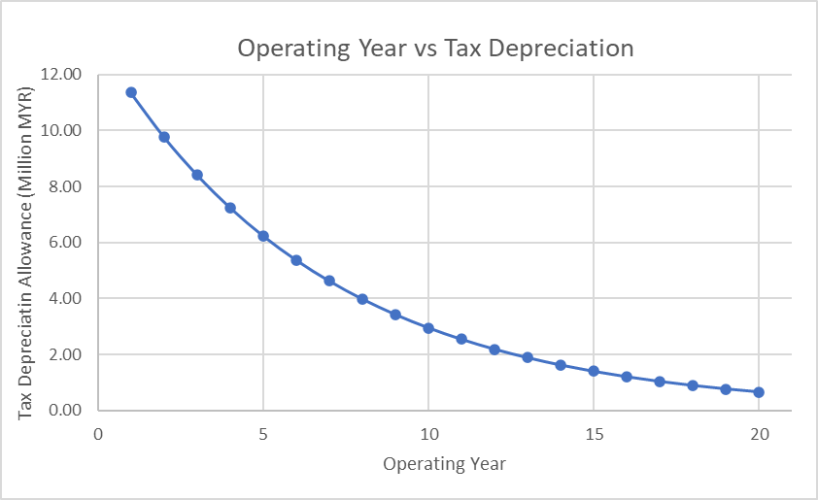
Figure F1: Graph of the operating year against tax depreciation allowance.

F.2 Cash Flow Table
For the first two years of construction, it is assumed that the fixed capital investment (FCI) is divided equally. In the first year, the plant is assumed to produce 70% of its nominal capacity, followed by 85% and 100% from the third operating year until its lifetime. As the plant runs at 70% of its capacity in the first operating year, it is assumed that 70% of the total working capital is used in that year, and 15% of total working capital is shared equally in the following years as the growth rate in production is linear. At the end of the project, it is anticipated that the total working capital will be recovered.
The declining balance method is used to compute tax depreciation allowance, with a 5% residual value that is recoverable at the end of this project. The fixed capital begins to depreciate at a rate of 13.91%. Tax payment is not required in the operating year where the tax depreciation allowance exceeds the cash flow before tax. So, the extra tax depreciation allowance can be pushed forward to the following year as a carried forward allowance from the previous year. In Malaysia, corporate tax is paid at the end of each year (final month). A company with a fixed capital of more than 2.5 million pays a corporate tax of 24%, which has remained consistent from 2016 to 2020 (LHDN Malaysia, 2020). Malaysia’s inflation rate is forecasted to be at around 2% in 2022, but the minor impact of inflation during the lifetime of operation of the plant is estimated to be negligible (Trading Economics, 2021).

Table F1: Cumulative cash flow table of glucose and furfural production plant from EFB, operating for 20 years.
Year |  | 2021 | 2022 | 2023 | 2024 | 2025 | 2026 | 2027 | 2028 | 2029 | 2030 | 2031 | 2032 | 2033 | 2034 | 2035 | 2036 | 2037 | 2038 | 2039 | 2040 | 2041 | 2042 | 2043 | 2044
Year of Operation |  | 0 | 1 | 2 | 3 | 4 | 5 | 6 | 7 | 8 | 9 | 10 | 11 | 12 | 13 | 14 | 15 | 16 | 17 | 18 | 19 | 20 | 21 | 22 | 23
Fixed Capital Cost | Million MYR | 0.00 | -40.80 | -40.80 |  |  |  |  |  |  |  |  |  |  |  |  |  |  |  |  |  |  |  |  | 4.08
Working Capital Cost | Million MYR |  |  | -7.90 | -1.69 | -1.69 |  |  |  |  |  |  |  |  |  |  |  |  |  |  |  |  |  |  | 11.29
Sales Volume 1 | tonne/  year |  |  |  | 7000 | 8500 | 10000 | 10000 | 10000 | 10000 | 10000 | 10000 | 10000 | 10000 | 10000 | 10000 | 10000 | 10000 | 10000 | 10000 | 10000 | 10000 | 10000 | 10000
Sales Volume 2 | tonne/  year |  |  |  | 3472.4 | 4216.5 | 4960.6 | 4960.6 | 4960.6 | 4960.6 | 4960.6 | 4960.6 | 4960.6 | 4960.6 | 4960.6 | 4960.6 | 4960.6 | 4960.6 | 4960.6 | 4960.6 | 4960.6 | 4960.6 | 4960.6 | 4960.6
Sales Revenue 1 | Million MYR |  |  |  | 14.98 | 18.19 | 21.40 | 21.40 | 21.40 | 21.40 | 21.40 | 21.40 | 21.40 | 21.40 | 21.40 | 21.40 | 21.40 | 21.40 | 21.40 | 21.40 | 21.40 | 21.40 | 21.40 | 21.40
Sales Revenue 2 | Million MYR |  |  |  | 30.83 | 37.44 | 44.05 | 44.05 | 44.05 | 44.05 | 44.05 | 44.05 | 44.05 | 44.05 | 44.05 | 44.05 | 44.05 | 44.05 | 44.05 | 44.05 | 44.05 | 44.05 | 44.05 | 44.05
Total Variable Cost | Million MYR |  |  |  | -11.71 | -14.22 | -16.73 | -16.73 | -16.73 | -16.73 | -16.73 | -16.73 | -16.73 | -16.73 | -16.73 | -16.73 | -16.73 | -16.73 | -16.73 | -16.73 | -16.73 | -16.73 | -16.73 | -16.73
Total Fixed Cost | Million MYR |  |  |  | -28.24 | -28.24 | -28.24 | -28.24 | -28.24 | -28.24 | -28.24 | -28.24 | -28.24 | -28.24 | -28.24 | -28.24 | -28.24 | -28.24 | -28.24 | -28.24 | -28.24 | -28.24 | -28.24 | -28.24
Cash Flow  Before Tax | Million MYR | 0.00 | -40.80 | -48.71 | 5.87 | 13.18 | 20.49 | 20.49 | 20.49 | 20.49 | 20.49 | 20.49 | 20.49 | 20.49 | 20.49 | 20.49 | 20.49 | 20.49 | 20.49 | 20.49 | 20.49 | 20.49 | 20.49 | 20.49 | 15.37
Tax Depreciation Allowance | Million MYR |  |  |  | 11.35 | 9.77 | 8.41 | 7.24 | 6.24 | 5.37 | 4.62 | 3.98 | 3.43 | 2.95 | 2.54 | 2.19 | 1.88 | 1.62 | 1.39 | 1.20 | 1.03 | 0.89 | 0.77 | 0.66
Carry forward Allowance | Million MYR |  |  |  | 5.48 | 2.07 | 0.00 | 0.00 | 0.00 | 0.00 | 0.00 | 0.00 | 0.00 | 0.00 | 0.00 | 0.00 | 0.00 | 0.00 | 0.00 | 0.00 | 0.00 | 0.00 | 0.00 | 0.00
Taxable Income | Million MYR |  |  |  | 0.00 | 0.00 | 10.00 | 13.25 | 14.25 | 15.12 | 15.87 | 16.51 | 17.06 | 17.54 | 17.95 | 18.30 | 18.61 | 18.87 | 19.10 | 19.29 | 19.46 | 19.60 | 19.72 | 19.83
Tax Payment | Million MYR |  |  |  | 0.00 | 0.00 | -2.40 | -3.18 | -3.42 | -3.63 | -3.81 | -3.96 | -4.10 | -4.21 | -4.31 | -4.39 | -4.47 | -4.53 | -4.58 | -4.63 | -4.67 | -4.70 | -4.73 | -4.76
Cash Flow  After Tax | Million MYR |  | -40.80 | -48.71 | 4.18 | 11.49 | 18.09 | 17.31 | 17.07 | 16.86 | 16.68 | 16.53 | 16.39 | 16.28 | 16.18 | 16.10 | 16.02 | 15.96 | 15.91 | 15.86 | 15.82 | 15.79 | 15.76 | 15.73 | 15.37
Cumulative Cash Flow After Tax | Million MYR | 0.00 | -40.80 | -89.51 | -85.33 | -73.85 | -55.76 | -38.45 | -21.38 | -4.52 | 12.16 | 28.69 | 45.08 | 61.36 | 77.54 | 93.64 | 109.66 | 125.62 | 141.53 | 157.39 | 173.21 | 189.00 | 204.75 | 220.48 | 235.86

Appendix G: Net Present Value
As highlighted in green in Table G1, the internal return rate (IRR) can be calculated by fixing the net present value (NPV) to the value of zero, which gives a discount rate of 14.25%.
Table G1: Discounted cash flowrate after tax with a various discounted rates and IRR.
Year | Year of operation | Discounted cash flow after tax at various discount rate (million MYR)
Year | Year of operation | 0 | 0.05 | 0.10 | 0.1425 | 0.20 | 0.30
0 | - | 0.00 | 0.00 | 0.00 | 0.00 | 0.00 | 0.00
1 | - | -40.80 | -40.80 | -40.80 | -40.80 | -40.80 | -40.80
2 | - | -48.71 | -46.39 | -44.28 | -42.64 | -40.59 | -37.47
3 | 1 | 4.18 | 3.79 | 3.45 | 3.20 | 2.90 | 2.47
4 | 2 | 11.49 | 9.92 | 8.63 | 7.70 | 6.65 | 5.23
5 | 3 | 18.09 | 14.88 | 12.36 | 10.62 | 8.72 | 6.33
6 | 4 | 17.31 | 13.56 | 10.75 | 8.89 | 6.96 | 4.66
7 | 5 | 17.07 | 12.74 | 9.63 | 7.68 | 5.72 | 3.54
8 | 6 | 16.86 | 11.98 | 8.65 | 6.64 | 4.71 | 2.69
9 | 7 | 16.68 | 11.29 | 7.78 | 5.75 | 3.88 | 2.04
10 | 8 | 16.53 | 10.65 | 7.01 | 4.98 | 3.20 | 1.56
11 | 9 | 16.39 | 10.06 | 6.32 | 4.33 | 2.65 | 1.19
12 | 10 | 16.28 | 9.52 | 5.71 | 3.76 | 2.19 | 0.91
13 | 11 | 16.18 | 9.01 | 5.16 | 3.27 | 1.81 | 0.69
14 | 12 | 16.10 | 8.54 | 4.66 | 2.85 | 1.50 | 0.53
15 | 13 | 16.02 | 8.09 | 4.22 | 2.48 | 1.25 | 0.41
16 | 14 | 15.96 | 7.68 | 3.82 | 2.17 | 1.04 | 0.31
17 | 15 | 15.91 | 7.29 | 3.46 | 1.89 | 0.86 | 0.24
18 | 16 | 15.86 | 6.92 | 3.14 | 1.65 | 0.71 | 0.18
19 | 17 | 15.82 | 6.57 | 2.85 | 1.44 | 0.59 | 0.14
20 | 18 | 15.79 | 6.25 | 2.58 | 1.26 | 0.49 | 0.11
21 | 19 | 15.76 | 5.94 | 2.34 | 1.10 | 0.41 | 0.08
22 | 20 | 15.73 | 5.65 | 2.13 | 0.96 | 0.34 | 0.06
23 | - | 15.37 | 5.26 | 1.89 | 0.82 | 0.28 | 0.05
Total | - | 235.86 | 98.39 | 31.45 | 0.00 | -24.52 | -44.84

Reference
ECHEMI, 2021. Sulphuric Acid Selling Price. https://www.echemi.com/productsInformation/pid_Rock19440-sulfuric-acid.html. (Accessed 15 April 2021).
Indiamart, 2021. Cellulase Enzyme selling price. https://www.indiamart.com/proddetail/cellulase-enzyme-9590230755.html. (Accessed 17 April 2021).
Krishna, S.H., Huang, K., Barnett, K.J., He, J., Maravelias, C.T., Dumesic, J.A., Huber, G.W., De Bruyn, M., Weckhuysen, B.M., 2018. Oxygenated commodity chemicals from chemo-catalytic conversion of biomass derived heterocycles. AlChE J. 64(6), 1910-1922.
LHDN Malaysia, 2020. Corporate tax rate in 2020. http://www.hasil.gov.my/bt_goindex.php?bt_kump=5&bt_skum=2&bt_posi=5&bt_unit=1&bt_sequ=1. (Accessed 30 April 2021).
Lo, S.L.Y., Choo, J.J.L., Kong, K.G.H., How, B.S., Lam, H.L., Ngan, S.L., Lim, C.H., Sunarso, J., 2020. Uncertainty Study of Empty Fruit Bunches-based Bioethanol Supply Chain. Chem. Eng. Trans. 81, 601-606.
Malaysia Indeed, 2021. Average base salary in Malaysia 2021. https://malaysia.indeed.com/career/factory-worker/salaries. (Accessed 30 April 2021).
MERCK, 2021. Sodium Hydroxide selling price. https://www.sigmaaldrich.com/catalog/product/sigald/415413?lang=en&region=MY&cm_sp=Insite-_-caSrpResults_srpRecs_srpModel_sodium%20hydroxide-_-srpRecs3-3. (Accessed 17 April 2021).
MIDA, 2021. Process water selling price. https://www.mida.gov.my/wp-content/uploads/2020/07/Utilities.pdf (Accessed 17 April 2021).
Nasional, T., 2021. Electricity Price. https://www.tnb.com.my/commercial-industrial/pricing-tariffs1/. (Accessed 5 May 2021).
Peters, M.S., Timmerhaus, K.D., West, R.E., 2003. Plant design and economics for chemical engineers. McGraw-Hill New York.
Thermo Fisher Scientific, 2021. Butyl Chloride selling price. https://www.alfa.com/en/catalog/A13004/. (Accessed 17 April 2021).
Sinnott, R., Towler, G., 2020. Chapter 6 - Costing and project evaluation, in: Sinnott, R., Towler, G. (Eds.), Chemical Engineering Design (Sixth Edition). Butterworth-Heinemann, pp. 275-369.
Trading Economics, 2021. Malaysia Inflation Rate. https://tradingeconomics.com/malaysia/inflation-cpi#:~:text=In%20the%20long%2Dterm%2C%20the,according%20to%20our%20econometric%20models.&text=High%20of%203.3%25-,Malaysia's%20annual%20inflation%20increased%20to%20a%20five%2Dmonth%20high%20of,market%20estimates%20of%203.2%20percent. (Accessed 25 December 2021).
UN Data, 2018. Glucose and furfural Data. http://data.un.org/. (Accessed 12 March 2021).
Wooley, R.J., Putsche, V., 1996. Development of an ASPEN PLUS physical property database for biofuels components. United States.
XE currency, 2021. Conversion rate of USD to MYR in May 2021. https://www.xe.com/currencyconverter/convert/?Amount=1&From=USD&To=MYR. (Accessed 30 April 2021).

