Graphical abstract
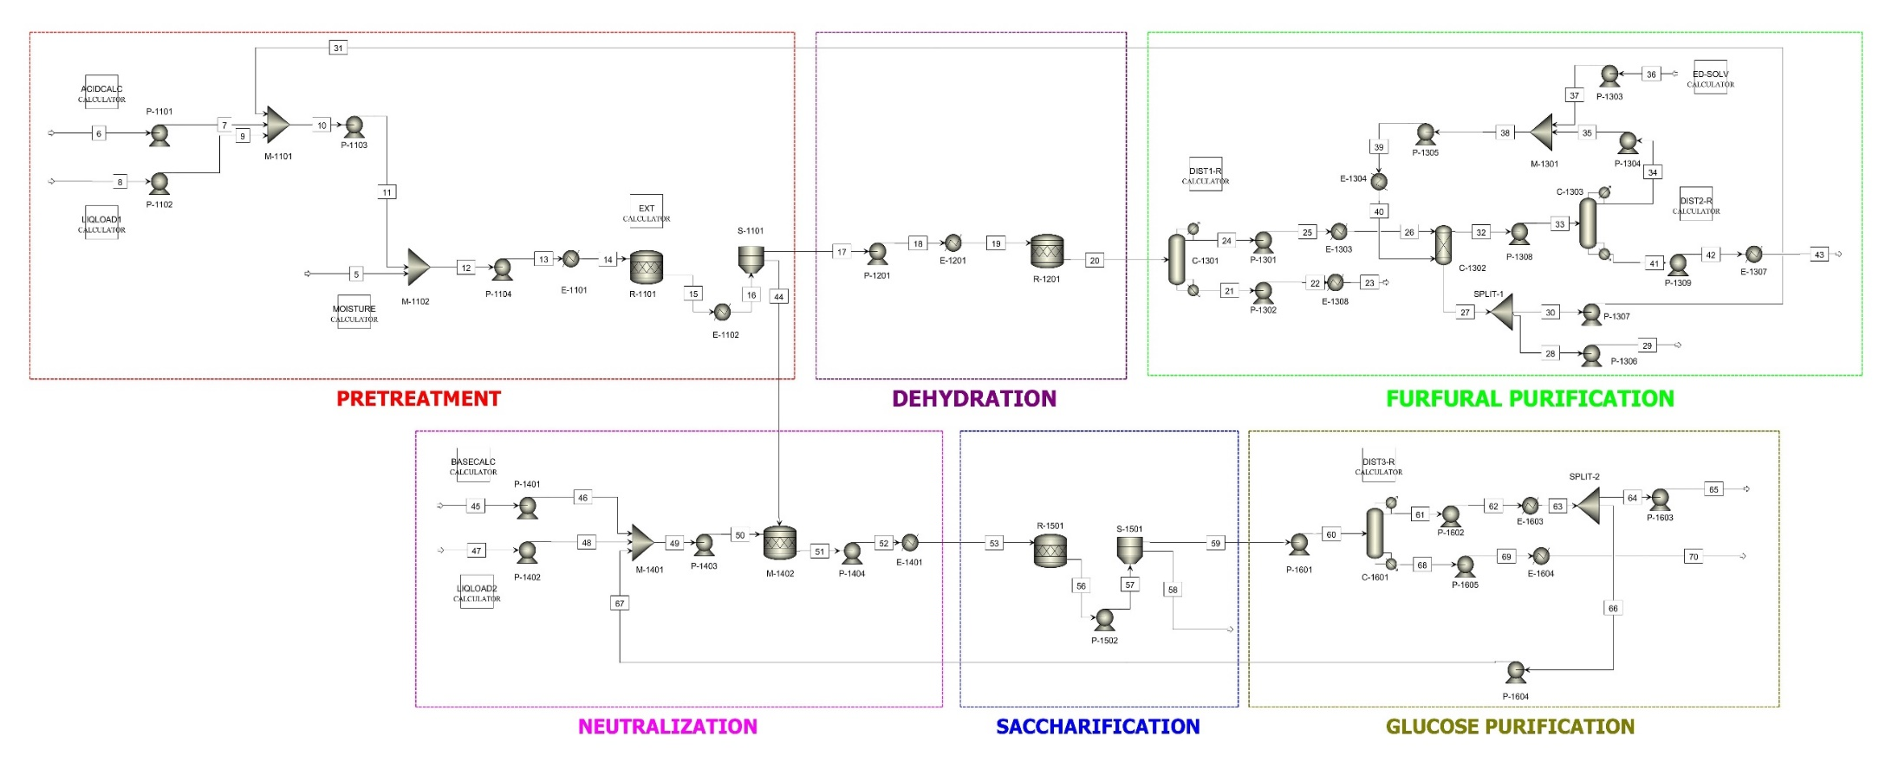
Integrated Industrial Process to Manufacture Furfural and Glucose from Empty Fruit Bunch

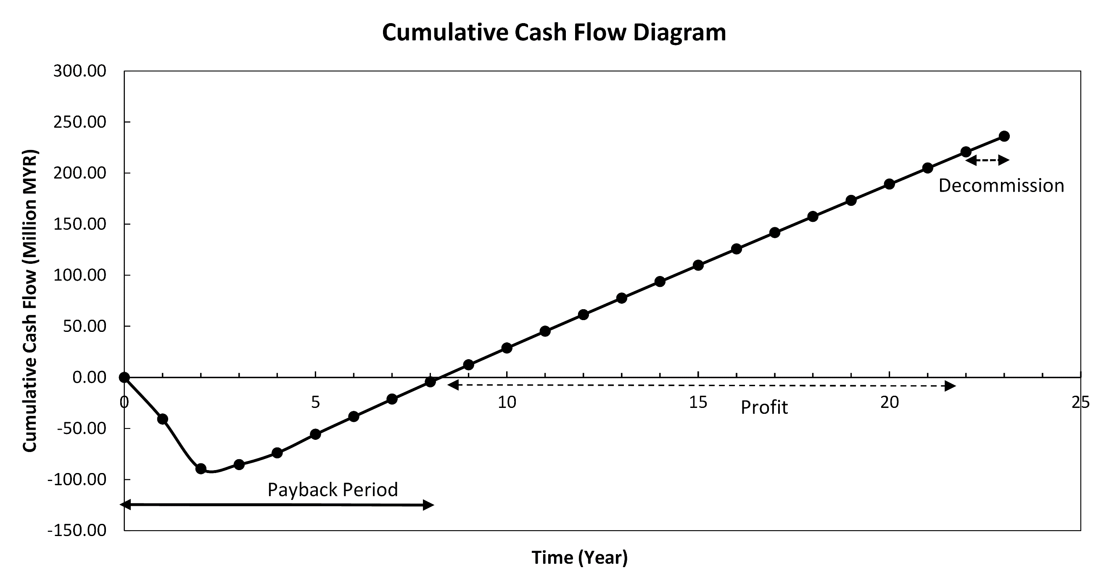
Cumulative Cash Flow Diagram of Furfural and Glucose Integrated Manufacturing Plant
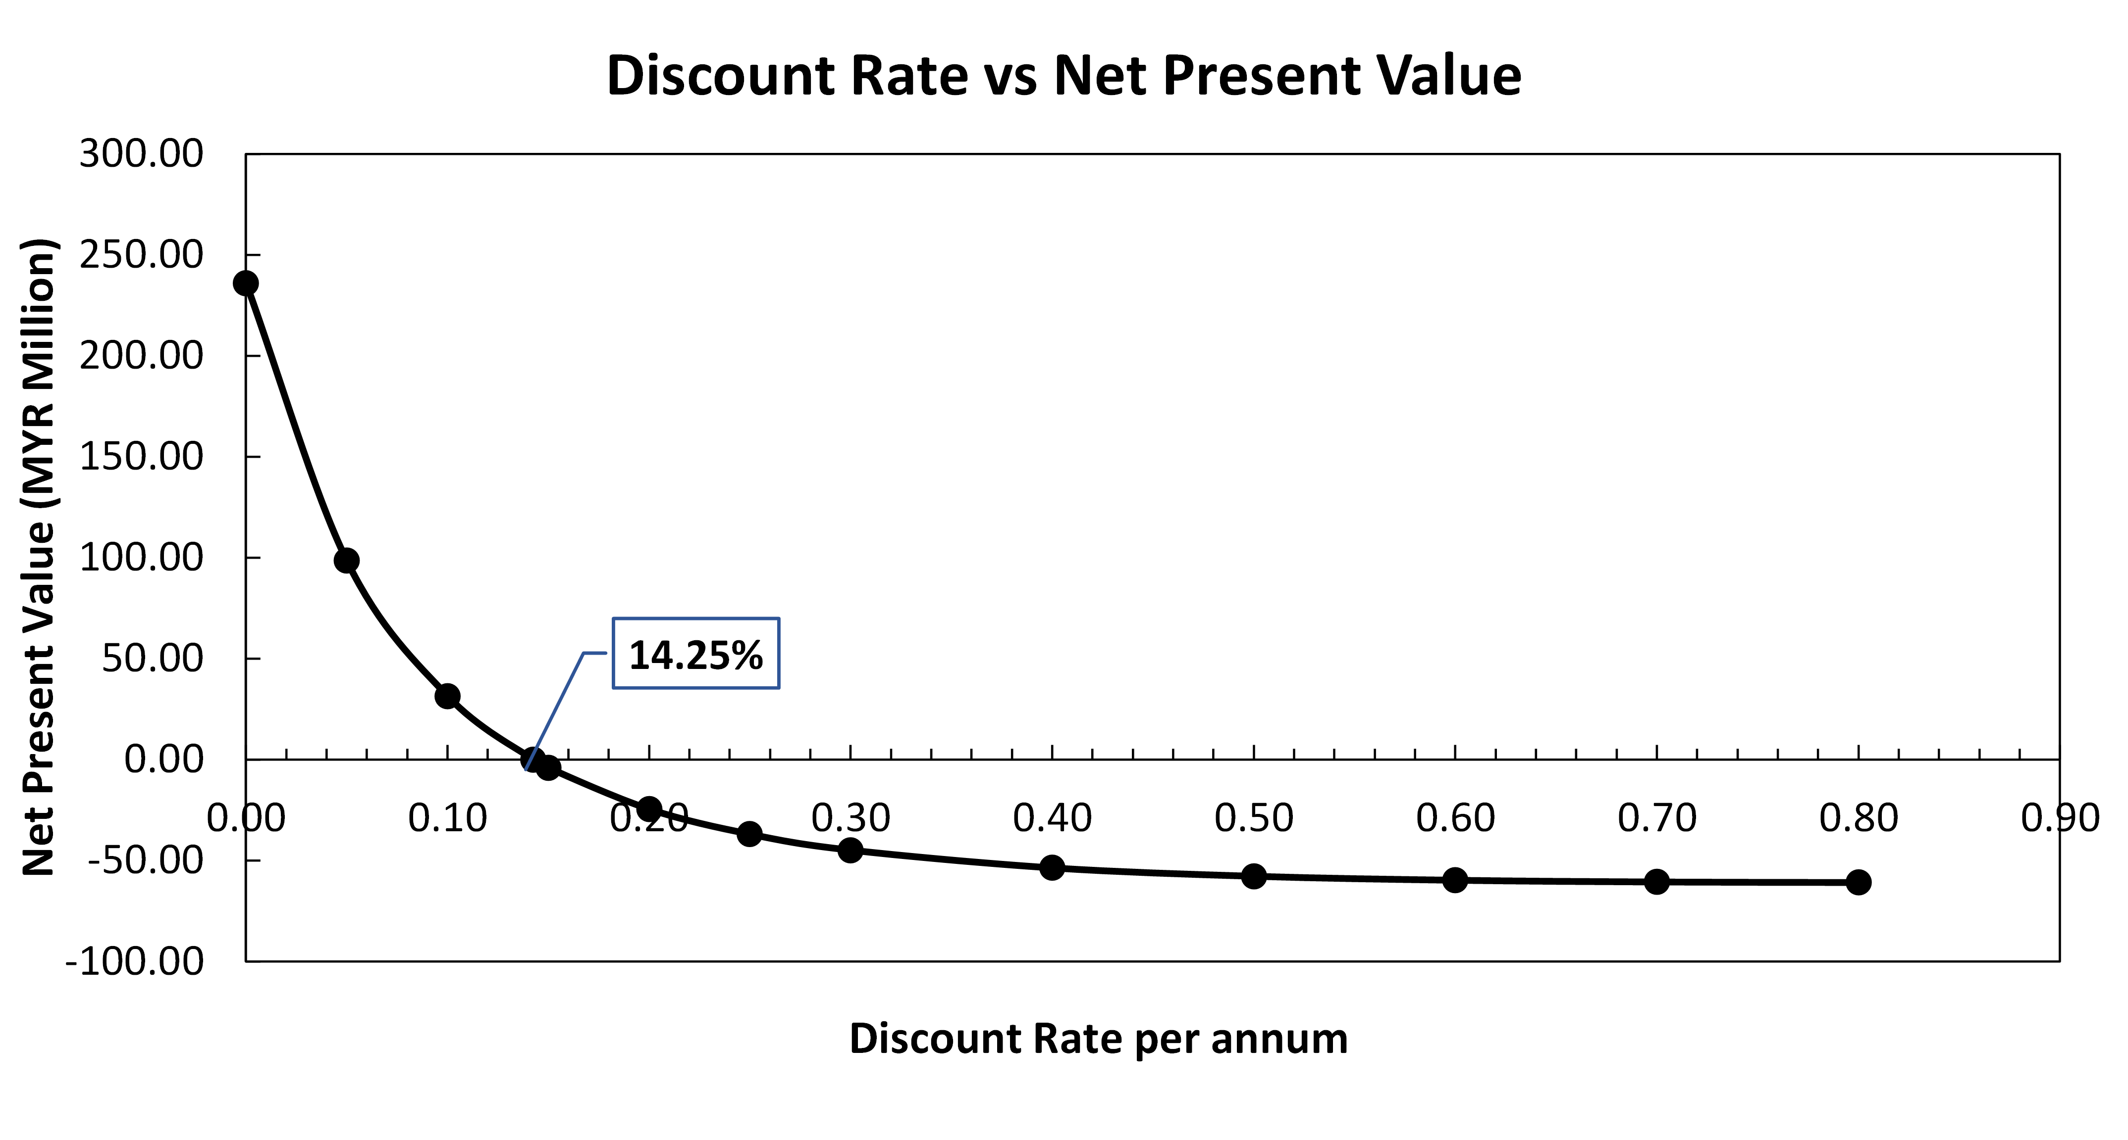
Discount Rate and Net Present Value of Furfural and Glucose Integrated Manufacturing Plant

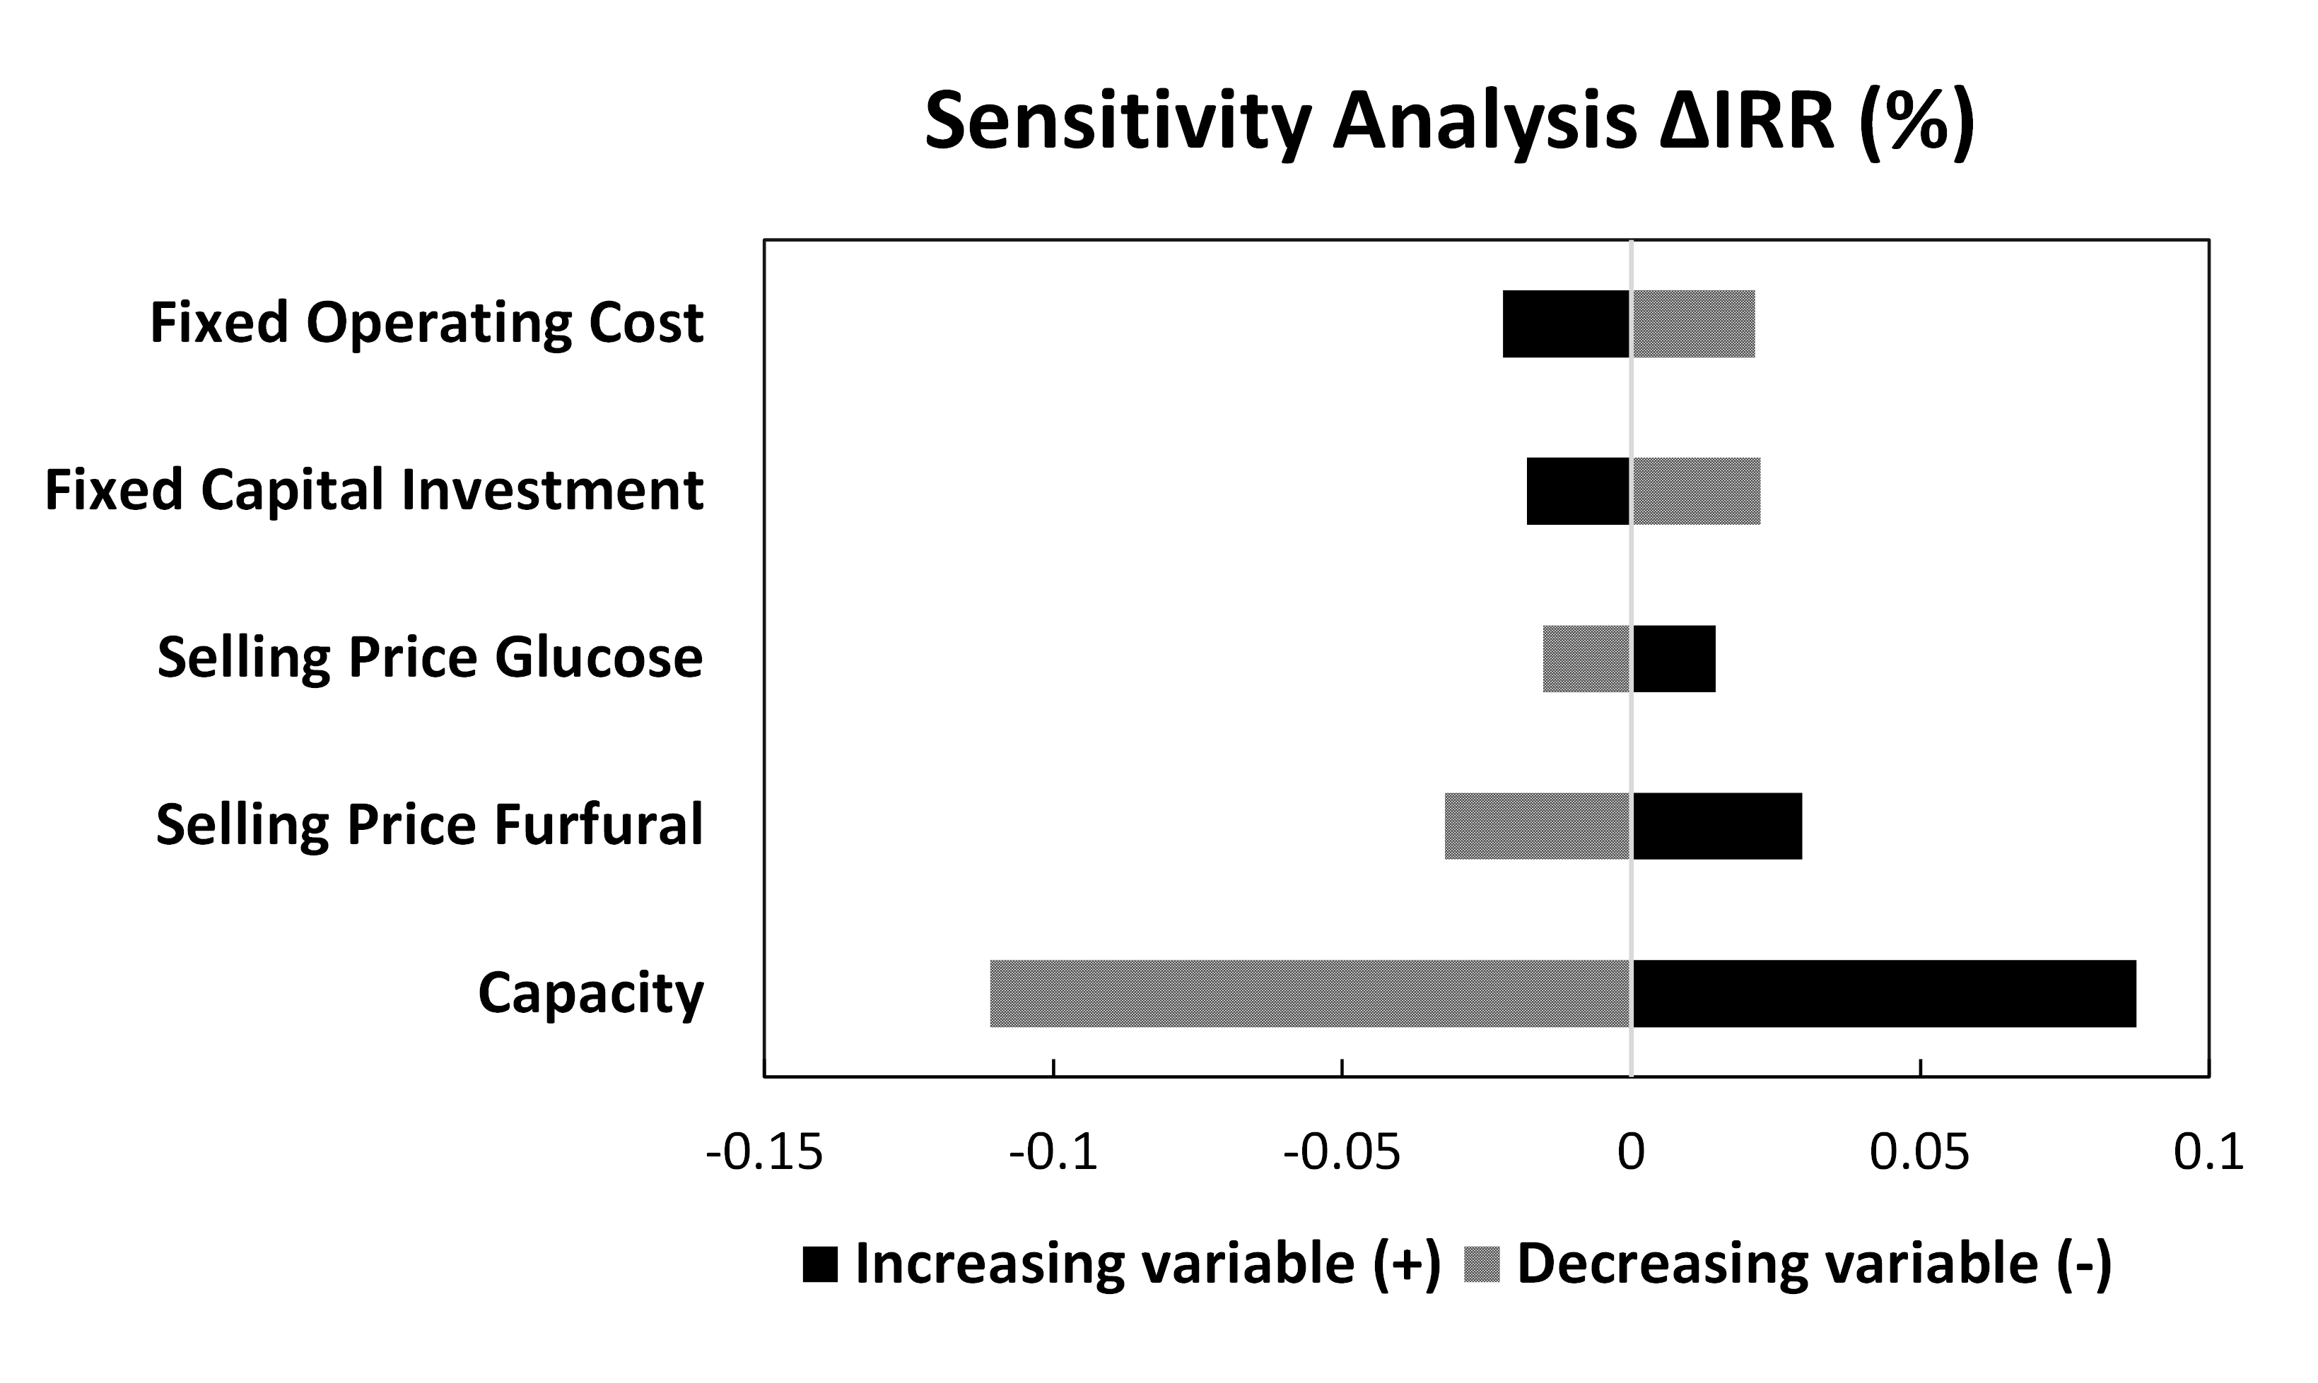
IRR Sensitivity Analysis of Furfural and Glucose Integrated Manufacturing Plant

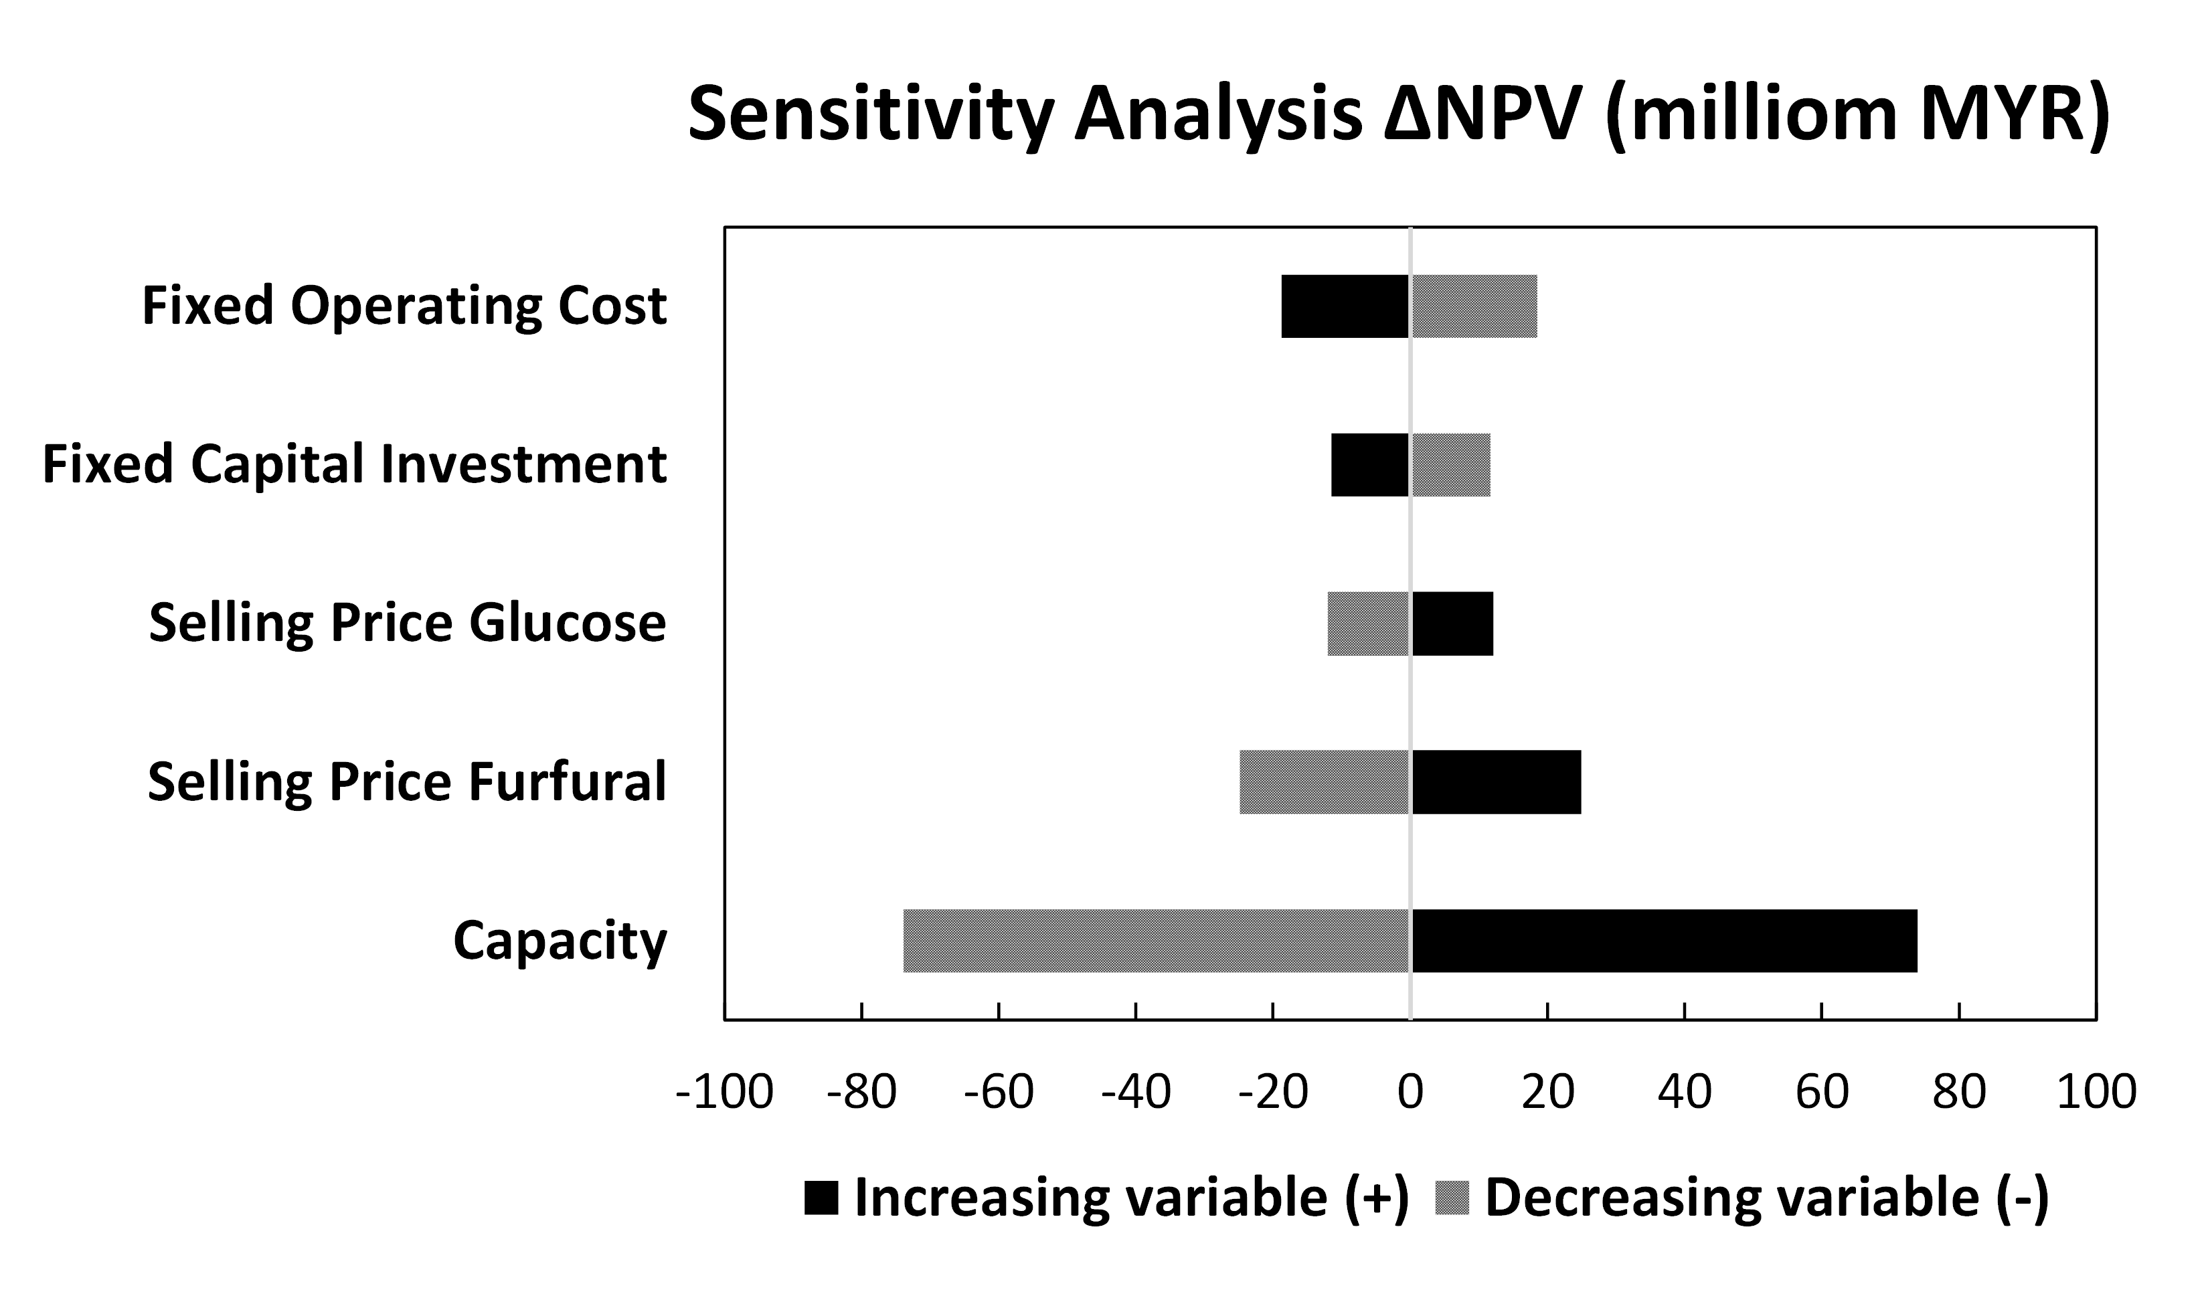
NPV Sensitivity Analysis of Furfural and Glucose Integrated Manufacturing Plant

