SUPPLEMENT
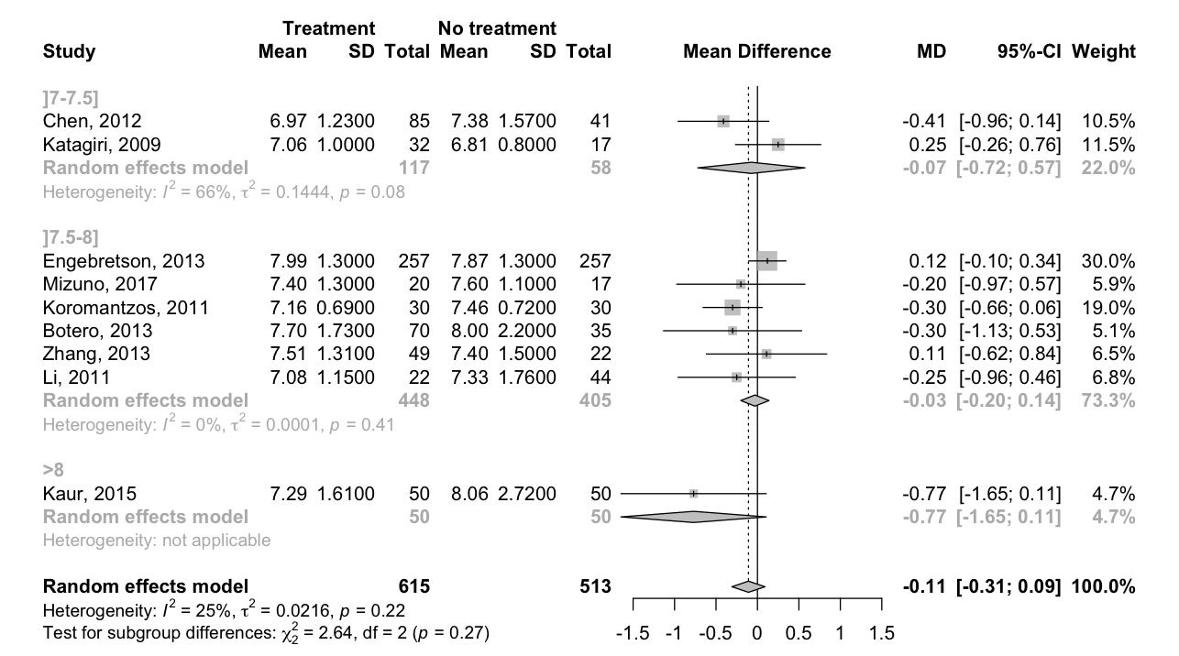
Figure 1: Non-surgical periodontal treatment vs no active treatment (no treatment, placebo, supragingival scaling, oral hygiene instruction), Sub-group analysis according to baseline HbA1c level, outcome HbA1c at 6 months. CI, confidence interval; df, degree of freedom; SD, standard deviation.

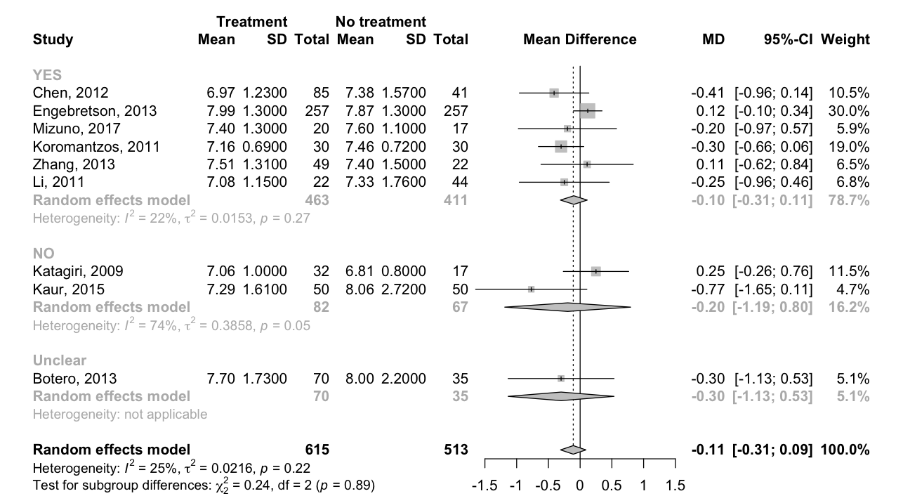
Figure 2: Non-surgical periodontal treatment vs no active treatment (no treatment, placebo, supragingival scaling, oral hygiene instruction), Sub-group analysis according to smoking characteristic, outcome HbA1c at 6 months. CI, confidence interval; df, degree of freedom; SD, standard deviation.

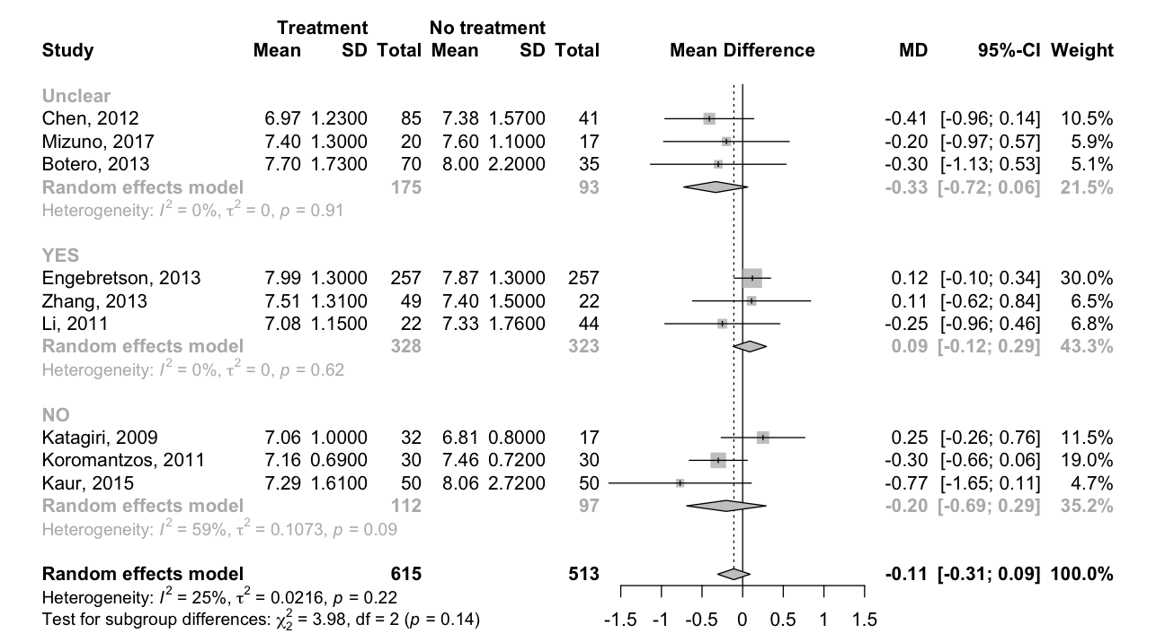
Figure 3: Non-surgical periodontal treatment vs no active treatment (no treatment, placebo, supragingival scaling, oral hygiene instruction), Sub-group analysis according to others conditions reported, outcome HbA1c at 6 months. CI, confidence interval; df, degree of freedom; SD, standard deviation.

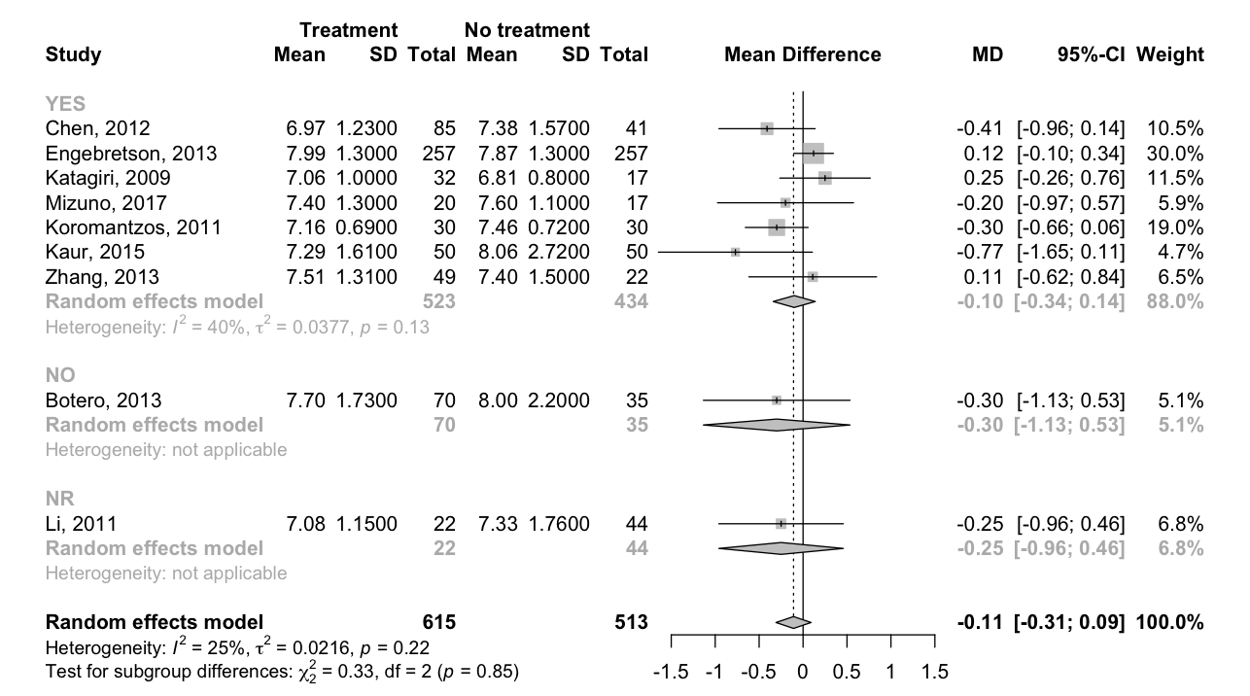
Figure 4: Non-surgical periodontal treatment vs no active treatment (no treatment, placebo, supragingival scaling, oral hygiene instruction), Sub-group analysis according to supportive periodontal treatment reported at 3 months, outcome HbA1c at 6 months. CI, confidence interval; df, degree of freedom; SD, standard deviation; NR non reported.

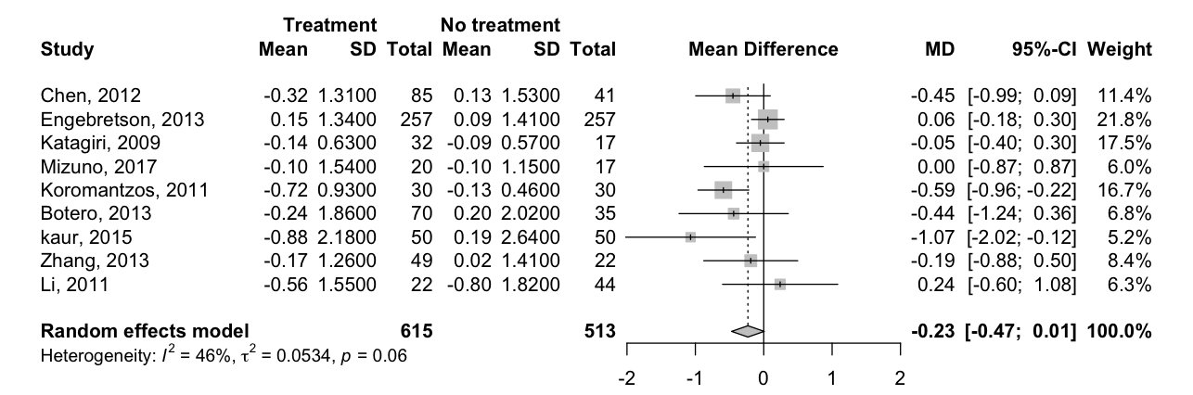
Figure 5: Non-surgical periodontal treatment vs no active treatment (no treatment, placebo, supragingival scaling, oral hygiene instruction), outcome 6 months HbA1c change from baseline. CI, confidence interval; df, degree of freedom; SD, standard deviation.

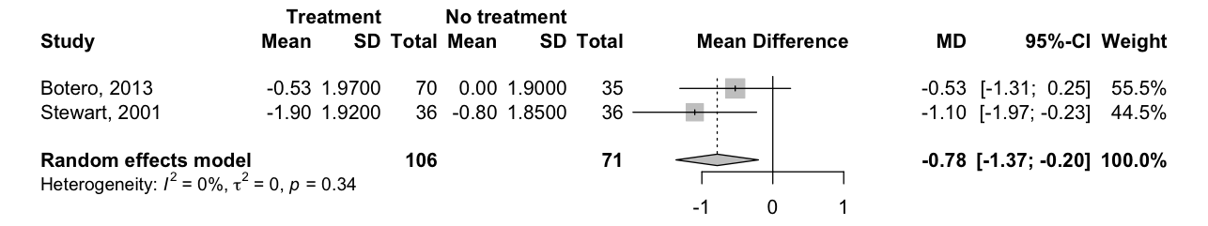
Figure 6: Non-surgical periodontal treatment vs no active treatment (no treatment, placebo, supragingival scaling, oral hygiene instruction), outcome 6 months HbA1c change from baseline. CI, confidence interval; df, degree of freedom; SD, standard deviation.

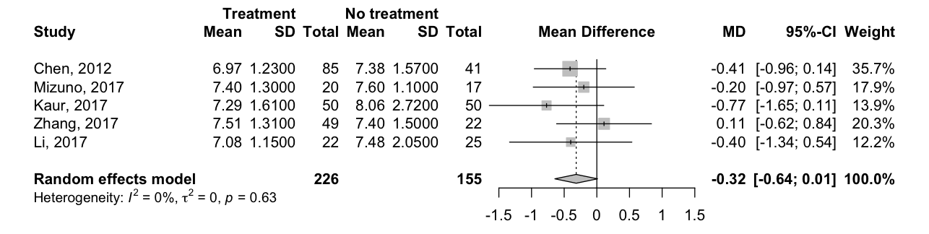
Figure 7: Non-surgical periodontal treatment vs oral hygiene instruction, outcome HbA1c at 6 months. CI, confidence interval; df, degree of freedom; SD, standard deviation.

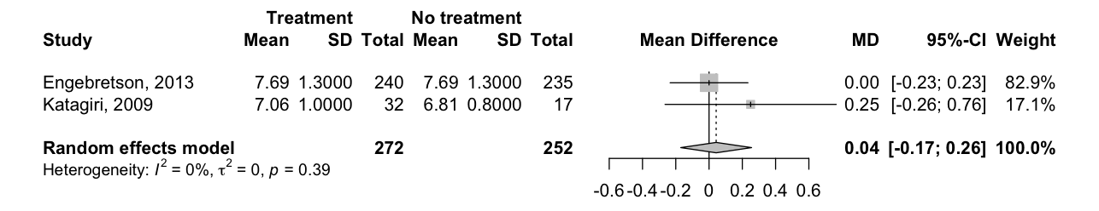
Figure 8: Non-surgical periodontal treatment + antibiotics vs no treatment, outcome HbA1c at 6 months. CI, confidence interval; df, degree of freedom; SD, standard deviation.

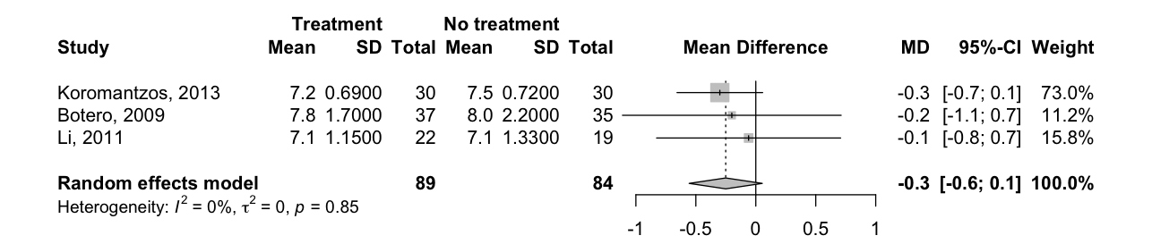
Figure 9: Non-surgical periodontal treatment vs supragingival scaling, outcome 6 months HbA1c change from baseline. CI, confidence interval; df, degree of freedom; SD, standard deviation.

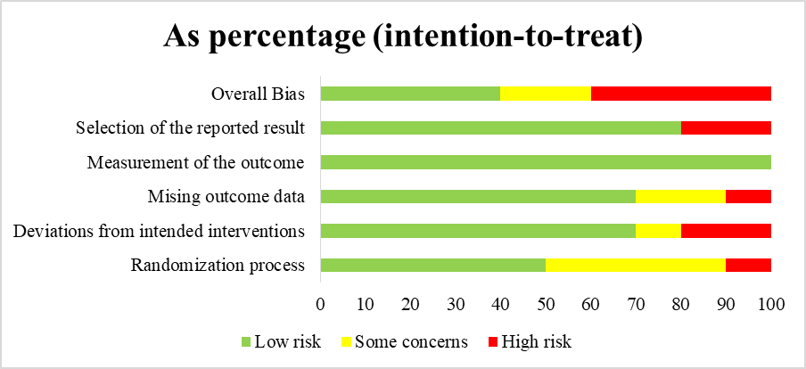

Figure 10: Risk of bias according to the 5 domains of ROB tool 2

Table 1a: Outcomes and main findings of included studies
Study | Main outcomes | Main findings
Chen et al. 2012 | Periodontal parameters and high sensitivity C-reactive protein, tumor necrosis factor-a glycated hemoglobin , fasting plasma glucose , and lipid profiles | A significant reduction in HbA1c was seen at 6months in treatment group SRP + OHI (P <0.05) but not in treatment group 1 or the control group (P >0.05) .Comparisons among the three groups showed no significant difference in HbA1c at baseline or 1.5, 3,or 6 months (P >0.05)  Both treatment groups had a significantly lower  hsCRP level after periodontal therapy (P <0.05).  The intergroup difference for FPG, TNF-a, and lipid  profiles were not statistically significant after therapy (P >0.05)
Engebreston et al. 2013 | Difference in change in HbA1c level from baseline between groups at 6 months. Secondary outcomes included changes in PD, CAL, BOP, GI, FPG level, and Homeostasis Model Assessment (HOMA2) score | At 6 months nonsurgical periodontal therapy did not improve glycemic control in patients with type 2 diabetes and moderate to advanced chronic periodontitis (mean difference, −0.05% [95% CI, −0.23% to 0.12%]; P = 0.55)  Periodontal measures improved in the treatment group compared with the control group at 6 Months (CAL, PD, BOP, GI with P <0.001 for all)
Katagiri et al. 2009 | Hb1Ac, CRP, BOP, PD | There were no significant differencesbetween the intervention and control group at each pointduring the follow-up period. Nevertheless, after meta-regression based on the hs-CRP level, HbA1c reduced significantly in the treatment group with hs-CRP decreased  At 6 months BOP and PD significantly reduced in the intervention compared to control group.
Mizuno et al. 2017 | The change in HbA1c levels from baseline to 3 months. Secondary outcomes included changes in oxidative stress balance, glycated albumin, QOL and clinical periodontal parameters from baseline to 3 months and baseline to 6 months. | Changes in HbA1c in the periodontal treatment group were not significantly different with those in the control group at 3 and 6 months  Systemic oxidative stress balance and QOL  significantly improved in the periodontal treatment group compared to the control group at 3 months
Koromantzos et al. 2011 | Periodontal parameters and glycosylated  haemoglobin (A1C) was evaluated at 1, 3 and 6 months | After 6 months of follow-up, participantsin the IG showed a significant reduction in A1C levels (0.72 to 0.93%, p<0.001)  non-surgical periodontal treatment can improve the periodontal status of patients with type 2 diabetes and have a favourable effect on glycaemic control of these patients
RCT Randomised Controlled Trial; T2DM: Tyoe 2 Diabetes Mellitus; CAL: Clinical Attachment Level; SRP: Scaling and Root Planning; OHI: Oral Hygiene instructions; ST: Supportive therapy; HbA1c: Gylcated Hemoglobin; PD: Probing Depth; BOP: Bleeding on Probing; GI: Gingival Index; FPG: Fasting Plasma Glucose; PI: Plaque Index; QoL: Quality of Life; SS: Supra-gingival Scaling; TNF-a: Tumor Necris Factor alpha; AZT: Azithromycin

Table 1b: Outcomes and main findings of included studies.
Study | Main outcomes | Main findings
Botero et al. 2013 | Glycated hemoglobin, glycemia and periodontal parameters were measured at baseline, 3, 6 and 9 mo after treatment. | A modest improvement in glycemic control was detected with a trend towards the use of SRP+AZT as compared to the no treatment, placebo  Periodontal parameters were improved in the SRP+AZT and SRP+no treatment, placebo groups as compared to the SS+AZT group. A greater reduction in probing depth was  observed in the SRP+AZT as compared to the SRP+no treatment, placebo group. Improvement in clinical attachment level was similar between SRP+AZT and SRP+no treatment, placebo groups
Kaur et al. 2015 | The primary study outcome was the change in HbA1c levels from baseline to 3 months. Secondary outcomes included changes in oxidative stress balance (Oxidative-INDEX), the Diabetes Therapy-Related QOL and clinical periodontal parameters from baseline to 3 months  and baseline to 6 months | Improvements in all periodontal parameters were significantly greater in the treatment group (T group) than in the no treatment group (NT group) throughout the study (P < 0.05)  Improvement in HbA1c was significant in the T group and was significantly greater in the T group than in NT group (P < 0.05)  Multivariate linear regression showed that being in a treatment  group (β = 0.519, P < 0.05) and baseline HbA1c level (β  = 0.430, P < 0.05) were independently and significantlyassociated with improvement in glycemic control over 6months
Stewart et al. 2001 | Change in HbA1c levels | During the nine-month observation period, there was a 6.7% improvement in glycemic control in the control group when compared to a 17.1% improvement in  the treatment group, a statistically significant difference.  We interpret the data in the study to suggest that periodontal therapy was associated with improved glycemic control in persons with type 2 DM
Zhang et al. 2013 | Change in HbA1C, FPG and periodontal parameters | The HbA1c level in the treatment group decreased from Baseline to 6 months evaluation (7.68 1.22% vs. 7.51 1.31%, P < 0.05).  The FPG level decreased from baseline to 6 months (138 16 vs. 135 19 mg/dL,  P < 0.05). Compared with the control group, no statistical  difference was found in the change in FPG (P > 0.05)  All clinical periodontal parameters in the treatment  group significantly improved from Baseline to 6 months evaluation.
Li et al. 2011 | HbA1c, PD, CAL, PI - change data only for periodontal parameters | At 6 months 0.56% and 1.01% reduction in HbA1c in 2 interventions groups respectively SRP group and SS group with a statistical significance in SS group. PD and CAL reduce significantly in the two interventions groups.
RCT Randomised Controlled Trial; T2DM: Tyoe 2 Diabetes Mellitus; CAL: Clinical Attachment Level; SRP: Scaling and Root Planning; OHI: Oral Hygiene instructions; ST: Supportive therapy; HbA1c: Gylcated Hemoglobin; PD: Probing Depth; BOP: Bleeding on Probing; GI: Gingival Index; FPG: Fasting Plasma Glucose; PI: Plaque Index; QoL: Quality of Life; SS: Supra-gingival Scaling; TNF-a: Tumor Necris Factor alpha; AZT: Azithromycin

