SUPPLEMENTARY INFORMATION

Effect of erythromycin on mortality and the host response in critically ill patients with sepsis: a target trial emulation

Tom D.Y. Reijnders¹*, Hessel Peters-Sengers¹, Lonneke A. van Vught¹, Fabrice Uhel¹⁻⁴, Marc J.M. Bonten^{5,6} , Olaf L. Cremer⁷, Marcus J. Schultz⁸⁻¹⁰, Martijn M. Stuiver¹¹, Tom van der Poll^{1,12}, on behalf of the MARS consortium

¹Center for Experimental and Molecular Medicine, Amsterdam University Medical Centers, location Academic Medical Center, Amsterdam, the Netherlands. ²AP-HP, Hôpital Louis Mourier, DMU ESPRIT, Médecine Intensive-Réanimation, F-92700, Colombes, France. ³Université de Paris, UFR de Médecine, F-75018, Paris, France. ⁴INSERM U1151, CNRS UMR 8253, Institut Necker-Enfants Malades, F-75015 Paris, France ⁵Department of Medical Microbiology, University Medical Center Utrecht, Utrecht, the Netherlands. ⁶Julius Center for Health Sciences and Primary Care, University Medical Center Utrecht, Utrecht, the Netherlands. ⁷Department of Intensive Care Medicine, University Medical Center Utrecht, Utrecht, the Netherlands. ⁸Departments of Intensive Care Medicine, and Laboratory of Experimental Intensive Care and Anesthesiology (LEICA), Amsterdam University Medical Centers, location Academic Medical Center, Amsterdam, The Netherlands. ⁹Mahidol-Oxford Tropical Medicine Research Unit (MORU), Mahidol University, Bangkok, Thailand. ¹⁰Nuffield Department of Medicine, University of Oxford, Oxford, United Kingdom. ¹¹Department of Epidemiology and Data Science, Amsterdam Public Health, Amsterdam UMC, location Academic Medical Center, Amsterdam, The Netherlands. ¹²Division of Infectious Diseases, Amsterdam University Medical Centers, location Academic Medical Center, University of Amsterdam, Amsterdam, The Netherlands.

*Corresponding author: Tom D.Y. Reijnders, Center for Experimental and Molecular Medicine, Academic Medical Center, Room T1.0-236. Meibergdreef 9, 1105 AZ Amsterdam, the Netherlands.
Telephone: +31 20 5664903. E-mail: t.d.reijnders@amsterdamumc.nl

TABLE OF CONTENTS
TABLE OF CONTENTS 2
STROBE STATEMENT 4
SUPPLEMENTARY METHODS 6
The MARS cohort 6
Clinical variables and definitions 6
Handling of missing baseline and outcome data 6
Host response biomarker assays and handling of missing biomarker data 7
Analysis of secondary clinical outcomes 8
Analysis of host response biomarkers 8
Calculation of E-Values to assess residual confounding 9
Competing risk analysis 10
R packages 10
SUPPLEMENTARY TABLES 11
Supplementary table 1. Study protocol for the target trial and its emulation 11
Supplementary Table 2. Overview of host response biomarker measurements 12
Supplementary Table 3. Overview of missing clinical data 13
Supplementary Table 4. Overview of missing biomarker data 15
Supplementary Table 5. PS matched and weighted populations for the primary analysis 16
Supplementary Table 6. E-Values to shift hazard ratios of the primary analysis to a range consistent with harm or benefit 18
Supplementary Table 7. Baseline characteristics and PS matched population for the host response biomarker analyses 19
Supplementary Table 8. Baseline characteristics for the intention-to-treat sensitivity analysis 21
Supplementary Table 9. PS matched and PS weighted populations for the intention-to-treat sensitivity analysis 23
Supplementary Table 10. Hazard ratios for mortality up to day 90 for the intention-to-treat sensitivity analysis 25
Supplementary Table 11. Secondary clinical outcomes for the intention-to-treat sensitivity analysis 26
Supplementary Table 12. Baseline characteristics for the sensitivity analysis with an exposure period of 48 hours 27
Supplementary Table 13. Baseline characteristics for the sensitivity analysis with an exposure period of 96 hours 29
Supplementary Table 14. PS matched and PS weighted populations for the sensitivity analysis with an exposure period of 48 hours 31
Supplementary Table 15. PS matched and PS weighted populations for the sensitivity analysis with an exposure period of 96 hours 33
Supplementary Table 16. Hazard ratios for mortality up to day 90 for the sensitivity analysis with an exposure period of 48 hours 35
Supplementary Table 17. Hazard ratios for mortality up to day 90 for the sensitivity analysis with a grace period of 96 hours 36
Supplementary Table 18. Secondary clinical outcomes for the sensitivity analysis with a grace period of 48 hours 37
Supplementary Table 19. Secondary clinical outcomes for the sensitivity analysis with a grace period of 96 hours 38
Supplementary Table 20. Cause-specific and subdistribution hazard ratios for ICU discharge and mortality for treatment with erythromycin 39
SUPPLEMENTARY FIGURES 40
Supplementary Figure 1. Flowchart of patients used in estimating the PS and subsequent analyses (complete cases) 40
Supplementary Figure 2. Proposed directed acyclic graph 41
Supplementary Figure 3. Balance statistics of the covariates used for PS matching in the population with measured biomarkers 42
Supplementary Figure 4. Balance statistics of the covariates used for PS matching and weighting for the intention-to-treat sensitivity analysis 43
Supplementary Figure 5. Balance statistics of the covariates used for PS matching and weighting for the sensitivity analysis with an exposure period of 48 hours 44
Supplementary Figure 6. Balance statistics of the covariates used for PS matching and weighting for the sensitivity analysis with an exposure period of 96 hours 45
REFERENCES 46

STROBE STATEMENT
 | Item | Recommendation | Page
Title and abstract | 1 | (a) Indicate the study’s design with a commonly used term in the title or the abstract | 1
Title and abstract | 1 | (b) Provide in the abstract an informative and balanced summary of what was done and what was found | 2
Introduction
Background/rationale | 2 | Explain the scientific background and rationale for the investigation being reported | 4-5
Objectives | 3 | State specific objectives, including any prespecified hypotheses | 4-5
Methods
Study design | 4 | Present key elements of study design early in the paper | 5-7
Setting | 5 | Describe the setting, locations, and relevant dates, including periods of recruitment, exposure, follow-up, and data collection | 5-7, Sup. 6
Participants | 6 | (a) Give the eligibility criteria, and the sources and methods of selection of participants. Describe methods of follow-up | 5-7, Sup. 6
Participants | 6 | (b) For matched studies, give matching criteria and number of exposed and unexposed | 8-9
Variables | 7 | Clearly define all outcomes, exposures, predictors, potential confounders, and effect modifiers. Give diagnostic criteria, if applicable | 5-9, Sup. 6, Sup. Fig. 2
Data sources/ measurement | 8 | For each variable of interest, give sources of data and details of methods of assessment (measurement). Describe comparability of assessment methods if there is more than one group | 5-7, Sup. 6
Bias | 9 | Describe any efforts to address potential sources of bias | 5-10
Study size | 10 | Explain how the study size was arrived at | 10, Fig. 1
Quantitative variables | 11 | Explain how quantitative variables were handled in the analyses. If applicable, describe which groupings were chosen and why | 7-10
Statistical methods | 12 | (a) Describe all statistical methods, including those used to control for confounding | 7-10, Sup. 8-10
Statistical methods | 12 | (b) Describe any methods used to examine subgroups and interactions | N/A
Statistical methods | 12 | (c) Explain how missing data were addressed | 8, Sup. 6-8
Statistical methods | 12 | (d) If applicable, explain how loss to follow-up was addressed | Sup. 7
Statistical methods | 12 | (e) Describe any sensitivity analyses | 10, Sup. 9-10
Results
Participants | 13 | (a) Report numbers of individuals at each stage of study—eg numbers potentially eligible, examined for eligibility, confirmed eligible, included in the study, completing follow-up, and analysed | 10-12, Fig. 1, Sup. Fig. 1
Participants | 13 | (b) Give reasons for non-participation at each stage | 10, Fig. 1
Participants | 13 | (c) Consider use of a flow diagram | Fig. 1, Sup. Fig. 2
Descriptive data | 14* | (a) Give characteristics of study participants (eg demographic, clinical, social) and information on exposures and potential confounders | 10, Table 1
Descriptive data | 14* | (b) Indicate number of participants with missing data for each variable of interest | 11, Sup. Tables 3-4
Descriptive data | 14* | (c) Summarise follow-up time (eg, average and total amount)
Outcome data | 15 | Report numbers of outcome events or summary measures over time | Tables 2-3 Fig. 3
Main results | 16 | (a) Give unadjusted estimates and, if applicable, confounder-adjusted estimates and their precision (eg, 95% confidence interval). Make clear which confounders were adjusted for and why they were included | 8-9, 11, Table 2
Main results | 16 | (b) Report category boundaries when continuous variables were categorized | N/A
Main results | 16 | (c) If relevant, consider translating estimates of relative risk into absolute risk for a meaningful time period | N/A
Other analyses | 17 | Report other analyses done—eg analyses of subgroups and interactions, and sensitivity analyses | 12-13, Sup. 8-10
Discussion
Key results | 18 | Summarise key results with reference to study objectives | 13-16
Limitations | 19 | Discuss limitations of the study, taking into account sources of potential bias or imprecision. Discuss both direction and magnitude of any potential bias | 15-16
Interpretation | 20 | Give a cautious overall interpretation of results considering objectives, limitations, multiplicity of analyses, results from similar studies, and other relevant evidence | 13-16
Generalisability | 21 | Discuss the generalisability (external validity) of the study results | 16
Other information
Funding | 22 | Give the source of funding and the role of the funders for the present study and, if applicable, for the original study on which the present article is based | 17

SUPPLEMENTARY METHODS

The MARS cohort
The MARS study (Molecular Assessment and Risk Stratification in Sepsis; ClinicalTrials.gov Identifier: NCT01905033) was a prospective cohort study conducted between January 2011 and December 2013 in two tertiary academic center adult ICUs in the Netherlands (Amsterdam University Medical Center, location AMC, and University Medical Center Utrecht). All admitted patients with an expected length of stay greater than 24 hours were included via an opt-out consent procedure approved by both institutional medical ethics committees (IRB no. 10-056C). Clinical data were prospectively collected by trained physician researchers or obtained from the patient data management system (MetaVision, iMDsoft, Tel Aviv, Israel), and plasma remaining after routine laboratory measurements (that would otherwise have been discarded) was stored for future analyses. Patients with a clinically suspected infection were assessed post-hoc (by a team of physicians) to determine the likelihood of the infection according to the Centers for Disease Control and Prevention and International Sepsis Forum criteria: definite, probable, possible, or none [1]. Survival status up to one year was determined through the governmental personal records database. A more extensive description of this cohort can be found in prior publications from our group [2–4].

Clinical variables and definitions
AKI was defined in accordance according to the RIFLE criteria (score of 1 or higher) [5]. The presence of ARDS was prospectively scored according to the American-European Consensus Criteria [6] (although all these patients also meet the more recent Berlin definition of ARDS) [7,8]. The presence of septic shock was defined as the use of vasopressors for hypotension in a dose of at least 0.1 μg/kg/min of norepinephrine (or equivalent doses of other vasopressors) during at least 50% of the day in the ICU. Chronic comorbidities were scored prospectively according to the Charlson Comorbidity Index [9].

Handling of missing baseline and outcome data
An overview missing baseline characteristics and outcomes with reason for missingness can be found in Supplementary Table 3. Variables with ≤ 5% overall missing data were assumed missing completely at random (MCAR) and therefore not imputed. All missing baseline characteristics that were used in estimating the propensity scores (PS; based on the directed acyclic graph shown in Supplementary Fig. 2) were considered MCAR. The fraction of missing information for the covariates used in estimating the propensity score was low, with missing values in any of the covariates in 18/705 (2.6%) patients. We therefore used a listwise deletion approach (complete case analysis) in which 5/235 (2.1%) patients in the erythromycin group and 13/470 (2.8%) patients in the control group were excluded from the analyses (flowchart depicted in Supplementary Fig. 1). Baseline characteristics assumed missing at random had >5% missing (PaO2/FiO2 ratio) were only used for descriptive purposes.
The proportions of patients lost to follow-up for the primary outcome of mortality were low and equally distributed among treatment and control groups (7/235 [3.0%] in the treatment group and 16/470 [3.4%] in the control group at day 90; Supplementary Table 3). These patients were censored on the day last known to be alive in survival analyses. In the secondary clinical outcomes, duration of mechanical ventilation was not reported in patients not mechanically ventilated at admission. The proportion of missing values in the change in SOFA from baseline to day 4 score outcomes (ΔSOFA) was fairly high (123/705 [17.4%]), mostly due to people leaving the ICU. This may slightly bias the results for the ΔSOFA, but is unlikely to change the conclusion (no difference between groups).

Host response biomarker assays and handling of missing biomarker data
Ethylenediaminetetraacetic acid-anticoagulated plasma (left-over after routine clinical laboratory measurements) was obtained from patients at admission (within 16 hours of admission), day 2 and day 4. Supplementary Table 2 provides an overview of the biomarkers used in this study. Biomarkers were measured using either FlexSet cytometric bead array (BD Biosciences, San Jose, California) on a FACS Calibur (Becton Dickenson, Frankin Lakes, New Jersey), or Luminex multiplex assays (from R&D Systems, Abingdon, United Kigdom, or Procartaplex, eBioscience, San Diego, California) on a BioPlex 200 (BioRad, Hercules, California). These biomarkers were supplemented with selected measurements from routine clinical laboratory measurements: platelet counts, and prothrombin time (PT).
Supplementary Table 4 displays the number and proportions of missing biomarker data in the PS matched biomarker cohort per group per timepoint (admission or day 4). None of the individual biomarkers exceeded 10% missingness. We assumed these values to be missing at random, and therefore used linear mixed models (as described in the main manuscript) to account for missingness.

Analysis of secondary clinical outcomes
For the secondary clinical outcomes, we assessed differences between groups using statistical tests that take into account the matched or weighted nature of the data. After PS matching, we used paired t-tests for normally distributed continuous variables, Wilcoxon’s signed-rank for non-normally distributed continuous variables, and McNemar’s test for categorical data. After PS weighting, we used t-tests for normally distributed continuous variables, Wilcoxon’s rank-sum for non-normally distributed continuous variables, and the chi-squared test for categorical data (as provided in the survey R package) [10].

Analysis of host response biomarkers
Patients in whom host response biomarkers had been measured were PS matched. To calculate the PS in this population, we used the same covariates as in the model used for mortality, because host response aberrations in inflammation, endothelial cell activation, and coagulation are affected by many of the same (potential) confounders, such as disease severity, site of infection, and comorbidities [11,12].
We used linear mixed models with log2-transformed biomarker levels as the dependent variables to examine whether erythromycin affects host response biomarkers over time between admission (when no patients had received erythromycin) and day 4 (when all patients in the treatment group had received erythromycin). The independent variables were treatment, time point (admission or day 4), and the interaction between treatment and time point. The model included a random intercept and slope, allowing the change over time to vary per individual patient. This also allowed us to include patients with missing biomarker values at either admission (at least one missing biomarker in 19/150 [12.7%] treated patients and 17/150 [11.3%] control patients) or day 4 (at least one missing biomarker in 22/143 [15.4%] of treated patients and 16/139 [11.5%] of control patients; considered missing at random, see Supplementary Methods and Supplementary Table 4). We were primarily interested in the P-values for the differences between the groups at day 4 – obtained as the P-value for the treatment coefficient in models using day 4, rather than admission, as the reference category – and the interaction term for treatment group and time.

Calculation of E-Values to assess residual confounding
Residual (unmeasured) confounding may play a role in non-randomized studies of interventions, even when carefully addressing common forms of selection bias and controlling for (measured) confounding variables based on a causal diagram/directed acyclic graph. The E-Value is a novel method to assess the potential impact of residual confounding. It “represents the minimum strength of association, on the risk ratio scale, that an unmeasured confounder would need to have with both the treatment and outcome to fully explain away a specific treatment–outcome association, conditional on the measured covariates” [13]. Because our treatment-outcome association did not reject the null-hypothesis (no difference between treated and untreated patients), we calculated E-Values that represent the strength of association needed for an unmeasured confounder to either move the lower limit of the 95% CI to >1.00 (which would indicate a harmful effect of treatment) or move the upper limit of the 95% CI to <1.00 (which would indicate a beneficial effect of treatment). We did this using the equation for calculating E-Values based on hazard ratios for common outcomes (occurring in >15% of patients), as provided in the “EValue” R package [14].
The E-Values for mortality up to day 90 in the PS matched and weighted populations of our primary analysis range from 1.61 to 2.08 (for a beneficial or harmful effect of treatment on 90-day mortality in the PS matched population, respectively; Supplementary Table 6). The interpretation of the E-Value depends on the context of the research and analysis in which it is being applied [13]. In our study, it seems unlikely that after controlling for a large number of (potential) confounders, any unmeasured confounders remain that could result in consistent rejection of the null-hypothesis.

Competing risk analysis
As the hazard for death at any point during follow-up is likely to be higher in patients admitted to the ICU than patients not in the ICU, we performed competing risk analysis to assess whether later ICU discharge observed in the erythromycin group in the unadjusted analysis affected the estimates for the effect of erythromycin treatment on mortality. We calculated cause-specific hazard ratios by using Cox proportional hazard models censoring patients in whom an event other than the event of interest occurred first. We calculated subdistribution hazard ratios as specified by Fine and Gray [15]. To account for the matched pairs in the PS matched population, we calculated the standard error of the cause-specific hazard ratio with a robust variance estimator [16], and used a clustered Fine-Gray model to calculate the subdistribution hazard ratios [17].

R packages
The R packages used for statistical analyses included: MatchIt, WeightIt, cobalt, survey, RISCA, survival, survminer, nlme, EValue, rstatix, broom, cmprsk, crrSC, and lmtest.

SUPPLEMENTARY TABLES

Supplementary table 1. Study protocol for the target trial and its emulation
 | Target trial specification | Target trial emulation
Eligibility criteria | - Sepsis (as defined by sepsis-3 criteria)  - No readmissions  - No transfers from other hospitals  - Not using azithromycin, clarithromycin, or high-dose erythromycin (≥500mg) at eligibility screening  - No contra-indications for erythromycin use | Same, but patients had to be alive and in the ICU during the exposure period of 72 hours.
Treatment strategies | - Low-dose erythromycin (125-250mg/administration)  - No low-dose erythromycin | Same strategies, but erythromycin prescribed for gastrointestinal dysmotility
Assignment procedures | Random assignment | Assigned to erythromycin group if started within a exposure period of 72 hours. Confounders balanced using PS methods
Follow-up period | Starts at assignment to treatment group, up to 90 days after ICU admission | Starts after 72 hour exposure period, up to 90 days after ICU admission
Primary outcome | Mortality up to 90 days | Same.
Causal contrast of interest | Per protocol analysis  Intention-to-treat analysis | Same*
Analysis plan | Estimate absolute and relative differences in mortality | Same, but estimate ATT and ATE separately
* exact per protocol treatment strategy is put in perspective in discussion section.
ATE = average treatment effect; ATT = average treatment effect on the treated; PS = propensity score

Supplementary Table 2. Overview of host response biomarker measurements
 | Assay / platform
INFLAMMATION
Interleukin-6 | FlexSet cytometric bead array* on FACS Calibur†
Interleukin-8 | FlexSet cytometric bead array* on FACS Calibur†
Interleukin-10 | FlexSet cytometric bead array* on FACS Calibur†
Matrix metalloproteinase 8 | Luminex‡ on BioPlex 200§
ENDOTHELIAL CELL ACTIVATION
E-Selectin | FlexSet cytometric bead array* on FACS Calibur†
Intercellular adhesion molecule 1 | FlexSet cytometric bead array* on FACS Calibur†
Fractalkine | FlexSet cytometric bead array* on FACS Calibur†
Angiopoetin-1 | Luminex‡ on BioPlex 200§
Angiopoetin-2 | Luminex‡ on BioPlex 200§
COAGULATION
D-dimer | Luminex‡ on BioPlex 200§
Prothrombin time | Photometric method with Dade Innovin Reagent‖
Protein C | Luminex‡ on BioPlex 200§
Antithrombin | Luminex‡ on BioPlex 200§
Platelets | Hemocytometry
*BD Biosciences, San Jose, California
† Becton Dickenson, Frankin Lakes, New Jersey
‡R&D Systems, Abingdon, United Kigdom, or Procartaplex, eBioscience, San Diego, California
§BioRad, Hercules, California
‖Siemens Healthcare Diagnostics

Supplementary Table 3. Overview of missing clinical data

 | UNADJUSTED |  | PS MATCHED |  | PS WEIGHTED
 | Erythromycin  (n = 235) | Controls  (n = 470) | Erythromycin  (n = 211) | Controls  (n = 211) | Erythromycin | Controls | Missingness  classification*
DEMOGRAPHICS
Age | 0 | 0 | 0 | 0 | 0 | 0
Sex | 0 | 0 | 0 | 0 | 0 | 0
Body mass index | 1 (0.4) | 7 (1.5) | 0 | 0 | 0 | 0 | MCAR
Race | 1 (0.4) | 1 (0.2) | 1 (0.5) | 0 | 0.5 | 0.2 | MCAR
ADMISSION DATA
Hospital A | 0 | 0 | 0 | 0 | 0 | 0
Admission type, surgical | 0 | 0 | 0 | 0 | 0 | 0
CHRONIC COMORBIDITIES
Charlson Comorbidity Index (no age) | 0 | 0 | 0 | 0 | 0 | 0
Any malignancy | 0 | 0 | 0 | 0 | 0 | 0
Non-metastatic solid tumor | 0 | 0 | 0 | 0 | 0 | 0
Metastatic malignancy | 0 | 0 | 0 | 0 | 0 | 0
Hematologic malignancy | 0 | 0 | 0 | 0 | 0 | 0
Diabetes mellitus (type 1 or type 2) | 0 | 0 | 0 | 0 | 0 | 0
Cerebrovascular disease | 0 | 0 | 0 | 0 | 0 | 0
Hemiplegia | 0 | 0 | 0 | 0 | 0 | 0
CHRONIC MEDICATION
Any immunosuppressant | 1 (0.4) | 15 (3.2) | 1 (0.5) | 6 (2.8) | 0.7 | 2.6 | MCAR
Antiplatelet drugs | 1 (0.4) | 15 (3.2) | 1 (0.5) | 6 (2.8) | 0.7 | 2.6 | MCAR
Calcium-entry blockers | 0 | 1 (0.2) | 0 | 1 (0.5) | 0 | 0.2 | MCAR
Beta-adrenergic blockers | 0 | 1 (0.2) | 0 | 1 (0.5) | 0 | 0.2 | MCAR
Oral antidiabetic drugs | 0 | 1 (0.2) | 0 | 1 (0.5) | 0 | 0.2 | MCAR
Insulin | 0 | 1 (0.2) | 0 | 1 (0.5) | 0 | 0.2 | MCAR
DISEASE SEVERITY AT ICU ADMISSION
APACHE IV score | 0 | 0 | 0 | 0 | 0 | 0
Acute physiology score | 0 | 0 | 0 | 0 | 0 | 0
mSOFA score | 4 (1.7) | 5 (1.1) | 0 | 0 | 0 | 0
Shock | 2 (0.9) | 1 (0.2) | 0 | 0 | 0 | 0
ARDS | 0 | 0 | 0 | 0 | 0 | 0
AKI | 0 | 0 | 0 | 0 | 0 | 0
Gastrointestinal Failure score | 0 | 1 (0.2) | 0 | 0 | 0 | 0
Gastrointestinal bleeding | 0 | 0 | 0 | 0 | 0 | 0
Mechanically ventilated | 2 (0.9) | 1 (0.2) | 0 | 0 | 0 | 0
PaO2/FiO2 ratio | 10 (4.3) | 50 (10.6) | 10 (4.7) | 10 (4.7) | 6.8 | 8.2 | MAR
SOURCE OF INFECTION
Pulmonary tract | 0 | 0 | 0 | 0 | 0 | 0
Abdominal tract | 0 | 0 | 0 | 0 | 0 | 0
Urinary tract | 0 | 0 | 0 | 0 | 0 | 0
Cardiovascular | 0 | 0 | 0 | 0 | 0 | 0
Skin | 0 | 0 | 0 | 0 | 0 | 0
Central nervous system | 0 | 0 | 0 | 0 | 0 | 0
Other or unknown | 0 | 0 | 0 | 0 | 0 | 0
PRIMARY CLINICAL OUTCOME
30-day mortality | 3 (1.3) | 9 (1.9) | 3 (1.4) | 6 (2.8) | 1.0 | 2.1 | MCAR
90-day mortality | 7 (3.0) | 16 (3.4) | 7 (3.3) | 9 (4.3) | 2.1 | 3.5 | MCAR
SECONDARY CLINICAL OUTCOMES
ICU length of stay | 0 | 0 | 0 | 0 | 0 | 0
Hospital length of stay | 0 | 2 (0.4) | 0 | 1 (0.5) | 0 | 0.4 | MCAR
Duration of mechanical ventilation | 10 (4.3) | 51 (10.9) | 8 (3.8) | 8 (3.8) | 5.9 | 8.1 | MNAR†
ΔSOFA day 4 | 21 (8.9) | 102 (21.7) | 16 (7.6) | 32 (15.2) | 7.5 | 18.9 | MAR
Incidence of ICU-acquired infections | 0 | 0 | 0 | 0 | 0 | 0
Incidence of ICU-acquired AKI | 0 | 0 | 0 | 0 | 0 | 0
Incidence of ICU-acquired ARDS | 0 | 0 | 0 | 0 | 0 | 0
MAR = missing at random; MCAR = missing completely at random; MNAR = missing not at random.
Variables are displayed as count (percentage) for unadjusted and PS matched data, and percentage for PS weighted data.
*All variables with ≤5% overall missing values were considered MCAR
†Duration of mechanical ventilation is only missing in patients not mechanically ventilated at ICU admission

Supplementary Table 4. Overview of missing biomarker data
 | Admission |  | Day 4
 | Erythromycin  (n = 150) | Controls  (n = 150) | Erythromycin  (n = 143) | Controls  (n = 139) | Missingness  classification*
INFLAMMATION
IL-6 | 14 (9.3) | 14 (9.3) | 14 (9.8) | 9 (6.5) | MAR
IL-8 | 14 (9.3) | 14 (9.3) | 14 (9.8) | 9 (6.5) | MAR
IL-10 | 14 (9.3) | 14 (9.3) | 14 (9.8) | 9 (6.5) | MAR
MMP-8 | 14 (9.3) | 14 (9.3) | 14 (9.8) | 10 (7.2) | MAR
ENDOTHELIAL CELL ACTIVATION
E-Selectin | 14 (9.3) | 14 (9.3) | 14 (9.8) | 9 (6.5) | MAR
ICAM-1 | 14 (9.3) | 14 (9.3) | 14 (9.8) | 9 (6.5) | MAR
Fractalkine | 14 (9.3) | 14 (9.3) | 14 (9.8) | 9 (6.5) | MAR
Angiopoetin-1 | 14 (9.3) | 14 (9.3) | 14 (9.8) | 10 (7.2) | MAR
Angiopoetin-2 | 14 (9.3) | 14 (9.3) | 14 (9.8) | 10 (7.2) | MAR
Angiopoetin-1/ Angiopoetin-2 ratio | 14 (9.3) | 14 (9.3) | 14 (9.8) | 10 (7.2) | MAR
COAGULATION
D-dimer | 14 (9.3) | 14 (9.3) | 14 (9.8) | 10 (7.2) | MAR
Prothrombin time | 6 (4.0) | 5 (3.3) | 12 (8.4) | 7 (5.0) | MAR
Protein C | 14 (9.3) | 14 (9.3) | 14 (9.8) | 10 (7.2) | MAR
Antithrombin | 14 (9.3) | 14 (9.3) | 14 (9.8) | 10 (7.2) | MAR
Platelets | 3 (2.0) | 2 (1.3) | 4 (2.8) | 2 (1.4) | MCAR
MAR = missing at random; MCAR = missing completely at random.
Variables are displayed as count (percentage)
*All variables with ≤5% overall missing values were considered MCAR

Supplementary Table 5. PS matched and weighted populations for the primary analysis
 | PS MATCHED |  |  | PS WEIGHTED
 | Erythromycin  (n = 211) | Controls  (n = 211) | SMD* | Erythromycin | Controls | SMD*
DEMOGRAPHICS
Age, years | 61.3 (13.9) | 60.5 (14.5) | 0.061 | 61.1 (13.8) | 60.8 (15.0) | 0.019
Sex, male | 142 (67.3) | 145 (68.7) | 0.030 | 67.4 | 63.4 | 0.083
Body mass index | 25.3 [23.0, 29.3] | 26.0 [23.1, 29.5] | 0.023 | 24.9 [22.6, 28.7] | 25.7 [22.9, 29.2] | 0.008
Race, white | 184 (87.6) | 196 (92.9) | 0.178 | 88.5 | 90.3 | 0.057
ADMISSION DATA
Hospital A | 129 (61.1) | 124 (58.8) | 0.048 | 56.2 | 54.5 | 0.034
Admission type, surgical | 66 (31.3) | 64 (30.3) | 0.021 | 29.0 | 27.4 | 0.035
CHRONIC COMORBIDITIES
Charlson Comorbidity Index (no age) | 2 [0, 4] | 2 [0, 3] | 0.013 | 2 [0, 3] | 2 [0, 3] | 0.005
Any malignancy | 50 (23.7) | 52 (24.6) | 0.022 | 21.6 | 22.7 | 0.027
Non-metastatic solid tumor | 30 (14.2) | 24 (11.4) | 0.085 | 12.7 | 10.9 | 0.055
Metastatic malignancy | 5 (2.4) | 10 (4.7) | 0.128 | 2.0 | 4.1 | 0.127
Hematologic malignancy | 17 (8.1) | 19 (9.0) | 0.034 | 8.1 | 8.0 | 0.001
Diabetes mellitus (type 1 or type 2) | 45 (21.3) | 46 (21.8) | 0.012 | 21.3 | 22.1 | 0.020
Cerebrovascular disease | 24 (11.4) | 20 (9.5) | 0.062 | 11.9 | 9.3 | 0.083
Hemiplegia | 5 (2.4) | 3 (1.4) | 0.070 | 3.8 | 3.1 | 0.034
CHRONIC MEDICATION
Any immunosuppressant | 28 (13.3) | 36 (17.6) | 0.117 | 14.0 | 16.0 | 0.057
Antiplatelet drugs | 58 (27.6) | 61 (29.8) | 0.047 | 25.0 | 26.4 | 0.033
Calcium-entry blockers | 38 (18.0) | 34 (16.2) | 0.048 | 17.8 | 16.9 | 0.024
Beta-adrenergic blockers | 59 (28.0) | 62 (29.5) | 0.035 | 26.8 | 27.2 | 0.009
Oral antidiabetic drugs | 27 (12.8) | 23 (11.0) | 0.057 | 12.8 | 13.5 | 0.021
Insulin | 25 (11.8) | 28 (13.3) | 0.045 | 12.8 | 12.2 | 0.018
DISEASE SEVERITY AT ICU ADMISSION
APACHE IV score | 90.6 (29.2) | 91.5 (28.5) | 0.032 | 88.2 (28.4) | 86.8 (28.8) | 0.048
Acute physiology score | 77.7 (27.0) | 78.3 (27.2) | 0.021 | 75.6 (26.4) | 73.8 (26.8) | 0.067
mSOFA score | 8 [6, 11] | 8.0 [7, 10] | 0.016 | 8 [5, 10] | 8 [5, 9] | 0.050
Shock | 157 (74.4) | 157 (74.4) | <0.001 | 62.7 | 60.2 | 0.051
ARDS | 71 (33.6) | 69 (32.7) | 0.020 | 28.9 | 29.4 | 0.010
AKI | 104 (49.3) | 104 (49.3) | <0.001 | 44.0 | 43.0 | 0.020
Gastrointestinal Failure score |  |  | 0.167 | 50.9 |  | 0.131
0 - Normal gastrointestinal function | 83 (39.3) | 84 (39.8) | 0.167 | 20.7 | 49.2 | 0.131
1 - Reduced/delayed enteral feeding† | 95 (45.0) | 82 (38.9) | 0.167 | 6.4 | 33.5 | 0.131
2 - Food intolerance or IAH | 31 (14.7) | 43 (20.4) | 0.167 | 4.3 | 16.7 | 0.131
3 - Food intolerance and IAH | 2 (0.9) | 2 (0.9) | 0.167 | 4.8 | 0.6 | 0.131
4 - Abdominal compartment syndrome | 0 (0.0) | 0 (0.0) | 0.167 | 3.0 | 0.0 | 0.131
Gastrointestinal Failure score >= 1 | 128 (60.7) | 127 (60.2) | 0.010 | 53.6 | 50.8 | 0.055
Gastrointestinal bleeding | 6 (2.8) | 3 (1.4) | 0.099 | 3.3 | 1.4 | 0.121
Mechanically ventilated | 203 (96.2) | 203 (96.2) | <0.001 | 94.1 | 91.9 | 0.087
PaO2/FiO2 ratio | 148 [97, 230] | 148 [100, 207] | 0.055 | 156 [99, 237] | 152 [102, 213] | 0.073
SOURCE OF INFECTION
Pulmonary tract | 109 (51.7) | 107 (50.7) | 0.019 | 50.9 | 52.5 | 0.032
Abdominal tract | 45 (21.3) | 41 (19.4) | 0.047 | 20.7 | 18.9 | 0.046
Urinary tract | 18 (8.5) | 16 (7.6) | 0.035 | 6.4 | 6.4 | <0.001
Cardiovascular | 10 (4.7) | 11 (5.2) | 0.022 | 4.3 | 4.3 | 0.002
Skin | 14 (6.6) | 13 (6.2) | 0.019 | 4.8 | 5.0 | 0.007
Central nervous system | 4 (1.9) | 5 (2.4) | 0.033 | 3.0 | 4.6 | 0.087
Other or unknown | 26 (12.3) | 31 (14.7) | 0.069 | 15.9 | 14.3 | 0.046
AKI = acute kidney injury; APACHE-IV = acute physiology and chronic health evaluation IV; ARDS = acute respiratory distress syndrome; IAH = intraabdominal hypertension; ICU = intensive care unit; mSOFA = modified sequential organ failure assessment score (without the central nervous system component); SMD = standardized mean difference.
*SMD >0.2 indicates a substantial imbalance between groups; <0.1 indicates a negligible difference
† “Enteral feeding <50% of calculated needs or no feeding 3 days after abdominal surgery” in the original paper.[18]

Supplementary Table 6. E-Values to shift hazard ratios of the primary analysis to a range consistent with harm or benefit

 | 90-day mortality rate
 | Harm | Benefit
PS MATCHED | 2.08 | 1.61
PS WEIGHTED | 2.02 | 1.80
These E-Values represent the strength of association (on the relative risk scale)* needed for an unmeasured confounder to either move the lower limit of the 95% CI to >1.00 (harm) or move the upper limit of the 95% CI to <1.00 (benefit).
*calculated based on hazard ratios for common outcomes (occurring in >15% of patients), with equations provided in the “EValue” R package [14].

Supplementary Table 7. Baseline characteristics and PS matched population for the host response biomarker analyses
 | BIOMARKER COHORT |  |  | PS MATCHED
 | Erythromycin  (n = 172) | Controls  (n = 304) | SMD* | Erythromycin  (n = 150) | Controls  (n = 150) | SMD*
DEMOGRAPHICS
Age, years | 61.4 (13.7) | 60.3 (15.3) | 0.075 | 61.3 (14.0) | 62.1 (13.9) | 0.059
Sex, male | 119 (69.2) | 180 (59.2) | 0.209 | 101 (67.3) | 98 (65.3) | 0.042
Body mass index | 25.9 [23.1, 29.4] | 25.4 [22.9, 29.0] | 0.095 | 25.8 [22.9, 29.4] | 25.8 [22.9, 29.2] | 0.019
Race, white | 152 (88.9) | 265 (87.2) | 0.053 | 131 (87.9) | 138 (92.0) | 0.136
ADMISSION DATA
Hospital A | 98 (57.0) | 128 (42.1) | 0.301 | 82 (54.7) | 76 (50.7) | 0.080
Admission type, surgical | 48 (27.9) | 74 (24.3) | 0.081 | 43 (28.7) | 38 (25.3) | 0.075
CHRONIC COMORBIDITIES
Charlson Comorbidity Index (no age) | 2 [0, 3] | 2 [0, 3] | 0.063 | 2 [0, 3] | 2 [0, 3] | 0.003
Any malignancy | 41 (23.8) | 67 (22.0) | 0.043 | 37 (24.7) | 37 (24.7) | <0.001
Non-metastatic solid tumor | 19 (11.0) | 26 (8.6) | 0.084 | 17 (11.3) | 14 (9.3) | 0.066
Metastatic malignancy | 5 (2.9) | 12 (3.9) | 0.057 | 4 (2.7) | 6 (4.0) | 0.074
Hematologic malignancy | 21 (12.2) | 31 (10.2) | 0.064 | 20 (13.3) | 17 (11.3) | 0.061
Diabetes mellitus (type 1 or type 2) | 34 (19.8) | 65 (21.4) | 0.040 | 30 (20.0) | 39 (26.0) | 0.143
Cerebrovascular disease | 21 (12.2) | 25 (8.2) | 0.132 | 19 (12.7) | 14 (9.3) | 0.107
Hemiplegia | 4 (2.3) | 11 (3.6) | 0.076 | 3 (2.0) | 4 (2.7) | 0.044
CHRONIC MEDICATION
Any immunosuppressant | 24 (14.0) | 52 (17.9) | 0.105 | 19 (12.8) | 28 (19.4) | 0.183
Antiplatelet drugs | 43 (25.1) | 73 (25.1) | 0.001 | 38 (25.5) | 37 (25.7) | 0.004
Calcium-entry blockers | 33 (19.2) | 53 (17.5) | 0.044 | 26 (17.3) | 31 (20.8) | 0.088
Beta-adrenergic blockers | 44 (25.6) | 81 (26.7) | 0.026 | 39 (26.0) | 40 (26.8) | 0.019
Oral antidiabetic drugs | 24 (14.0) | 38 (12.5) | 0.042 | 23 (15.3) | 20 (13.4) | 0.054
Insulin | 16 (9.3) | 35 (11.6) | 0.074 | 13 (8.7) | 19 (12.8) | 0.132
DISEASE SEVERITY AT ICU ADMISSION
APACHE IV score | 89.5 (27.2) | 87.2 (28.5) | 0.085 | 89.2 (27.6) | 89.7 (27.7) | 0.017
Acute physiology score | 76.5 (25.2) | 74.1 (26.5) | 0.092 | 76.2 (25.6) | 75.9 (26.2) | 0.011
mSOFA score | 8 [7, 11] | 7 [5, 9] | 0.394 | 8 [6, 10] | 8 [7, 10] | 0.004
Shock | 132 (76.7) | 167 (54.9) | 0.473 | 111 (74.0) | 109 (72.7) | 0.030
ARDS | 71 (41.3) | 110 (36.2) | 0.105 | 60 (40.0) | 65 (43.3) | 0.068
AKI | 86 (50.0) | 138 (45.4) | 0.092 | 76 (50.7) | 78 (52.0) | 0.027
Gastrointestinal Failure score |  |  | 0.369 |  |  | 0.157
0 - Normal gastrointestinal function | 64 (37.2) | 162 (53.3) | 0.369 | 58 (38.7) | 59 (39.3) | 0.157
1 - Reduced/delayed enteral feeding† | 77 (44.8) | 89 (29.3) | 0.369 | 65 (43.3) | 56 (37.3) | 0.157
2 - Food intolerance or IAH | 29 (16.9) | 50 (16.4) | 0.369 | 26 (17.3) | 33 (22.0) | 0.157
3 - Food intolerance and IAH | 2 (1.2) | 2 (0.7) | 0.369 | 1 (0.7) | 2 (1.3) | 0.157
4 - Abdominal compartment syndrome | 0 (0.0) | 0 (0.0) | 0.369 | 0 (0.0) | 0 (0.0) | 0.157
Gastrointestinal Failure score >= 1 | 108 (62.8) | 141 (46.5) | 0.331 | 92 (61.3) | 91 (60.7) | 0.014
Gastrointestinal bleeding | 3 (1.7) | 4 (1.3) | 0.035 | 3 (2.0) | 2 (1.3) | 0.052
Mechanically ventilated | 165 (95.9) | 279 (91.8) | 0.174 | 143 (95.3) | 145 (96.7) | 0.068
PaO2/FiO2 ratio | 136 [93, 206] | 153 [101, 216] | 0.096 | 136 [92, 208] | 144 [94, 194] | 0.060
SOURCE OF INFECTION
Pulmonary tract | 90 (52.3) | 161 (53.0) | 0.013 | 78 (52.0) | 82 (54.7) | 0.053
Abdominal tract | 39 (22.7) | 59 (19.4) | 0.080 | 37 (24.7) | 32 (21.3) | 0.079
Urinary tract | 13 (7.6) | 15 (4.9) | 0.109 | 11 (7.3) | 13 (8.7) | 0.049
Cardiovascular | 13 (7.6) | 15 (4.9) | 0.109 | 11 (7.3) | 10 (6.7) | 0.026
Skin | 15 (8.7) | 11 (3.6) | 0.213 | 8 (5.3) | 9 (6.0) | 0.029
Central nervous system | 3 (1.7) | 16 (5.3) | 0.192 | 3 (2.0) | 3 (2.0) | <0.001
Other or unknown | 16 (9.3) | 52 (17.1) | 0.232 | 16 (10.7) | 13 (8.7) | 0.068
AKI = acute kidney injury; APACHE-IV = acute physiology and chronic health evaluation IV; ARDS = acute respiratory distress syndrome; IAH = intraabdominal hypertension; ICU = intensive care unit; mSOFA = modified sequential organ failure assessment score (without the central nervous system component); SMD = standardized mean difference.
*SMD >0.2 indicates a substantial imbalance between groups; <0.1 indicates a negligible difference
† “Enteral feeding <50% of calculated needs or no feeding 3 days after abdominal surgery” in the original paper.[18]

Supplementary Table 8. Baseline characteristics for the intention-to-treat sensitivity analysis
 | Erythromycin  (n = 235) | Controls  (n = 571) | P-value | SMD*
DEMOGRAPHICS
Age, years | 60.8 (13.6) | 60.3 (15.4) | 0.659 | 0.033
Sex, male | 162 (68.9) | 344 (60.2) | 0.020 | 0.182
Body mass index | 25.5 [23.0, 29.3] | 25.2 [22.6, 28.8] | 0.238 | 0.104
Race, white | 208 (88.9) | 510 (89.5) | 0.803 | 0.019
ADMISSION DATA
Hospital A | 149 (63.4) | 289 (50.6) | 0.001 | 0.261
Admission type, surgical | 75 (31.9) | 140 (24.5) | 0.035 | 0.165
CHRONIC COMORBIDITIES
Charlson Comorbidity Index (no age) | 2 [0, 4] | 2.0 [0, 3] | 0.269 | 0.075
Any malignancy | 58 (24.7) | 126 (22.1) | 0.460 | 0.062
Non-metastatic solid tumor | 33 (14.0) | 62 (10.9) | 0.229 | 0.097
Metastatic malignancy | 6 (2.6) | 21 (3.7) | 0.521 | 0.065
Hematologic malignancy | 23 (9.8) | 46 (8.1) | 0.410 | 0.061
Diabetes mellitus (type 1 or type 2) | 49 (20.9) | 110 (19.3) | 0.627 | 0.040
Cerebrovascular disease | 28 (11.9) | 55 (9.6) | 0.372 | 0.074
Hemiplegia | 6 (2.6) | 18 (3.2) | 0.821 | 0.036
CHRONIC MEDICATION
Any immunosuppressant | 32 (13.7) | 87 (15.7) | 0.514 | 0.057
Antiplatelet drugs | 63 (26.9) | 143 (25.8) | 0.790 | 0.025
Calcium-entry blockers | 43 (18.3) | 94 (16.5) | 0.537 | 0.048
Beta-adrenergic blockers | 65 (27.7) | 160 (28.1) | 0.931 | 0.009
Oral antidiabetic drugs | 29 (12.3) | 68 (11.9) | 0.905 | 0.013
Insulin | 26 (11.1) | 59 (10.4) | 0.801 | 0.023
DISEASE SEVERITY AT ICU ADMISSION
APACHE IV score | 90.9 (28.5) | 86.2 (28.1) | 0.031 | 0.168
Acute physiology score | 78.2 (26.4) | 73.3 (26.2) | 0.017 | 0.186
mSOFA score | 8 [6, 11] | 7 [5, 9] | <0.001 | 0.347
Shock | 176 (75.5) | 309 (54.5) | <0.001 | 0.452
ARDS | 78 (33.2) | 175 (30.6) | 0.504 | 0.055
AKI | 117 (49.8) | 233 (40.8) | 0.023 | 0.181
Gastrointestinal Failure score |  |  | <0.001 | 0.431
0 - Normal gastrointestinal function | 86 (36.6) | 313 (54.8) | <0.001 | 0.431
1 - Reduced/delayed enteral feeding† | 112 (47.7) | 166 (29.1) | <0.001 | 0.431
2 - Food intolerance or IAH | 35 (14.9) | 87 (15.2) | <0.001 | 0.431
3 - Food intolerance and IAH | 2 (0.9) | 2 (0.4) | <0.001 | 0.431
4 - Abdominal compartment syndrome | 0 (0.0) | 0 (0.00 | <0.001 | 0.431
Gastrointestinal Failure score >= 1 | 149 (63.4) | 255 (44.9) | <0.001 | 0.378
Gastrointestinal bleeding | 7 (3.0) | 12 (2.1) | 0.451 | 0.056
Mechanically ventilated | 225 (96.6) | 513 (90.5) | 0.003 | 0.249
PaO2/FiO2 ratio | 148 [99, 230] | 152 [104, 214] | 0.873 | 0.025
SOURCE OF INFECTION
Pulmonary tract | 119 (50.6) | 302 (52.9) | 0.587 | 0.045
Abdominal tract | 48 (20.4) | 112 (19.6) | 0.846 | 0.020
Urinary tract | 20 (8.5) | 32 (5.6) | 0.155 | 0.114
Cardiovascular | 15 (6.4) | 18 (3.2) | 0.049 | 0.152
Skin | 17 (7.2) | 20 (3.5) | 0.026 | 0.166
Central nervous system | 6 (2.6) | 35 (6.1) | 0.035 | 0.176
Other or unknown | 30 (12.8) | 91 (15.9) | 0.279 | 0.091
AKI = acute kidney injury; APACHE-IV = acute physiology and chronic health evaluation IV; ARDS = acute respiratory distress syndrome; IAH = intraabdominal hypertension; ICU = intensive care unit; mSOFA = modified sequential organ failure assessment score (without the central nervous system component); SMD = standardized mean difference.
*SMD >0.2 indicates a substantial imbalance between groups; <0.1 indicates a negligible difference
† “Enteral feeding <50% of calculated needs or no feeding 3 days after abdominal surgery” in the original paper.[18]
Categorical data are displayed as count (percentage) and compared using Fisher's exact test.
Normally distributed continuous data are displayed as mean (standard deviation) and compared using Welch's t-test.
Non-normally distributed continuous data are displayed as median [interquartile range] and compared using Wilcoxon's rank-sum test.

Supplementary Table 9. PS matched and PS weighted populations for the intention-to-treat sensitivity analysis
 | PS MATCHED |  |  | PS WEIGHTED
 | Erythromycin  (n = 224) | Controls  (n = 224) | SMD* | Erythromycin | Controls | SMD*
DEMOGRAPHICS
Age, years | 61.0 (13.7) | 59.7 (14.4) | 0.093 | 60.6 (13.9) | 60.4 (15.2) | 0.014
Sex, male | 152 (67.9) | 154 (68.8) | 0.019 | 66.2 | 62.7 | 0.073
Body mass index | 25.3 [23.0, 29.3] | 25.3 [22.5, 29.1] | 0.029 | 24.9 [22.5, 28.7] | 25.4 [22.8, 29.0] | 0.011
Race, white | 197 (88.3) | 210 (93.8) | 0.190 | 88.1 | 90.7 | 0.085
ADMISSION DATA
Hospital A | 141 (62.9) | 141 (62.9) | <0.001 | 56.4 | 54.5 | 0.039
Admission type, surgical | 69 (30.8) | 63 (28.1) | 0.059 | 28.8 | 26.9 | 0.043
CHRONIC COMORBIDITIES
Charlson Comorbidity Index (no age) | 2 [0, 3] | 2 [0, 3] | 0.006 | 2 [0, 3] | 2 [0, 3] | 0.002
Any malignancy | 56 (25.0) | 58 (25.9) | 0.021 | 21.9 | 22.8 | 0.022
Non-metastatic solid tumor | 32 (14.3) | 27 (12.1) | 0.066 | 12.4 | 11.5 | 0.028
Metastatic malignancy | 6 (2.7) | 6 (2.7) | <0.001 | 2.0 | 3.8 | 0.105
Hematologic malignancy | 22 (9.8) | 25 (11.2) | 0.044 | 8.7 | 8.1 | 0.021
Diabetes mellitus (type 1 or type 2) | 45 (20.1) | 43 (19.2) | 0.022 | 20.3 | 20.1 | 0.006
Cerebrovascular disease | 25 (11.2) | 23 (10.3) | 0.029 | 11.7 | 9.3 | 0.081
Hemiplegia | 5 (2.2) | 5 (2.2) | <0.001 | 3.6 | 2.9 | 0.044
CHRONIC MEDICATION
Any immunosuppressant | 31 (13.9) | 39 (18.0) | 0.111 | 14.2 | 15.9 | 0.049
Antiplatelet drugs | 60 (26.9) | 53 (24.4) | 0.057 | 24.9 | 26.1 | 0.029
Calcium-entry blockers | 40 (17.9) | 36 (16.1) | 0.046 | 17.5 | 16.5 | 0.027
Beta-adrenergic blockers | 61 (27.2) | 58 (26.0) | 0.028 | 26.7 | 28.4 | 0.037
Oral antidiabetic drugs | 28 (12.5) | 23 (10.3) | 0.069 | 12.0 | 11.8 | 0.008
Insulin | 24 (10.7) | 25 (11.2) | 0.016 | 12.2 | 11.1 | 0.032
DISEASE SEVERITY AT ICU ADMISSION
APACHE IV score | 90.9 (28.8) | 88.6 (27.4) | 0.082 | 88.8 (28.4) | 87.4 (28.1) | 0.048
Acute physiology score | 78.0 (26.6) | 75.5 (25.3) | 0.097 | 76.2 (26.5) | 74.5 (26.2) | 0.067
mSOFA score | 8 [6, 11] | 8 [6, 10] | 0.020 | 8 [5, 10] | 8 [5, 10] | 0.050
Shock | 169 (75.4) | 167 (74.6) | 0.021 | 63.8 | 61.0 | 0.057
ARDS | 77 (34.4) | 72 (32.1) | 0.047 | 30.7 | 31.3 | 0.013
AKI | 113 (50.4) | 101 (45.1) | 0.107 | 43.4 | 42.8 | 0.011
Gastrointestinal Failure score |  |  | 0.220 |  |  | 0.147
0 - Normal gastrointestinal function | 85 (37.9) | 79 (35.3) | 0.220 | 45.7 | 49.1 | 0.147
1 - Reduced/delayed enteral feeding† | 104 (46.4) | 91 (40.6) | 0.220 | 39.5 | 33.4 | 0.147
2 - Food intolerance or IAH | 33 (14.7) | 52 (23.2) | 0.220 | 13.9 | 17.1 | 0.147
3 - Food intolerance and IAH | 2 (0.9) | 2 (0.9) | 0.220 | 0.9 | 0.4 | 0.147
4 - Abdominal compartment syndrome | 0 (0.0) | 0 (0.0) | 0.220 | 0.0 | 0.0 | 0.147
Gastrointestinal Failure score >= 1 | 139 (62.1) | 145 (64.7) | 0.056 | 54.3 | 50.9 | 0.067
Gastrointestinal bleeding | 7 (3.1) | 4 (1.8) | 0.087 | 3.2 | 1.9 | 0.082
Mechanically ventilated | 216 (96.4) | 214 (95.5) | 0.045 | 94.2 | 92.5 | 0.067
PaO2/FiO2 ratio | 149 [98, 230] | 140 [100, 214] | 0.118 | 151 [97, 236] | 149 [102, 211] | 0.072
SOURCE OF INFECTION
Pulmonary tract | 117 (52.2) | 118 (52.7) | 0.009 | 50.2 | 52.3 | 0.042
Abdominal tract | 46 (20.5) | 50 (22.3) | 0.044 | 21.8 | 19.9 | 0.048
Urinary tract | 19 (8.5) | 19 (8.5) | <0.001 | 6.3 | 6.5 | 0.008
Cardiovascular | 14 (6.2) | 11 (4.9) | 0.058 | 4.0 | 3.9 | 0.005
Skin | 15 (6.7) | 13 (5.8) | 0.037 | 4.8 | 4.8 | 0.002
Central nervous system | 4 (1.8) | 5 (2.2) | 0.032 | 3.7 | 4.9 | 0.057
Other or unknown | 28 (12.5) | 26 (11.6) | 0.027 | 16.3 | 14.5 | 0.047
AKI = acute kidney injury; APACHE-IV = acute physiology and chronic health evaluation IV; ARDS = acute respiratory distress syndrome; IAH = intraabdominal hypertension; ICU = intensive care unit; mSOFA = modified sequential organ failure assessment score (without the central nervous system component); SMD = standardized mean difference.
*SMD >0.2 indicates a substantial imbalance between groups; <0.1 indicates a negligible difference
† “Enteral feeding <50% of calculated needs or no feeding 3 days after abdominal surgery” in the original paper.[18]

Supplementary Table 10. Hazard ratios for mortality up to day 90 for the intention-to-treat sensitivity analysis
 | 90-day mortality rate
UNADJUSTED | Events, n (%) | HR (95% CI)
Erythromycin (n = 235) | 76 (33.3) | 0.86 (0.66, 1.12)
Controls (n = 571) | 213 (38.4) | 1.00 (ref)
PS MATCHED
Erythromycin (n = 224) | 73 (33.6) | 0.96 (0.69 - 1.34)
Controls (n = 224) | 77 (35.6) | 1.00 (ref)
PS WEIGHTED | Events, %
Erythromycin | 33.8 | 0.89 (0.62 - 1.27)
Controls | 38.6 | 1.00 (ref)
CI = confidence interval; HR = hazard ratio; IPTW = inverse probability of treatment weighting; PS = propensity score; ref = referent.

Supplementary Table 11. Secondary clinical outcomes for the intention-to-treat sensitivity analysis
 | UNADJUSTED |  |  | PS MATCHED |  |  | PS WEIGHTED
 | Erythromycin  (n = 235) | Controls  (n = 571) | P-value | Erythromycin  (n = 224) | Controls  (n = 224) | P-value | Erythromycin | Controls | P-value
SECONDARY CLINICAL OUTCOMES
30-day mortality | 60 (25.9) | 152 (27.1) | 0.791 | 59 (26.7) | 57 (26.0) | 0.919 | 27.1 | 27.5 | 0.903
ICU length of stay, days | 8 [5, 14] | 8 [5, 13] | 0.200 | 8 [5, 14] | 8 [5, 15] | 0.949 | 8 [5, 14] | 8 [5, 14] | 0.929
Duration of mechanical ventilation, days | 6 [4, 11] | 6 [3, 10] | 0.314 | 7 [4, 11] | 6 [4, 11] | 0.828 | 6 [4, 10] | 6 [3, 11] | 0.885
ΔSOFA day 4 | -1.5 (2.9) | -1.2 (2.7) | 0.171 | -1.4 (2.9) | -1.6 (2.8) | 0.798 | -1.3 (2.8) | -1.2 (2.7) | 0.672
Incidence of ICU-acquired infections | 42 (17.9) | 91 (15.9) | 0.531 | 40 (17.9) | 36 (16.1) | 0.804 | 13.9 | 16.6 | 0.354
Incidence of ICU-acquired AKI | 17 (7.2) | 40 (7.0) | 0.881 | 17 (7.6) | 19 (8.5) | 0.868 | 6.7 | 7.3 | 0.764
Incidence of ICU-acquired ARDS | 9 (3.8) | 23 (4.0) | >0.999 | 9 (4.0) | 11 (4.9) | 0.823 | 3.6 | 4.4 | 0.642
AKI = acute kidney injury; ARDS = acute respiratory distress syndrome; ICU = intensive care unit; PS = propensity score; ΔSOFA = change in sequential organ failure assessment score from admission to day 2, 3, or 4.
Categorical data are displayed as count (percentage) or and compared using Fisher's exact test (unadjusted) or McNemar's test (after PS matching), or displayed as percentage and compared using a chi-square test† (after PS weighting).
Normally distributed continuous data are displayed as mean (standard deviation) and compared using a t-test (unadjusted), a paired t-test (after PS matching) or a t-test† (after PS weighting).
Non-normally distributed continuous data are displayed as median [interquartile range] and compared using Wilcoxon's rank-sum test (unadjusted), Wilcoxon's signed-rank test, or Wilcoxon rank-sum test† (after PS weighting).
†for weighted samples, as provided in the survey R package

Supplementary Table 12. Baseline characteristics for the sensitivity analysis with an exposure period of 48 hours
 | Erythromycin  (n = 191) | Controls  (n = 637) | P-value | SMD*
DEMOGRAPHICS
Age, years | 61.1 (12.6) | 60.4 (15.5) | 0.550 | 0.046
Sex, male | 134 (70.2) | 378 (59.3) | 0.008 | 0.228
Body mass index | 25.6 [22.9, 29.2] | 25.3 [22.8, 29.1] | 0.330 | 0.112
Race, white | 171 (90.0) | 560 (88.5) | 0.602 | 0.049
ADMISSION DATA
Hospital A | 121 (63.4) | 293 (46.0) | <0.001 | 0.354
Admission type, surgical | 58 (30.4) | 177 (27.8) | 0.522 | 0.057
CHRONIC COMORBIDITIES
Charlson Comorbidity Index (no age) | 2 [0, 4] | 2 [0, 3] | 0.141 | 0.106
Any malignancy | 52 (27.2) | 137 (21.5) | 0.116 | 0.133
Non-metastatic solid tumor | 27 (14.1) | 66 (10.4) | 0.152 | 0.115
Metastatic malignancy | 7 (3.7) | 27 (4.2) | 0.837 | 0.029
Hematologic malignancy | 21 (11.0) | 46 (7.2) | 0.098 | 0.131
Diabetes mellitus (type 1 or type 2) | 36 (18.8) | 138 (21.7) | 0.420 | 0.070
Cerebrovascular disease | 23 (12.0) | 58 (9.1) | 0.266 | 0.096
Hemiplegia | 5 (2.6) | 24 (3.8) | 0.653 | 0.065
CHRONIC MEDICATION
Any immunosuppressant | 28 (14.7) | 97 (15.8) | 0.819 | 0.030
Antiplatelet drugs | 50 (26.3) | 160 (26.1) | >0.999 | 0.004
Calcium-entry blockers | 36 (18.8) | 98 (15.4) | 0.264 | 0.091
Beta-adrenergic blockers | 55 (28.8) | 167 (26.3) | 0.515 | 0.057
Oral antidiabetic drugs | 22 (11.5) | 89 (14.0) | 0.468 | 0.074
Insulin | 20 (10.5) | 68 (10.7) | >0.999 | 0.007
DISEASE SEVERITY AT ICU ADMISSION
APACHE IV score | 90.6 (29.6) | 83.8 (28.8) | 0.005 | 0.233
Acute physiology score | 77.7 (27.2) | 71.1 (26.8) | 0.003 | 0.246
mSOFA score | 8 [6, 11] | 7 [5, 9] | <0.001 | 0.404
Shock | 136 (72.3) | 331 (52.0) | <0.001 | 0.428
ARDS | 56 (29.3) | 160 (25.1) | 0.260 | 0.095
AKI | 95 (49.7) | 256 (40.2) | 0.024 | 0.193
Gastrointestinal Failure score |  |  | 0.001 | 0.358
0 - Normal gastrointestinal function | 78 (41.3) | 363 (57.1) | 0.001 | 0.358
1 - Reduced/delayed enteral feeding† | 85 (45.0) | 186 (29.2) | 0.001 | 0.358
2 - Food intolerance or IAH | 25 (13.2) | 82 (12.9) | 0.001 | 0.358
3 - Food intolerance and IAH | 1 (0.5) | 3 (0.5) | 0.001 | 0.358
4 - Abdominal compartment syndrome | 0 (0.0) | 1 (0.2) | 0.001 | 0.358
Gastrointestinal Failure score >= 1 | 111 (58.7) | 271 (42.7) | <0.001 | 0.324
Gastrointestinal bleeding | 4 (2.1) | 11 (1.7) | 0.758 | 0.027
Mechanically ventilated | 183 (97.3) | 546 (85.8) | <0.001 | 0.423
PaO2/FiO2 ratio | 144 [93, 210] | 164 [110, 225] | 0.017 | 0.190
SOURCE OF INFECTION
Pulmonary tract | 103 (53.9) | 323 (50.7) | 0.458 | 0.065
Abdominal tract | 34 (17.8) | 118 (18.5) | 0.915 | 0.019
Urinary tract | 16 (8.4) | 40 (6.3) | 0.325 | 0.081
Cardiovascular | 9 (4.7) | 28 (4.4) | 0.843 | 0.015
Skin | 12 (6.3) | 25 (3.9) | 0.166 | 0.107
Central nervous system | 5 (2.6) | 35 (5.5) | 0.124 | 0.146
Other or unknown | 25 (13.1) | 104 (16.3) | 0.307 | 0.092
AKI = acute kidney injury; APACHE-IV = acute physiology and chronic health evaluation IV; ARDS = acute respiratory distress syndrome; IAH = intraabdominal hypertension; ICU = intensive care unit; mSOFA = modified sequential organ failure assessment score (without the central nervous system component); SMD = standardized mean difference.
*SMD >0.2 indicates a substantial imbalance between groups; <0.1 indicates a negligible difference
† “Enteral feeding <50% of calculated needs or no feeding 3 days after abdominal surgery” in the original paper.[18]
Categorical data are displayed as count (percentage) and compared using Fisher's exact test.
Normally distributed continuous data are displayed as mean (standard deviation) and compared using Welch's t-test.
Non-normally distributed continuous data are displayed as median [interquartile range] and compared using Wilcoxon's rank-sum test.

Supplementary Table 13. Baseline characteristics for the sensitivity analysis with an exposure period of 96 hours
 | Erythromycin  (n = 242) | Controls  (n = 371) | P-value | SMD*
DEMOGRAPHICS
Age, years | 60.7 (13.6) | 60.9 (15.1) | 0.864 | 0.014
Sex, male | 163 (67.4) | 218 (58.8) | 0.033 | 0.179
Body mass index | 25.4 [22.9, 29.1] | 25.7 [22.9, 29.3] | >0.999 | 0.018
Race, white | 215 (89.2) | 335 (90.3) | 0.682 | 0.036
ADMISSION DATA
Hospital A | 154 (63.6) | 192 (51.8) | 0.005 | 0.242
Admission type, surgical | 76 (31.4) | 81 (21.8) | 0.010 | 0.218
CHRONIC COMORBIDITIES
Charlson Comorbidity Index (no age) | 2 [0, 4] | 2 [0, 3] | 0.157 | 0.088
Any malignancy | 60 (24.8) | 85 (22.9) | 0.627 | 0.044
Non-metastatic solid tumor | 35 (14.5) | 42 (11.3) | 0.264 | 0.094
Metastatic malignancy | 6 (2.5) | 14 (3.8) | 0.488 | 0.074
Hematologic malignancy | 23 (9.5) | 31 (8.4) | 0.663 | 0.040
Diabetes mellitus (type 1 or type 2) | 50 (20.7) | 81 (21.8) | 0.763 | 0.029
Cerebrovascular disease | 30 (12.4) | 39 (10.5) | 0.514 | 0.059
Hemiplegia | 6 (2.5) | 14 (3.8) | 0.488 | 0.074
CHRONIC MEDICATION
Any immunosuppressant | 36 (15.1) | 58 (16.2) | 0.733 | 0.030
Antiplatelet drugs | 62 (25.9) | 94 (26.2) | 1.000 | 0.006
Calcium-entry blockers | 43 (17.8) | 62 (16.8) | 0.744 | 0.027
Beta-adrenergic blockers | 69 (28.5) | 96 (25.9) | 0.515 | 0.058
Oral antidiabetic drugs | 30 (12.4) | 52 (14.1) | 0.628 | 0.049
Insulin | 26 (10.7) | 41 (11.1) | >0.999 | 0.011
DISEASE SEVERITY AT ICU ADMISSION
APACHE IV score | 91.5 (27.8) | 85.4 (28.1) | 0.008 | 0.219
Acute physiology score | 78.7 (25.5) | 72.5 (26.1) | 0.004 | 0.239
mSOFA score | 8 [6, 11] | 7 [5, 9] | <0.001 | 0.467
Shock | 178 (74.2) | 199 (53.8) | <0.001 | 0.434
ARDS | 86 (35.5) | 114 (30.7) | 0.219 | 0.102
AKI | 123 (50.8) | 154 (41.5) | 0.025 | 0.188
Gastrointestinal Failure score |  |  | <0.001 | 0.482
0 - Normal gastrointestinal function | 85 (35.1) | 215 (58.0) | <0.001 | 0.482
1 - Reduced/delayed enteral feeding† | 113 (46.7) | 104 (28.0) | <0.001 | 0.482
2 - Food intolerance or IAH | 42 (17.4) | 51 (13.7) | <0.001 | 0.482
3 - Food intolerance and IAH | 2 (0.8) | 1 (0.3) | <0.001 | 0.482
4 - Abdominal compartment syndrome | 0 (0.0) | 0 (0.0) | <0.001 | 0.482
Gastrointestinal Failure score >= 1 | 157 (64.9) | 156 (42.0) | <0.001 | 0.470
Gastrointestinal bleeding | 9 (3.7) | 4 (1.1) | 0.041 | 0.173
Mechanically ventilated | 232 (96.7) | 337 (91.1) | 0.008 | 0.235
PaO2/FiO2 ratio | 145 [99, 233] | 153 [102, 214] | 0.836 | 0.006
SOURCE OF INFECTION
Pulmonary tract | 122 (50.4) | 208 (56.1) | 0.185 | 0.113
Abdominal tract | 49 (20.2) | 64 (17.3) | 0.394 | 0.077
Urinary tract | 18 (7.4) | 23 (6.2) | 0.620 | 0.049
Cardiovascular | 13 (5.4) | 15 (4.0) | 0.437 | 0.063
Skin | 14 (5.8) | 12 (3.2) | 0.152 | 0.123
Central nervous system | 7 (2.9) | 19 (5.1) | 0.221 | 0.114
Other or unknown | 39 (16.1) | 54 (14.6) | 0.645 | 0.043
AKI = acute kidney injury; APACHE-IV = acute physiology and chronic health evaluation IV; ARDS = acute respiratory distress syndrome; IAH = intraabdominal hypertension; ICU = intensive care unit; mSOFA = modified sequential organ failure assessment score (without the central nervous system component); SMD = standardized mean difference.
*SMD >0.2 indicates a substantial imbalance between groups; <0.1 indicates a negligible difference
† “Enteral feeding <50% of calculated needs or no feeding 3 days after abdominal surgery” in the original paper.[18]
Categorical data are displayed as count (percentage) and compared using Fisher's exact test.
Normally distributed continuous data are displayed as mean (standard deviation) and compared using Welch's t-test.
Non-normally distributed continuous data are displayed as median [interquartile range] and compared using Wilcoxon's rank-sum test.

Supplementary Table 14. PS matched and PS weighted populations for the sensitivity analysis with an exposure period of 48 hours
 | PS MATCHED |  |  | PS WEIGHTED
 | Erythromycin  (n = 175) | Controls  (n = 175) | SMD* | Erythromycin | Controls | SMD*
DEMOGRAPHICS
Age, years | 61.3 (12.7) | 62.7 (14.5) | 0.106 | 61.8 (12.9) | 60.8 (15.3) | 0.069
Sex, male | 120 (68.6) | 115 (65.7) | 0.061 | 66.1 | 61.7 | 0.092
Body mass index | 25.5 [23.0, 29.2] | 26.0 [23.4, 29.4] | 0.027 | 24.9 [22.8, 28.0] | 25.5 [22.8, 29.2] | 0.013
Race, white | 155 (89.1) | 166 (95.4) | 0.238 | 87.2 | 89.7 | 0.080
ADMISSION DATA
Hospital A | 109 (62.3) | 118 (67.4) | 0.108 | 54.3 | 51.1 | 0.063
Admission type, surgical | 53 (30.3) | 51 (29.1) | 0.025 | 31.2 | 28.3 | 0.065
CHRONIC COMORBIDITIES
Charlson Comorbidity Index (no age) | 2 [0, 3] | 2 [0, 3] | 0.030 | 2 [0, 3] | 2 [0, 3] | 0.003
Any malignancy | 47 (26.9) | 44 (25.1) | 0.039 | 22.7 | 23.1 | 0.010
Non-metastatic solid tumor | 23 (13.1) | 26 (14.9) | 0.049 | 11.8 | 11.2 | 0.017
Metastatic malignancy | 7 (4.0) | 5 (2.9) | 0.063 | 3.5 | 4.4 | 0.048
Hematologic malignancy | 20 (11.4) | 13 (7.4) | 0.137 | 8.4 | 7.7 | 0.024
Diabetes mellitus (type 1 or type 2) | 32 (18.3) | 44 (25.1) | 0.167 | 18.6 | 22.4 | 0.095
Cerebrovascular disease | 20 (11.4) | 20 (11.4) | <0.001 | 11.6 | 9.1 | 0.081
Hemiplegia | 4 (2.3) | 7 (4.0) | 0.098 | 3.9 | 3.3 | 0.034
Any immunosuppressant | 26 (14.9) | 33 (19.4) | 0.119 | 13.8 | 16.4 | 0.071
Antiplatelet drugs | 45 (25.9) | 48 (28.2) | 0.053 | 24.3 | 26.4 | 0.048
Calcium-entry blockers | 34 (19.4) | 38 (21.7) | 0.057 | 20.4 | 15.3 | 0.133
Beta-adrenergic blockers | 51 (29.1) | 47 (26.9) | 0.051 | 32.5 | 26.2 | 0.138
Oral antidiabetic drugs | 20 (11.4) | 23 (13.1) | 0.052 | 11.4 | 13.9 | 0.074
Insulin | 18 (10.3) | 26 (14.9) | 0.138 | 10.7 | 11.2 | 0.016
DISEASE SEVERITY AT ICU ADMISSION
APACHE IV score | 90.6 (30.2) | 92.9 (28.3) | 0.078 | 88.3 (30.1) | 85.7 (29.6) | 0.087
Acute physiology score | 77.7 (27.8) | 79.0 (26.8) | 0.049 | 75.6 (27.6) | 72.8 (27.5) | 0.101
mSOFA score | 8 [6, 11] | 8 [6, 10] | 0.044 | 7 [5, 10] | 7 [5, 9] | 0.057
Shock | 126 (72.0) | 127 (72.6) | 0.013 | 59.1 | 56.5 | 0.052
ARDS | 53 (30.3) | 51 (29.1) | 0.025 | 26.4 | 25.7 | 0.015
AKI | 86 (49.1) | 89 (50.9) | 0.034 | 45.4 | 42.5 | 0.059
Gastrointestinal Failure score |  |  | 0.104 |  |  | 0.103
0 - Normal gastrointestinal function | 76 (43.4) | 76 (43.4) | 0.104 | 48.5 | 53.2 | 0.103
1 - Reduced/delayed enteral feeding† | 75 (42.9) | 69 (39.4) | 0.104 | 36.5 | 31.8 | 0.103
2 - Food intolerance or IAH | 23 (13.1) | 29 (16.6) | 0.104 | 14.3 | 14.4 | 0.103
3 - Food intolerance and IAH | 1 (0.6) | 1 (0.6) | 0.104 | 0.7 | 0.6 | 0.103
4 - Abdominal compartment syndrome | 0 (0.0) | 0 (0.0) | 0.104 | 0.0 | 0.0 | 0.103
Gastrointestinal Failure score >= 1 | 99 (56.6) | 99 (56.6) | <0.001 | 51.5 | 46.8 | 0.093
Gastrointestinal bleeding | 3 (1.7) | 1 (0.6) | 0.108 | 2.2 | 1.6 | 0.043
Mechanically ventilated | 170 (97.1) | 169 (96.6) | 0.033 | 93.8 | 89.0 | 0.175
PaO2/FiO2 ratio | 144 [90, 212] | 153 [102, 223] | 0.105 | 161 [93, 236] | 158 [108, 222] | 0.066
SOURCE OF INFECTION
Pulmonary tract | 96 (54.9) | 100 (57.1) | 0.046 | 51.2 | 52.0 | 0.018
Abdominal tract | 31 (17.7) | 33 (18.9) | 0.030 | 20.7 | 18.3 | 0.061
Urinary tract | 14 (8.0) | 16 (9.1) | 0.041 | 6.3 | 6.8 | 0.022
Cardiovascular | 9 (5.1) | 7 (4.0) | 0.055 | 3.6 | 4.0 | 0.020
Skin | 12 (6.9) | 6 (3.4) | 0.156 | 4.6 | 4.3 | 0.014
Central nervous system | 3 (1.7) | 4 (2.3) | 0.041 | 3.3 | 4.7 | 0.073
Other or unknown | 22 (12.6) | 19 (10.9) | 0.053 | 16.0 | 15.4 | 0.015
AKI = acute kidney injury; APACHE-IV = acute physiology and chronic health evaluation IV; ARDS = acute respiratory distress syndrome; IAH = intraabdominal hypertension; ICU = intensive care unit; mSOFA = modified sequential organ failure assessment score (without the central nervous system component); SMD = standardized mean difference.
*SMD >0.2 indicates a substantial imbalance between groups; <0.1 indicates a negligible difference
† “Enteral feeding <50% of calculated needs or no feeding 3 days after abdominal surgery” in the original paper.[18]

Supplementary Table 15. PS matched and PS weighted populations for the sensitivity analysis with an exposure period of 96 hours
 | PS MATCHED |  |  | PS WEIGHTED
 | Erythromycin  (n = 211) | Controls  (n = 211) | SMD* | Erythromycin | Controls | SMD*
DEMOGRAPHICS
Age, years | 60.7 (13.9) | 61.6 (14.3) | 0.069 | 61.5 (13.5) | 60.9 (14.7) | 0.042
Sex, male | 139 (65.9) | 134 (63.5) | 0.050 | 65.2 | 62.5 | 0.057
Body mass index | 25.4 [22.9, 29.1] | 25.7 [22.8, 29.2] | 0.012 | 25.5 [22.9, 28.8] | 25.7 [22.8, 29.3] | 0.002
Race, white | 184 (87.6) | 197 (93.4) | 0.197 | 89.6 | 91.6 | 0.068
ADMISSION DATA
Hospital A | 125 (59.2) | 124 (58.8) | 0.010 | 56.9 | 56.4 | 0.009
Admission type, surgical | 60 (28.4) | 59 (28.0) | 0.011 | 25.6 | 25.6 | <0.001
CHRONIC COMORBIDITIES
Charlson Comorbidity Index (no age) | 2.0 [0.0, 3.5] | 2.0 [0.0, 3.0] | 0.009 | 2.0 [0.0, 3.0] | 2.0 [0.0, 3.0] | 0.018
Any malignancy | 52 (24.6) | 51 (24.2) | 0.011 | 22.9 | 23.8 | 0.022
Non-metastatic solid tumor | 30 (14.2) | 22 (10.4) | 0.116 | 14.3 | 11.3 | 0.089
Metastatic malignancy | 5 (2.4) | 13 (6.2) | 0.188 | 1.9 | 4.2 | 0.129
Hematologic malignancy | 20 (9.5) | 18 (8.5) | 0.033 | 7.8 | 8.8 | 0.038
Diabetes mellitus (type 1 or type 2) | 44 (20.9) | 46 (21.8) | 0.023 | 21.1 | 22.3 | 0.029
Cerebrovascular disease | 27 (12.8) | 22 (10.4) | 0.074 | 11.8 | 10.1 | 0.056
Hemiplegia | 5 (2.4) | 4 (1.9) | 0.033 | 3.1 | 3.1 | 0.002
Any immunosuppressant | 32 (15.4) | 36 (17.6) | 0.059 | 18.1 | 16.7 | 0.037
Antiplatelet drugs | 56 (26.9) | 50 (24.4) | 0.058 | 23.8 | 26.4 | 0.060
Calcium-entry blockers | 36 (17.1) | 34 (16.1) | 0.025 | 17.1 | 16.6 | 0.012
Beta-adrenergic blockers | 61 (28.9) | 62 (29.4) | 0.010 | 28.5 | 26.1 | 0.054
Oral antidiabetic drugs | 27 (12.8) | 28 (13.3) | 0.014 | 13.6 | 13.5 | 0.001
Insulin | 23 (10.9) | 25 (11.8) | 0.030 | 11.9 | 12.2 | 0.008
DISEASE SEVERITY AT ICU ADMISSION
APACHE IV score | 90.5 (27.6) | 90.8 (29.4) | 0.014 | 89.9 (27.4) | 88.5 (29.6) | 0.052
Acute physiology score | 77.6 (25.4) | 77.5 (27.5) | 0.004 | 76.7 (25.2) | 75.4 (27.4) | 0.052
mSOFA score | 8 [6, 11] | 8 [6, 10] | 0.055 | 8 [5, 10] | 8 [5, 10] | 0.034
Shock | 150 (71.1) | 147 (69.7) | 0.031 | 63.9 | 62.6 | 0.027
ARDS | 76 (36.0) | 74 (35.1) | 0.020 | 32.5 | 32.0 | 0.011
AKI | 104 (49.3) | 107 (50.7) | 0.028 | 47.6 | 45.8 | 0.035
Gastrointestinal Failure score |  |  | 0.097 |  |  | 0.110
0 - Normal gastrointestinal function | 82 (38.9) | 83 (39.3) | 0.097 | 46.9 | 48.1 | 0.110
1 - Reduced/delayed enteral feeding† | 90 (42.7) | 84 (39.8) | 0.097 | 37.7 | 34.1 | 0.110
2 - Food intolerance or IAH | 37 (17.5) | 43 (20.4) | 0.097 | 14.7 | 17.5 | 0.110
3 - Food intolerance and IAH | 2 (0.9) | 1 (0.5) | 0.097 | 0.7 | 0.3 | 0.110
4 - Abdominal compartment syndrome | 0 (0.0) | 0 (0.0) | 0.097 | 0.0 | 0.0 | 0.110
Gastrointestinal Failure score >= 1 | 129 (61.1) | 128 (60.7) | 0.010 | 53.1 | 51.9 | 0.023
Gastrointestinal bleeding | 7 (3.3) | 1 (0.5) | 0.210 | 3.3 | 1.0 | 0.165
Mechanically ventilated | 203 (96.2) | 206 (97.6) | 0.082 | 94.5 | 93.4 | 0.045
PaO2/FiO2 ratio | 144 [96, 236] | 144 [95, 213] | 0.055 | 152 [99, 237] | 148 [100, 210] | 0.106
SOURCE OF INFECTION
Pulmonary tract | 109 (51.7) | 110 (52.1) | 0.009 | 51.9 | 53.5 | 0.032
Abdominal tract | 44 (20.9) | 43 (20.4) | 0.012 | 19.8 | 18.9 | 0.025
Urinary tract | 16 (7.6) | 16 (7.6) | <0.001 | 6.7 | 6.6 | 0.003
Cardiovascular | 12 (5.7) | 11 (5.2) | 0.021 | 4.3 | 4.4 | 0.004
Skin | 10 (4.7) | 8 (3.8) | 0.047 | 4.2 | 4.4 | 0.011
Central nervous system | 6 (2.8) | 7 (3.3) | 0.027 | 3.4 | 4.0 | 0.032
Other or unknown | 32 (15.2) | 30 (14.2) | 0.027 | 16.0 | 14.6 | 0.039
AKI = acute kidney injury; APACHE-IV = acute physiology and chronic health evaluation IV; ARDS = acute respiratory distress syndrome; IAH = intraabdominal hypertension; ICU = intensive care unit; mSOFA = modified sequential organ failure assessment score (without the central nervous system component); SMD = standardized mean difference.
*SMD >0.2 indicates a substantial imbalance between groups; <0.1 indicates a negligible difference
† “Enteral feeding <50% of calculated needs or no feeding 3 days after abdominal surgery” in the original paper.[18]

Supplementary Table 16. Hazard ratios for mortality up to day 90 for the sensitivity analysis with an exposure period of 48 hours
 | 90-day mortality rate
UNADJUSTED | Events, n (%) | HR (95% CI)
Erythromycin (n = 191) | 63 (34.2) | 0.93 (0.70 - 1.23)
Controls (n = 637) | 227 (36.7) | 1.00 (ref)
PS MATCHED
Erythromycin (n = 175) | 57 (33.9) | 0.79 (0.56 - 1.12)
Controls (n = 175) | 70 (41.4) | 1.00 (ref)
PS WEIGHTED | Events, %
Erythromycin | 35.8 | 0.94 (0.65 – 1.37)
Controls | 38.2 | 1.00 (ref)
CI = confidence interval; HR = hazard ratio; IPTW = inverse probability of treatment weighting; PS = propensity score; ref = referent.

Supplementary Table 17. Hazard ratios for mortality up to day 90 for the sensitivity analysis with a grace period of 96 hours
 | 90-day mortality rate
UNADJUSTED | Events, n (%) | HR (95% CI)
Erythromycin (n = 242) | 83 (35.3) | 0.93 (0.71 - 1.23)
Controls (n = 371) | 138 (38.3) | 1.00 (ref)
PS MATCHED
Erythromycin (n = 211) | 70 (34.1) | 0.89 (0.64 - 1.24)
Controls (n = 211) | 78 (38.2) | 1.00 (ref)
PS WEIGHTED | Events, %
Erythromycin | 36.2 | 0.96 (0.70 - 1.31)
Controls | 38.9 | 1.00 (ref)
CI = confidence interval; HR = hazard ratio; IPTW = inverse probability of treatment weighting; PS = propensity score; ref = referent.

Supplementary Table 18. Secondary clinical outcomes for the sensitivity analysis with a grace period of 48 hours
 | UNADJUSTED |  |  | PS MATCHED |  |  | PS WEIGHTED
 | Erythromycin  (n = 191) | Controls  (n = 637) | P-value | Erythromycin  (n = 175) | Controls  (n = 175) | P-value | Erythromycin | Controls | P-value
SECONDARY CLINICAL OUTCOMES
30-day mortality | 51 (27.1) | 166 (26.5) | 0.851 | 47 (27.3) | 51 (29.8) | 0.727 | 27.7 | 27.9 | 0.955
ICU length of stay, days | 7 [4, 12] | 5 [3, 9] | <0.001 | 7 [4, 11] | 6 [3, 10] | 0.173 | 6 [4, 11] | 5 [3, 9] | 0.007
Hospital length of stay, days | 20 [11, 36] | 17 [9, 33] | 0.094 | 20 [12, 36] | 18 [10, 32] | 0.509 | 20 [10, 34] | 17 [9, 32] | 0.355
Duration of mechanical ventilation, days | 5 [3, 9] | 4 [2, 7] | <0.001 | 5 [3, 9] | 4 [2, 8] | 0.034 | 5 [2, 9] | 4 [2, 8] | 0.044
ΔSOFA day 4 | -1.7 (2.8) | -1.2 (2.6) | 0.106 | -1.7 (2.9) | -1.6 (2.6) | 0.759 | -1.5 (2.7) | -1.4 (2.7) | 0.636
Incidence of ICU-acquired infections | 25 (13.1) | 51 (8.0) | 0.044 | 22 (12.6) | 19 (10.9) | 0.877 | 8.8 | 8.8 | 0.974
Incidence of ICU-acquired AKI | 9 (4.7) | 24 (3.8) | 0.532 | 9 (5.1) | 4 (2.3) | 0.228 | 4.0 | 4.0 | 0.976
Incidence of ICU-acquired ARDS | 5 (2.6) | 19 (3.0) | >0.999 | 5 (2.9) | 5 (2.9) | >0.999 | 1.8 | 3.3 | 0.228
AKI = acute kidney injury; ARDS = acute respiratory distress syndrome; ICU = intensive care unit; PS = propensity score; ΔSOFA = change in sequential organ failure assessment score from admission to day 2, 3, or 4.
Categorical data are displayed as count (percentage) or and compared using Fisher's exact test (unadjusted) or McNemar's test (after PS matching), or displayed as percentage and compared using a chi-square test† (after PS weighting).
Normally distributed continuous data are displayed as mean (standard deviation) and compared using a t-test (unadjusted), a paired t-test (after PS matching) or a t-test† (after PS weighting).
Non-normally distributed continuous data are displayed as median [interquartile range] and compared using Wilcoxon's rank-sum test (unadjusted), Wilcoxon's signed-rank test, or Wilcoxon rank-sum test† (after PS weighting).
†for weighted samples, as provided in the survey R package

Supplementary Table 19. Secondary clinical outcomes for the sensitivity analysis with a grace period of 96 hours
 | UNADJUSTED |  |  | PS MATCHED |  |  | PS WEIGHTED
 | Erythromycin  (n = 242) | Controls  (n = 371) | P-value | Erythromycin  (n = 211) | Controls  (n = 211) | P-value | Erythromycin | Controls | P-value
SECONDARY CLINICAL OUTCOMES
30-day mortality | 64 (26.8) | 93 (25.4) | 0.706 | 52 (25.0) | 53 (25.6) | 0.913 | 27.6 | 26.0 | 0.694
ICU length of stay, days | 9 [6, 15] | 8 [5, 12] | 0.054 | 9 [6, 15] | 8 [6, 13] | 0.440 | 8 [6, 14] | 8 [6, 13] | 0.858
Hospital length of stay, days | 24 [13, 43] | 21 [13, 39] | 0.191 | 24 [14, 43] | 21 [12, 39] | 0.286 | 21 [12, 39] | 22 [13, 39] | 0.943
Duration of mechanical ventilation, days | 7 [4, 11] | 6 [4, 10] | 0.061 | 7 [4, 12] | 7 [4, 10] | 0.309 | 7 [4, 11] | 7 [4, 10] | 0.569
ΔSOFA day 4 | -1.4 (2.9) | -1.2 (2.6) | 0.412 | -1.3 (3.0) | -1.4 (2.8) | 0.716 | -1.2 (2.8) | -1.4 (2.7) | 0.439
Incidence of ICU-acquired infections | 46 (19.0) | 51 (13.7) | 0.090 | 38 (18.0) | 37 (17.5) | >0.999 | 15.1 | 15.6 | 0.874
Incidence of ICU-acquired AKI | 18 (7.4) | 24 (6.5) | 0.629 | 16 (7.6) | 15 (7.1) | >0.999 | 6.5 | 6.6 | 0.930
Incidence of ICU-acquired ARDS | 10 (4.1) | 19 (5.1) | 0.698 | 9 (4.3) | 16 (7.6) | 0.230 | 3.4 | 5.6 | 0.214
AKI = acute kidney injury; ARDS = acute respiratory distress syndrome; ICU = intensive care unit; PS = propensity score; ΔSOFA = change in sequential organ failure assessment score from admission to day 2, 3, or 4.
Categorical data are displayed as count (percentage) or and compared using Fisher's exact test (unadjusted) or McNemar's test (after PS matching), or displayed as percentage and compared using a chi-square test† (after PS weighting).
Normally distributed continuous data are displayed as mean (standard deviation) and compared using a t-test (unadjusted), a paired t-test (after PS matching) or a t-test† (after PS weighting).
Non-normally distributed continuous data are displayed as median [interquartile range] and compared using Wilcoxon's rank-sum test (unadjusted), Wilcoxon's signed-rank test, or Wilcoxon rank-sum test† (after PS weighting).
†for weighted samples, as provided in the survey R package

Supplementary Table 20. Cause-specific and subdistribution hazard ratios for ICU discharge and mortality for treatment with erythromycin
 | 90-day mortality rate
UNADJUSTED | Cause-specific HR (95% CI) |  | Subdistribution HR (95% CI)
ICU discharge | 0.76 (0.64 - 0.91) |  | 0.79 (0.67 - 0.93)
Mortality | 0.97 (0.69 - 1.38) |  | 1.25 (0.89 - 1.76)
PS MATCHED
ICU discharge | 1.02 (0.83 - 1.26) |  | 0.99 (0.80 - 1.21)
Mortality | 0.97 (0.65 - 1.46) |  | 0.96 (0.64 - 1.43)
CI = confidence interval; HR = hazard ratio; PS = propensity score

SUPPLEMENTARY FIGURES

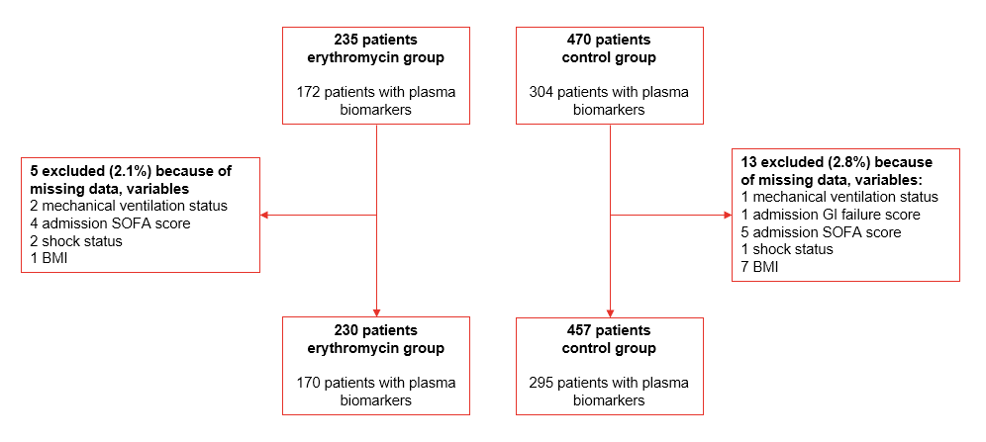
Supplementary Figure 1. Flowchart of patients used in estimating the PS and subsequent analyses (complete cases)
BMI = body mass index; GI = gastrointestinal; SOFA = sequential organ failure assessment score

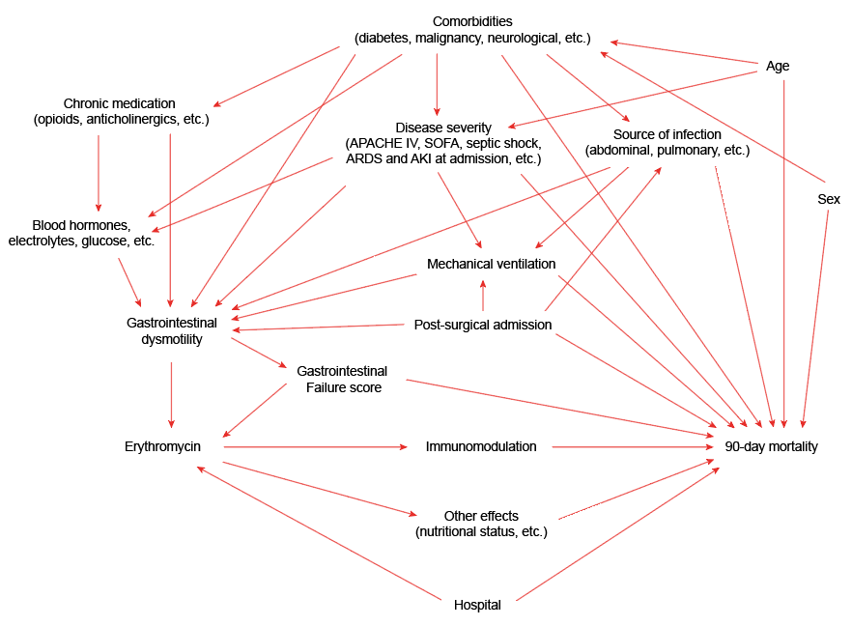
Supplementary Figure 2. Proposed directed acyclic graph
Relationship between the exposure (treatment with erythromycin to alleviate gastrointestinal dysmotility) and the primary outcome (90-day mortality), and the baseline covariates that affect this relationship. AKI = acute kidney injury; APACHE-IV = Acute Physiology And Chronic Health Evaluation IV score; ARDS = acute respiratory distress syndrome; SOFA = sequential organ failure assessment score.

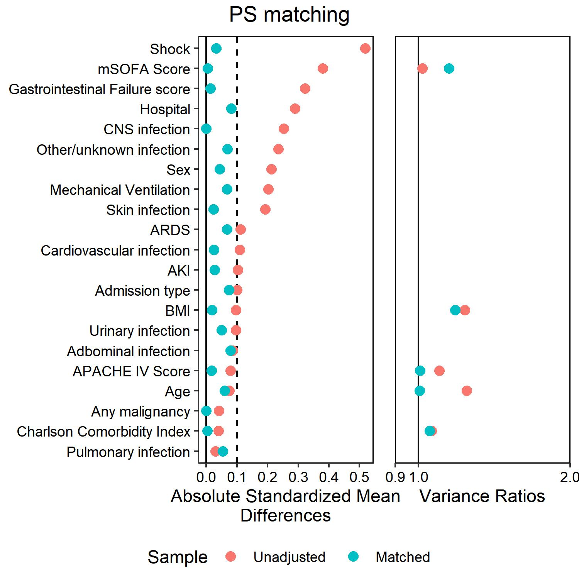
Supplementary Figure 3. Balance statistics of the covariates used for PS matching in the population with measured biomarkers
Plot depicting the absolute SMDs and absolute variance ratios between the unadjusted and the propensity score matched population for the covariates used in the model to estimate the propensity scores.

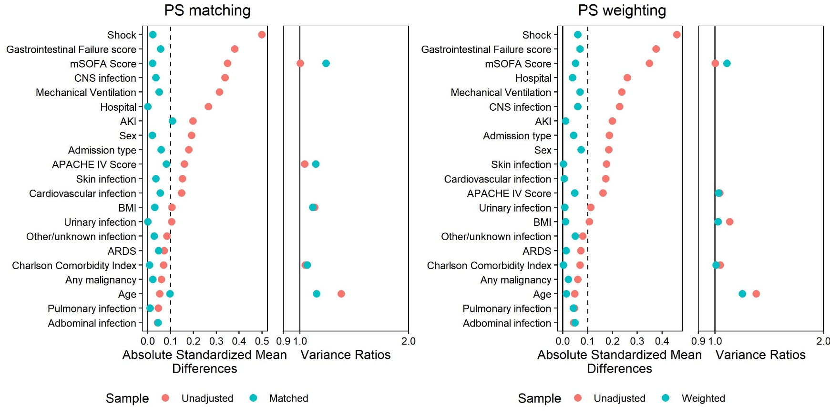
Supplementary Figure 4. Balance statistics of the covariates used for PS matching and weighting for the intention-to-treat sensitivity analysis
Plot depicting the absolute SMDs and absolute variance ratios between the unadjusted and the propensity score matched or propensity score weighted populations for the covariates used in the model to estimate the propensity scores.

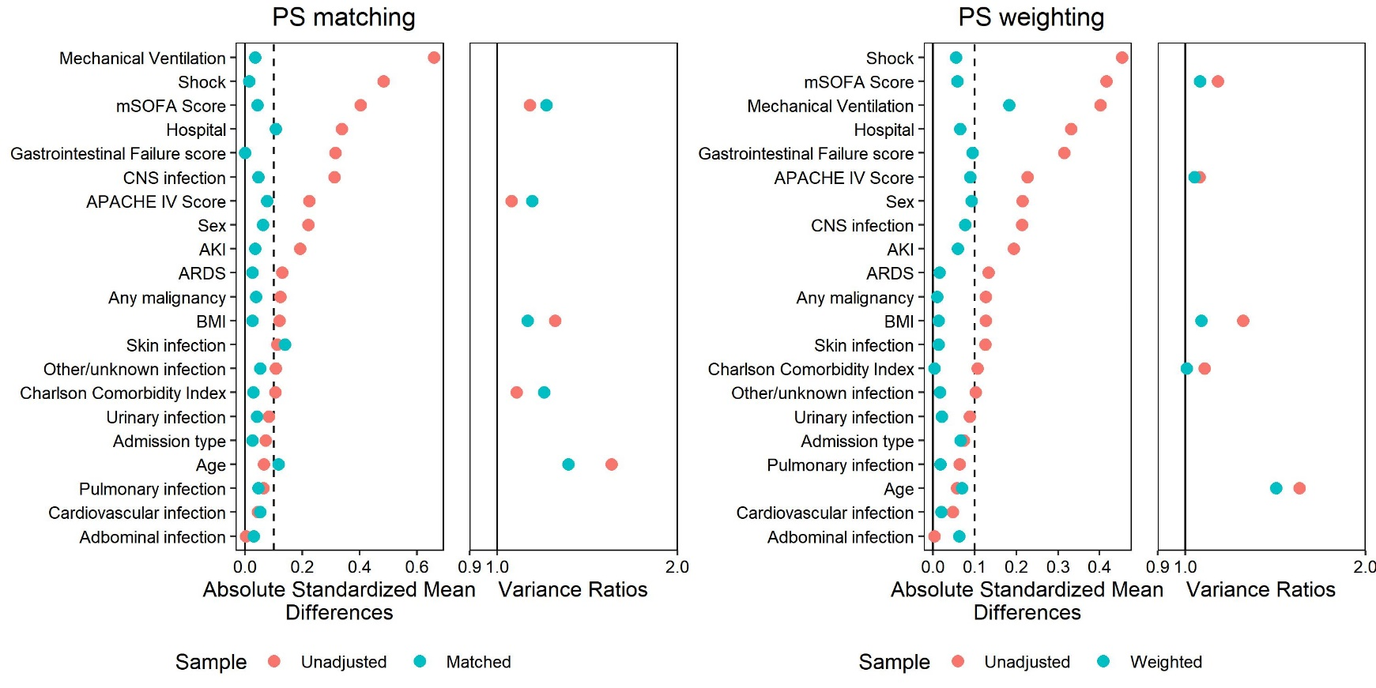
Supplementary Figure 5. Balance statistics of the covariates used for PS matching and weighting for the sensitivity analysis with an exposure period of 48 hours
Plot depicting the absolute SMDs and absolute variance ratios between the unadjusted and the propensity score matched or propensity score weighted populations for the covariates used in the model to estimate the propensity scores.

Supplementary Figure 6. Balance statistics of the covariates used for PS matching and weighting for the sensitivity analysis with an exposure period of 96 hours
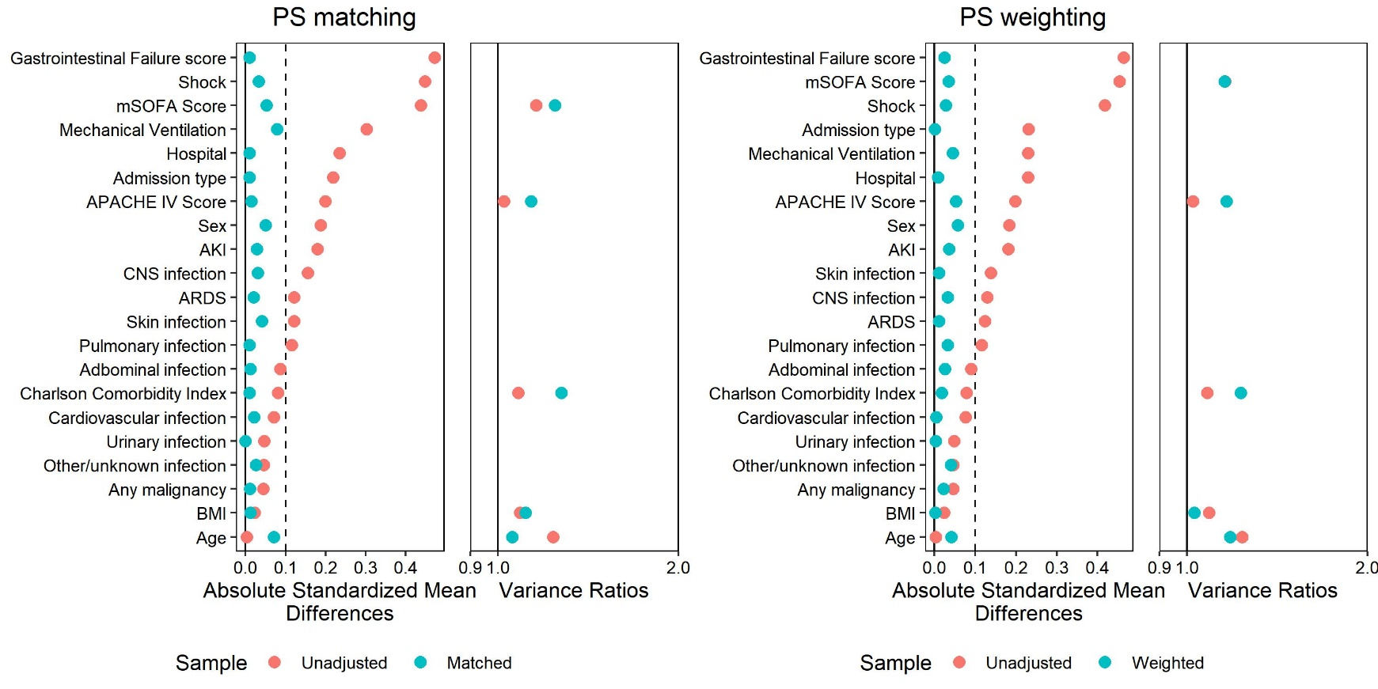
Plot depicting the absolute SMDs and absolute variance ratios between the unadjusted and the propensity score matched or propensity score weighted populations for the covariates used in the model to estimate the propensity scores.

REFERENCES
1. Klouwenberg PMCK, Ong DSY, Bos LDJ, De Beer FM, Van Hooijdonk RTM, Huson MA, et al. Interobserver agreement of centers for disease control and prevention criteria for classifying infections in critically ill patients. Critical Care Medicine. 2013;41:2373–8.
2. Van Vught LAV, Klouwenberg PMCK, Spitoni C, Scicluna BP, Wiewel MA, Horn J, et al. Incidence, risk factors, and attributable mortality of secondary infections in the intensive care unit after admission for sepsis. JAMA - Journal of the American Medical Association. 2016;315:1469–79.
3. Scicluna BP, Klein Klouwenberg PMC, van Vught LA, Wiewel MA, Ong DSY, Zwinderman AH, et al. A molecular biomarker to diagnose community-acquired pneumonia on intensive care unit admission. American journal of respiratory and critical care medicine. United States; 2015;192:826–35.
4. Uhel F, Peters-Sengers H, Falahi F, Scicluna BP, van Vught LA, Bonten MJ, et al. Mortality and host response aberrations associated with transient and persistent acute kidney injury in critically ill patients with sepsis: a prospective cohort study. Intensive Care Medicine. Springer Berlin Heidelberg; 2020;46:1576–89.
5. Bellomo R, Ronco C, Kellum JA, Mehta RL, Palevsky P. Acute renal failure - definition, outcome measures, animal models, fluid therapy and information technology needs: the Second International Consensus Conference of the Acute Dialysis Quality Initiative (ADQI) Group. Critical care (London, England). 2004;8:R204-12.
6. Bernard GR, Artigas A, Brigham KL, Carlet J, Falke K, Hudson L, et al. Report of the American-European consensus conference on ARDS: Definitions, mechanisms, relevant outcomes and clinical trial coordination. Intensive Care Medicine. 1994;20:225–32.
7. Ranieri VM, Rubenfeld GD, Thompson BT, Ferguson ND, Caldwell E, Fan E, et al. Acute respiratory distress syndrome: The Berlin definition. JAMA - Journal of the American Medical Association. 2012;307:2526–33.
8. Simonis FD, de Iudicibus G, Cremer OL, Ong DSY, van der Poll T, Bos LD, et al. Macrolide therapy is associated with reduced mortality in acute respiratory distress syndrome (ARDS) patients. Annals of translational medicine. 2018;6:24.
9. Charlson ME, Pompei P, Ales KL, MacKenzie CR. A new method of classifying prognostic comorbidity in longitudinal studies: development and validation. Journal of chronic diseases. England; 1987;40:373–83.
10. Lumley T. Analysis of Complex Survey Samples. Journal of Statistical Software; Vol 1, Issue 8 (2004). 2004;
11. Van Vught LA, Wiewel MA, Hoogendijk AJ, Frencken JF, Scicluna BP, Klouwenberg PMCK, et al. The host response in patients with sepsis developing intensive care unit-acquired secondary infections. American Journal of Respiratory and Critical Care Medicine. 2017;196:458–70.
12. Van Vught LA, Scicluna BP, Wiewel MA, Hoogendijk AJ, Klouwenberg PMCK, Franitza M, et al. Comparative analysis of the host response to community-acquired and hospital-acquired pneumonia in critically ill patients. American Journal of Respiratory and Critical Care Medicine. 2016;194:1366–74.
13. Van Der Weele TJ, Ding P. Sensitivity analysis in observational research: Introducing the E-Value. Annals of Internal Medicine. 2017;167:268–74.
14. Mathur MB, Ding P, Riddell CA, VanderWeele TJ. Web Site and R Package for Computing E-values. Epidemiology (Cambridge, Mass). 2018;29:e45–7.
15. Fine JP, Gray RJ. A Proportional Hazards Model for the Subdistribution of a Competing Risk. Journal of the American Statistical Association [Internet]. Taylor & Francis; 1999;94:496–509. Available from: https://www.tandfonline.com/doi/abs/10.1080/01621459.1999.10474144
16. Austin PC. The use of propensity score methods with survival or time-to-event outcomes: Reporting measures of effect similar to those used in randomized experiments. Statistics in Medicine. 2014;33:1242–58.
17. Austin PC, Fine JP. Propensity-score matching with competing risks in survival analysis. Statistics in Medicine. John Wiley and Sons Ltd; 2019;38:751–77.
18. Reintam A, Parm P, Kitus R, Starkopf J, Kern H. Gastrointestinal Failure score in critically ill patients: A prospective observational study. Critical Care. 2008;12:1–8.

