Ultrasonography of women with PCOS

Figures 1 and 2 show representative ultrasound findings of the ovaries of the subjects before treatment with d-chiro-inositol, while Figures 3 and 4 show the findings after three months of treatment.

Figure 1. Representative ultrasound finding in polycystic ovary syndrome before treatment. A very characteristic picture was noticed on the ultrasound result: the ovaries were enlarged up to twice, the capsules thickened, under which numerous follicles were arranged like a necklace.

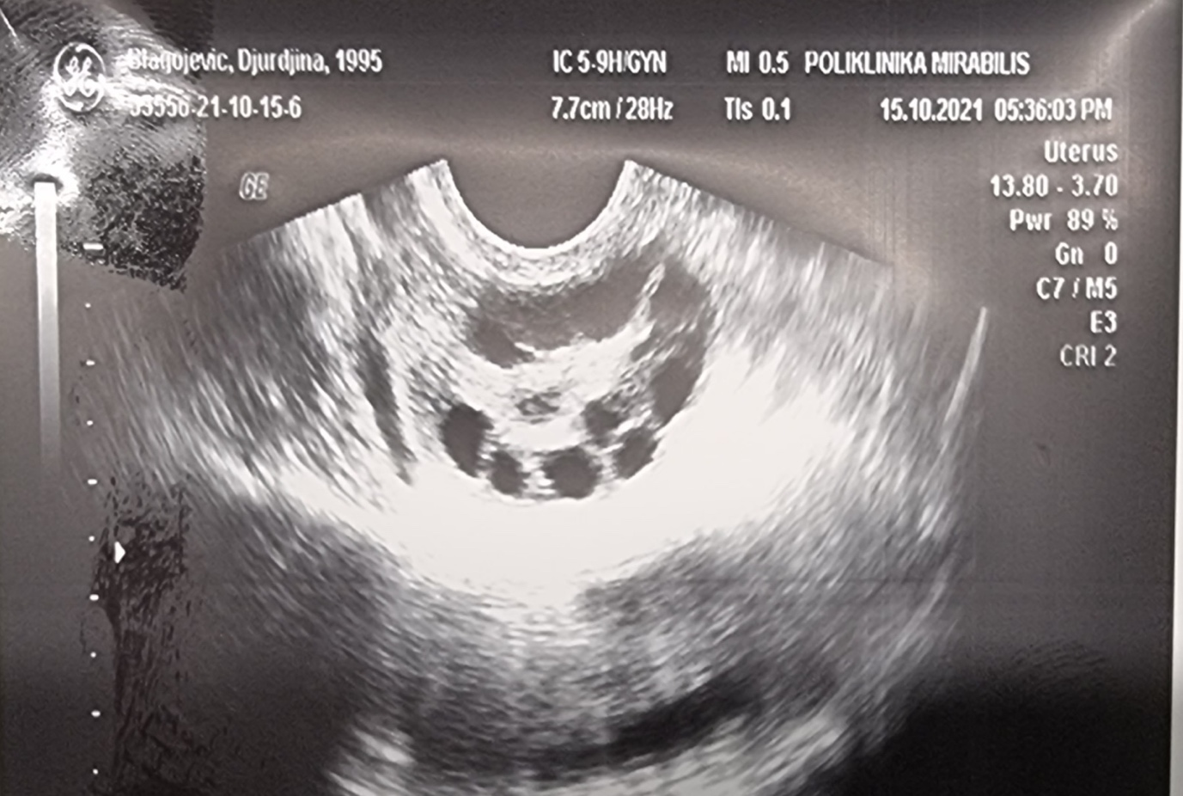

Figure 2. Representative ultrasound finding in polycystic ovary syndrome before treatment. A very characteristic picture was noticed on the ultrasound result: the ovaries were enlarged up to twice, the capsules thickened, under which numerous follicles were arranged like a necklace.

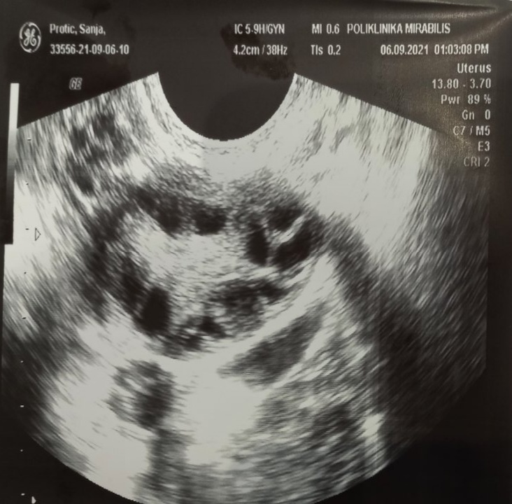

Figure 3. Representative ultrasound finding in polycystic ovary syndrome after treatment. The following was noticed on the ultrasound findings: The ovaries are slightly enlarged, the capsules under which there are some follicles are thickened.
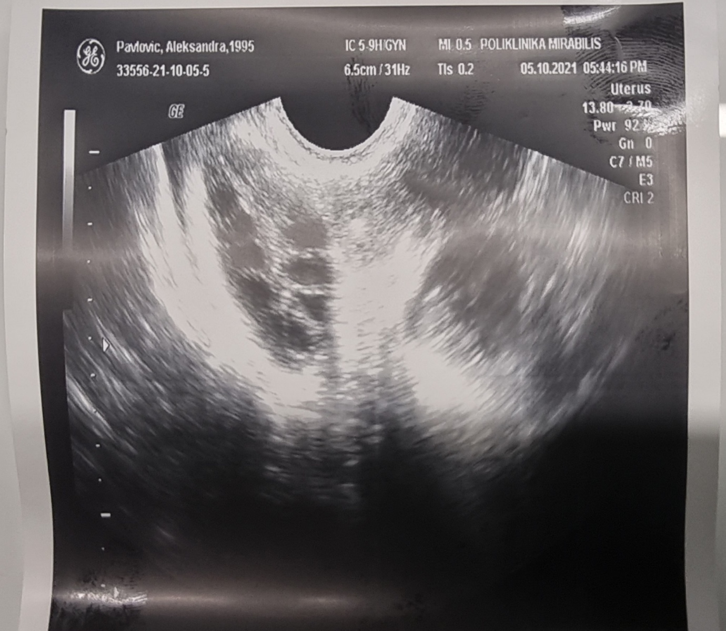

Figure 4. Representative ultrasound finding in polycystic ovary syndrome after treatment. The following was noticed on the ultrasound finding: The ovaries are of normal size, thickened capsules under which sporadic follicles can be seen.

