Supporting Information
Captions

1.Methods 2
1.1 The calculation of traffic congestion economic losses 2
1.2 The job - housing balance among different cities 4
2. The proportion of cars on road 5
3. The difference test of traffic congestion under different rainfall intensities 6
4. The changes of rainfall frequency in the BTH region in 2080 ~ 2098 under the RCP 4.5 scenario 7
5. The car ownership per thousand people in developed countries 8

1.Methods

1.1 The calculation of traffic congestion economic losses
1.1.1 The direct economic cost and its losses due to rainfall
(1) The gasoline consumption in workday and holiday
Gasoline consumption differed significantly between workdays and holidays, due to travel volume on road. As a result, the ratio (R) of gasoline consumption on workdays and holidays can be estimated based on their days, private car travel proportion, and daily frequency on the road on holidays and workdays. Therefore, the gasoline consumption on workdays and holidays can be calculated using the total gasoline consumption (TGC) and the ratio R.
$R=\frac{D_{W}*{TP}_{W}*{TT}_{W}}{D_{h}*{TP}_{h}*{TT}_{h}}$ (1)
Here: $D_{W}$, $D_{h}$ were the days of workday and holiday; ${TP}_{W}$ and ${TP}_{h}$ were the travel proportion of private cars of workdays and holidays; ${TT}_{W}$ and ${TT}_{h}$ were the daily frequency on road for each car of workdays and holidays.
(2) Daily recurrent gasoline consumption on workday and on holiday
Total gasoline consumption was made up of recurrent gasoline consumption, which represented gasoline consumption under normal traffic conditions (namely on sunny days), and extra gasoline consumption due to rainfalls. Because the proportion of cars on the road (b_{t}) at different times varied a lot , the hourly recurrent gasoline consumption can be estimated by $DGc*b_{t}$, DGc was daily average recurrent gasoline consumption. Furthermore, extra gasoline consumption due to rainfall can be calculated by $DGc*b_{t}*{ITCI}_{t}$. ${ITCI}_{t}$ was the percentage of traffic congestion index growth under rainfall. Therefore, gasoline consumption on workday or holiday (Gc) was the sum of hourly recurrent gasoline consumption and hourly extra gasoline consumption (Equation 2), and we can estimate the DGc as Equation 3 if we obtained rainfall hours from meteorological data.
$Gc=\sum_{t=1}^{24}{((}DGc*b_{t})*(m+{ITCI}_{t}*m_{1}))$ (2)
$DGc=\frac{\sum_{t=1}^{24}{(b_{t}*\left(m+{ITCI}_{t}*m_{1}\right))}}{Gc}$ (3)
Here: $Gc$ was gasoline consumption in workday or holiday; DGc was daily average recurrent gasoline consumption, $b_{t}$was the hourly proportion of cars on road at t moment, m was the total hours of t moment on workday or holiday and the $m_{1}$was the total rainfall hours at t moment.
(3) The direct economic cost and its losses due to rainfall
The recurrent gasoline consumption represented gasoline consumption under normal traffic conditions; therefore, with the help of hourly average TCI under normal traffic conditions and gasoline price, we can estimate the direct economic cost of recurrent traffic congestion (Equation 4) and also its direct economic losses due to rainfalls (Equation 5).
${Dec}_{t}= \frac{DGc*bt}{{TCI}_{t}}*({TCI}_{t}-1)*G$ (4)
${RDec}_{t}= \frac{DGc*bt}{{TCI}_{t}}* ∆{TCI}_{t}*G$ (5)
Here: ${TCI}_{t}$was the average traffic congestion index under normal traffic conditions at t moment; G was the price of gasoline; ${Dec}_{t}$ and ${RDec}_{t}$ were the direct economic cost and its losses due to rainfall at time t.
1.1.2 The social cost and its losses due to rainfall
The social cost ($Sec$) referred to the economic costs of travel time due to traffic congestion. Due to traffic congestion index (TCI) was defined as the ratio of the travel time in real flows and the travel time in the free flow, therefore, the travel time caused by recurrent traffic congestion was ${TCI}_{t}-1$. With the help of travel volume ($V_{t}$) and hourly salaries (F) among cities in the BTH region, we can estimate the social cost caused by recurrent traffic congestion (${Sec}_{t}$):
${Sec}_{t}=\left({TCI}_{t}-1\right)*$ $V_{t}×F$ (6)
Besides, we can calculate the social losses (${RSec}_{t}$) due to rainfall by extra travel time, the travel volume and their salaries in the BTH region (Equation 7):
${RSec}_{t}=∆{TCI}_{t}*$ $V_{t}×F$ (7)
Here: ${Sec}_{t}$was the social cost caused by recurrent traffic congestion at t moment; ${RSec}_{t}$ was the social cost caused by rainfall at t moment; $V_{t}$was the travel volume, F was the hourly salaries in each city.
1.1.3 The environmental cost and its losses due to rainfall
The environmental cost referred to the economic costs of carbon emissions from gasoline consumption due to traffic congestion, and it could be estimated by the carbon price (C) and carbon emission intensity of gasoline ($β$). Thus, the environmental cost caused by recurrent traffic congestion can be estimated by Equation 8:
${Eec}_{t}=\frac{DCc*bt}{{TCI}_{t}}*({TCI}_{t}-1)×β×C$ (8)
Similarly, the environmental losses (REec) due to rainfall could be estimated with the increase of traffic congestion ($∆{TCI}_{t}$):
${REec}_{t}=\frac{DCc*bt}{{TCI}_{t}}* ∆{TCI}_{t}×β×C$ (9)
Here: ${Eec}_{t}$ was the environmental cost caused by recurrent traffic congestion, ${REec}_{t}$ was the extra environmental cost caused by rainfall.$β$ was the carbon emission intensity of gasoline, $C$ was the carbon trade price in 2019 of each city.

1.1.4 The total economic cost and the total economic losses
The total economic cost, namely the recurrent traffic congestion cost, which was compromised by the direct economic, social and environmental costs, and it can be estimated by the following equation.
${Tec}_{t}={Dec}_{t}+{Sec}_{t}+{Eec}_{t}$ (10)
And the total economic losses due to rainfall, it can be estimated by Equation 11:
${RTec}_{t}={RDec}_{t}+{RSec}_{t}+{REec}_{t}$ (11)

1.2 The job - housing balance among different cities
To estimate the job - housing balance among different cities in the BTH region, we collected the hourly Tencent Location Big Data during the period 11st to 15th March, 2019. The tencent Location Big Data has acquired global positioning more than 55 billion times a day, covering more than 800 million people, and thus it was widely used in the study of inter-city population flow, urban spatial connection patterns and population distribution. In our research, we regarded the ratio of the positioning number at working time (9:00 am – 17: 00 pm) to positioning number at resting time (except working time) as the job – housing balance, and it can be estimated by:
$B_{i}=\frac{{wc}_{i}}{{rc}_{i}}$ (12)
Here: $B_{i}$refers to the job - housing balance result in city i, ${wc}_{i}$ refers to the total positioning number at working time in city i, and ${rc}_{i}$ refers to the total positioning number at resting time in city i.

2. The proportion of cars on road
To estimate the proportion of cars on road at different windows on holidays, we studied the relationship between traffic congestion index and the proportion of cars on road on workday (Fig. SI-1). Therefore, we could estimate the proportion of cars on road on holidays by the relationship (Fig. SI-2).
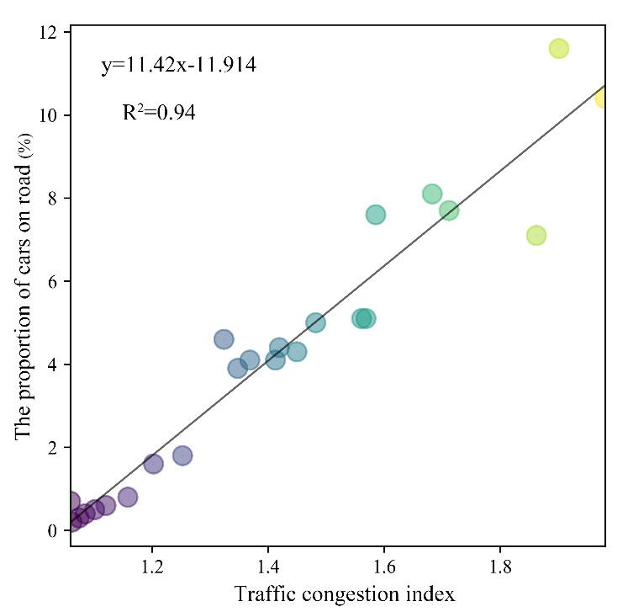
Fig. SI-1. The relationship between TCI and the proportion of cars on road on workday
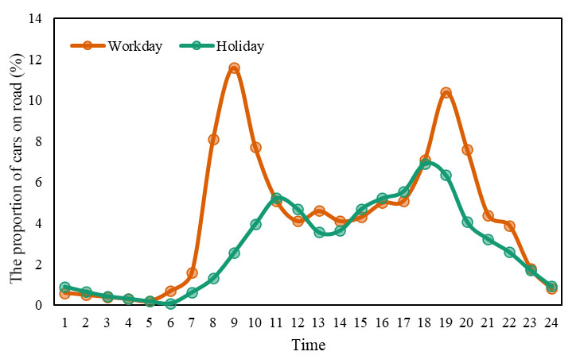
Fig. SI-2. The proportion of cars on road on workday and holidays at different time windows

3. The difference test of traffic congestion under different rainfall intensities
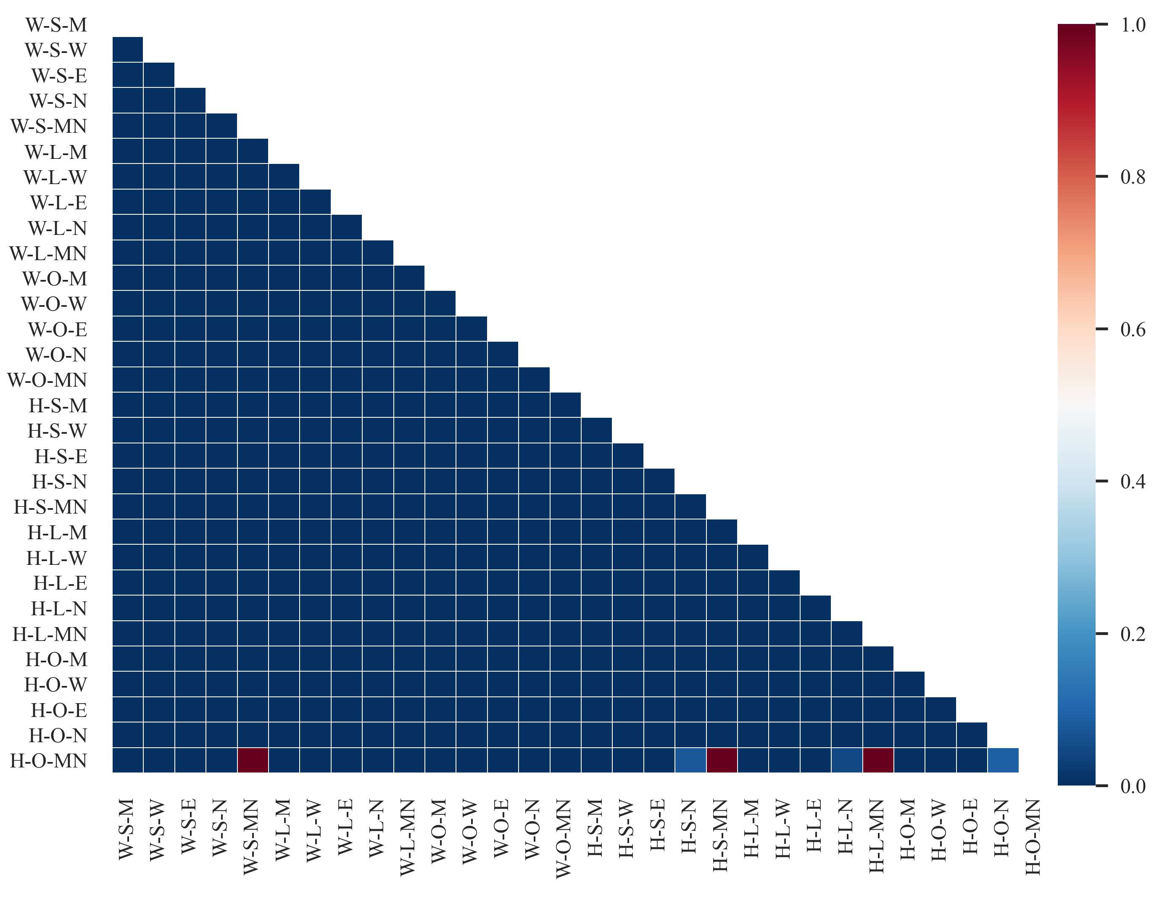
Fig. SI-3. The results of Kruskal-Walls test (Note: H represents Holiday, W represents Workday, S represents Sunny, L represents Light rain, O represents Heavy rain, MN represents Midnight, M represents Morning peak hour, W represents Working hour, E represents Evening peak hour, N represents Night economic hour).

4. The changes of rainfall frequency in the BTH region in 2080 ~ 2098 under the RCP 4.5 scenario
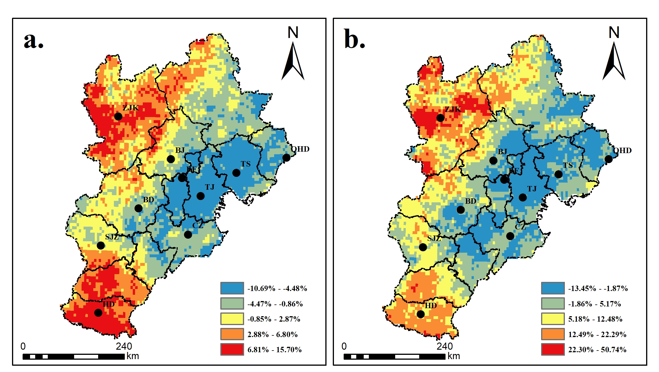
Fig. SI-4. The changes of rainfall frequency in the BTH region in 2080 ~ 2098 under the RCP 4.5 scenario (a, light rainfall, b, heavy rainfall)
Table. SI-1: The changes in rainfall frequency in 2080~2100 under the RCP 4.5 scenario among different cities
City | Light rainfall /% | Heavy rainfall /%
BJ | -1.00 | 0.00
TJ | -7.00 | -4.00
SJZ | 0.00 | 5.00
BD | -2.00 | 0.00
CZ | -4.00 | 0.00
HD | 9.00 | 13.00
LF | -5.00 | -4.00
QHD | -4.00 | -4.00
TS | -7.00 | -1.00
ZJK | 6.00 | 19.00
JJJ | -1.50 | 2.40

5. The car ownership per thousand people in developed countries
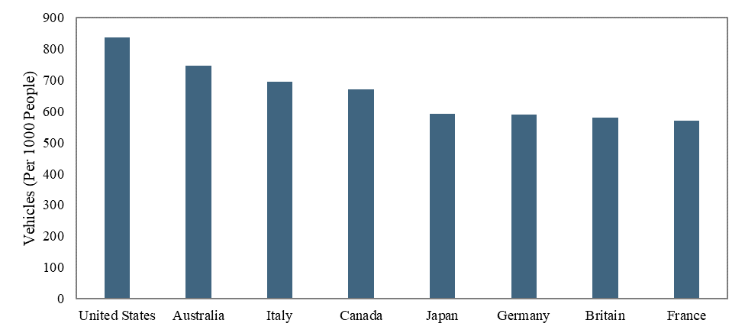
Fig. SI-5. The car ownership per thousand people in some developed countries (collected from World Bank (https://datacatalog.worldbank.org/vehicles-1000-people))

