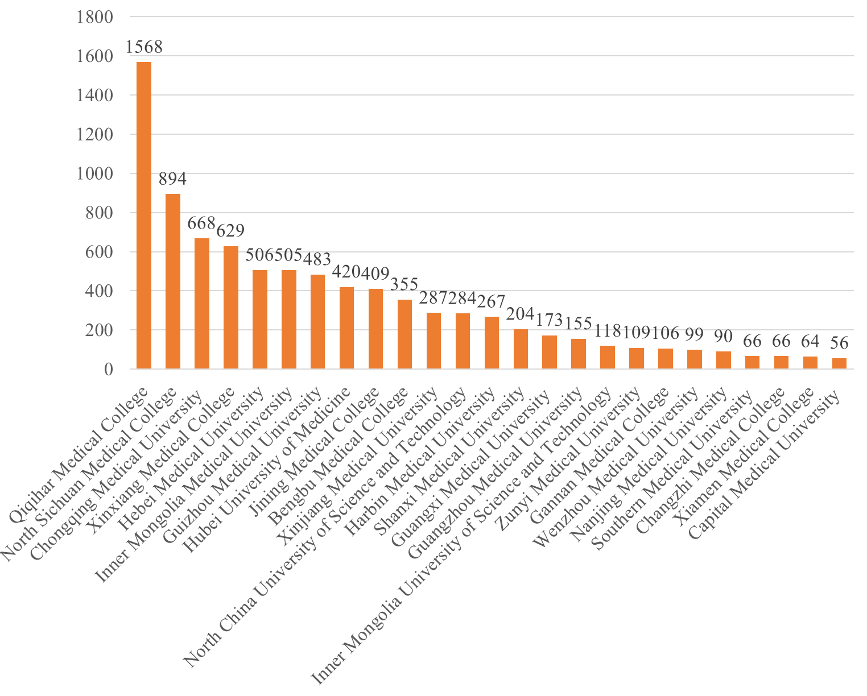
Online Resource 1. Sample number for each medical school.

Online Resource 2. Examples of coding and statements about psychiatry.
 | Choosing psychiatry | Rejecting psychiatry
Personal interest | “I’m interested in psychiatry.”  “I’m interested in psychology and I also want to be a doctor.” | “I'm not interested in psychiatry.”  “I'm interested in psychiatry but more in clinical medicine.”
Family’s suggestion or influence | “I have a family member working in psychiatry.”  “My parents advised me to choose a psychiatry major.” | “Despite my interest in psychiatry, my family and friends objected.”  “Family member did the choice for me.”
Experience of mental problems of oneself or others | “My mother had emotional problems and insomnia. I want to learn more about mental disorders and help her.”  “I once had a mental problem and I want to heal myself, know more about myself.” | —
Low admission score of psychiatry | “The admission score of psychiatry is lower than clinical medicine. My score meets the requirement of psychiatry but not for clinical medicine, and I want to be a doctor.”  “My application for other specialties was rejected so I was transferred to psychiatry, or I will miss the opportunity of medical school. ” | “I got a much higher score than psychiatry at matriculation.”  “Psychiatry has a lower admission score rank.”
Lack knowledge of psychiatry | “I didn’t know this subject. I just filled in the application form casually.”  “I don’t know. It was an accident for me to be enrolled in this specialty.” | “I have no idea what this major is.”  “I don't know this major at all.”
Positive/negative attitudes toward psychiatry | “Psychiatrists are in great demand. The prospect of psychiatry is promising.”  “China has a shortage of psychiatrists. It’s easy for psychiatry major students to find a job.” | “Income and social status are bad in psychiatry.”  “Psychiatry is so obscure to learn. I’m afraid of psychiatric patients.”
School | “Psychiatry is the best major in school.” | “Despite my interest in psychiatry, my school didn't encourage me to apply for this specialty.”
 | “The school is close to my home.”
Other reasons | “I don’t want to say.” | “No clear reasons.”

Online Resource 3. When thinking about your career specialty after medical school, how important are the following considerations?
 | 1. Not important | 2. Somewhat important | 3. Partially important | 4. Very important
Working for social change
High income potential
Social recognition or status
Stable, secure future
Creativity and initiative
Expression of personal values
Availability of jobs
Leadership potential
Opportunity for innovation
Competitiveness of specialty
Level of educational debt
Role model influence
Income expectations
Length of residency training
Family expectations
My future family plans
Work/life balance
Fit with personality, interests, and skills
Content of specialty

Online Resource 4. Initial 36 variables, in order of p value, from the bivariate analysis.
Female*
Higher grade*
Psychiatry clerkship*
Matriculation reason: Personal interest*
Matriculation reason: Experience of mental problems*
Matriculation reason: Low admission score*
Matriculation reason: Lack knowledge of psychiatry *
Leadership potential*
Level of educational debt*
Matriculation reason: Family’s suggestion or influence*
My future family plans*
ATP score*
Stigma score*
Length of residency training*
Social recognition or status*
Role model influence*
Fit with personality, interests, and skills*
Content of specialty*
Income expectations*
Opportunity for innovation*
Work-life balance*
Competitiveness of specialty
History of psychiatry visit
Experience of illegal acts related to medical staff
Family history of mental disorders
Family lives in urban area
Higher family income
High income potential
Creativity and initiative
Availability of jobs
Working for social change
Matriculation reason: School
Family expectations
Stable, secure future
Expression of personal values
Better academic achievement
*p < 0.05.

Online Resource 5. Liner correlation between psychiatry career choice and economic level and mental health service capacity of each province.
 | Regional GDP per capita |  | Rate of career choice for psychiatry
 | r | p | r | p
Regional GDP per capita | — | — | 0.13 | 0.605
No. of health workers | 0.79 | < 0.001 | 0.43 | 0.075
No. of psychiatrists | 0.91 | < 0.001 | 0.32 | 0.207
No. of psychiatry beds | 0.35 | 0.159 | 0.02 | 0.934

Online Resource 6. Hierarchical analysis of influence of demographic factors on psychiatry specialty choice at matriculation classified by grade.
 |  | Freshman |  | Low grade |  | High grade
 |  | OR (95% CI) | p | OR (95% CI) | p | OR (95% CI) | p
Gender
 | Male | reference |  | reference |  | reference
 | Female | 1.39 (1.18-1.64) | < 0.001 | 1.51 (1.34-1.69) | < 0.001 | 1.26 (0.87-1.82) | 0.23
Family living area
 | Village | reference |  | reference |  | reference
 | Town | 1.15 (0.92-1.46) | 0.22 | 0.83 (0.71-0.97) | 0.02 | 1.76 (1.03-3.01) | 0.04
 | City | 1.59 (1.29-1.96) | < 0.001 | 1.02 (0.88-1.18) | 0.84 | 1.57 (1.02-2.42) | 0.04
Family income (RMB/month)
 | < 1000 | reference |  | reference |  | reference
 | 1000-2999 | 1.94 (1.22-3.07) | 0.01 | 1.05 (0.79-1.40) | 0.73 | 0.76 (0.3-1.93) | 0.57
 | 3000-4999 | 1.93 (1.22-3.05) | < 0.001 | 1.18 (0.89-1.55) | 0.25 | 0.69 (0.28-1.71) | 0.42
 | 5000-9999 | 2.39 (1.51-3.78) | < 0.001 | 1.24 (0.94-1.64) | 0.13 | 0.68 (0.27-1.7) | 0.41
 | 10000-14999 | 1.82 (1.10-3.02) | 0.02 | 1.43 (1.05-1.95) | 0.02 | 1.24 (0.41-3.8) | 0.71
 | 15000-20000 | 1.92 (1.08-3.40) | 0.03 | 1.51 (1.02-2.24) | 0.04 | 0.63 (0.18-2.24) | 0.47
 | > 20000 | 2.50 (1.33-4.71) | < 0.001 | 1.77 (1.21-2.58) | < 0.001 | 0.61 (0.17-2.21) | 0.45
History of using psychiatry service
 | No | reference |  | reference |  | reference
 | Yes | 3.07 (1.48-6.36) | < 0.001 | 1.21 (0.80-1.82) | 0.36 | 1.64 (0.8-3.35) | 0.18
Family history of mental disorders
 | No | ref |  | ref |  | ref
 | Yes | 1.23 (0.85-1.76) | 0.27 | 1.42 (1.16-1.75) | < 0.001 | 4.22 (0.55-32.63) | 0.17

