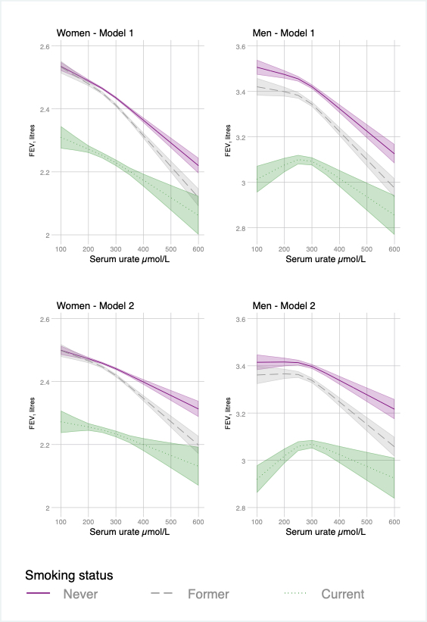

Figure S1: Observational associations between serum urate an d FEV₁ by sex adjusted for age, calendar year, ethnicity (first 40 principal components), height and recruitment centre (Model 1) and additionally for weight (Model 2). Non-linear relationships were captured using restricted cubic spline transformation with three knots placed at the 10th, 50th and 90th percentiles of urate levels.

Table S1: Association between genetically predicted urate using rs12498742 and rs2231142, FEV₁ and lung cancer incidence.
 | Coefficient per 100 µmol* |  | Coefficient per 100 µmol*
 | FEV₁ (ml) | p-value | IRR lung cancer | p-value | Incidence change per 10,000 PYs
Overall | -2.2 (-15.5 to 11.1) | 0.74 | -0.48 (-2.58 to 1.62) | 0.65 | 0.94 (0.71 to 1.24)
Never | 1.1 (-16.0 to 18.3) | 0.90 | 1.09 (0.47 to 2.52) | 0.84 | 0.17 (-1.53 to 1.88)
Former | -12.4 (-35.0 to 10.2) | 0.28 | 0.82 (0.55 to 1.21) | 0.31 | -1.77 (-5.22 to 1.68)
Current | 17.7 (-29.2 to 64.6) | 0.46 | 1.04 (0.67 to 1.59) | 0.87 | 1.28 (-13.67 to 16.22)
Overall regular | 4.6 (-21.4 to 30.5) | 0.73 | 0.96 (0.70 to 1.32) | 0.81 | -0.73 (-6.69 to 5.24)
Light former | -26.9 (-65.9 to 12) | 0.17 | 1.74 (0.70 to 4.36) | 0.24 | 4.15 (-2.73 to 11.02)
Heavy former | 15.6 (-25.6 to 56.8) | 0.46 | 0.71 (0.44 to 1.15) | 0.17 | -5.34 (-12.93 to 2.25)
Current light | 24.4 (-38.9 to 87.7) | 0.45 | 1.12 (0.55 to 2.26) | 0.75 | 3.95 (-20.8 to 28.7)
Current heavy | 60.6 (-35.6 to 156.7) | 0.22 | 0.70 (0.38 to 1.30) | 0.26 | -25.21 (-68.87 to 18.45)

*Adjusted for sex, age, calendar year, ethnicity (first 40 principal components) and recruitment centre.
IRR=incidence rate ratio

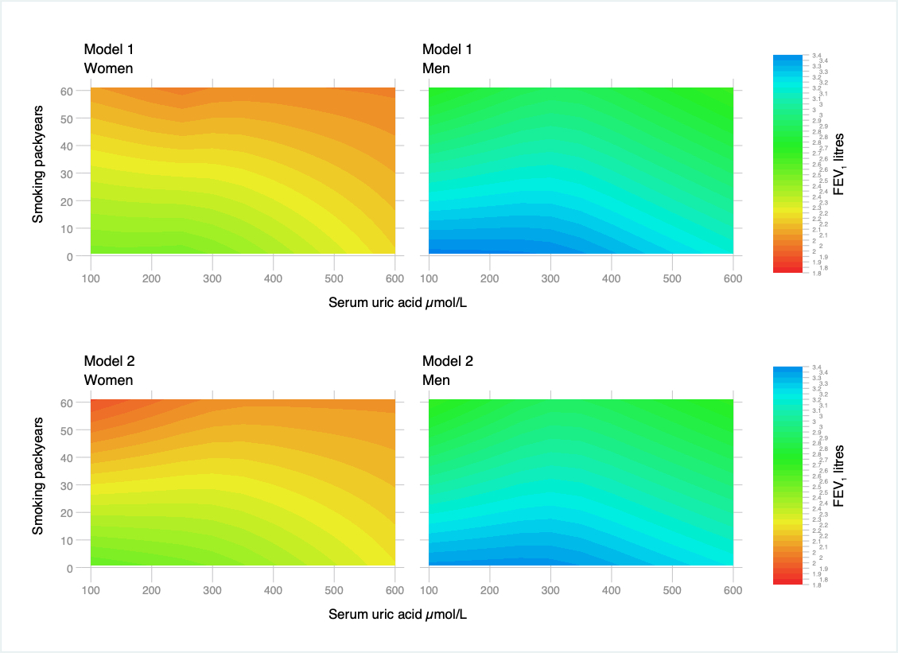
Figure S2: Observational associations between serum urate and FEV₁ with interactions with smoking packyears in regular smokers by sex adjusted for age, calendar year, ethnicity (first 40 principal components), height, recruitment centre (Model 1) and additionally for weight (Model 2). Non-linear relationships were captured using restricted cubic spline transformation with three knots placed at the 10th, 50th and 90th percentiles of urate level.
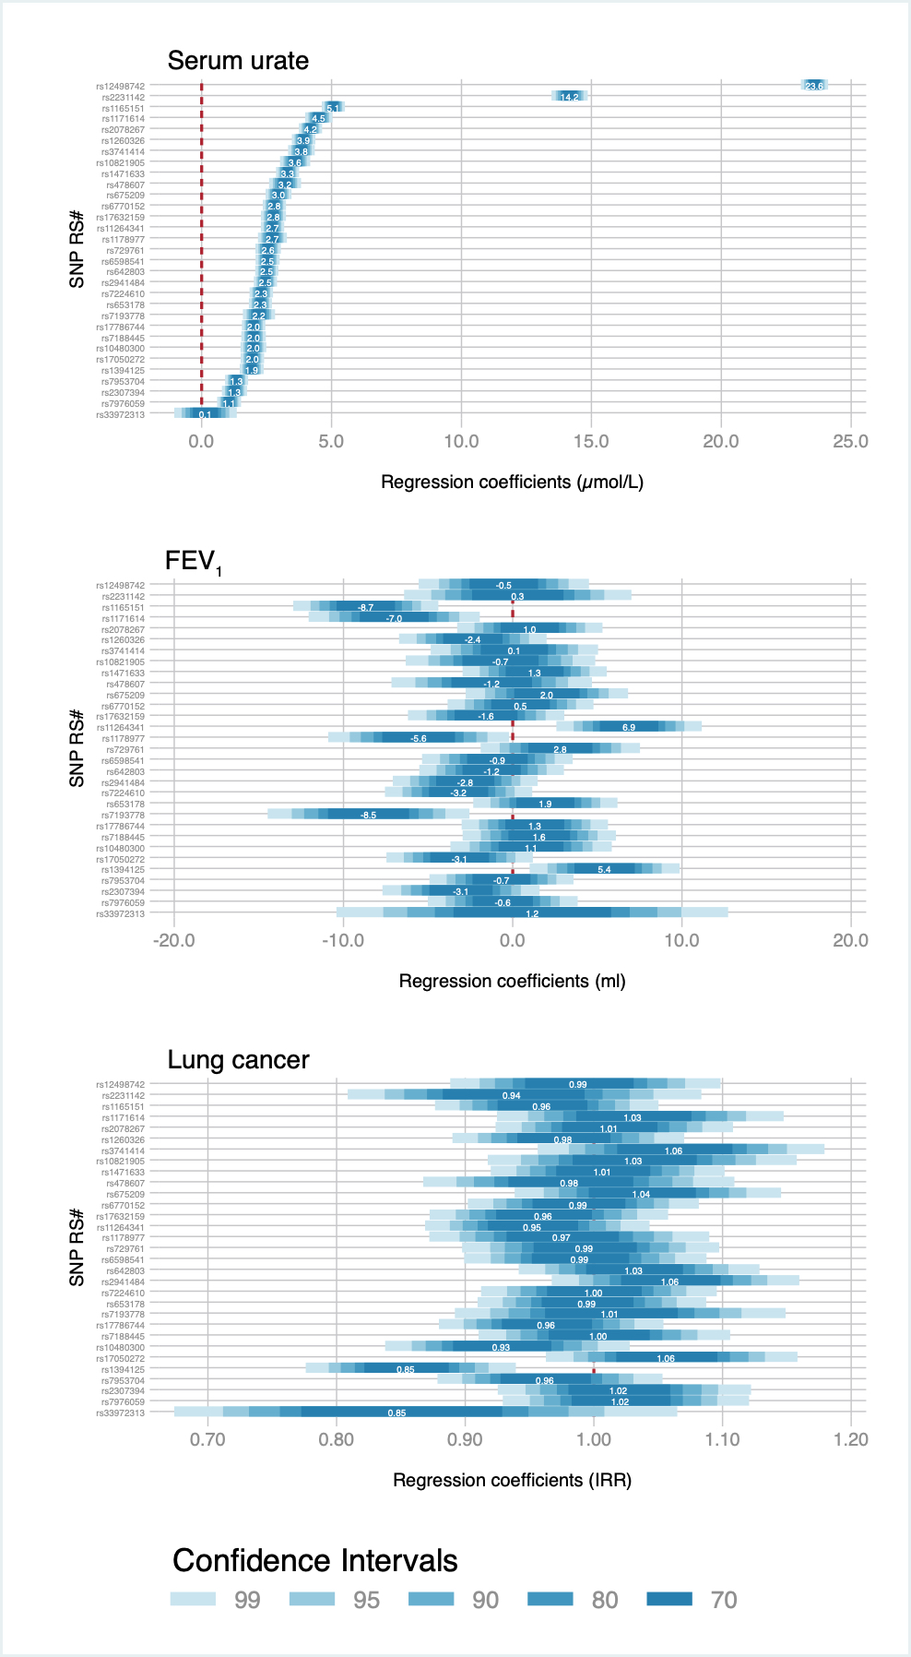
Figure S3: Per allele effects on serum urate, FEV₁ and lung cancer incidence.

Table S2: The genetically instrumented cross-sectional relationships between urate and potential mediating/intervening variables in the relationship with lung cancer.
Total | 305,614 | OR (95%CI) per 100 μmol/L increase* | p-value
Family history of lung cancer
Overall | 39,414 (12.9%) | 0.96 (0.90 to 1.01) | 0.13
Never smokers | 20,521 (12.4%) | 0.95 (0.88 to 1.03) | 0.19
Former smokers | 14,437 (13.4%) | 0.96 (0.88 to 1.06) | 0.43
Current smokers | 4,294 (13.9%) | 0.99 (0.84 to 1.17) | 0.91
History of COPD/emphysema
Overall | 6,979 (2.3%) | 0.99 (0.88 to 1.13) | 0.93
Never smokers | 1,962 (1.1%) | 1.03 (0.81 to 1.29) | 0.83
Former smokers | 3,377 (3.1%) | 0.94 (0.78 to 1.13) | 0.51
Current smokers | 1,596 (5.1%) | 1.11 (0.85 to 1.45) | 0.42

*Adjusted for age, gender, calendar year, ethnicity (first 40 principal components) recruitment centre. Estimates derived using a one-sample Mendelian randomisation approach and the two‐stage predictor substitution method. Number may differ overall and by strata due to missing smoking data.

