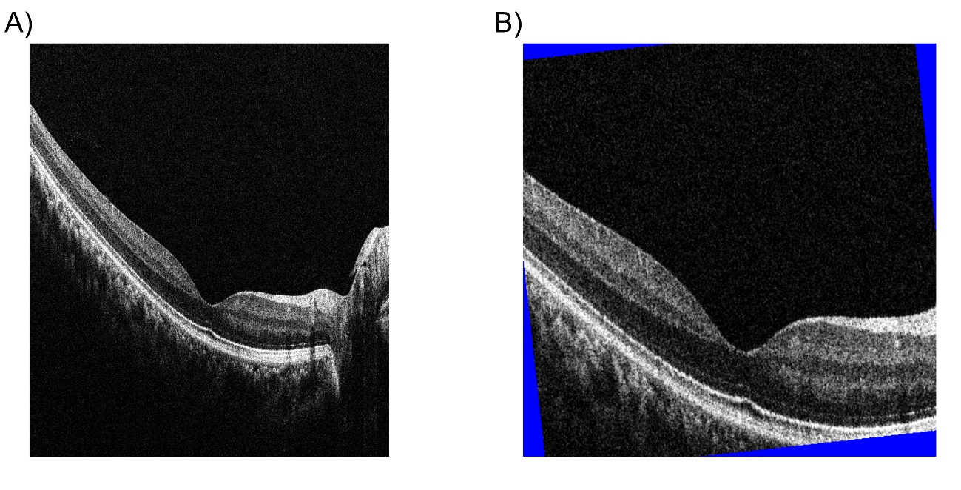
Supplementary Figure 1. Data augmentation for training the CNN model.
(A) Original OCT image with a resolution of 1,021 × 1,176 pixels was center-cropped to 600 × 600 pixels (probability = 50%) and then resized to 512 × 512 pixels. After resizing, the following data augmentations were applied to the images: random brightness from 0.8 to 2.0 times, random contrast from 0.8 to 1.5 times, random rotation within 10 degrees, random horizontal and vertical shift within 50 pixels, and random horizontal mirroring (probability = 50%). (B) If margins were created by image processing, these were padded with blue (red, green, and blue color information of 0, 0, and 255, respectively) to prevent misrecognition. CNN, convolutional neural network; OCT, optical coherence tomography.

Supplementary Figure 2. Confusion matrix in the (A) ResNet-152, (B) DenseNet-201 (C), EfficientNet-B7, and (D) ensemble models.
The horizontal and vertical labels indicate the prediction by each model and ground truth, respectively. (A) ResNet-152 showed an accuracy of 95% (abnormal 49/50, normal 46/50). (B) DenseNet-201 showed an accuracy of 95% (abnormal 49/50, normal 46/50). (C) EfficientNet-B7 showed an accuracy of 96% (abnormal 48/50, normal 48/50). (D) The ensemble model showed an accuracy of 99% (abnormal 50/50, normal 48/50).

Supplementary Figure 3. Classification of each segment in the ML model.
The red and green dots and areas indicate the abnormal and normal eyes classified by the ML model in each segment. The accuracies of each segment were (A) 83% for segment 1 (peripheral temporal retina), (B) 87% for segment 2 (temporal perimacular area), (C) 96% for segment 3 (central macular area), (D) 88% for segment 4 (nasal perimacular area), and (E) 89% for segment 5 (peripheral nasal retina). ML, machine learning.

Supplementary Figure 4. Confusion matrix in the (A) ML, (B) ensemble, and (C) ensemble with ML models.
The horizontal and vertical labels indicate the prediction by each model and ground truth, respectively. (A) The ML model showed an accuracy of 89% (abnormal 45/50, normal 44/50). (B) The ensemble model with four CNN models showed accuracies of 98.0% (abnormal 50/50, normal 48/50) and 99% (abnormal 50/50, normal 49/50). (C) The ensemble with four CNN and ML model showed an accuracy of 99% (abnormal 50/50, normal 49/50). ML, machine learning.

Supplementary Table 1. Failure data on the ML model
Disease | Training and validation  data | Test data | ML  Failure
AMD | 122 | 5
Asteroid hyalosis | 3
CSC | 33 | 1
Drusen | 60
ERM | 107 | 6 | 1
Glaucoma | 25
Location error | 5
Macular degeneration | 17
Macular edema | 60 | 14 | 2
Macular hole | 15 | 3
High myopia | 72 | 5
Post-operation | 3 | 2
RP | 76 | 12 | 2
RRD | 3 | 1
VMTS | 4 | 1
Total | 605 | 50 | 5
AMD, age-related macular degeneration; CNN, convolutional neural network; CSC, central serious chorioretinopathy; ERM, epiretinal membrane; ML, machine learning; OCT, optical coherence tomography; RP, retinitis pigmentosa; RRD, rhegmatogenous retinal detachment; VMTS, vitreomacular traction syndrome.

