A randomized trial of scapular exercises with electromyography biofeedback in oral cancer patients with accessory nerve dysfunction

Yueh-Hsia Chen^{1,2}, Wei-An Liang², Chi-Rung Lin², Cheng-Ya Huang^{1*}

¹ School and Graduate Institute of Physical Therapy, College of Medicine, National Taiwan University, Taipei, Taiwan
² Rehabilitation Center, Department of Plastic and Reconstructive Surgery, Chang Gung Memorial Hospital Linkou Branch, Taoyuan City, Taiwan

Corresponding Author:
Cheng-Ya Huang, PhD
Associate Professor
School and Graduate Institute of Physical Therapy, College of Medicine
National Taiwan University, Taipei 100, Taiwan
E-mail: rcyhuang@ntu.edu.tw
Tel: 886-2-33668131

Online Resource 2. Scapular-focused exercises.

Target Muscle | Exercise | Description
Upper trapezius | 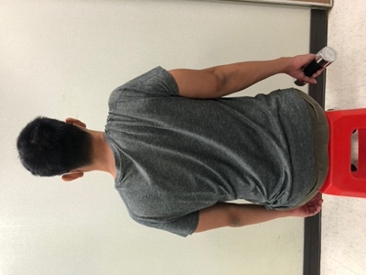  Shoulder shrug | Sitting or standing. Hang one arm on the side of the trunk with elbow in extension and hold a 1kg dumbbell. Elevate scapula to the maximal point and maintain the position of the glenohumeral joint and elbow extension.
Upper trapezius | 90° shoulder abduction with neck side-bending to the ipsilateral side  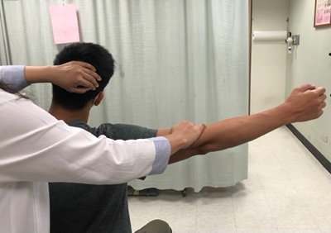 | Sitting. Shoulder abducts 90° with neck side-bending to the ipsilateral side. Resistance applied above the elbow into depression and head into contralateral side.
Middle trapezius,  Lower trapezius | Side-lying external rotation  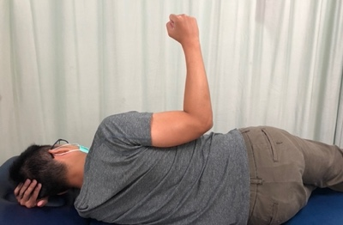 | Lie on one side with arm at side and elbow flexion at 90° and perform shoulder external rotation.
Middle trapezius,  Lower trapezius | Side-lying forward flexion  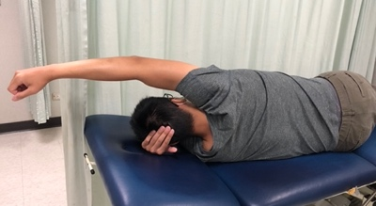 | Lie on one side with arm at side, elbow in extension and shoulder in neutral position. Perform shoulder forward flexion.
Middle trapezius,  Lower trapezius | Prone extension  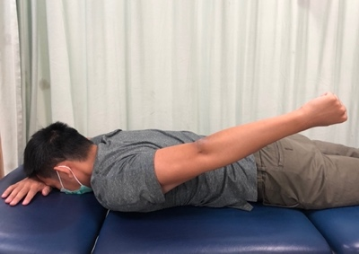 | Prone with an arm pointing to the floor. Perform shoulder extension.

Middle trapezius,  Lower trapezius | Prone horizontal extension with external rotation  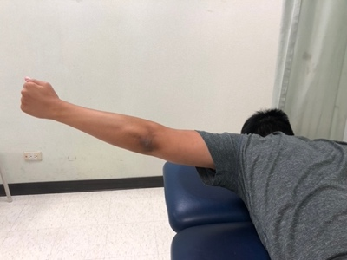 | Prone with an arm horizontal extension at 90° with external rotation to raise the arm.
Middle trapezius,  Lower trapezius | Prone horizontal abduction with external rotation  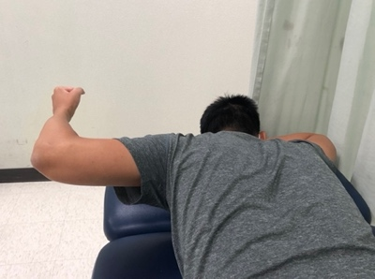 | Prone. Arm in forward flexion at 90° to perform shoulder horizontal abduction to horizontal plane with shoulder external rotation until the thumb points to the ceiling.
Middle trapezius,  Lower trapezius | Overhead arm raise  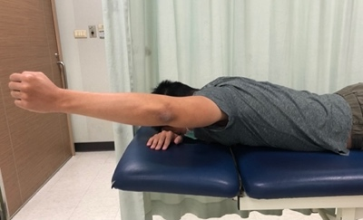 | Prone. Shoulder horizontal abduction at 125° with shoulder external rotation and elbow extension to raise the arm or slide on the wall to retract the scapula.
Middle trapezius,  Lower trapezius | One-arm row  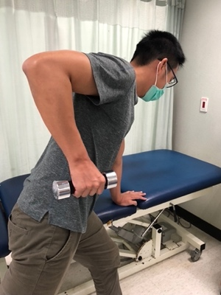 | Standing. Place contralateral hand on the table and lunge with the contralateral forward. Lean the trunk forward to 45°. Ipsilateral hand holds a 1-kg dumbbell with elbow in extension. Pull the dumbbell to the level of the lower rib with shoulder in retraction.
Middle trapezius,  Lower trapezius, | Anti-scapular winging exercise  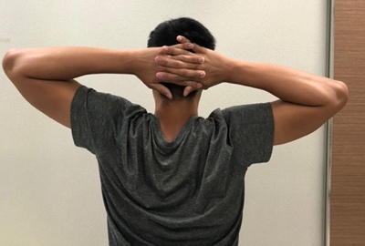 | Sitting or standing. Hold both hands together and elevate arms above the head. Then, place both hands behind the head. Pull bilateral scapular closer, then elevate both arms above the head to put arms back to the front of the trunk.

