A randomized trial of scapular exercises with electromyography biofeedback in oral cancer patients with accessory nerve dysfunction

Yueh-Hsia Chen^{1,2}, Wei-An Liang², Chi-Rung Lin², Cheng-Ya Huang^{1*}

¹ School and Graduate Institute of Physical Therapy, College of Medicine, National Taiwan University, Taipei, Taiwan
² Rehabilitation Center, Department of Plastic and Reconstructive Surgery, Chang Gung Memorial Hospital Linkou Branch, Taoyuan City, Taiwan

Corresponding Author:
Cheng-Ya Huang, PhD
Associate Professor
School and Graduate Institute of Physical Therapy, College of Medicine
National Taiwan University, Taipei 100, Taiwan
E-mail: rcyhuang@ntu.edu.tw
Tel: 886-2-33668131

Online Resource 3. Placement of the EMG electrodes and maximal voluntary isometric contraction (MVIC) task for the trapezius muscle.

 | Electrode placement | MVIC task
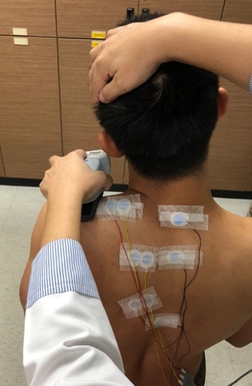 | Upper trapezius: 2 cm apart in the middle between the seventh cervical vertebra and the posterior tip of the acromion process  Reference electrode: on the seventh cervical vertebra | - Sitting  - Scapula elevation with resistance applied into shoulder depression and head into contralateral side  - Contract against manual resistance and maintain for 5 sec
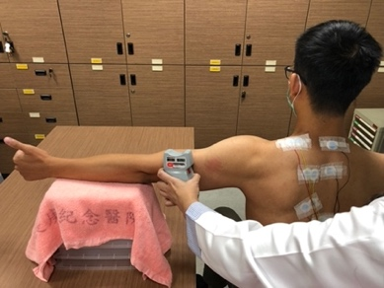 | Middle trapezius: 2 cm apart between the third thoracic vertebra and the root of the spine of the scapula  Reference electrode: on the third thoracic vertebra | - Sitting  - Resistance applied to shoulder horizontal abduction at 90° with glenohumeral external rotation and elbow extension  - Contract against manual resistance and maintain for 5 sec
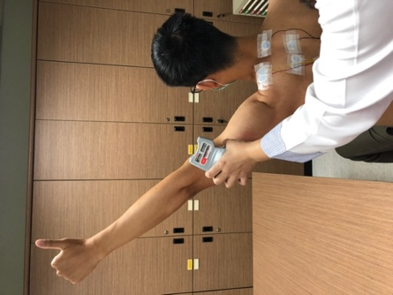 | Lower trapezius: 2 cm apart at the 2/3 position of the line from the trigonum spinae to the eighth thoracic vertebra  Reference electrode: on the eighth thoracic vertebra | - Sitting  - Arm placed diagonally overhead in line with the fibers of the lower trapezius  - Resistance applied on the measured arm from posterior to anterior  - Contract against shoulder horizontal abduction and maintain for 5 sec

