Survey Structure

Prior to the COVID-19 pandemic, what was your primary type of insurance coverage?
Please select the best response regardless of whether you are the policy holder or another member of your household (spouse/partner/parent) is providing coverage.
o COBRA (1)
o Employer based insurance (insurance provided through an employer or business) (2)
o Marketplace Exchange (Sometimes referred to as Obama Care) (3)
o Medicaid (4)
o Medicare (5)
o Medicare and Medicaid (8)
o Other (6)
o I do not have insurance (7)

In addition to your COVID-19 diagnosis, are there any other health conditions that you are currently
or should be in ACTIVE treatment for?
Please select all that apply or select "no additional health conditions".
▢ Arthritis (1)
▢ Asthma (23)
▢ Autoimmune disease (2)
▢ Cancer (3)
▢ Cardiovascular disease (4)
▢ Colitis (5)
▢ Crohn’s disease (6)
▢ Chronic Fatigue Syndrome (27)
▢ Chronic pain (31)
▢ Chronic obstructive pulmonary disease (COPD) (7)
▢ Cystic fibrosis (25)
▢ Diabetes (8)
▢ Epilepsy (26)
▢ Genetic disorder (9)
▢ Heart disease (10)
▢ Hepatitis (11)
▢ HIV/AIDS (12)
▢ Hypertension (22)
▢ Kidney disease (13)
▢ Lupus (28)
▢ Migraine headaches (29)
▢ Multiple sclerosis (24)
▢ Myelodysplastic syndrome (14)
▢ Nervous system condition (15)
▢ Neuromuscular disease (16)
▢ Osteoporosis (17)
▢ Pulmonary condition (18)
▢ Sickle Cell Anemia (30)
▢ Vascular disease (19)
▢ Other chronic disease or illness (20)
▢ No additional health conditions (21)

Please select the type of cancer you were diagnosed with from the list below:
o Bladder (1)
o Bone (2)
o Breast (3)
o Colon or Rectal (4)
o Endocrine (5)
o Gastrointestinal (6)
o Genitourinary (7)
o Gynecologic (8)
o Head and Neck (9)
o Hodgkin Lymphoma (10)
o Leukemia (11)
o Liver (12)
o Lung (13)
o Myeloma (14)
o Neurological (15)
o Non-Hodgkin Lymphoma (16)
o Ocular (17)
o Prostate (18)
o Sarcoma (19)
o Skin (20)
o Thyroid (21)
o Other (22)

What is your main source of employment right now?
o Employed full time by someone else (> 32 hours/week) (1)
o Employed part time by someone else (1-31 hours/week) (2)
o Self-employed, I own my own business (3)
o Not employed, but looking for work (4)
o Not employed (5)
o Retired (6)
o Disabled, not able to work (7)
o Student (8)
o Other (9)

Have you ever used telehealth services to connect with a medical provider regarding your healthcare?
o Yes, before the COVID-19 pandemic (1)
o Yes, my first time was during the COVID-19 pandemic (2)
o No, I have never used telehealth services (3)

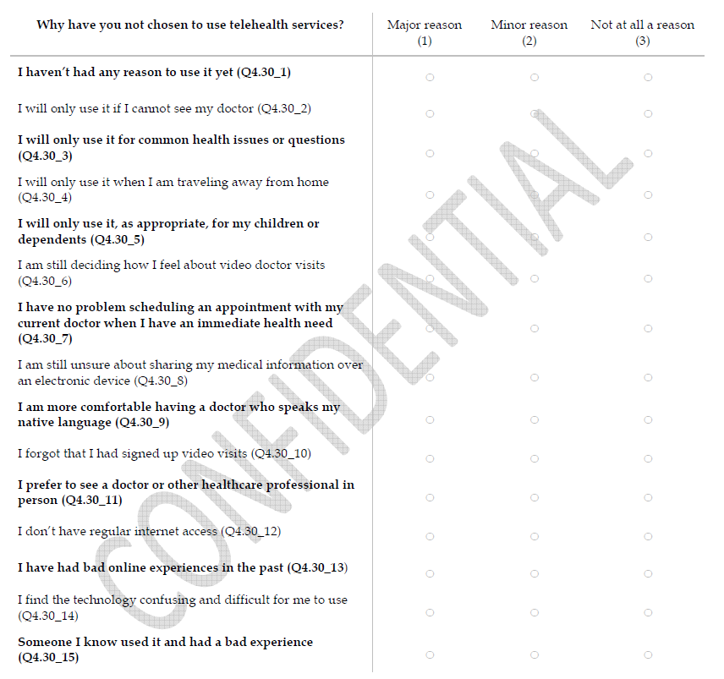

How many telehealth visits have you completed since the start of the COVID-19 pandemic?
o 0 (7)
o 1 (1)
o 2 (2)
o 3 (3)
o 4 (4)
o 5 (5)
o More than 5 (6)
In the past 4 months, how frequently did you use telehealth for your healthcare visits instead of in-office
visits?
o All of my visits were telehealth visits (1)
o At least half of my visits were telehealth visits (2)
o Some of my visits were telehealth visits (3)
o At least one of my visits was a telehealth visits (4)
o None of my visits were telehealth visits (5)

Thinking about the telehealth visits you have received during the COVID-19 pandemic, how were these
visits conducted?
o Live face to face over a computer or smart phone with video (Skype, FaceTime, Zoom, GoogleChat etc.) (1)
o Visit conducted over the phone but without video so you could not see each other’s faces (2)
o Both - My visits were done by phone and live face to face (3)

Thinking about the telehealth visits you have received during the COVID-19 pandemic, what is your
preferred method for having these visits?
o I prefer live face to face over a computer or smart phone with video (Skype, FaceTime, Zoom, GoogleChat ) (1)
o I prefer over the phone (audio-only without video) (2)
o No preference - I like over the phone and live face to face video equally (3)

Thinking about the telehealth visits you have received during the COVID-19 pandemic, how often did
your doctor ask you about your most pressing concerns?
o Never (1)
o Sometimes (2)
o Usually (3)
o Always (4)

Thinking about the telehealth visits you have received during the COVID-19 pandemic, how often did
your doctor ask you about your preferences regarding how you want medical and care information discussed?
o Never (1)
o Sometimes (2)
o Usually (3)
o Always (4)

Thinking about the telehealth visits you have received during the COVID-19 pandemic did you
understand what your out of pocket costs would be for the visit?
o Yes, provider spoke with me (1)
o Yes, health insurance plan spoke with me (2)
o Both - My provider and health insurance plan spoke with me (3)
o No (7)
o Unsure (8)

Thinking about the telehealth visits you have received during the COVID-19 pandemic, did you
understand what you or your insurance company would be covering the costs for?
o Yes (1)
o No (2)
o Unsure (3)

What do you feel are the benefits of receiving telehealth visits instead of in person care?
▢ It can save me money on transportation costs (1)
▢ It allows me to access care sooner that I would be able to in person (2)
▢ I can access experts outside of my immediate area that I would normally not have access to (3)
▢ It does not disrupt my ability to work (7)
▢ It is more affordable than an in person office visit (8)
▢ It is more convenient than scheduling an in person office visit (9)
▢ I do not feel that there are any benefits to telehealth visits instead of in person office visits (10)

Thinking about the telehealth visits you have received during the COVID-19 pandemic, did your provider
or care team talk to you about things other than your primary concern for the visit (costs of care, food, housing
transportation etc.)
o Yes (1)
o No (2)
o Unsure (3)

Who did you speak with during your telehealth visit about your financial and social needs?
o Provider (for example doctor, nurse, medical assistant) (1)
o Social Worker (2)
o Office staff (3)
o Patient navigator (4)
o Other (5)

Q4.42 Thinking about the telehealth visits you received during the COVID-19 pandemic, did you have any
of the following concerns/barriers to using telehealth?
Please select all that apply.
▢ Lack of access to video-enabled devices such as smartphones or camera-equipped computers (7)
▢ My internet connection during the visit was poor making it difficult to see or hear the medical professional
throughout much of it (8)
▢ Lack of technical knowledge to connect with telehealth services (9)
▢ Lack of robust and reliable access to internet, mobile data and/or cell service (10)
▢ Discomfort or embarrassment being on video (11)
▢ I had no concerns (12)

Thinking about your last telehealth visit, did you have any concerns about using these services?
Please select all that apply.
▢ I felt like I did not have the proper skills or training required to use the technology (1)
▢ I felt like the telehealth experience was not appropriate for my medical needs and was a poor substitute for an inperson
office visit (2)
▢ I am concerned about the security/privacy of the information I am providing during the telehealth encounter (3)
▢ I am concerned about the quality of care offered via telehealth visits (4)
▢ I had no concerns (6)

