Increased parenchymal free water may be decreased by revascularization surgery in patients with moyamoya disease

*Shoko Hara^{1,2}, Masaaki Hori^{2,3}, Koji Kamagata², Christina Andica², Motoki Inaji¹, Yoji Tanaka¹, Shigeki Aoki², Tadashi Nariai¹, Taketoshi Maehara¹

1. Department of Neurosurgery, Tokyo Medical and Dental University, Tokyo, Japan
2. Department of Radiology, Juntendo University, Tokyo, Japan
3. Department of Diagnostic Radiology, Toho University Omori Medical Center, Tokyo, Japan

Correspondence to:
Shoko Hara, shara.nsrg@tmd.ac.jp

Supplementary Figure 1. Surgical procedure.
A representative lateral view of the bone windows of indirect revascularization surgery is shown in Fig.1. The yellow circle highlights the revascularization surgery targeting the fronto-parietal lobe (encephalo-duro-arterio-synangiosis using the parietal branch of the superficial temporal artery). The white circle shows the revascularization surgery targeting the fronto-parietal and parieto-occipital lobes (encephalo-duro-pericranial-synangiosis on the posterior part of the brain).
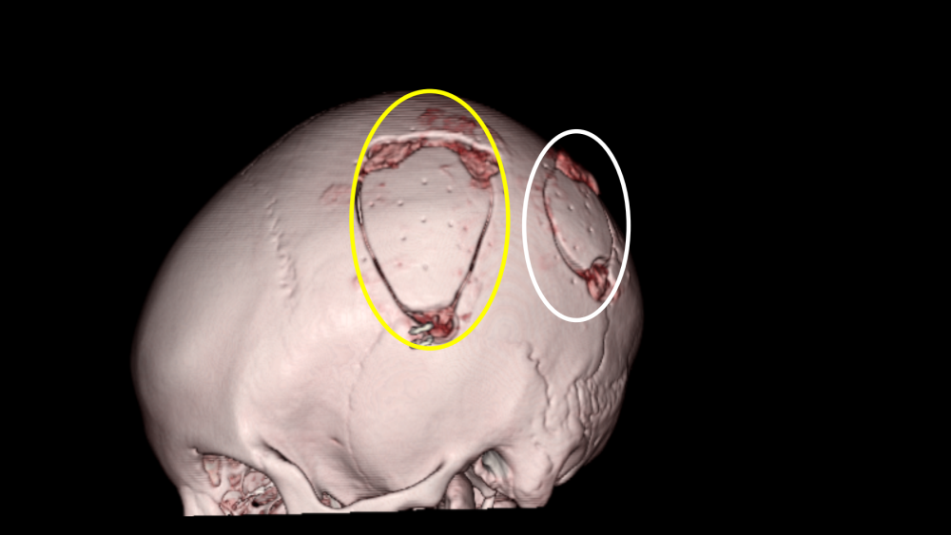

Supplementary Figure 2. Postoperative differences (Post-Pre, Δ) in the parameter values in six regions. Compared with patients without cognitive improvement (not improved), patients with cognitive improvement (improved) showed a significant decrease in the orientation dispersion (OD) index in the anterior cerebral artery (ACA) areas. No significant differences were observed between the values of the other parameters. V_{ic}, intracellular volume fraction; V_{iso}, isotropic volume fraction; FW, free water fraction; FA, fractional anisotropy; FAt, free water-corrected FA; GM, gray matter. *P<.0083 (unpaired T test; P<.05 after Bonferroni correction for six parameters).

Supplementary Table 1. Details of the cognitive performance before and after the surgery.
Mean (SD) / n (%) | Preop | Postop | P value | Preop Decline | Postop Improvement
Full-scale IQ | 90.0 (11.7) | 89.5 (12.5) | 0.71 | 4 (36%) | 2 (18%)
Verbal Comprehension Index | 94.9 (12.5) | 93.7 (9.6) | 0.43 | 3 (27%) | 2 (18%)
Perceptual Organization Index | 90.0 (12.9) | 90.8 (10.8) | 0.7 | 4 (36%) | 5 (46%)
Working Memory Index | 82.2 (11.9) | 85.4 (13.6) | 0.26 | 7 (64%) | 6 (54%)
Processing Speed Index | 92.8 (10.1) | 90.8 (7.39 | 0.34 | 2 (18%) | 4 (36%)
SD, standard deviation; IQ, intelligence quotient.

Supplementary Table 2. Exact P values of all comparative analyses
 |  | (n=15) |  |  | (n=13)
 |  | Normal vs Pre | Pre vs Post |  | Post-Pre, Improved vs Not improved
 |  | (unpaired T) | (paired T) |  | (unpaired T)
Vic | ACA GM | .06 | .29 |  | .97
 | MCA GM | ,07 | .09 |  | .96
 | PCA GM | .19 | .50 |  | .89
 | ACA WM | .01 | .07 |  | .32
 | MCA WM | .01 | .045 |  | .38
 | PCA WM | .13 | .31 |  | .97
OD | ACA GM | .08 | .41 |  | .14
 | MCA GM | .12 | .28 |  | .31
 | PCA GM | .33 | .48 |  | .74
 | ACA WM | .002* | .45 |  | <.001*
 | MCA WM | .05 | .48 |  | .35
 | PCA WM | <.001* | .09 |  | .24
Viso | ACA GM | <.001* | .003* |  | .34
 | MCA GM | <.001* | .001* |  | .80
 | PCA GM | <.001* | .09 |  | .75
 | ACA WM | <.001* | .003* |  | .23
 | MCA WM | <.001* | .002* |  | .66
 | PCA WM | .03 | .008* |  | .43
FW | ACA GM | <.001* | <.001* |  | .21
 | MCA GM | <.001* | .005* |  | .60
 | PCA GM | <.001* | .004* |  | .12
 | ACA WM | <.001* | .002* |  | .18
 | MCA WM | <.001* | <.001* |  | .51
 | PCA WM | .004* | .003* |  | .16
FAt | ACA GM | .40 | .005* |  | .51
 | MCA GM | .21 | .007* |  | .34
 | PCA GM | .48 | .007* |  | .66
 | ACA WM | .001* | .31 |  | .17
 | MCA WM | .01 | .43 |  | .39
 | PCA WM | <.001* | .99 |  | .91
FA | ACA GM | .51 | .85 |  | .76
 | MCA GM | .26 | .35 |  | .53
 | PCA GM | .32 | .06 |  | .27
 | ACA WM | <.001* | .03 |  | .59
 | MCA WM | <.001* | .002* |  | .90
 | PCA WM | .003* | .22 |  | .97
*P<.0083 (P<.05 after Bonferroni correction for comparing six parameters).

