SUPPLEMENTARY FIGURES

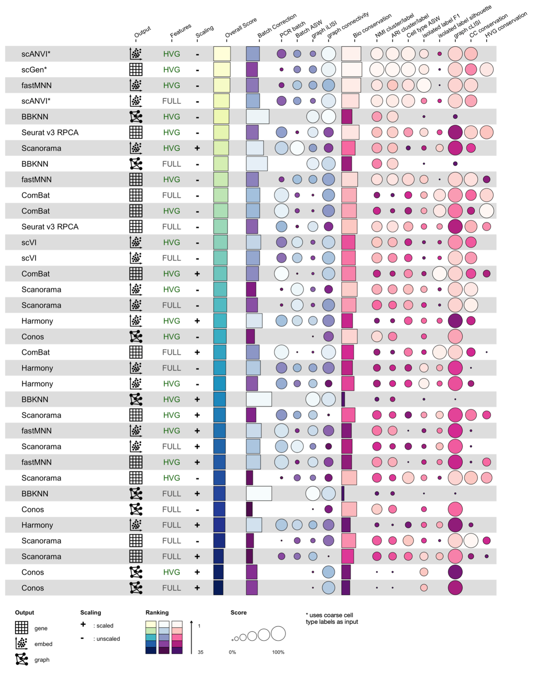
Extended Data Figure 1. Results of dataset integration benchmarking. Rows represent methods tested, using a particular preprocessing. Preprocessing is summarized by “Features” (either HVG or FULL, corresponding to a gene selection of the 2000 or 6000 most highly variable genes, respectively) and “Scaling” (specifying whether or not gene values were scaled to mean 0 and standard deviation 1 across cells). Methods are sorted by overall score. Overall score is a weighted mean of the batch correction score and an th bio conservation score, which in turn are a mean of the individual metrics within the category. Metrics have been previously described¹⁶. The output column specifies whether a method has corrected gene counts, an integrated embedding, or an integrated graph as output. Scanorama and fastMNN were benchmarked twice, once with a corrected gene matrix as output, and once with a corrected embedding as output. scANVI and scGen were given coarse cell type labels as input, as indicated by the asterisk. fastMNN required too much memory on the full feature (6000 gene) data, therefore only the hvg results are included in the figure.

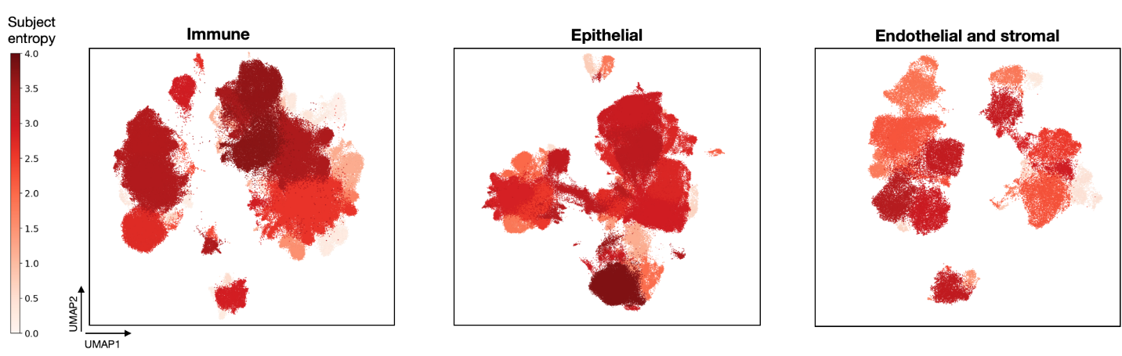
Extended Data Figure 2. Subject diversity per HLCA core cluster. Subject diversity is calculated for every cluster as entropy of subject proportions in the cluster, with high entropy indicating the cluster contains cells from many different subjects. Matching cell type annotations are shown in fig. 3d.

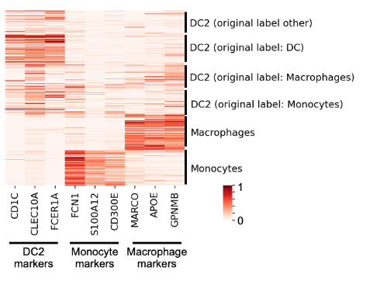
Extended Data Figure 3. Marker expression among cells from a high-label-entropy cluster. DC2, monocyte and macrophage marker expression is shown for cells from the immune cluster with highest label entropy, as depicted in fig. 3c. Cells are labeled by their final annotation, as well as their original label. Log-normalized counts are scaled such that for each gene the 99th expression percentile, as calculated among all cells included in the heatmap, is set to 1.

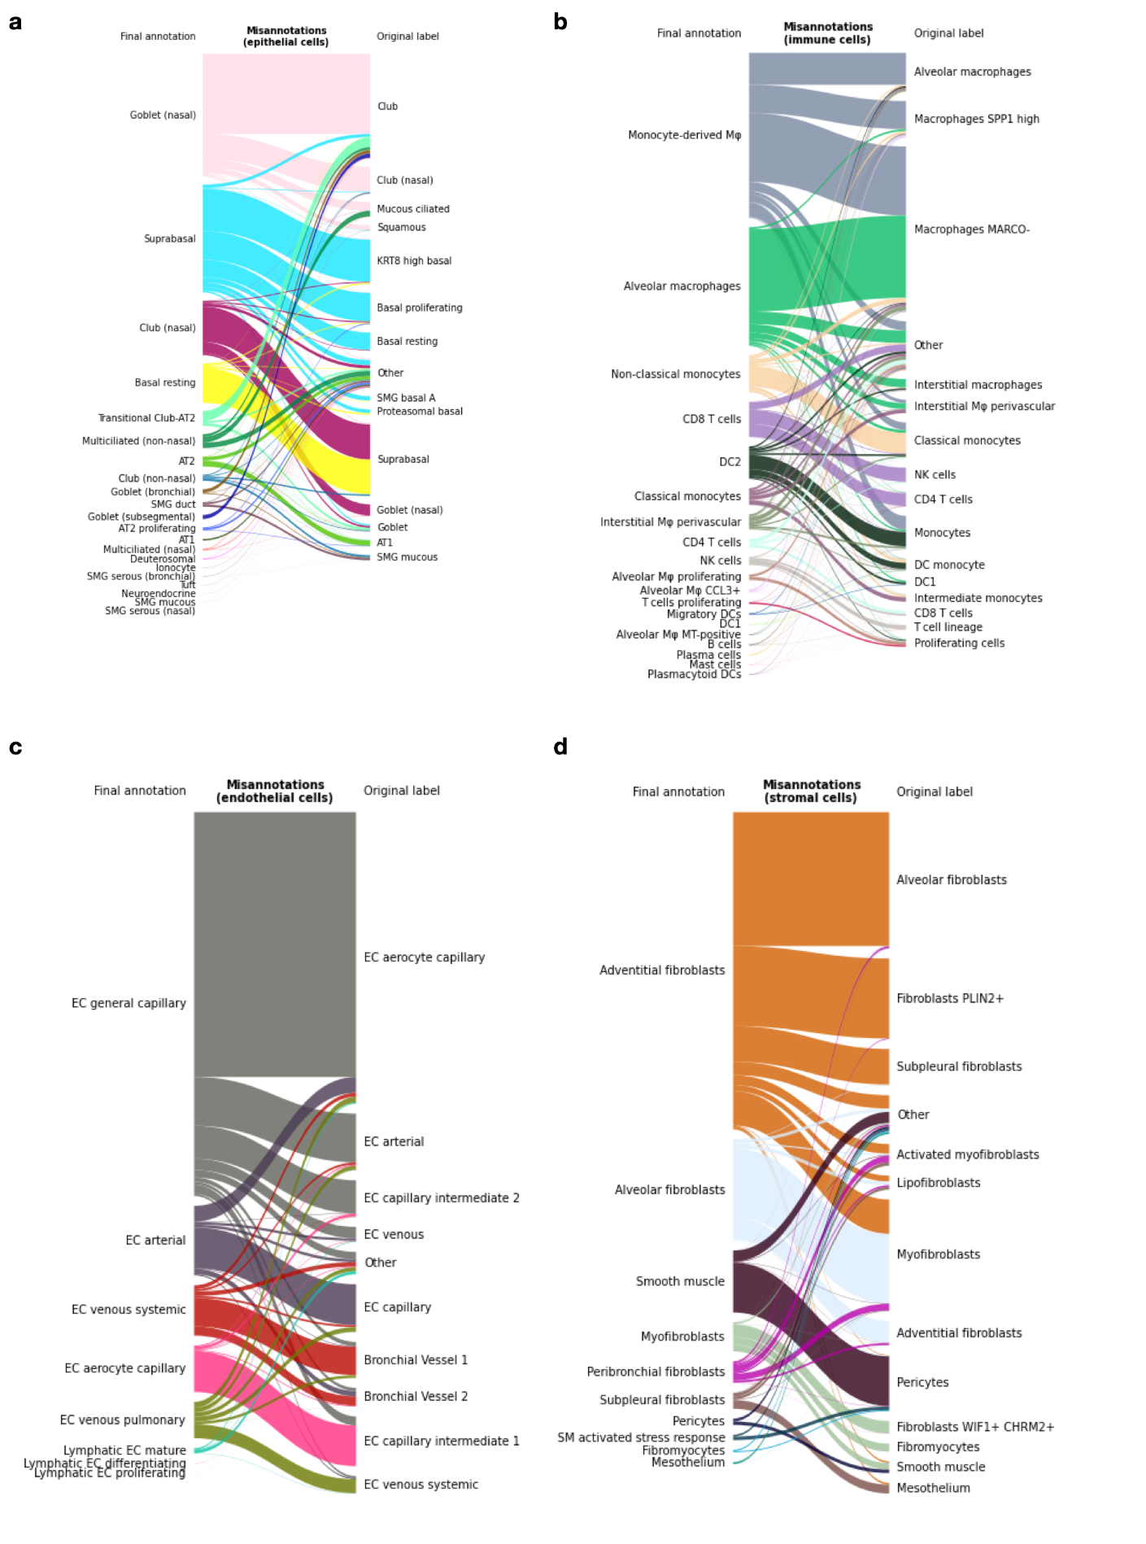

Extended Data Figure 4. Final annotations and original annotations of mislabeled cells. a, Final annotations (left) and original harmonized labels (right) of epithelial cells for which the final annotation and original label are contradictory, i.e. misannotated cells. Original labels that represent less than 1% of epithelial cells are set to “Other”. b, c, d, as a but for immune, endothelial and stromal cells, respectively.

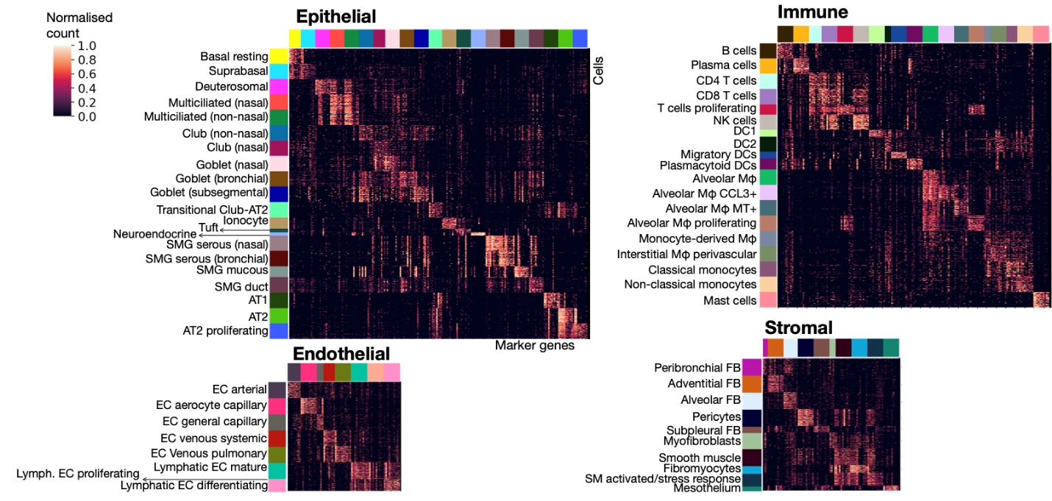
Extended Data Figure 5. Expression of top 10 marker genes for every HLCA cell type annotation. Marker gene names are included in Supplementary Data Table 5. Where more than 750 cells of the cell type were present in the HLCA, expression is only shown for 750 randomly sampled cells from that cell type. Counts were normalized such that a gene’s 99th expression percentile across all cells for the heatmaps was set to 1. DC: dendritic cell. AT1, 2: alveolar type 1, 2 cells. EC: endothelial cells. FB: fibroblasts. Mφ: macrophages. MT: metallothionein. NK cells: natural killer cells. SM: smooth muscle. SMG: submucosal gland.

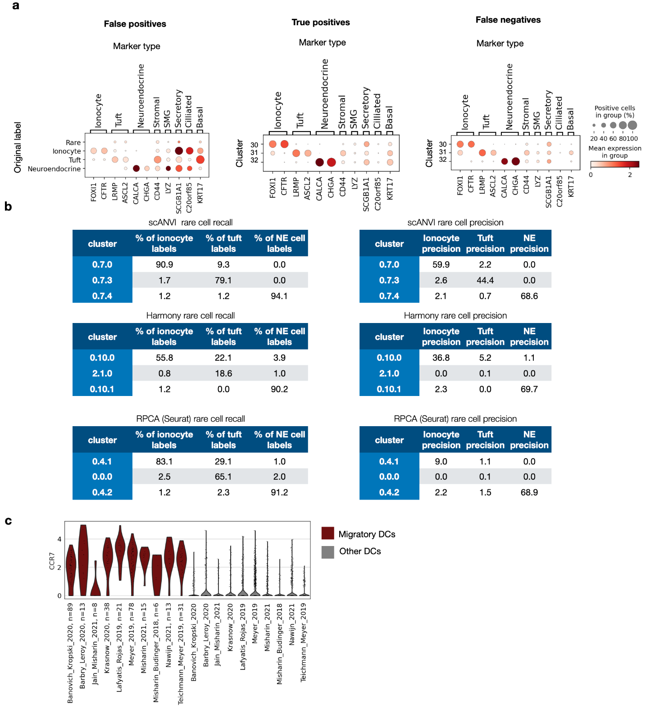
Extended Data Figure 6. Rare cell identification and recovery for three different integration methods. a, Rare cell marker expression among different cell groups in the HLCA core. Markers of other cell types are included to show possible mis-annotations. Left: marker expression of cells originally labeled as rare, but who did not fall in one of the three rare cell clusters of the HLCA (“false positives”), subdivided by original label. Middle: Marker expression of cells originally labeled as rare, and who fell in one of the three rare cell clusters in the HLCA (“true positives”), subdivided by cluster. Right: marker expression of cells who were not originally labeled as rare, but which nonetheless were classified in one of the three rare cell clusters of the HLCA core (“false negatives”), subdivided by cluster. b, Recall and precision of rare cell types in distinct clusters for three different integration methods: scANVI²⁴, Harmony³² and Seurat’s RPCA²⁸. Results are shown for the best-performing preprocessing for each method, and based on the benchmarking data (12 datasets from the HLCA core). Recall (i.e. the percentage of cells with a specific label that are present in the cluster under consideration) and precision (i.e. the percentage of cells from a cluster labeled as the cell type under consideration) are shown for the three level 3 clusters with the highest recall of ionocytes, tuft, and NE cells respectively. NE: neuroendocrine. c, Expression of migratory DC marker CCR7 among migratory DCs versus other DCs, split by study. Number of migratory DCs per study is specified in the x-axis labels. DC: dendritic cell.

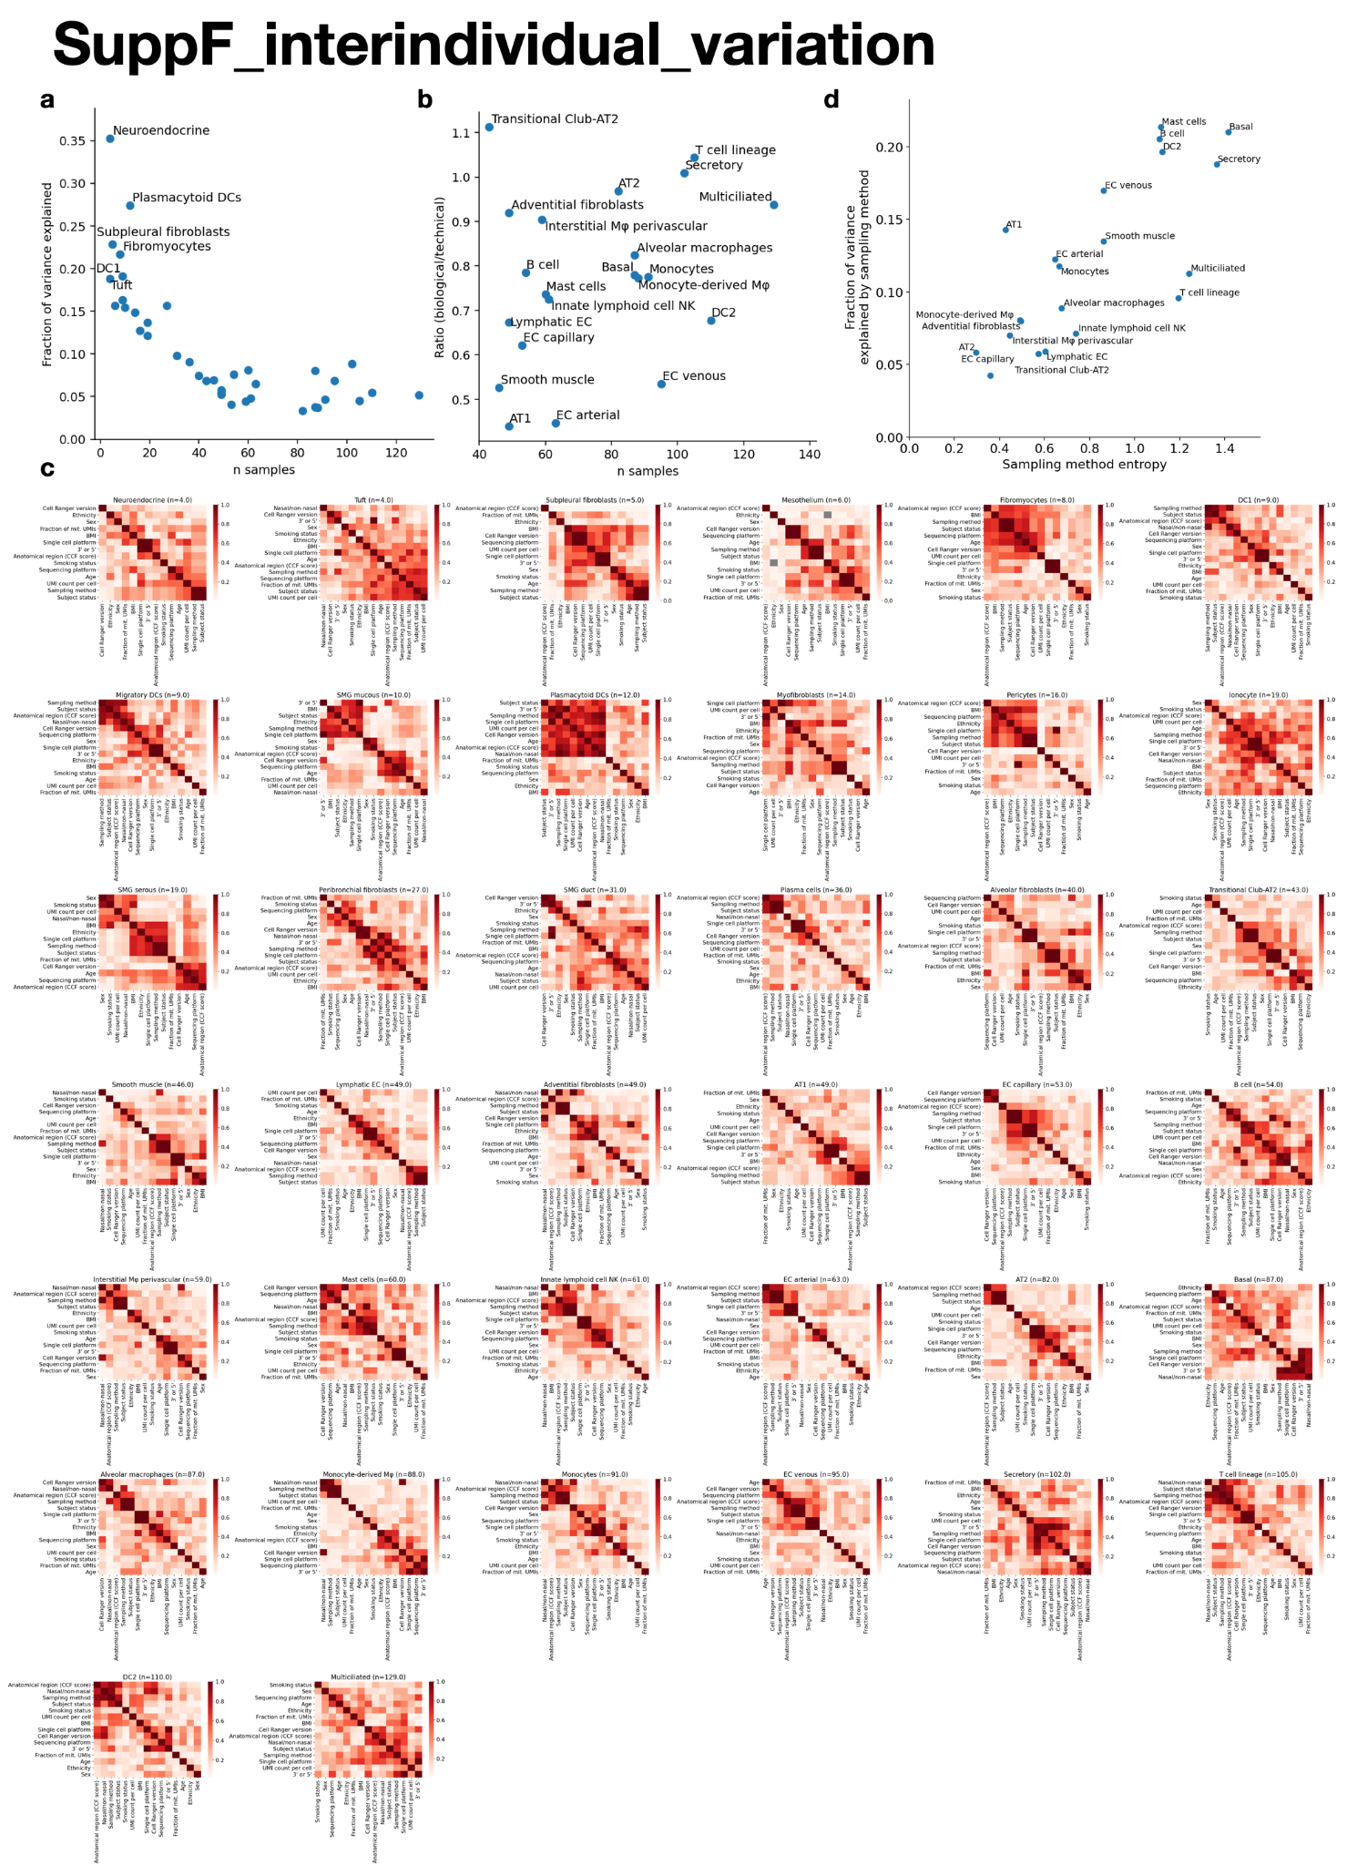Extended Data Figure 7. Correlation of technical and biological covariates with number of samples, and with each other. a, Relation between the number of samples in which a cell type was observed, and the mean inter-sample variance explained by the technical and biological covariates. After n=40, these two variables become independent. Inter-sample variance was calculated based on the scANVI-integrated embedding, taking the mean score of each latent dimension across cells, for every sample for every cell type. b, The ratio of mean variance explained by biological covariates over that explained by technical covariates for different cell types (y-axis), and its association with the number of samples in which a cell type was observed (x-axis) (Pearson r: 0.28, p=0.21). c, Correlation between covariates for every cell type, calculated at sample level. The square root of the fraction of variance from one covariate that could be explained by the other covariate through linear regression is shown (equivalent of Pearson r for two continuous covariates). If both covariates were categorical and had more than two categories, normalized mutual information was calculated instead. d, Variance explained by sampling method depends only partly on diversity in sampling methods as quantified by the sampling method entropy (Pearson r=0.75, p=0.0001). Some cell types, such as T cells, are less sensitive to sampling than others, despite higher sampling method entropy. AT1, 2: alveolar type 1, 2 cells. DC: dendritic cells. DC1, 2: DC type 1, 2. EC: endothelial cells. Mφ: macrophages. NK cells: natural killer cells. NKT cells: natural killer T cells. SMG: submucosal gland.

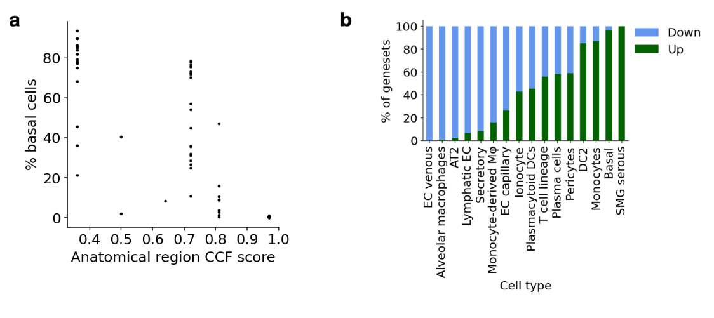
Extended Data Figure 8. Trends associated with BMI and sample anatomical location. a, The percentage of basal cells per sample decreases with higher anatomical region CCF score, i.e. towards the distal lung (Spearman r=-0.89, p<0.001). CCF: common coordinate framework. b, Proportions of gene sets significantly up- and down-regulated with BMI, per cell type. AT2: Alveolar type 2 cells. DC: dendritic cells. DC2: DC type 2. EC: endothelial cells. Mφ: macrophages. SMG: submucosal gland.

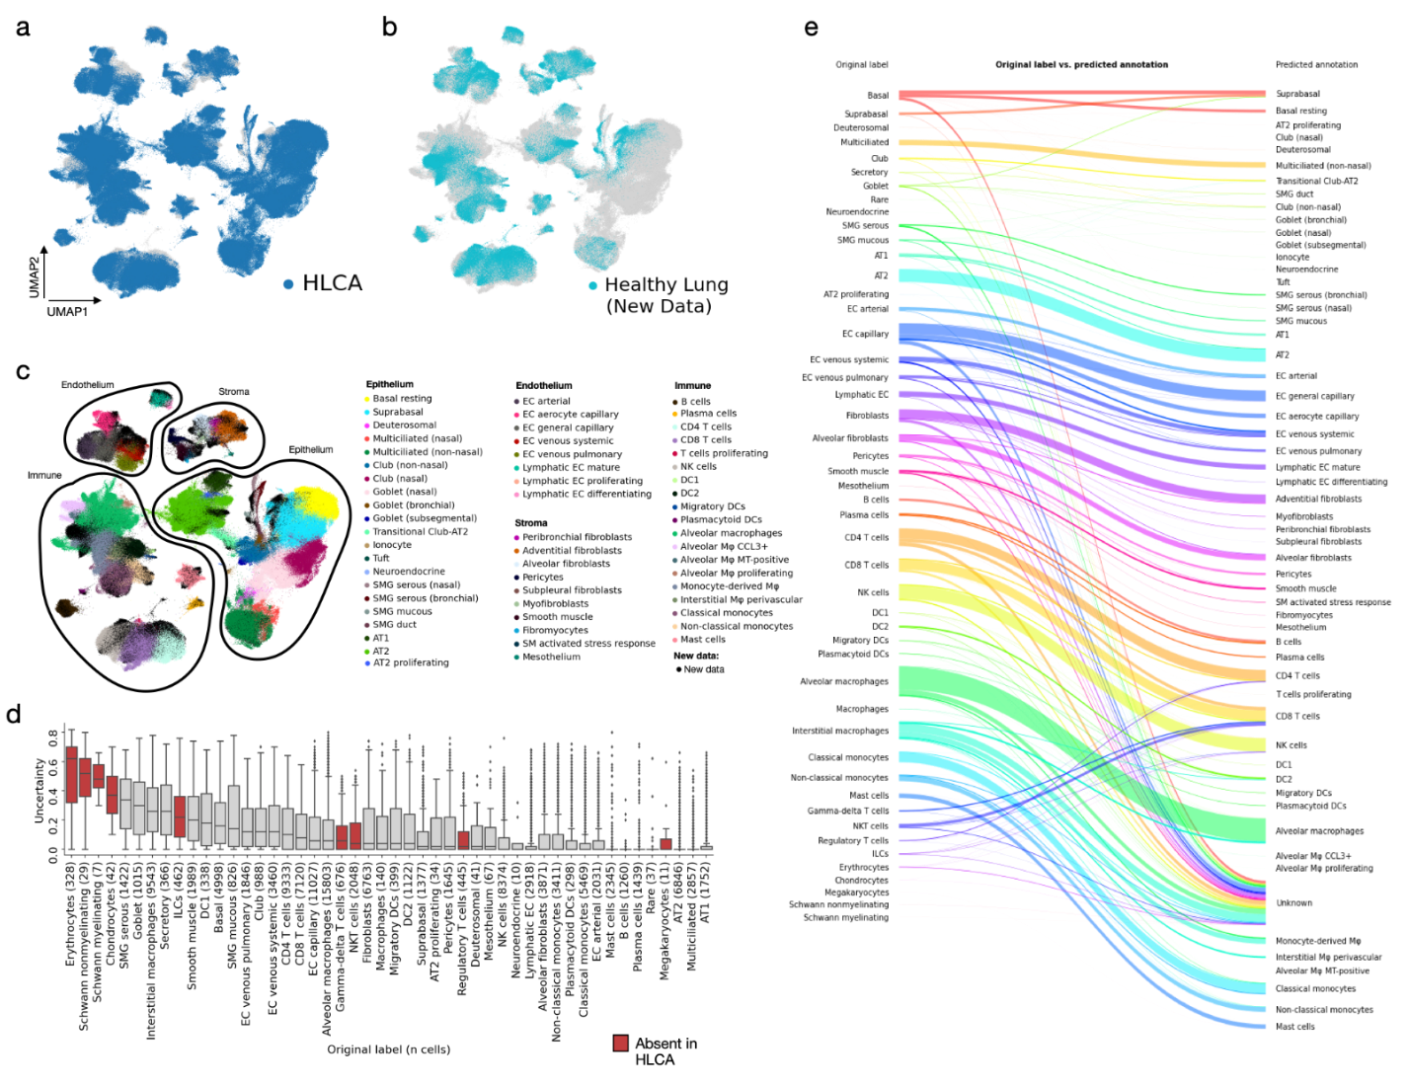
Extended Data Figure 9. Mapping of unseen healthy lung scRNA-seq data to the HLCA core. a, A UMAP of the jointly embedded HLCA core and the newly mapped healthy lung data. Cells from the new data are shown in gray, cells from the HLCA are shown in blue and plotted on top. b, Same as a, but now plotting cells from the HLCA in gray, and cells from the new data on top in light blue. c, Same as a, but now coloring cells from the HLCA core by their final annotation, and coloring cells from the new data in black. d, Uncertainty of label transfer (ranging from 0 to 1) for cells from the mapped data, subdivided by original cell type label. Number of cells per label is shown between brackets. Cell labels are ordered by mean uncertainty. Boxes of cell labels not present in the HLCA core are colored red. Boxes show median and interquartile range of uncertainty. Cells with uncertainties more than 1.5 times the interquartile range away from the high and low quartile are considered outliers and plotted as points. Whiskers extend to the furthest non-outlier point. e, Sankey plot of original labels of cells from the mapped dataset versus predicted annotations based on label transfer. Cells with uncertainty >0.3 are labeled “unknown”. AT1, 2: alveolar type 1, 2 cells. DC: dendritic cells. DC1, 2: DC type 1, 2. EC: endothelial cells. ILCs: innate lymphoid cells. MT: metallothionein. Mφ: macrophages. NK cells: natural killer cells. NKT cells: natural killer T cells. SM: smooth muscle. SMG: submucosal gland.

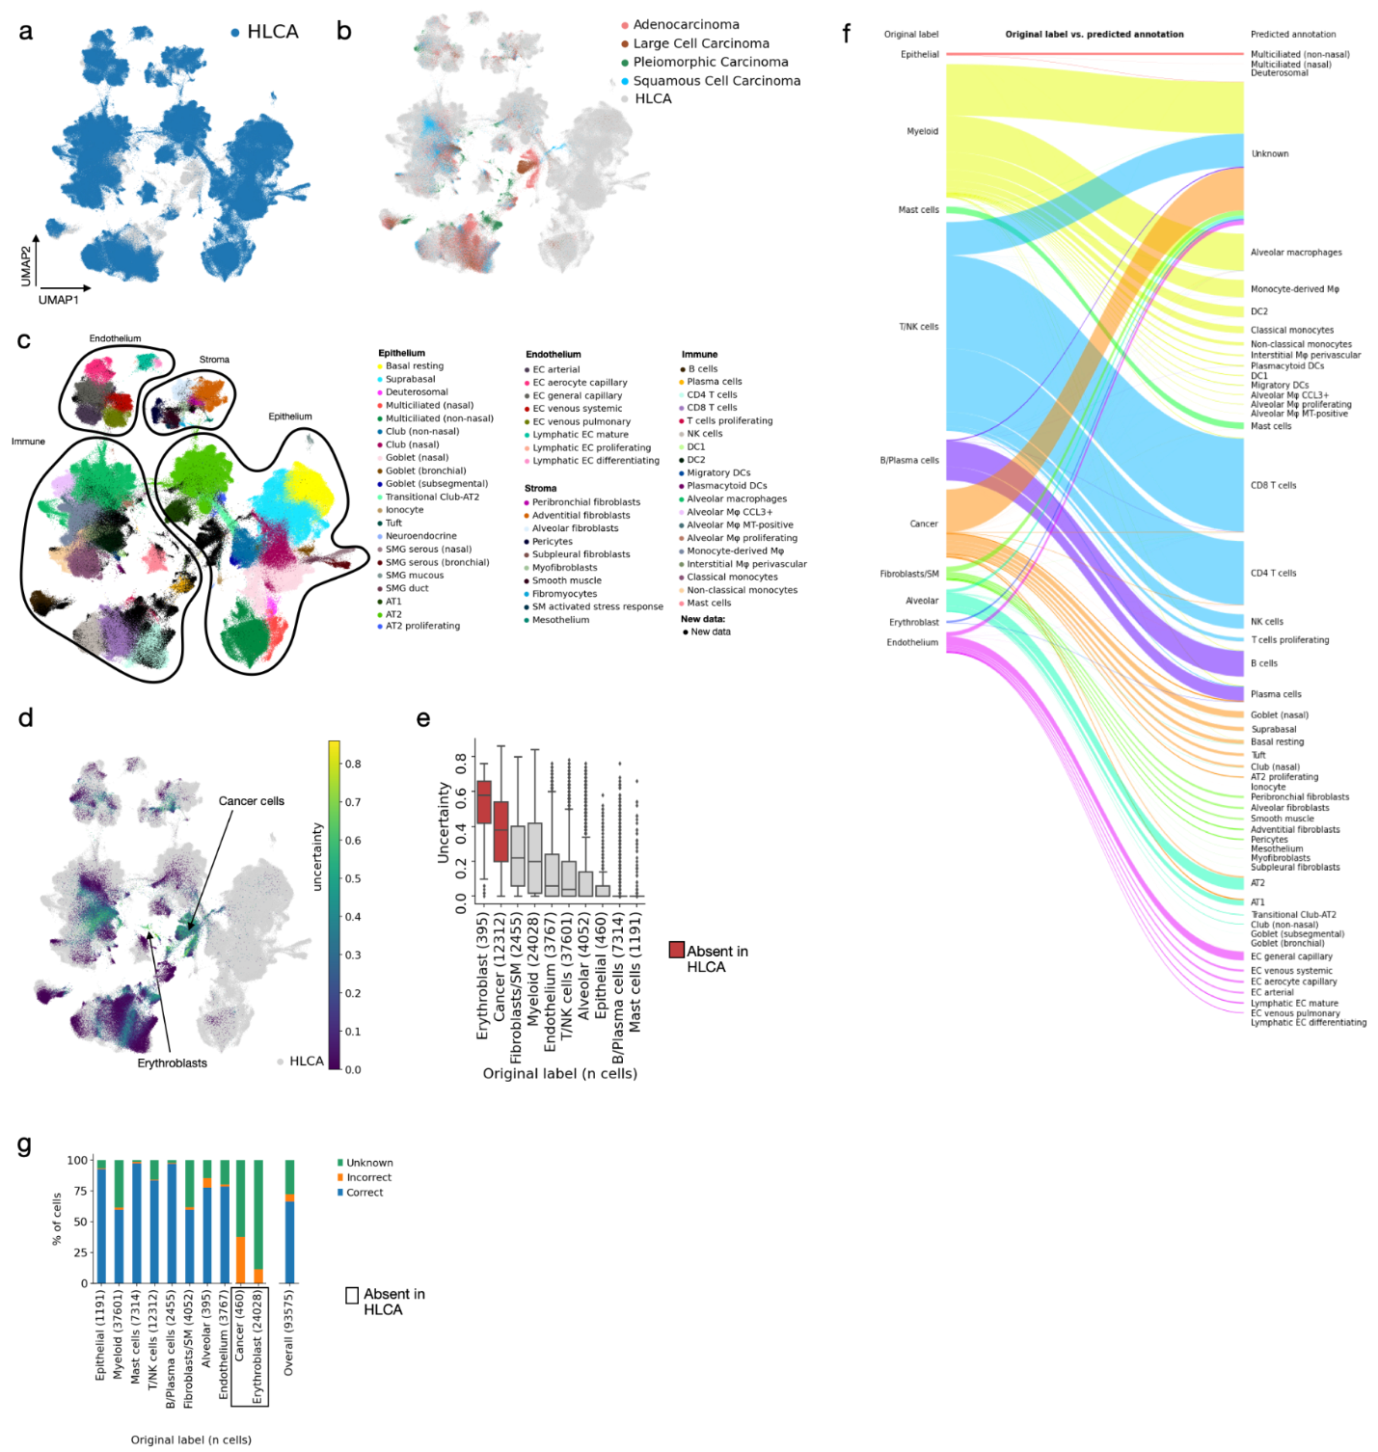
Extended Data Figure 10. Mapping of unseen lung cancer data to the HLCA. a, A UMAP of the jointly embedded HLCA and lung cancer data. Cells from the lung cancer dataset are shown in gray, cells from the HLCA core are shown in blue and plotted on top. b, Same as a, but now plotting cells from the HLCA core in gray. Cells from the mapped data are plotted on top, and colored by the cancer type of the patient. c, Same as a, but now coloring cells from the HLCA core by their final (coarse) annotation, and coloring cells from the mapped cancer data in black. d, Uncertainty of label transfer, shown for all cells from the mapped data. Regions dominated by high-uncertainty cells are labeled by the original cell type label. e, Uncertainty of label transfer (ranging from 0 to 1) for the mapped cells, subdivided by original cell type label. Number of cells per label is shown between brackets. Boxes of cell type labels not present in the HLCA core are colored red. Cell types are ordered by mean uncertainty. Boxes show median and interquartile range of uncertainty. Cells with uncertainties more than 1.5 times the interquartile range away from the high and low quartile are considered outliers and plotted as points. Whiskers extend to the furthest non-outlier point. f, Sankey plot of original labels of the mapped data versus predicted annotations based on label transfer. Cells with uncertainty >0.3 are labeled “unknown”. g, Percentage of cells from newly mapped healthy lung dataset that are either annotated correctly or incorrectly by label transfer annotation, or annotated as unknown, subdivided by original cell type label. The number of cells in the mapped dataset labeled with each label are shown between brackets after cell type names. Cell type labels not present in the HLCA are boxed. AT1, 2: alveolar type 1, 2 cells. DC: dendritic cells. DC1, 2: DC type 1, 2. EC: endothelial cells. MT: metallothionein. Mφ: macrophages. NK cells: natural killer cells. NKT cells: natural killer T cells. SM: smooth muscle. SMG: submucosal gland.

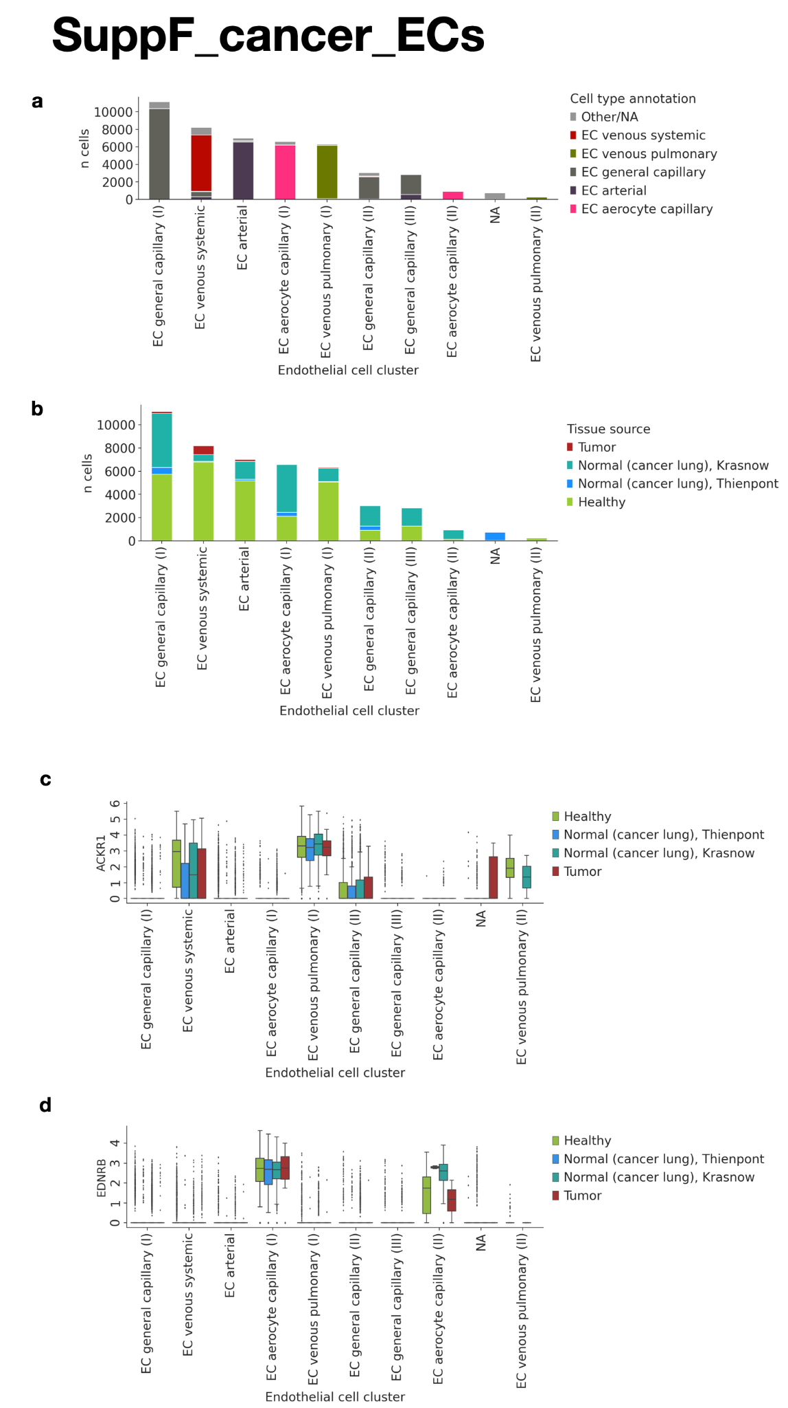
Extended Data Figure 11. Endothelial cell clustering and marker expression in the joint embedding of unseen lung cancer data and the HLCA core. a, Cell type composition of EC clusters from the joint embedding of the HLCA core and the mapped lung cancer data. Final HLCA core annotations are shown, with cells from the cancer data as well as HLCA core annotations with fewer than 50 cells set to “Other/NA”. Clusters are named by their dominant cell type. b, Tissue source composition of EC clusters. Tissue source is either tumor, normal (but from cancer patients), or healthy (from subjects without lung cancer). Normal is split by dataset, including the Krasnow dataset from the HLCA core (with non-tumorous tissue from lung cancer patients) for comparison. c, ACKR1 expression in EC clusters, split by tissue source. Boxes show median and interquartile range of expression. Cells with uncertainties more than 1.5 times the interquartile range away from the high and low quartile are considered outliers and plotted as points. Whiskers extend to the furthest non-outlier point. d, same as c, but now showing EDNRB expression. EC: endothelial cell.

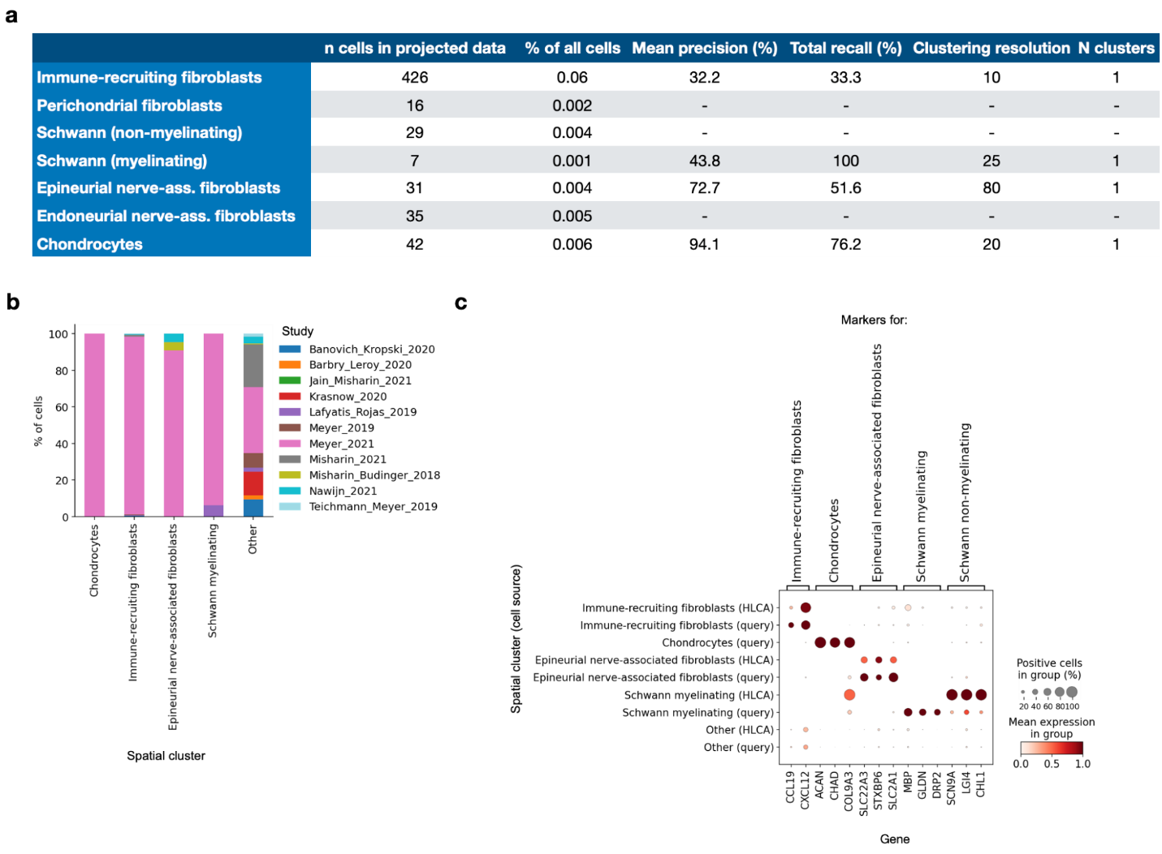

Extended Data Figure 12. Identification of spatial-location-based cell types in the HLCA core based on mapping of spatially labeled data. a, Precision (i.e. the percentage of cells from a cluster labeled as the cell type under consideration) and recall (i.e. the percentage of cells with a specific label that are present in the cluster under consideration) of spatial cell types in spatial clusters. Precision and recall were calculated among cells of the mapped data only. Clustering resolution at which the cluster was identified, and number of clusters per spatial cell type is also shown. % of all cells specifies the percentage of cells with the label among cells of both the projected data and the HLCA core. b, Composition of spatially annotated clusters in terms of study from which the cells came. c, Marker expression of spatially annotated cell type markers across spatially annotated clusters, splitting clusters in cells from the HLCA core, and cells from the newly mapped data (“query”). Gene expression was normalized to range, within fibroblasts, from 0 to 1.

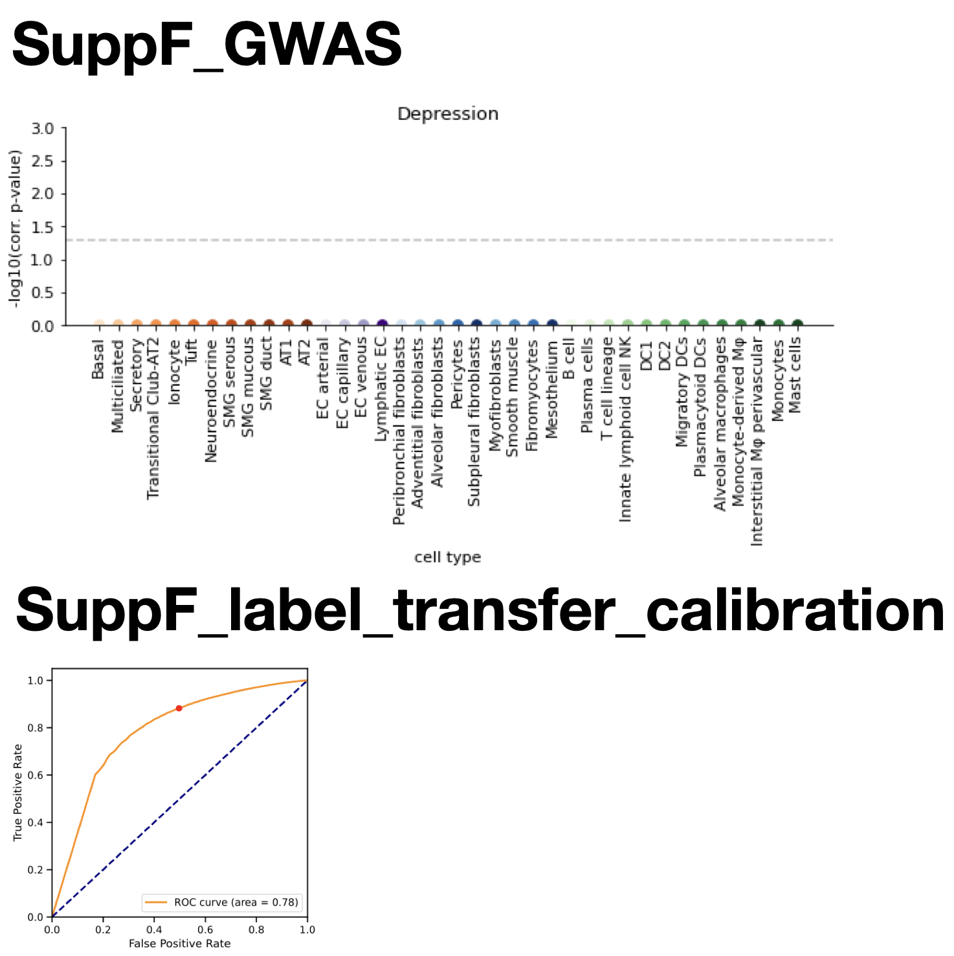
Extended Data Figure 13. Association of lung cell types with depression. Negative control for analysis of fig. 5d. Association is based on phenotype-related genomic variants from a GWAS study on depression, and cell-type specific differentially expressed genes calculated from the HLCA core. Horizontal dashed line indicates significance threshold alpha=0.05. p-values are multiple-testing-corrected with the Benjamini-Hochberg procedure.

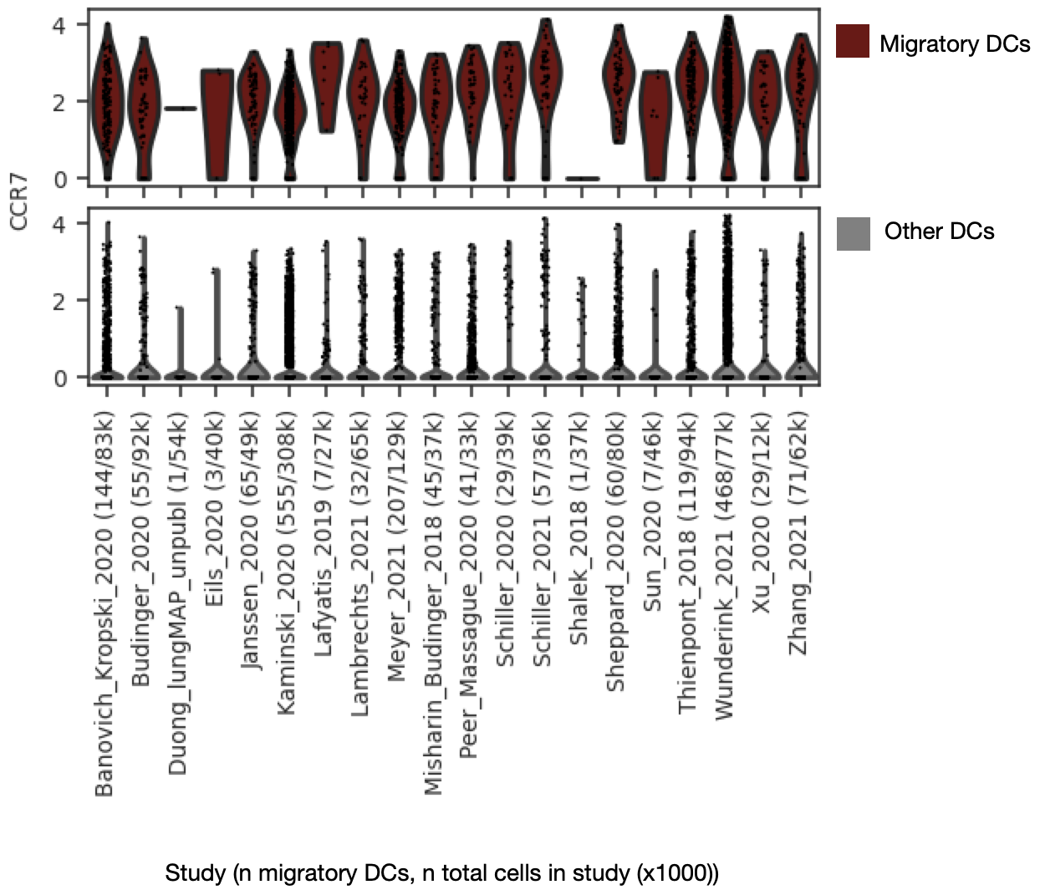
Extended Data Figure 14. Expression of CCR7 among cells annotated as migratory DCs by label transfer. Expression of CCR7 is shown for all cells that were annotated as migratory DCs with low uncertainty (<0.2) (top) and all other cells annotated as DC (bottom) by label transfer from the HLCA core to the extended HLCA. Cells are grouped based on study of origin (some studies contain multiple datasets). X-tick labels show study, number of cells annotated as migratory DCs, and number of total cells (in thousands) per study. CCR7 counts shown are counts that were normalized based on the total count among 2000 genes used for mapping to the HLCA core, and then log-transformed. DCs: dendritic cells.

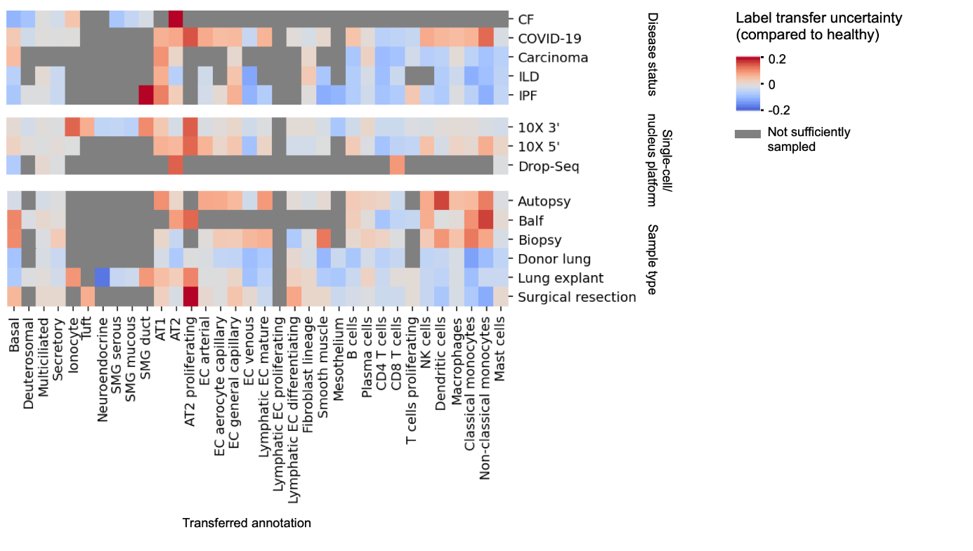
Extended Data Figure 15. Label transfer uncertainty per cell type across different experimental features. Label transfer uncertainty of cell types is shown for categories of three experimental features, as compared to uncertainty in healthy cells. For every category and for each cell type, the mean uncertainty across datasets from that category was calculated, using per-dataset means and splitting up datasets with samples from more than one category. The difference between cell type uncertainty from each category and those of healthy datasets is shown. Where mean uncertainty was higher than 0.25 even in healthy, coarser parent labels were included (e.g. for macrophages) instead of the finest cell type annotations. Datasets with fewer than 20 cells of a cell type are excluded for that cell type. When no dataset sampled enough cell types, the plot is masked in gray. Values higher than 0.2 or lower than -0.2 are cut off to 0.2 and -0.2, respectively.

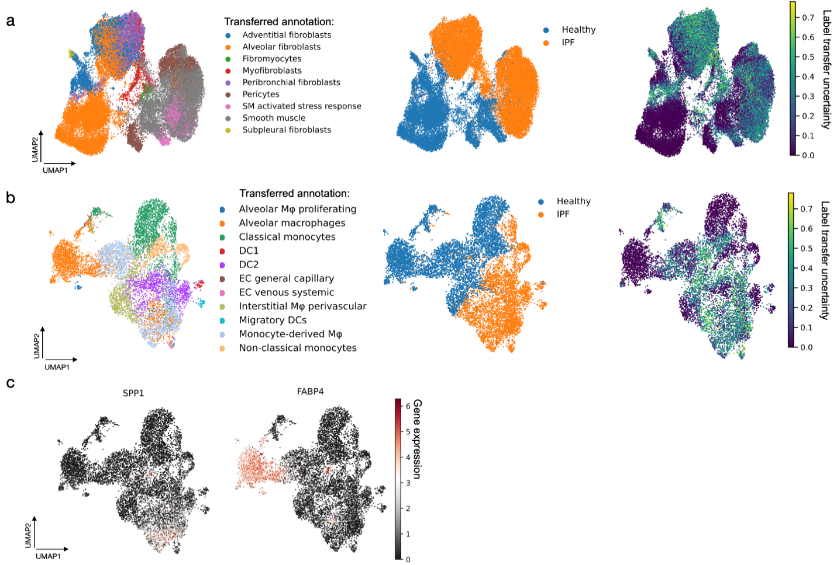
Extended Data Figure 16. Transferred labels and matching uncertainty for a mapped IPF dataset. a, UMAPs of cells originally labeled as stroma, from a mapped IPF dataset⁶² including both healthy and IPF samples. Cells are labeled by annotation transferred from the HLCA core (left), by disease status (middle), and by label transfer uncertainty (right). Cells with labels transferred to fewer than 10 cells were excluded. b, same as a, but showing cells originally labeled as macrophages. c, As b, but now colored by expression of SPP1 and FABP4.

Extended Data Figure 17. Calibration of label transfer uncertainty cutoff. ROC curve of label transfer accuracy across 7 datasets. The true and false positive rate of the chosen cutoff point (0.2), below which transferred labels will be considered low uncertainty, are shown as a red point on the ROC curve.

