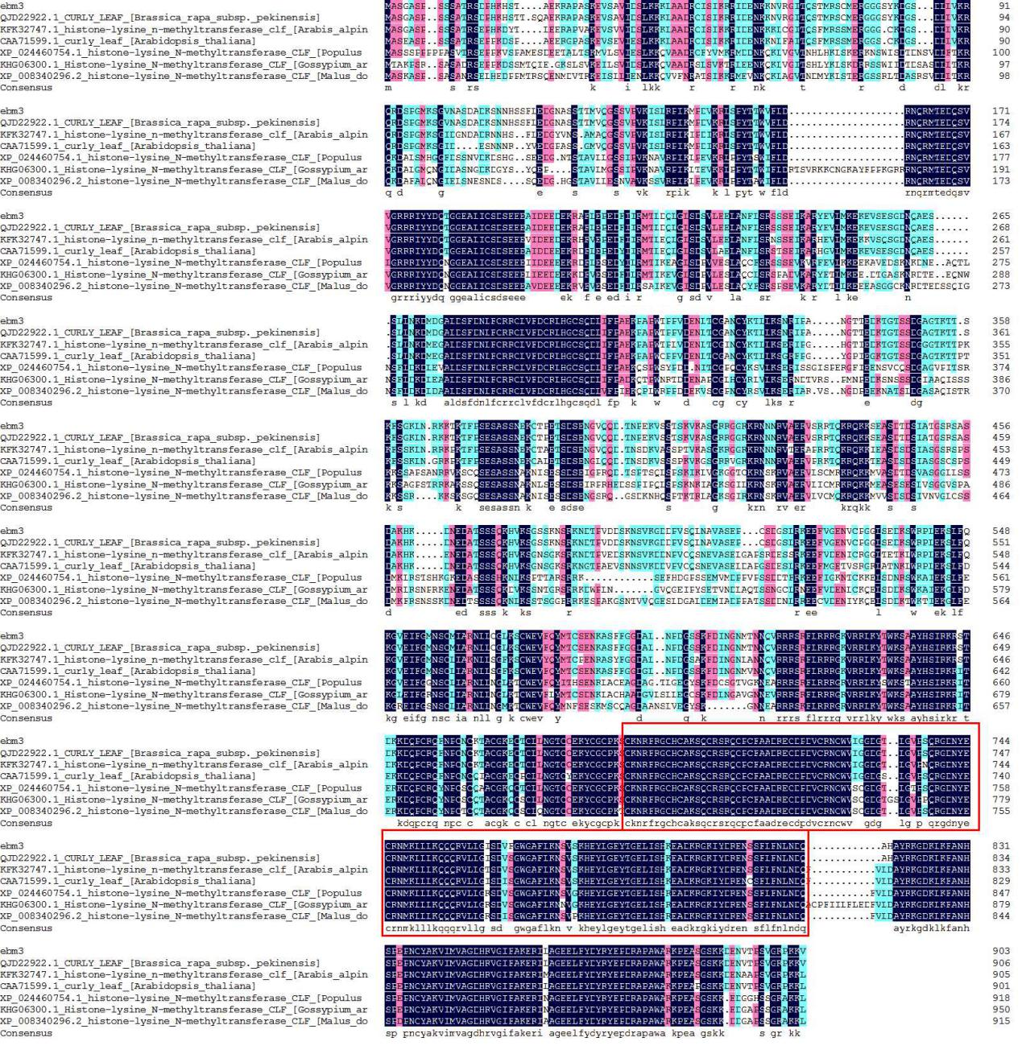
Figure S1 Original figure of CLF sequence alignment in various species. The red line inner part is the cropping part in Fig. 2C.

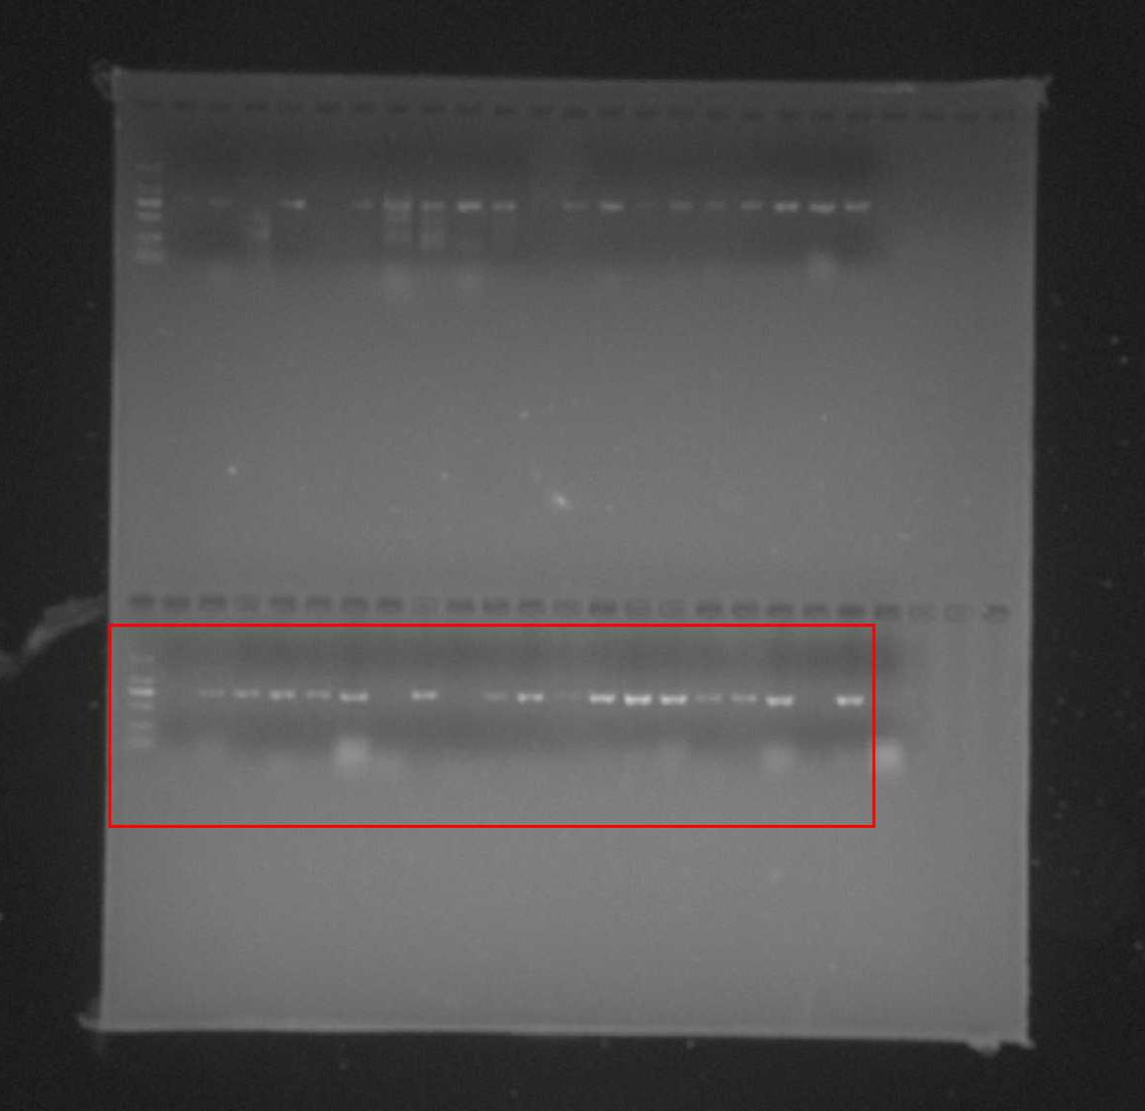
Figure S2 Full-length gels and blots of GUS reporter gene. The red line inner part is the cropping part in Fig. 3C. The marker is 2,000 bp.

Figure S3 GO enrichment analysis of DEGs obtained in the SAM of mutant ebm3 and wild-type line ‘FT’ by transcriptome profiling

Figure S4 Pathway enrichment analysis of DEGs obtained in the SAM of mutant ebm3 and wild-type line ‘FT’ by transcriptome profiling.

