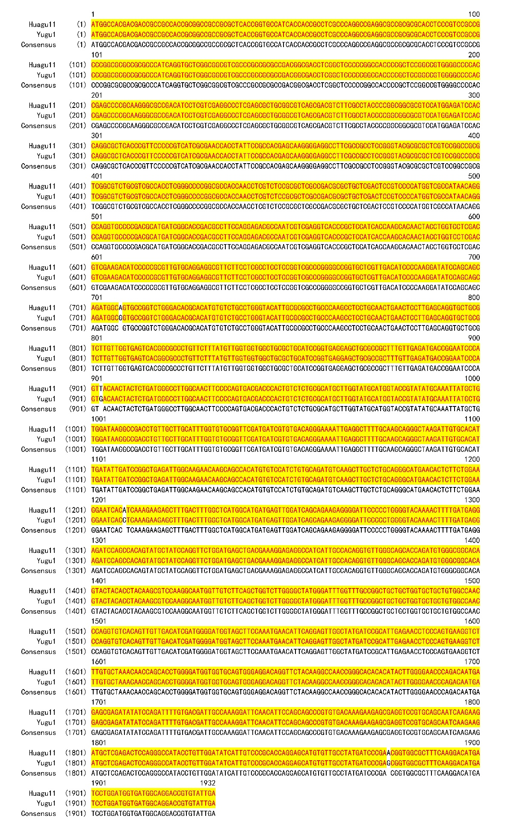
Figure S5. The nucleotide sequence alignment of AHAS from the genome of Huagu11 and Yugu1.

