Appendix
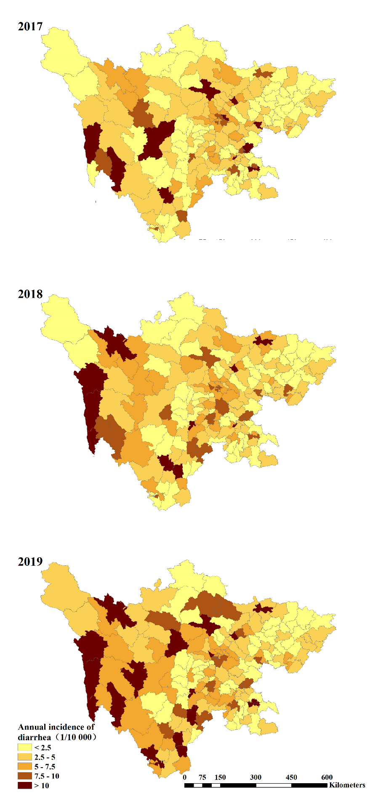

Figure S1 The geographical distribution of diarrhea morbidity at county-level from 2017 to 2019
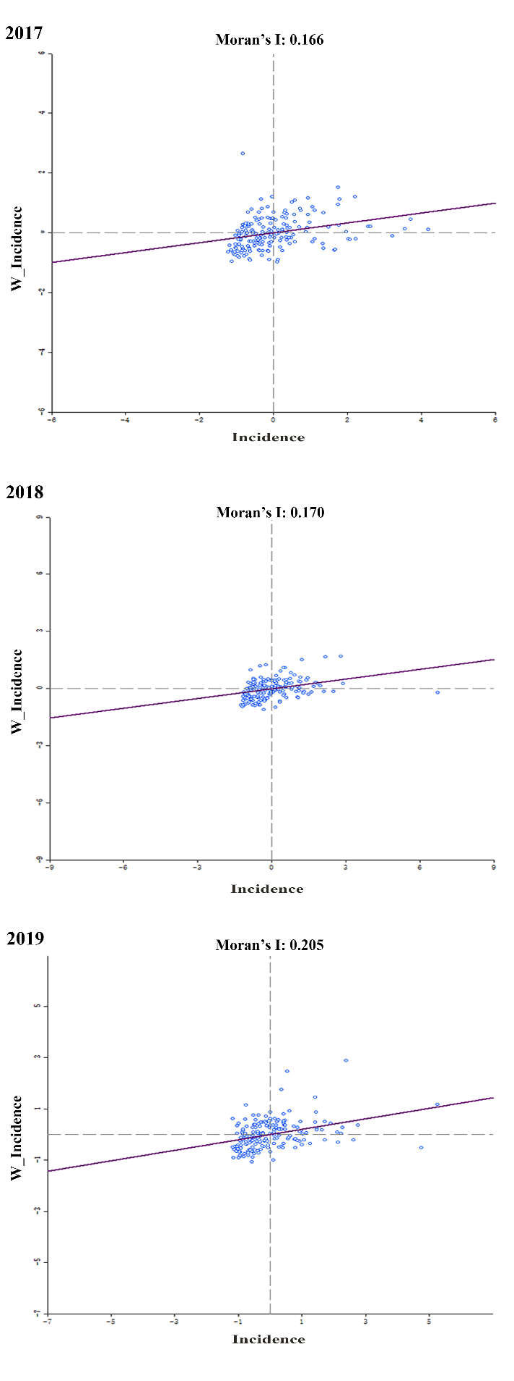

Figure S2 Moran scatter plot for the annual diarrhea morbidity at county-level from 2017 to 2019
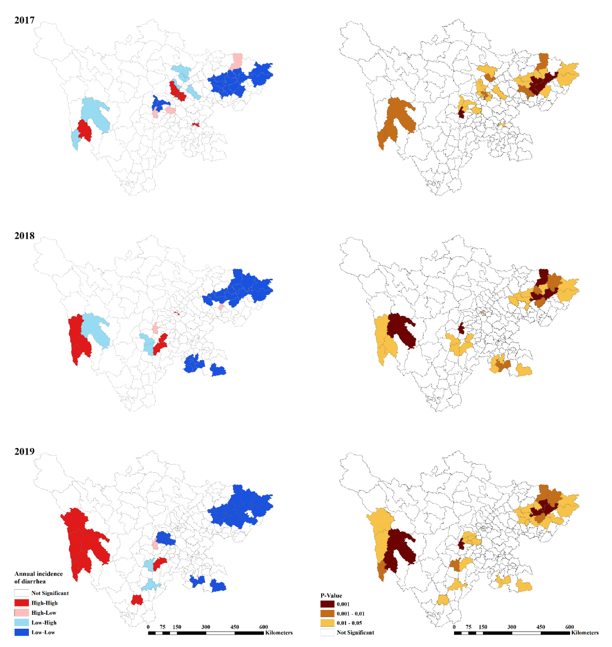

Figure S3 LISA significance map and cluster map for diarrhea morbidity at county-level in Sichuan Province, China, 2017-2019.

