Supplemental materials

Temporal-spatial progress of cartilage nanocalcification in osteoarthritis development
Xiaozhao Wang^{1,2,3,4, #}, Qin Wu^{3, #}, Ru Zhang^{1,2,3,4, #}, Zhang Fan³, Wenyue Li^{1,2,3,4}, Renwei Mao⁵, Zihao Du⁵, Xudong Yao⁶, Yuanzhu Ma^{1,2,3,4}, Yiyang Yan^{1,2,3,4}, Wei Sun^{1,2,3,4}, Hongwei Wu^{1,2,3,4}, Wei Wei⁶, Yejun Hu¹, Yi Hong^{1,2,3,4}, Huan Hu⁵, Yi Wen Koh,³ Wangping Duan⁷, Hongwei Ouyang^{1,2,3,4,}*

1.Dr. Li Dak Sum & Yip Yio Chin Center for Stem Cells and Regenerative Medicine, and Department of Orthopedic Surgery of the Second Affiliated Hospital, Zhejiang University School of Medicine, Hangzhou, 310058, China.
2.Department of Sports Medicine, Zhejiang University School of Medicine, Hangzhou, 310058, China.
3.Zhejiang University-University of Edinburgh Institute, Zhejiang University School of Medicine, and Key Laboratory of Tissue Engineering and Regenerative Medicine of Zhejiang Province, Zhejiang University School of Medicine, Hangzhou, 314400, China.
4.China Orthopedic Regenerative Medicine Group (CORMed), Hangzhou, 310058, China.
5. Zhejiang University/University of Illinois at Urbana-Champaign Institute, Zhejiang University, Haining, 314400, China
6. International Institutes of Medicine, The 4th Affiliated Hospital of Zhejiang University School of Medicine, Yiwu, Zhejiang, China
7. Department of Orthopedics, Second Hospital of Shanxi Medical University, Shanxi Key Laboratory of Bone and Soft Tissue Injury Repair, Taiyuan, Shanxi, 030001, China.

Materials and Methods
Methods, including statements of data availability and any associated accession codes and references, are available in the online version of this paper.

Sample preparation
All samples of OA cartilages were obtained from patients undergoing joint replacement surgery (n=36). Normal cartilage samples collected at the time of surgical amputation (without OA, n=6) were used as control. All tissues were carefully collected and washed with sterile phosphate buffered saline (PBS) until being stored at -80 ºC for materials characterization. Informed consent was obtained from all patients. This study was approved by the Second Hospital of Shanxi Medical University Ethics Committee (2019YX260). For electron microscopy, Raman spectroscopy, nanoindentation studies, and AFM methods, 30-μm thick cryo-sectioned slices were prepared. For the X-ray diffraction and Fourier transform infrared spectroscopy (FTIR) measurement, the osteochondral interface tissues were carefully extracted by scalpel.

Histology
All cartilage samples were cut into small pieces and fixed in 4% paraformaldehyde for 48 h, and decalcified in 10% EDTA-2Na (w/v) solution for at least 4 weeks. Then, all samples were dehydrated and embedded in paraffin. 7-μm thick sections were cut for Safranin-O (SO) staining to assess OA histopathology according to the established scoring system.¹ The system divided the samples into the main 4 stages (0-4), where normal cartilages were graded to be 0 and OA cartilages were graded as 1-2 (OA-E) and 3-4 (OA-A). Since the cartilage was almost denuded at grade 4, these samples were not considered for further materials analysis. Also, subgrade 0.5 was utilized in the grading.

Micro-computed tomography
The microstructure of calcified cartilage was evaluated by microcomputed tomography (μCT). The frozen samples were cut into cubes of 3-5 mm using a scalpel, fixed in 2.5% glutaraldehyde solution for at least 48 h under agitation. After washing, the samples were soaked in a contrast agent Imeron 300, followed by vacuumed (1000 mbar) for 2 mins to enhance tissue penetration. Then, samples were incubated in the same solution overnight. Samples were washed with 75% ethanol several times and stored in 100% ethanol solution for further measurement. Then, microcomputed tomography was carried out. About 1200 projections were collected with a pixel size of 2.5 μm. For rendering, Avizo Fire (Version 8.10, FEI Visualization) was utilized.

SEM and EDX analyses
Samples were thawed at room temperature and washed with DI water, followed by dehydration with a graded ethanol treatment (20, 30, 40, 50, 70, 80, 90, 95, 100 and 100 % (v/v)) for 20 min in each solution and air-dried. To prevent surface charging, samples were gold-sputtered and imaging was performed (Zeiss G300). To observe the microstructure of the cartilage surface, 3 kV accelerating voltage was used to collect secondary electrons. To obtain the DDC-SEM images, an accelerating voltage of 10 kV was used. The instrument was equipped with inlens detector and a backscatter electron detector that recorded secondary electrons and backscattered electrons, respectively. The DDC-SEM images were acquired by imaging the same region in the two modes. Using Image J software, the inlens images were assigned to the green channel and the backscatter images were assigned to the red channel. Subsequently, both images were stacked. EDX spectra were also collected in the same regions using point and mapping mode to further measure the elemental compositions.

FTIR
The chemical composition of the osteochondral interface tissues was detected using an FTIR spectrometer (Thermo Fisher, Nicolet iS50). Each spectrum was collected with a spectral resolution of 4 cm⁻¹ and wavenumber ranging from 400 to 4000 cm⁻¹.

XRD
The crystalline structure of the mineralized interface of osteochondral tissues was detected using X-ray powder diffraction (X’Pert3 Powder, Malvern Panalytical, Netherlands) with Cu Kα radiation (λ= 0.154 nm) operating at 40 kV. The data were collected with a sampling step of 0.2º in the 2θ range from 5º to 90º.

Raman spectroscopy
The Raman spectroscopy was performed to measure the chemical components across the osteochondral interface using a confocal Raman microscope (LabRAM HR Evolution, Horiba Co., Ltd.) equipped with a 532 nm laser. Each spectrum was collected in the 200~1900 cm⁻¹ using an electron multiplying charge-coupled device (EMCCD) detector with a spectral resolution of ~1 cm⁻¹. In the point mode, the spectra were obtained using an accumulation time of 5 s. As for the Raman mapping, continuous scanning (spatial resolution ~1 μm) with an accumulation time of 0.1-0.5 s was performed. No sample degradation was noticed using this parameter.

Nanoindentation
Indentation studies were performed with a nano-indenter (PIUMA, Optics 11, Amsterdam Netherlands). The elastic modulus of tissues was measured using a soft cantilever with a radius of 10 μm and a stiffness of 159 N/m. To map the modulus transition of the osteochondral interface, a nanoindentation test matrix (step: x and y-2×2 μm) was performed on the calcified cartilage region. To mimic the physiological environment, all measurements were operated in PBS solution.

AFM
The Force-Displacement (FD) measurements of the Atomic force microscope (AFM) were performed to describe the nanomechanical properties of calcified cartilage tissue. We used a Cypher ES AFM (Oxford instruments Asylum Research, USA) and Si cantilevers (AC160TS-R3, Olympus, Japan) with a tip radius < 10 nm, a determined spring constant 26 N/m, and a back angle α = 35º. Measurements for a 40×40 array of FD data were taken of three different OA regions in 6×6 μm² large area. The tip approach speed was 3 μm/s until a force of 6 μN was reached, followed by tip retraction at the same speed. Hertz model with a conical tip was assumed to analyze the FD data to fit Young’s modulus. From maps of FD data, we wrote our MATLAB scripts to construct profiles of the indentation modulus.

FIB-SEM
Specimen Preparation. Cartilages at different OA stages, containing the osteochondral interfaces regions between noncalcified to calcified regions, were carefully dissected using a scalpel. Then, samples were chemically fixed in 2.5% glutaraldehyde in PBS overnight, followed by staining with 2% osmium tetroxide in PBS solution for 2 h. After washing with PBS solution several times, the samples were dehydrated with a graded acetone series (30%, 50%, 70%, 90%, 100%, and 100%; one h for each step except for 70% overnight) and finally embedded in spur resin. All embedded samples were grounded to expose longitudinal sections for the osteochondral interfaces and polished with a diamond suspension to improve surface smoothness for subsequent FIB-SEM serial imaging.

Data collection by FIB-SEM. Resin blocks were trimmed using Leica EM trimmer carefully until the surface of black tissue in the block was seen. To get the area of interest, we used a scanning electron microscope (Thermo Fisher, Teneo VS) with one ultramicrotome in its specimen chamber which allowed us to trim the resin blocks and acquire the electron microscopic image of the sample synchronously. After finding the area of interest, imaging was performed using dual-beam scanning electron microscopy (Thermo Fisher, FIB Helios G3 UC). The data collection procedure was operated in the serial-surface view mode with the slice thickness 10 nm at 30 keV, 0.43 nA. Each serial face was then imaged with a 2 kV acceleration voltage and a current of 0.2 nA in backscatter mode (BSE) with an ICD detector. The image store resolution was set to 3072×2048 pixels with a dwell time of 15 μs per pixel and 4.25 nm per pixel.

Image processing and segmentation. The image stack was aligned and cropped using Amira 6.5 (Thermo Fisher). Segmentation and labeling of cuticle and sensilla were carried out manually using Amira 6.5. Finally, surface-generation tools were used to compute surfaces of structures of interest using Amira 6.5.

TEM, EDX, EELS and SAED analyses
The sample prepared with FIB were imaged in an aberration-corrected scanning transmission electron microscope (FEI Titan G2 80-200 microscope equipped with a Super-X EDX detector) at 200 kV. HAADF-STEM, STEM-EDX mapping and SAED patterns were performed at regions of interest. EELS spectra images were collected in the range of 250~400 eV to investigate the fine structure of C (K-edge) and Ca (L2,3-edge). Each spectrum was calibrated, normalized, and background subtracted and processed by principal component analysis. Before each experiment, the electron probe of the microscope was aligned with a DCOR plus spherical aberration corrector using a gold standard sample. No obvious damage was observed during the experiments. Gatan Digital Micrograph software was used for STEM image, SAED and EELS analysis.

Statistical analysis
All data were presented as the mean ± SD. Differences between the values were evaluated using one-way ANOVA analysis (Tukey’s post-hoc test). p < 0.05 was considered statistically significant.

Reference
1. Pritzker KP, Gay S, Jimenez S, Ostergaard K, Pelletier J-P, Revell P, et al. Osteoarthritis cartilage histopathology: grading and staging. Osteoarthritis and cartilage 2006, 14(1): 13-29.

Supplementary table 1: Donor information for cartilage tissues (n=40).

Supplementary table 2: EELS characteristic features of minerals, organic compounds, and resin with different particles at calcified cartilages.

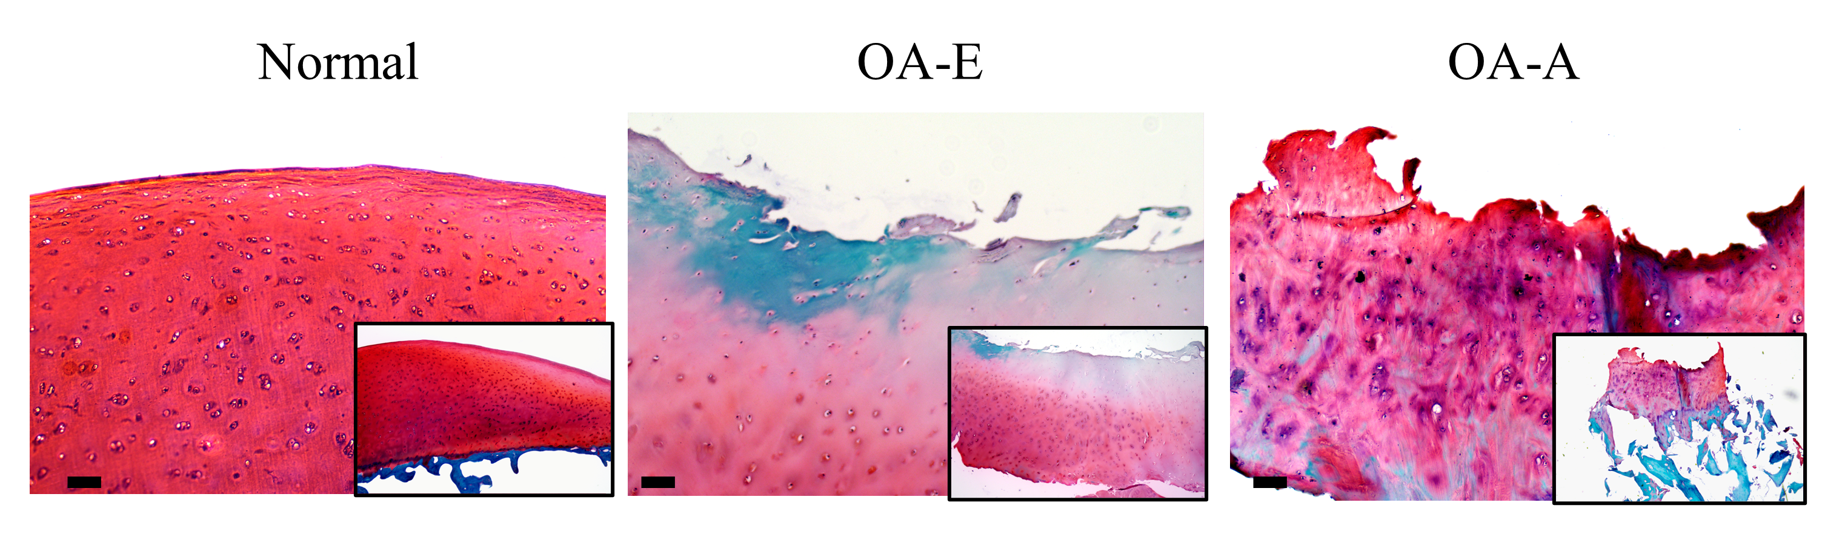

Figure S1. SO staining images showing histological OA features of different samples (normal samples, early-stage OA samples (OA-E) and cartilage at advanced OA stages (OA-A).

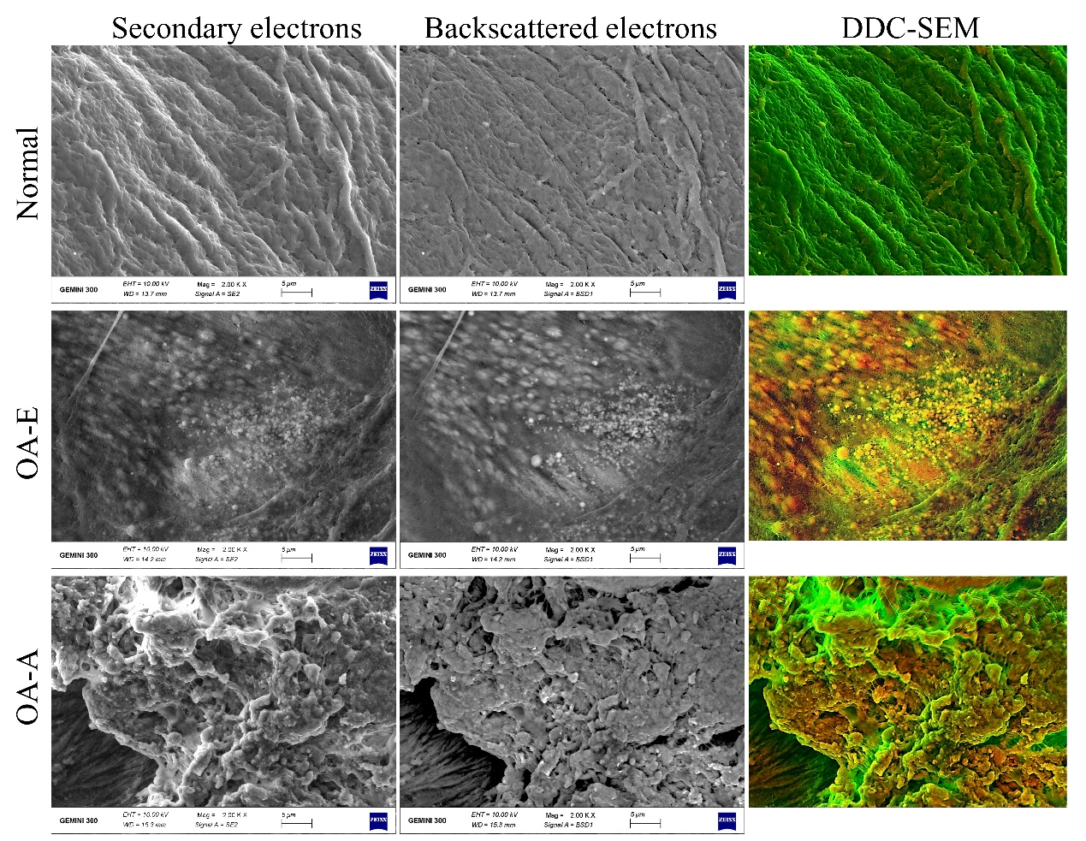
Figure S2. Image processing steps used to create the density-dependent scanning electron micrographs (DDC-SEM) presented in Fig. 1. Using the stack command in ImageJ software, SEM images acquired in secondary electron mode and backscatter electron mode were first assigned to green and red channel, respectively, followed by stacking the two images and converted to a single RGB image to create the DDC-SEM micrographs. Using this technique, simultaneous visualization of both microstructure and relative density could be obtained. The final output DDC-SEM images showed denser materials in orange and less denser materials in green. The corresponding EDX analysis on the right panel further illustrated the elemental compositions of the marked sites on DDC-SEM images, revealing the inorganic features of the denser materials in orange.

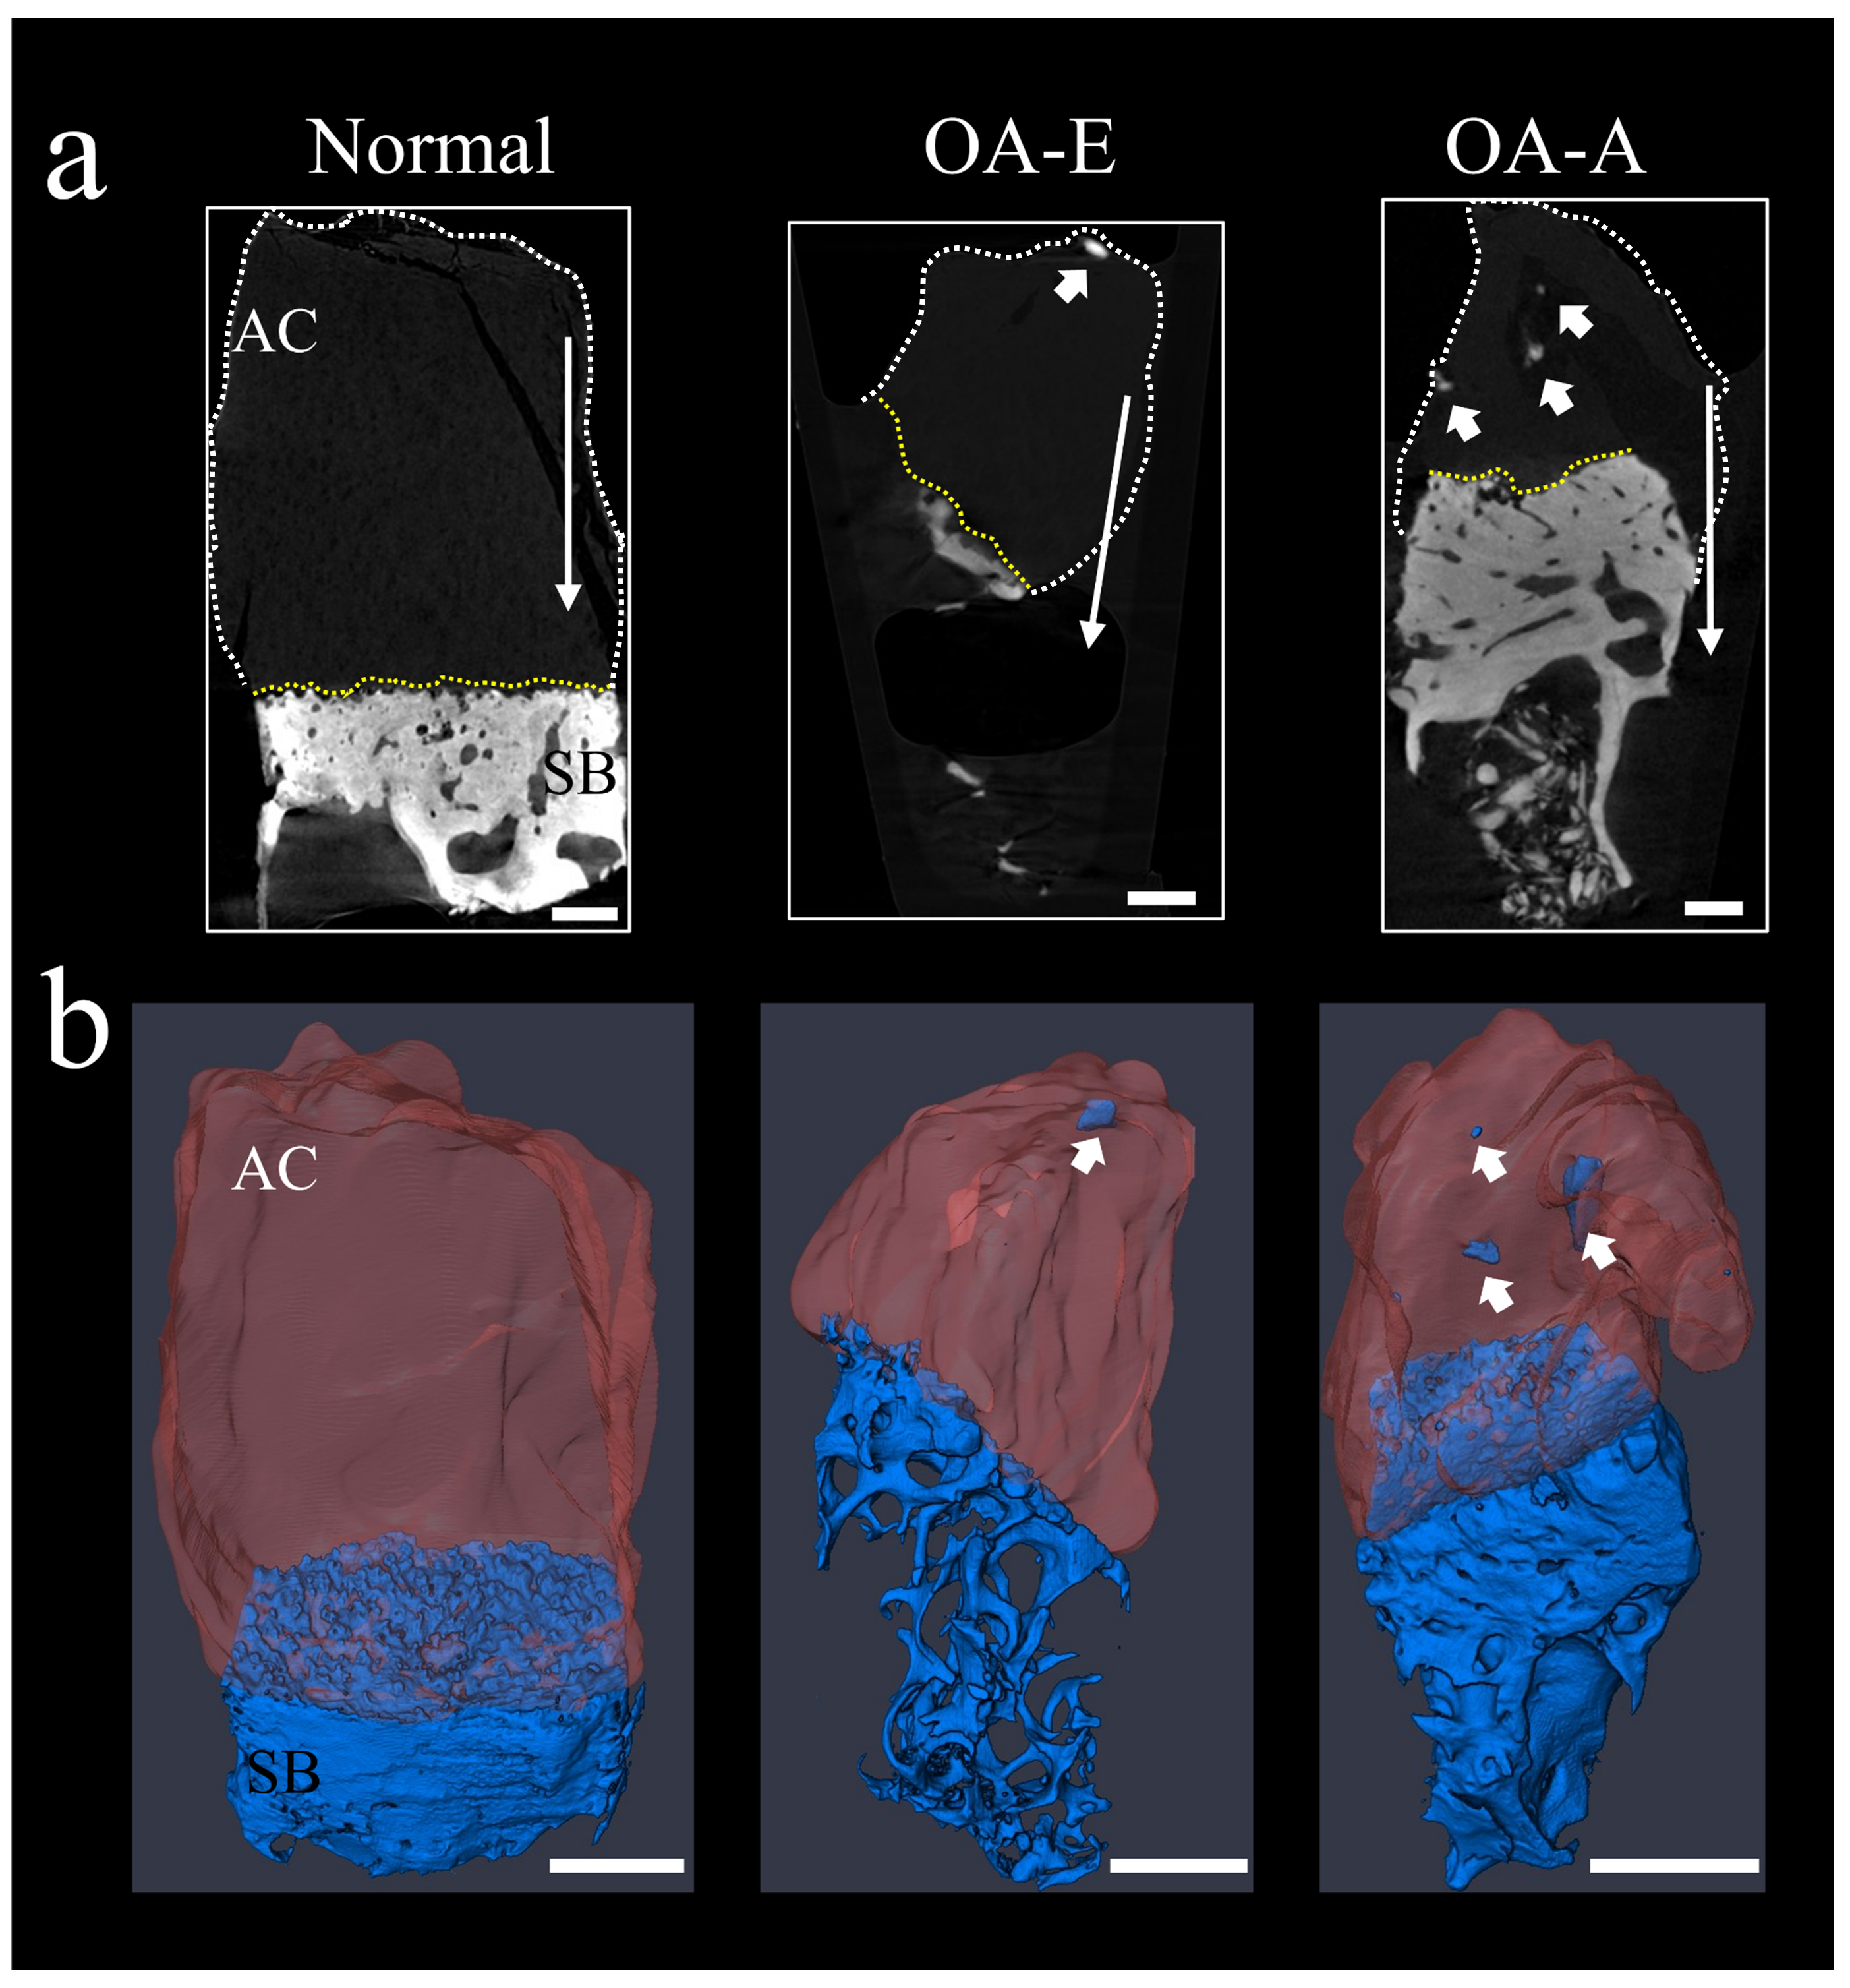
Figure S3. High-resolution CT images (a) and 3D reconstruction (b) of cross-sectional cartilages of different samples, reveal mineral deposition at cartilage surface of OA-E samples and mineral invasion into deeper cartilage region of OA-A samples. White arrowheads marked the minerals distribution in cartilage.

Figure S4. DDC-SEM micrographs of local calcified cartilage in OA progression. The arrows indicated the direction of calcified cartilage from subchondral bone to cartilage. Normal samples exhibited clear calcified cartilage with two kinds of hypertrophic chondrocyte lacuna (white dotted ovals) near the interface as the uncalcified and calcified. In calcified cartilage of OA-E and OA-A samples, the isolated spherical mineral particles were gradually invaded into cartilage with the frontier of interface containing empty calcified lacuna (white dotted ovals); scale bar: 10 μm.

Figure S5. (a). DDC-SEM micrographs of calcified cartilage tissues for normal, OA-E and OA-A samples. (b). Bright-field TEM images illustrating the ultra-structures and mineral distribution patterns at calcified cartilage of different samples. Scale bar in a= 5 μm, in b = 2 μm.

Figure S6. Chemical composition of minerals at calcified cartilage for different samples. (a). XRD diffraction patterns of calcified cartilage for normal, OA-E and OA-A samples, revealing HAp crystals ((JCPDS no. 09-0432). (b). FTIR spectra of calcified cartilage for different samples. (c-d). Raman spectra of the calcified cartilage tissues from cartilage to subchondral bone of OA-E (c) and OA-A samples (d).

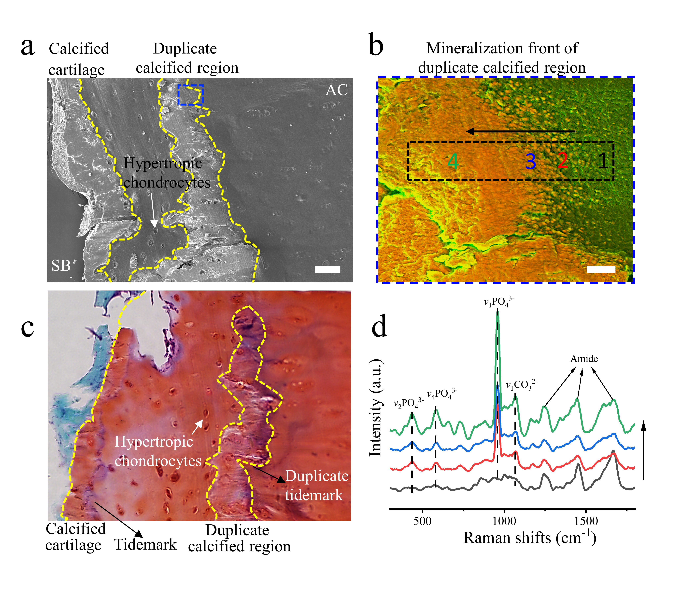
Figure S7. Microstructures and mineral compositions of the duplicate calcified layer. (a) and (c). BSE-SEM and histological staining images showing duplicate tidemarks features. (b). DDC-SEM images showing the mineral distributions at the front of the duplicate tidemarks. (d). Raman spectra collected at numbered sites across the duplicate calcified region revealed the gradient distributions of HAp particles.

Figure S8. Gaussian fitting of carbon K edge of minerals at calcified cartilage for normal (a), OA-E (b) and OA-A sample (c), respectively. The carbonyl peak at the carbon K edge present at 287 eV is mainly discernable in OA-E and OA-A samples. The carbonate peak at 290 eV is was more predominant in OA-A samples.

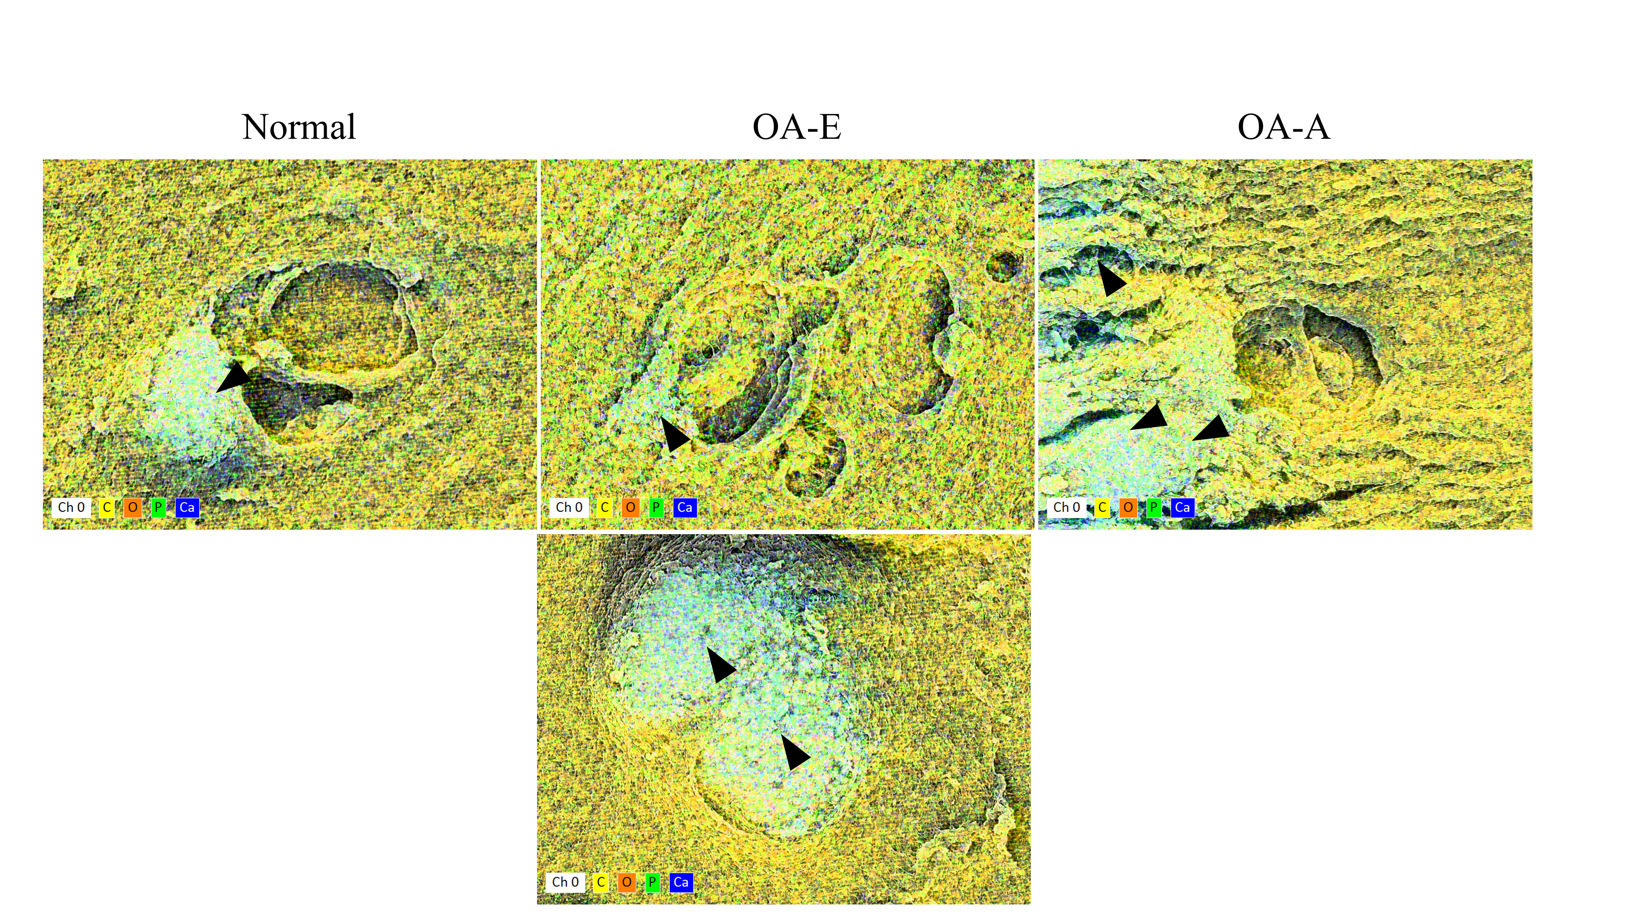
Figure S9. EDX mapping showing the calcification of the hypertrophic chondrocyte lacunae for different samples (yellow: carbon, dark orange: oxygen, light green: phosphorus, blue: calcium). Black arrows highlighted the calcified regions around the hypertrophic lacunae for different samples. For OA-E samples, the whole lacuna was largely calcified.

Figure S10. FIB-SEM reconstruction revealing mineral-containing matrix vesicles secreted by hypertrophic chondrocytes at calcified cartilage of OA-E samples. (a). FIB-SEM slices of hypertrophic chondrocyte lacuna at the calcified cartilage for OA-E samples. The hypertrophic chondrocyte was marked with white dotted box. (b). The 3D reconstructed chondrocytes (gold) and the secreted vesicles (black dotted box). (c). Corresponding EDX spectrum of the mineral region in vesicles in b, revealing the calcium/phosphate-containing features of the vesicles.

