Supplemental material
The image below shows an example of code used to predict scores given to Usual activities (eq5d3 in the code)
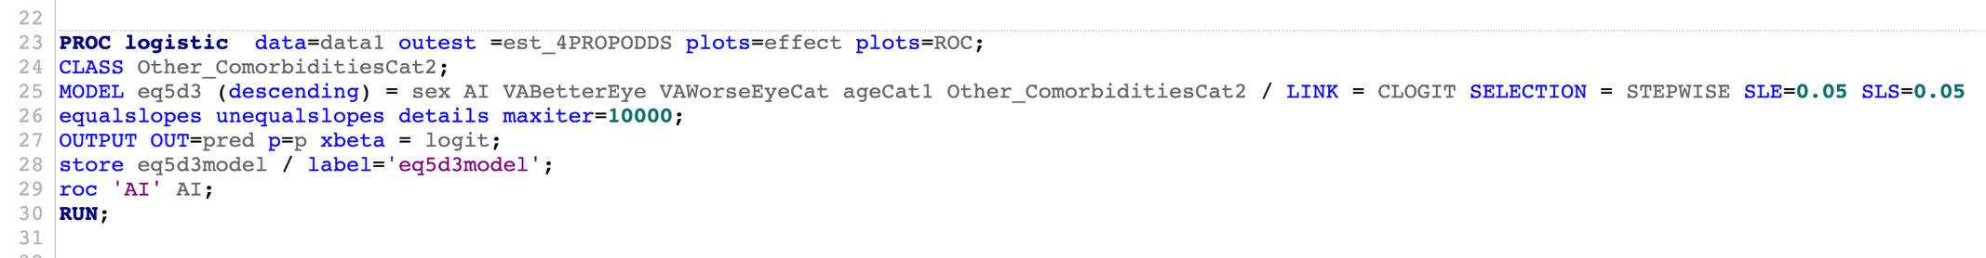

In the MODEL:
- sex: male = 1, female =2
- AI =visual ability given by the Activity Inventory (continuous)
- VABetterEye: visual acuity in the better seeing eye (continuous)
- VAWorseEyeCat (visual acuity in the worse seeing eye): visual acuity 1.02 or worse (higher values correspond to worse acuity) = 1, visual acuity 1.0 or better = 2
- ageCat1: 65 years or less = 0, >65 = 1
- Other_ComorbiditiesCat2: YES = 0, NO = 1

